CampusSeat User Manual
CampusSeat lets students and staff browse campus events, book one seat each, and download a registration card; administrators manage events, bookings, users and reports.

1. Getting started
Open CampusSeat in any modern browser at http://localhost:4000 (or the live address your team deploys to). Anyone can browse events; you need an account to book.
Role | What you can do
Guest | Browse and search events, read Help, register, log in
Student or staff (user) | Everything above, plus book one seat per event, view and download your registration cards, change your password
Administrator (admin) | Everything above, plus the Admin panel: events, bookings, users, reports and audit logs
Demo accounts created by the seed script:
Role | Email | Password
Administrator | admin@campusseat.local | Admin@12345
Student | student@campusseat.local | Student@12345
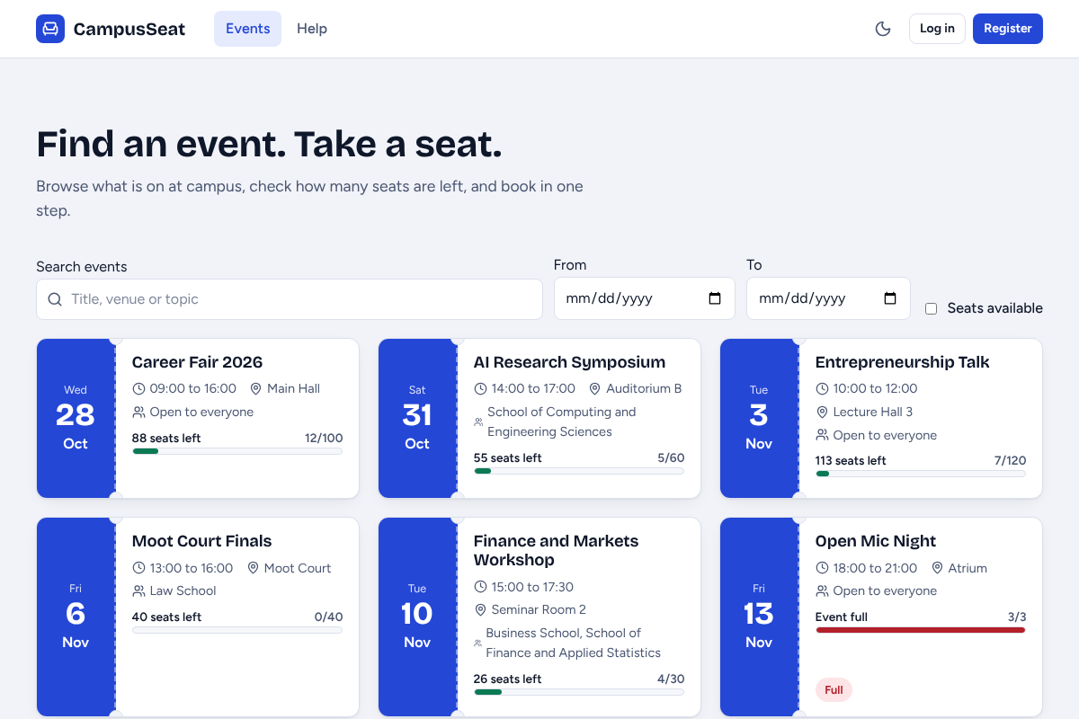
Figure 1. The events page. Each ticket shows date, venue, who may attend and how many seats are left.

Setting up the system (administrator or developer, once)
1. Install Node.js (LTS) and MySQL Server 8.
2. In PowerShell from the project folder, create the database: mysql -u root -p -e "source database/schema.sql"
3. In the backend folder, copy .env.example to .env and fill in the database user, password and a long random JWT_SECRET.
4. In the backend folder run npm install, then npm run seed (adds schools, demo accounts and sample events), then npm start.
5. In the frontend folder run npm install, then npm run build. The backend serves the built site, so open http://localhost:4000.

2. Student and staff guide

2.1 Create an account
Choose Register, enter your name, email, student or staff number, school and a password of at least 8 characters with a letter and a number. Fields with a problem show a message under them before anything is saved.
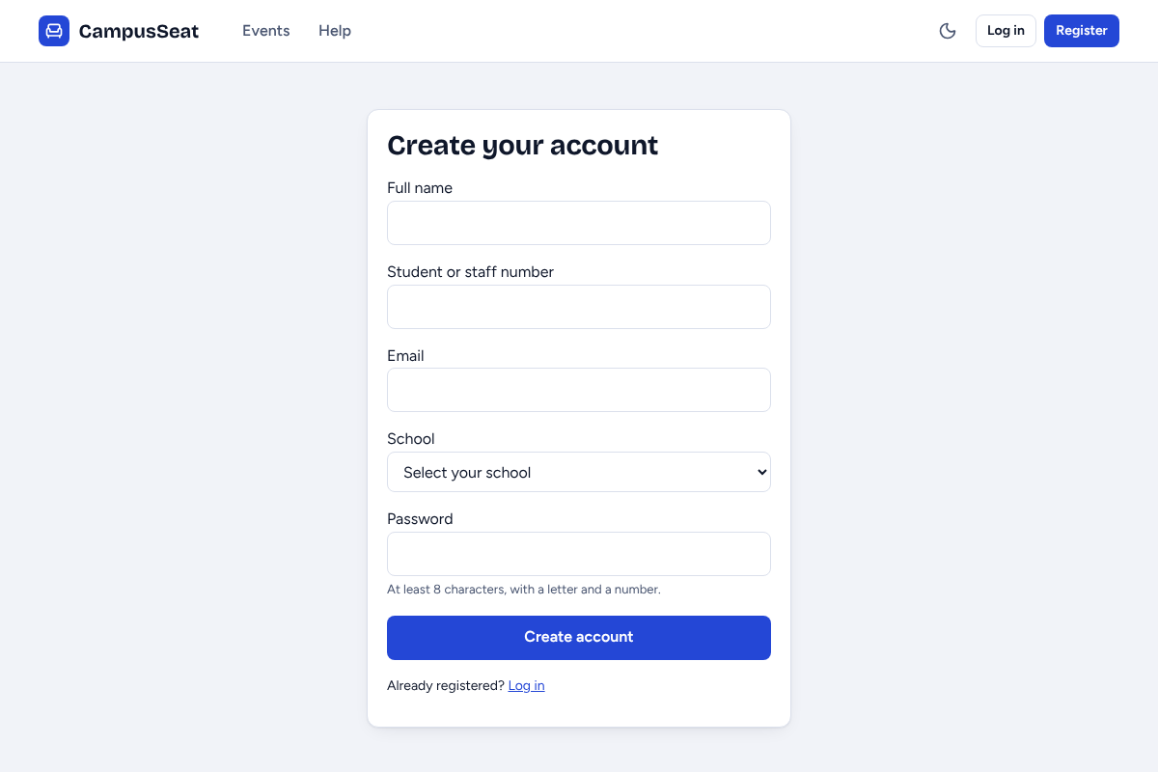
Figure 2. Registration form.
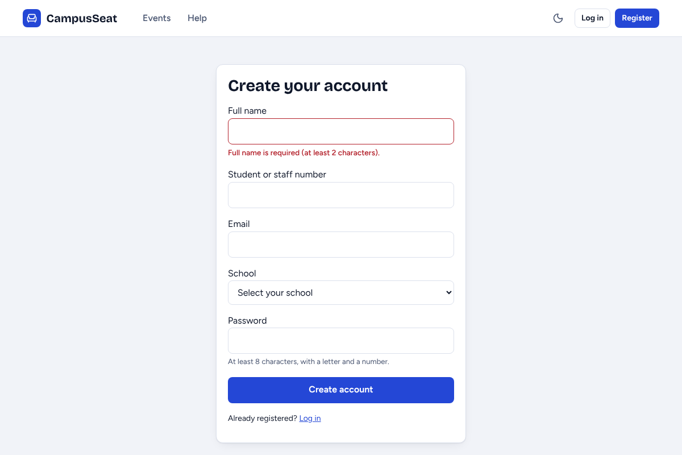
Figure 3. Submitting an empty form lists what must be fixed.

2.2 Log in and log out
Enter your email and password and choose Log in. Use Log out (top right) when you finish on a shared computer. A wrong email or password shows one general message so nobody can tell which half was wrong.
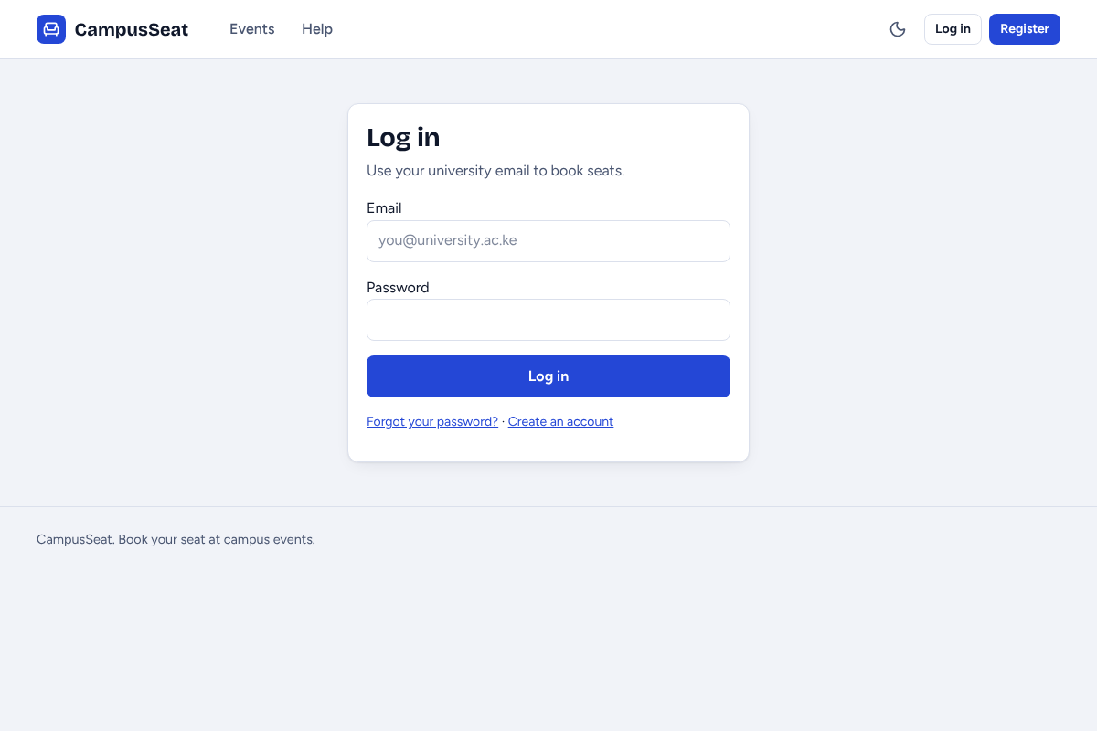
Figure 4. Login.
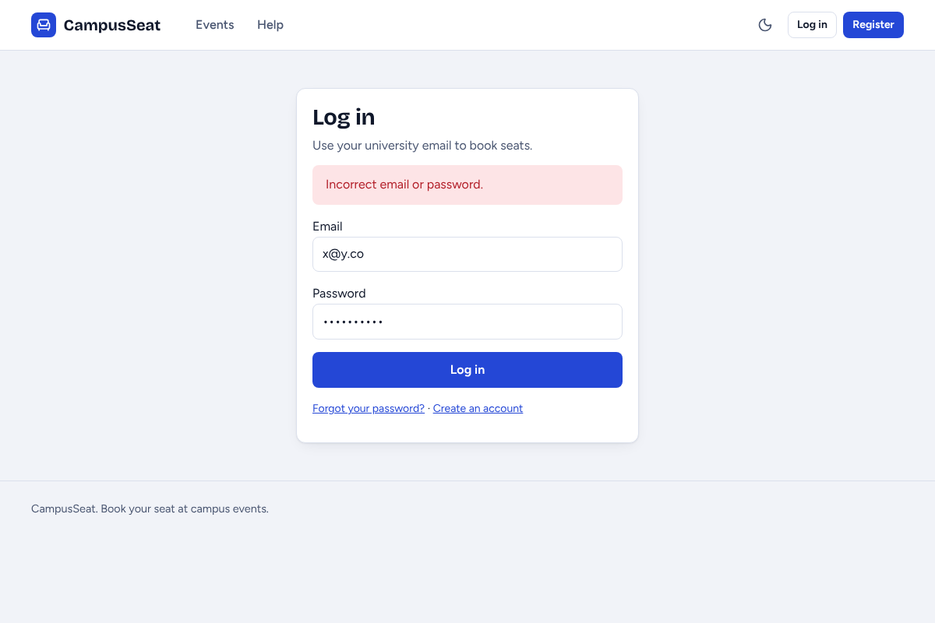
Figure 5. A failed login.

2.3 Forgot password
Choose Forgot password on the login page. Enter your email, your student or staff number and a new password. If the email and number match one account, the password is changed and you can log in. If you also lose your number, ask an administrator to reset your password; they will give you a temporary one.
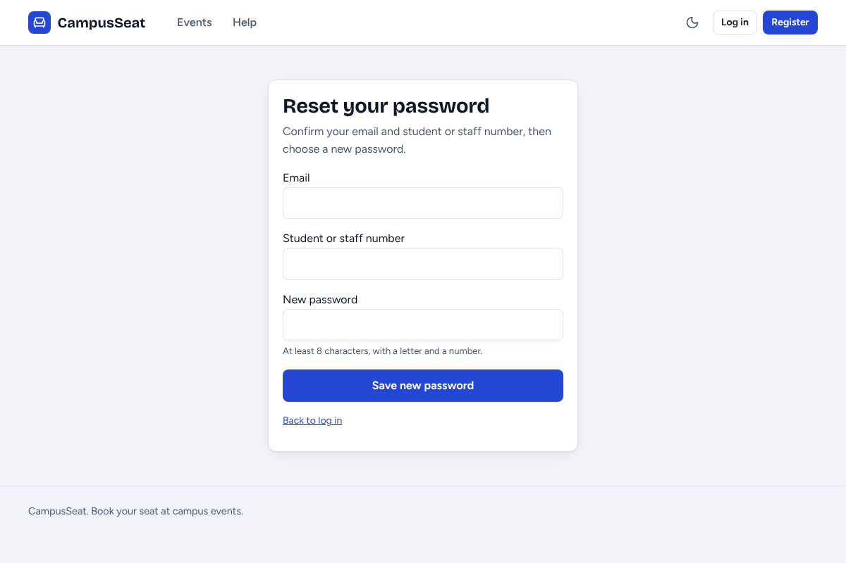
Figure 6. Forgot password.

2.4 Browse and search events
The Events page lists upcoming events as tickets. Type in the search box to filter by title, venue or topic, and use the From and To dates to narrow the range. The seat meter on each ticket shows how full the event is.
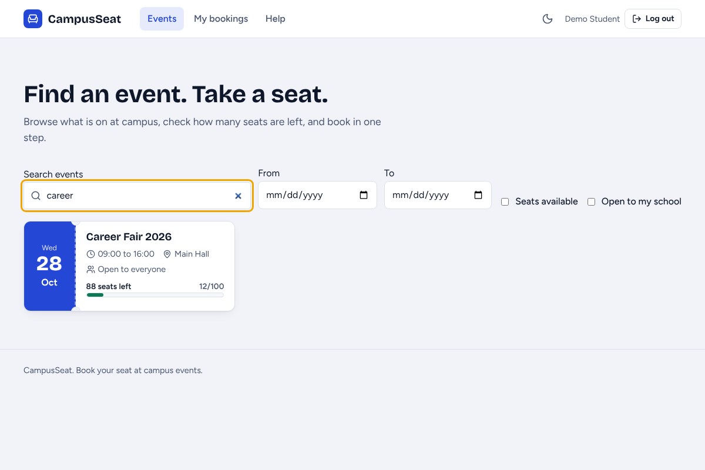
Figure 7. Searching for "career".

2.5 Book a seat
1. Log in and open an event.
2. Check the date, time, venue and who the event is open to.
3. Confirm your name, student or staff number and school. They must match your account.
4. Choose Confirm booking. A message shows your booking reference, for example CS-2026-00032.
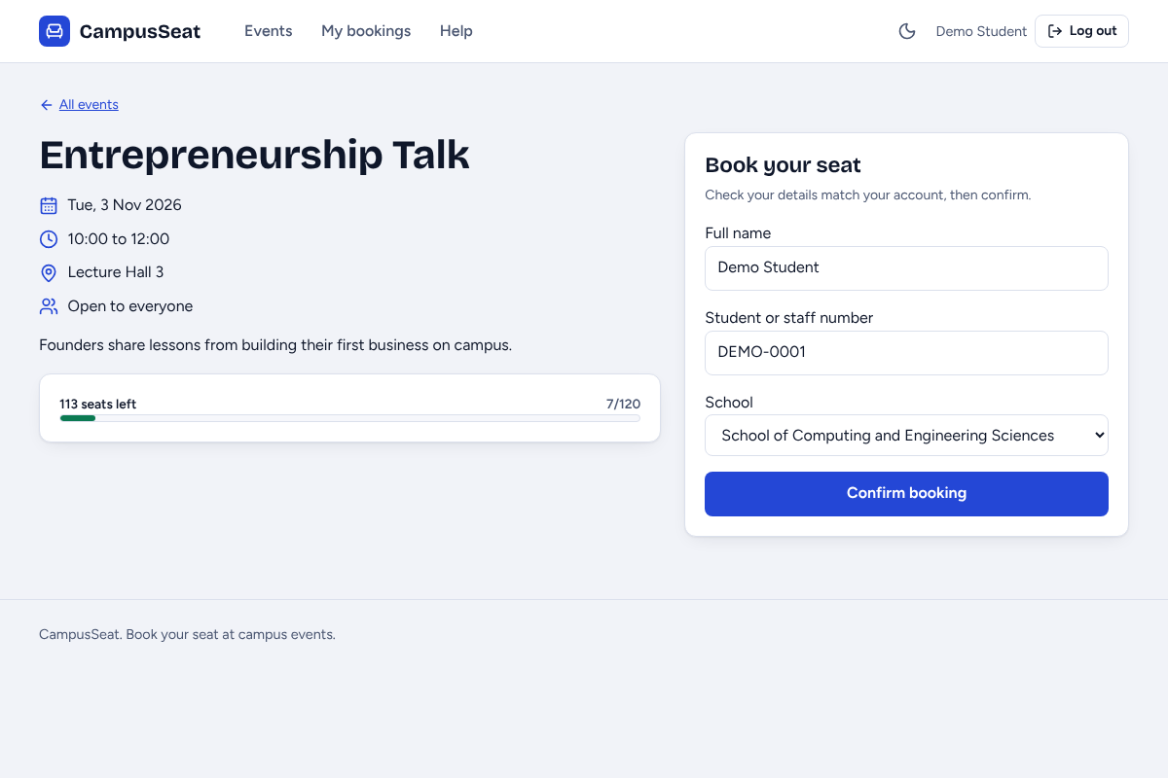
Figure 8. The booking form on an event page.
The system books a seat only if the event has not passed, you have not already booked it, your school is allowed and a seat is free. Two people cannot take the last seat.
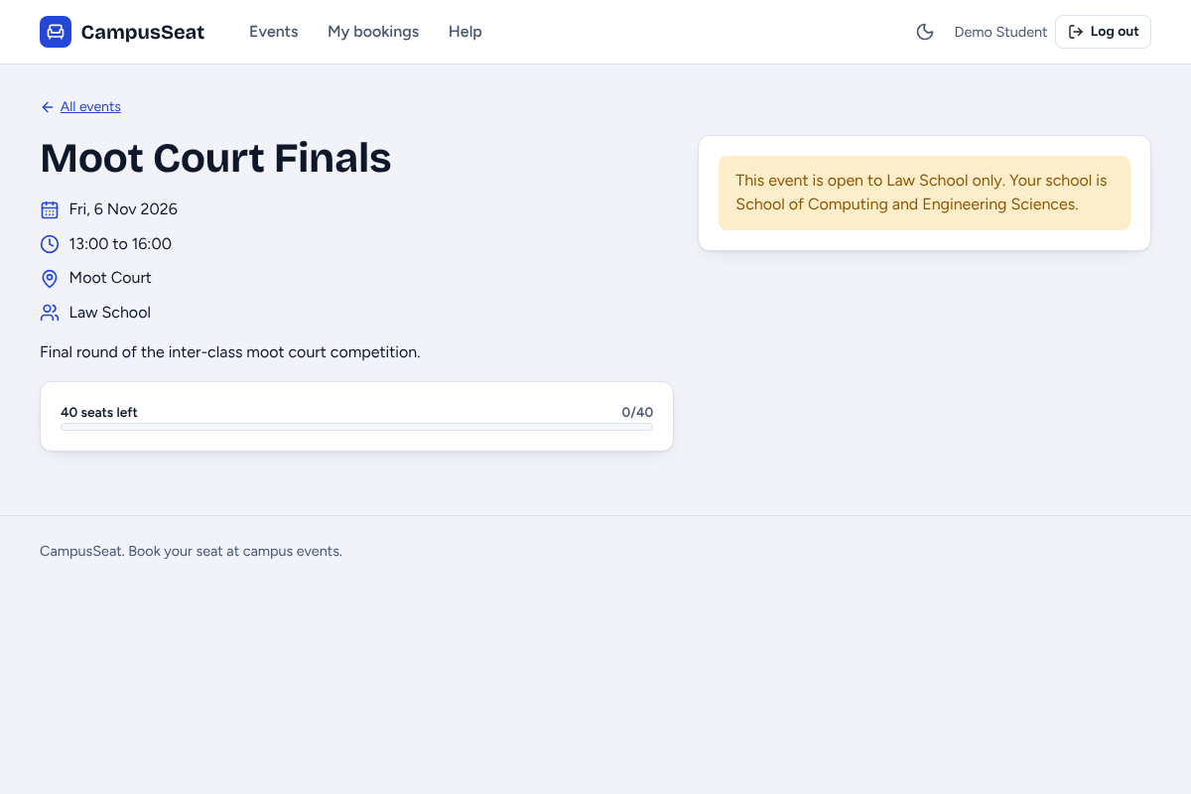
Figure 9. An event restricted to other schools.
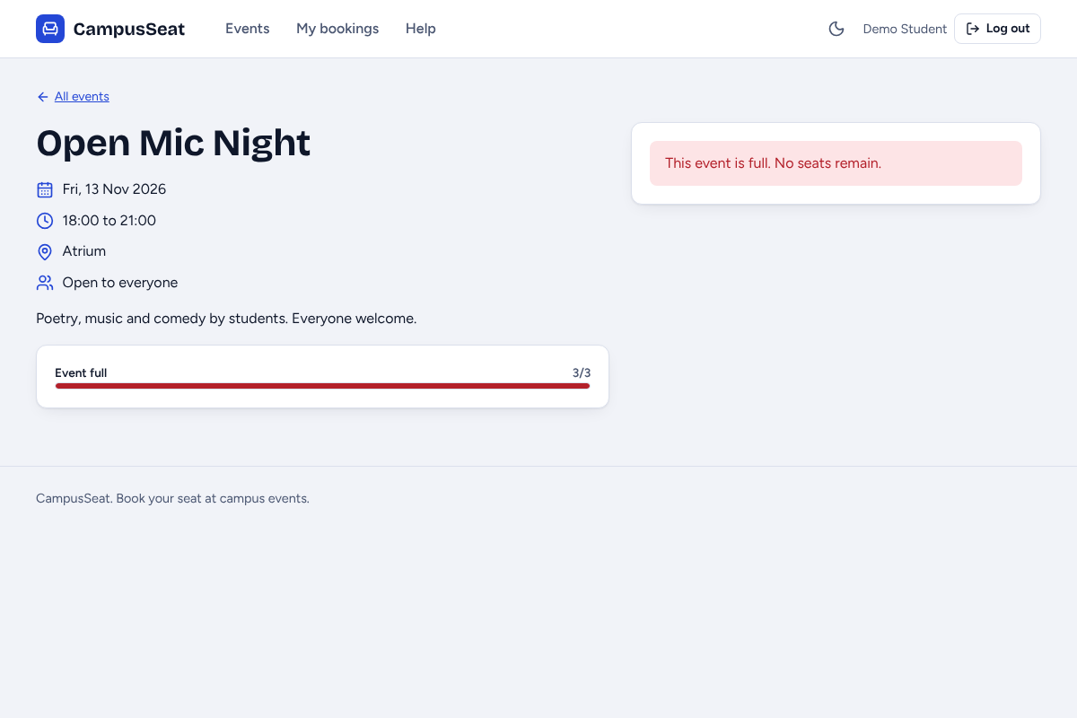
Figure 10. An event with no seats left.

2.6 Your registration card
After booking you land on My bookings, where each booking is a registration card. Choose Download PDF for a printable card with a QR code, or Print. Show the card or the reference at the event as proof of attendance.
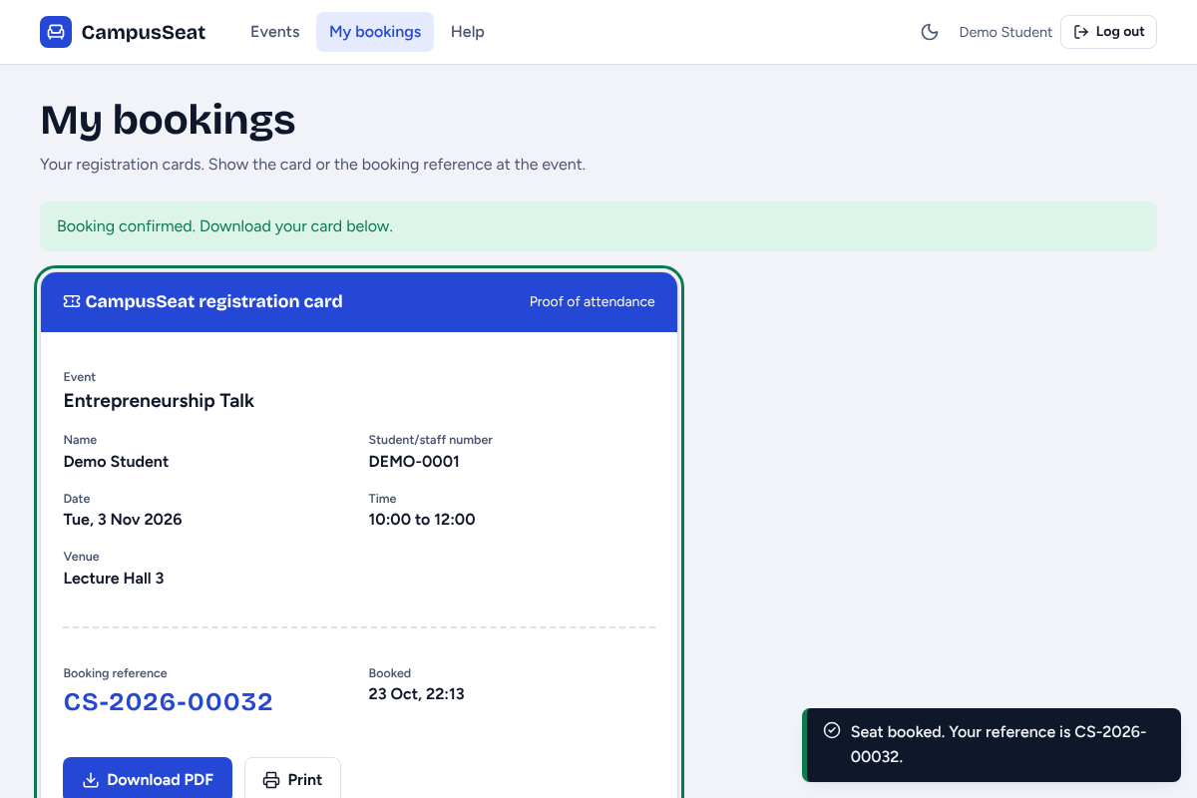
Figure 11. A new registration card.
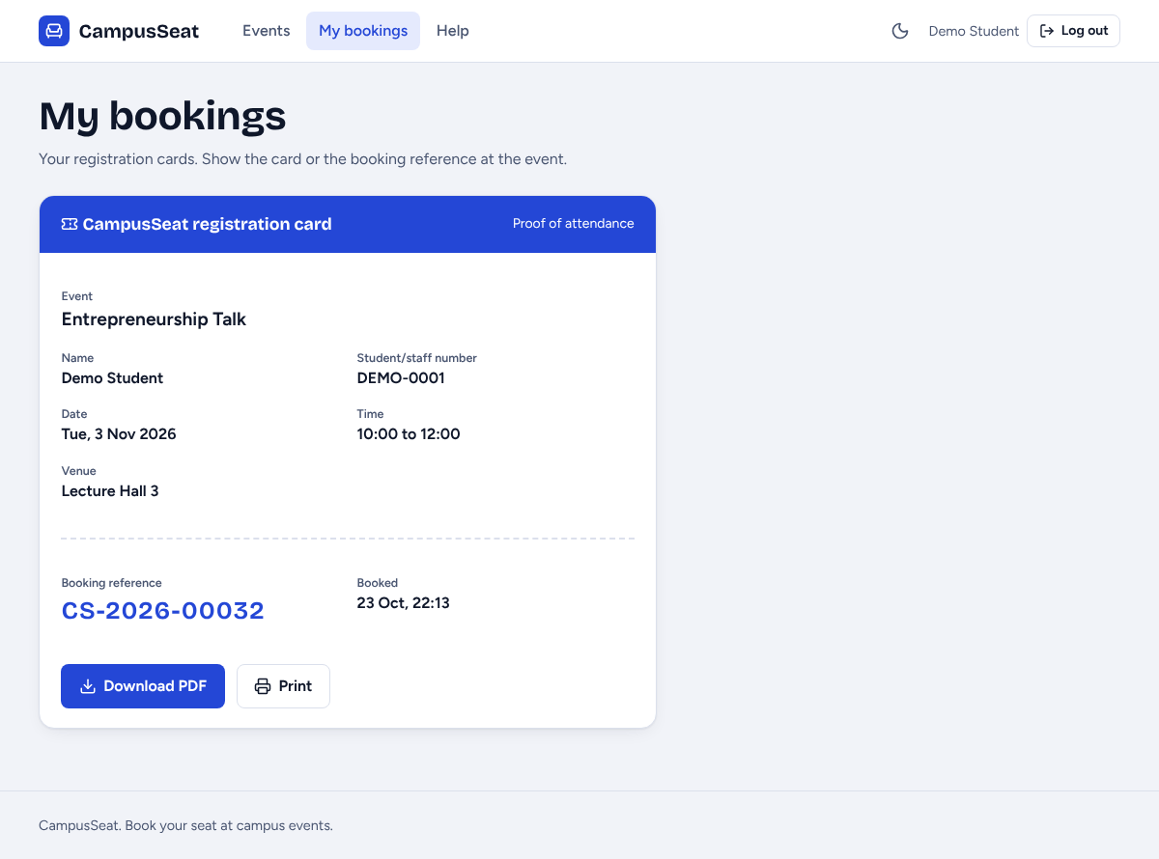
Figure 12. My bookings lists every card.
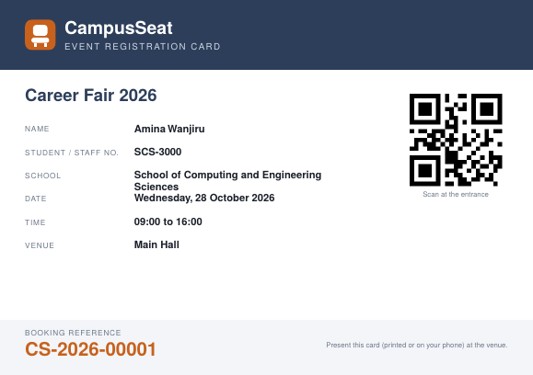
Figure 13. The PDF card.

2.7 Help and dark mode
The Help page answers common questions. The moon icon in the top bar switches between light and dark mode, and the choice is remembered.
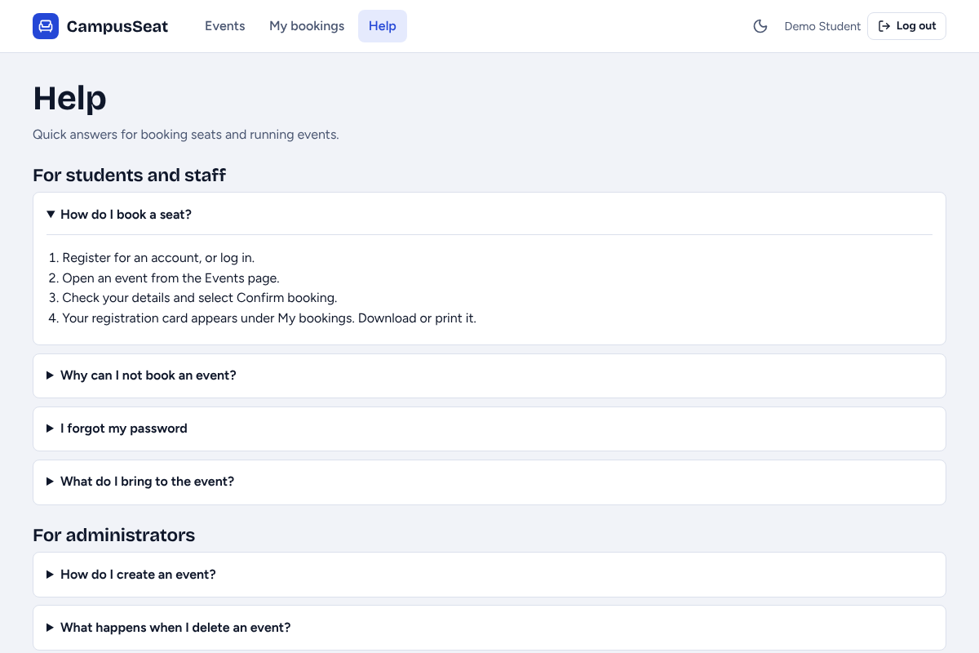
Figure 14. Help.
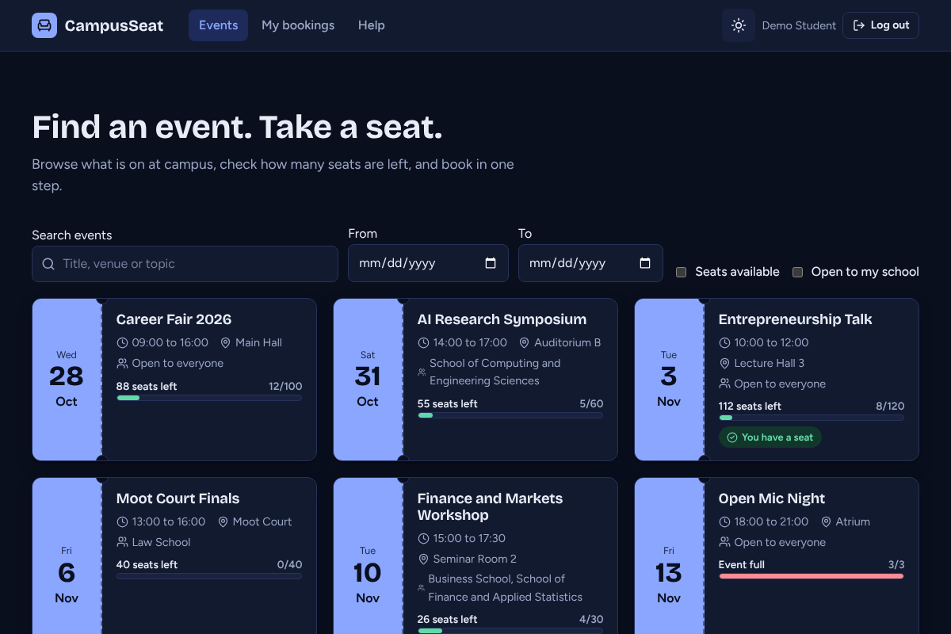
Figure 15. Dark mode.

3. Administrator guide
Log in with an administrator account. An Admin panel link appears in the top bar and opens the dashboard. The left menu moves between Dashboard, Events, Bookings, Users, Reports and Audit logs. Normal users who type an admin address are turned away.

3.1 Dashboard
The dashboard shows upcoming events, total bookings, registered users, events that are 80% full or more, bookings over the last 7 days, and the latest bookings.
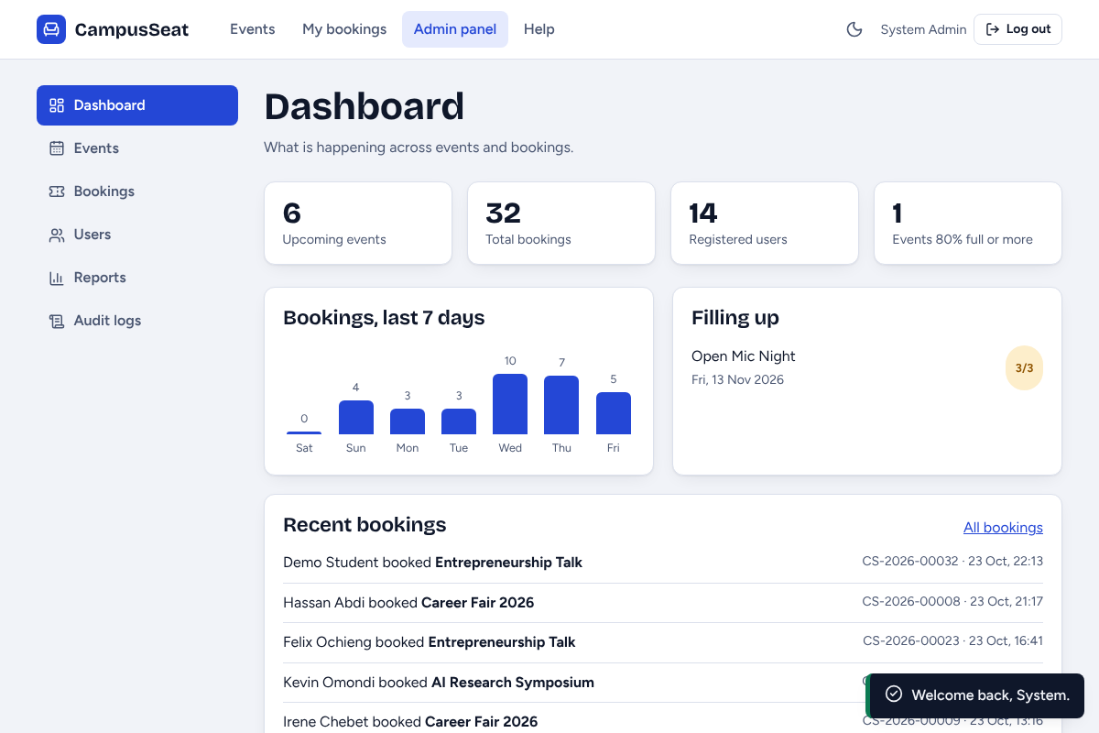
Figure 16. Dashboard.

3.2 Manage events (add, edit, delete)
1. Open Events. Use the table to browse all events.
2. Choose New event, fill in the name, date, start and end time, venue, capacity, description and the schools it is open to (leave none selected for all schools), then choose Save event. The date cannot be in the past and the end time must be after the start time.
3. Choose Edit on a row to change an event. Capacity cannot be set below the seats already booked.
4. Choose Delete on a row. A confirmation window appears first, because deleting an event also removes its bookings.
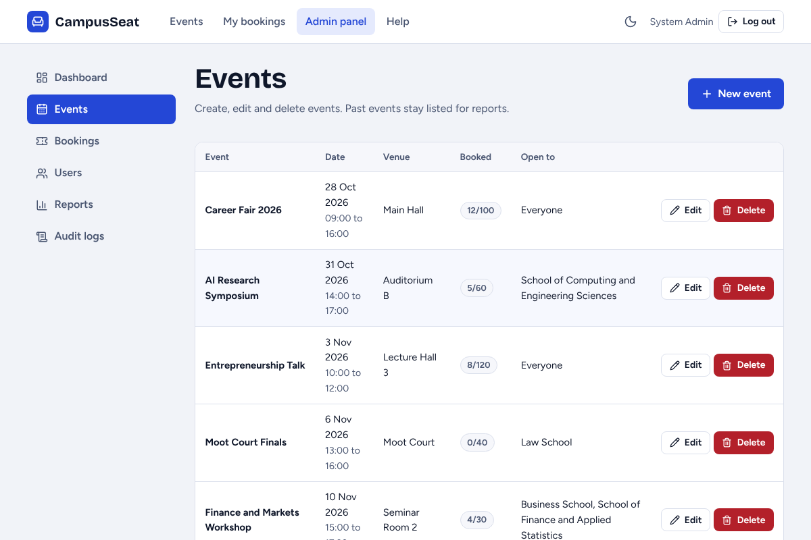
Figure 17. Events list with Edit and Delete.
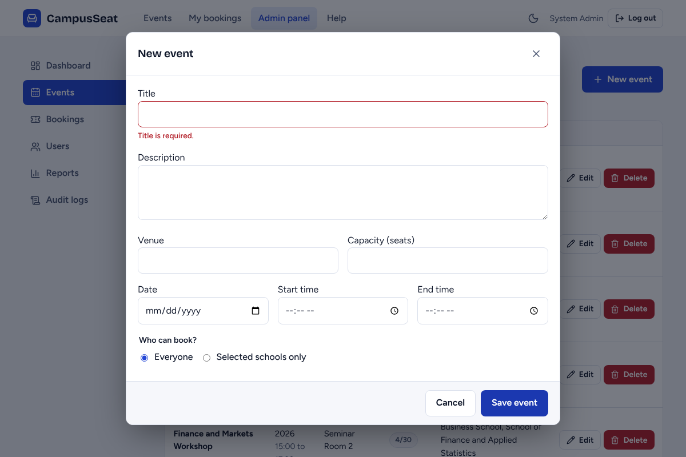
Figure 18. The form explains each problem before saving.
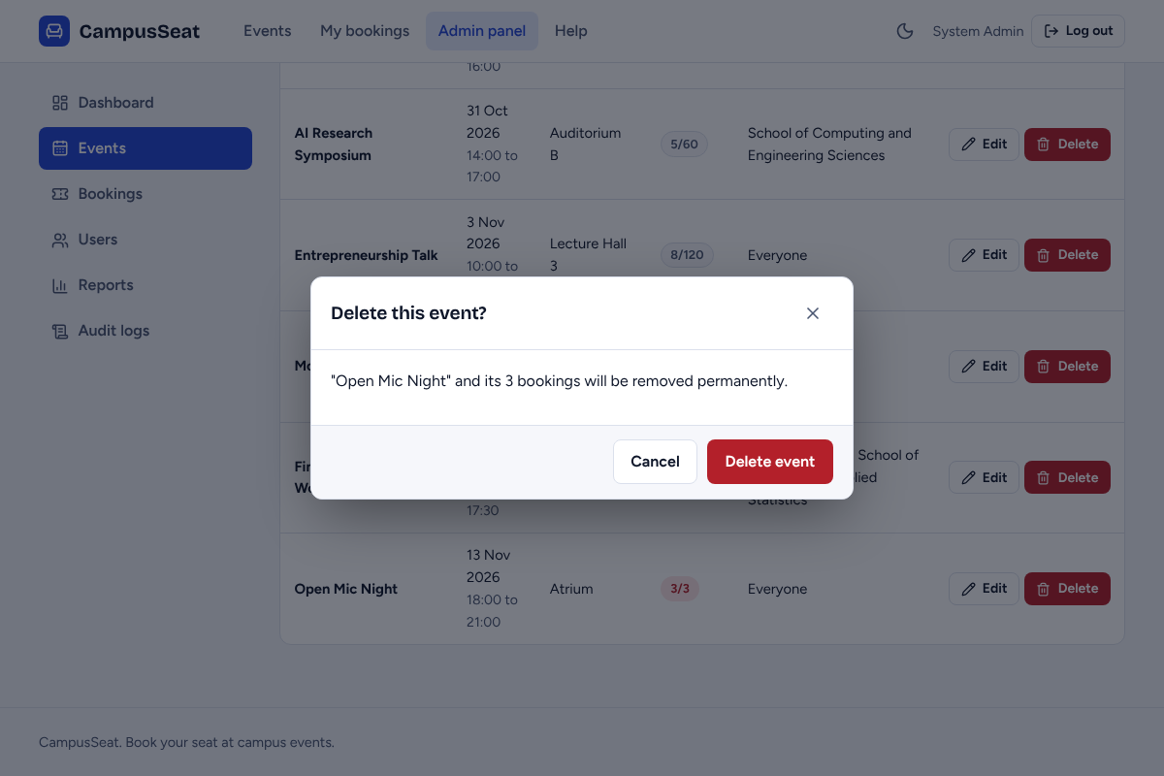
Figure 19. Delete asks for confirmation.

3.3 Bookings
The Bookings page lists every booking with the student, event and reference. Search and filter the list, and cancel a booking if needed; the seat becomes free again.
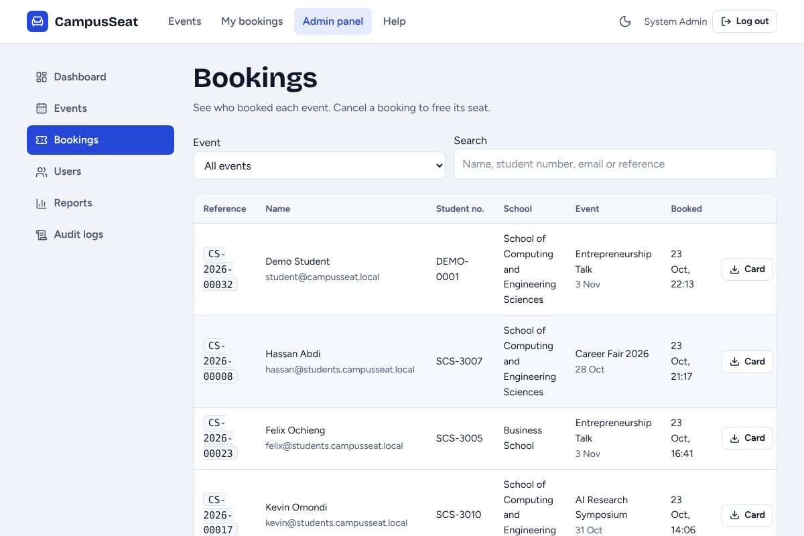
Figure 20. Bookings.

3.4 Users and roles
The Users page lists accounts with their school and role. An administrator can make a user an admin (or back to a user), reset a password (the system shows a temporary password to pass on), or delete an account. You cannot change or delete your own account, and an account that has bookings or created events cannot be deleted until those are removed.
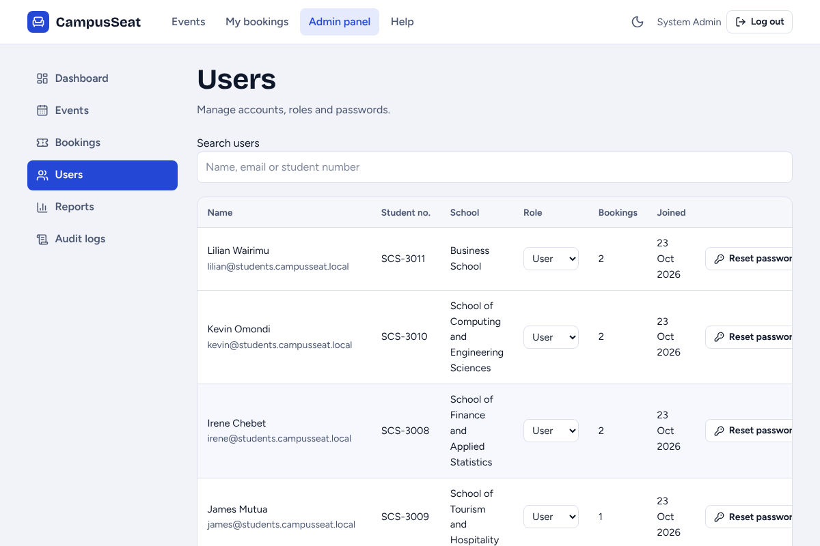
Figure 21. Users.

3.5 Reports
Choose the report (bookings or events), set filters (booked from and to, event, school), pick the sort column and order, then Download PDF or Download CSV. The preview table shows the total. PDF reports carry the CampusSeat logo and name, the date generated, the filters used, the totals and page numbers.
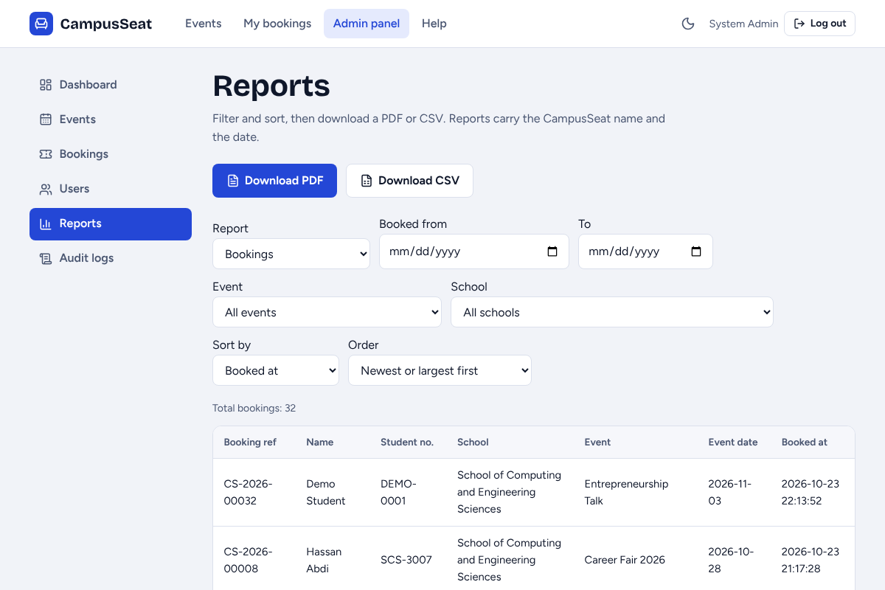
Figure 22. Report filters and preview.
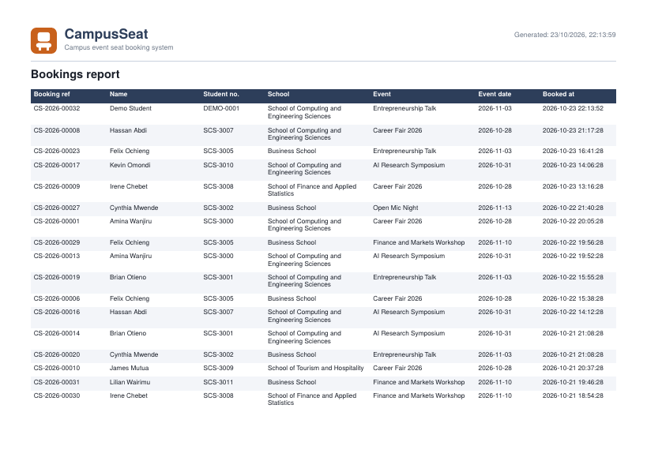
Figure 23. A PDF report.

3.6 Audit logs
Registrations, sign-ins (including failed ones), bookings, cancellations, event changes, role changes, password resets, user deletions and report downloads are recorded with who did it and when. Audit logs are read-only.
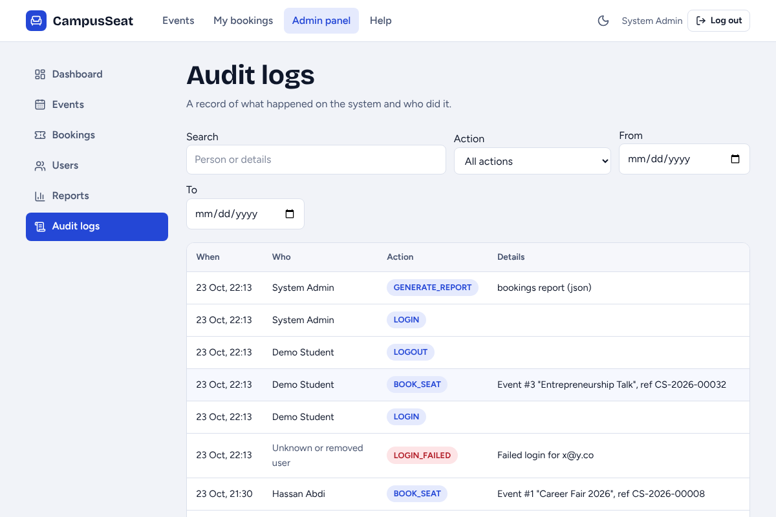
Figure 24. Audit logs.

4. Messages and troubleshooting
Message or problem | Meaning | What to do
Password must be at least 8 characters / must contain a letter and a number | The password is too weak | Choose a longer password with letters and digits
You have already booked a seat for this event | One seat per person per event | Open My bookings to find your card
This event is open to ... only | Your school is not on the guest list | Choose another event, or ask the organiser
Sorry, this event is full. No seats remain. | Capacity reached | Check back later, or ask an administrator to raise capacity
This event has already taken place | The event date has passed | Pick an upcoming event
The name, student number or school you entered does not match your account | Booking details differ from your account | Use the details you registered with
Too many attempts | Rate limit against password guessing | Wait a few minutes and try again
Capacity cannot be lower than the N seats already booked | Admin set capacity too low | Enter N or more
This user has bookings or created events | Admin tried to delete a user in use | Cancel their bookings first
Page does not load | The server is not running | Start it with npm start in the backend folder and check the MySQL service is running

