
PRATHYUSHA ENGINEERING COLLEGE
(An Autonomous Institution)

Department of Computer Science and Engineering

A Micro Project Report on
COURIER TRACKING SYSTEM
SUBMITTED BY
Team Members : K.S.MUTHTHAMIZH SELVI - 111424104081
M.MUTHUSELVI - 111424104082
N.NITHEESH KUMAR - 111424104083

Course Code : 241CSC411L
Course Name : DataBase Management Systems Laboratory
Year/Sec : II Year / B sec

Department | : Computer Science and Engineering
Date of Submission | :

BONAFIDE CERTIFICATE
Register No:

Certified that this is the Micro Project Report “COURIER TRACKING SYSTEM” is the Bonafide work of the “ K.S.MUTHTHAMIZH SELVI (111424104081) ”, “ M.MUTHUSELVI(111424104082) ”, “ N.NITHEESH KUMAR (111424104083) ” who carried out the micro project work under my supervision

SIGNATURE SIGNATURE
Ms JERCY, Dr THAMBA MESHACH W,
ASSISTANT PROFESSOR, PROFESSOR,
SUPERVISOR, HEAD OF THE DEPARTMENT,
Department of CSE, Department of CSE,
Prathyusha Engineering College Prathyusha Engineering College,
Thiruvallur – 602 025 Thiruvallur – 602 025
Place: Tiruvallur- 602025.
Date:
________________________________________________________________
Submitted for the Micro Project Viva-Voce held on …………………………. at PRATHYUSHA ENGINEERING COLLEGE (Autonomous), Tiruvallur – 605 025.

INTERNAL EXAMINER EXTERNAL EXAMINER

PRATHYUSHA ENGINEERING COLLEGE
(An Autonomous Institution)

Department of Computer Science and Engineering

INDEX
S.No. | Contents | Page No.
1. | Abstract | 4
2. | Introduction | 5
3. | Problem Statement | 7
4. | Objectives | 8
5. | Methodology | 9
6. | System Design – ER Diagram | 12
7. | Implementation | 16
8. | Tools Used | 18
9. | Sample SQL Queries Used | 20
10. | Outcomes and Future Enhancements | 22
11. | Conclusion and Reference | 24

Abstract

The Courier Tracking System is a web-based application designed to simplify and automate the process of managing courier shipments. In today’s fast-paced environment, customers expect transparency and efficiency when sending or receiving parcels. Traditional manual systems often lead to delays, errors, and poor customer satisfaction.
This project introduces a digital solution that allows customers to track their shipments in real time using a unique tracking ID. Administrators can manage parcel entries, assign delivery staff, and update shipment statuses seamlessly. The system integrates a relational database for secure storage of shipment details, a user-friendly interface for customers, and backend modules for staff operations.
By implementing this system, courier companies can reduce operational costs, minimize human error, and improve service quality. The project also demonstrates how modern technologies such as SQL databases, server-side programming, and responsive web design can be combined to create a robust solution. Ultimately, the Courier Tracking System bridges the gap between courier companies and customers, ensuring trust, transparency, and efficiency in parcel delivery.

Introduction
Courier services play a vital role in connecting businesses and individuals across regions. With the growth of e-commerce and global trade, the demand for reliable courier systems has increased significantly. However, many courier companies still rely on outdated manual methods for tracking shipments, which often result in inefficiencies.

Customers frequently face challenges such as lack of visibility into parcel status, delayed updates, and difficulty in contacting courier staff. The Courier Tracking System aims to address these challenges by providing a digital platform that automates the process of shipment management. Customers can log in to the system, enter their tracking ID, and instantly view the current status of their parcel. Administrators can update shipment details, assign delivery routes, and generate reports.
The system is designed to be scalable, meaning it can handle thousands of shipments simultaneously without performance issues. Moreover, it emphasizes data security, ensuring that customer information and shipment records are protected. By introducing this system, courier companies can enhance their competitiveness, improve customer satisfaction, and adapt to the growing digital economy.

Problem Statement
In traditional courier services, customers often face difficulties in knowing the exact status and location of their parcels after dispatch. Manual tracking methods are time-consuming, less accurate, and may lead to delays, lost shipments, or poor communication between customers and courier staff.
Courier companies also face challenges in managing shipment records, updating delivery status, assigning staff, and handling customer queries efficiently. Lack of a centralized system can result in data errors and reduced productivity.

To overcome these issues, a Courier Tracking System is developed to automate courier booking, shipment management, real-time tracking, payment handling, and delivery updates. The system provides transparency, improves operational efficiency, reduces errors, and enhances customer satisfaction through faster and more reliable service.

Objectives
- Develop a web-based system for courier tracking.
- Provide real-time status updates for shipments.
- Enable customers to track parcels using unique IDs.
- Simplify administrative tasks like parcel entry, route assignment, and delivery confirmation.
- Ensure data security and accuracy.

The Courier Tracking System has been developed with the aim of improving efficiency, transparency, and customer satisfaction in courier services. The objectives of this project can be grouped into several categories:

1. Primary Goals
The foremost objective is to design a digital platform that automates the process of shipment tracking. By eliminating manual record-keeping, the system ensures accuracy and reduces delays. It provides a centralized solution where both customers and administrators can interact with shipment data seamlessly.

2. Customer-Oriented Objectives
Customers are the end-users of courier services, and their satisfaction is critical. The system aims to:
- Provide real-time tracking of parcels through a unique tracking ID.
- Offer transparency by showing clear shipment stages such as Booked, In Transit, Out for Delivery, and Delivered.
- Enhance accessibility by making the system available across devices.
- Build trust by reducing uncertainty and improving communication.

3. Administrative Objectives
For courier staff and administrators, the system simplifies daily operations. It enables:
- Efficient entry and management of shipment details.
- Reduction of errors caused by manual processes.
- Easy assignment of delivery routes and staff responsibilities.
- Generation of reports and analytics to monitor performance.

4. Technical Objectives
The system is designed with technical robustness in mind. Objectives include:
- Secure database integration for storing customer and shipment data.
- Scalability to handle large volumes of shipments without performance issues.
- Strong authentication and authorization to protect sensitive information.
- Automation of updates and notifications to minimize manual intervention.

5. Long-Term Vision
Beyond immediate goals, the project envisions future enhancements such as mobile app integration, GPS-based live tracking, AI-driven delivery predictions, and automated notifications via SMS or email. These objectives ensure that the system remains adaptable and relevant in the evolving logistics industry.

Methodology

Requirement Analysis

System Design Approach

Database Development

Implementation Strategy

Testing and Validation

Deployment Plan

The methodology adopted for developing the Courier Tracking System follows a systematic approach to ensure accuracy, efficiency, and reliability. Each stage of the process was carefully planned and executed to meet the objectives of the project.

1. Requirement Analysis
The first step was to identify the needs of both customers and administrators. Customers required a simple way to track parcels, while administrators needed tools to manage shipments, assign routes, and update statuses. These requirements formed the foundation of the system design.

2. System Design Approach
Based on the requirements, the system was designed using flowcharts and ER diagrams. The design focused on creating clear relationships between entities such as customers, shipments, and staff. This ensured that data could be managed efficiently and retrieved quickly when needed.

3. Database Development
A relational database was created using SQL to store shipment details, customer information, and staff records. Tables were normalized to reduce redundancy, and primary keys were assigned to uniquely identify each record. This database serves as the backbone of the system.

4. Implementation Strategy
The system was implemented in modules. The frontend was developed using HTML, CSS, and JavaScript to provide a user-friendly interface. The backend was built using PHP/Java/Python to handle business logic and connect with the database. A tracking module was integrated to update shipment statuses automatically.

5. Testing and Validation
Extensive testing was carried out to ensure the system worked as expected. Unit testing verified individual modules, while integration testing checked the interaction between components. User acceptance testing was conducted to confirm that the system met customer and administrator needs.

6. Deployment Plan
Finally, the system was deployed on a secure server. Administrators were trained to use the platform, and customers were provided with instructions for tracking parcels. The deployment ensured that the system was accessible, reliable, and ready for real-world use.

System Design ER Diagram

Relationships
A Donor donates blood → stored in BloodInventory
A Hospital requests blood → stored in BloodRequest
Foreign Keys ensure referential integrity between tables

Relational Schema
The ER diagram is transformed into relational tables:
- Donor(DonorID PK, Name, BloodGroup, Phone, Address, LastDonationDate)
- BloodInventory(InventoryID PK, BloodGroup, Units, ExpiryDate, DonorID FK)
- Hospital(HospitalID PK, Name, Phone, Address, Email)
- BloodRequest(RequestID PK, HospitalID FK, BloodGroup,
Units, Status).

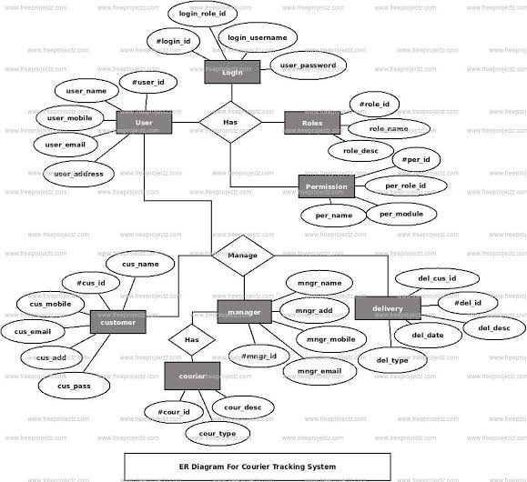
System Design
The Courier Tracking System is designed to manage courier booking, parcel tracking, payment, and delivery operations efficiently. The system allows customers to register, send parcels, and track shipment status in real time. Delivery staff update parcel locations and delivery status, while the admin manages users, shipments, and overall system records. It reduces manual work, improves accuracy, and ensures timely delivery.
ER Diagram
The ER Diagram of the Courier Tracking System consists of six main entities: Customer, Shipment, Tracking, Payment, Delivery Staff, and Admin. A customer can place many shipments, and each shipment can have multiple tracking updates. Customers make payments for courier services. Delivery staff are assigned to shipments for delivery. The admin manages all records and monitors system activities. These relationships help maintain organized data flow and efficient courier operations.

Courier Tracking System is widely used in real life by many delivery companies and online shopping platforms. It helps customers and companies to know the current location and delivery status of parcels. This system improves speed, transparency, and customer satisfaction. Below are some real-time case study examples.

REAL TIME EXAMPLES
Case Study 1: DHL International Courier

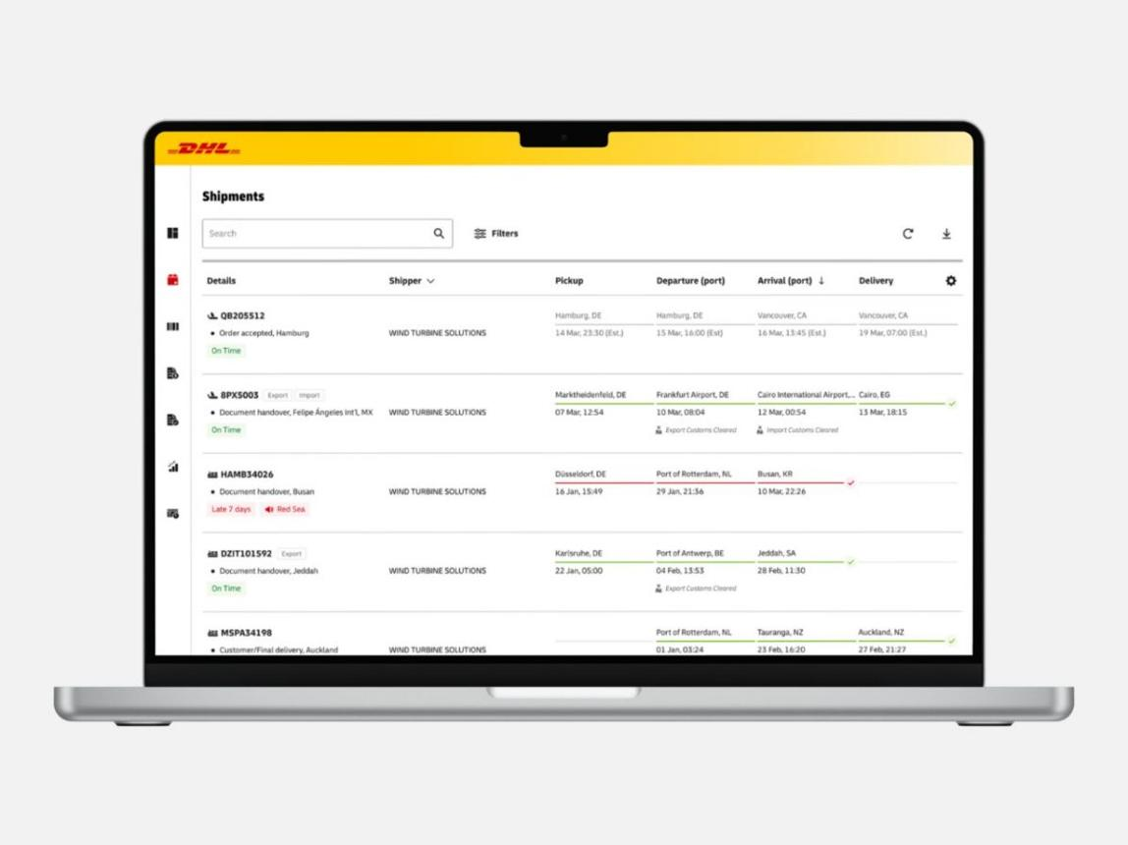

DHL is a famous international courier company. It delivers parcels between countries. Customers receive a tracking ID after booking a shipment. By entering the tracking number on the DHL website, users can check the parcel location and delivery progress.
The system updates every movement such as parcel received, customs clearance, in transit, arrived at destination country, and delivered. This is very useful for business people and customers sending important documents or products.
Benefits
- Global tracking system
- Safe parcel movement
- Customs updates
- Delivery confirmation
This case study shows the importance of tracking in international logistics.

Case Study 2: Blue Dart in India
Blue Dart is one of the leading courier companies in India and a good real-time example of a Courier Tracking System. It offers domestic and international parcel delivery services for customers, businesses, and e-commerce companies. When a customer books a parcel, the system generates an AWB (Air Waybill) number. This unique number helps users track the parcel from pickup to final delivery.

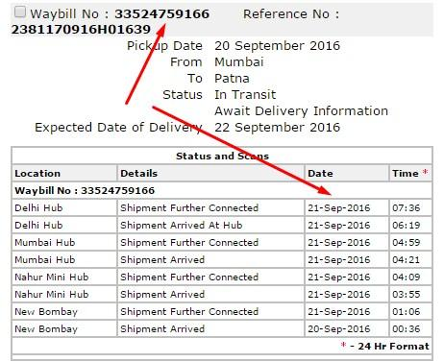
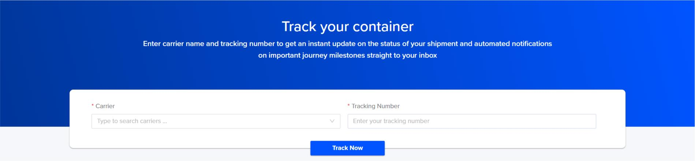


Case Study 3: Food Delivery Apps
Swiggy and Zomato are popular food delivery platforms that use courier tracking concepts in daily life. Although they deliver food instead of parcels, they use the same real-time tracking technology. When a customer places an order, the app starts updating each stage of the delivery process.
The customer can see order confirmed, restaurant preparing food, picked up by delivery partner, on the way, and delivered. One of the most useful features is live map tracking. Customers can watch the delivery partner travel toward their location in real time. The app also shows estimated delivery time and allows direct contact with the delivery person if needed.
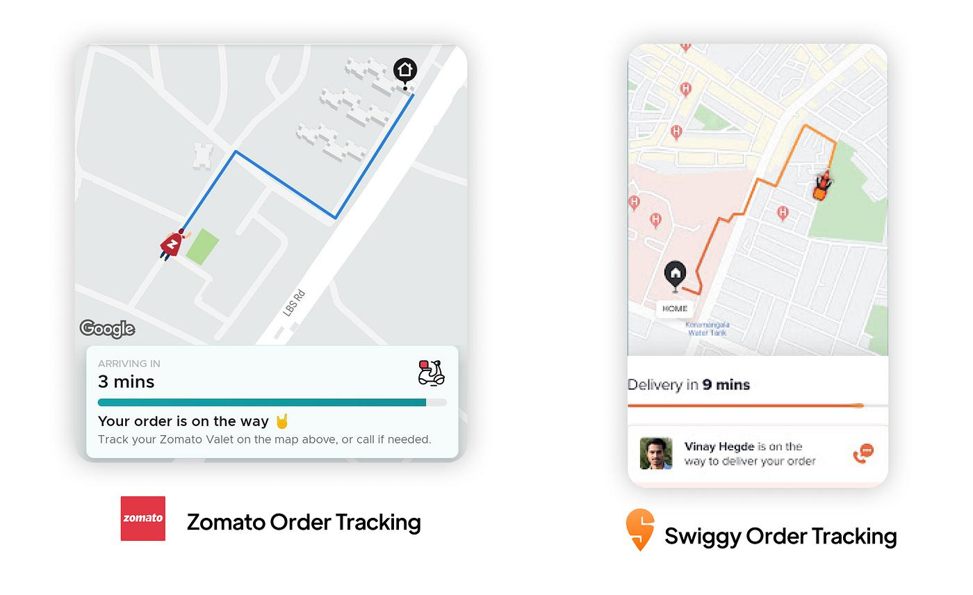

For restaurants, the system helps manage order preparation and delivery timing. For delivery partners, the app gives navigation support and the best route to reach the customer quickly. If there is traffic or delay, the app updates the estimated time automatically.
Notifications are sent at every stage, which keeps the customer informed. This reduces waiting confusion and improves the user experience. If there is any issue, customer support can also access the tracking details and provide help quickly.
The major benefit of this tracking system is convenience, speed, and customer satisfaction. It makes food delivery easy and transparent. This case study shows that courier tracking systems are not limited to parcel delivery but are also valuable in modern service industries.

IMPLEMENTATION

-- Courier Tracking System SQL Program
CREATE DATABASE CourierTrackingSystem;
USE CourierTrackingSystem;
-- Customer Table
CREATE TABLE Customer (
Customer_ID INT PRIMARY KEY AUTO_INCREMENT,
Name VARCHAR(50),
Phone VARCHAR(15),
Address VARCHAR(100),
Email VARCHAR(50)
);

-- Shipment Table
CREATE TABLE Shipment (
Shipment_ID INT PRIMARY KEY AUTO_INCREMENT,
Customer_ID INT,
Source VARCHAR(50),
Destination VARCHAR(50),
Weight DECIMAL(5,2),
Status VARCHAR(30),
Booking_Date DATE,
FOREIGN KEY (Customer_ID) REFERENCES Customer(Customer_ID)
);
-- Tracking Table
CREATE TABLE Tracking (
Tracking_ID INT PRIMARY KEY AUTO_INCREMENT,
Shipment_ID INT,
Current_Location VARCHAR(50),
Update_Time DATETIME,
Status VARCHAR(30),
FOREIGN KEY (Shipment_ID) REFERENCES Shipment(Shipment_ID)
);
-- Delivery Staff Table
CREATE TABLE Delivery_Staff (
Staff_ID INT PRIMARY KEY AUTO_INCREMENT,
Name VARCHAR(50),
Phone VARCHAR(15),
Vehicle_No VARCHAR(20)
);

-- Payment Table
CREATE TABLE Payment (
Payment_ID INT PRIMARY KEY AUTO_INCREMENT,
Customer_ID INT,
Amount DECIMAL(10,2),
Payment_Mode VARCHAR(20),
Payment_Date DATE,
FOREIGN KEY (Customer_ID) REFERENCES Customer(Customer_ID)
);
-- Admin Table
CREATE TABLE Admin (
Admin_ID INT PRIMARY KEY AUTO_INCREMENT,
Name VARCHAR(50),
Password VARCHAR(50)
);
-- Insert Sample Data
INSERT INTO Customer (Name, Phone, Address, Email)
VALUES
('Arun', '9876543210', 'Chennai', 'arun@gmail.com'),
('Priya', '9123456780', 'Coimbatore', 'priya@gmail.com');

INSERT INTO Shipment (Customer_ID, Source, Destination, Weight, Status, Booking_Date)
VALUES
(1, 'Chennai', 'Madurai', 2.5, 'Shipped', '2026-04-19'),
(2, 'Coimbatore', 'Salem', 1.2, 'Delivered', '2026-04-18');
INSERT INTO Tracking (Shipment_ID, Current_Location, Update_Time, Status)
VALUES
(1, 'Trichy', NOW(), 'In Transit'),
(2, 'Salem', NOW(), 'Delivered');
INSERT INTO Delivery_Staff (Name, Phone, Vehicle_No)
VALUES
('Kumar', '9000011111', 'TN10AB1234'),
('Ravi', '9000022222', 'TN20CD5678');
INSERT INTO Payment (Customer_ID, Amount, Payment_Mode, Payment_Date)
VALUES
(1, 250.00, 'UPI', '2026-04-19'),
(2, 180.00, 'Cash', '2026-04-18');
INSERT INTO Admin (Name, Password)
VALUES
('Admin1', 'admin123');

-- Queries
-- View Customers
SELECT * FROM Customer;
-- View Shipments
SELECT * FROM Shipment;
-- Track Parcel
SELECT Shipment_ID, Current_Location, Status
FROM Tracking
WHERE Shipment_ID = 1;
-- Customer with Shipment Details
SELECT C.Name, S.Source, S.Destination, S.Status
FROM Customer C
JOIN Shipment S ON C.Customer_ID = S.Customer_ID;
-- Update Shipment Status
UPDATE Shipment
SET Status = 'Delivered'
WHERE Shipment_ID = 1;
-- Delete Tracking Record
DELETE FROM Tracking
WHERE Tracking_ID = 1;

Implementation Description – Courier Tracking System
The Courier Tracking System is implemented to automate and simplify courier service operations such as parcel booking, shipment tracking, payment processing, and delivery management. The system is developed using front-end, back-end, and database technologies to ensure smooth and efficient performance. The front-end provides a user-friendly interface for customers, delivery staff, and administrators. Customers can register, log in, book parcels, track shipments, and make payments easily. Delivery staff can update parcel location and delivery status, while administrators can manage users, shipments, payments, and reports.
TOOLS USED
The development of the Courier Tracking System requires various software and hardware tools to design, implement, test, and maintain the application successfully. These tools help in creating a reliable, efficient, and user-friendly system.
The first important tool is the programming language used for development. Languages such as Java, Python, PHP, or C# can be used for implementing the system logic. These languages help in creating modules for customer registration, shipment booking, tracking updates, payment processing, and report generation. For web-based systems, HTML, CSS, and JavaScript are used to design attractive and interactive user interfaces.
The next essential tool is the database management system. Databases such as MySQL, Oracle, SQL Server, or PostgreSQL are used to store customer information, parcel details, tracking history, staff records, and payment transactions. SQL queries are used to insert, update, delete, and retrieve data efficiently.

SAMPLE SQL QUERIES

-- View all customers
SELECT * FROM Customer;

-- View all shipments
SELECT * FROM Shipment;

-- Track a parcel by Shipment ID
SELECT Shipment_ID, Current_Location, Status
FROM Tracking
WHERE Shipment_ID = 1;

-- Customer with shipment details
SELECT C.Name, S.Source, S.Destination, S.Status
FROM Customer C
JOIN Shipment S
ON C.Customer_ID = S.Customer_ID;

-- Update shipment status
UPDATE Shipment
SET Status = 'Delivered'
WHERE Shipment_ID = 1;

-- Delete tracking record
DELETE FROM Tracking
WHERE Tracking_ID = 1;

Outcomes and Future Enhancements – Courier Tracking System

The Courier Tracking System provides many positive outcomes for both customers and courier companies. It automates parcel booking, shipment tracking, payment processing, and delivery management, which reduces manual work and saves time. Customers can easily track their parcels in real time, know the delivery status, and receive timely updates. This increases transparency, trust, and customer satisfaction. For courier companies, the system improves record management, reduces errors, increases delivery efficiency, and helps in better decision-making through accurate data.
The system also enhances communication between customers, delivery staff, and administrators. It provides secure data storage, quick access to shipment information, and faster problem resolution. Overall, the Courier Tracking System creates a more reliable and organized courier service.

Conclusion
The Courier Tracking System is an effective solution for managing courier operations in a fast and organized manner. It automates important tasks such as parcel booking, shipment tracking, payment handling, and delivery management. Customers can easily know the current location and status of their parcels, which improves transparency and trust. The system also helps courier companies reduce manual errors, save time, and increase operational efficiency. Overall, the Courier Tracking System plays an important role in modern logistics by providing reliable service and better customer satisfaction.
References
- Elmasri, R., & Navathe, S. B. Fundamentals of Database Systems. Pearson Education.
- Silberschatz, A., Korth, H. F., & Sudarshan, S. Database System Concepts. McGraw-Hill.
- Official MySQL Documentation – SQL Reference and User Guide.
- Courier company websites such as DHL, Blue Dart, and FedEx for tracking system examples.
- Online tutorials and academic resources related to DBMS, SQL, and system design.

