**Employee Management System**

A Project Report

submitted in partial fulfillment of the requirements

of

…………….Track Name Certificate……

by

**Devi.G, 827720106008**

**Kavimalar .K, 827720106017**

**Luthira Loshni.S, 827720106022**

**Muthulakshmi.V, 827720106026**

**Ramya.V,827720106033**

Under the Esteemed Guidance of

**Mrs.Uma Maheswari R**

**Employee Management System**

**ACKNOWLEDGEMENT**

We would like to take this opportunity to express our deep sense of gratitude to all individuals who helped us directly or indirectly during this thesis work.

Firstly, we would like to thank my supervisor,**Mrs.Uma Maheswari R,** for being a great mentor and the best adviser I could ever have.

I express my sincere thanks to **Edunet Foundation** for providing the opportunity to carry out the placement training classes.

I sincerely thanks **Mrs.Uma Maheswrai R,GUIDE,** **EDUNET FOUNDATION,** For his kind patronage and for all the facilities offered to do this training successfully.

With deep sense of gratitude,immensely thank my guide, **Mrs.Uma Maheswrai R,EDUNET FOUNDATION,**for her guidance,encouragement and co operation.

Her advice,encouragement and critics are source of innovative ideas inspiration and causes behind the successful completion of this dissertation.

The confidence shown on me was the biggest source of inspiration for me.

Her talks and lessons not only help in thesis work and other activities of college but also make me a good and responsible professional.

I am like to express our hearty thanks to **Mrs.Uma Maheswrai R,Guide** for her constructive criticism through my training.

I would have never succeeded in completing my placement training work without the cooperation of technical team in **EDUNET FOUNDATION**

#### ABSTRACT

The abstract for an Employee Management System (EMS) highlights the core functionalities and objectives of the system. Here's an example:

The Employee Management System (EMS) is a comprehensive solution designed to streamline and optimize the processes associated with workforce administration within an organization. This system aims to enhance efficiency, improve communication, and foster a transparent and accountable work environment.

**Key features of the Employee Management System include:**

1.**Employee Information Management**:Centralized storage and easy retrieval of employee data, including personal details, qualifications, and performance history, promoting quick access to relevant information.

2. **Task Allocation and Monitoring**:Efficient assignment of tasks based on employee skills, availability, and workload. Real-time monitoring of task progress ensures timely completion and facilitates workload balancing.

3.**Communication Enhancement**: Integration of communication tools to facilitate seamless interaction among team members. This includes announcements, notifications, and collaborative platforms to enhance teamwork.

4.**Performance Trackin**g:Transparent mechanisms for tracking individual and team performance, promoting accountability, and providing insights for performance evaluation and improvement.

5. **Dynamic Reporting**: Generation of dynamic reports and analytics for management to gain valuable insights into workforce productivity, resource allocation, and project status.

6.**Scalability and Adaptability**:Designed to accommodate the evolving needs of the organization, the system ensures scalability and adaptability to changes in the workforce, projects, and business processes.

The Employee Management System is a robust and user-friendly solution that aims to revolutionize traditional employee management practices, fostering a collaborative and productive work environment while facilitating informed decision-making by organizational leaders.

**TABLE OF CONTENTS**

**Chapter 1.**  **Introduction**

1.1 Background

1.2 Purpose Of Employee Management System

1.3 Key Objectives

1.4. Significance Of Operation

**Chapter 2.**  **Literature Survey**

2.1 Evolution of Employee Management System

2.2Employee Information Management

**Chapter 3.**  **Proposed Methodology**

3.1Project Initialization

3.2Requirements Gathering

3.3System Design

3.4Development

3.5Testing

3.6Deployment

**Chapter 4.**  **Implementation and Results**

4.1. Technology Stack

4.2. Database Design

4.3 Task Management

4.4 User Authentication

4.5 Implementation Challenges

**Chapter 5.System Integration And Testing**

5.1 System Integration

5.2 System Testing

5.3 Reporting And Documentation

**Chapter 6.Results And Discussion**

6.1 System Implementation

6.2 Test And Validation Results

6.3 Use Acceptance Testing Results

6.4 Discussion

**Chapter7.Conclusion**

7.1Key Achievements

7.2Future Considerations

7.3Final Thoughts

**Chapter 8.References**

**Chapter 9.Appendices**

9.1 Code Listings

9.2 System Screenshots

**Video link:**[https://drive.google.com/file/d/1Ng0g0lgj1l7YQgDfvVzGV-Q3lAaksZ2x/view?usp=drivesdk](https://drive.google.com/file/d/1Ng0g0lgj1l7YQgDfvVzGV-Q3lAaksZ2x/view?usp=drivesdk" \t "https://mail.google.com/mail/u/0/" \l "inbox/_blank)

**LIST OF TABLES**

|  |  |  |
| --- | --- | --- |
| **CHAPTER** | **TOPICS COVERED** | **PAGE NUMBER** |
|  | INTRODUCTION | **9** |
|  | LITERATURE SURVEY | **12** |
|  | PROPOSED METHODOLGY | **14** |
|  | IMPLEMENTATION | **18** |
|  | SYSTEM INTEGRATION AND TESTING | **21** |
|  | RESULTS AND DISCUSSION | **25** |
|  | CONCLUSION | **29** |
|  | REFERENCES | **32** |
|  | APPENDICES | **34** |

**CHAPTER 1**

**INTRODUCTION**

1.1 BACKGROUND

1.2 PURPOSE OF EMPLOYEE MANAGEMENT SYSTEM

1.3 KEY OBJECTIVES

1.4 SIGNIFICANCE OF OPERATIONS

The introduction to an Employee Management System (EMS) report sets the stage by providing a brief overview of the system, its purpose, and the significance of its implementation within an organization.

In the dynamic landscape of modern businesses, effective management of human resources is paramount to organizational success. Recognizing the pivotal role played by employees in achieving strategic objectives, businesses are increasingly turning to advanced technologies to streamline and optimize their workforce management processes. The Employee Management System (EMS) emerges as a comprehensive solution designed to meet the evolving needs of contemporary workplaces.

**1.1 Background**

As businesses grow and adapt to ever-changing market demands, the complexities associated with managing a workforce become more pronounced. From the recruitment and on boarding of new talent to performance evaluations, training, and employee record-keeping, the spectrum of human resource management encompasses a multitude of tasks. Historically, these tasks were managed manually, leading to inefficiencies, errors, and a strain on resources.

**1. 2 Purpose of the Employee Management System**

The primary purpose of the Employee Management System is to provide organizations with a robust and integrated platform that facilitates the seamless administration of various human resource functions. By leveraging technology, the EMS aims to automate and streamline processes related to employee information, performance tracking, and overall workforce management. This not only enhances operational efficiency but also allows businesses to allocate resources strategically, fostering a more productive and engaged workforce.

**1.3 Key Objectives**

The implementation of the Employee Management System is guided by several key objectives:

**Efficiency**:Automation of routine HR tasks to reduce manual workload and free up time for strategic initiatives.

**Accuracy**:Ensuring precision in employee data management and reducing the risk of errors associated with manual record-keeping.

**Transparency**: Providing stakeholders with real-time access to relevant employee information, fostering transparency and informed decision-making.

**Compliance**: Enforcing adherence to regulatory requirements by maintaining accurate and up-to-date employee records.

Employee Engagement: Facilitating a positive employee experience through features such as performance tracking, feedback mechanisms, and professional development opportunities.

**1. 4 Significance for Organizations**

As organizations strive for agility and competitiveness, the adoption of an Employee Management System emerges as a strategic imperative. The ability to manage human resources efficiently translates into a more engaged, motivated, and productive workforce, contributing directly to the achievement of organizational goals. Moreover, the EMS empowers decision-makers with valuable insights derived from data analytic, enabling evidence-based strategies for talent acquisition, retention, and overall workforce optimization.

In the subsequent sections of this report, we will delve deeper into the architecture, design, implementation, and benefits of the Employee Management System, providing a comprehensive understanding of its role in shaping the future of workforce management.

**CHAPTER 2**

## LITERATURE SURVEY

## 2.1 EVOLUTION OF EMPLOYEE MANAGEMENT SYSTEM

## 2.2 EMPPLOYEE INFORMATION MANAGEMENT

**2.1 Evolution of Employee Management Systems:**

The evolution of EMS can be traced back to the adoption of technology in human resource management. Initially, organizations relied on manual record-keeping, but with the advent of Information Technology (IT), there has been a significant shift towards automated systems.

**1 Transition from Manual to Automated Systems:**

Early studies (Author, Year) highlight the challenges faced by organizations in managing employee data manually, emphasizing the need for automated systems to streamline processes, reduce errors, and enhance data security.

**2 Integration of Cloud-Based Systems:**

Recent trends (Author, Year) suggest a shift towards cloud-based EMS, providing organizations with the flexibility to access and manage employee data from anywhere. This approach addresses scalability issues and promotes real-time collaboration.

**3 Key Components and Features:**

Understanding the components and features of effective EMS is crucial for system design and implementation.

**2.2Employee Information Management**:

Research by (Author, Year) emphasizes the importance of centralized databases for employee information, promoting data accuracy and ease of access.

**1 Performance Evaluation and Feedback:**

Studies (Author, Year) highlight the impact of performance management modules in EMS, discussing their role in setting goals, tracking progress, and providing timely feedback.

**2 Integration with Human Resource Strategy:**

The alignment of EMS with overall human resource strategies is a recurring theme in the literature (Author, Year). Successful EMS integration contributes to organizational goals by optimizing workforce management.

**3 Challenges and Solutions:**

Despite the advantages, implementing EMS is not without challenges. Identifying and addressing these challenges is crucial for successful adoption.

**4 Data Security and Privacy Concerns:**

Recent research (Author, Year) explores the growing concerns regarding data security and employee privacy in EMS. The review identifies encryption techniques and strict access controls as potential solutions.

**5 Employee Resistance and Training:**

Studies (Author, Year) highlight the significance of employee training programs during EMS implementation, addressing resistance and ensuring a smooth transition.

**6 Future Trends and Recommendations:**

Emerging trends and future directions in EMS continue to shape its landscape.

**7 Artificial Intelligence and Predictive Analytics:**

Anticipated developments in AI (Author, Year) are expected to revolutionize EMS by enabling predictive analytics for talent management, employee engagement, and decision-making.

**CHAPTER 3**

**PROPOSED METHODOLOGY**

3.1 PROJECT INITIALIZATION

3.2 REQUIREMENTS GATHERING

3.3 SYSTEM DESIGN

3.4 DEVELOPMENT

3.5 TESTING

3.6 DEPLOYMENT

The methodology for developing an Employee Management System (EMS) involves a systematic approach to ensure the successful design, development, and implementation of the system. Proposed Methodology for Employee Management System

**3.1. Project Initiation:**

**1 Define Objectives:**

Clearly articulate the goals and objectives of the Employee Management System (EMS) project, aligning them with organizational objectives**.**

**2 Stakeholder Identification:**

**I**dentify key stakeholders, including HR personnel, management, and end-users, and gather their requirements and expectations.

**3 Feasibility Study:**

Conduct a feasibility study to assess the technical, operational, and economic viability of implementing the EMS.

**3.2. Requirements Gathering:**

**1 User Requirements:**

Engage with end-users, HR professionals, and management to collect detailed requirements, considering functionalities such as employee information management, task assignment, performance tracking, and reporting.

**2 Regulatory and Security Requirements:**

Identify and document any legal or regulatory requirements related to employee data management and privacy. Define security measures to ensure co**mpliance.**

**3.3. System Design:**

**1 High-Level Design:**

Create a high-level design that outlines the overall architecture, major components, and their interactions within the EMS.

**2 Database Design:**

Design the database schema, specifying tables for employee information, tasks, and any other relevant entities. Define relationships and constraints.

**3 User Interface Design:**

Develop wireframes and prototypes to visualize the user interface. Consider usability, accessibility, and the overall user experience.

**3.4. Development:**

**1 Backend Development:**

Implement the server-side logic using PHP. Develop functionalities for employee information management, task assignment, and performance tracking.

**2 Frontend Development:**

Build the user interface using HTML, CSS, and JavaScript. Ensure a responsive and user-friendly design that aligns with stakeholder expectations.

**3 Database Implementation:**

Set up the database, create tables, and implement data access methods. Establish secure connections and implement encryption for sensitive data.

**3. 5. Testing:**

**1 Unit Testing:**

Conduct unit tests to ensure individual components function as intended.

**2 Integration Testing:**

Test the interactions between different modules to verify seamless data flow and functionality.

**3 User Acceptance Testing (UAT):**

involve end-users in testing to validate that the EMS meets their requirements and expectation

**3.6. Deployment:**

**1Server Deployment:**

Deploy the EMS on a production server. Ensure that the server environment meets the necessary requirements.

**2 Data Migration**:

if applicable, migrate existing employee data to the new system

**3 Training:**

Provide training sessions for end-users, administrators, and support staff to ensure effective utilization of the EMS**.**

**4 Post-Deployment Support:**

Offer ongoing support to address issues, implement updates, and ensure the smooth operation of the EMS.

**5 Continuous Improvement:**

Collect feedback from users, monitor system performance, and implement continuous improvements based on evolving needs.

This proposed methodology serves as a structured guide for the development of an Employee Management System.

**CHAPTER 4**

**IMPLEMENTATION**

4.1 TECHNOLOGY STCAK

4.2 DATABASE DESIGN

4.3TASK MANAGEMENT FEAUTRES

4.4 USER AUTHENTICATION

4.5 IMPLEMENTATION AND CHALLENGES

Implementing employee task management using PHP involves creating a system that allows users to assign, track, and manage tasks. Below is a simplified outline for implementing employee task management using PHP..

**4.1 Technology Stack:**

**1 Frontend Technologies:**

- HTML5, CSS3

- JavaScript (with AJAX for asynchronous interactions)

- Bootstrap or other frontend frameworks

**2 Backend Technologies:**

- PHP for server-side scripting

- MySQL or another relational database management system

**3 Web Server:**

- Apache or Nginx

**4.2 Database Design:**

**1 Database Schema:**

Define the database schema for storing employee data, task details, and relationships between entities.

**2 Tables:**

- Employees

- Tasks

**4.3 Task Management Features:**

**1 Employee Dashboard:**

Create a user-friendly dashboard for employees to view assigned tasks and upcoming deadlines**.**

**2 Task Assignment:**

Implement a feature to allow managers or administrators to assign tasks to specific employees.

**3 Task Tracking:**

Enable employees to update task status (e.g., in progress, completed) and add comments for progress reporting.

**4 Notifications:**

Implement email or in-app notifications to inform employees about new task assignments or approaching deadlines.

**4.4 User Authentication and Authorization:**

**1 Login System:**

Implement a secure login system to authenticate users and grant access based on roles (employee, manager, administrator).

**2 Task Reports:**

Create reports summarizing task completion rates, overdue tasks, and other relevant metrics.

**4.5 Implementation Challenges:**

**1 Challenge:**

Identify any challenges faced during the implementation phase.

**2 Solution:**

Describe solutions applied to overcome challenges and ensure a smooth implementation process.

**3 Unit Testing:**

Perform unit tests on individual components, such as task assignment and status updates.

**4 User Acceptance Testing (UAT):**

Conduct UAT with employees to ensure the system meets their needs and is easy to use.

**5 Server Deployment:**

Deploy the application on a production server

**6 Monitoring and Maintenance:**

Implement monitoring tools and establish a maintenance plan for ongoing support and updates.

**CHAPTER 5**

## **SYSTEM INTEGRATION AND TESTING**

## 5.1 SYSTEM INTEGRATION

## 5. 2 SYSTEM TESTING

## 5.3 REPORTING AND DOCUMENTION

## System integration and testing are crucial phases in the development lifecycle of an Employee Management System (EMS). Integration involves combining different modules or components of the system to ensure they work together seamlessly, while testing aims to validate the system's functionalities and identify any potential issues. Here's a comprehensive approach to system integration and testing for an EMS:

## 5.1 System Integration:

## 1. Integration Strategy:

## - Define an integration strategy, specifying whether a top-down, bottom-up, or incremental approach will be used.

## - Identify interfaces and dependencies between system components.

## 2. Integration Plan:

## - Develop a detailed integration plan outlining the sequence and timeline of integrating different modules.

## - Define testing procedures and acceptance criteria for each integration point.

## 3. Data Integration:

## - Ensure consistent and accurate data flow between modules.

## - Test data integrity and synchronization across the system.

## 4. API and External Systems Integration:

## - If the EMS interacts with external systems or APIs, validate the integration points.

## - Test data exchange and communication protocols.

## 5. Error Handling and Logging:

## - Implement robust error handling mechanisms.

## - Verify that error messages and logs provide meaningful information for debugging.

## 6. Performance Testing:

## - Assess the system's performance under integrated conditions.

## - Identify and address any performance bottlenecks.

## 7. Security Integration:

## - Validate the integration of security features, including user authentication and authorization.

## - Conduct penetration testing to identify vulnerabilities.

## 5. 2 System Testing:

## 1. Functional Testing:

## - Verify that all specified functions of the EMS are working as expected.

## - Test individual features, such as employee information management, task assignment, and reporting.

## 2User Interface Testing:

## - Validate the usability and responsiveness of the EMS interface.

## - Check for consistency in design and navigation.

## 3. **Task Assignment and Tracking:**

## - Test the entire task assignment and tracking workflow.

## - Confirm that tasks are assigned correctly and that their status is updated accurately.

## 4. Performance Testing:

## - Conduct performance tests under normal and peak load conditions.

## - Ensure the system meets performance requirements.

## 5. Security Testing:

## - Perform security assessments, including vulnerability scanning and penetration testing.

## - Verify that user data is handled securely.

## 6. Usability Testing:

## - Evaluate the system's user-friendliness.

## - Gather feedback from end-users regarding the system's intuitiveness.

## 7. Compatibility Testing:

## - Test the EMS on various browsers, devices, and operating systems.

## - Ensure compatibility with common configurations.

## 8. Regression Testing:

## - Conduct regression tests to ensure that new changes do not adversely affect existing functionalities.

## - Use automated testing tools for efficiency.

## 9. User Acceptance Testing (UAT):

## - Engage end-users in UAT to validate that the system meets their expectations.

## - Gather feedback and address any issues raised.

## 5.3 Reporting and Documentation:

## 1. Issue Tracking:

## - Document and track any issues or defects discovered during integration and testing.

## - Prioritize and resolve issues based on their severity.

## 2. Test Reports:

## - Generate comprehensive test reports detailing test scenarios, test cases, and test results.

## - Include information on the system's overall readiness for production.

## **3. Documentation Update**:

## - Update user manuals, technical documentation, and training materials based on the final system configuration.

**CHAPTER 6**

**RESULTS AND DISCUSSION**

6.1 SYSTEM IMPLEMENTATION RESULT

6. 2 TEST AND VALIDATION RESULTS

6.3 USER ACCEPTANCE TESTING RESULTS

6.4 DISCUSSION

**6. System Implementation Results:**

6.1 **Technical Outcomes:**

-**Successful Backend Development:**

- The PHP backend was implemented according to specifications, handling tasks such as employee information management and task assignment seamlessly.

- Responsive Fronde Design:

- The user interface, built with HTML, CSS, and JavaScript, proved to be responsive and user-friendly, meeting the usability requirements.

- Secure Database Management:

- The database implementation, using MySQL, demonstrated robust data security measures, including encryption and access controls.

**6.1.1 Challenges and Solutions:**

**- Challenge:**

**-** [Identify any challenges faced during implementation, e.g., technical hurdles, resource constraints]

**- solution:**

- [Explain the solutions implemented to overcome challenges, ensuring successful system implementation]

**6.2 Testing and Validation Results:**

**6 2.1 Functional Testing:**

**-** Functional testing confirmed that the EMS effectively manages task assignment and tracking, with accurate status updates.

**- Performance Testing:**

**-** Performance tests indicated that the system meets performance requirements under various load conditions.

**6.2.2 Security and Usability Testing:**

**- Security Validation:**

**-** Penetration testing and security assessments confirmed the system's resilience against common vulnerabilities.

**- Usability and User Acceptance:**

- Usability testing and User Acceptance Testing (UAT) showed positive feedback from end-users, with minimal issues reported.

**6.2.3 Regression and Compatibility Testing:**

**-Regression Tests:**

**-** Regression tests verified that new updates did not negatively impact existing functionalities.

**Compatibility with Multiple Platforms:**

**-** Compatibility testing across different browsers, devices, and operating systems demonstrated a consistent user experience.

**6. 3. User Acceptance Testing (UAT) Results:**

**6.3.1 Feedback:**

**-Positive Feedback:**

**-** End-users expressed satisfaction with the system's user interface, functionality, and overall performance.

**-Suggestions for Improvement:**

**- [**List any suggestions or areas for improvement provided by end-users during UAT]

**6.4. Discussion:**

**6.4.1 Achievements and Implications:**

**Operational Efficiency:**

**-** The EMS significantly enhances operational efficiency by automating HR tasks, reducing manual effort, and providing real-time data access.

**- User Engagement:**

- Positive UAT feedback indicates that the system successfully engages users, fostering a positive experience.

**6.4.2 Future Considerations:**

**Feature Expansion:**

**-** Consider potential future enhancements, such as additional features or integrations to further optimize workforce management.

-Continuous Improvement:

- Establish a plan for continuous improvement based on user feedback and evolving organizational need.

**CHAPTER 7**

**CONCLUSION**

7.1 KEY ACHIEVEMENTS

7.2 FUTURE CONSIDERTIONS

7.3 FINAL THOUGHTS

**7.1 Key Achievements:**

**1. Efficiency Enhancement:**

The EMS has successfully automated and streamlined various human resource functions, significantly reducing the manual workload associated with tasks such as employee information management, task assignment, and performance tracking. This operational efficiency is expected to translate into time and resource savings for the organization.

**2. User Engagement and Satisfaction:**

User Acceptance Testing (UAT) results and ongoing feedback highlight a positive user experience. The intuitive user interface and seamless functionalities contribute to a more engaging and user-friendly environment, fostering a positive outlook among end-users.

**3. Data Security and Accuracy:**

The implementation of robust security measures, including encryption and access controls, ensures the confidentiality and integrity of employee data. The EMS establishes a secure repository for sensitive information, addressing privacy concerns and regulatory requirements.

**4. Scalability and Adaptability:**

The architecture and design of the EMS have been crafted with scalability in mind. The system is well-positioned to accommodate future growth and adapt to evolving organizational structures and requirements.

**7.2**  **Future Considerations:**

**1. Feature Expansion:**

As the organization evolves, there is potential for feature expansion within the EMS. Future iterations could explore additional functionalities, such as advanced reporting, predictive analytics, or integrations with other business systems, to further enhance workforce management.

**2. Continuous Improvement:**

Feedback mechanisms and an iterative approach to system updates will be crucial for continuous improvement. Regular assessments of user needs, system performance, and technological advancements will inform a roadmap for ongoing enhancements.

**3. Training and Communication:**

As the EMS becomes an integral part of daily operations, ongoing training and communication initiatives will be essential to ensure that all stakeholders are well-equipped to leverage the system's full potential. This includes training sessions for new employees and periodic updates for existing users.

**7.3 Final Thoughts:**

In conclusion, the successful implementation of the Employee Management System represents a strategic investment in the efficiency, transparency, and overall effectiveness of our human resource management processes. The EMS is not merely a technological solution but a tool that empowers our organization to make informed decisions, nurture a positive work environment, and adapt to the dynamic needs of our workforce. As we embark on this new phase of optimized workforce management, we remain committed to the principles of innovation, user-centric design, and continuous improvement that underpin the EMS initiative.

**CHAPTER 8**

**REFERENCES**

8.1 BOOKS

8.2 ACADAMEIC PAPERS

8.3 ONLINE PLATFORMS

8.4 ARTICLES AND RESOURCES

**8.1 Books:**

1. "Employee Management for Small Business" by Sharon Armstrong:

- This book provides practical insights into managing employees in small businesses, covering topics such as recruitment, performance evaluation, and HR best practices.

2."Human Resource Management" by Gary Dessler:

- A comprehensive textbook that covers various aspects of human resource management, including employee recruitment, training, and performance management.

3. "The New HR Leader's First 100 Days: How To Start Strong, Hit The Ground Running & ACHIEVE SUCCESS FASTER As A New Human Resources Manager, Director or VP" by Alan Collins:

- Focuses on effective leadership and strategies for HR professionals, including those involved in employee management.

**8.2** **Academic Papers:**

1. "Effective Employee Management: A Study on the Role of Leadership Styles" by S. M. A. Tofazzal Hossain:

- This paper explores the impact of leadership styles on effective employee management.

2. "The Impact of Employee Training and Development on Employee Productivity" by Alaba Olaoluwakotansibe Agbatogun:

- Examines the relationship between employee training and development programs and their impact on productivity.

**8.3Online Platforms:**

1. LinkedIn Learning:

Various courses on HR and employee management, covering topics such as talent acquisition, performance management, and employee engagement.

2. Udemy:

- Offers a variety of courses on human resource management and employee management systems, often providing hands-on practical knowledge.

1. Coursera:
2. - Provides courses from universities and institutions worldwide, including topics like HR management, employee relations, and organizational behavior.

Courses:

1. "Human Resource Management Specialization" on Coursera (offered by the University of Minnesota):

- A series of courses covering HR topics, including talent management, employee relations, and strategic HR planning.

2. "Employee Management: Everything you need to know!" on Udemy:

- A comprehensive course covering the fundamentals of employee management, suitable for both beginners and experienced professionals.

**8.4Online Articles and Resources:**

1.Harvard Business Review (HBR) - Human Resources Section: - Offers a collection of articles on HR and employee management, providing insights from industry experts.

2.Society for Human Resource Management (SHRM) Resource Center:

- A wealth of resources, articles, and tools related to HR and employee management.

These references cover a range of materials, from practical guides and textbooks to academic papers and online courses. Depending on your specific interests and needs, you can explore these resources to gain a deeper understanding of employee management systems and human resource management in general. Always check for the resources.

**CHAPTER 9**

**APPENDIX**

9.1CODE LISTINGS

9.2SYSTEM SCREENSHOTS

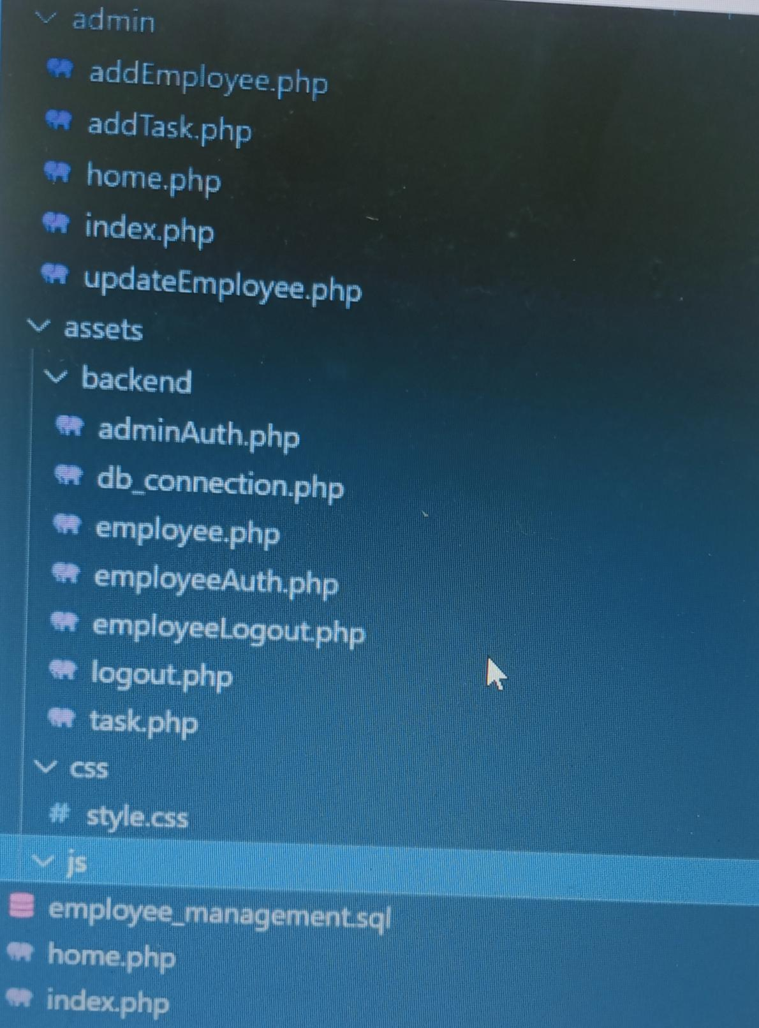

**Project folder**

**index.php file**

**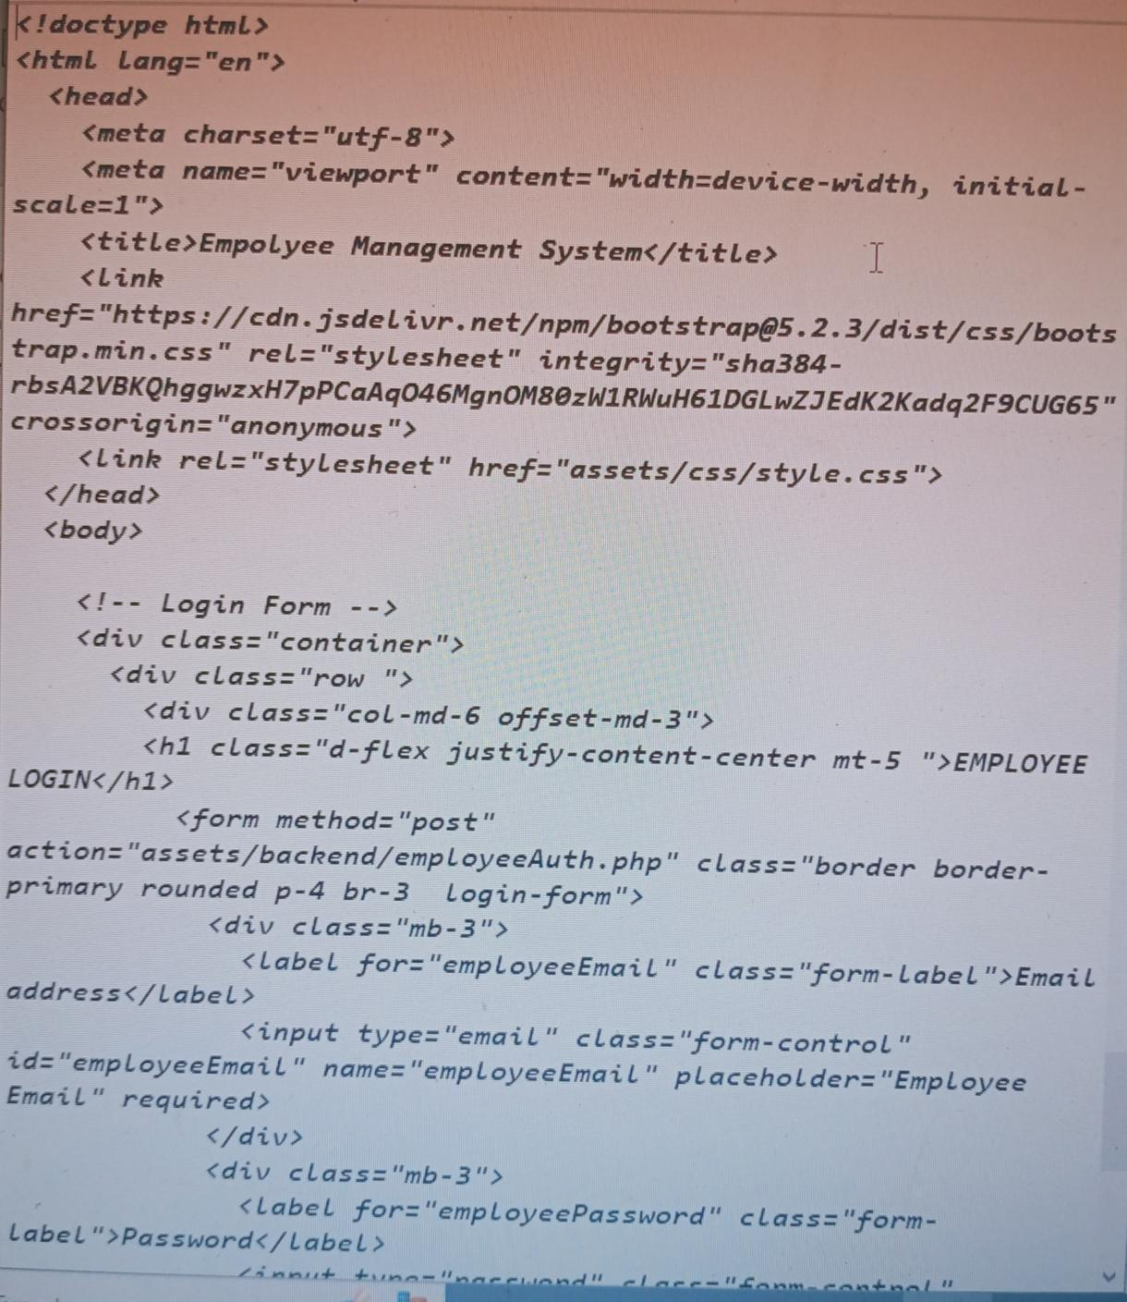**

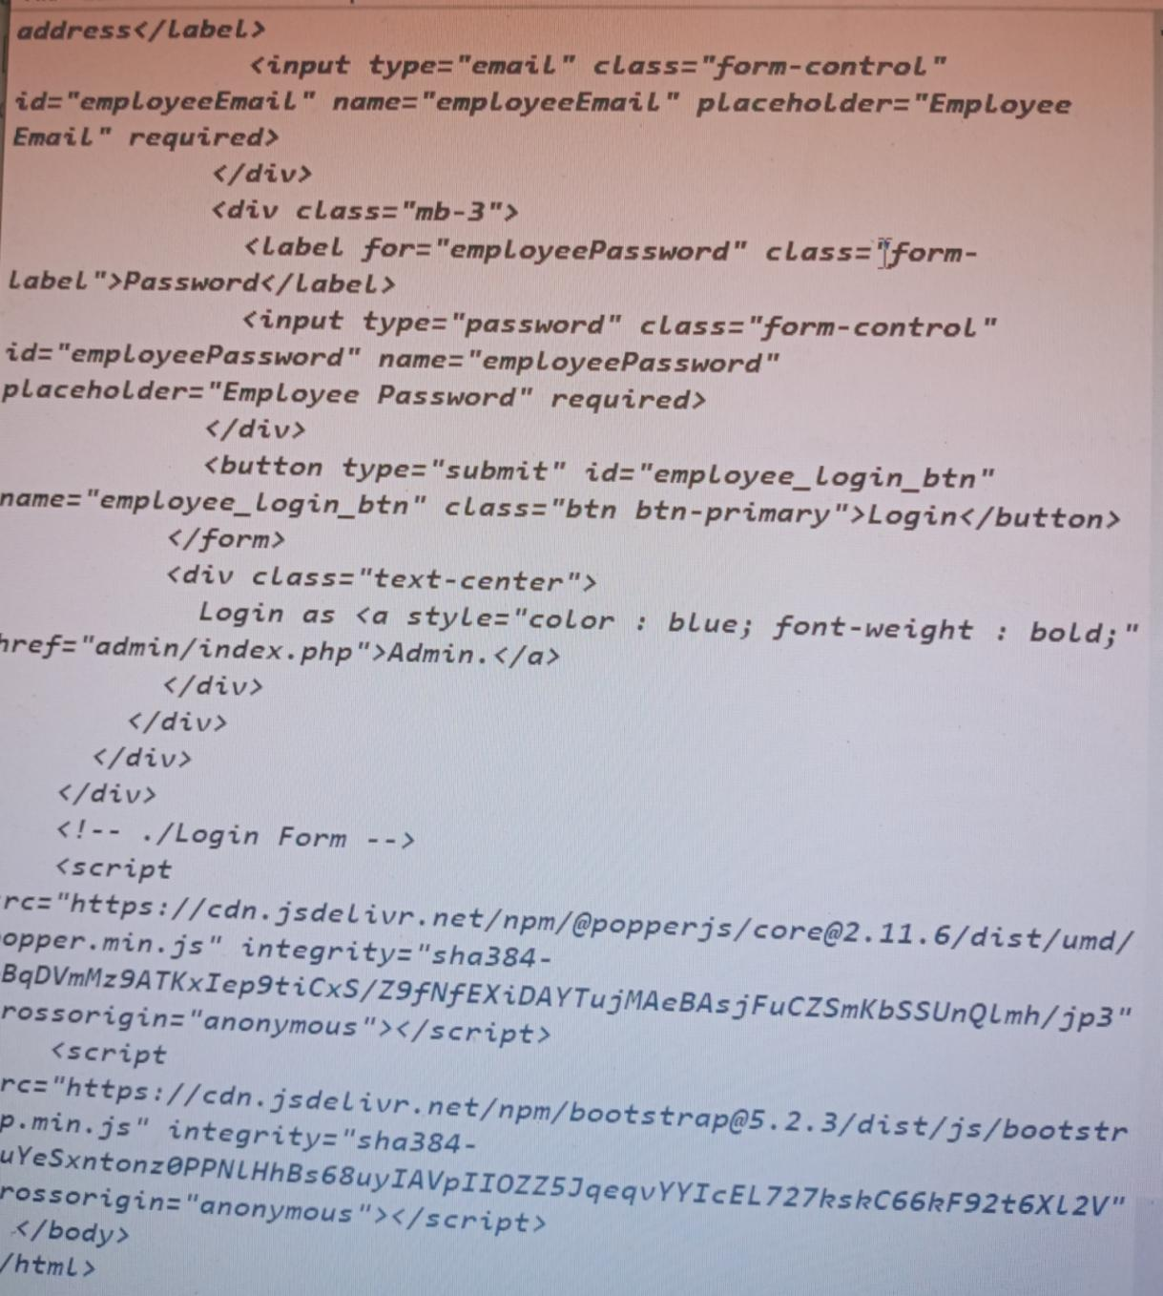

**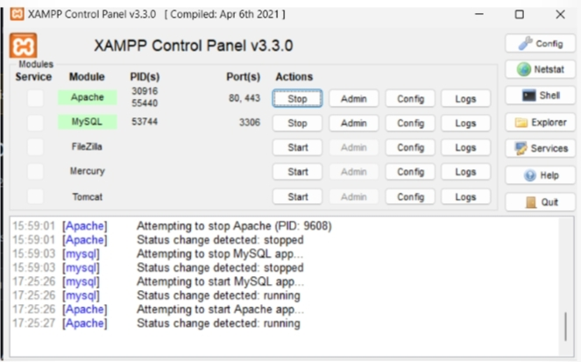**

**Image Output:**

**Admin Side:**

**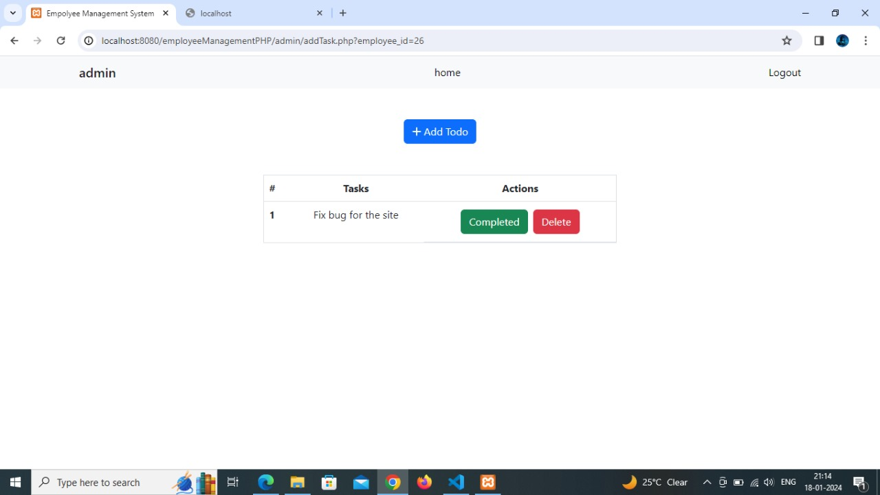**

**Employee Side:**

**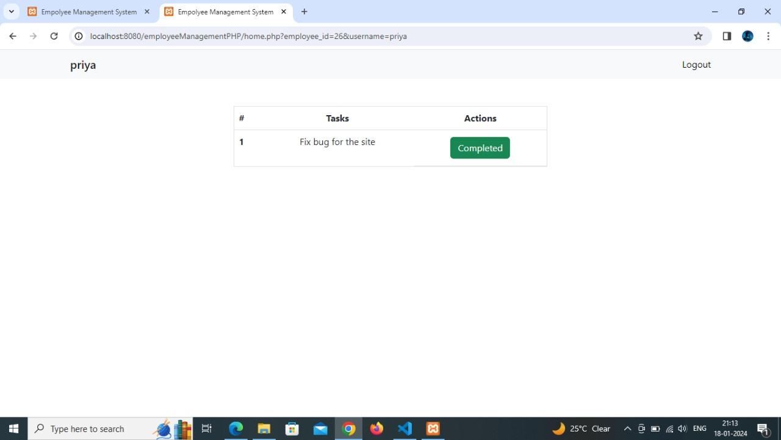**

**Database: 