**Functional Requirement Document**

|  |  |  |  |  |
| --- | --- | --- | --- | --- |
| Project Name | Find the Interest Amount for current year | | | |
| Name of product | [www.emicalculator.net](http://www.emicalculator.net) | | | |
| Product Description | Web application is designed to calculate various EMI’s. | | | |
| Project Description | To perform functional and GUI testing. | | | |
| Project Type | Automation Testing | | | |
| Project Duration | Start Date | 07-04-2021 | End Date | 17-04-2021 |

**Project Overview**

**Contents:**

**1. Introduction 3 1.1 Purpose 3**

**1.2 Intended Audience 3**

**2. Functional Requirements 3**

**2.1 Home Page 3**

**2.1.1 Menu Bar– UI 5**

**2.1.2 Car Loan - UI 5**

**2.2 Car Loan 7**

**2.2.1 Input Fields & Scales 7**

**2.2.2 Result Table 9**

**2.3 Home Loan EMI Calculator 9**

**2.3.1 Input Fields 9**

**2.3.2 Result Table 11**

**2.4 Loan Calculator 11**

**2.4.1 EMI Calculator 11**

**2.4.2 Loan Amount Calculator 13**

**2.4.3 Loan Tenure Calculator 14**

**2.4.4 Interest Rate Calculator 15**

**1. Introduction:**

The function requirement document is a complete description of the features Home Page, Car Loan, Home Loan EMI Calculator, Loan Calculator:

EMI Calculator, Loan Amount Calculator, Loan Tenure Calculator, Interest Rate Calculator. This document also describes the user interaction and the response of the website.

**1.1 Purpose:**

The purpose of the document is to give the functional requirements for the ‘emicalculator.net’ website. This document will help the audience for to understand the behavior of the website for development.

**1.2 Intended Audience:**

* Business Unit (BU) Person
* Academy Coach
* Technical Trainer
* Project Team

**2. Functional Requirements:**

* When the user types the URL <https://emicalculator.net/> it should navigate to the Home Page of the “emicalculator” website.

**2.1 Home Page:**

* Menu Bar
* Home Loan
* Personal Loan
* Car Loan
* Top of the Home Page contains menu bar with the logo of the web application.
* Middle frame of the webpage contains the major features of the website like: Home Loan, Personal Loan and Car Loan, Articles and Graphs for the calculated data.
* Home page contains basic definitions of the EMI, Instructions like how to use EMI Calculator, Floating Rate EMI Calculation.
* Contains timeline for the posted comments.

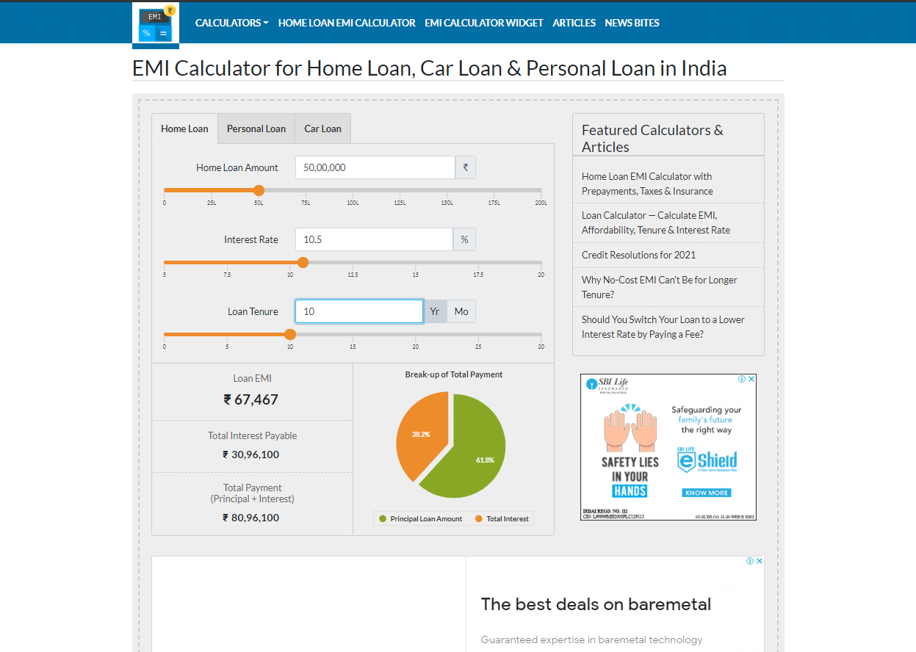

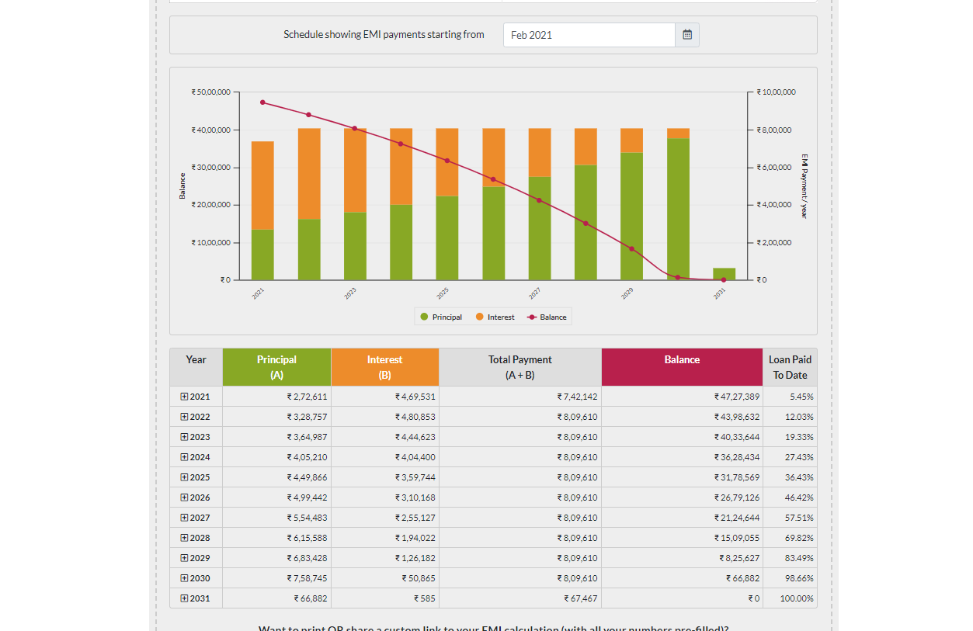

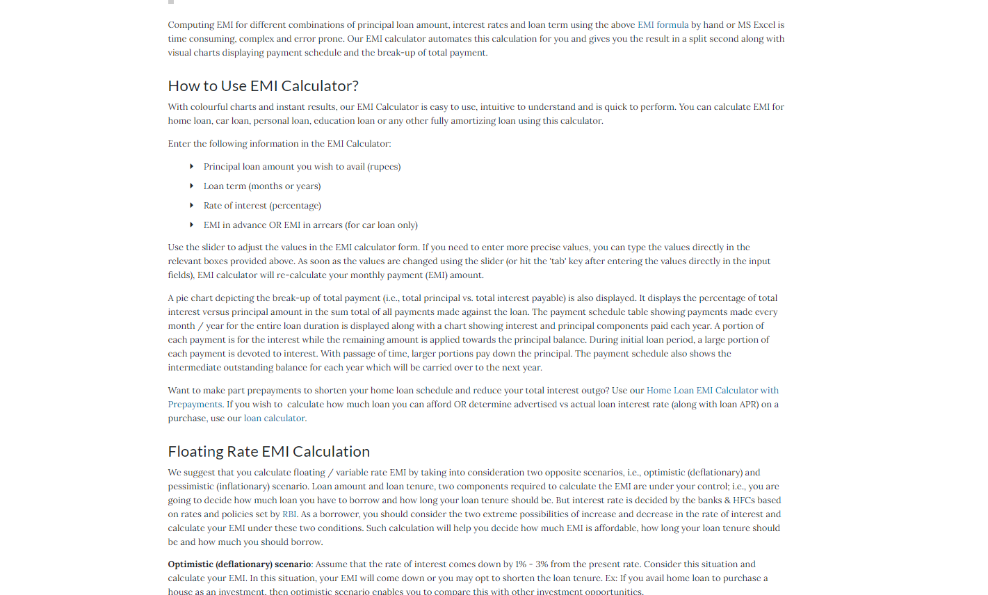

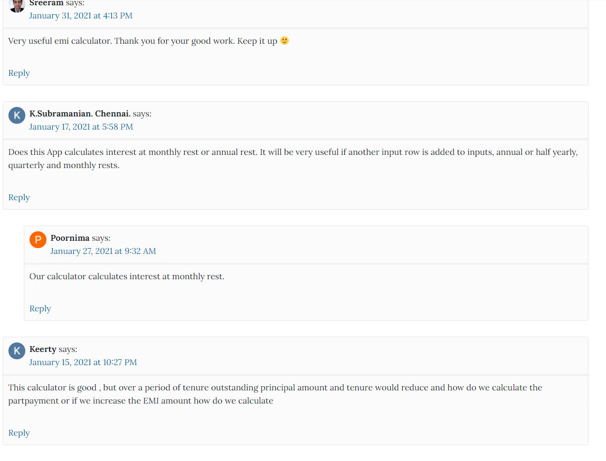

**Figure 2.1**

**2.1.1Menu Bar -UI:**

* Before the features list menu bar contains logo image for the web application.
* Menu Bar is available at the top of the Home Page of the web application.
* It contains the features of the web applications like: Calculators,

Home Loan EMI Calculator, EMI Calculator Widget,Articles,

News Bites. All are placed in listed menu.

**2.1.2 Car Loan – UI:**

* Car Loan option is placed in the middle of the home page and right side of the Personal Loan option.
* It contains the input fields for the user insertion.
* Contains the scales for the input field to set the value using scales.
* Contains the graph for “Break-up of Total Payment”, Schedule for EMI payments with date input field option for starting month.
* Contains label for the values of Loan EMI, Total Interest Payable, Total Payment (Principal + Interest).
* Contains table for the payment break down based on year with months.

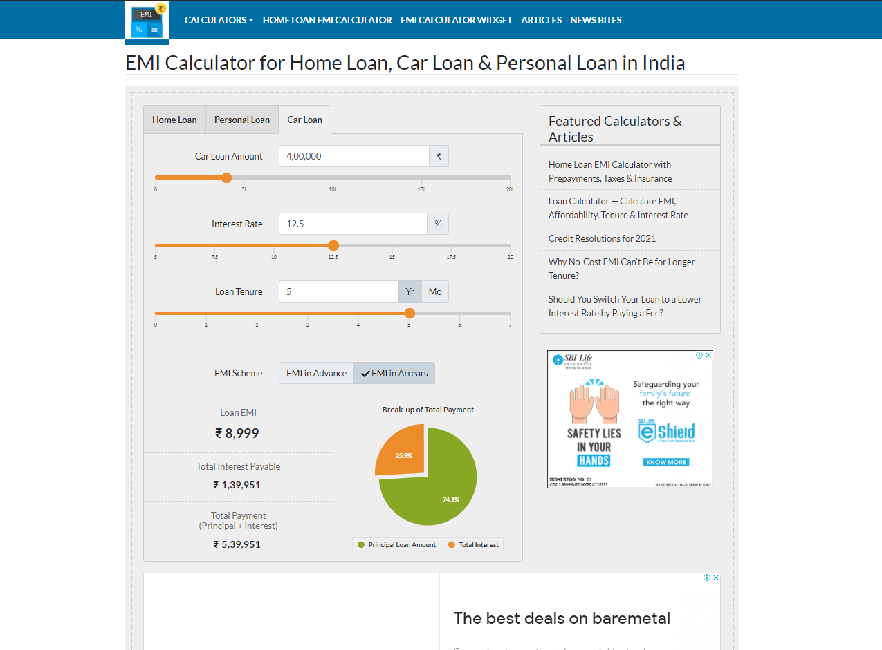

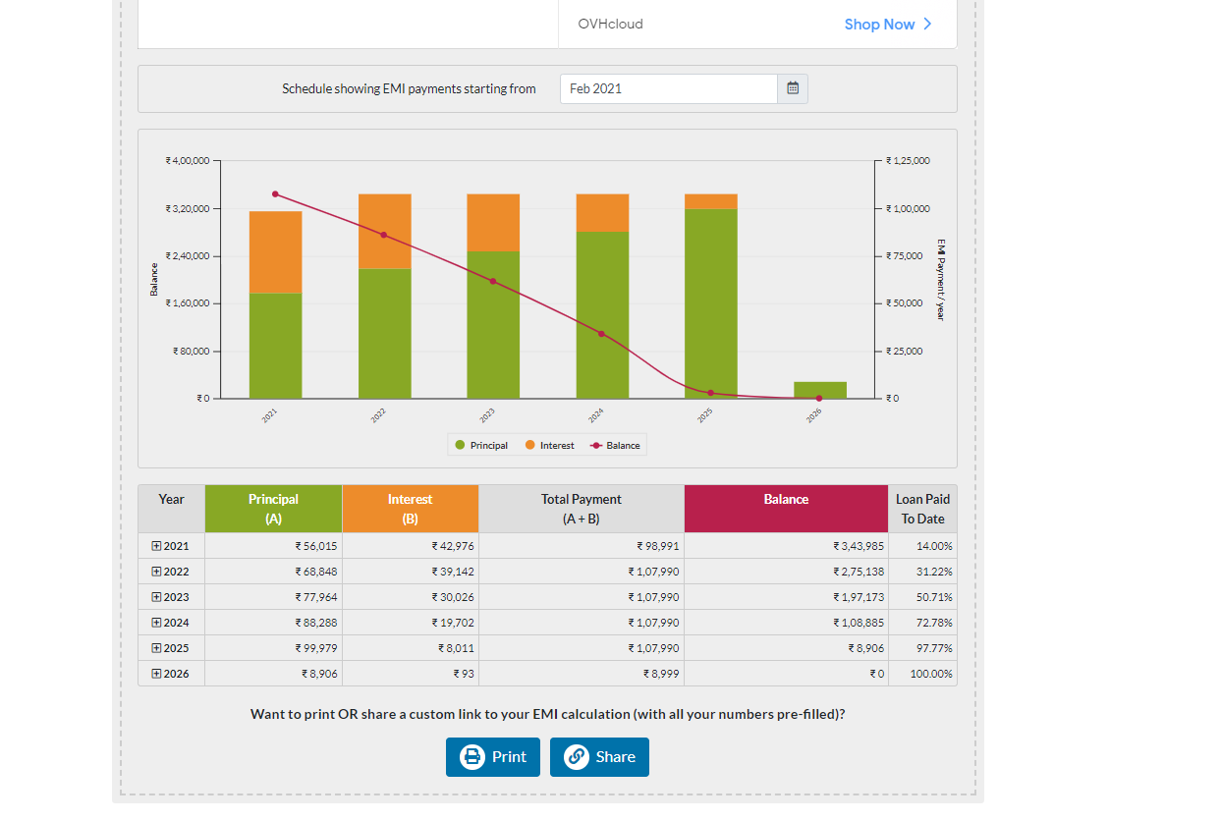

**Figure 2.1.1 & 2.1.2**

**2.2 Car Loan:**

* Car Loan option is used to calculate the EMI for the given amount of the loan. It accepts “Car Loan Amount”, “Interest Rate”, “Loan Tenure” and options to choose EMI plan like: “EMI in Advance” or “EMI in Arrears”.
* Calculates the EMI for the given values and displays a graph for “Loan EMI”, “Total Interest Payable” and “Total Payment (Principal + Interest) along with the values presentation.
* Also displays the bar graph and table structure of the break down payment for the calculated EMI based on year with month.

**2.2.1 Input Fields & Scales:**

* Car Loan Amount Input Field& Scale: Accepts all values and keeps only numeric value, empty click will accept “0” as a default value and on invalid input in alphanumeric will keep only numeric and remove characters & alphabetic and special characters values discards and makes “0” as input. Scale will set the value for “Car Loan Amount” from minimum “0” to maximum “20L” with the increment of “10000” at each step.
* Interest Rate Input Field & Scale: Accepts all values and keeps only numeric value, empty click will accept “5” as a default value and on invalid input in alphanumeric will keep only numeric and remove characters & alphabetic and special characters values discards and makes “0” as input.
* Loan Tenure Input Field & Scale: Accepts all values and keeps only numeric value, empty clickaccepts for year “1” and for month “12” as a default value and on invalid input in alphanumeric will keep only numeric and remove characters & alphabetic and special characters values discards and makes for year “1” and for month “12” as input.



**Figure 2.2**

**2.2.2 Result Table:**

* It will produce one pie graph for “Break-up of Total Payment” and will display “Principal Loan Amount” and “Total Interest”.
* It will produce bar graph for yearly EMI payment details.
* It will create a table for description of “Amount” in detailed. It will include columns like: Year, Principal, Interest, Total Payment, Balance etc. Year will be expanded in months and as well as other relevant columns.

**2.3 Home Loan EMI Calculator:**

**2.3.1 Input Fields:**

* It will accept the valid numeric value, In alphanumeric value it will remove alphabets and special characters, keeps numeric value only. Alphabetic and special character will be discarded and will set it to “0”.
  + Home Value (HV)
  + Loan Insurance (LI)
  + Loan Fees & Charges
  + Homeowner Expenses
  + Property Taxes/Year
  + Home Insurance/Year
  + Maintenance Expenses/month
* Margin OR Down Payment (DP) – It will accept the valid numeric value till range of 100, In alphanumeric value it will remove alphabets and special characters, keeps numeric value only. Alphabetic and special character will be discarded and will set it to “0”.
* Loan Amount (HV + LI - DP) – It will be calculated based on HV,DP and LI.
* Interest Rate - It will accept the valid numeric value, In alphanumeric value it will remove alphabets and special characters, keeps numeric value only. Alphabetic and special character will be discarded and will set it to “5”.
* Loan Tenure - It will accept the valid numeric value, In alphanumeric value it will remove alphabets and special characters, keeps numeric value only. Alphabetic and special character will be discarded and will set it to for year “30” and for month “360”.
* Start Month & Year –It will open calendar to choose value. Inserting data will be blocked.

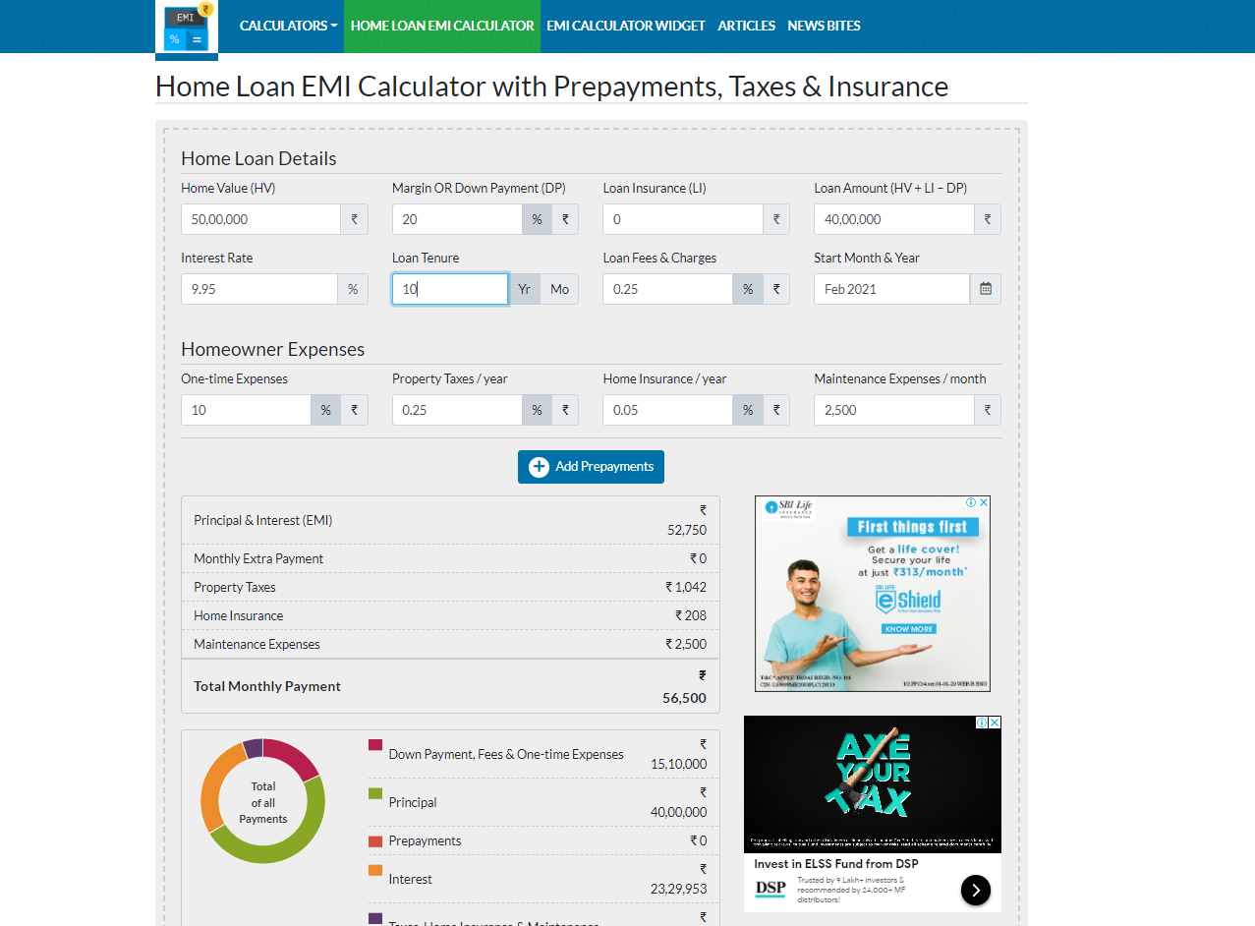

**Figure – 2.3.1**

**2.3.2 Result Table:**

* It will produce one pie graph for “Total of all Payments” and will display “Principal Loan Amount” and “Total Interest”.
* It will produce bar graph for yearly EMI payment details.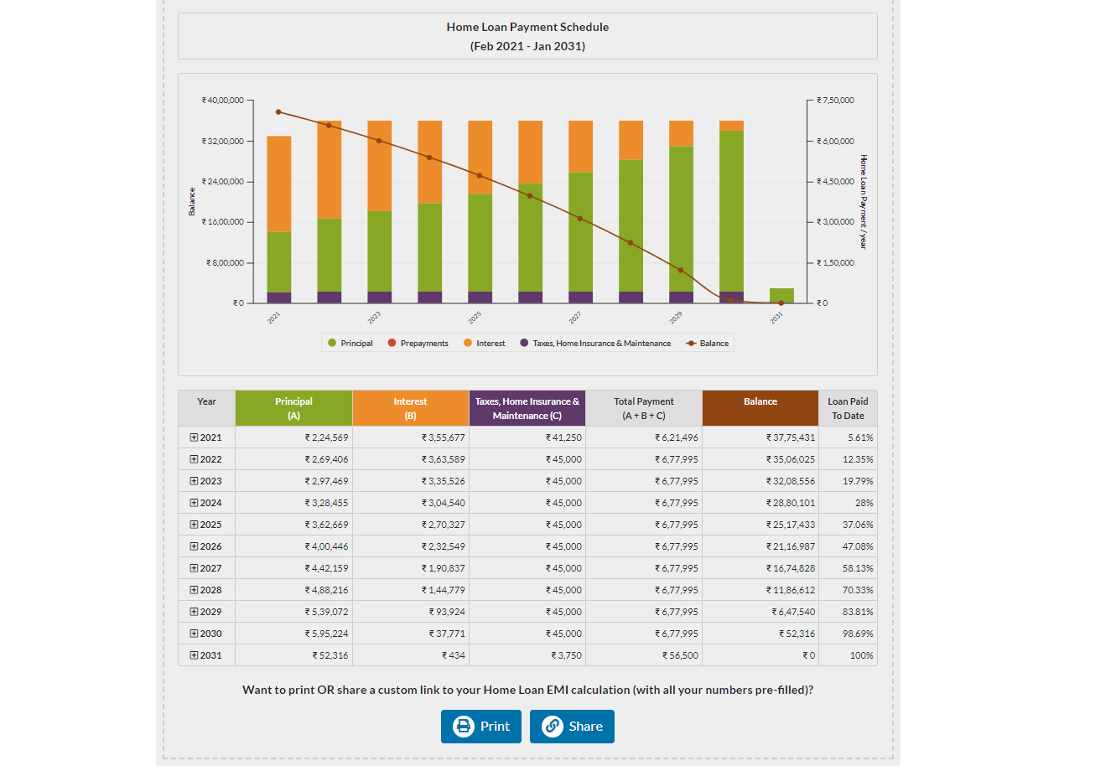It will create a table for description of “Amount” in detailed. It will include columns like: Year, Principal, Interest, Taxes and Home Insurance & Maintenance, Balance etc. Year will be expanded in months and as well as other relevant columns.

**Figure – 2.3.2**

**2.4 Loan Calculator:**

**2.4.1 EMI Calculator:**

EMI Calculator option will be available in main frame and left side of the “Loan Amount Calculator”.

* Loan Amount Input Field & Scale– It will be placed under EMI Calculator option and left side in the middle frame. It contains Rupee symbol. Scale contains values from “0” to “200L” with the increment interval “25L”.
* Interest Rate Input Field & Scale – It will be placed under “Loan Amount” and will contain “%”. Scale contains values from “0” to “20” with the interval of “2.5”.
* Loan Tenure Input Field & Scale – It will be placed under “Interest Rate” and will contain “Year” & “Month”. Scale contains values from “0” to “30” for year and “0” to “360” for month.
* Fees & Charges Input Field and Scale – It will be placed under “Loan Tenure” and will contain Rupee symbol. Scale contains values from “0” to “1L” with the interval of “0.25L”.

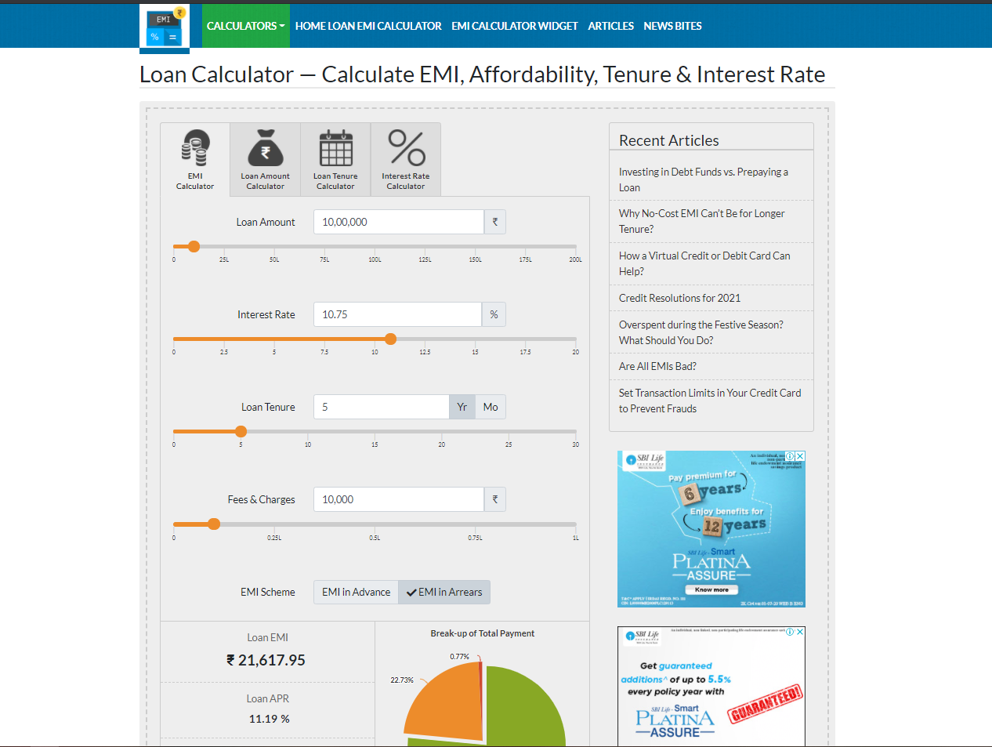

**Figure - 2.4.1**

**2.4.2 Loan Amount Calculator:**

* EMI Field & Scale– It will be placed under Loan Amount Calculator option and left side in the middle frame. It contains Rupee symbol. Scale contains values from “0” to “1L” with the increment interval “0.25L”.
* Interest Rate Input Field & Scale – It will be placed under “Loan Amount” and will contain “%”. Scale contains values from “0” to “20” with the interval of “2.5”.
* Loan Tenure Input Field & Scale – It will be placed under “Interest Rate” and will contain “Year” & “Month”. Scale contains values from “0” to “30” for year and “0” to “360” for month.
* 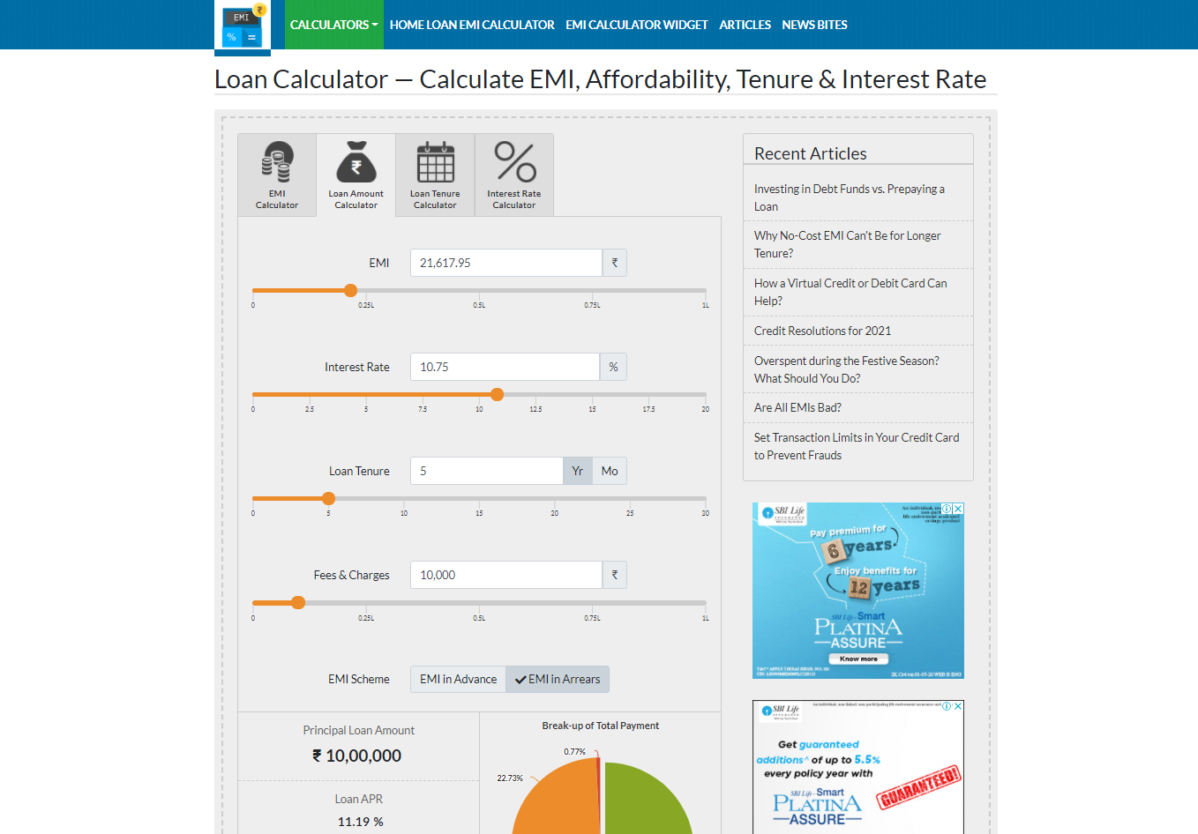Fees & Charges Input Field and Scale – It will be placed under “Loan Tenure” and will contain Rupee symbol. Scale contains values from “0” to “1L” with the interval of “0.25L”.

**Figure – 2.4.2**

**2.4.3 Loan Tenure Calculator:**

* Loan Amount Field & Scale– It will be placed under Loan Amount Calculator option and left side in the middle frame. It contains Rupee symbol. Scale contains values from “0” to “200L” with the increment interval “25L”.
* EMI Input Field & Scale – It will be placed under “Loan Amount” and will contain rupee symbol. Scale contains values from “0” to “1L” with the interval of “0.25L”.
* Interest Rate Input Field & Scale – It will be placed under “EMI” and will contain “%”. Scale contains values from “0” to “20” with the interval of “2.5”.
* 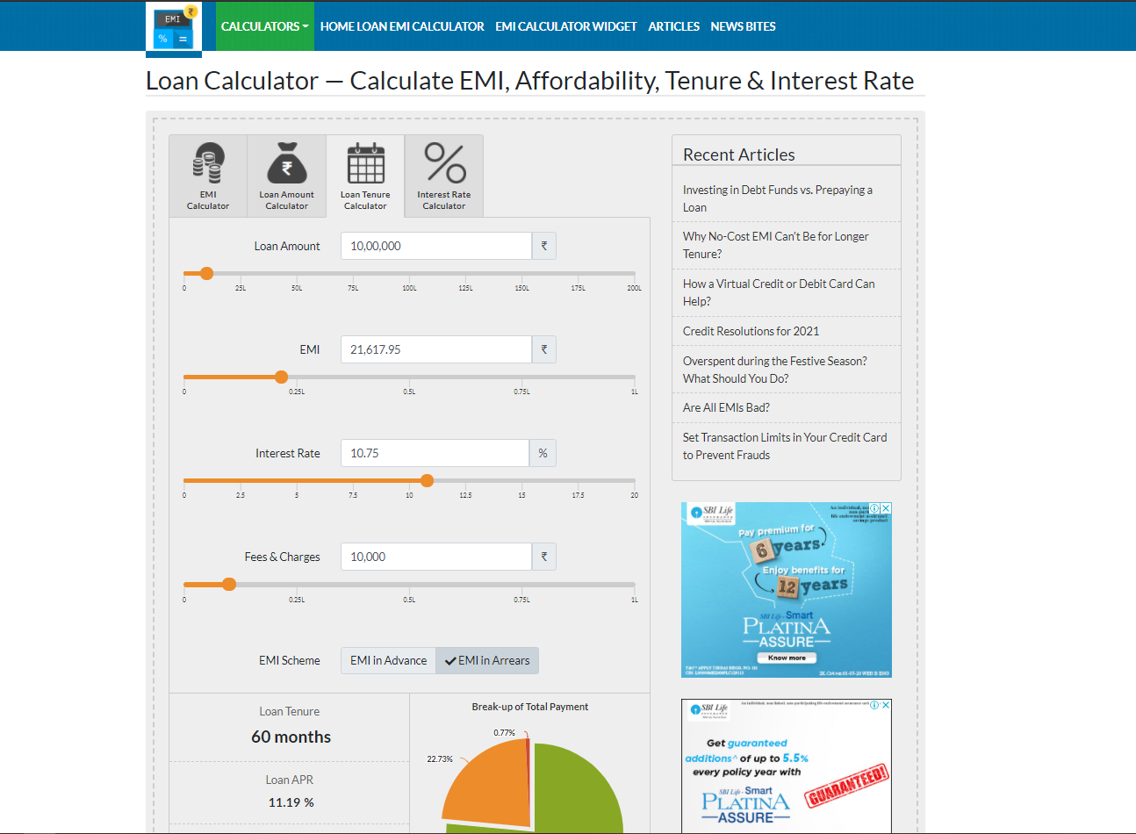Fees & Charges Input Field and Scale – It will be placed under “Loan Tenure” and will contain Rupee symbol. Scale contains values from “0” to “1L” with the interval of “0.25L”.

**Figure – 2.4.3**

**2.4.4 Interest Rate Calculator:**

* Loan Amount Field & Scale– It will be placed under Loan Amount Calculator
* option and left side in the middle frame. It contains Rupee symbol. Scale contains values from “0” to “200L” with the increment interval “25L”.
* EMI Input Field & Scale – It will be placed under “Loan Amount” and will contain rupee symbol. Scale contains values from “0” to “1L” with the interval of “0.25L”.
* Fees & Charges Input Field and Scale – It will be placed under “Loan Tenure” and will contain Rupee symbol. Scale contains values from “0” to “1L” with the interval of “0.25L”.
* 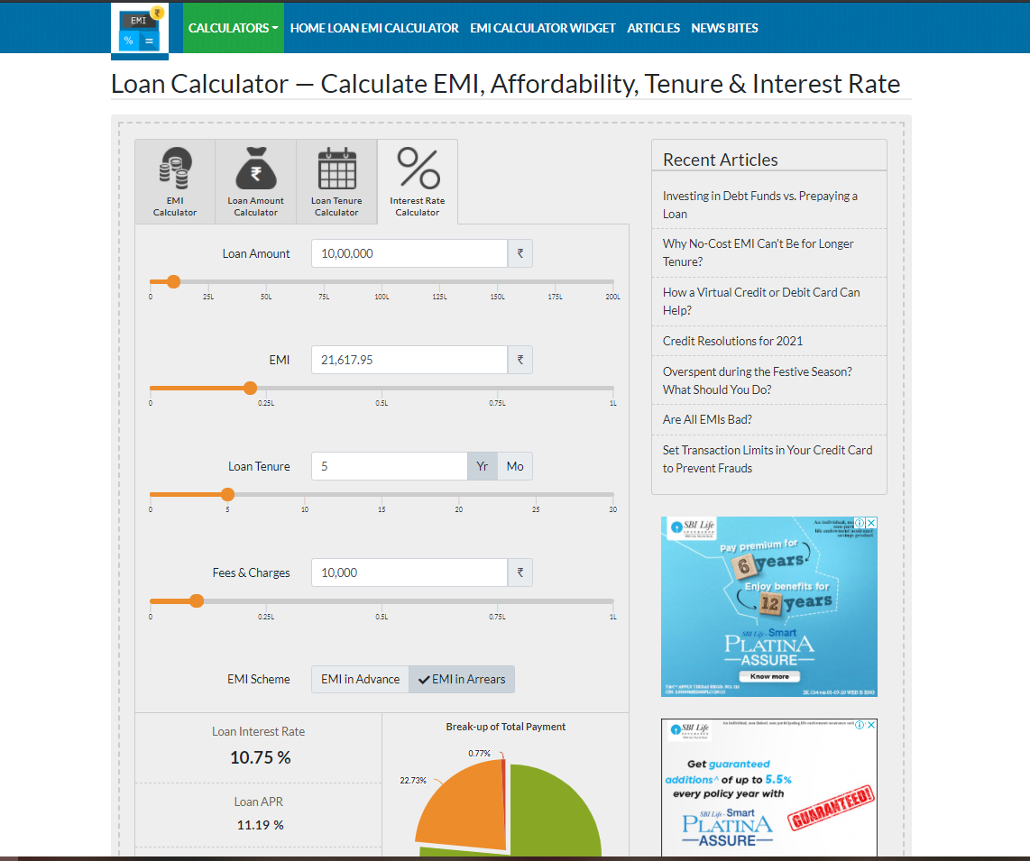Loan Tenure Input Field & Scale – It will be placed under “Interest Rate” and will contain “Year” & “Month”. Scale contains values from “0” to “30” for year and “0” to “360” for month.

**Figure – 2.4.4**

**Change Logs –**

|  |  |  |  |  |  |  |
| --- | --- | --- | --- | --- | --- | --- |
| **Change ID** | **Requirement** | **Requirement No** | **Review Date** | **Change Date** | **Reviewer** | **Comments** |
| **1** | **Menu Bar – UI** | **2.1.1** | **03/02/2021** | **04/02/2021** | **SHANMUGASUNDARAM, MAHESWARAN** | **“Home Loan EMI Calculator” shifted to “Calculators” feature from “Menu Bar”** |
|  |  |  |  |  |  |  |
|  |  |  |  |  |  |  |
|  |  |  |  |  |  |  |
|  |  |  |  |  |  |  |
|  |  |  |  |  |  |  |
|  |  |  |  |  |  |  |