COGNIZANT

Framework

|  |  |  |  |  |
| --- | --- | --- | --- | --- |
| Project Name | Find the Interest Amount for current year | | | |
| Name of product | [www.emicalculator.net](http://www.emicalculator.net) | | | |
| Product Description | Web application is designed to calculate various EMI’s. | | | |
| Project Description | To perform functional and GUI testing. | | | |
| Project Type | Automation Testing | | | |
| Project Duration | Start Date | 07-04-2021 | End Date | 17-04-2021 |

Project Overview

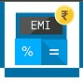

Team Members

|  |  |
| --- | --- |
| Emp ID | Emp Name |
| 899386 | Vyshnavi Garikapati |
| 899433 | Nimmanapalli Sai Abhijith Reddy |
| 899490 | Navitha Jutur Chinna Reddy |
| 899447 | Anusha Vontela |
| 899424 | Balla Divya Bhargavi |

**Introduction –**The Framework document is expected to provide the complete information about the framework used for project. It is expected to contain the types of framework, structure of the framework, templates, repositories, results, test data, scope, environment, utils. Automation framework is expected to be done when the scope of test cases is 80% automatable. Framework is expected to cover user processes.

**Templates –** Templates contains the following –

* Test Case Name
* Test Package Name
* Test Class Name
* Test Application Page Name
* Test Class Location
* Application Page Class Name
* Application Page Class Location
* Test Results Folder
* Test Data
* Test Output Data
* Utils Classes
* Base Classes
* Common Methods

Templates contains scripting knowledge –

* Steps, Keywords, Type, Suites, Action, Parameters

**Automation Framework Artifacts –**

|  |  |  |  |
| --- | --- | --- | --- |
| # | Artifact | Description | Type |
| 1 | Functional Requirement Document | Functional Requirements from user perspective | MS Word Docx, PDF, PLAN Docx |
| 2 | Manual Test Case | Manual Test Case Preparation for manual Testing | MS Excel |
| 3 | Object Library | Contains required objects for the auto test case | Properties File |
| 4 | Test Data Library | Contains required Test Data for auto test case | MS Excel |
| 5 | Test Report | Contains the report for executed auto test cases | HTML |
| 6 | Auto Script | Auto Script contains the script format | Java, Selenium |
| 7 | Test Summary Report | Manual Test Case Summary | MS Word Docx |
| 8 | Feasibility Report | Feasibility case study report of product | MS Word Docx |

**Automation Framework Process –**

|  |  |  |  |
| --- | --- | --- | --- |
| # | Process | Description | Role |
| 1 | Create Test Case | Creation of the Test Cases | Tester |
| 2 | Execute Test Case | Execution of the Test Cases | Tester |
| 3 | Produce Test Report | Produce the Test Report based on Test Cases | Tester |
| 4 | Update the Script | Update Script if any changes required | Tester |
| 5 | Manage Object Repositories | Update the Object Repositories for auto script if needed | Tester |

**Artifacts –**Below is the List of Artifacts for Framework –

1. Framework –

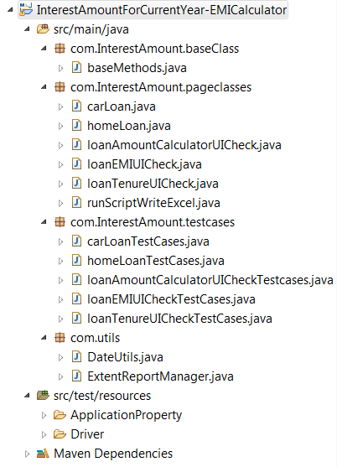

2. Environment Setup –

D:\Selenium Hackthon\environment.PNG

3. Utils –

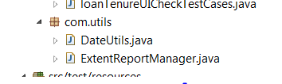

4. Web Pages –

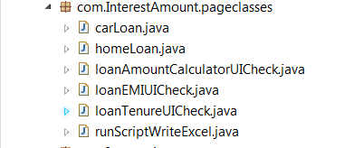

5. Test Results to Be Stored –

D:\Selenium Hackthon\output.PNG

. Auto Test Cases –

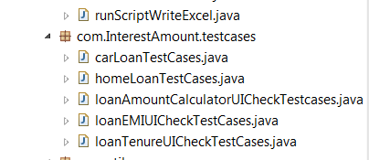

**Results & Dry Run –**

Console – 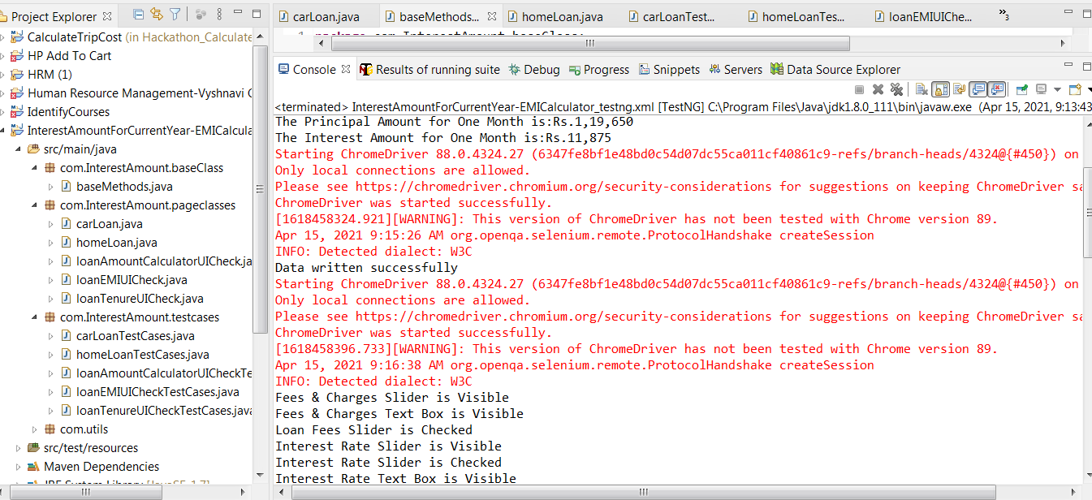

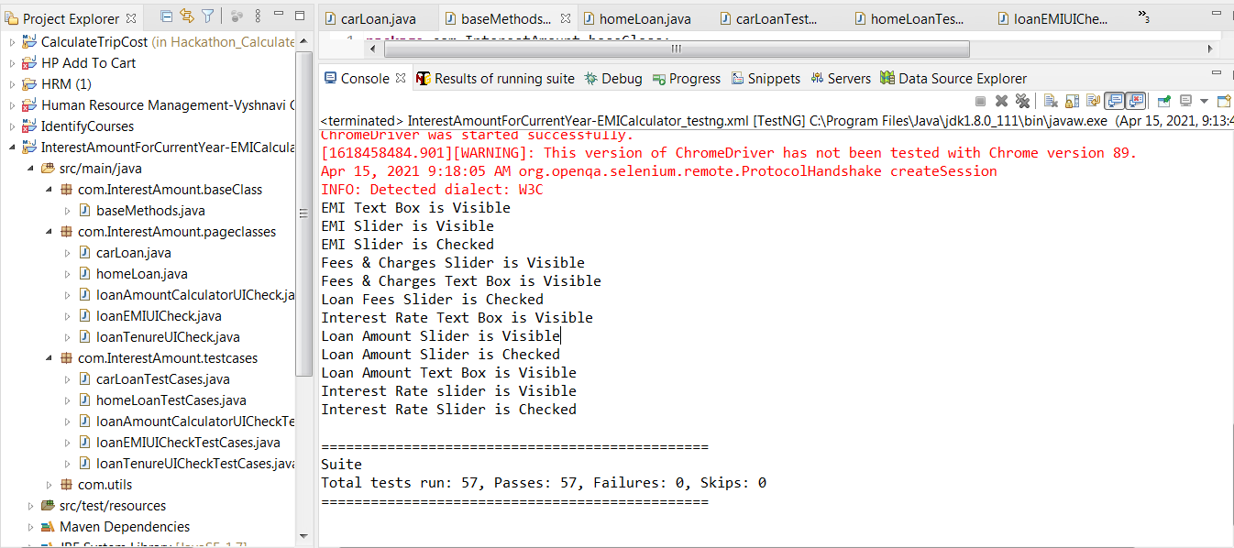

Results of TestNG Running Suite:

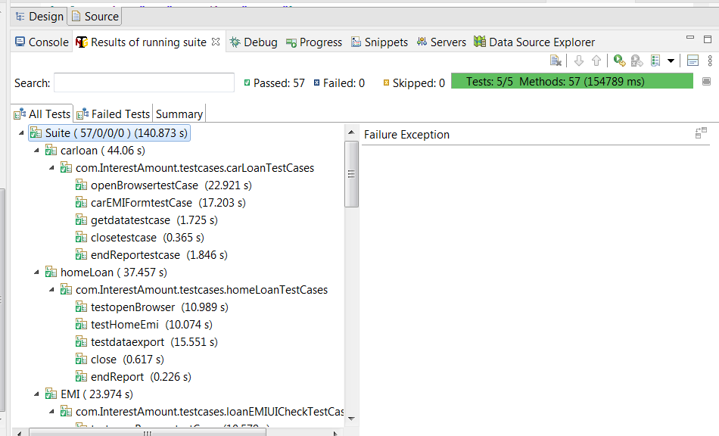

TestNG Report

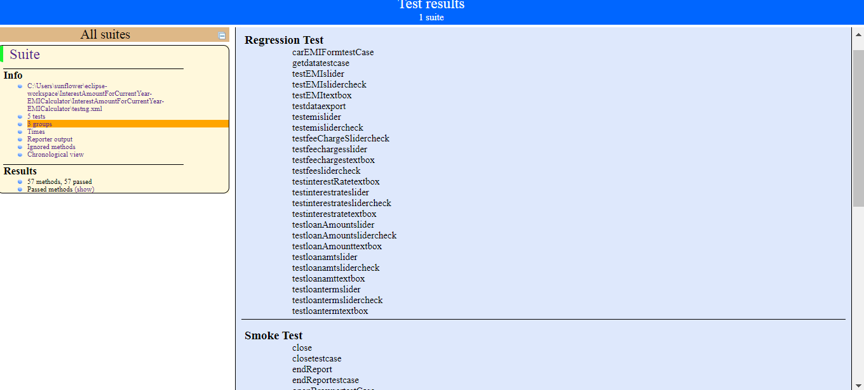

Extent Report:

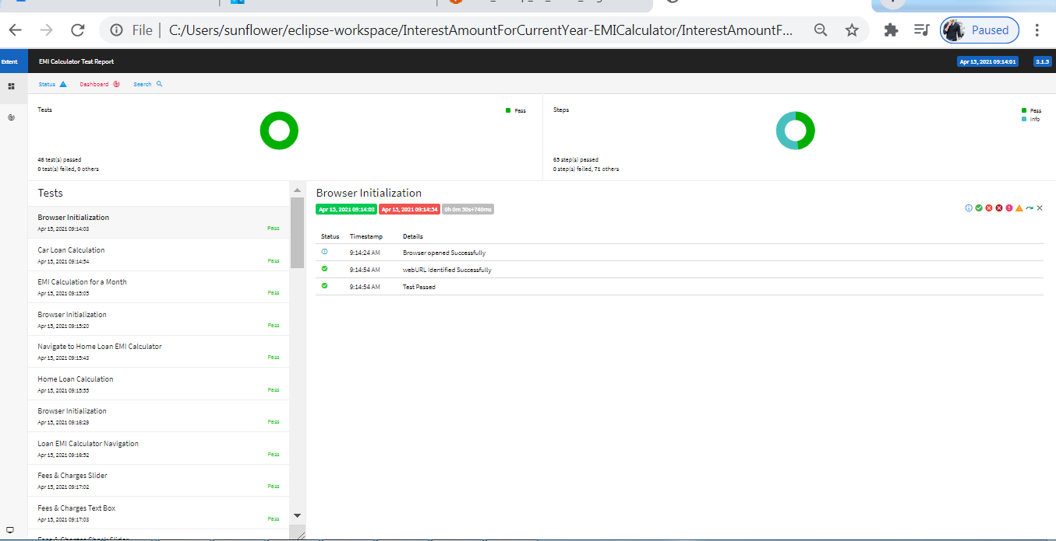

Jenkins:

