MongoDB:
- NoSql,open source document oriented database
- It doesn’t follow any fixed schema structure like relational database
- It’s not an replacement of relational database,it should be viewed as an alternative to it.
- It’s a crossplatform database. We can install mac,linux,windows..
- Best feature of mongodb is easily scalable & high performance.

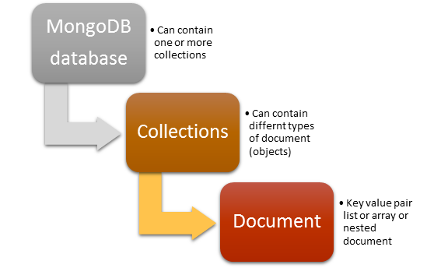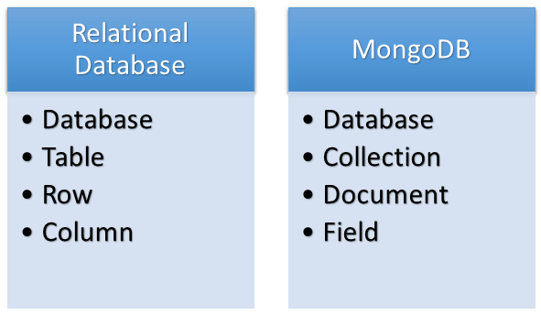
- MongoDB shell is an interactive javascript interpreter
Creating your own database:
For example : type ‘ use students’ to create a database named students.
Creating collections:
db.mycol.insert({name:'vikas'})
Here mycol is the name of collection and we have inserted a document in it. We just have to write the name of collection and insert record in it MongoDB will automatically create collection if it’s been not created else will insert the record in the existing collection.
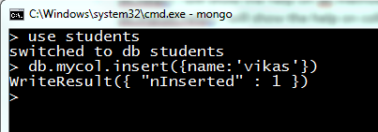
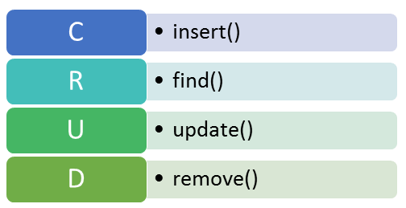

Insert():
- Insert command is used to insert documents in a collection
- document in MongoDB stores JSON object .so, insert command accept JSON object as parameter.

Eg: doc={
name:'xyx',
class:'12th',
subjects:['physics','chemisrty','maths','english','computer'],
address:{
house_no:'123',
sector:'50',
city:'noida'
}
}
db.mycol.insert(doc);
Here we created an object named doc and used that object as a parameter in insert command.
You can also insert document without creating any variable and directly pass document in the insert command see below for example:
db.mycol.insert({
name:'Vivek',
class : '12th',
subjects: [ 'physics', 'chemistry', 'math', 'english', 'computer'],
address: {
house_no: '12B',
block: 'B',
sector: 12,
city : 'noida',
},
grade: [
{
exam: 'unit test 1',
score: '60%'
},
{
exam: 'unit test 2',
score: '70%'
}

]
});
One thing to notice here that we didn’t provided _id for any of the above document but MongoDB itself inserted unique _id which is something like:

"_id" : ObjectId("560f767315f507b3c0bae3f5")

When we insert a document in MongoDB ,_id field should be unique. _id field is immutable which means you cannot change it. ObjectId is a type to generate unique keys which takes current time, identifier for the machine that constructing the ObjectId, the process id of the process that constructing the ObjectId and the counter that is global to object that constructing the ObjectId, by pushing these information together MongoDB creates a unique id for us. Of course we can create our own _id field but for every other document it must be unique.

Using loop to add more than one records in a collections:
Eg: for(i=0;i<100;i++)
{
subjects=['chemistry','physics','maths','english','computer'];
for(j=0;j<5;j++)
{
db.marks.insert({
name:"student"+ i,
subject:subjects[j],
marks:Math.round(Math.random()*100)
}
);
}
}

Note: I have used indentation just to make code readable but when you write the above code in MongoDB shell please remove all tabs and spaces.
Find():
To retrieve all records in collections:
db.CollectionName.find()
Passing parameter in find() method:
db.marks.find({name:'student0'})
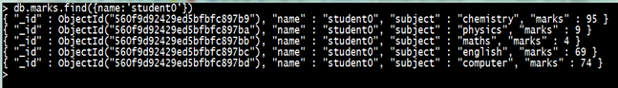
db.marks.find({name:'student0',subject:'computer'}).pretty()
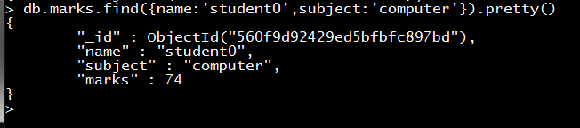

Find records of all students whose marks in computer is greater than 50:
db.marks.find({subject:'computer',marks:{$gt:50}}).pretty()
find command takes an object as a parameter similarly we will also pass document to match condition that is marks should be greater than 50.
Greater than: $gt
Greater and Equal : $gte
Less than: $lt
Less and Equal: $lte
Find records of all students whose marks in computer is greater than 50 and less than equal to 90:
db.marks.find({subject:'computer',marks:{$gt:50,$lte:90}}).pretty()
Find records of all students whose marks in computer or physics is greater than 90
db.marks.find({$or:[{subject:'computer'},{subject:'physics'}],marks:{$gt:90}})
$or takes an array of criteria that needs to be matched.
- In our previous collection mycol, documents had different schema design so let’s say we want to find the records in which class field exists:
Hide Copy Code
db.mycol.find({class:{$exists:true}})
similarly, we can write $exists : false for records in which class field doesn’t exists.
- Let’s say we have another collection named additionalsubject:
Hide Copy Code
db.additionalsubject.insert({name:'student1',subject:['arts','music']})

db.additionalsubject.insert({name:'student2',subject:['sports','arts']})

db.additionalsubject.insert({name:'student3',subject:['sports','cooking','music']})

db.additionalsubject.insert({name:'student4',subject:['arts','craft','music']})
And we want to find the records of those students who are enrolled in arts. So the query will be written as :db.additionalsubject.find({subject:'arts'})
But if we want to find records of those students who are enrolled in arts and music both, then our query will be:
Hide Copy Code
db.additionalsubject.find({subject:{$all:['arts','music']}})
The important thing to notice here is that $all will look for all the values passed in the array irrespective of the sequence they are present in collection.
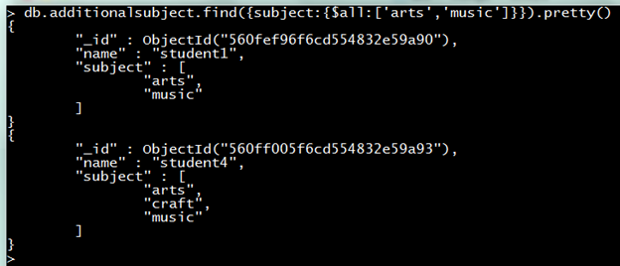
- Similarly we have $in to look for either of the values passed in it. Let’s say we want to find the records of students who are either enrolled in sports or arts. Then the query will be:
Hide Copy Code
db.additionalsubject.find({subject:{$in:['sports','arts']}})
- We have dot notations to query collections having nested documents.
db.additionalsubject.find({subject:{$in:['arts','music']}})
"_id" : ObjectId("57f2398fc23e0c8130793d3e"), "name" : "student1", "subject" :
[ "arts", "music" ] }
"_id" : ObjectId("57f239a4c23e0c8130793d3f"), "name" : "student2", "subject" :
[ "sports", "arts" ] }
"_id" : ObjectId("57f239b6c23e0c8130793d40"), "name" : "student3", "subject" :
[ "sports", "cooking", "music" ] }
"_id" : ObjectId("57f239c1c23e0c8130793d41"), "name" : "student4", "subject" :
[ "arts", "craft", "music" ] }
For example in first document shown earlier in which grades contains arrays of documents and if we want to find the grade of exam unit test 1 then the query will be written as:
Hide Copy Code
db.mycol.find({'grade.exam':'unit test 1'})

{ "_id" : ObjectId("57f23bf0c23e0c8130793d42"), "name" : "Vidya", "class" : "12t
h", "subjects" : [ "physics", "chemistry", "math", "english", "computer" ], "add
ress" : { "house_no" : "12B", "block" : "B", "sector" : 12, "city" : "noida" },
"grade" : [ { "exam" : "unit test 1", "score" : "60%" }, { "exam" : "unit test 2
", "score" : "70%" } ] }

Update():
Update command takes two parameter first one is matching criteria and second one is updated value. Syntax:db.[collectionName].update({matching criteria},{updated value});
update command in MongoDB performs four major tasks.
the ObjectId. For example in our additionalsubject collection if want to change the subject of student1, and we write like this then:
Hide Copy Code
db.additionalsubject.update({name:'student1'},{subject:['craft']})
It will not only change the subject field but will replace the whole document.
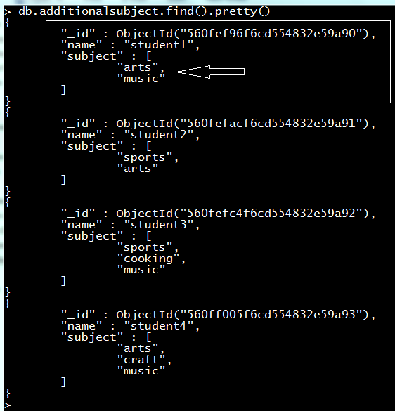
After updating document:
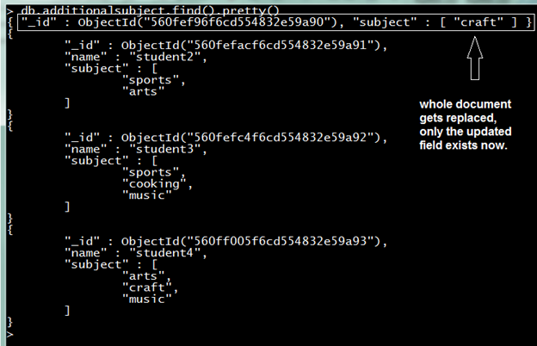
Now there is no name field only ObjectId and subject field, so we can say this is not the right way to update a document because updating in this manner will replace the whole document with new updated value but this command is useful when you want replace the old document with new fields and new values.
- Modifying only the desired field, if we want to just modify some values of field then we have $set operator for this. For example : Let’s say we want to change the name of student2 to ‘xyz’, in this case we only want to modify the name field and don’t want to touch other field so we will write:
Hide Copy Code
db.additionalsubject.update({name:'student2'},{$set:{name:'xyz'}})
Before Update:
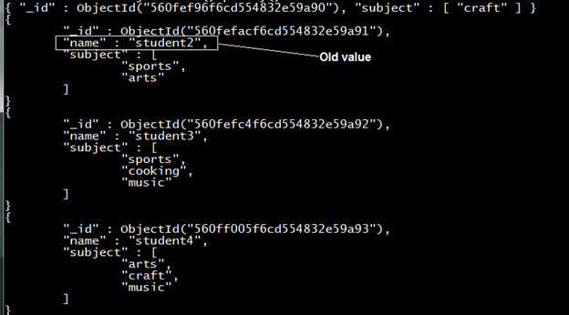
After update:
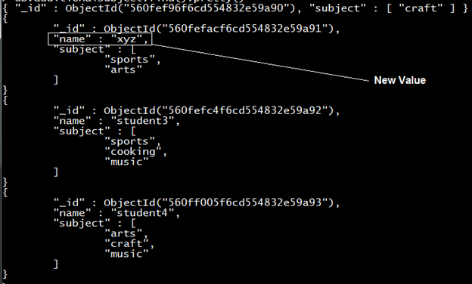
- Removing undesirable field, means we can remove a field from a document when we don’t require it for this we have $unset opearator. For example, let’s say we want to subject field for the student name ‘xyz’:
Hide Copy Code
db.additionalsubject.update({name:'xyz'},{$unset:{subject:1}})
Before update:
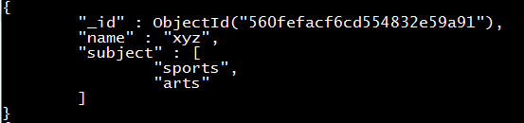
After update:
- Update command searches for the record that matches the criteria specified in the parameter and if finds the record then it updates it otherwise nothing is updated. We have a special operator upsert that creates the new record and then update it. So if we will try to update the record of student5 nothing will happen because we do not have student5 record but if we use upsert then a new record for student5 gets created and updated.
Hide Copy Code
db.additionalsubject.update({name:'student5'},{$set:{subject:['music']}},{upsert:true})
- If we want to update arrays in a document then we can easily do this in MongoDB. We also have some special operators in MongoDB to update arrays in a document. Let’s see some examples to update arrays in a document:
  - Change subject of student3 from sports to arts:
Hide Copy Code
db.additionalsubject.update({name:'student3'},{$set:{'subject.0':'arts'}});
subject is the array so if we want change the subject indexed at 0th place we will write subject.0

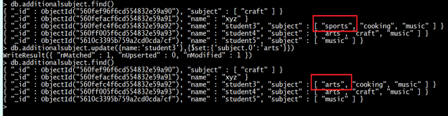
  - Add one more subject to student3 record. For this we have $push:
Hide Copy Code
db.additionalsubject.update({name:'student3'},{$push:{'subject':'sports'}})
It will add one more subject ‘sports’ at the end of the subject field.
  - Similarly, we have $pop to remove a value from the array. But it will remove the rightmost value from the array.
Hide Copy Code
$pop : 1 (remove rightmost value)

$pop : -1 (remove leftmost value)

db.additionalsubject.update({name:'student3'},{$pop:{'subject':1}});
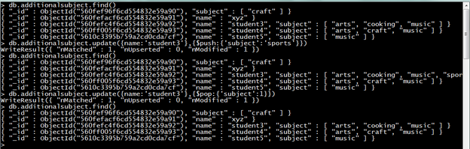
4.We have $pushAll to add one or more value to array. Similarly we $pull to remove one specified value from array, and $pullAll to remove one or more values from the array. Let’s see example:
Hide Copy Code
db.additionalsubject.update({name:'student3'},{$pushAll:{'subject':['sports','craft']}})

db.additionalsubject.update({name:'student3'},{$pullAll:{'subject':['sports','craft']}})
- MongoDB updates only one document that fulfills the matching criteria but if you want to update all document at a time then we have to pass one additional parameter mult:true.
For example if we want one more additional field to all document of additionalsubject collection:
Hide Copy Code
db.additionalsubject.update({},{$set:{'class':&rsquo;12<sup>th</sup>&rsquo;}},{multi:true})
It will add a new field class to every document in the collection.

Remove()
Remove command is used to remove records from collection it works same as find command it requires one parameter which is the matching criteria for the document.
- If we want remove the record of student named student3 then we will write:
Hide Copy Code
db.additionalsubject.remove({name:'student3'})
- And we want to remove all documents of a collection then we have to pass an empty document as a parameter to the remove command.
Hide Copy Code
db.additionalsubject.remove({})
It will remove all the documents of collection.

