> install.packages("ggplot2")

Installing package into ‘C:/Users/admin/AppData/Local/R/win-library/4.3’

(as ‘lib’ is unspecified)

--- Please select a CRAN mirror for use in this session ---

There is a binary version available but the source version is later:

binary source needs_compilation

ggplot2 3.5.1 3.5.2 FALSE

installing the source package ‘ggplot2’

trying URL 'https://cran.icts.res.in/src/contrib/ggplot2_3.5.2.tar.gz'

Content type 'application/x-gzip' length 3580451 bytes (3.4 MB)

downloaded 3.4 MB

* installing *source* package 'ggplot2' ...

** package 'ggplot2' successfully unpacked and MD5 sums checked

** using staged installation

** R

** data

*** moving datasets to lazyload DB

** inst

** byte-compile and prepare package for lazy loading

** help

*** installing help indices

*** copying figures

** building package indices

** installing vignettes

** testing if installed package can be loaded from temporary location

** testing if installed package can be loaded from final location

** testing if installed package keeps a record of temporary installation path

* DONE (ggplot2)

The downloaded source packages are in

‘C:\Users\admin\AppData\Local\Temp\RtmpoR3gdE\downloaded_packages’

>

> cat("Enter Values:")

Enter Values:

1: 5

2: 4

3: 6

4: 5

5: 4

6:

Read 5 items

> values

[1] 5 4 6 5 4

> values <- c(10,6,7,5,6)

> print(values)

[1] 10 6 7 5 6

> values <- c(10:100)

> print(values)

[1] 10 11 12 13 14 15 16 17 18 19 20 21 22 23 24 25 26 27 28 29 30 31 32 33 34 35 36 37 38

[30] 39 40 41 42 43 44 45 46 47 48 49 50 51 52 53 54 55 56 57 58 59 60 61 62 63 64 65 66 67

[59] 68 69 70 71 72 73 74 75 76 77 78 79 80 81 82 83 84 85 86 87 88 89 90 91 92 93 94 95 96

[88] 97 98 99 100

> seq(1,100)

[1] 1 2 3 4 5 6 7 8 9 10 11 12 13 14 15 16 17 18 19 20 21 22 23 24 25 26 27 28 29

[30] 30 31 32 33 34 35 36 37 38 39 40 41 42 43 44 45 46 47 48 49 50 51 52 53 54 55 56 57 58

[59] 59 60 61 62 63 64 65 66 67 68 69 70 71 72 73 74 75 76 77 78 79 80 81 82 83 84 85 86 87

[88] 88 89 90 91 92 93 94 95 96 97 98 99 100

> seq(1,20)

[1] 1 2 3 4 5 6 7 8 9 10 11 12 13 14 15 16 17 18 19 20

values = c(7,2,8,4,5)

barplot(values,names.arg=c("E","N","E","M","Y"))

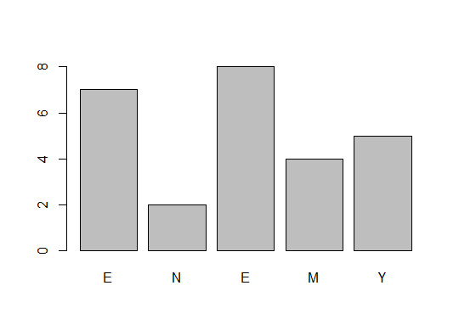

values = c(7,2,8,4,5)

barplot(values,names.arg=c("E","N","E","M","Y"))

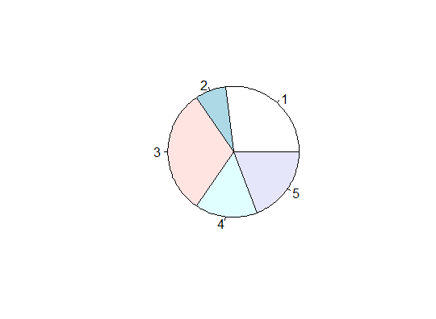

> mu <- function(x) mean(x)

> mu(c(1:5))

[1] 3