**Transactional Replication**

**Design**:

**Node1 – Publisher, Node2 – Subscriber & Node3 – Distributer**

**Pre request:**

1. Create new three service account for agents.

Svc_repl_snapshot , Svc_repl_logreader & Svc_repl_distributer

1. Create share path for snapshot files BCP & DML

Create it on Distributer server and add permission at security of folder and advanced security of permission. Svc_repl_snapshot (**Full control**) , Svc_repl_logreader (Only **read**) & Svc_repl_distributer (Only **read**)

Better create logins into SQL and grant all necessary permission, before configure replication.

All three logins as db owners to replicated DB, for distributer give DB owner as well.

1. Create DB on subscriber and grant permission to login accounts.

**Configuration**

**On Distributer server Create and configure**

Choose Node3 🡪 Next 🡪 pass share path 🡪 Leave Distributer DB name and change MDF and LDF file path 🡪Choose Publisher 🡪Add Node1 🡪Pass the password and remember or store it for adding another publisher for this remote Distributer 🡪Configure🡪Finish

1. Grant permission for all three logins to Distribution DB.

Svc_repl_snapshot (**DB_Owner**) , Svc_repl_logreader (**DB_Owner**) & Svc_repl_distributer (**DB_Owner**)

**After creation from GUI – 2 LS on DIST to 1 Pub and other DIST & 7 Jobs:**

You will see 2 **linked servers**. 1 to publisher node1 and other is for Distributor i.e named as repl_distributor and 7 common jobs.

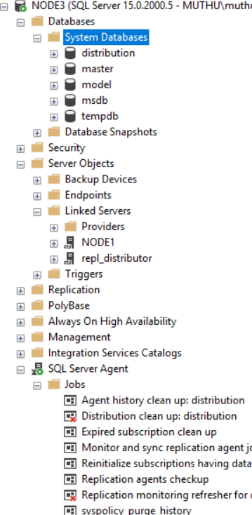

**On Publisher server Create Publisher Distributer – You need to pass Snapshot &Log reader agent account**

Before creating publisher, create DB name for Subscriber on Node2. You can have same name or different name. Better have same name.

1. Grant permission for all three logins to DB.

Grant **DB_Owner** onlyforSvc_repl_distributer to the Subscriber DB.

1. Create Publisher
2. Grant permission to the logins

Svc_repl_snapshot (**DB_Owner**) , Svc_repl_logreader (**DB_Owner**) & Svc_repl_distributer (**DB_Owner**)

1. Go to replication 🡪Local publication 🡪choose and add distributor server 🡪choose DB 🡪Transaction replication 🡪 Choose articles (Tables, SP, Views / Indexed View, UDF). You can configure the article properties (FK, Constraint and index to replicate etc. For SP you can have both schema and execution to be replicated etc.) 🡪 Next 🡪 Mark check box Create snapshot immediately or schedule it in the agent 🡪pass snapshot agent credential & log reader credential 🡪 Publication Name 🡪Finish
2. Check snapshot agent status and make sure the data is replicated.

If the snapshot agent is says starting more than X time then there might be issue with password or permission etc. You can check that in Distributor DB Exec sp_helpdistpublisher 🡪Check column called active is 1. If it is 0 you need to enable to active.

sp_helpdistpublisher

sp_changedistpublisher @publisher = 'node1', @property = 'active' , @value = 'true'

You can get error like - string or binary data would be truncated transactional replication

1. Right click on publication 🡪Properties 🡪 publication access list 🡪 add distributor agent (Svc_repl_distributer)

**After creation from GUI: 1 LS on Pub to DIST & 3 Jobs**

One linked server on publisher created that is to connect with **distributor** named as repl_distributor and only **one** job Expired subscription clean up.

**Two jobs are created on distributor**

**1 is for snapshot agent and other is for log reader agent.**



**On Publisher server Create subscriber – You need to pass distributer agent account**

1. Right click on publication and new subscriber

Choose subscription 🡪 choose push or pull🡪push🡪 add subscriber to Node2 🡪choose DB 🡪next 🡪Pass credential for distributer agent (Svc_repl_distributer) 🡪Run continuously or in schedule 🡪next🡪Finish

1. That’s all done. Do some changes in the table and make sure the changes are replicating.

**After creation from GUI: 2 LS on Pub & DIST 🡪 to SUB & 1 Job**

There is one linked server created in publisher side which is having connection to subscriber Node2. One more linked server is created on distributer side which is having connection to subscriber Node2.

**1 new job been created in distributer**

**That is for distributer push agent.**

