SERVIZIO
23CS54C - MODERN WEB TECHNOLOGIES

Submitted by

MUTHURAMALINGAM A | 2312090
AJAY KUMAR K L | 2312091
HARISHPANDIAN I | 2312107

In partial fulfillment for the award of the degree
of
BACHELOR OF ENGINEERING/TECHNOLOGY
in
COMPUTER SCIENCE AND ENGINEERING/ INFORMATION TECHNOLOGY


NATIONAL ENGINEERING COLLEGE
(An Autonomous Institution affiliated to Anna University, Chennai)

K.R.NAGAR, KOVILPATTI - 628503
OCTOBER - 2025

NATIONAL ENGINEERING COLLEGE
(An Autonomous Institution affiliated to Anna University, Chennai)
K.R.NAGAR, KOVILPATTI - 628503

BONAFIDE CERTIFICATE

This is to certify that this project report, “Servizio”, is the bonafide work of MUTHURAMALINGAM A(2312090), AJAY KUMAR K L (2312091), HARISHPANDIAN I (2312107) who carried out the project work under my supervision.

Course Instructor/Guide

Submitted to the 23CS54C – MODERN WEB TECHNOLOGIES Viva-Voce examination held at National Engineering College, K.R.Nagar, Kovilpatti on ___________

Internal Examiner Co Examiner

TABLE OF CONTENTS

CH NO | TITLE | PAGE NO
1 | INTRODUCTION | 3
2 | OBJECTIVES | 4
3 | DESCRIPTION | 5
4 | CLASS DIAGRAM | 6
5 | TABLE STRUCTURES | 7
6 | ER DIAGRAM | 11
7 | MODULES | 12
8 | CONCLUSION | 40

CHAPTER 1

INTRODUCTION

In the modern digital era, freelancing platforms have revolutionized the way individuals and businesses collaborate. With the growing demand for remote work and flexible job opportunities, platforms such as Fiverr and Justdial have become essential bridges connecting clients with skilled professionals. However, many existing systems face challenges in providing real-time communication, secure payment gateways, and efficient service discovery.
To address these limitations, this project presents a Freelancer Platform developed using React.js, designed to connect clients and freelancers seamlessly. The platform enables users to register, list their services, chat in real-time, and make secure online payments through Razorpay integration.
The primary objective of this system is to create an easy-to-use and efficient digital marketplace where freelancers can showcase their skills, and clients can quickly find and hire professionals suited to their needs. The integrated chat system enhances collaboration by allowing instant communication between users, while the Razorpay module ensures smooth and secure financial transactions.
This project demonstrates the complete lifecycle of a web-based freelancer system—from frontend interface design to backend integration—providing a scalable, interactive, and secure environment for both freelancers and clients.

CHAPTER 2
OBJECTIVES

- To implement separate login access for Admin, Freelancer, and Client users, ensuring secure authentication and controlled access to different platform functionalities.
- To allow the Admin to manage user accounts (freelancers & clients), monitor service listings, track transactions, and oversee overall platform performance and security.
- To enable Freelancers to add, update, and delete service listings, ensuring that the service catalog remains accurate, relevant, and up-to-date.
- To allow Clients to browse, search, and filter freelancer services based on categories such as skill, price, experience, and ratings, providing a transparent and efficient hiring process.
- To provide real-time chat functionality between freelancers and clients for communication, negotiation, and project discussions, enhancing engagement and collaboration.
- To integrate Razorpay Payment Gateway for secure, reliable, and instant online transactions between clients and freelancers.
- To offer real-time updates on new service postings, featured freelancers, and transaction statuses, improving the overall user experience.
- To maintain detailed and accurate records of all service listings, chats, inquiries, and payments, ensuring accountability, traceability, and data reliability.
- To automate workflows related to user management, communication, and payment processing, thereby improving operational efficiency and reducing manual intervention.

CHAPTER 3
DESCRIPTION

The Freelancer Platform is a web-based application developed using React.js that connects freelancers offering various services with clients seeking skilled professionals. The platform is designed to provide a secure, transparent, and interactive digital workspace similar to Fiverr or Justdial, where users can communicate, collaborate, and complete transactions seamlessly.
The system includes three types of users — Admin, Freelancer, and Client, each with distinct functionalities and access privileges. The Admin oversees the platform’s operations, manages users, monitors transactions, and ensures system security. Freelancers can create, modify, and manage their service listings, while Clients can browse, search, and hire freelancers based on their specific needs.
A key feature of the system is the integration of real-time chat functionality, enabling instant communication between freelancers and clients for project discussions and negotiations. Additionally, the Razorpay Payment Gateway ensures secure and hassle-free transactions between users.
The platform is built with a modular architecture, separating the frontend (React.js) and backend (Node.js/Express) for scalability and easy maintenance. Data is securely stored in the database, and APIs facilitate smooth communication between components.
Overall, this project provides a complete digital ecosystem for freelance collaboration, empowering users to connect, communicate, and transact effectively within a safe and user-friendly environment.

CHAPTER 4
CLASS DIAGRAM

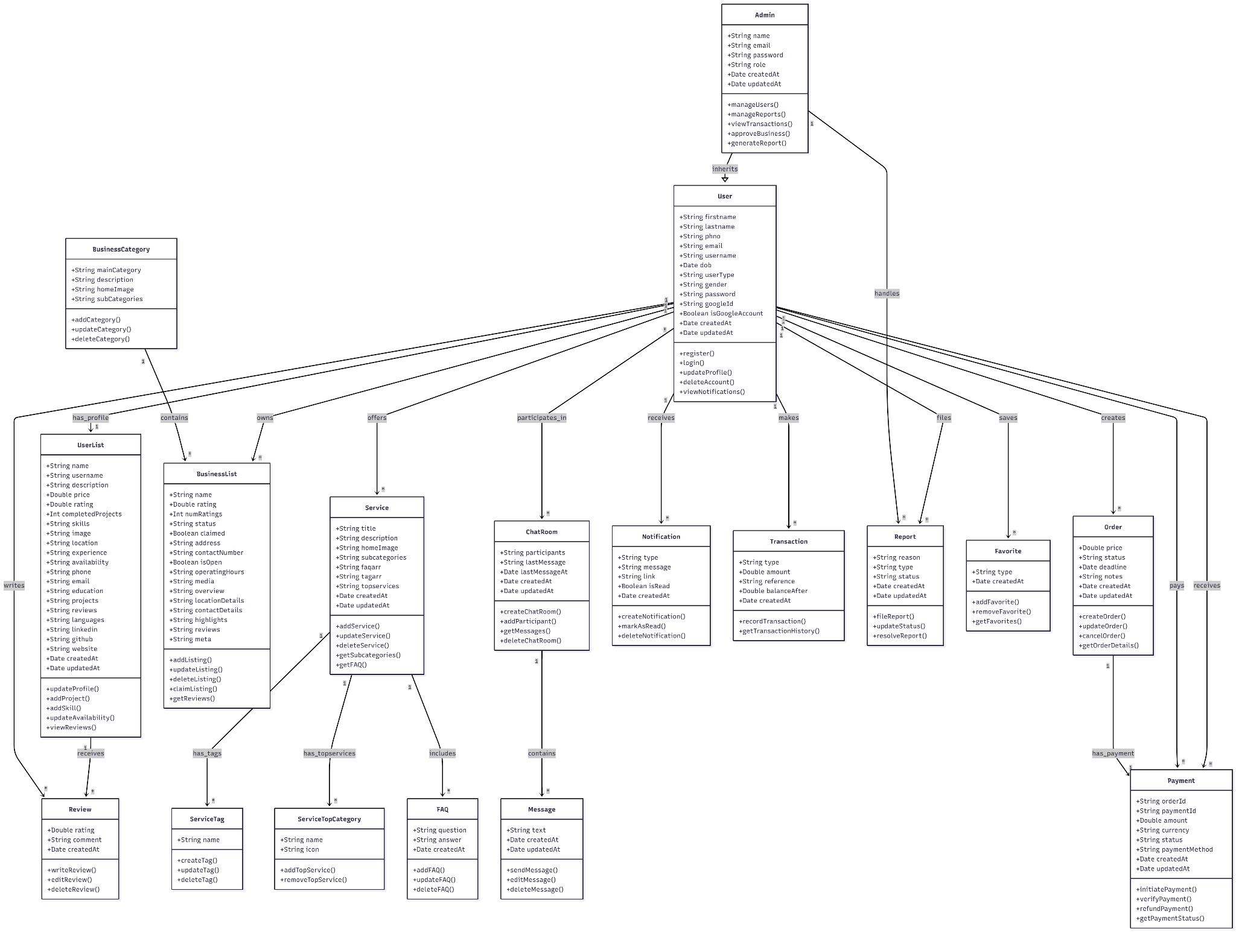

CHAPTER 5
TABLE STRUCTURES
User Table
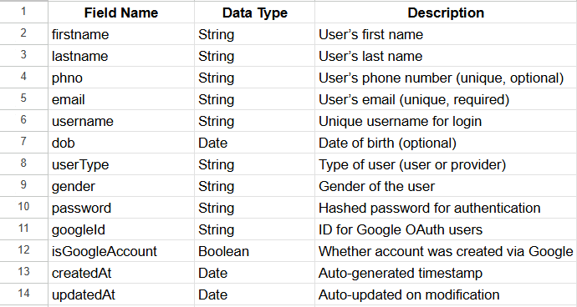

UserList Table
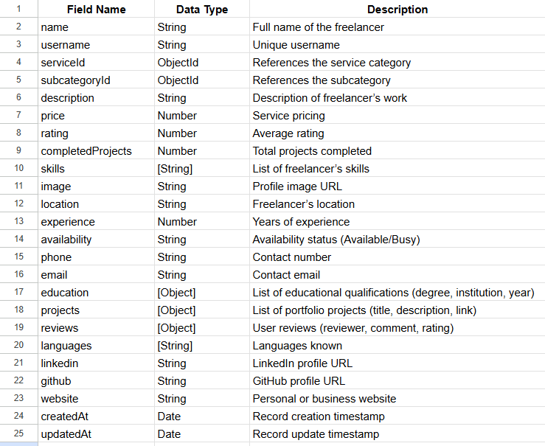
Service Table
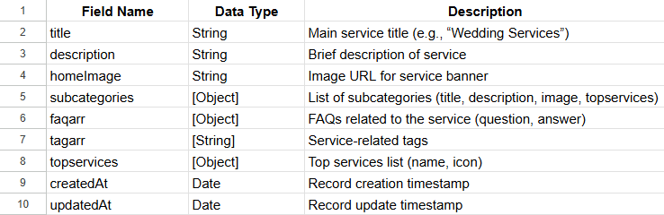

BusinessCategory Table
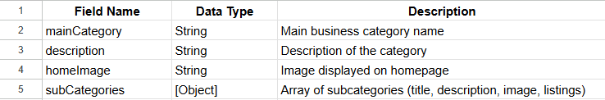
BusinessList Table
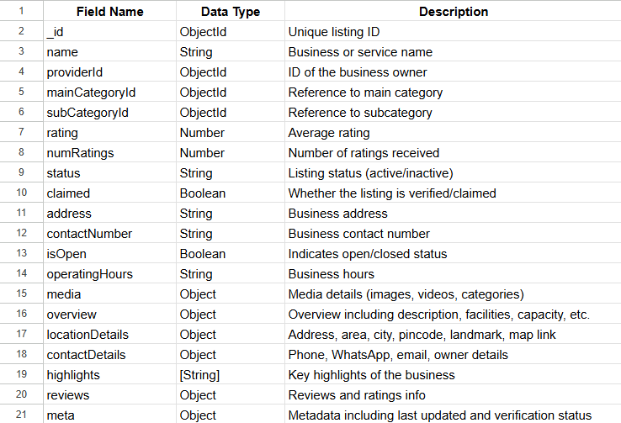
Message Table
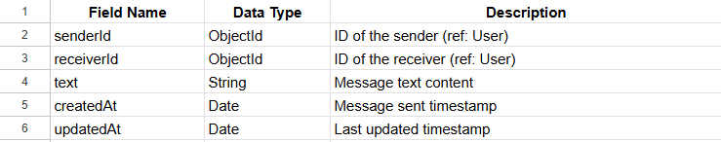

Guide Table

ServiceTag Table
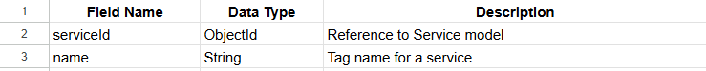

ServiceTopCategory Table
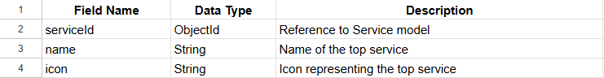

CHAPTER 6
ER DIAGRAM

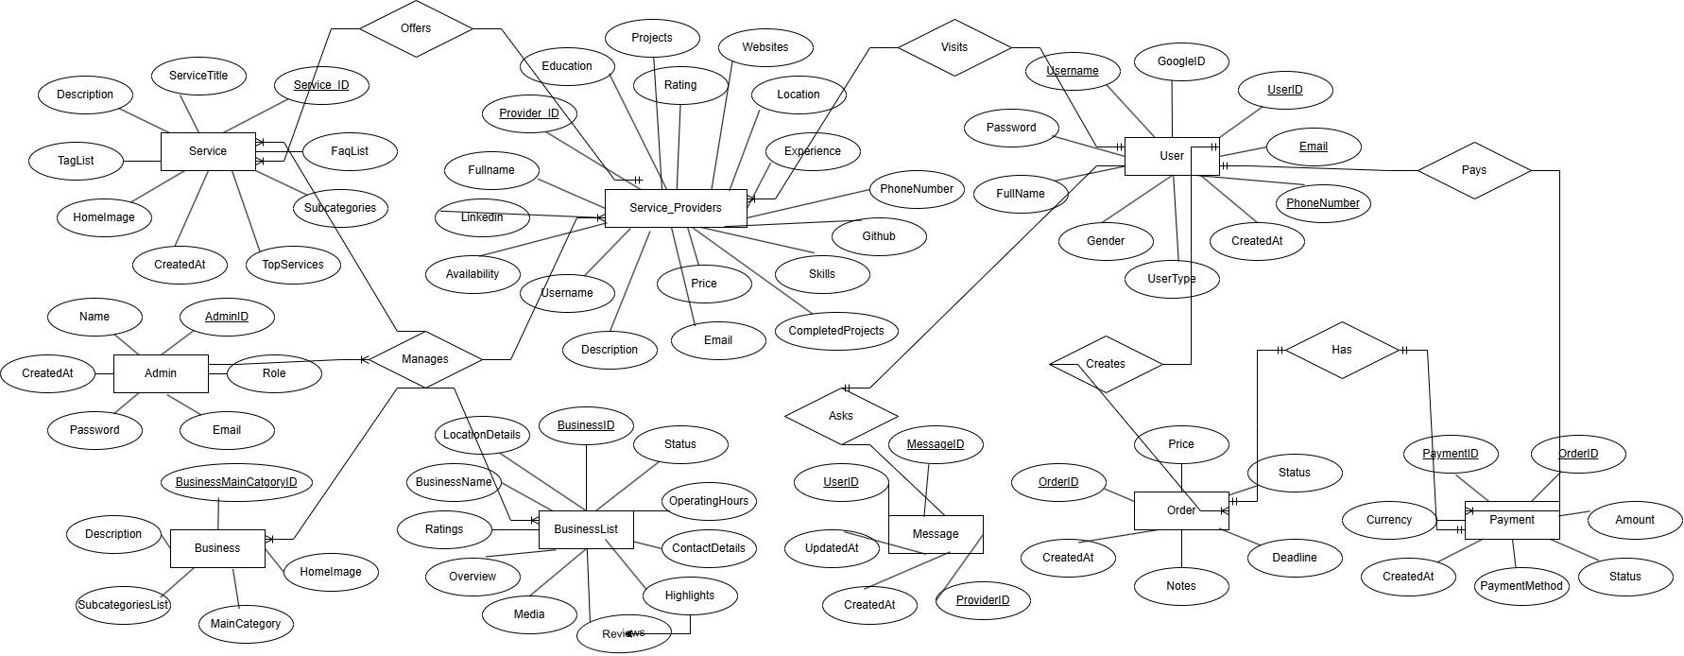

CHAPTER 7
PROJECT OVERVIEW
The Freelancer Marketplace Platform is a full-stack web application that connects clients and freelancers/service providers on a unified platform, allowing users to discover, communicate, and collaborate efficiently. The system provides features similar to Fiverr and Justdial, enabling users to browse services, hire professionals, chat in real-time, and make secure payments via Razorpay.
This project ensures seamless interaction among multiple user roles — Admin, Service Provider, and Customer — while maintaining scalability, data security, and user engagement through modern web technologies.

Front-End Technologies
The frontend is built using React.js and Tailwind CSS, offering a dynamic, interactive, and responsive interface that ensures smooth navigation and modern aesthetics.
- React.js – Component-based structure for reusable UI design and efficient state management.
- React DOM – Handles rendering and virtual DOM updates efficiently.
- Tailwind CSS – Provides utility-first CSS for consistent, responsive layouts.
- Axios – Handles REST API communication with the backend.
- React Router DOM – Enables seamless navigation between pages.
- Vite – Optimized build tool for fast frontend development.
- Socket.io Client – Enables real-time chat and notifications between users.
- Razorpay Integration (Client SDK) – Handles secure and smooth payment flow.
The frontend allows users to:
- Register/login as a Customer or Service Provider.
- Browse, search, and filter services or freelancers.
- Manage service listings (add/update/delete).
- Initiate real-time chat with providers or clients.
- Make secure payments using Razorpay.

Back-End Technologies
The backend is powered by Node.js and Express.js, providing RESTful APIs that manage user authentication, chat services, and payment processing. It ensures secure and efficient data handling for all user operations.
- Express.js – Handles API routing and middleware logic.
- Mongoose – Manages MongoDB schemas and data validation.
- bcrypt.js – Hashes and secures passwords.
- jsonwebtoken (JWT) – Authenticates users and secures routes.
- Multer – Manages image uploads for user and service profiles.
- Socket.io – Facilitates real-time chat and instant messaging.
- Razorpay SDK – Manages payments and order transactions.
- dotenv – Manages environment variables securely.
The backend supports:
- Role-based access control (Admin, User, Provider).
- Secure authentication and session handling.
- Real-time chat and notifications.
- Payment processing via Razorpay.
- Service listing and business directory management.

Middleware
Middleware in Express.js ensures that every incoming request is validated, authenticated, and processed efficiently.
- express.json() / express.urlencoded() – Parses incoming data.
- JWT Middleware – Protects restricted routes for authenticated users.
- Error Handling Middleware – Manages and formats error responses consistently.
- Role-Based Access Middleware – Grants or restricts actions based on user type (Admin/Provider/User).

Database
The project uses MongoDB Atlas, a cloud-hosted NoSQL database that stores user, service, and transaction data with high availability and scalability.
- MongoDB Atlas – Cloud-based database for high performance.
- Mongoose ODM – Defines schema structures, validations, and relationships.
- Collections include:
  - User – Manages users and providers with authentication details.
  - UserList – Stores provider portfolios, skills, projects, and reviews.
  - Service – Maintains service categories, subcategories, FAQs, and top services.
  - Message – Handles chat communication between users.
  - BusinessList – Stores local business listings similar to Justdial integration.
  - Guide – Contains guides or tips displayed in the frontend.

Packages Used
The Freelancer Marketplace Platform integrates a comprehensive set of frontend and backend dependencies to deliver a seamless, real-time, and scalable web application. The combination of React with Tailwind CSS on the client side and Node.js with Express.js on the server side ensures high performance, reliability, and a responsive user experience. The following outlines the major packages and their roles in the system.

Frontend Packages
The frontend uses React, Tailwind CSS, and supporting libraries to create a modern, responsive, and user-friendly interface. These packages together enable live updates, chat functionality, secure API integration, and intuitive service browsing.
- react & react-dom – Core libraries for building reusable, component-based user interfaces.
- react-router-dom – Enables smooth navigation between pages without page reloads.
- tailwindcss – Utility-first CSS framework for responsive and consistent styling.
- @tailwindcss/vite – Integrates Tailwind CSS with Vite for optimized builds and hot-reloading.
- axios – Handles API communication between frontend and backend securely and efficiently.
- @reduxjs/toolkit & react-redux – Manages global state, such as user sessions, chat, and listings.
- framer-motion – Adds smooth animations and UI transitions.
- lucide-react & react-icons – Provides scalable icons for UI consistency.
- socket.io-client – Enables real-time chat and instant notifications between users and service providers.
- razorpay (client SDK) – Handles secure payments directly within the frontend interface.
- jwt-decode – Decodes JWT tokens for maintaining authenticated sessions.
- crypto-js – Encrypts sensitive data and ensures secure communication.
- country-state-city – Provides location data for easy selection during registration and profile setup.
- firebase – Used for optional notification and cloud-based real-time features.

- vite – Fast build tool and development server that enhances frontend performance.

Development Dependencies
- @vitejs/plugin-react – Enables React-specific optimizations for Vite builds.
- eslint, eslint-plugin-react-hooks, eslint-plugin-react-refresh, globals – Ensure code quality, linting, and consistency across development.
Backend Packages
The backend stack uses Node.js, Express.js, and MongoDB to provide scalable APIs, secure authentication, and real-time communication. It handles all business logic, user roles, payments, and chat operations efficiently.
- express – Core backend framework for defining routes, middleware, and REST APIs.
- mongoose – ODM (Object Data Modeling) library for MongoDB, managing schemas and validations.
- bcrypt – Hashes passwords for secure authentication.
- jsonwebtoken (JWT) – Provides authentication and role-based authorization for users and providers.
- cors – Manages cross-origin requests between frontend and backend.
- dotenv – Stores and protects sensitive environment variables like API keys and database URIs.
- multer – Handles image and file uploads for user and service profiles.
- cloudinary – Cloud-based storage for managing uploaded images and media.
- socket.io – Provides real-time, bidirectional communication for chat and notifications.
- razorpay – Integrates a secure payment gateway for hiring freelancers or booking services.
- nodemailer – Sends confirmation, notification, or verification emails to users and providers.
- express-session – Manages user sessions for persistent logins.
- passport & passport-google-oauth20 – Enables Google OAuth login for quick and secure access.
- csv-parser – Parses and imports/export service data in CSV format efficiently.
- @google-analytics/data – Integrates analytics tracking to monitor platform performance and usage.
Database Packages
The platform uses MongoDB Atlas, a cloud-hosted NoSQL database, to store and manage all application data including user profiles, chat messages, services, and transactions.
- MongoDB Atlas – Cloud-based database offering scalability and reliability.
- Mongoose – Defines schema-based models, handles queries, and ensures data integrity across collections.

Approach Followed (Promise-based)
The Freelancers Platform Integration System follows a Promise-based asynchronous programming approach using async/await across all API controllers and service layers. This ensures efficient handling of operations such as user authentication, chat messaging, payment processing (Razorpay), and database queries.
This approach provides:
- Clean, readable, and maintainable backend logic.
- Better error handling and debugging.
- Non-blocking performance for real-time processes such as chat and payment confirmation.
By adopting the async/await pattern, the system ensures smooth execution of multiple concurrent tasks, enhancing user experience and backend reliability.
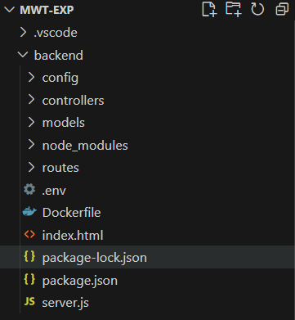
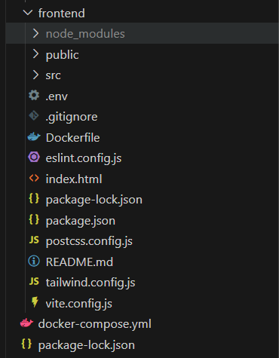

MODULES
7. Screens
- Home.jsx – Main landing page showing featured freelancers, popular services, and site overview.
- Services / Listings (ServiceList.jsx, ServiceView.jsx, ServiceViewPage.jsx) – Displays available freelance services with details and filtering options.
- Customization (AddService.jsx, UploadService.jsx) – Allows freelancers to upload, edit, and manage their service listings.
- Cart & Wishlist (Favorites.jsx, YourServices.jsx) – Manages saved and selected services for booking or later viewing.
- Chat / Support (ChatPage.jsx, SellerChats.jsx) – Real-time communication between clients and freelancers.
- Subscription (Subscription.jsx) – Displays membership or subscription plans for users and freelancers.
- Admin Dashboard (AdminDashboard.jsx) – Admin control panel for managing users, freelancers, payments, and platform activities.
- Freelancer Dashboard (FreelancerDashboard.jsx) – Freelancer panel for handling projects, chats, and payments.
- Profile / Edit Profile (Profile.jsx, EditProfile.jsx) – User profile page for viewing and updating personal information.
- Authentication (Login.jsx, Register.jsx, ForgotPassword.jsx, SendOtp.jsx) – Handles user registration, login, OTP verification, and password recovery.
- Payment.jsx – Manages secure transactions and booking payments using Razorpay integration.
- Notifications.jsx – Displays real-time alerts for chats, payments, and bookings.
- Contact.jsx / About.jsx / FAQs.jsx – Informational pages for user support and platform guidance.
- TermsConditions.jsx / PrivacyPolicy.jsx – Legal and policy-related pages.

7.1 User
The system enables users (clients/customers) to browse through a wide range of freelance services offered by verified freelancers. Users can view detailed service descriptions, pricing, ratings, and reviews, helping them make informed hiring decisions. Advanced features such as category-based filtering, budget range selection, and search by skill or location enhance the overall browsing experience.
During the booking process, users can save favorite services, add freelancers to their shortlist, and proceed with secure payments through Razorpay integration. Real-time chat functionality allows clients to communicate directly with freelancers for inquiries, negotiations, or project clarifications before finalizing the order.
All user activities — such as browsing services, managing favorites, placing orders, chatting with freelancers, and tracking transactions — are backed by MongoDB Atlas, using Mongoose models for structured and reliable data management.
The system also employs Role-Based Access Control (RBAC) to ensure that users can only access features relevant to their roles. This enhances data security, user privacy, and operational efficiency, delivering a seamless and professional freelancing experience similar to platforms like Fiverr and Justdial.
(Figure 7.1 shows the user structure.)

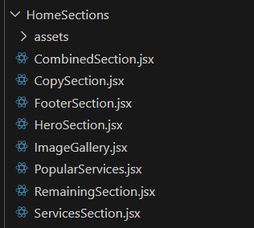
Figure 7.1 User Structure

7.1.1 User Home page
The User Home Page serves as the main interface for clients, allowing them to explore, filter, and connect with freelancers offering a wide range of professional services on the platform. It dynamically fetches freelancer and service data from the backend via REST APIs.
Users can easily navigate between categories such as “All Services,” “Top Rated,” “Popular,” and “Recommended”, and apply filters like category, skill, experience level, price range, and rating. The interface is designed for an interactive and visually appealing experience, offering real-time search, responsive layouts, and smooth transitions using Tailwind CSS and Framer Motion.

React Concepts
- useState & useEffect: Manage dynamic service fetching, filtering inputs, and pagination updates in real time.
- Conditional Rendering: Display service cards, loading skeletons, or “No Results Found” messages based on API responses.
- Axios Integration: Securely fetch service and freelancer data from backend endpoints, handling asynchronous updates efficiently.
- Props & Component Composition: Reuse modular components such as Navbar, ServiceList, and FreelancerCard for scalability and a clean UI structure.
- Event Handling: Capture user interactions like searching, applying filters, saving to wishlist, and navigating to freelancer profiles.

Backend Concepts
- Fetch All Services: GET /api/services/ — Retrieves all freelancer services for display in “All Services” and “Popular” sections.
- Fetch By Category: GET /api/services/category/:name — Returns all services under a specific category such as “Web Development” or “Graphic Design.”
- User Activity Tracking: POST /api/activity/ — Logs user actions such as viewed services, selected freelancers, and searches for analytics and recommendations.
- Manage Wishlist:
  - PATCH /api/users/addToFavorites/ — Adds a selected service to the user’s wishlist.
  - PATCH /api/users/removeFromFavorites/ — Removes a service from the wishlist while maintaining database consistency.
- Authentication: All secured routes require a valid JWT token stored in localStorage, ensuring that only authenticated users can browse, favorite, or book services securely.

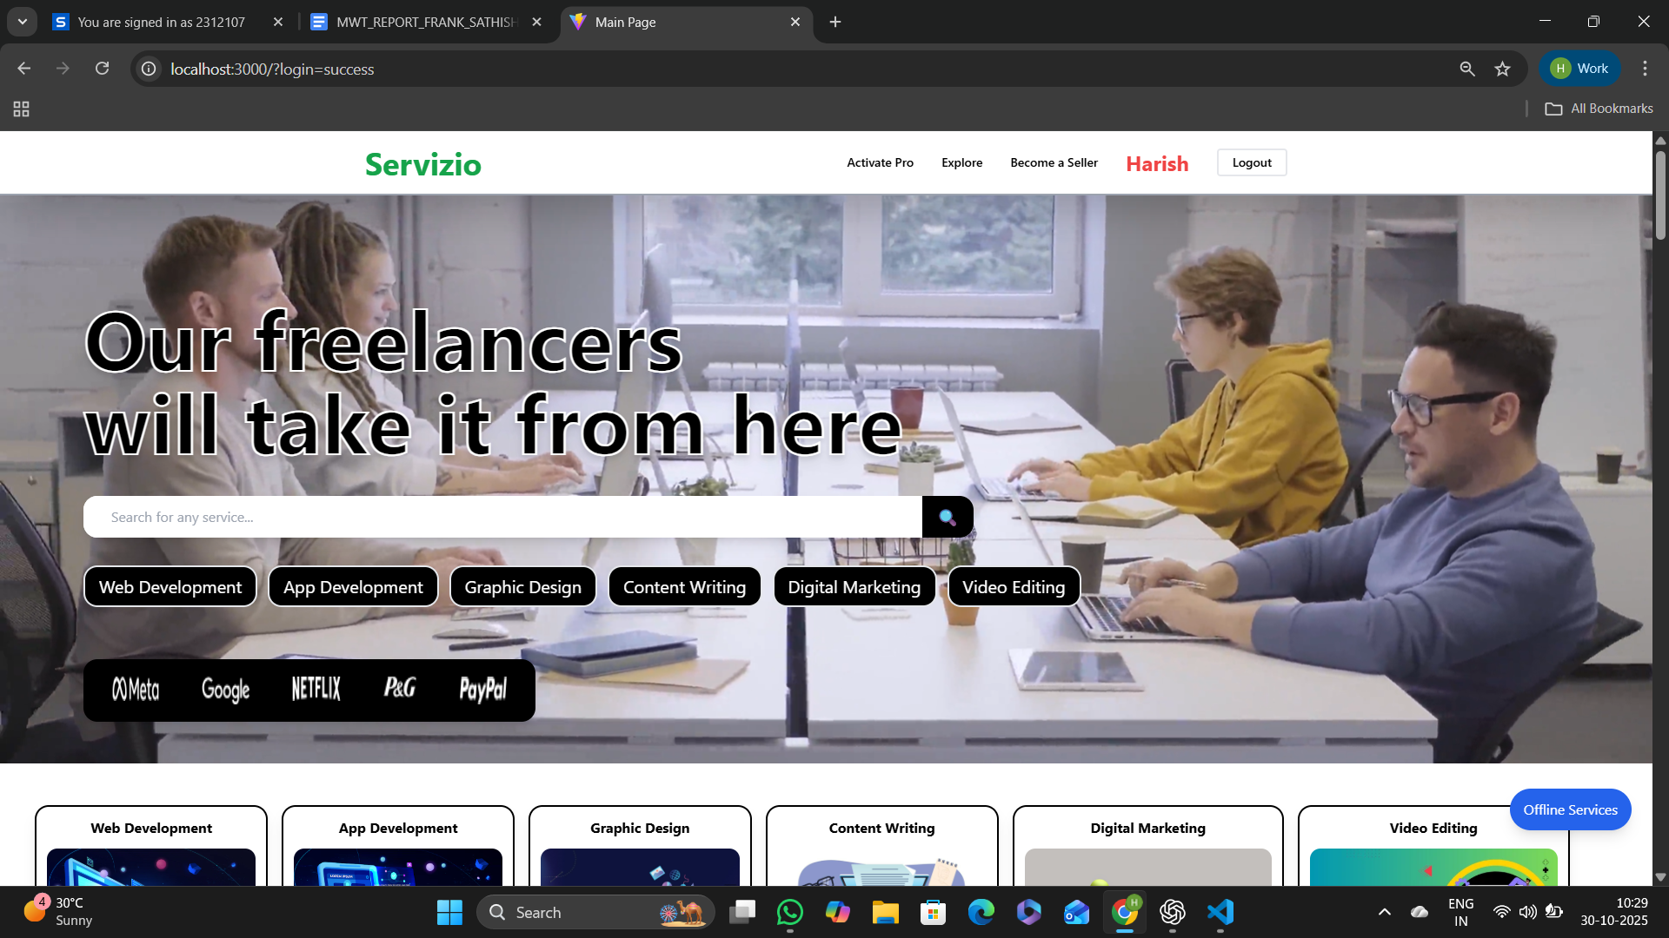

Figure 7.1.1 shows the User Home Page
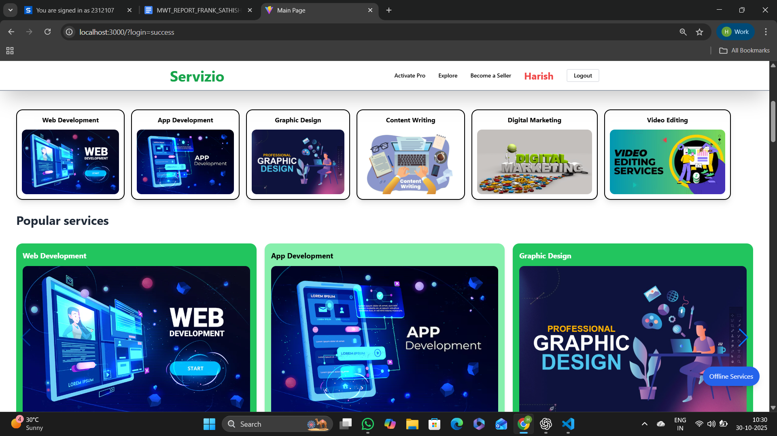
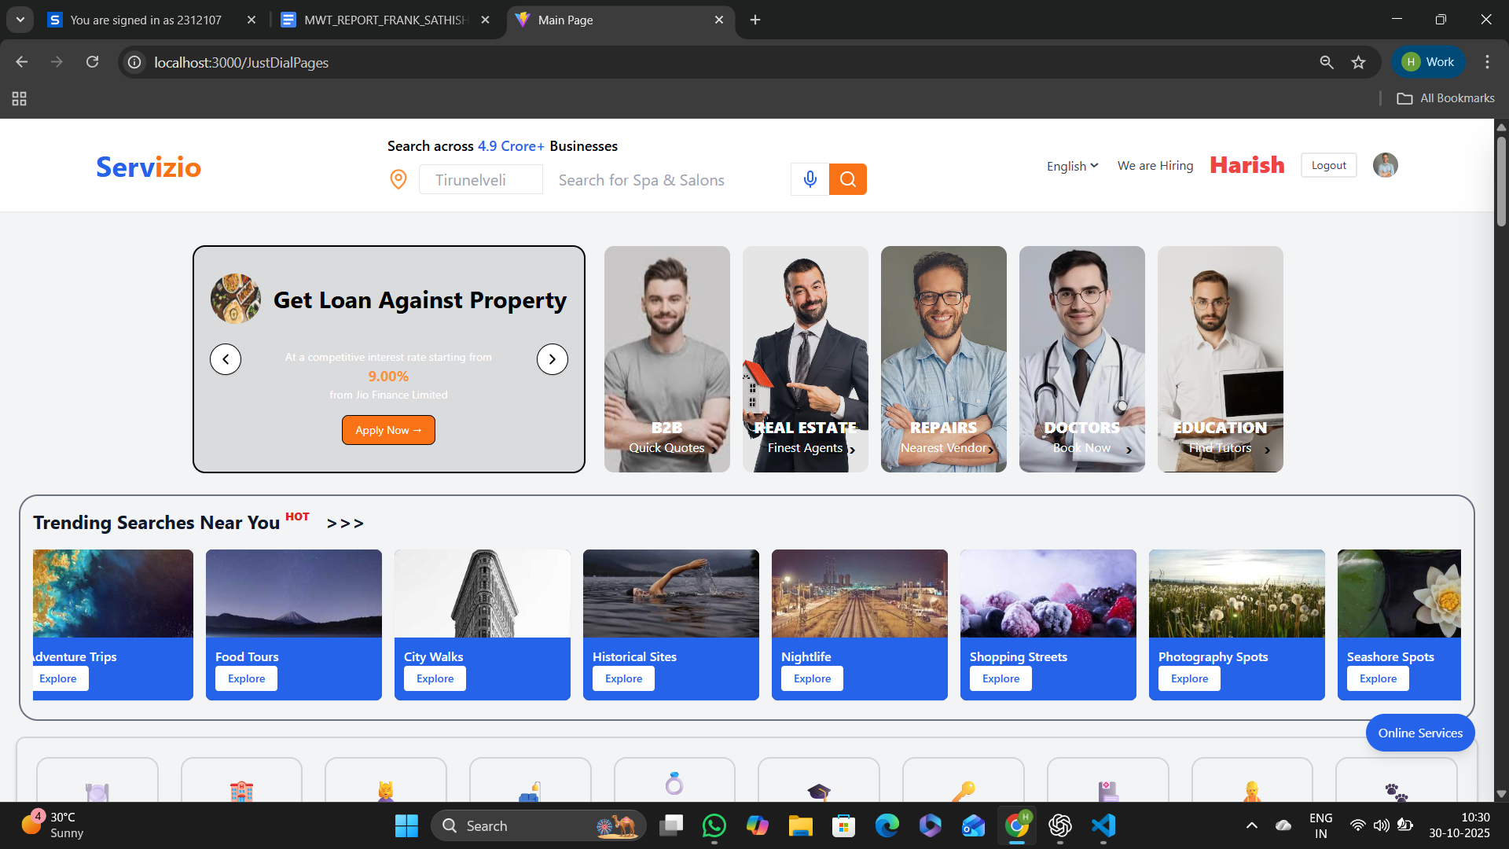
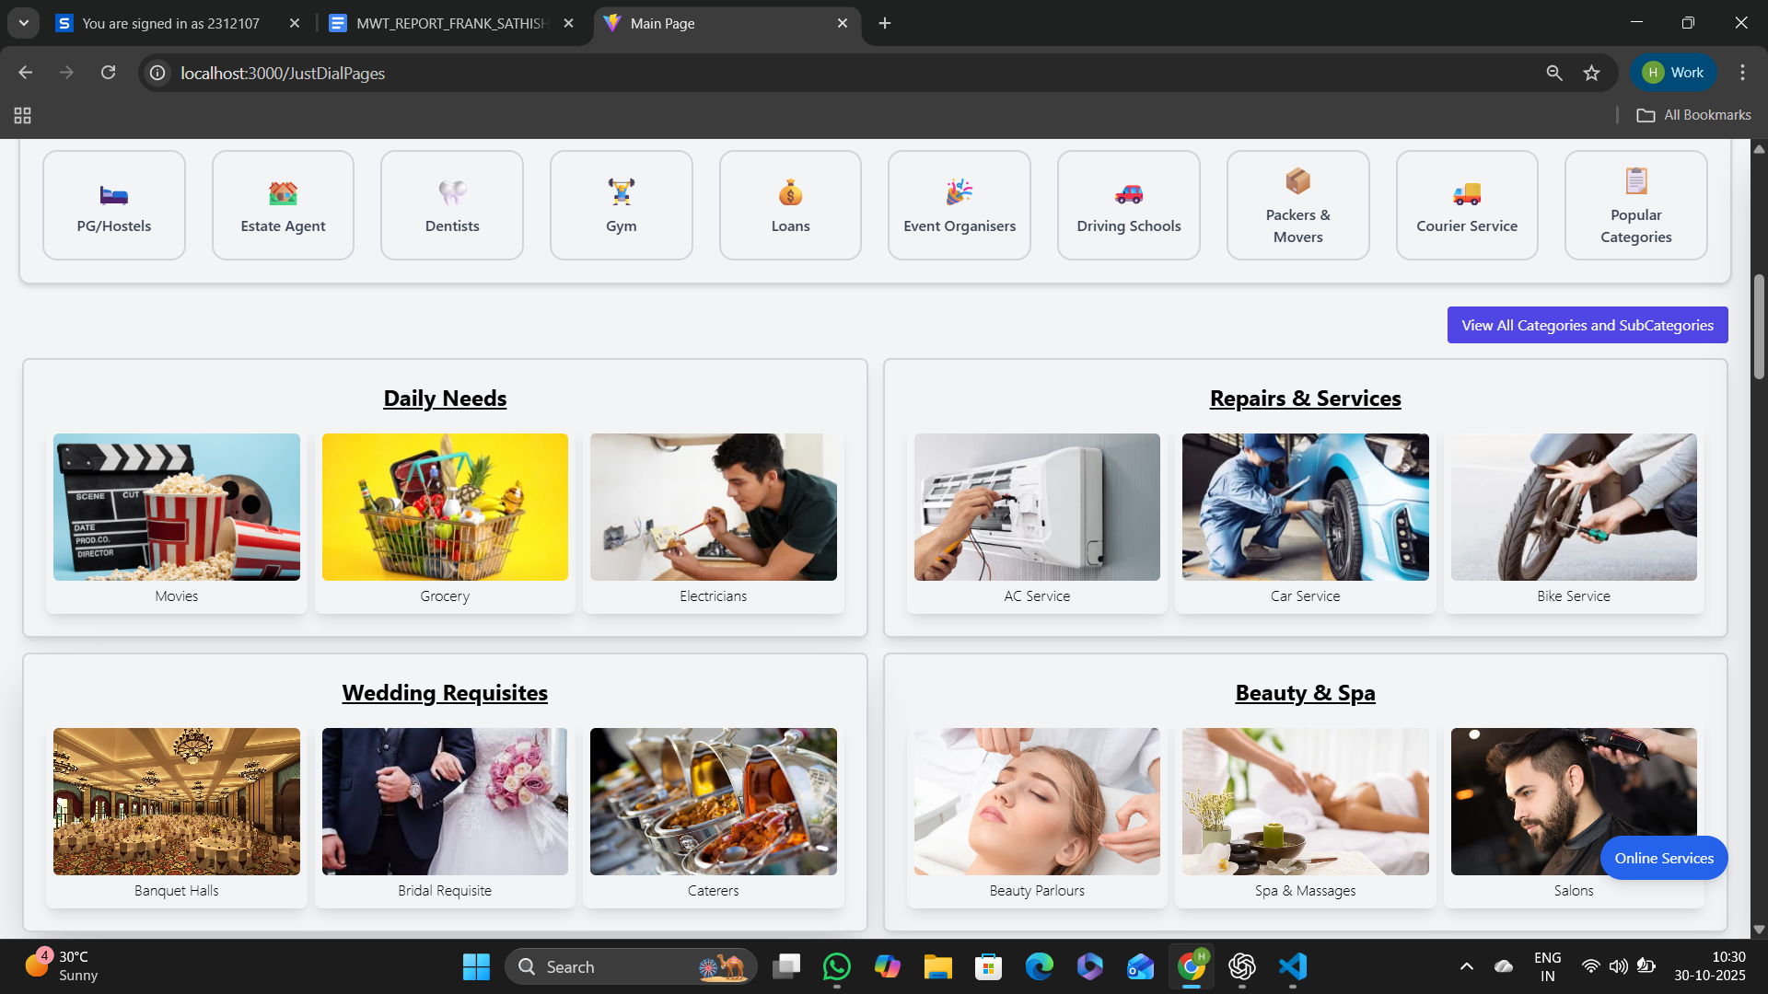

7.1.2 User Signup
The User Signup Page enables new users to create an AutoHub account by entering essential information such as username, email address, phone number, and password. This page ensures secure data entry, validates all inputs, and seamlessly redirects users to the OTP Verification Page after successful submission. The interface is designed using Tailwind CSS, offering a modern, responsive, and visually appealing layout that enhances the onboarding experience for all users.

React Concepts:
- useState: Manages user input dynamically for fields like username, email, phone number, and password, ensuring real-time updates as the user types.
- Form Handling: Implements controlled components with onChange and onSubmit handlers to validate user data before proceeding to the next step.
- useNavigate (React Router): Redirects users to the OTP verification page (/Otp) while securely passing registration details through React state.
- Conditional Rendering & Alerts: Displays real-time validation feedback, such as incorrect email format or invalid phone number, to improve user experience.
- Component Composition: Combines a responsive form layout with an image panel to achieve a professional split-screen design suitable for both desktop and mobile devices.

Backend Integration:
- OTP Verification Flow: Once the registration form is submitted, the frontend sends the entered data to the backend API, which triggers an OTP generation process. Users are then redirected to the OTP verification page for validation.
- User Data Handling: Collected user information (username, email, phone, password) is securely transmitted and stored in the database only after OTP verification is successful.
- Input Validation: Ensures that all fields meet predefined validation criteria and that no duplicate user accounts are created, maintaining data integrity.
- Authentication Integration: The signup process aligns with the JWT-based authentication system, ensuring secure token generation post-verification for protected route access.

Figure 7.1.2 shows the User Registration Page.

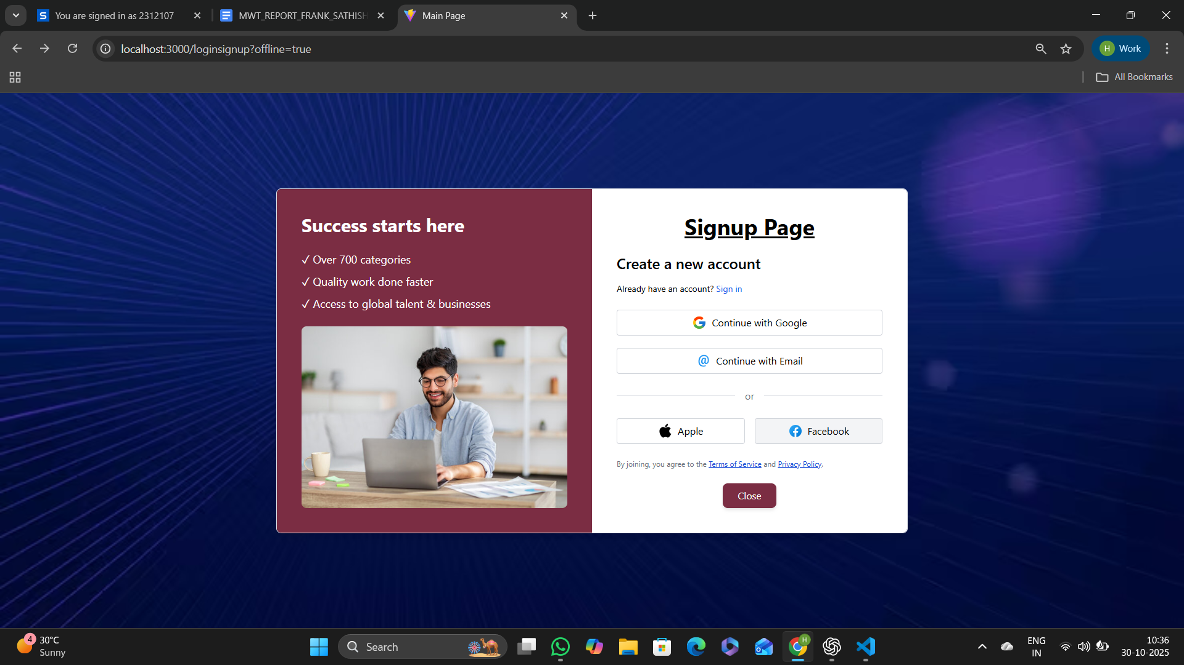
Figure 7.1.2 User Signup page

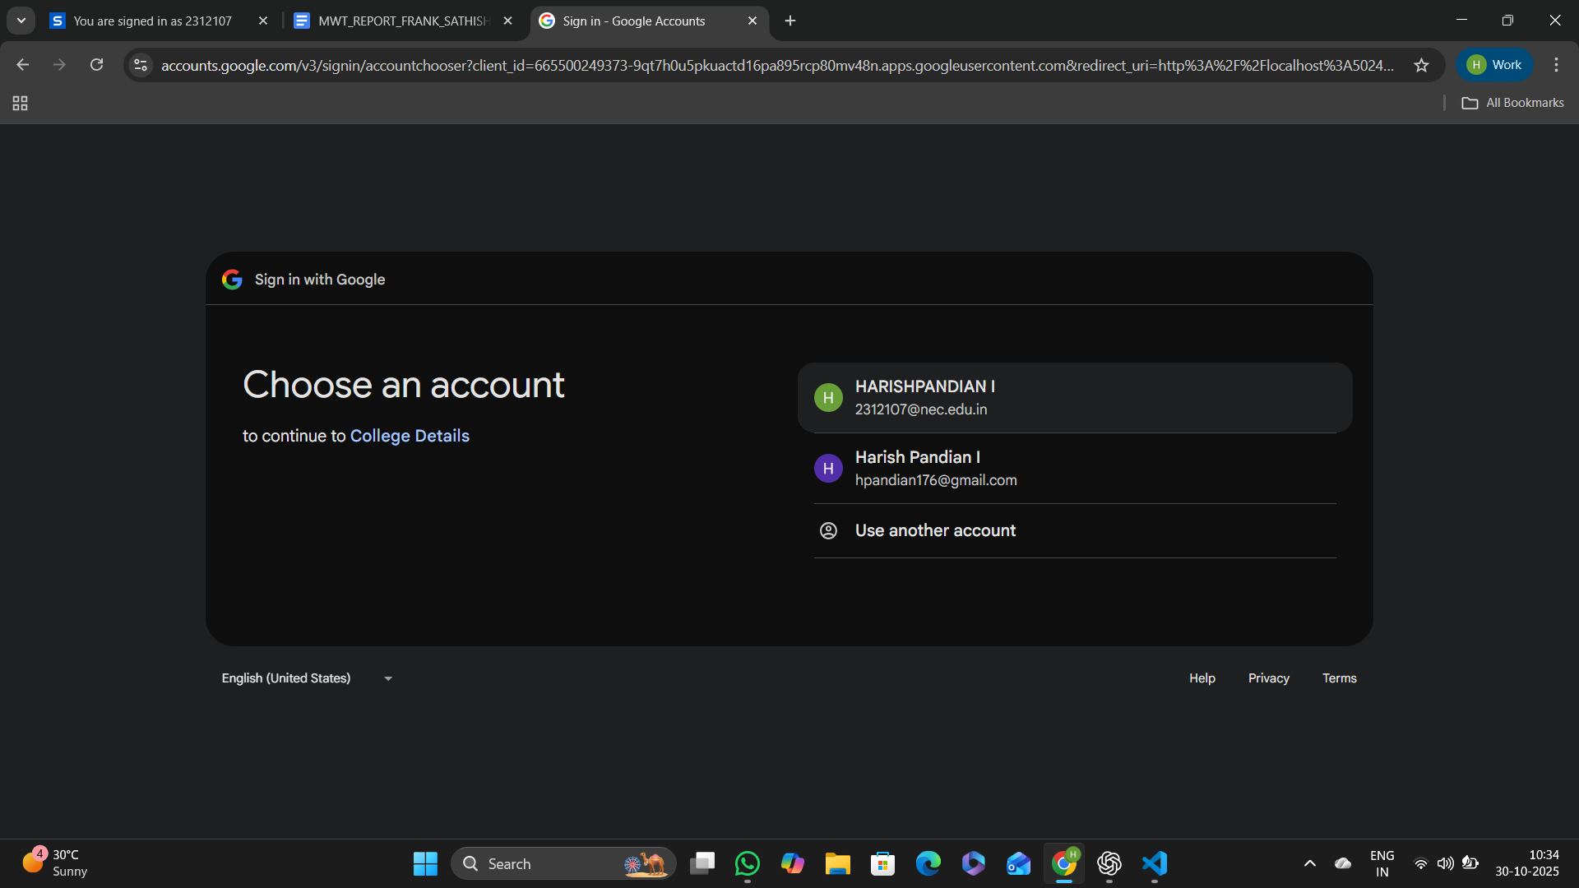

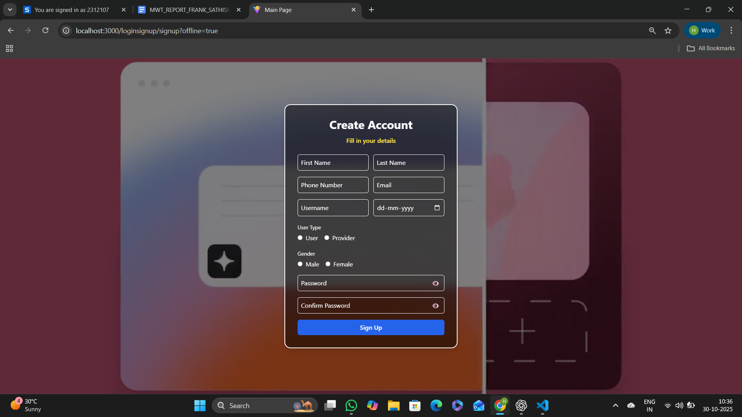

7.1.3 User Login Page
The User Login Page provides secure authentication for users to access the AutoHub platform. It supports both traditional email/password login and Google OAuth integration, ensuring flexibility, convenience, and data security. Upon successful login, user credentials and JWT tokens are securely stored in local storage, enabling access to personalized features such as buying, selling, and browsing cars. The page is designed with Tailwind CSS, ensuring a simple, responsive, and visually appealing user interface for a seamless experience across devices.

React Concepts:
- useState: Manages real-time updates for user input fields such as email and password.
- useEffect: Detects and processes Google authentication tokens retrieved through URL query parameters after successful OAuth login.
- useNavigate & useLocation: Handles page redirection after successful authentication and decodes tokens to identify user roles.
- Conditional Rendering: Displays appropriate alerts for incorrect credentials or login errors and redirects authenticated users to the home page.
- Event Handling: Executes login logic on button clicks, including both traditional and Google OAuth-based authentication flows.

Backend Integration:
- Email/Password Login:
Endpoint: POST /users/login — Validates user credentials, generates a JWT token, and returns authenticated user details.
- Google Authentication:
Endpoint: GET /auth/google — Redirects users to the Google OAuth service for secure single sign-on (SSO) authentication.
- JWT Decoding: Verifies the authenticity of tokens and extracts user information to manage sessions securely.
- Session Handling: Stores JWT tokens and user details in local storage to maintain persistent login sessions until logout.
- Error Handling: Detects unauthorized access, expired sessions, or invalid credentials, prompting users with appropriate error alerts or redirects.

Figure 7.1.3 shows the User Login Page.

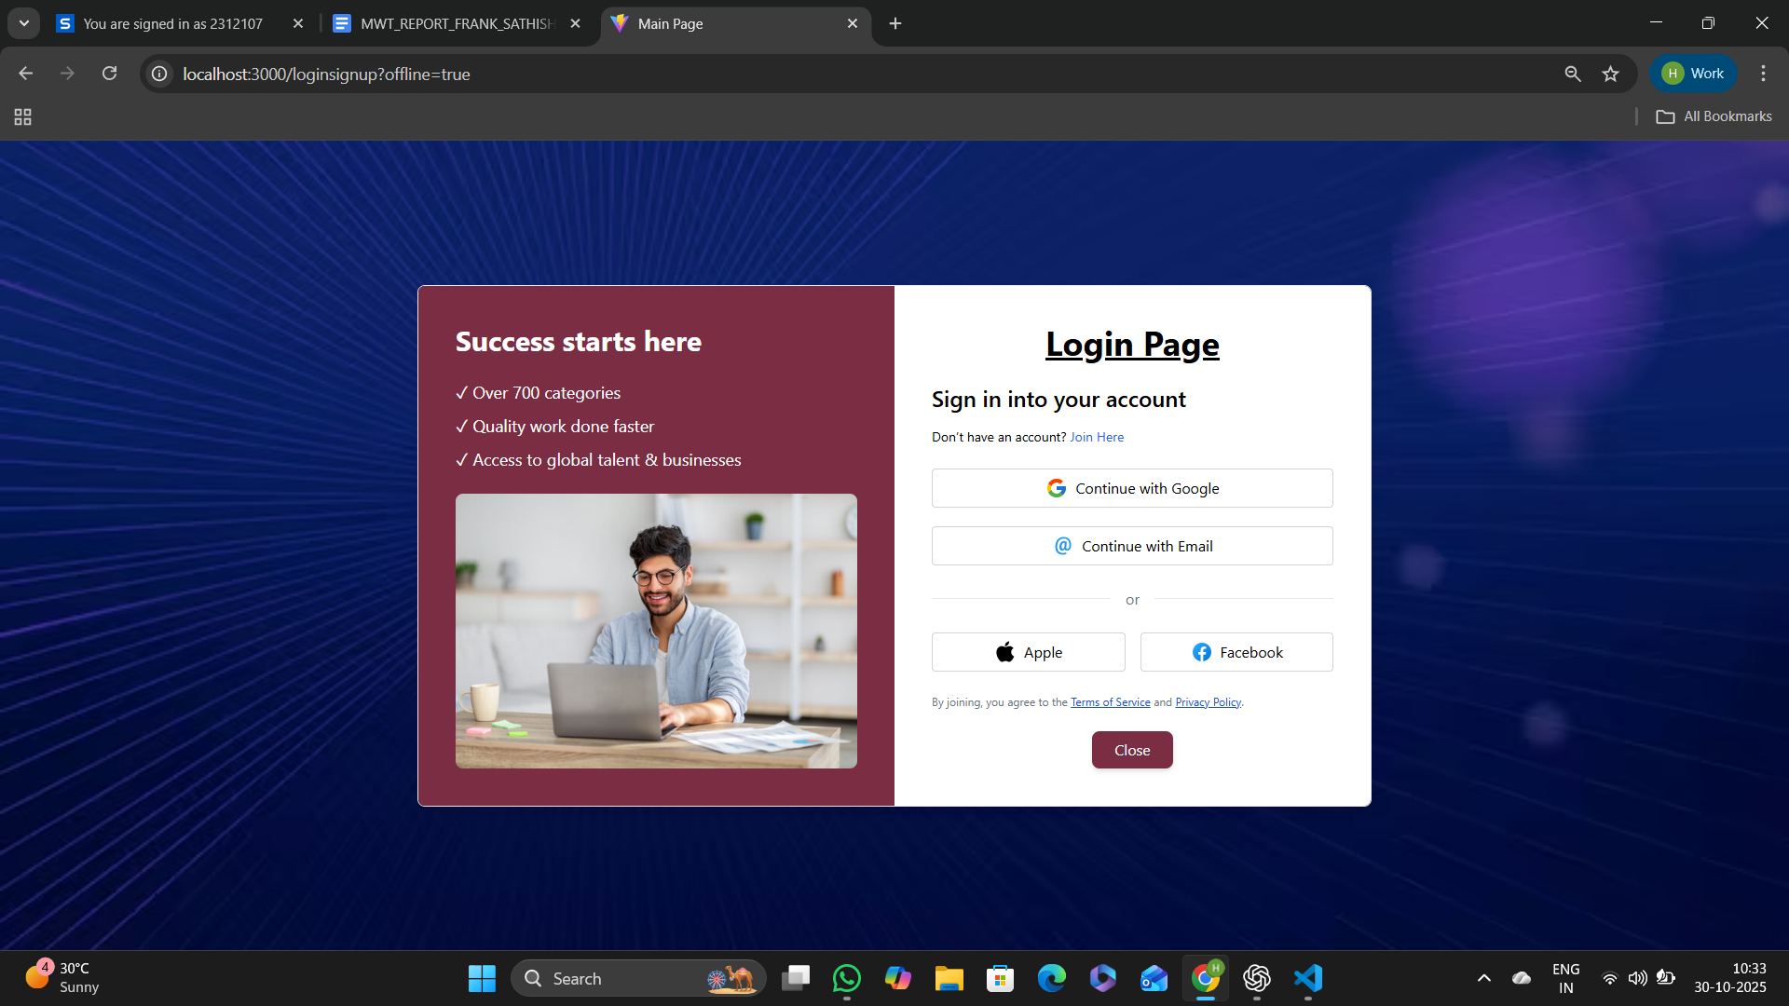
Figure 7.1.3 User Login Page

7.1.4 User Profile Page
The User Profile Page serves as a centralized dashboard where authenticated users can view and manage their personal information. It displays essential details such as name, email, and phone number, which are retrieved securely from local storage after successful authentication. The page offers quick navigation to important sections — including Edit Profile, Your Cars, Favorites, and Activity History — enabling users to customize their experience efficiently.
Designed using Tailwind CSS, the interface combines clean design, responsive layout, and intuitive navigation supported by interactive icons for a seamless and engaging user experience.

React Concepts:
- useState & useEffect: Manage user session data and render dynamic information retrieved from local storage in real time.
- useNavigate: Handles smooth redirection to related pages such as Edit Profile, Favorites, or Activity History through button interactions.
- Conditional Rendering: Ensures that the page is accessible only to authenticated users. If no valid session is found, a “User not found” message is displayed.
- Component Reusability: Integrates shared UI components like NavBarBasic and Footer for consistent application layout and navigation flow.
- Event Handling: Implements click-based navigation and updates for a fluid, interactive profile management experience.

Backend Integration:
- User Data Retrieval: Fetches user details such as name, email, and phone number from stored session tokens and validates them against the server for accuracy.
- Edit Profile Integration: Connects to backend endpoints that handle updates to user details (e.g., name, contact information, or password changes).
- Favorites and Activity Management: Linked routes fetch user-related data such as saved cars, browsing history, and interaction logs directly from MongoDB Atlas.
- Access Control: Enforces JWT-based authentication to prevent unauthorized access to personal or sensitive user data.

Figure 7.1.4 shows the User Profile Page.
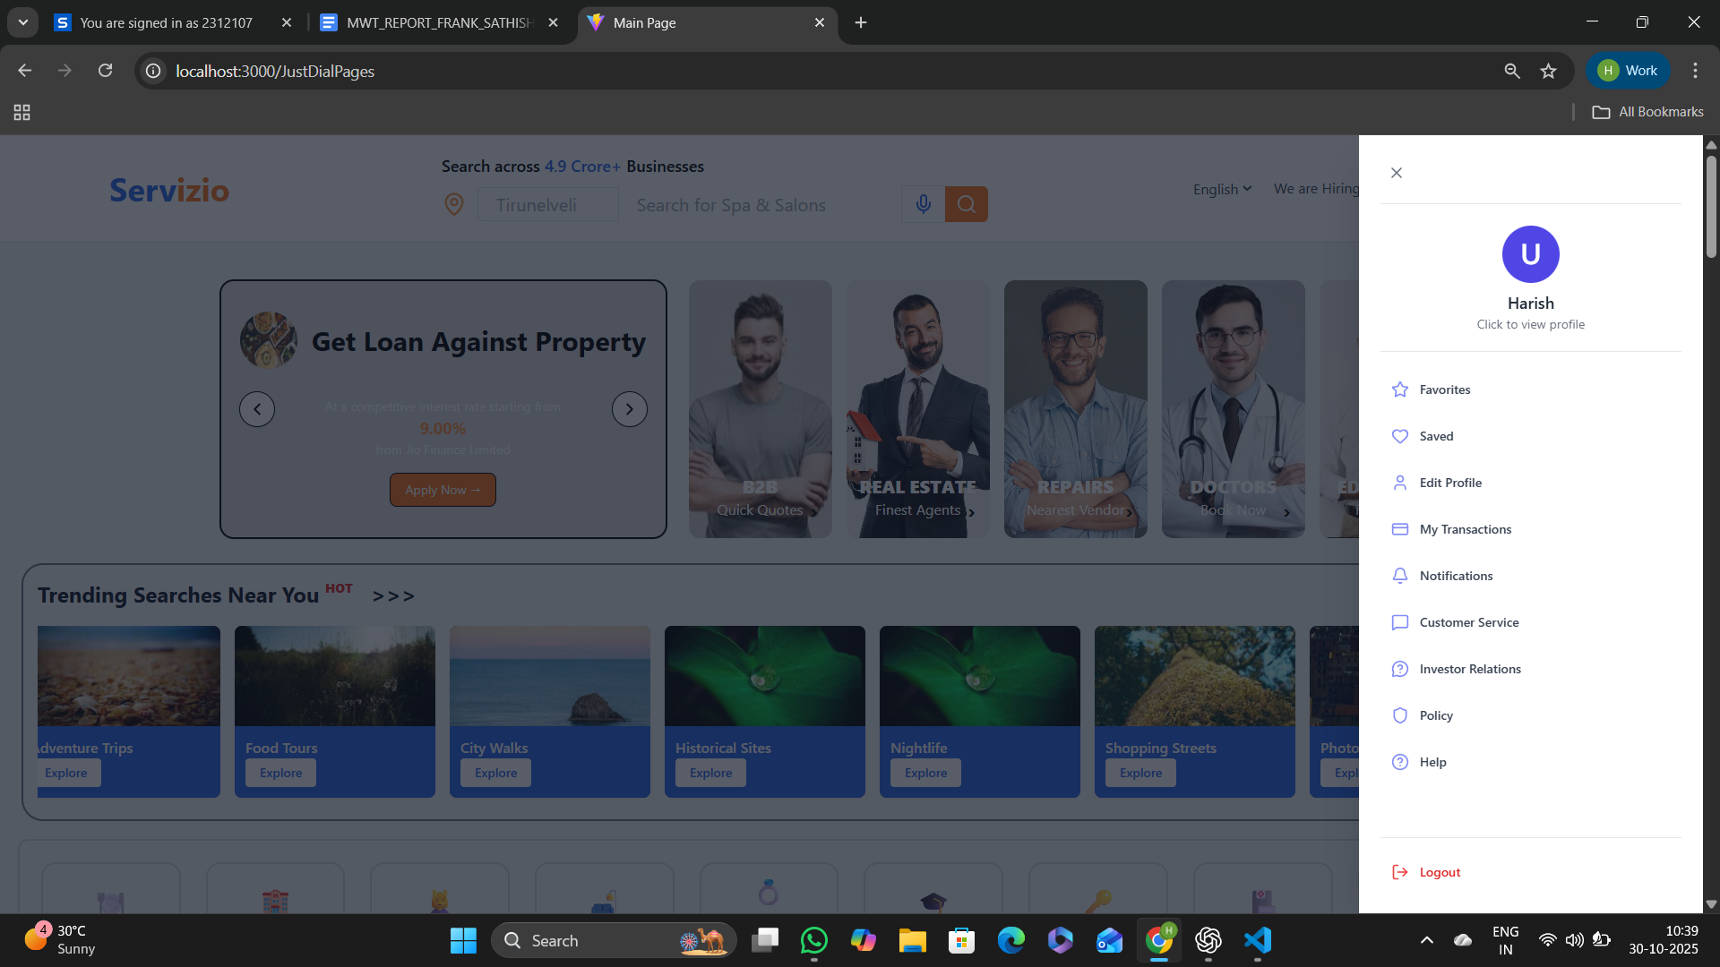
Figure 7.1.4 Profile Page

7.1.5 Service Info Page
The Service Info Page provides detailed information about a selected service on the Servizio platform. It dynamically fetches data based on the service ID from the backend and displays all relevant details such as description, top categories, subcategories, FAQs, and related tags. The page also integrates user session handling, allowing logged-in users to interact with services, view personalized recommendations, and navigate easily across categories.
Designed using Tailwind CSS and enhanced with Framer Motion and React Typewriter, the page offers smooth transitions, responsive layouts, and visually appealing animations that ensure an engaging browsing experience.
React Concepts
• useParams: Extracts the dynamic id parameter from the URL to fetch specific service details from the backend.
• useState: Manages multiple state variables including service data, FAQs, tags, top categories, and user session dynamically.
• useEffect: Handles API calls for fetching service details, top categories, and logged-in user session data when the component mounts or id changes.
• useNavigate: Enables page navigation to related components such as Home or Subcategory details when users click navigation buttons.
• useRef: References the horizontal scroll container for smooth left-right navigation of top categories.
• Conditional Rendering: Displays dynamic content such as loading animations, data sections, or fallback messages based on API response states.
• Event Handling: Implements user interactions like logout, category scrolling, FAQ toggling, and subcategory navigation.
• Component Composition: Combines reusable components such as FooterSection and modular layout sections to maintain clean structure and scalability.
Backend Integration
• Service Data Retrieval:Endpoint — GET /services/:id
Fetches the full details of the selected service including title, description, tags, FAQs, subcategories, and top services.
• Top Categories Fetching:Endpoint — GET /services/topcategories/:id
Retrieves the most popular related categories for the displayed service.
• User Session Management:Endpoint — GET /session/me
Verifies current user session, retrieves user details, and stores them securely in sessionStorage and localStorage.
• Logout Functionality:Endpoint — POST /session/logout
Logs out the current user and clears session credentials while displaying confirmation.
• FAQ & Tag Management:FAQs and tags for each service are dynamically fetched and rendered from backend arrays (faqarr, tagsarr), ensuring updated contextual data.
• Access Control & Security:User session is verified through server-side authentication before allowing interaction with personalized features.
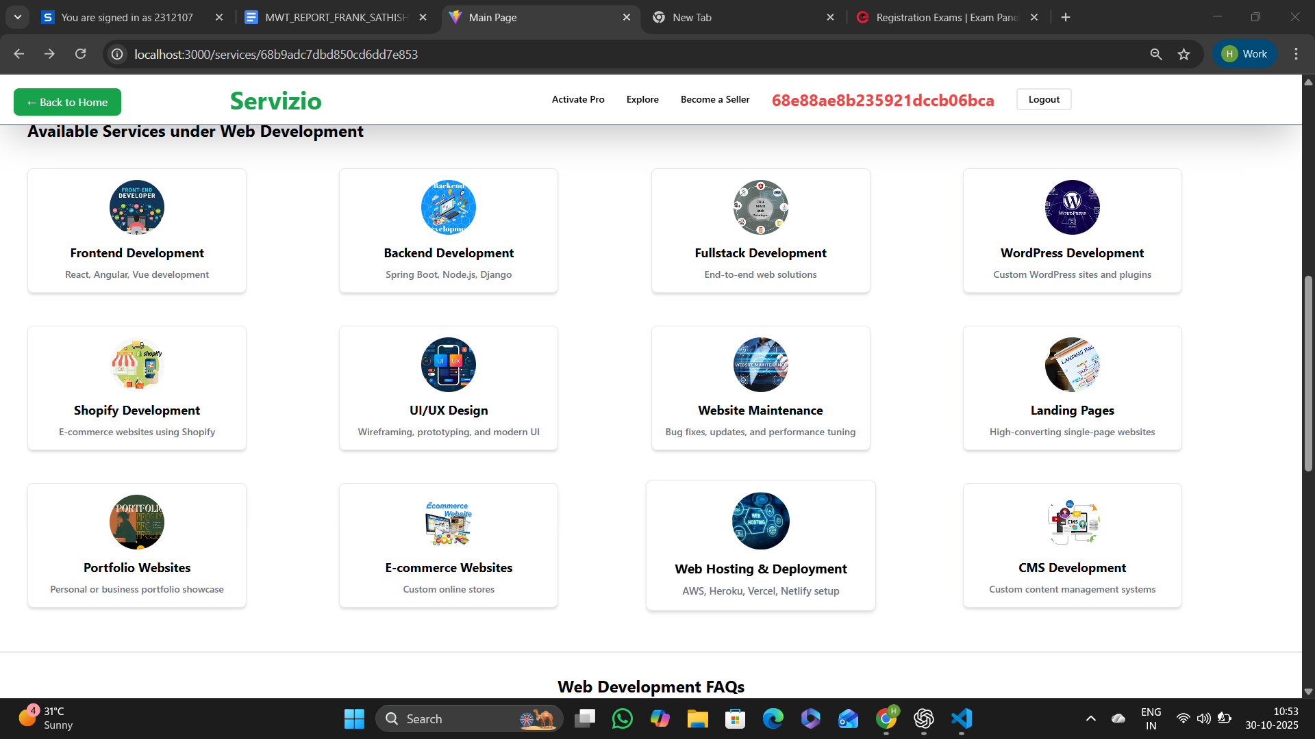
Figure 7.1.5 Service Info Page
7.1.6 Subcategory Information Page
The Subcategory Information Page dynamically showcases service details, expert listings, FAQs, and related categories based on the selected subcategory. It retrieves all data through API calls and displays user-specific content by verifying session status. Designed with Tailwind CSS, the page delivers a modern, responsive interface with clear navigation and interactive UI elements that enhance usability and user engagement.
React Concepts:
• useState & useEffect: Manage component state and handle asynchronous API requests to fetch data such as service details, FAQs, top categories, and user profiles whenever the subcategory ID changes.
• useParams: Extracts the subId parameter from the route to fetch corresponding experts and services dynamically.
• useNavigate: Enables smooth client-side navigation, supporting functionalities like the back button and redirection to user profile pages through interactive buttons.
• Conditional Rendering: Displays a visually appealing animated loading screen while data is being retrieved, and dynamically updates the interface once content loads. Also handles user authentication state by showing “Guest” when the user is not logged in and “Logout” for authenticated users.
• Event Handling: Facilitates interactive user actions such as logging out or viewing a professional’s profile, using event-driven updates that maintain application flow without page reloads.
• Dynamic Rendering: Renders categories, FAQs, and expert cards directly from fetched JSON data, ensuring real-time updates based on backend changes.
• Component Reusability: Integrates shared layout components such as TipsSection, RemainingSection, and FooterSection for a cohesive look and consistent user experience.
• Responsive Design: Tailwind CSS ensures layout adaptability across devices, delivering a uniform and polished design with scalable text, spacing, and hover effects.
Backend Concepts:
• Data Retrieval: Connects with backend endpoints to fetch service data (/services/:id) and subcategory-related user information (/subcategory/users/:subId) using RESTful API requests, ensuring dynamic content population.
• Session Verification: Uses the /session/me endpoint to verify the currently logged-in user’s identity and maintain session integrity.
• Logout Functionality: Implements a secure logout process through the /session/logout endpoint, invalidating sessions and updating the frontend to reflect a logged-out state.
• User and Service Data Management: Displays details such as name, price, experience, availability, and rating for each professional fetched from the MongoDB backend, allowing users to view profiles and make informed selections.
• Access Control: Uses JWT-based authentication to protect endpoints and restrict sensitive operations like viewing personalized data or initiating profile edits to authorized users only.
• FAQ and Category Integration: Fetches and displays FAQs and top services associated with a selected subcategory, enriching the informational context for users.

Figure 7.1.6 Provider Information Page
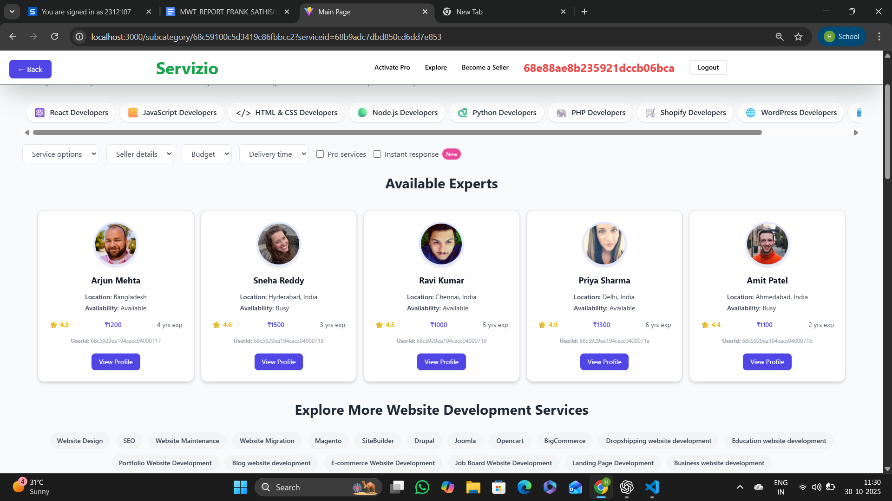

Figure 7.1.6 Provider Information Page
7.1.7 User Profile Page
The User Profile Page acts as a personalized dashboard where authenticated users can view and manage their account information and perform essential actions like viewing their favorite cars, updating profiles, or managing payment activities. It displays key user details such as name, email, and phone number by retrieving data from session storage after a successful login. The page also integrates real-time Razorpay payment functionality, allowing users to initiate secure transactions directly from their dashboard. Designed with Tailwind CSS, it ensures a clean, modern, and responsive layout that maintains both usability and accessibility across all devices.
React Concepts:
• useState & useEffect: Manage dynamic user state and render details such as username, email, and phone number by retrieving them from local or session storage. The hook also ensures real-time updates when session data changes.
• useNavigate: Handles navigation between pages such as Edit Profile, Favorites, and Activity History. It also supports redirection after successful payments or logout.
• Event Handling: Manages user-triggered actions like logging out, initiating Razorpay payments, or navigating between profile sections through button click events.
• Conditional Rendering: Ensures that only authenticated users can access profile features; if no session exists, an appropriate “Please login” message is displayed.
• Component Reusability: Incorporates reusable UI elements such as NavBarBasic and FooterSection to maintain a consistent and professional interface throughout the application.
• Responsive Design: Built with Tailwind CSS, the layout automatically adjusts for various screen sizes, offering an intuitive and visually appealing experience across devices.
• Third-Party Integration: Implements Razorpay’s Checkout interface for seamless in-app payments, using JavaScript injection to configure payment details and callbacks securely.
Backend Concepts:
• User Data Management: Retrieves user details like name, email, and phone number from the session using RESTful APIs and validates them using JWT-based authentication for secure data handling.
• Session Handling: Uses /session/me to verify active sessions, ensuring only authenticated users can view or modify their profiles. The /session/logout endpoint is used to safely terminate user sessions.
• Payment Integration: Implements Razorpay API for secure, token-based transactions. Payment amounts, user data, and order details are securely transmitted to the backend for processing.
• Profile Management: Connects to backend endpoints to allow profile updates and data synchronization between frontend state and the MongoDB database.
• Security and Access Control: JWT-based authentication ensures user privacy and prevents unauthorized access to profile data or payment functionality.
• API Communication: Utilizes fetch-based REST API calls to communicate between frontend components and backend services for all data retrieval and update operations, ensuring smooth synchronization and reliability.
Figure 7.1.7 Provider Profile Page.

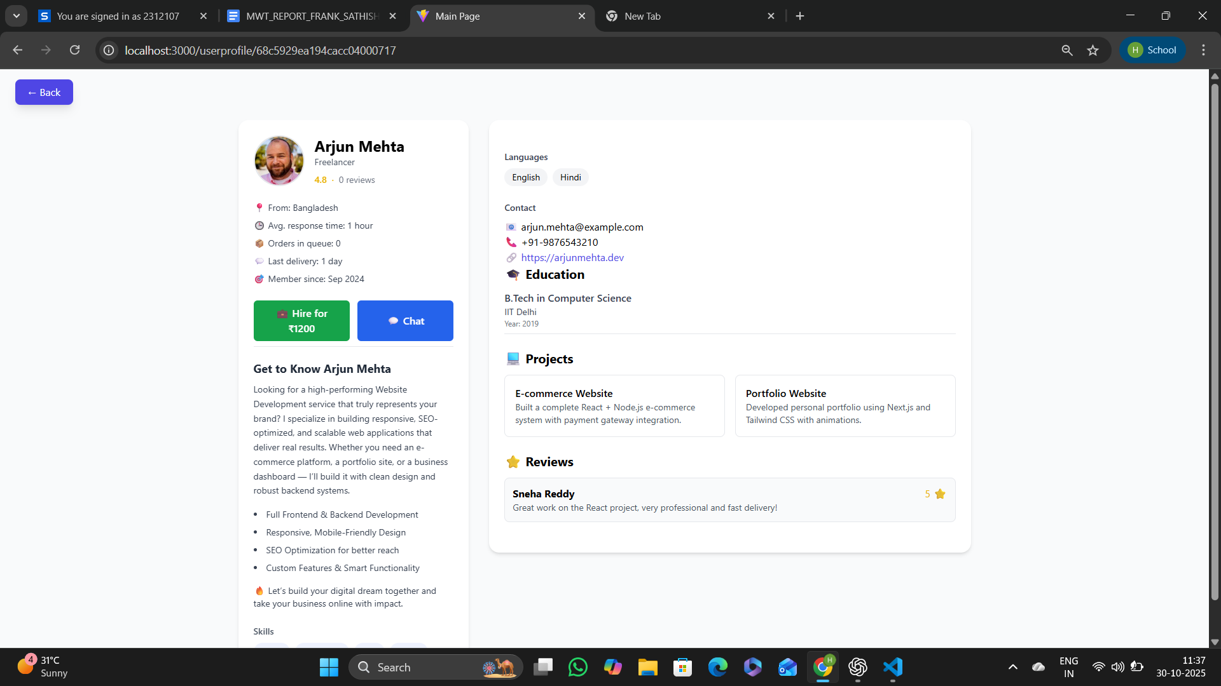
Figure 7.1.7 Provider Profile Page

7.1.8 Payment Page
The Payment Page provides a secure and seamless interface for users to simulate payments using Razorpay’s test mode. It enables customers to make test transactions through multiple payment methods such as UPI, card, net banking, wallet, and pay-later options. Designed with inline styling and Razorpay’s SDK integration, the page ensures a realistic checkout experience by generating a backend test order and invoking the Razorpay payment modal dynamically. The system uses a secure API call to create an order before opening the payment gateway, ensuring proper transaction flow and backend synchronization.
React Concepts:
• useState: Manages dynamic input values such as payment amount and displays messages for success or error responses.
• Event Handling: Handles user-triggered actions like modifying the amount or initiating a test payment through the Razorpay checkout.
• Axios Integration: Sends a POST request to the backend endpoint (/payment/create-order) to generate a test order with amount details before launching the payment interface.
• Conditional Rendering: Displays real-time feedback or error messages based on payment success or API call responses, ensuring clear communication with the user.
• Dynamic Razorpay Integration: Loads Razorpay Checkout dynamically with configuration options such as test API key, order ID, prefilled user details, and supported payment methods.
• UI Design: Built using simple inline CSS for clarity and responsiveness, featuring structured input controls and action buttons that enhance user interaction.
Backend Concepts:
• Order Creation Endpoint: The backend (/payment/create-order) creates a Razorpay order by generating a unique order ID and returning both the order object and key to the frontend.
• Payment Initialization: The frontend consumes this API response to open Razorpay Checkout using the generated order details for a simulated test transaction.
• Test Mode Configuration: Operates under Razorpay’s sandbox environment, allowing the use of test credentials (e.g., rzp_test_RSdArGEUMuy9EL) for transaction simulation.
• Error Handling: Implements robust validation for API failures, invalid order generation, or network interruptions by displaying user-friendly error messages.
• Transaction Flow Management: Upon successful simulation, Razorpay returns a payment response containing transaction details such as Payment ID, which is displayed to the user as confirmation.
• Security Integration: Ensures all communication with the backend uses proper headers and secure routes for order creation, maintaining integrity even in test mode.

Figure 7.1.9 shows the Payment Page.

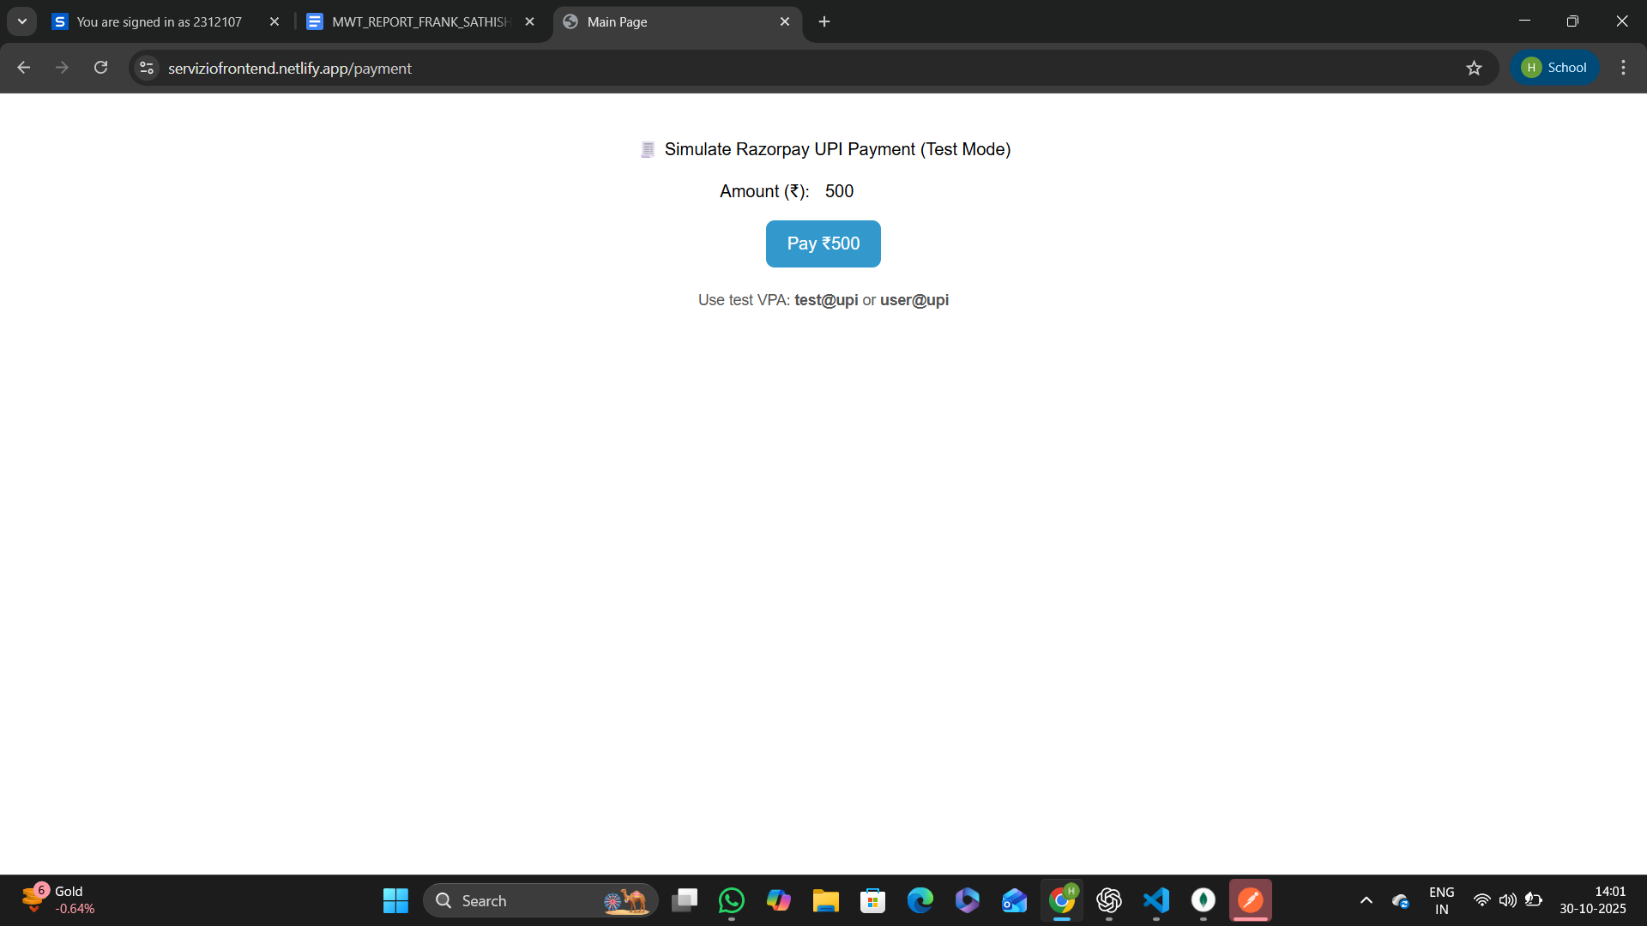

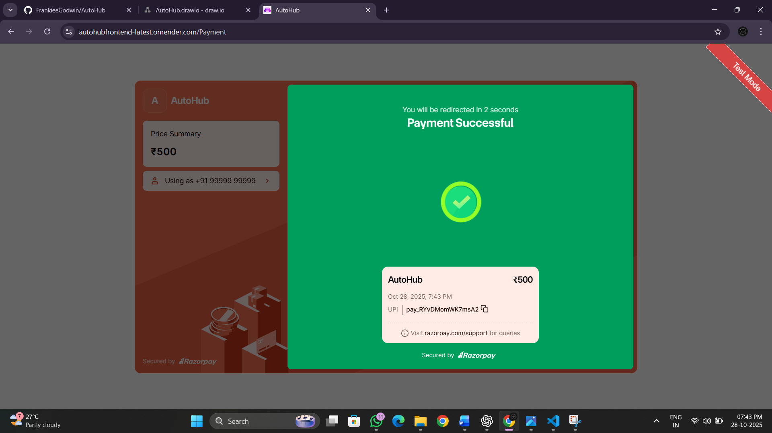

Figure 7.1.9 Payment Page

7.1.10 Chat and Messaging Page
The Chat and Messaging Page enables real-time, user-to-provider communication within the AutoHub platform. It facilitates direct interaction between customers and service providers or dealers through an integrated socket-based chat system. The chat interface supports seamless message exchange, live updates, and message persistence, offering a responsive and intuitive messaging experience. Designed using React, Socket.IO, and Axios, it ensures instant data synchronization between the frontend and backend servers while maintaining a clean, accessible UI powered by Tailwind CSS.

React Concepts:
• useState & useEffect: Manage the chat session state, active user information, and dynamic message updates in real time. useEffect is also used to initialize the socket connection, join rooms, and fetch previous chat history on component load.
• Socket.IO Integration: Establishes a bidirectional communication channel using Socket.IO, enabling instant message transmission between the sender and receiver without requiring page reloads. Events such as joinRoom, sendMessage, and receiveMessage ensure smooth message flow.
• Axios Integration: Fetches stored chat history from the backend using secure REST API calls (GET /chat/:senderId/:receiverId) and supports message persistence in MongoDB.
• useParams & useNavigate: Retrieves the providerId from the URL to identify the chat partner dynamically and handles navigation back to the previous page or redirects unauthenticated users to the login screen.
• Conditional Rendering: Displays appropriate states — such as “Loading chat…” or “Please log in” — based on authentication and message availability, ensuring a clear user experience during asynchronous operations.
• useRef & Auto-Scroll: Automatically scrolls the chat view to the latest message using the useRef hook, maintaining conversational flow without manual user action.
• Event Handling: Supports actions like typing, sending messages via the Enter key, and updating input state dynamically to enhance interactivity and responsiveness.
• Component Reusability: The modular ChatBox component is integrated into the ChatPage for flexibility, allowing it to be reused in different chat contexts such as user–dealer or user–support interactions.
• UI/UX Design: Developed using Tailwind CSS to achieve a modern, mobile-friendly layout with smooth transitions, rounded chat bubbles, and color-coded sender/receiver messages for better readability.

Backend Integration:
• Chat History Retrieval: The frontend uses a GET /chat/:senderId/:receiverId endpoint to load existing messages from the MongoDB database, ensuring users can view their full conversation history upon reloading the chat.
• Real-Time Communication: The backend, through Socket.IO, manages events such as joining rooms, broadcasting messages, and storing sent messages in the database for persistence and later retrieval.
• Session Management: The system verifies the current user session via the /session/me endpoint before granting access to chat functionality. Unauthorized users are redirected to the login page with a custom banner alert.
• Message Transmission: When a user sends a message, the sendMessage event emits data containing the senderId, receiverId, and message text to the server, which then broadcasts it to the respective room for real-time delivery.
• Authentication & Access Control: Only authenticated users with valid session tokens can access chat rooms, ensuring privacy and preventing unauthorized communication.
• Data Storage & Consistency: Each message, along with metadata such as timestamps and sender/receiver IDs, is securely stored in MongoDB, ensuring chat integrity and historical tracking.
• Error Handling: Both frontend and backend include validation and error responses for failed connections, missing sessions, or invalid room joins, improving overall system reliability.

Figure 7.1.10 shows the Chat Page.

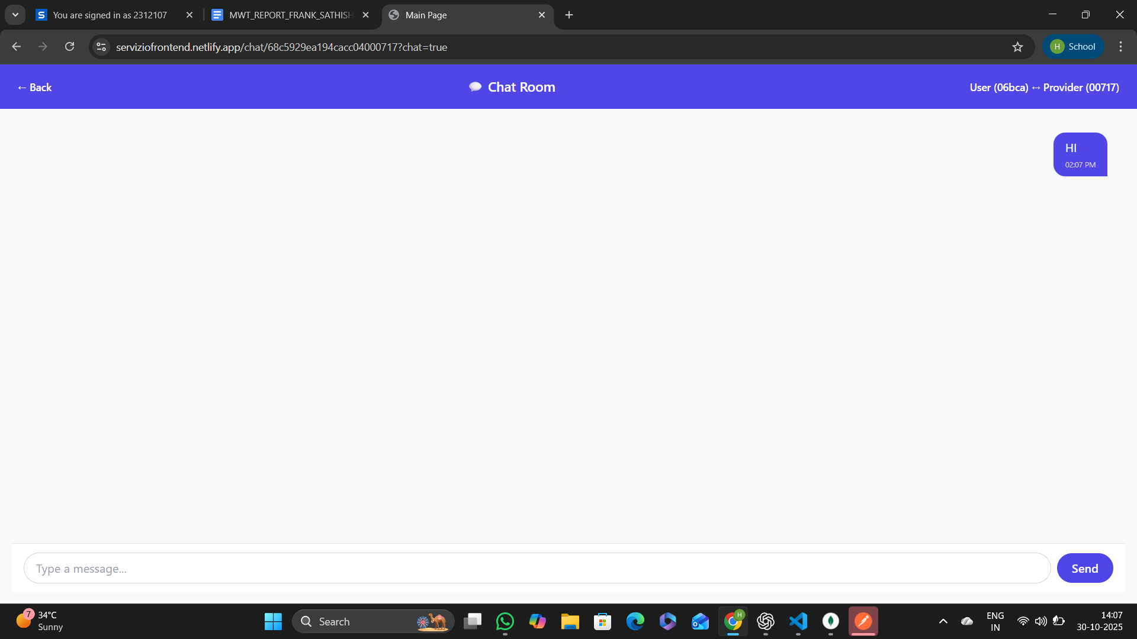

Figure 7.1.10 Users Chat Page

CHAPTER 8
CONCLUSION:
The Servizio project stands as a comprehensive, full-stack service management platform designed to bridge the gap between users and professionals across multiple domains. By combining the power of React for the frontend, Node.js and Express.js for the backend, and MongoDB Atlas for scalable data management, it delivers a seamless and interactive user experience. Each module — from dynamic category and subcategory pages to expert listings, authentication, and session handling — demonstrates a well-structured implementation of modern web technologies. Features such as real-time API integration, secure JWT-based authentication, and responsive UI built with Tailwind CSS collectively ensure performance, accessibility, and user satisfaction.
Overall, Servizio not only showcases the technical depth of full-stack development but also emphasizes modularity, scalability, and usability. It effectively digitalizes the process of discovering and availing professional services, fostering transparency, trust, and engagement between users and service providers in a unified, intuitive platform.

