Week7Project2

MuthukumarSrinivasan & RajagopalSrinivasan

Saturday, March 14, 2015

This is an R Markdown document. Markdown is a simple formatting syntax for authoring HTML, PDF, and MS Word documents. For more details on using R Markdown see <http://rmarkdown.rstudio.com>.

When you click the **Knit** button a document will be generated that includes both content as well as the output of any embedded R code chunks within the document. You can embed an R code chunk like this:

Note that the echo = FALSE parameter was added to the code chunk to prevent printing of the R code that generated the plot.

require(ggplot2)

## Loading required package: ggplot2

library(ggplot2)  
  
week7project2<-read.csv('c:/temp/Week7Project2ForR.csv',header=TRUE)  
summary(week7project2)

## x1 y1 x2 y2   
## Min. : 4.0 Min. : 4.260 Min. : 4.0 Min. :3.100   
## 1st Qu.: 6.5 1st Qu.: 6.315 1st Qu.: 6.5 1st Qu.:6.695   
## Median : 9.0 Median : 7.580 Median : 9.0 Median :8.140   
## Mean : 9.0 Mean : 7.501 Mean : 9.0 Mean :7.501   
## 3rd Qu.:11.5 3rd Qu.: 8.570 3rd Qu.:11.5 3rd Qu.:8.950   
## Max. :14.0 Max. :10.840 Max. :14.0 Max. :9.260   
## x3 y3 x4 y4   
## Min. : 4.0 Min. : 5.39 Min. : 8 Min. : 5.250   
## 1st Qu.: 6.5 1st Qu.: 6.25 1st Qu.: 8 1st Qu.: 6.170   
## Median : 9.0 Median : 7.11 Median : 8 Median : 7.040   
## Mean : 9.0 Mean : 7.50 Mean : 9 Mean : 7.501   
## 3rd Qu.:11.5 3rd Qu.: 7.98 3rd Qu.: 8 3rd Qu.: 8.190   
## Max. :14.0 Max. :12.74 Max. :19 Max. :12.500

str(week7project2)

## 'data.frame': 11 obs. of 8 variables:  
## $ x1: int 10 8 13 9 11 14 6 4 12 7 ...  
## $ y1: num 8.04 6.95 7.58 8.81 8.33 ...  
## $ x2: int 10 8 13 9 11 14 6 4 12 7 ...  
## $ y2: num 9.14 8.14 8.74 8.77 9.26 8.1 6.13 3.1 9.13 7.26 ...  
## $ x3: int 10 8 13 9 11 14 6 4 12 7 ...  
## $ y3: num 7.46 6.77 12.74 7.11 7.81 ...  
## $ x4: int 8 8 8 8 8 8 8 19 8 8 ...  
## $ y4: num 6.58 5.76 7.71 8.84 8.47 7.04 5.25 12.5 5.56 7.91 ...

qplot(week7project2$x1,week7project2$y1,data=week7project2)

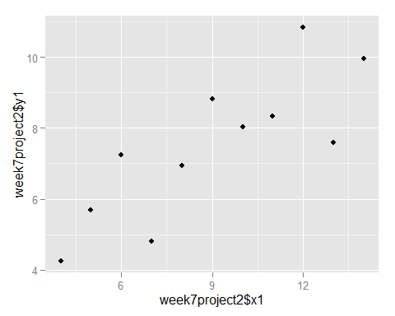

qplot(week7project2$x2,week7project2$y2,data=week7project2)

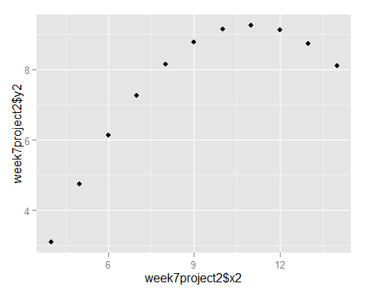

qplot(week7project2$x3,week7project2$y3,data=week7project2)

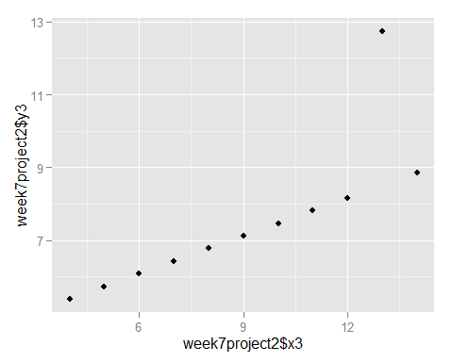

qplot(week7project2$x1,week7project2$y1,data=week7project2,geom="boxplot")

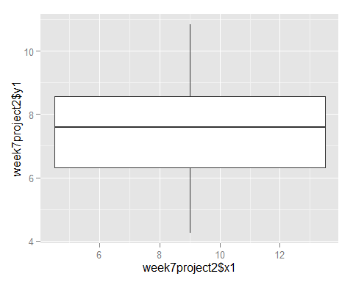

qplot(week7project2$x2,week7project2$y2,data=week7project2,geom="boxplot")

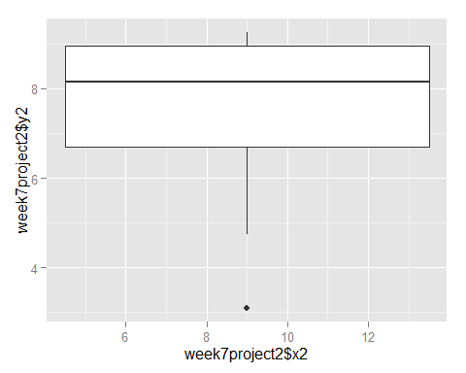

qplot(week7project2$x3,week7project2$y3,data=week7project2,geom="boxplot")

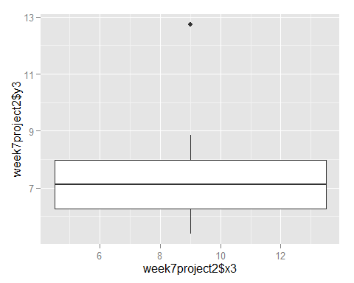

qplot(week7project2$x1,data=week7project2,geom="histogram")

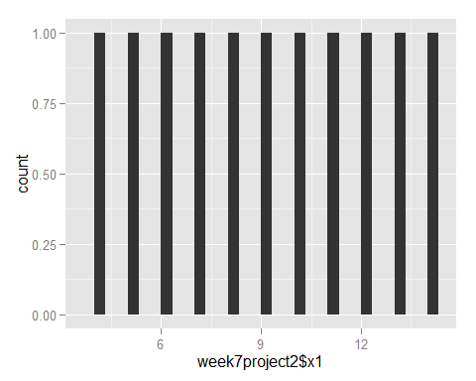

qplot(week7project2$x2,data=week7project2,geom="histogram")

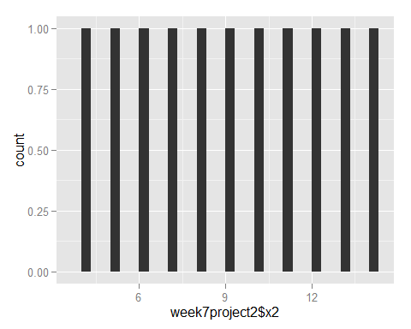

qplot(week7project2$x3,data=week7project2,geom="histogram")

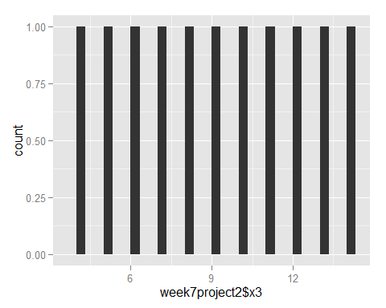

qplot(week7project2$x1,data=week7project2,geom="bar")



qplot(week7project2$x2,data=week7project2,geom="bar")



qplot(week7project2$x3,data=week7project2,geom="bar")



boxplot(week7project2$x1)

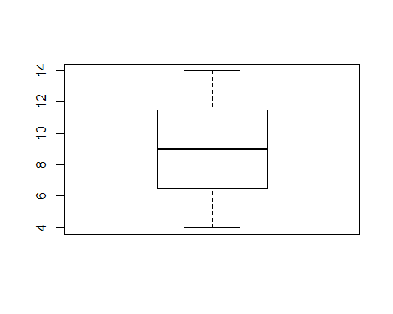

hist(week7project2$x1)

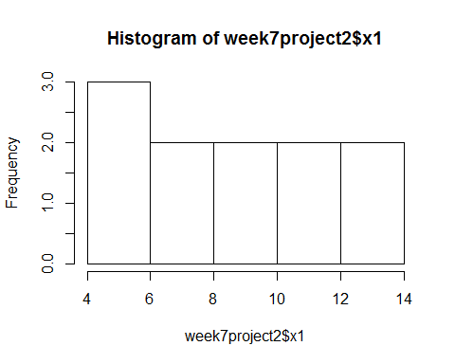

boxplot(week7project2$y1)

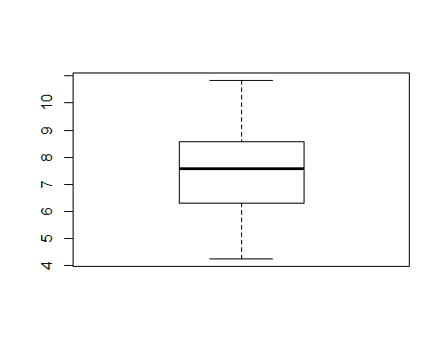

hist(week7project2$y1)

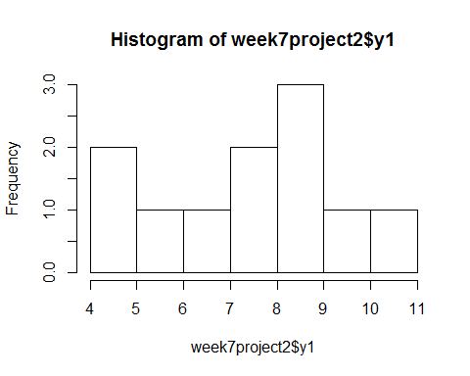

boxplot(week7project2$x2)



hist(week7project2$x2)

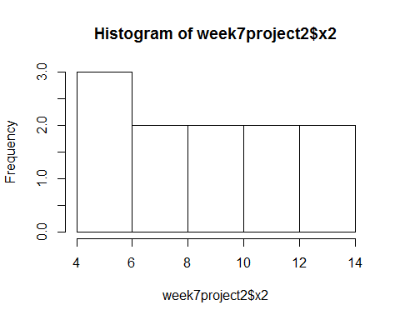

boxplot(week7project2$y2)

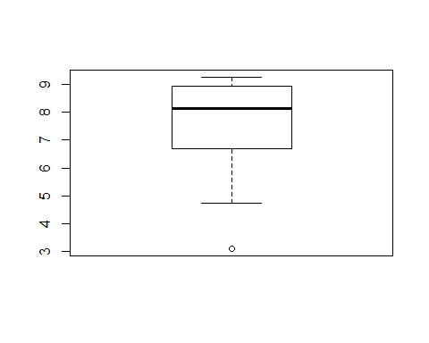

hist(week7project2$y2)

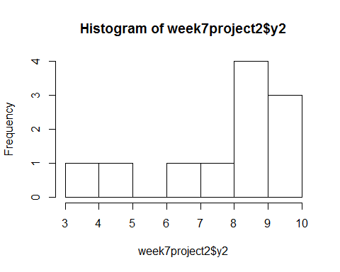

boxplot(week7project2$x3)



hist(week7project2$x3)

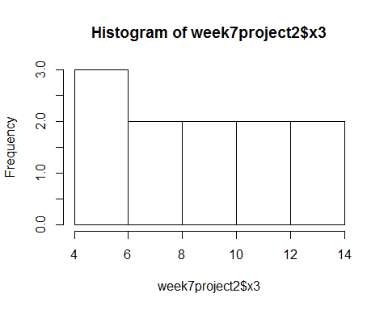

boxplot(week7project2$y3)

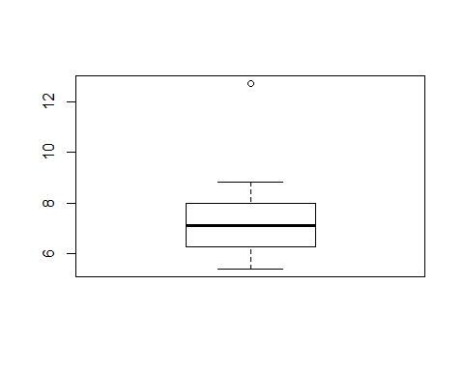

hist(week7project2$y3)

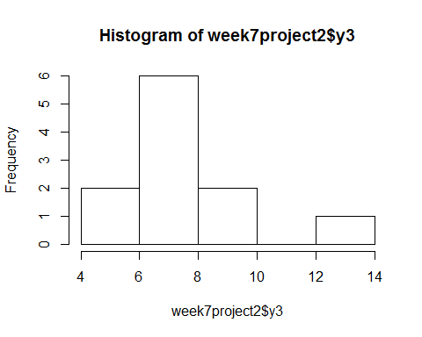

ggplot(data=week7project2,aes(x=week7project2$x1,y=week7project2$y1))+ geom_line() + geom_point()

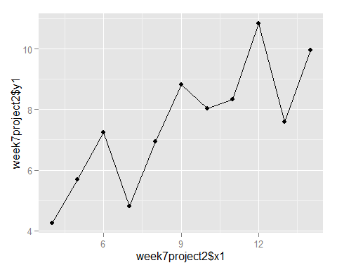

ggplot(data=week7project2,aes(x=week7project2$x2,y=week7project2$y2))+ geom_line() + geom_point()

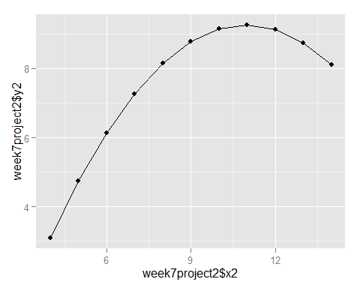

ggplot(data=week7project2,aes(x=week7project2$x3,y=week7project2$y3))+ geom_line() + geom_point()

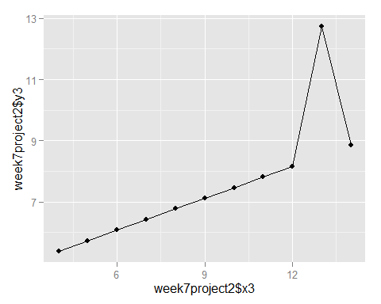

table(week7project2$x1)

##   
## 4 5 6 7 8 9 10 11 12 13 14   
## 1 1 1 1 1 1 1 1 1 1 1

week7project2<-read.csv('c:/temp/Week7Project2ForR.csv',header=TRUE)  
x1<-week7project2$x1  
y1<-week7project2$y1  
x2<-week7project2$x2  
y2<-week7project2$y2  
x3<-week7project2$x3  
y3<-week7project2$y3  
x4<-week7project2$x4  
y4<-week7project2$y4  
  
## various derivation for x1 and y1  
  
plot(week7project2$x1,week7project2$y1, main="Scatter Plot of I SET of DATA", xlab="x axis", ylab="y axis",)  
  
abline(lm(x1~y1), col="red") #regression line (y~x)  
abline(lm(y1~x1), col="blue") #regression line (y~x)  
lines(lowess(x1,y1),col="yellow") #lowess line (x,y)

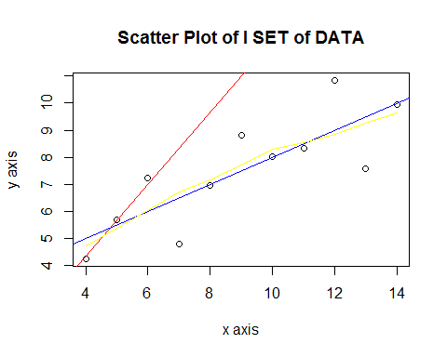

library(compare)

## Warning: package 'compare' was built under R version 3.1.3

##   
## Attaching package: 'compare'  
##   
## The following object is masked from 'package:base':  
##   
## isTRUE

comparison<-compare(x1,y1, allowAll=TRUE)  
  
comparison$tM

## [1] 4 5 6 7 8 9 10 11 12 13 14

## various derivation for x2 and y2  
  
plot(week7project2$x2,week7project2$y2, main="Scatter Plot of II SET of DATA", xlab="x axis", ylab="y axis",)  
  
abline(lm(x2~y2), col="red") #regression line (y~x)  
abline(lm(y2~x2), col="blue") #regression line (y~x)  
lines(lowess(x2,y2),col="yellow") #lowess line (x,y)

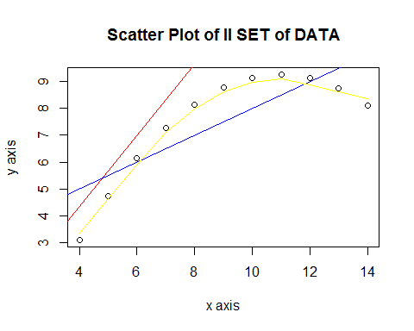

library(compare)  
comparison<-compare(x2,y2, allowAll=TRUE)  
  
comparison$tM

## [1] 4 5 6 7 8 9 10 11 12 13 14

## various derivation for x3 and y3  
  
plot(week7project2$x3,week7project2$y3, main="Scatter Plot of III SET of DATA", xlab="x axis", ylab="y axis",)  
  
abline(lm(x3~y3), col="red") #regression line (y~x)  
abline(lm(y3~x3), col="blue") #regression line (y~x)  
lines(lowess(x3,y3),col="yellow") #lowess line (x,y)

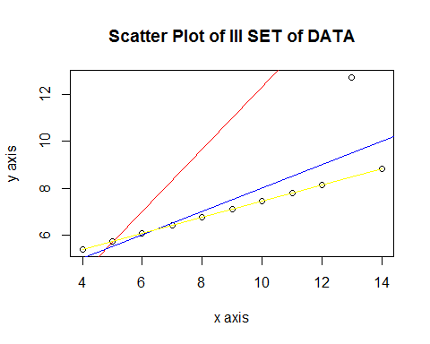

library(compare)  
comparison<-compare(x3,y3, allowAll=TRUE)  
  
comparison$tM

## [1] 4 5 6 7 8 9 10 11 12 13 14

## various derivation for x4 and y4  
  
plot(week7project2$x4,week7project2$y4, main="Scatter Plot of IV SET of DATA", xlab="x axis", ylab="y axis",)  
  
abline(lm(x4~y4), col="red") #regression line (y~x)  
abline(lm(y4~x4), col="blue") #regression line (y~x)  
lines(lowess(x4,y4),col="yellow") #lowess line (x,y)

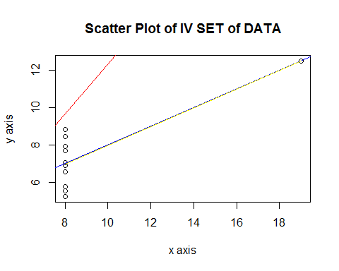

library(compare)  
comparison<-compare(x4,y4, allowAll=TRUE)  
  
comparison$tM

## [1] 8 8 8 8 8 8 8 8 8 8 19

## All points in one Graph  
  
week7project2<-read.csv('c:/temp/Week7Project2ForR.csv',header=TRUE)  
x1<-week7project2$x1  
y1<-week7project2$y1  
x2<-week7project2$x2  
y2<-week7project2$y2  
x3<-week7project2$x3  
y3<-week7project2$y3  
x4<-week7project2$x4  
y4<-week7project2$y4  
  
plot(x1,y1, main="Scatter Plot of All SET of DATA", xlab="x axis", ylab="y axis",)  
points(x2,y2,col=2,pch=2)  
points(x3,y3,col=3,pch=3)  
points(x4,y4,col=4,pch=4)  
  
legend(24,80,c("I Set","II Set","III Set","IV Set"),col=c(1,2,3,4),pch=c(1,2,3,4))

