AUTO TICKET CLASSIFICATION USING FLOW DESIGNER

1. Project Overview
The school IT helpdesk receives multiple support requests every day from students and teachers. Common requests include network connectivity problems, hardware failures, account access issues, and system performance problems.
Currently, IT staff manually review each ticket to identify the issue type, select the correct category and subcategory, and inform the caller about ticket creation. This manual process is time-consuming, error-prone, and difficult to scale as the number of requests increases.

Project Objective
The objective is to automate ticket classification using ServiceNow Flow Designer. The solution reads the short description entered by the caller, identifies common issue patterns, automatically assigns the appropriate category and subcategory, and sends an acknowledgement email.
- Reduce manual ticket categorization effort.
- Improve consistency and accuracy of category/subcategory selection.
- Provide immediate confirmation to the caller.
- Use a no-code/low-code ServiceNow Flow Designer implementation.
- Create a reusable solution that can be extended with additional rules.

2. Update Set Configuration
An update set is used to capture the configuration changes made during development so that the solution can be moved to another environment when required.

Navigation Steps
- Go to All menus and search for Update Set.
- Under System Update Sets, select Local Update Sets.
- Click New at the top-right corner.
- Enter Name as Project Update Set.
- Set State to In progress.
- Set Application to Global.
- Save the form.
- Under Related Links, click Make This My Current Set.
- Verify that the created update set appears as the Current Set.
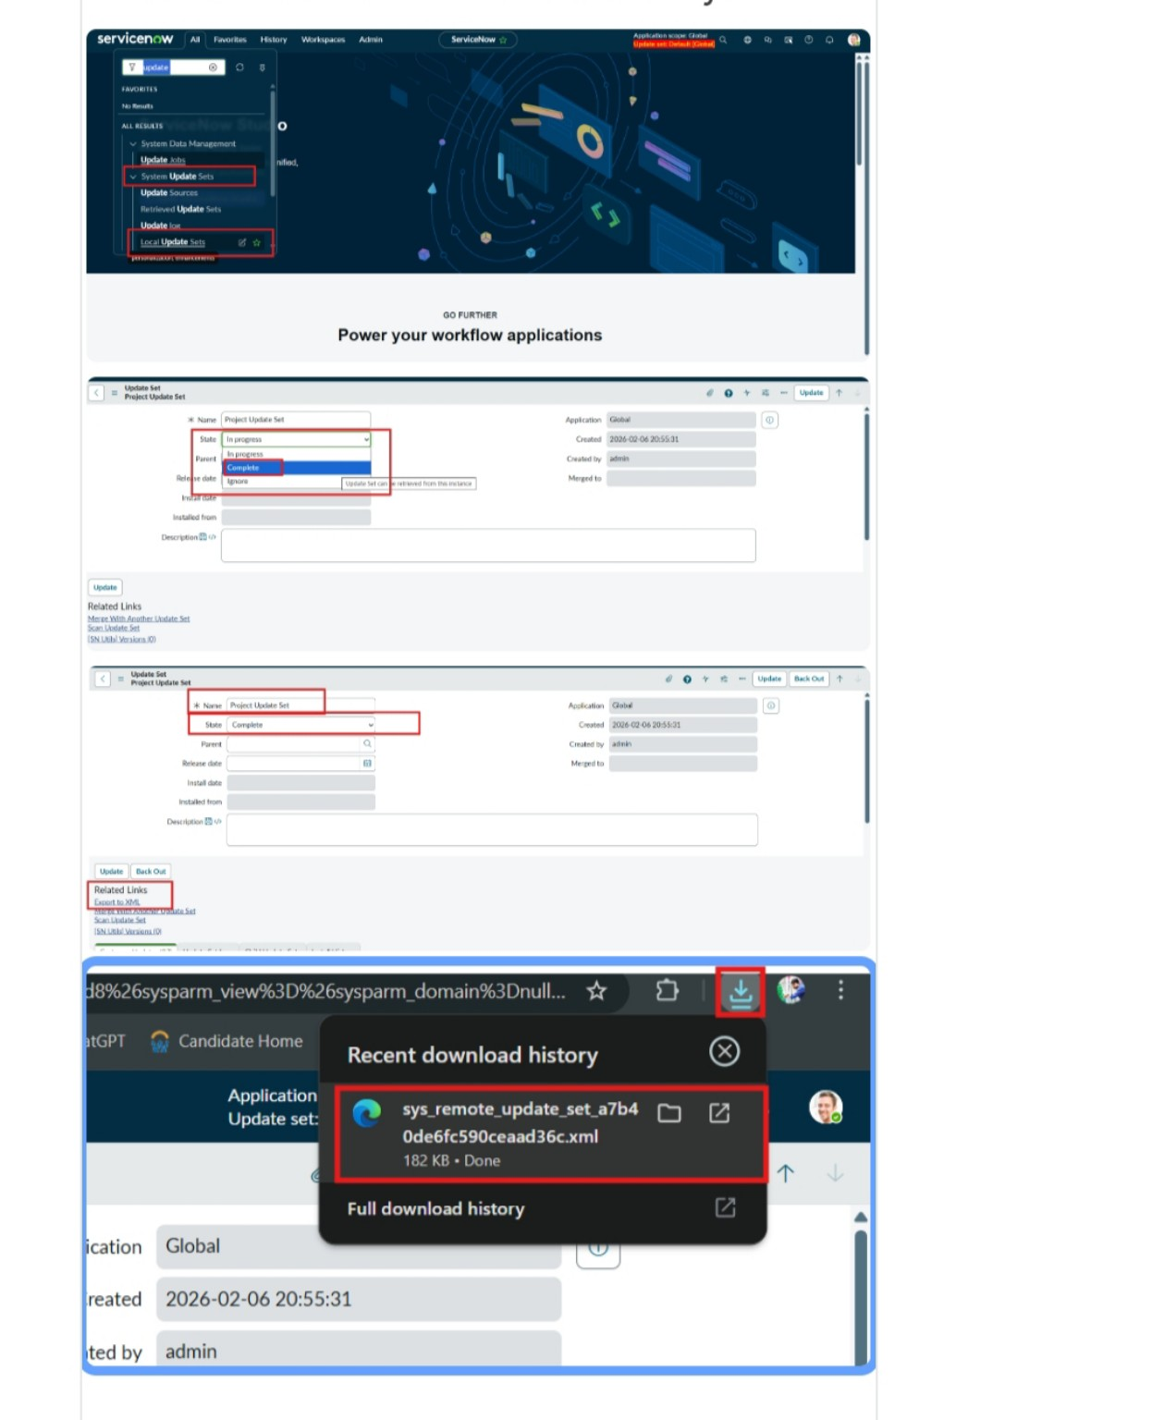
Figure 1. ServiceNow Update Set navigation, Project Update Set configuration, completion, and XML download.

3. Custom Table and Form Configuration
A custom table is created to store and manage ticket-related information in a structured format. The table is configured with the required fields, auto-numbering, and an organized form layout. Form Designer is used to arrange the fields according to the project requirements.

Recommended Ticket Fields
Field Label | Type | Reference / Choice | Purpose
Number | Auto Number | — | Uniquely identifies each ticket.
Caller | Reference | sys_user | Identifies the person raising the ticket.
Category | Choice | Network, Hardware, Access, Performance | Stores the main issue category.
Subcategory | Choice | Wi-Fi, Projector, Forgot Password, Slow Computer | Stores the specific issue type.
Short Description | String | — | Captures the main issue in a short phrase.
Description | String | — | Stores additional issue details.
State | Choice | New, In progress, On hold, Resolved, Closed | Tracks ticket status.
Assigned Group | Reference | sys_user_group | Identifies the support group.
Assigned to | Reference | sys_user | Identifies the individual assignee.

After creating the fields with the appropriate data types, add the required choices to the Category, Subcategory, and State choice-list fields. Save the form and reload it to verify the configuration.
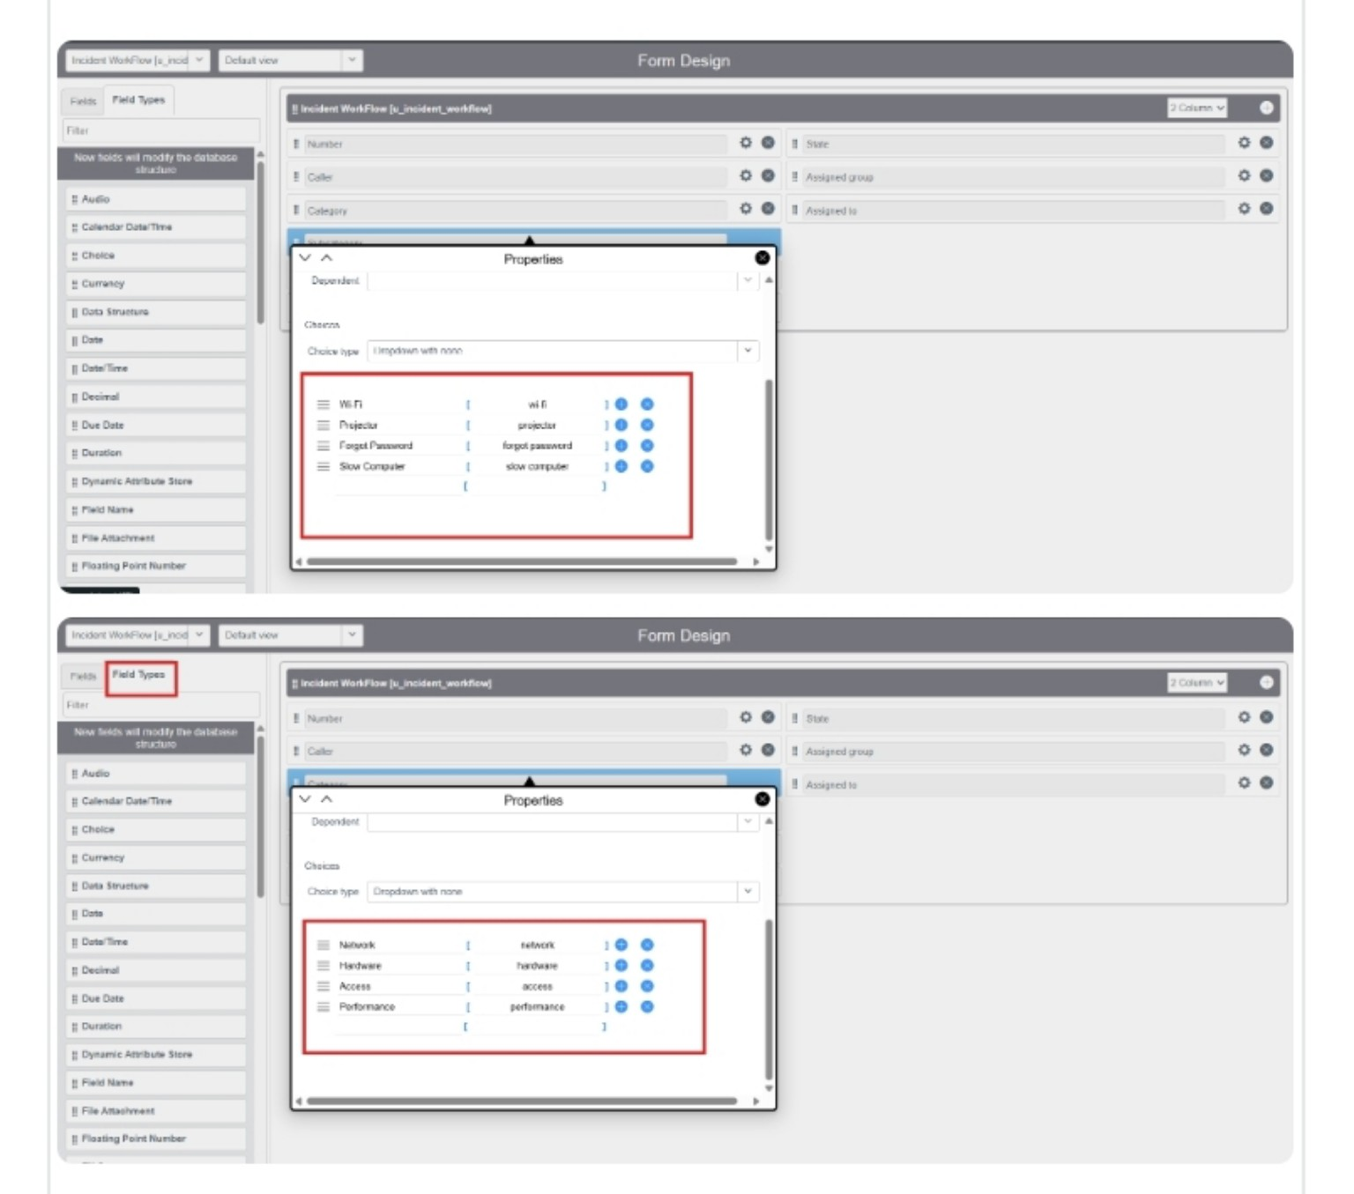
Figure 2. Form Designer showing the choice values for the Category and Subcategory fields.
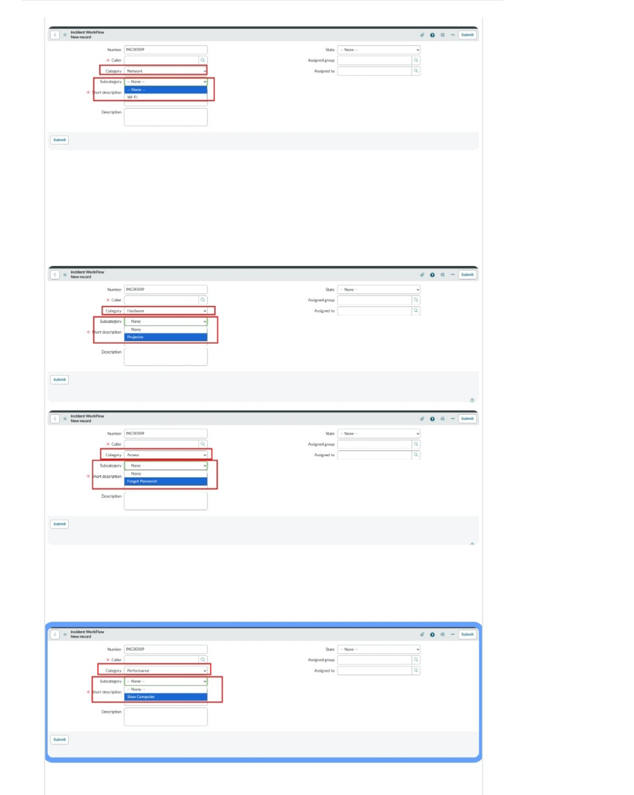
Figure 3. Ticket form showing dependent Subcategory choices for Network, Hardware, Access, and Performance categories.
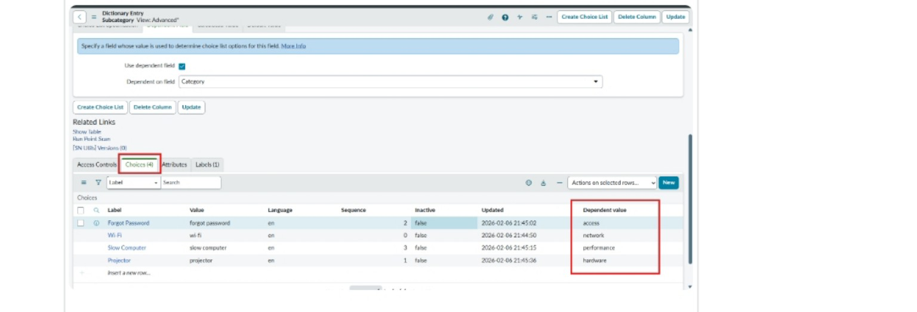
Figure 4. Dictionary Entry choices showing the dependent values associated with each category.

4. Activity 2 – Field Creation and Data Type Configuration
The objective of this milestone is to create all required fields in the School IT Ticket table with correct data types, choices, and dependencies, ensuring structured and consistent data capture.

Choice Configuration
- Category choices: Network, Hardware, Access, Performance.
- Subcategory choices: Wi-Fi, Projector, Forgot Password, Slow Computer.
- State choices: New, In progress, On hold, Resolved, Closed.
- Reference fields use the appropriate ServiceNow reference tables.
- The Number field uses auto-numbering for unique ticket identification.

5. Activity 3 – Implementing Dependency Between Category and Subcategory
The objective of this milestone is to implement a dependency relationship between the Category and Subcategory fields so that the available Subcategory options dynamically change according to the selected Category.

Navigation Steps
- Open the created ticket table form.
- Right-click the Subcategory field.
- Select Configure Dictionary.
- Under Related Links, open Advanced view.
- Enable Use dependent field.
- Set Dependent on field to Category.
- Save the form.
- In the Choices section, configure the dependent values.

Dependent Choice Mapping
Subcategory | Dependent Category
Wi-Fi | Network
Projector | Hardware
Forgot Password | Access
Slow Computer | Performance
After saving the form, each Subcategory is displayed only when its corresponding Category is selected.

6. Flow Designer – Auto Ticket Classification

Activity 1 – Create the Flow
- Go to All menus and search for Flow Designer.
- Under Process Automation, open Flow Designer.
- Click New at the top-right corner and select Flow.
- Enter the Flow Name as Auto Classify School IT Tickets.
- Set Application to Global.
- Click Build Flow.
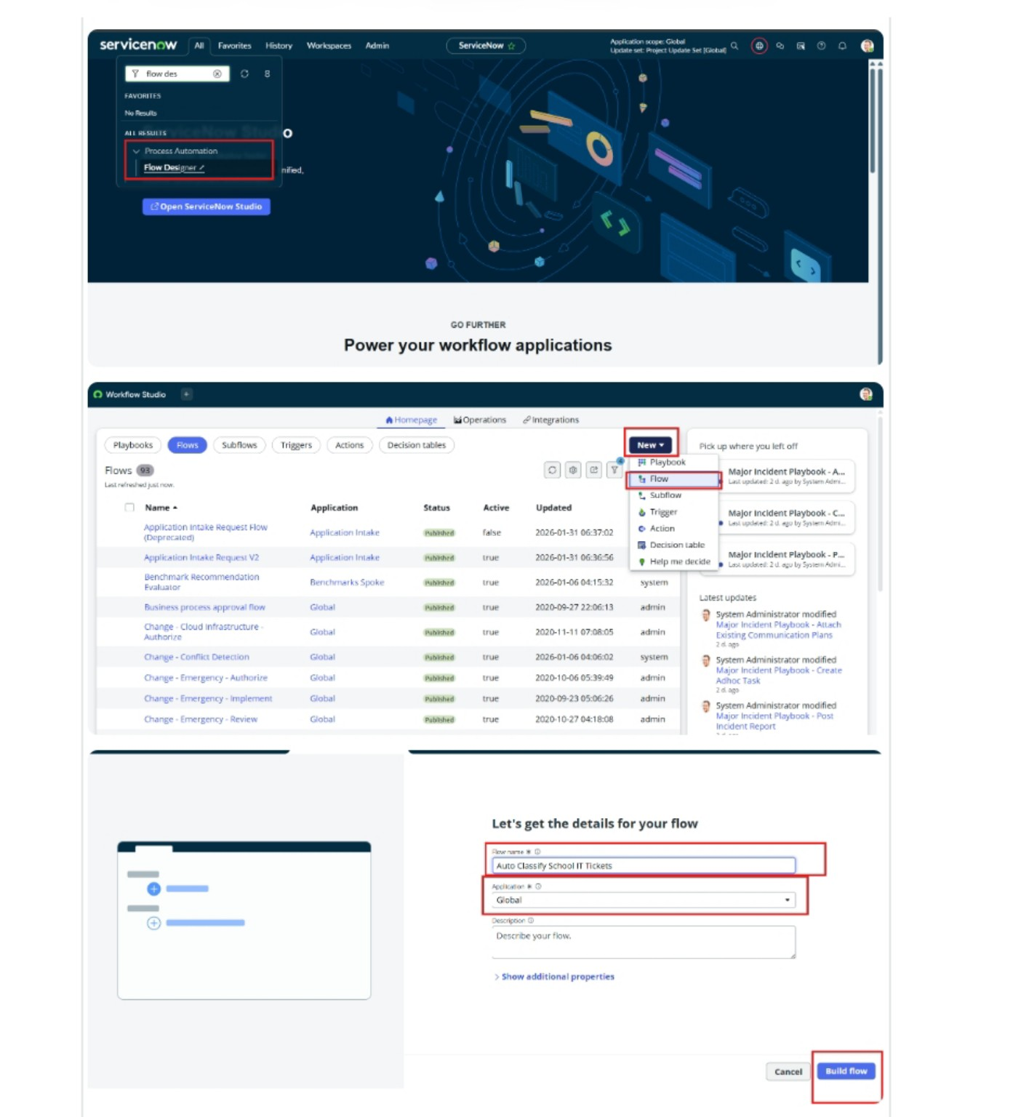
Figure 5. Flow Designer navigation, New → Flow selection, and creation of the Auto Classify School IT Tickets flow.

Activity 2 – Trigger Configuration
- Trigger: Record Created.
- Table: Incident Workflow.
- Condition: Category is empty.
- Click Done to save the trigger configuration.
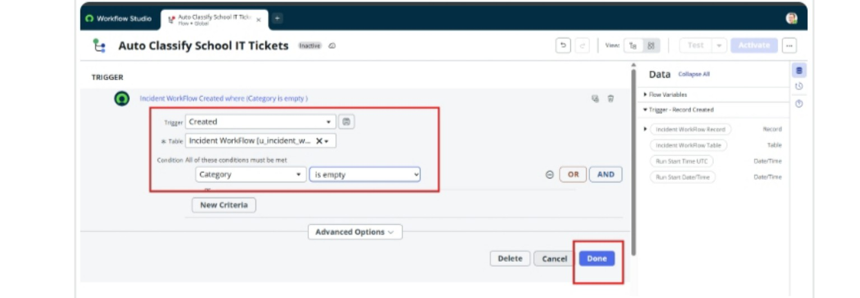
Figure 6. Flow trigger configured for a newly created Incident Workflow record when Category is empty.

7. Flow Logic and Classification Rules
The flow uses If / Else If conditions to classify tickets based on the Short Description. After a matching condition is identified, an Update Record action sets the Category and Subcategory.

Activity 3 – Wi-Fi / Network Issue Classification
- Add an If condition.
- Condition label: SD is Wi-Fi or Network.
- Condition 1: Short Description contains Wi-Fi.
- Condition 2: Short Description contains Network.
- Click Done.
- Add an Update Record action.
- Set Category = Network.
- Set Subcategory = Wi-Fi.
- Click Done.

Activity 4 – Projector / Hardware Issue Classification
- Add an Else If condition.
- Condition label: SD is Projector or Hardware.
- Condition: Short Description contains Projector.
- Click Done.
- Add an Update Record action.
- Set Category = Hardware.
- Set Subcategory = Projector.
- Click Done.

Activity 5 – Password Issue Classification
- Add another Else If condition.
- Condition label: SD is Forgot Password.
- Condition: Short Description contains Forgot password.
- Click Done.
- Add an Update Record action.
- Set Category = Access.
- Set Subcategory = Forgot Password.
- Click Done.
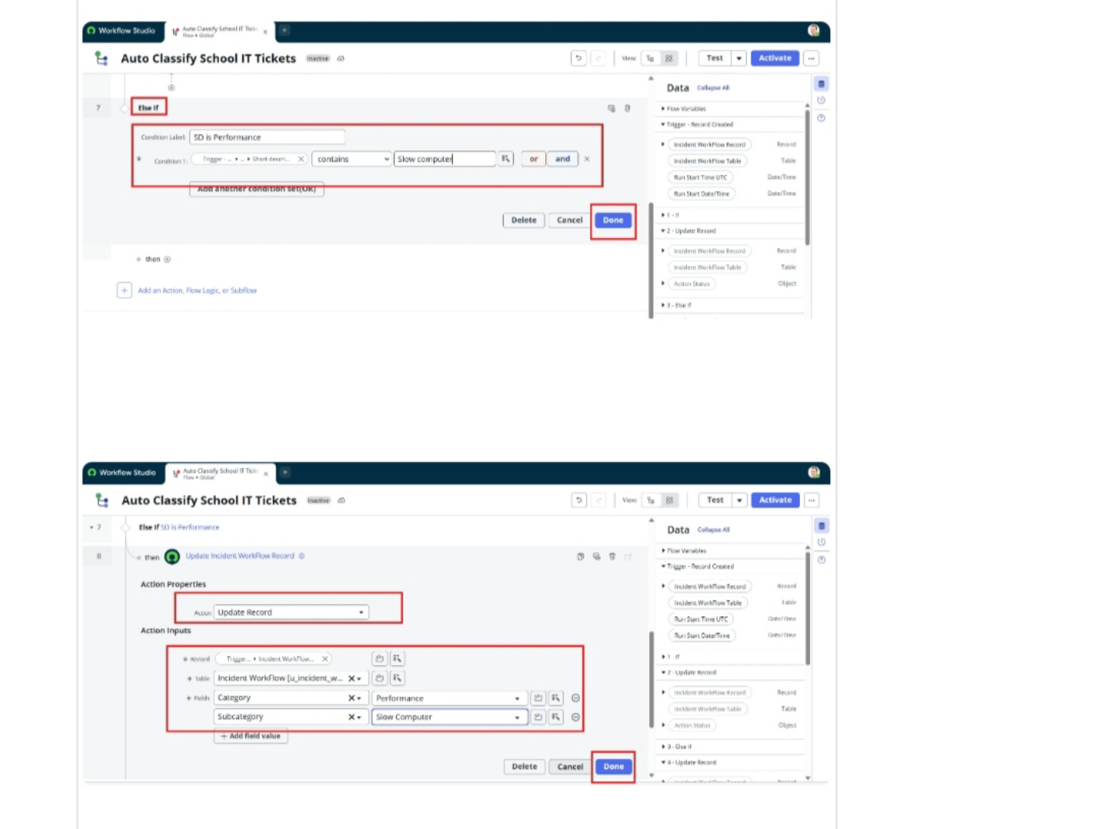
Figure 7. Flow conditions and Update Record actions used for ticket classification.
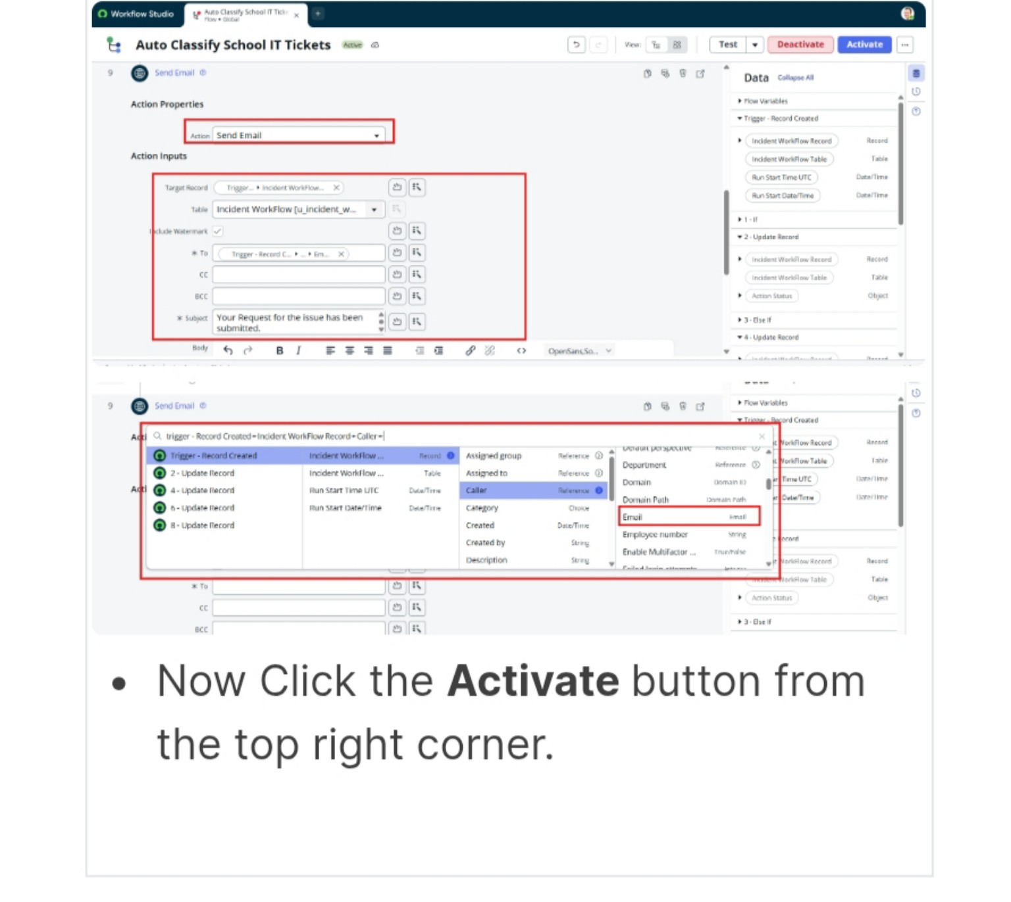
Figure 8. Flow action configuration and activation of the Auto Classify School IT Tickets flow.

8. Activity 7 – Email Notification Setup
After classification, the flow sends an acknowledgement email to the caller using the email address stored in the Caller reference.
- Action: Send Email.
- To: Caller → Email.
- Subject: Your Request for the issue has been submitted.
- Body: Ticket confirmation message.
- Click Done.
- Click Activate at the top-right corner of Flow Designer.
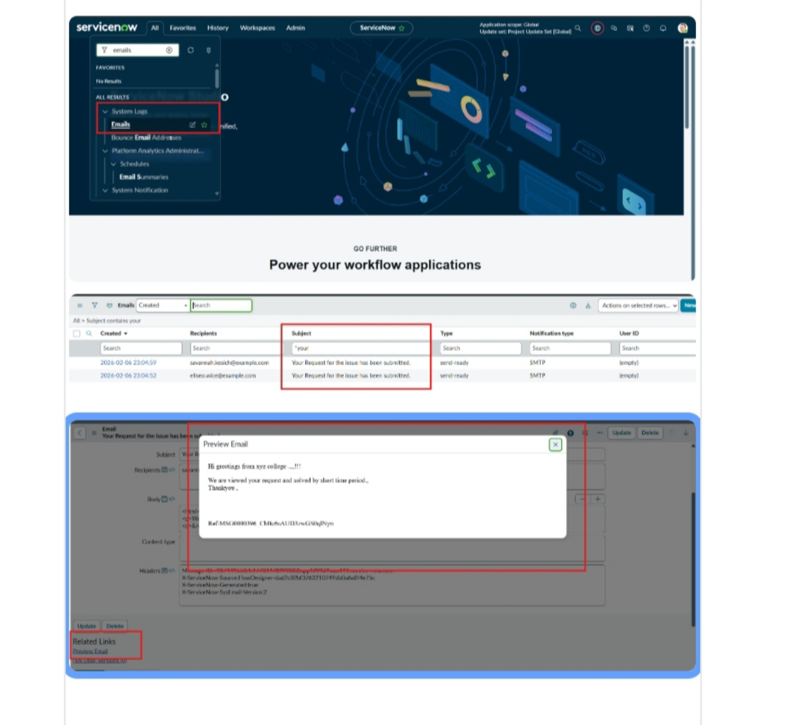
Figure 9. ServiceNow email log and Preview Email showing the acknowledgement message.

9. Testing and Validation

Test Scenario 1 – Wi-Fi Issue
- Enter a valid Caller.
- Set Short Description to: WiFi not working in library.
- Save the form.
- Reload the form.
- Verify Category is automatically set to Network.
- Verify Subcategory is automatically set to Wi-Fi.
- Verify that an email is sent to the caller's email address.
Expected result: Network → Wi-Fi classification is applied automatically and the caller receives an acknowledgement email.

Test Scenario 2 – Projector Issue
- Enter a valid Caller.
- Set Short Description to: Projector not turning on.
- Save the form.
- Reload the form.
- Verify Category is automatically set to Hardware.
- Verify Subcategory is automatically set to Projector.
- Verify that an email is sent to the caller's email address.
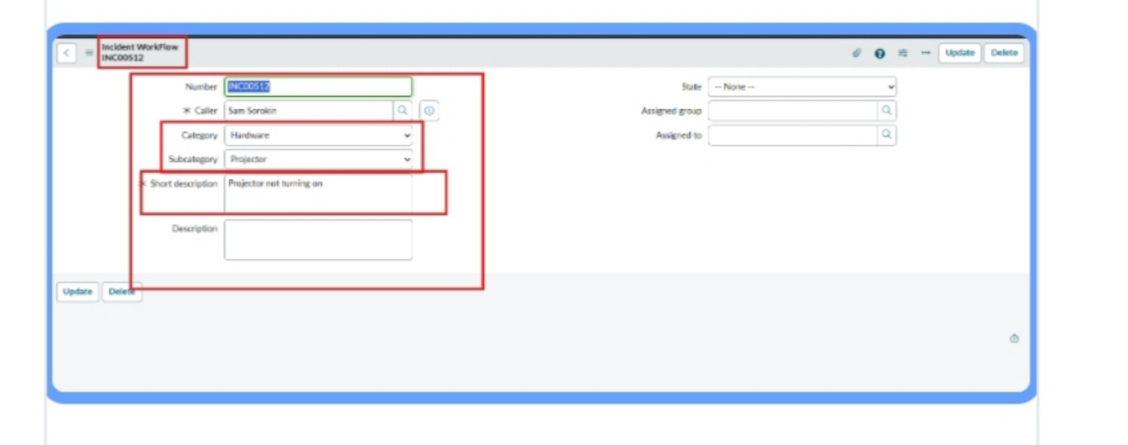
Figure 10. Incident Workflow ticket showing automatic Hardware → Projector classification.

Checking Email Notification
- Open All menus and search for Emails.
- Under System Logs, select Emails.
- Search using the configured subject name.
- Open the relevant email record.
- Under Related Links, select Preview Email.
- Verify that the acknowledgement message is displayed.

10. Deployment and Finalization
The final phase is to deploy the developed solution to the target environment and finalize all project documentation. This ensures that the solution is stable, reusable, ready for demonstration or production use, and supported by clear documentation for future reference.
- Verify that all required fields and choice values are present.
- Verify Category/Subcategory dependency.
- Verify the flow is activated.
- Test representative ticket scenarios.
- Verify email notifications are generated correctly.
- Ensure the update set contains the required configuration changes.
- Move or deploy the update set to the target environment according to the organization's ServiceNow process.

11. Conclusion
The Auto Ticket Classification using Flow Designer project successfully delivers a complete, end-to-end automation solution for a school IT helpdesk. The primary objective of reducing manual effort in ticket categorization and improving response efficiency has been achieved through structured configuration and no-code automation.
The system automatically classifies IT tickets based on the short description provided by students or teachers. Dependent choice fields improve data consistency by restricting Subcategory options to the selected Category, while automated email notifications provide immediate acknowledgement to the caller.
The solution was developed using a phased approach, supporting clarity, stability, and maintainability. Testing confirms the intended classification behavior for common scenarios such as Wi-Fi/network and projector/hardware issues.
Overall, the project demonstrates how ServiceNow can be used to build scalable, maintainable, and user-friendly helpdesk automation without relying on complex scripting or machine learning. The design can be extended in the future with assignment automation, SLA tracking, additional classification rules, knowledge suggestions, or predictive intelligence.

— End of Project Documentation —

