1. **What is DAM and why we use it?**  
   **DAM (Digital Asset Management)** in AEM is a system for storing, managing, and delivering digital assets like images, videos, documents, and PDFs.

**Why use DAM in AEM?**

1. **Centralized Storage** – Keeps all assets in one place.
2. **Version Control** – Manages different versions of assets.
3. **Metadata Management** – Tags assets for easy search and retrieval.
4. **Renditions Support** – Generates different image sizes for optimization.
5. **Workflow Integration** – Enables approval and publishing workflows.
6. **Performance Optimization** – Improves site speed by delivering optimized assets.

**2) Create one folder inside our project folder and follow the path: “/content/dam/myTraining/us/en-us” and upload 2 images and author those images on page using image component as we see today.**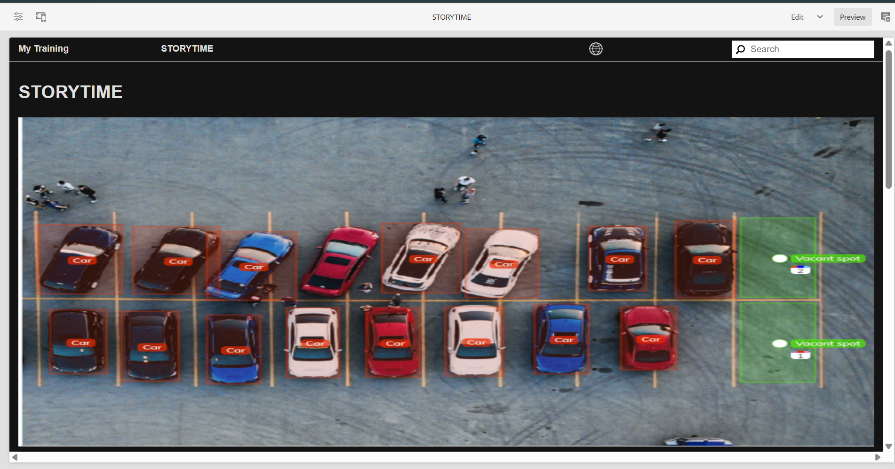

**  
  
3) What is renditions? Check the renditions for 2 images which we had uploaded**

**Renditions** in AEM are automatically generated variations of an image in different sizes and formats. They are used to optimize performance and responsiveness.  
  
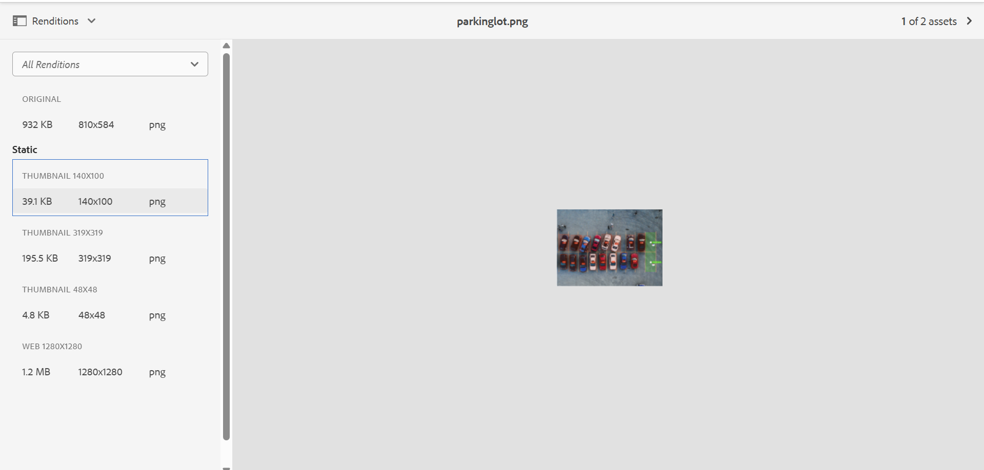

**4) Add two fields in hello world component with name FirstName and Last Name and print the values on hello world.html component using properties**



**5) Give try using @ValueMapValue annotation on HelloWorldModel sling java model “com.myTraining.core.models.HelloWorldModel”**

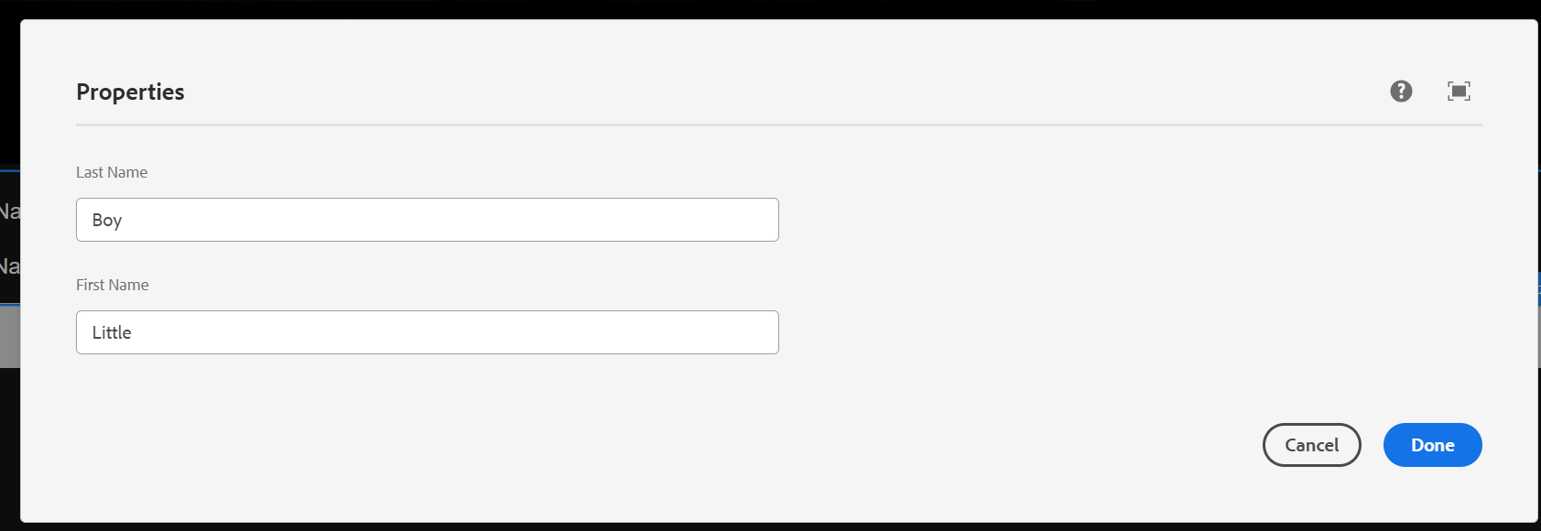

**6) Why we are using package manager and jar create package for the hello world component and 2 images what we have uploaded**

**There should be 2 packages 1 for dam which is images and 2 one is for helloworld component**

**Why We Use Package Manager in AEM?**

AEM’s **Package Manager** is used to:

* Deploy and distribute content or code between environments.
* Create backups of components, configurations, or assets
* Move custom components, templates, dialogs, and assets efficiently
* Export/import DAM assets and custom components as ZIP packages.

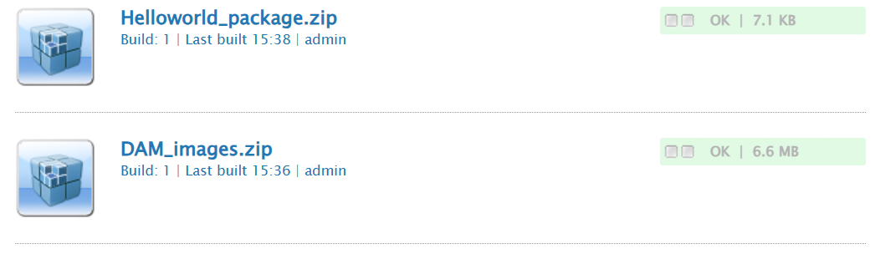

**7) Configure replication agent and publish the page from author to publish env(4502(author)—>4503(publish))**

