1. **Create News room page component using base page component**

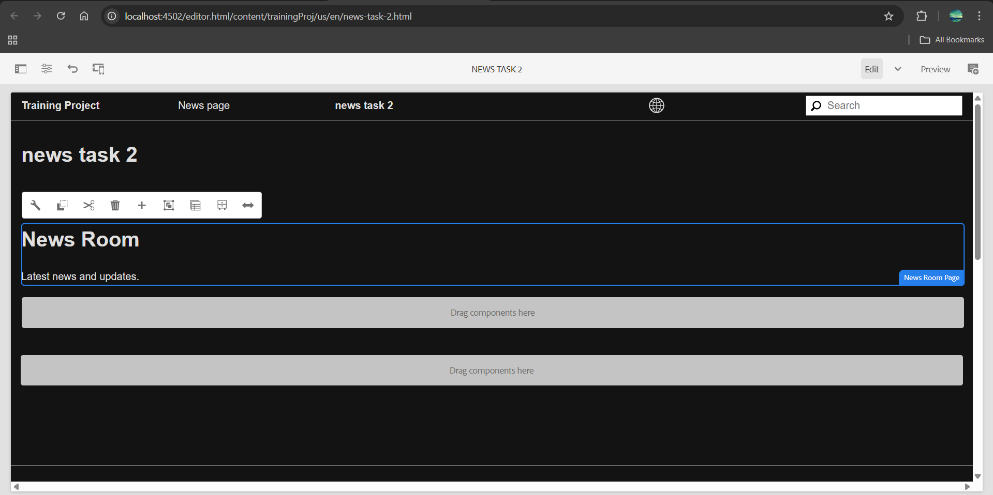

1. **Create custom page property as NEWS configurations where I can author the default news image. Read More CTA for News Article**

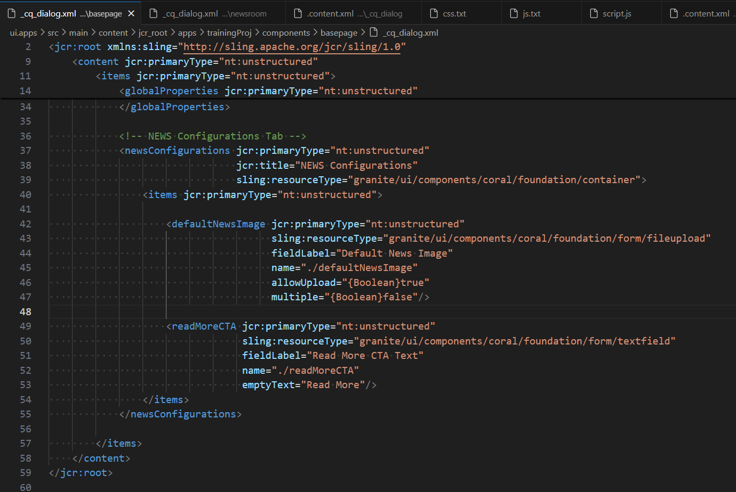

1. **Create News room template type by using news room page component**

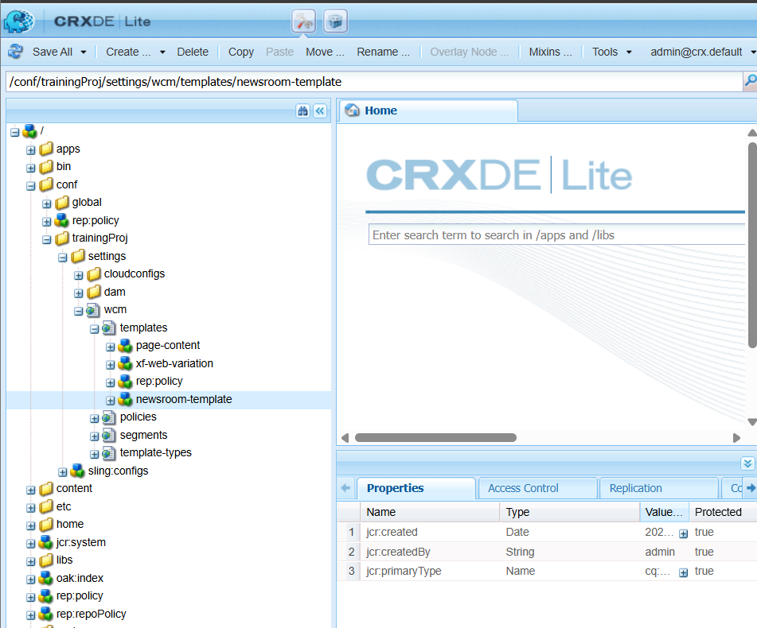

1. **Apply the styling to news/ hello world component from ui.frontend folder**

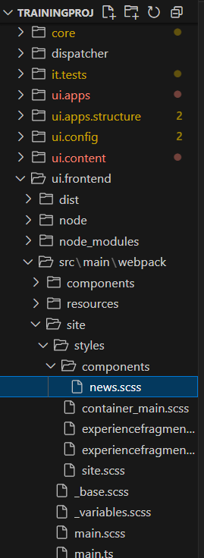 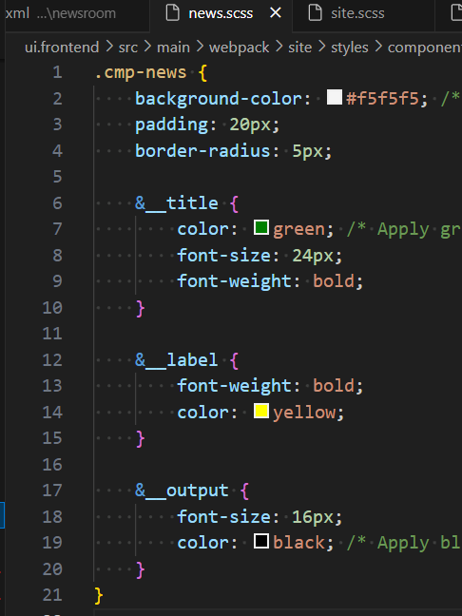

1. **Additionally you can create custom style to apply above styling to hello world or news component.**

<cq:style jcr:primaryType="nt:unstructured"

          sling:resourceType="granite/ui/components/coral/foundation/select"

          fieldLabel="Choose a Style"

          name="./cq:style">

    <items jcr:primaryType="nt:unstructured">

        <default jcr:primaryType="nt:unstructured"

                 text="Default"

                 value="default"/>

        <highlighted jcr:primaryType="nt:unstructured"

                     text="Highlighted News"

                     value="highlighted"/>

        <bordered jcr:primaryType="nt:unstructured"

                  text="Bordered News"

                  value="bordered"/>

    </items>

</cq:style>