**1.Create SampleServlet extend the SlingAllMethod Servlet and register it using resourceType**

package com.project2.core.servlets;

import org.apache.sling.api.SlingHttpServletRequest;

import org.apache.sling.api.SlingHttpServletResponse;

import org.apache.sling.api.servlets.SlingAllMethodsServlet;

import org.osgi.service.component.annotations.Component;

import javax.servlet.Servlet;

import javax.servlet.ServletException;

import java.io.IOException;

@Component(service = Servlet.class,

    property = {

        "sling.servlet.methods=GET",

        "sling.servlet.resourceTypes=project2/components/helloworld",

        "sling.servlet.extensions=json"

    })

public class SampleServlet extends SlingAllMethodsServlet {

    @Override

    protected void doGet(SlingHttpServletRequest request, SlingHttpServletResponse response)

            throws ServletException, IOException {

        response.setContentType("application/json");

        response.getWriter().write("{\"message\": \"Hello from SampleServlet on servlets-page!\"}");

    }

}

2.Create CreatePageServlet extend the SlingSafeMethod Servlet and register it using path

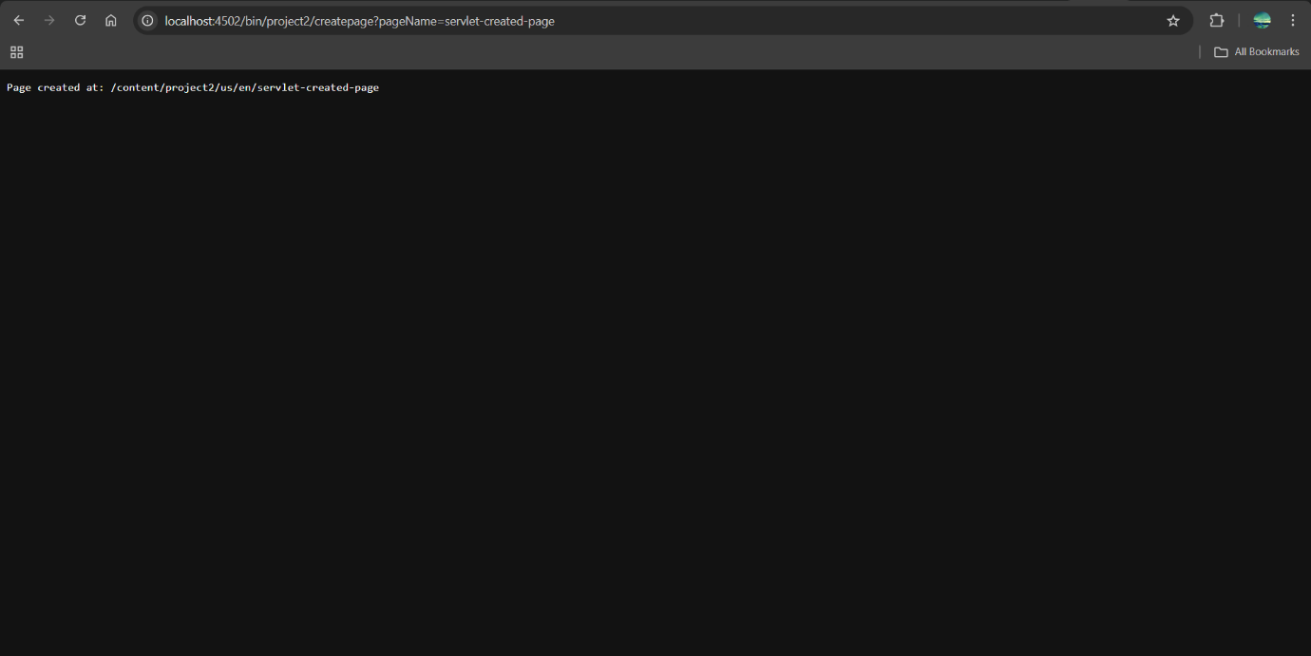

3.Take page name from user and create pages in aem using above servlet

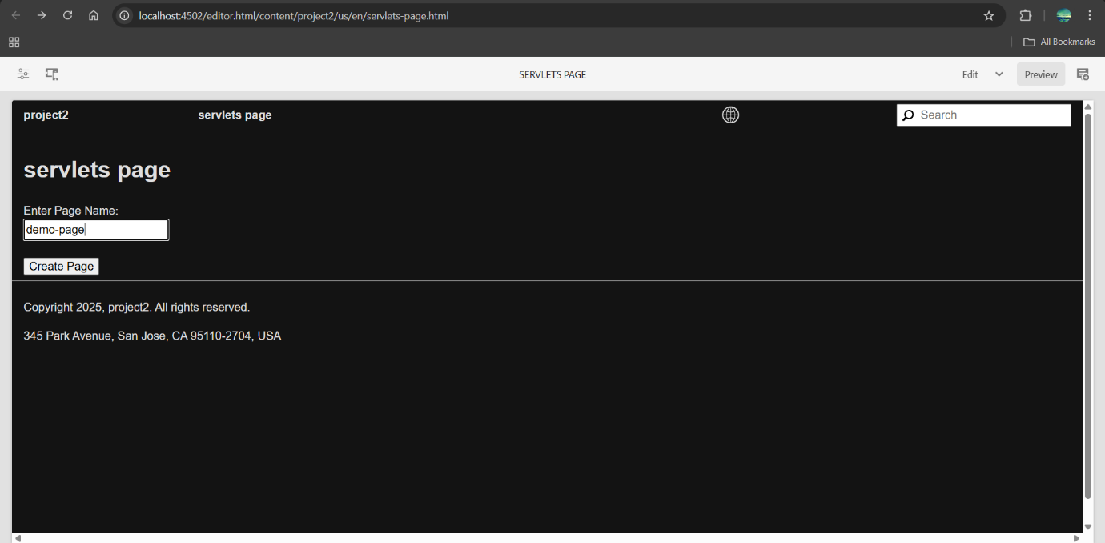

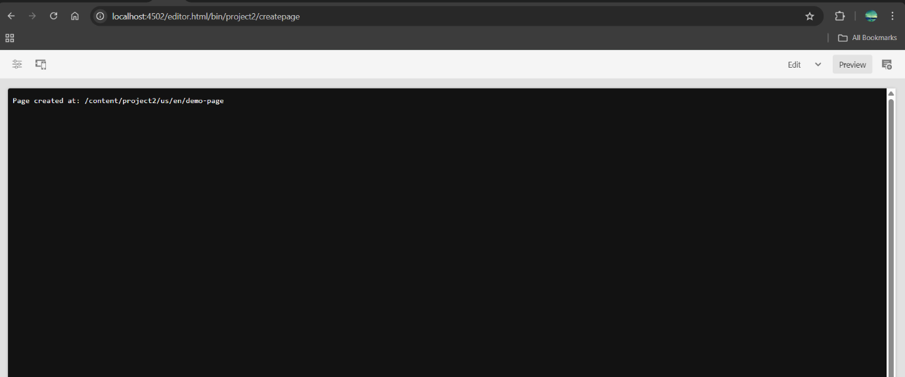

**4.Use page Manager Apis for above task.**

package com.project2.core.servlets;

import com.day.cq.wcm.api.Page;

import com.day.cq.wcm.api.PageManager;

import org.apache.sling.api.SlingHttpServletRequest;

import org.apache.sling.api.SlingHttpServletResponse;

import org.apache.sling.api.resource.ResourceResolver;

import org.apache.sling.api.servlets.SlingSafeMethodsServlet;

import org.osgi.service.component.annotations.Component;

import javax.servlet.Servlet;

import javax.servlet.ServletException;

import java.io.IOException;

@Component(service = Servlet.class,

        property = {

                "sling.servlet.methods=GET",

                "sling.servlet.paths=/bin/project2/createpage"

        })

public class CreatePageServlet extends SlingSafeMethodsServlet {

    private static final String PARENT_PATH = "/content/project2/us/en";

    private static final String TEMPLATE_PATH = "/conf/project2/settings/wcm/templates/landing-page";

    @Override

    protected void doGet(SlingHttpServletRequest request, SlingHttpServletResponse response)

            throws ServletException, IOException {

        String pageName = request.getParameter("pageName");

        if (pageName == null || pageName.isEmpty()) {

            response.getWriter().write("Page name is missing.");

            return;

        }

        try {

            // Get resource resolver from request

            ResourceResolver resolver = request.getResourceResolver();

            // Adapt to PageManager

            PageManager pageManager = resolver.adaptTo(PageManager.class);

            if (pageManager == null) {

                response.getWriter().write("Unable to adapt to PageManager.");

                return;

            }

            // Create new page

            Page createdPage = pageManager.create(PARENT_PATH, pageName, TEMPLATE_PATH, "Page created by servlet");

            if (createdPage != null) {

                response.getWriter().write("Page successfully created at: " + createdPage.getPath());

            } else {

                response.getWriter().write("Page creation failed.");

            }

        } catch (Exception e) {

            response.getWriter().write("Error occurred: " + e.getMessage());

        } }

}

**5.Create one SearchServlet to search the content using PredicateMap to search the content from pages**

SearchServlet.java

package com.project2.core.servlets;

import com.day.cq.search.Query;

import com.day.cq.search.QueryBuilder;

import com.day.cq.search.eval.PredicateGroup;

import com.day.cq.search.result.Hit;

import com.day.cq.search.result.SearchResult;

import org.apache.sling.api.SlingHttpServletRequest;

import org.apache.sling.api.SlingHttpServletResponse;

import org.apache.sling.api.resource.ResourceResolver;

import org.apache.sling.api.servlets.SlingSafeMethodsServlet;

import org.osgi.framework.Constants;

import org.osgi.service.component.annotations.Component;

import javax.jcr.Session;

import javax.servlet.Servlet;

import javax.servlet.ServletException;

import java.io.IOException;

import java.util.HashMap;

import java.util.List;

import java.util.Map;

@Component(service = Servlet.class,

    property = {

        Constants.SERVICE_DESCRIPTION + "= AEM Search Pages Servlet",

        "sling.servlet.paths=/bin/project2/searchpages",

        "sling.servlet.methods=GET"

    })

public class SearchServlet extends SlingSafeMethodsServlet {

    @Override

    protected void doGet(SlingHttpServletRequest request, SlingHttpServletResponse response)

            throws ServletException, IOException {

        String keyword = request.getParameter("q");

        if (keyword == null || keyword.trim().isEmpty()) {

            response.getWriter().write("Please provide query string like ?q=article");

            return; }

        ResourceResolver resolver = request.getResourceResolver();

        Session session = resolver.adaptTo(Session.class);

        QueryBuilder queryBuilder = resolver.adaptTo(QueryBuilder.class);

        if (session == null || queryBuilder == null) {

            response.getWriter().write("QueryBuilder or session is null");

            return;

        }

        // Define query predicates

        Map<String, String> predicates = new HashMap<>();

        predicates.put("path", "/content/project2/us/en/news");

        predicates.put("type", "cq:Page");

        predicates.put("fulltext", keyword);

        predicates.put("p.limit", "-1");

        PredicateGroup predicateGroup = PredicateGroup.create(predicates);

        Query query = queryBuilder.createQuery(predicateGroup, session);

        SearchResult result = query.getResult();

        List<Hit> hits = result.getHits();

        response.setContentType("application/json");

        StringBuilder json = new StringBuilder("{ \"results\": [");

        for (int i = 0; i < hits.size(); i++) {

            String path = hits.get(i).getPath();

            System.out.println("Found path: " + path);

            json.append("\"").append(path).append("\"");

            if (i < hits.size() - 1) json.append(", ");

        }

        json.append("]}");

        response.getWriter().write(json.toString());

    }

}