**1.What is MSM, blueprint, live copy and rollout?**

* MSM (Multi Site Manager): AEM feature that helps manage multiple sites sharing common content and structure.
* Blueprint: The source site/page that acts as the template. Changes here can be pushed to Live Copies.
* Live Copy: A copy of a blueprint page/site that stays in sync with the source (can also be customized).
* Rollout: The action of pushing changes from a Blueprint to one or more Live Copies.

**2.what is language copy?**

* A **Language Copy** is a version of a site/page translated into another language.
* Created using the **Language Copy Wizard** in AEM.
* Content can be translated via **Translation Projects** or **manual editing**.
* Helps manage **multi-lingual** websites efficiently.

**3.Create a site using MSM and us en should be source.**

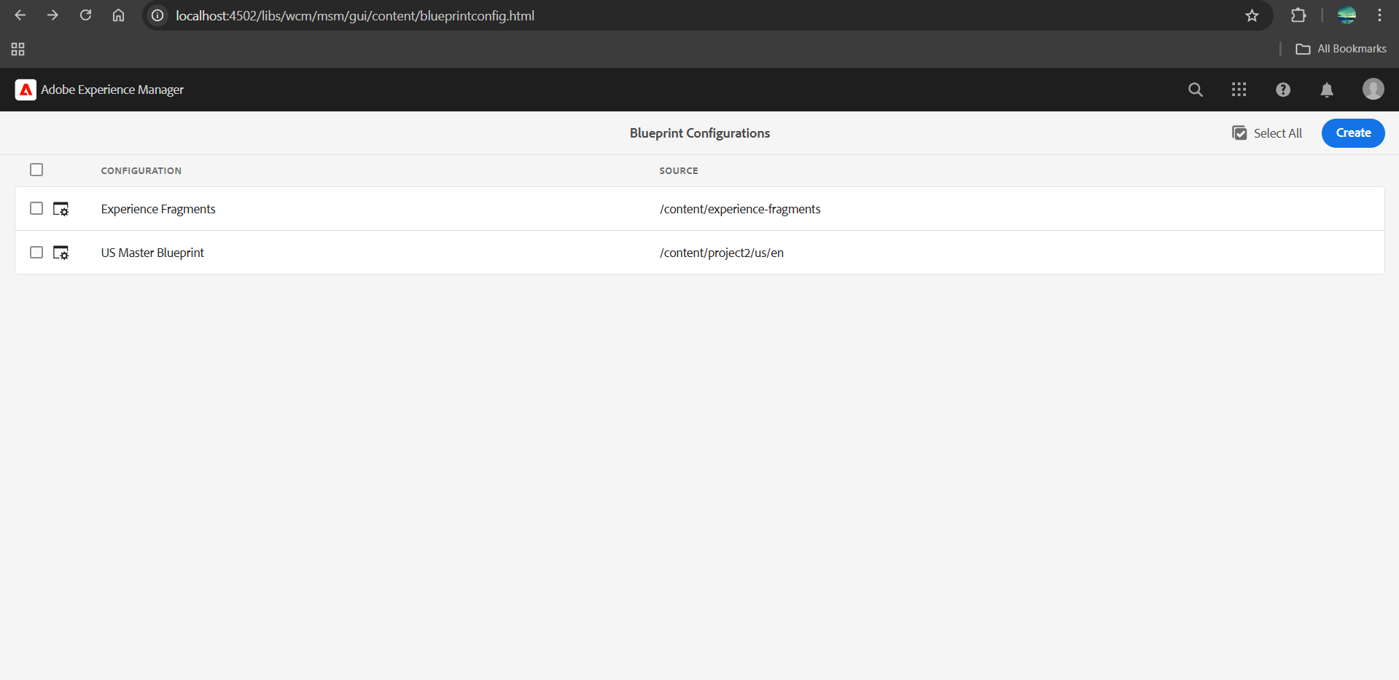

**4.Create this page https://www.mcdonalds.com/us/en-us/about-our-food.html**

**and author the page using components use the content/images from above page.**

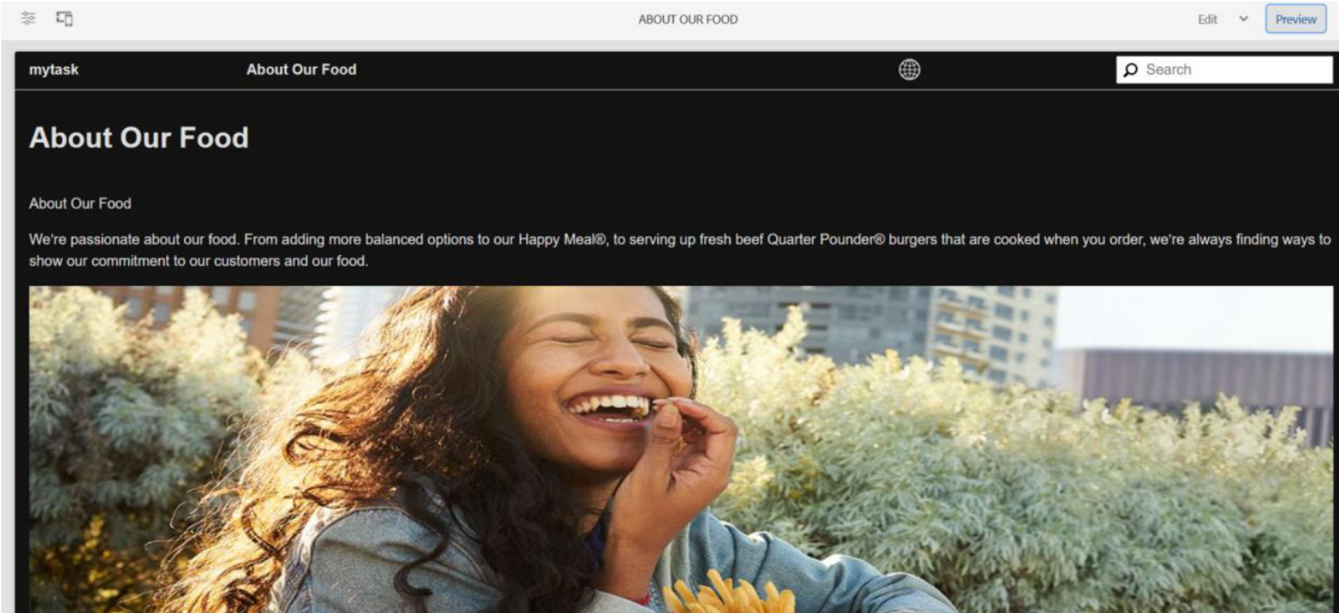

**5.Setup the dispatcher**

**Steps:**

1. Install Apache HTTP Server and Download Dispatcher Module(Place it in: C:\Apache24\modules\)
2. Modify httpd.conf file:

<IfModule dispatcher_module>

DispatcherConfig conf/dispatcher.any

DispatcherLog logs/dispatcher.log

DispatcherLogLevel 3

DispatcherNoServerHeader On

DispatcherDeclineRoot On

DispatcherUseProcessedURL Off

DispatcherPassError 0

</IfModule>

<VirtualHost *:80>

ServerName localhost

DocumentRoot "/path/to/docroot"

<Directory "/path/to/docroot">

AllowOverride All

Require all granted

</Directory>

<IfModule dispatcher_module>

SetHandler dispatcher-handler

</IfModule>

</VirtualHost>

1. Create Dispatcher Configuration File(dispatcher.any)

/cache

{

/docroot "/path/to/docroot"

/rules

{

/0000

{

/glob "*"

/type "allow"

}

}

}

/farms

{

/website

{

/clientheaders

{

"*"

}

/virtualhosts

{

"*"

}

/renders

{

/rend01

{

/hostname "localhost"

/port "4503"

}

}

}

}

1. Restart Apache:

httpd.exe -k restart

1. Test Your Dispatcher(content should be served via Dispatcher and cached in the docroot folder)