**Newsroom portfolio website assignment**

**Header:**

**Steps:**

1. Go to Navigation -> Experience Fragments
2. Select myTraining -> us -> en -> site , create experience fragment-> template -> webvariation template -> next
3. Provide title: ExperinceFragmentHeader2
4. Select create. Open and edit
5. Add text component (NewsReporter)
6. Use button component and create the Home Page, Article 1, Article 2, Article 3 till Article 5 and About Us and Contact Us

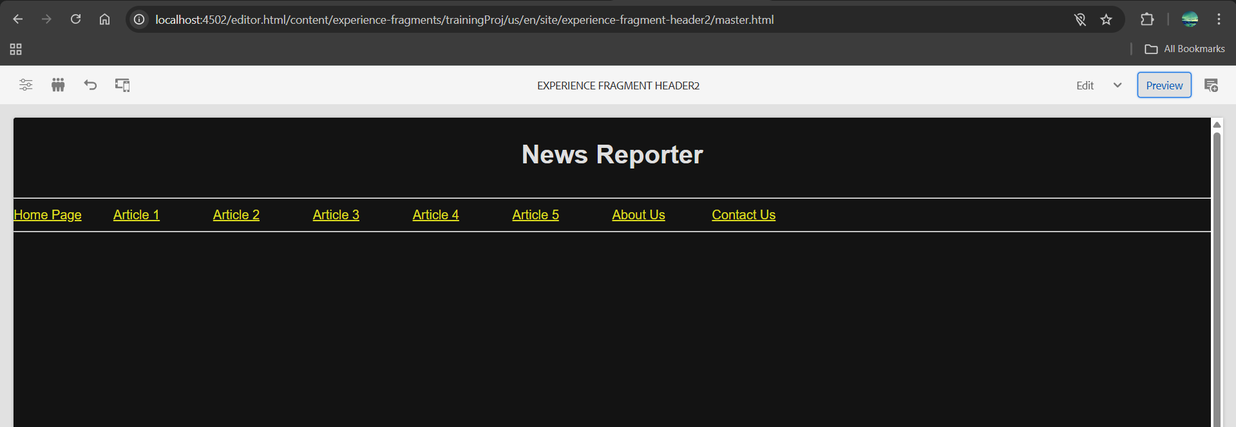

**Footer:**

**Steps:**

1. Follow same steps till step 4 as header but in step3 change title as ExperienceFragmentFooter
2. About us and Contact Us are built using teaser component
3. List component is used to access the pages (routing)
4. Arrange the components like below in layout mode

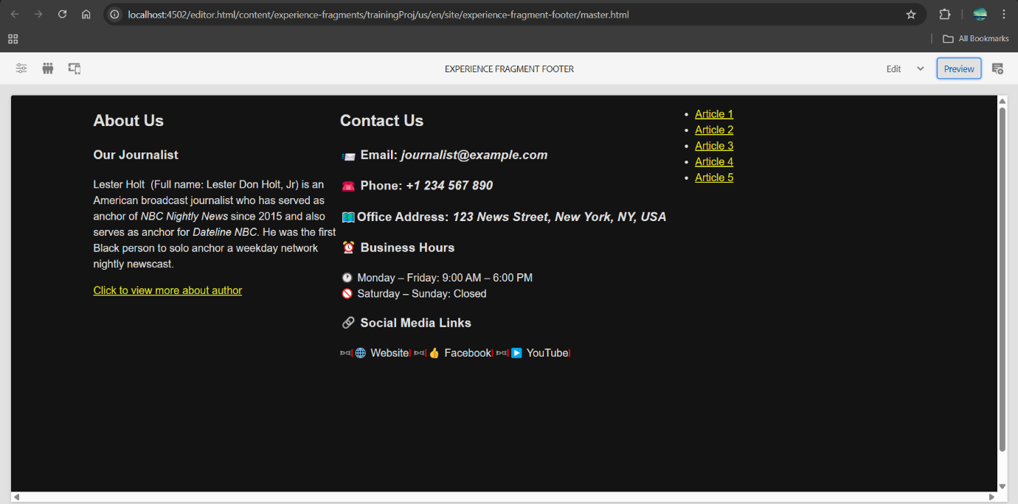

**Template :**

**Steps:**

1. Tools -> general -> Templates -> Select project
2. Create Page
3. Fill Template Title
4. Edit and add experience fragment and add the header
5. Do step 4 again but for footer

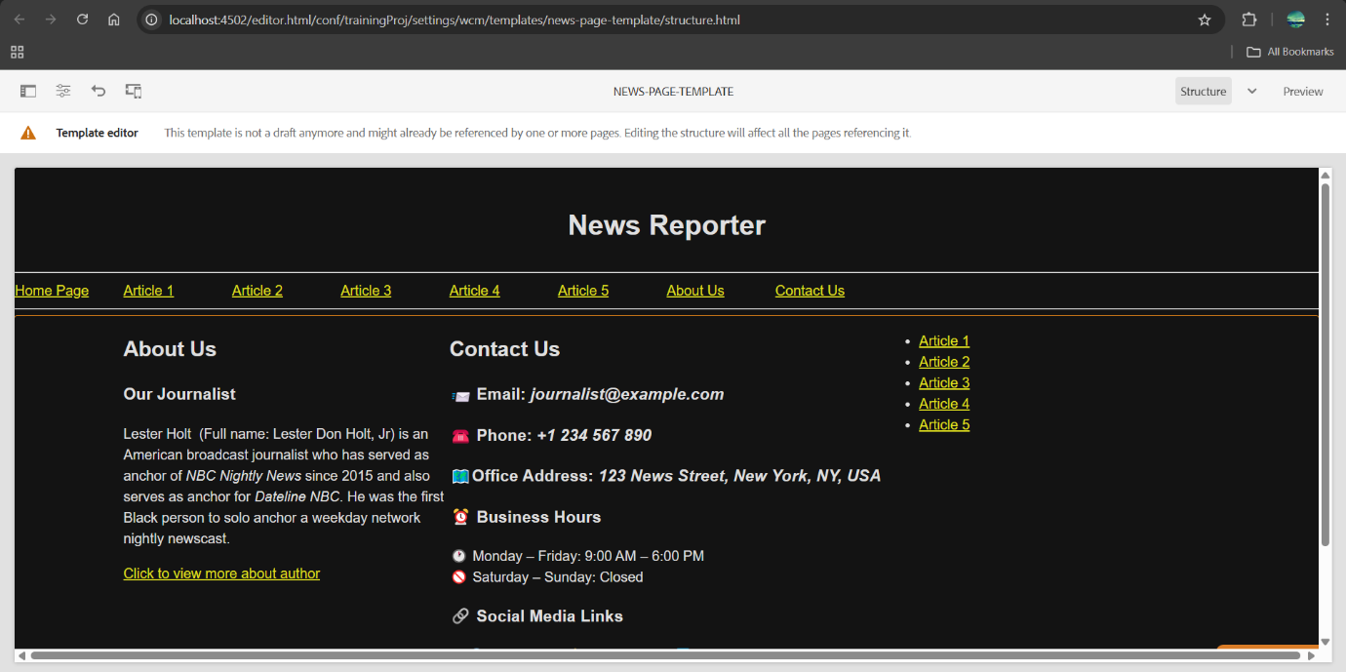

**Home page:**

**Steps:**

1. Create Home page ( in en)
2. Add teaser component, add title as JournalistExcellanceAward2025
3. Fill content
4. Under teaser component configuration, click links -> call-to-actions -> add path to award details( For read more)

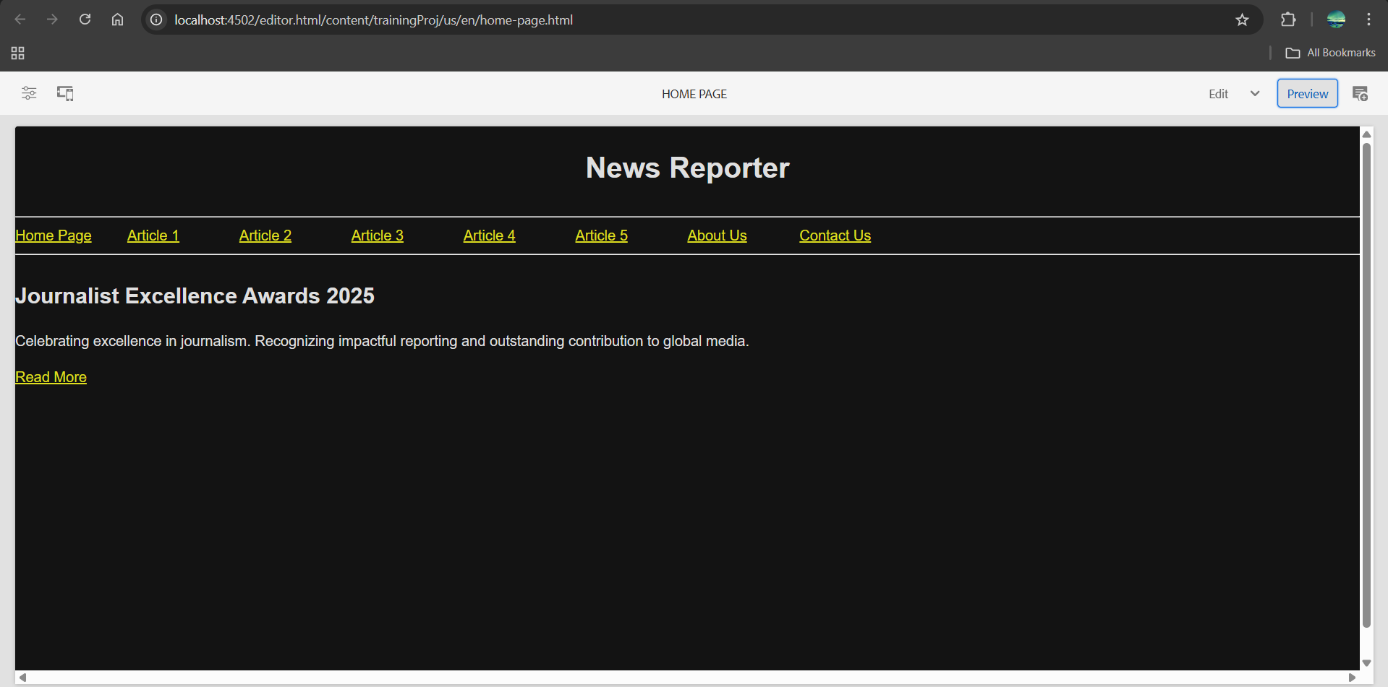

**News page:**

Article 1 to Article 5 pages are created under newspage

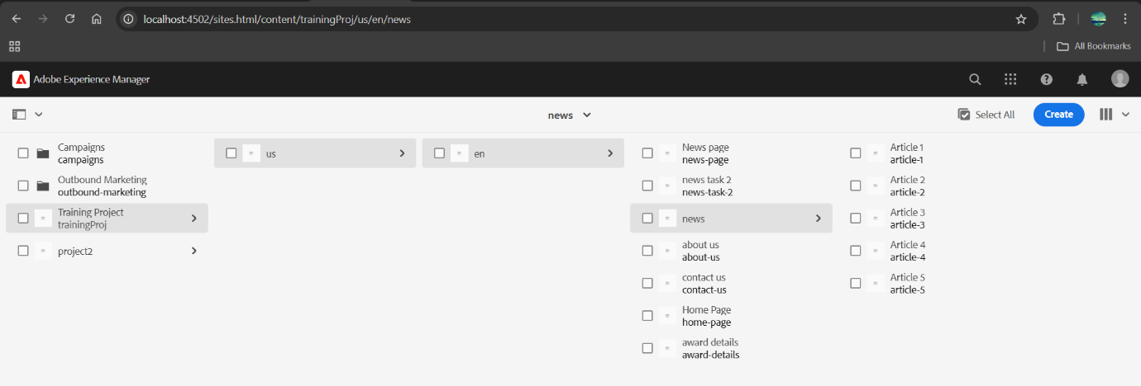

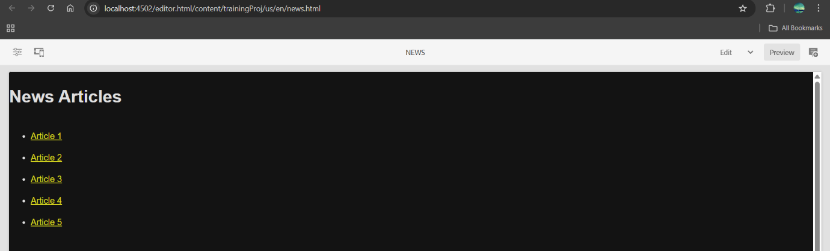

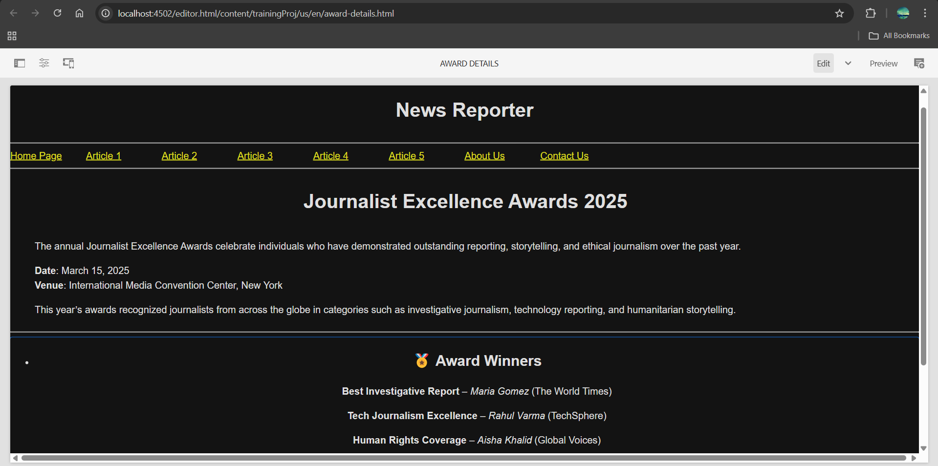

**About US Page:**

**Steps:**

1. Use teaser component and create about us page

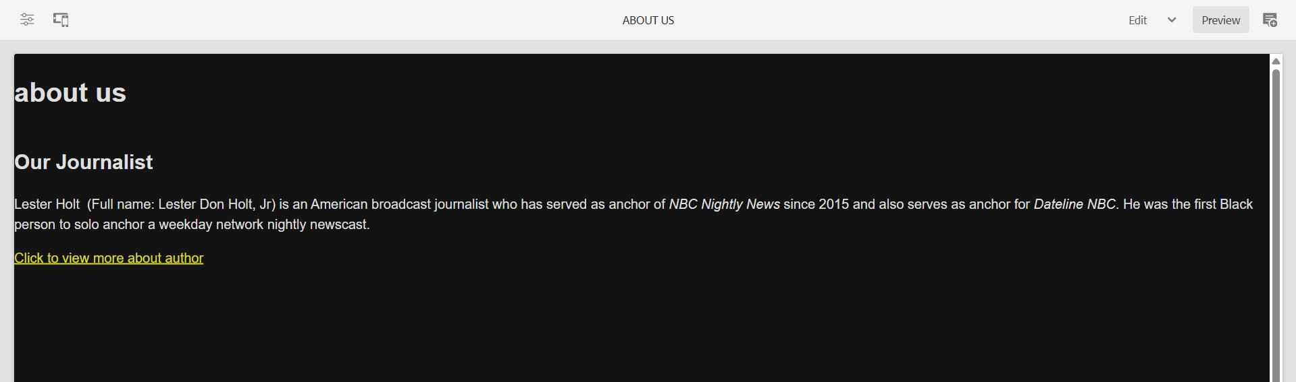

**Contact Me Page:**

1. Use teaser component and create Contact Me page
2. Paste the content.

