# Home Page:

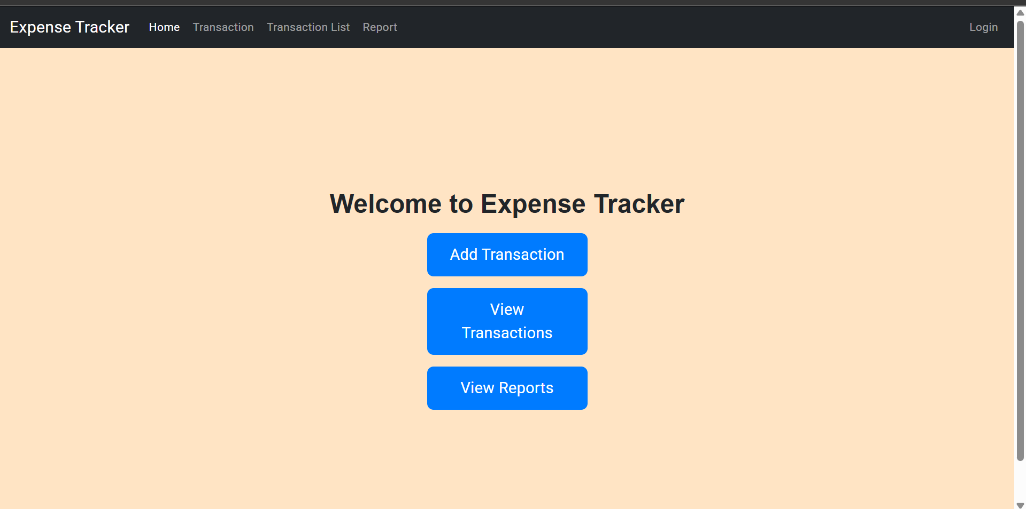

Has 3 buttons -> to add transactions, to view transaction list and the report

# Transaction Page:

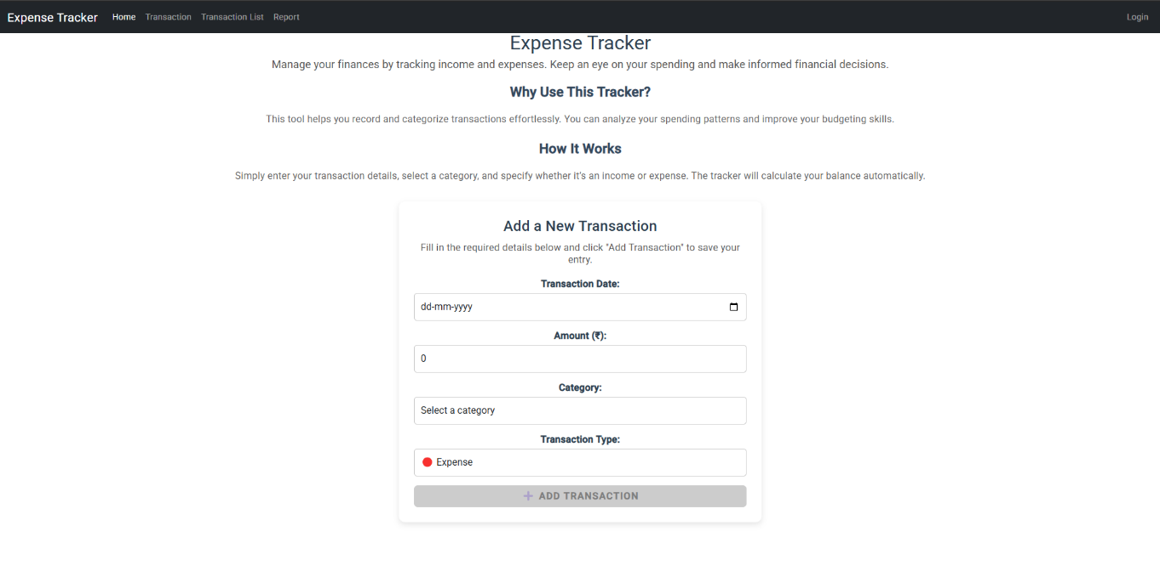

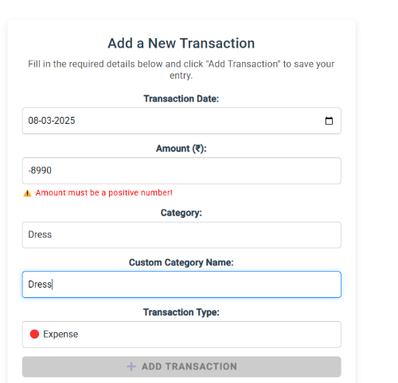 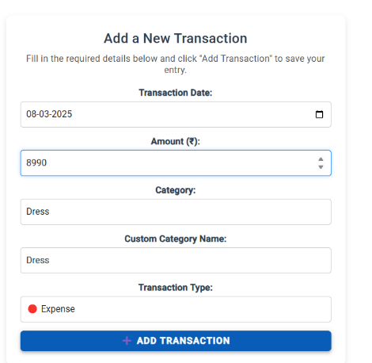

Template Based Form to add the transaction. Has certain conditions to submit the form. Upon submission alert message will be displayed.

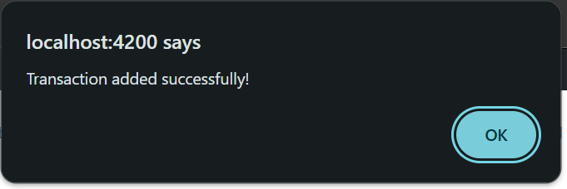

# Transaction List:

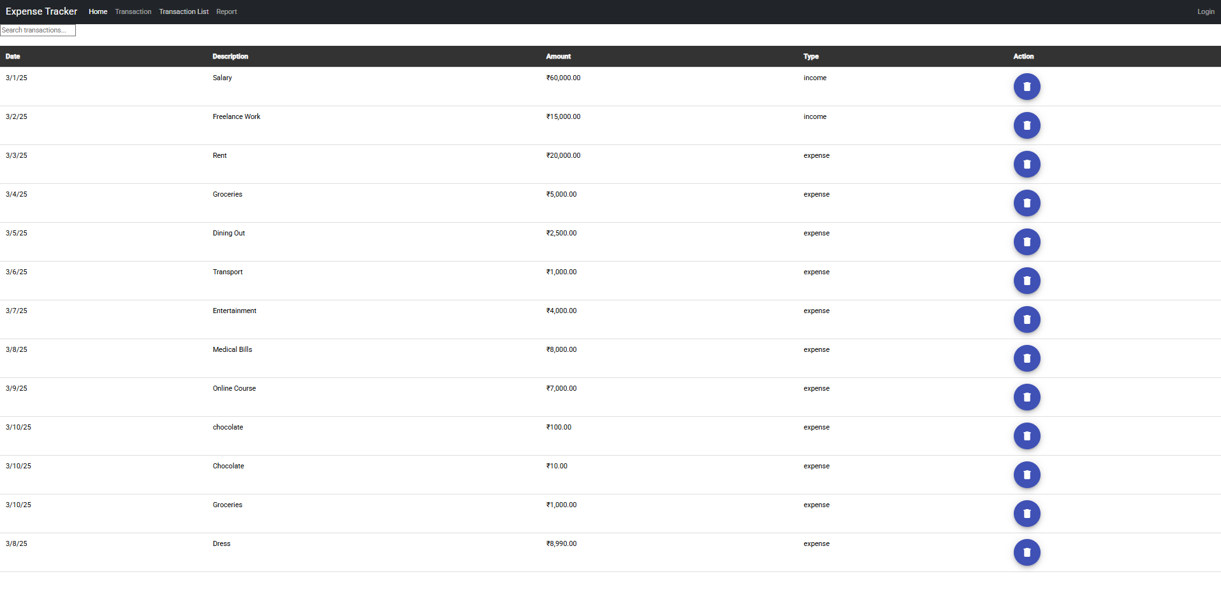

Allows to search transaction based on description.

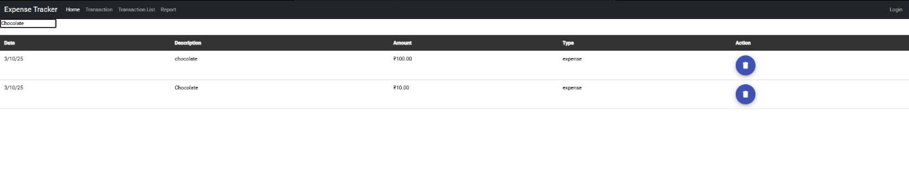

Can delete mistyped rows  
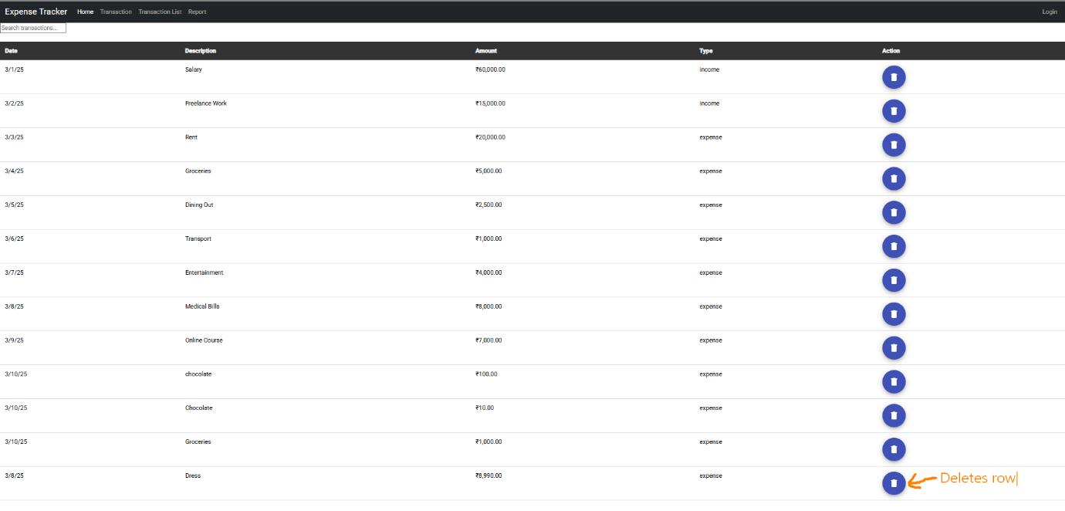

Report Page:

