**DevOps – Final Project**

(Deploy the given react application to production ready state)

**Application:**

1. Create AWS Ec2 instance with t2.micro to deploy the application
2. Assign the security Groups based on the given condition
3. Clone the Given Git Repo URL = git clone <https://github.com/sriram-R-krishnan/devops-build>
4. Create Docker file and Docker-compose file
5. Create the Bash scripts file as build.sh and deploy.sh for building docker image and deploying the image to the server
6. Create the “dev & prod” repo in the Docker Hub
7. Create “.gitignore & .dockerignore” file for ignore the log & unnecessary files
8. Do version control using git and push the codes into dev branch
9. Install the Jenkins and configure the build step in **Multibranch** Pipeline to configure the given condition
10. Create a Jenkinsfile for the integration
11. Connect jenkins to the Github repo with auto build trigger from both dev & main branch

Git Repo URL:<https://github.com/muthunatesa/Final-Project.git>

Deployed site URL:<http://65.2.69.143:80>

Docker Images Name: (react-image)

REPOSITORY TAG IMAGE ID CREATED SIZE

muthunatesa/dev latest 7975621dfd17 6 hours ago 55.1MB

muthunatesa/prod latest 7975621dfd17 6 hours ago 55.1MB

**EC2 Instance Console:**

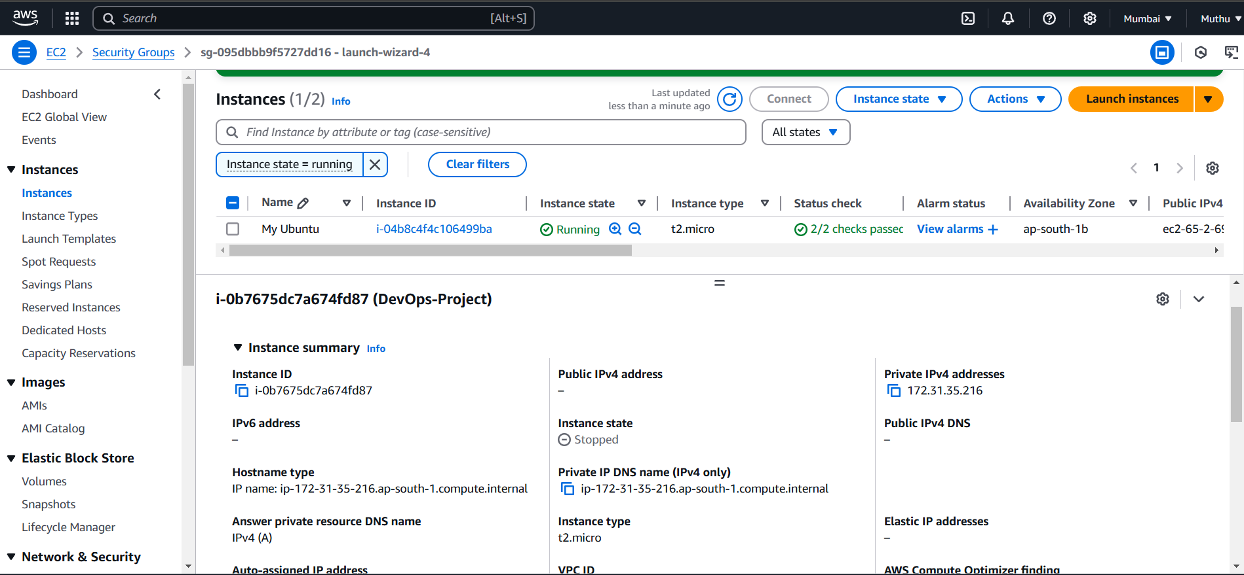

**Security Groups:**

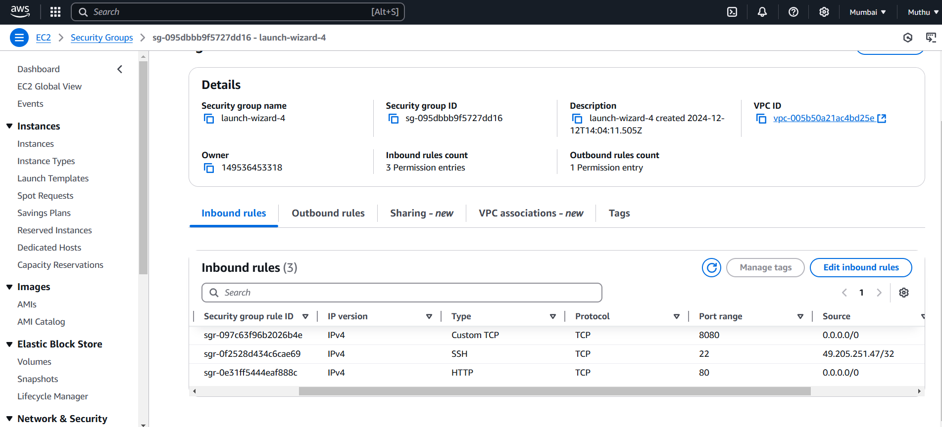

**SSH Connection to Instance:**

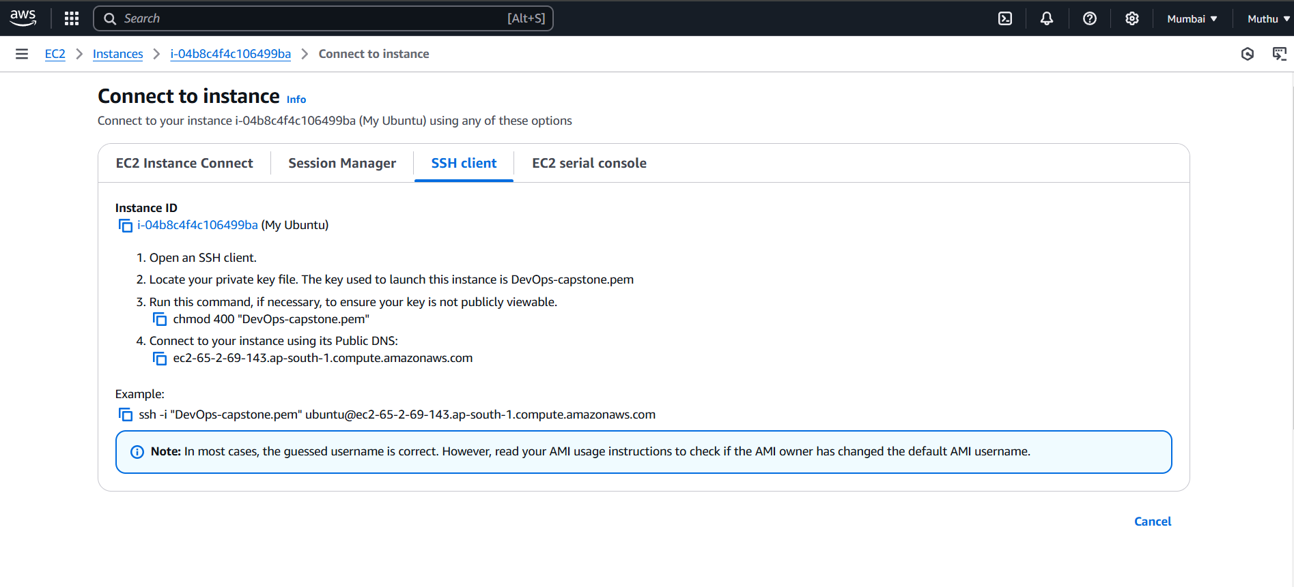

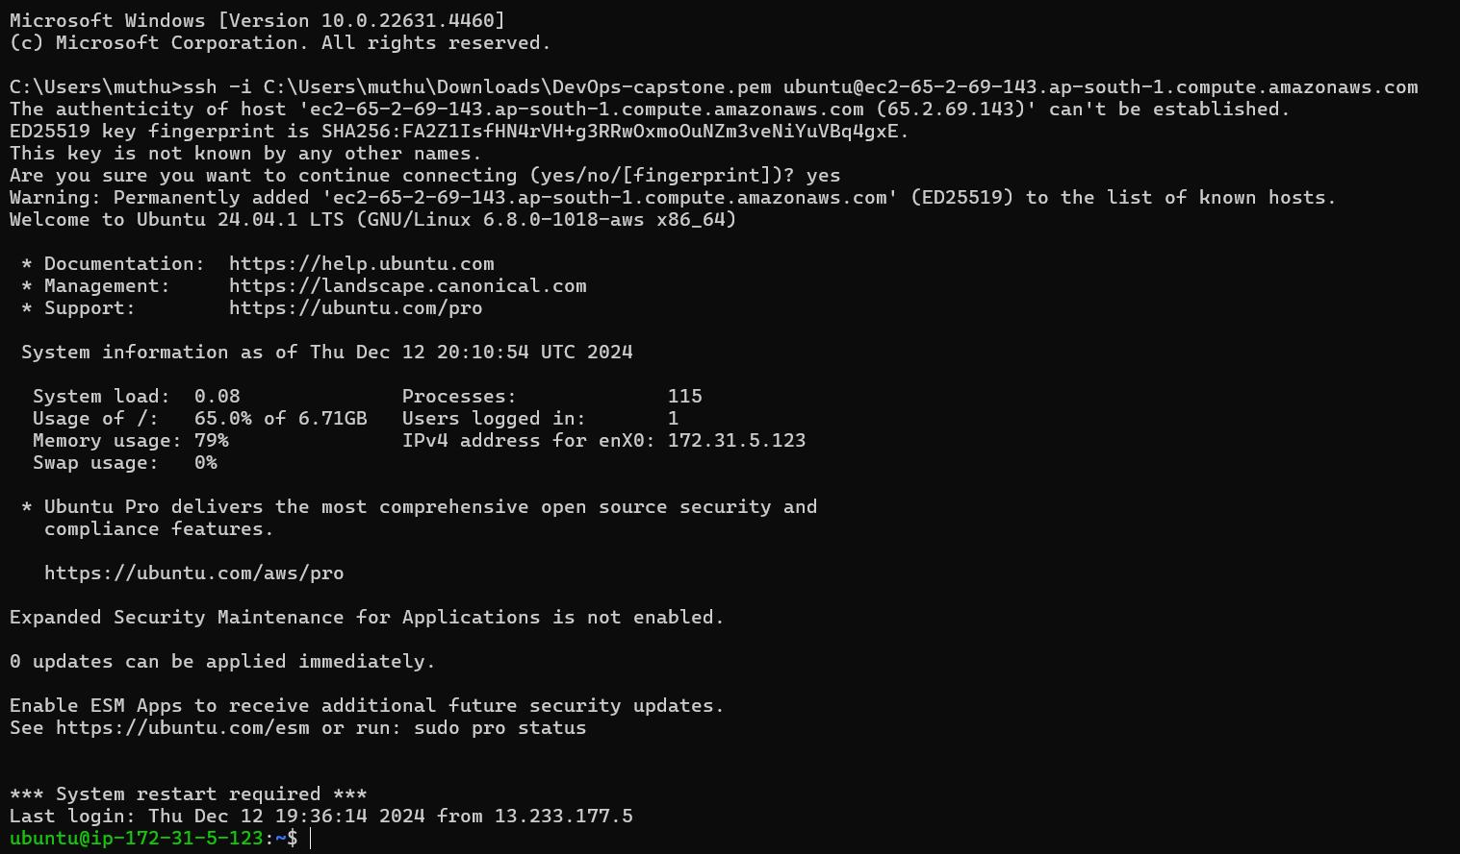

**Dockerfile:**

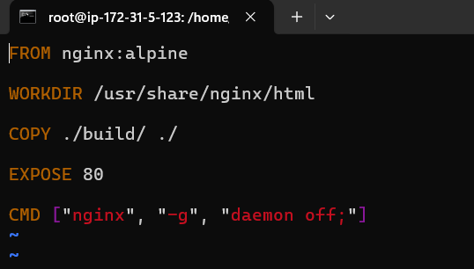

**Docker Compose File:**

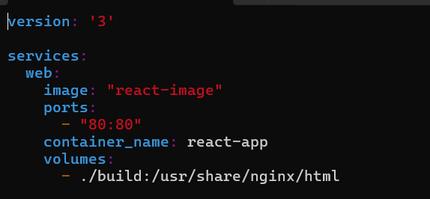

**Build.sh:**

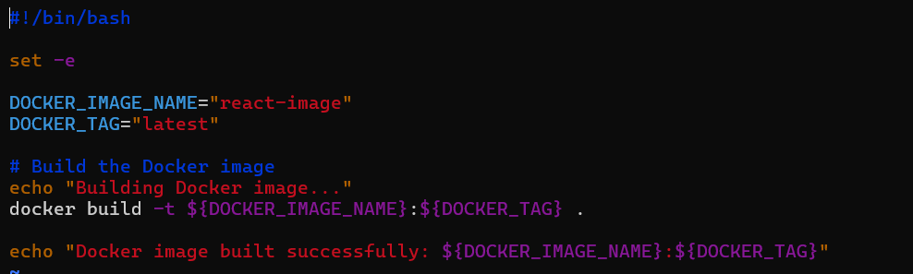

**Deploy.sh:**

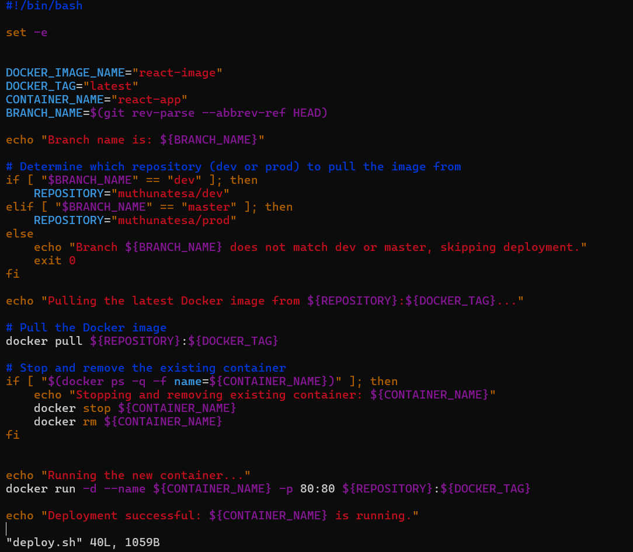

**GitHub Repo:**

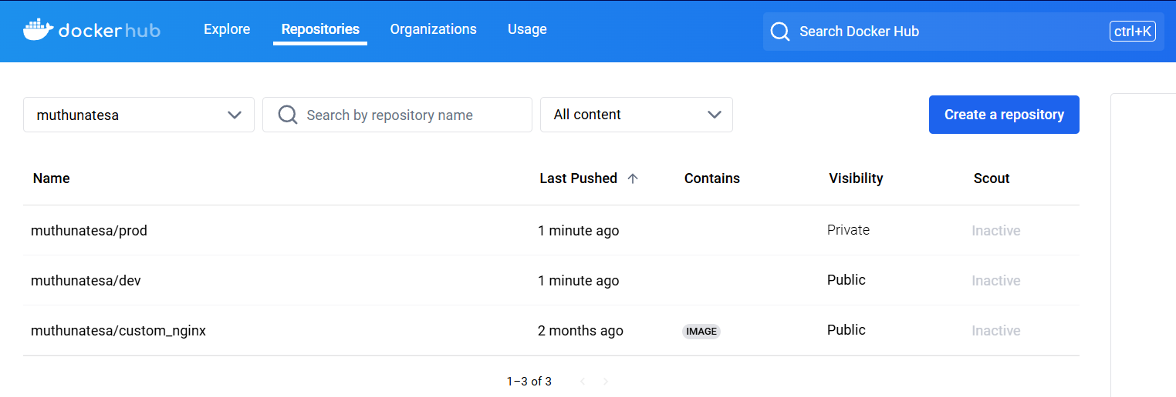

**Git :**

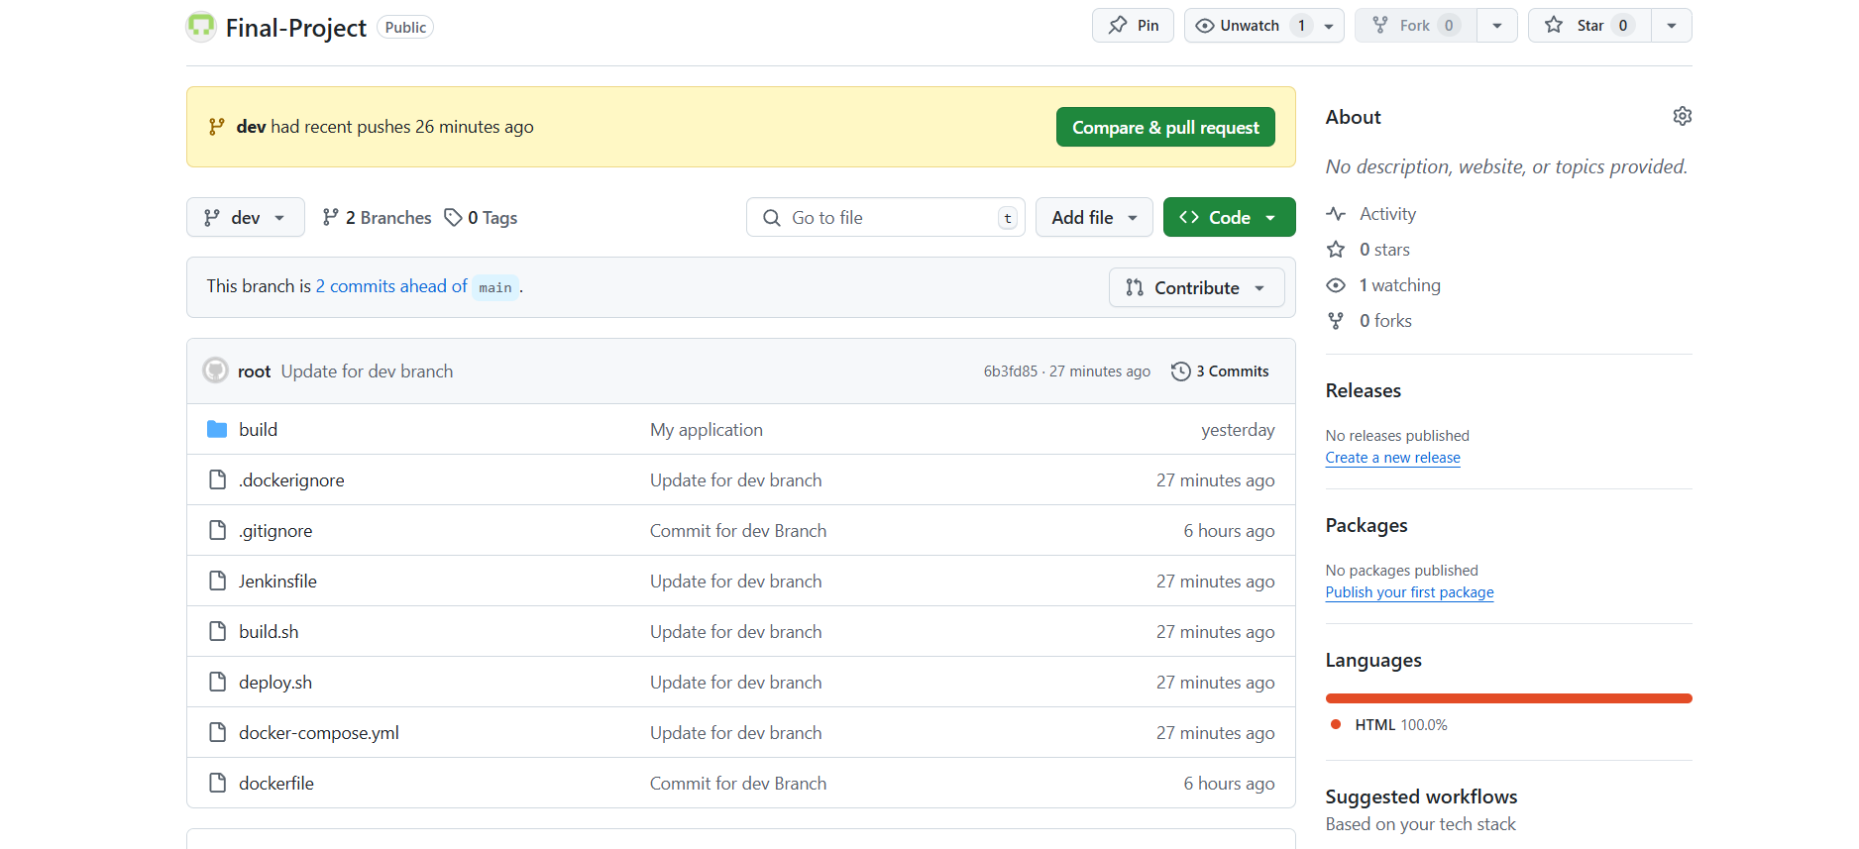

**Jenkins Login Page:**

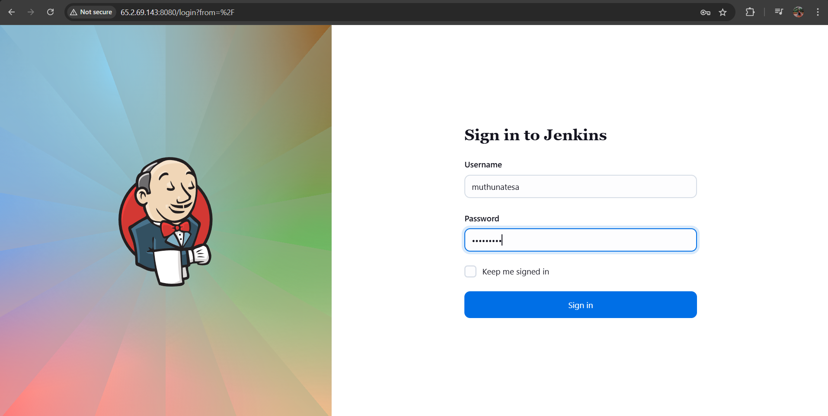

**Jenkins Multibranch Pipeline configuration:**

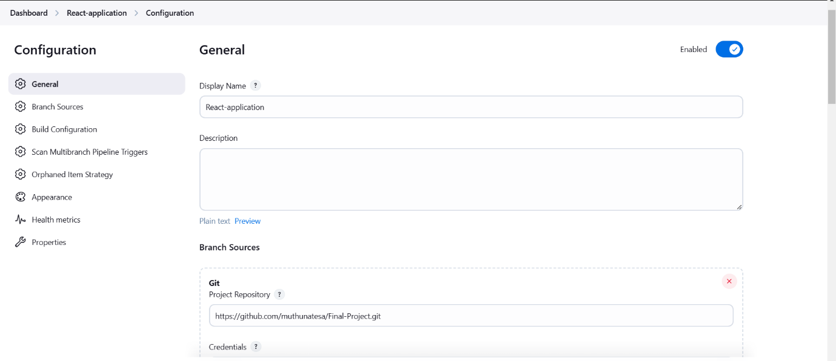

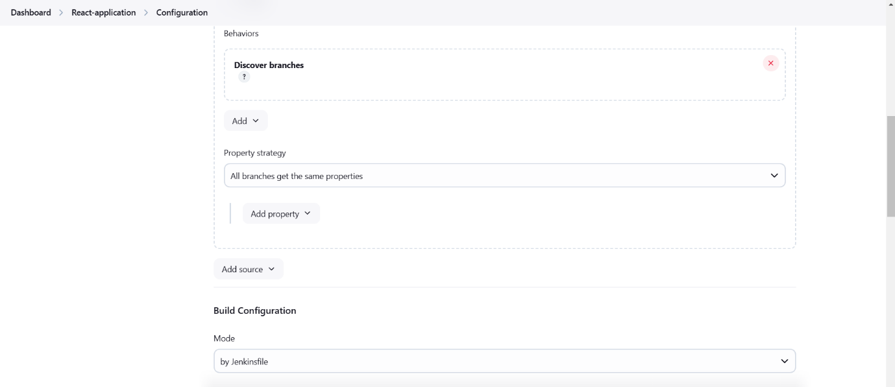

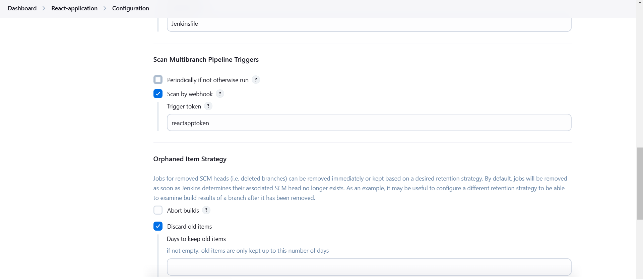

**Webhook Setup:**

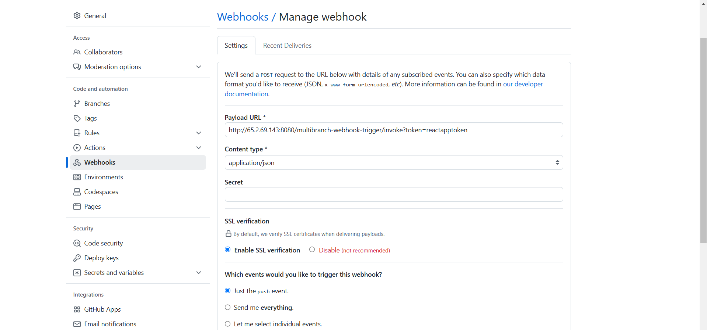

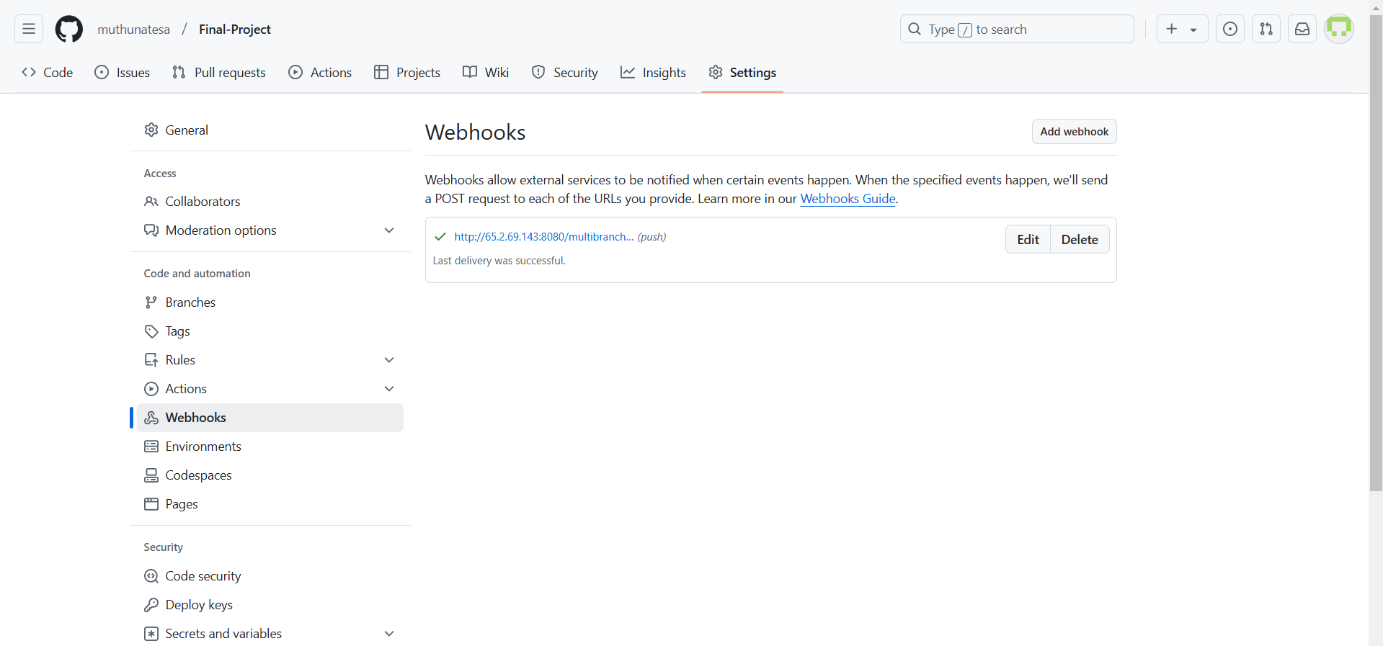

**After Pushing the code to the “dev” Branch Jenkins Build Level:**

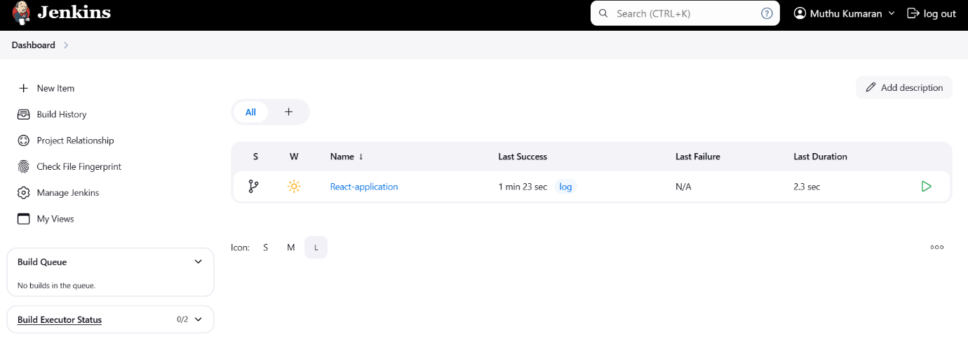

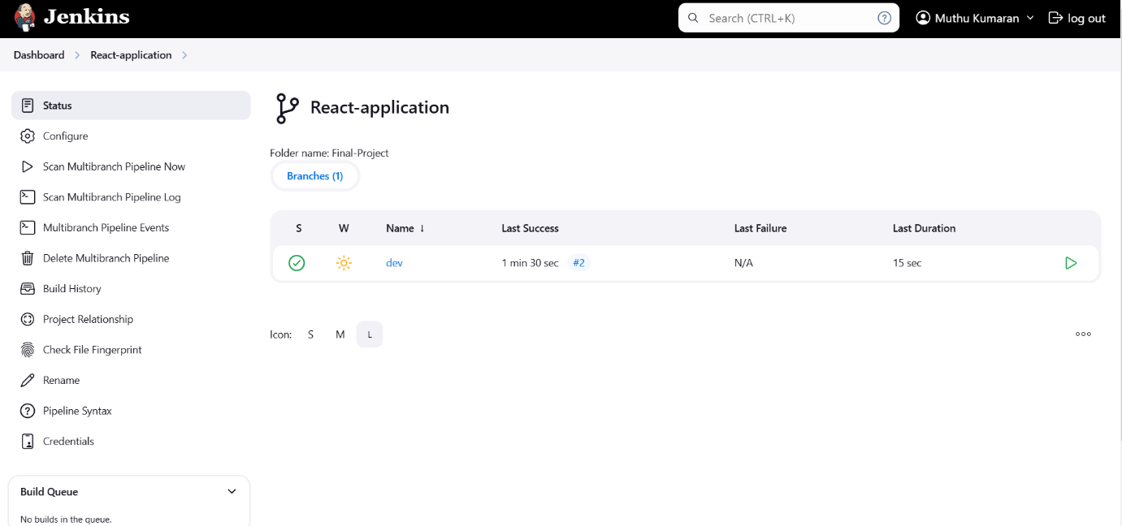

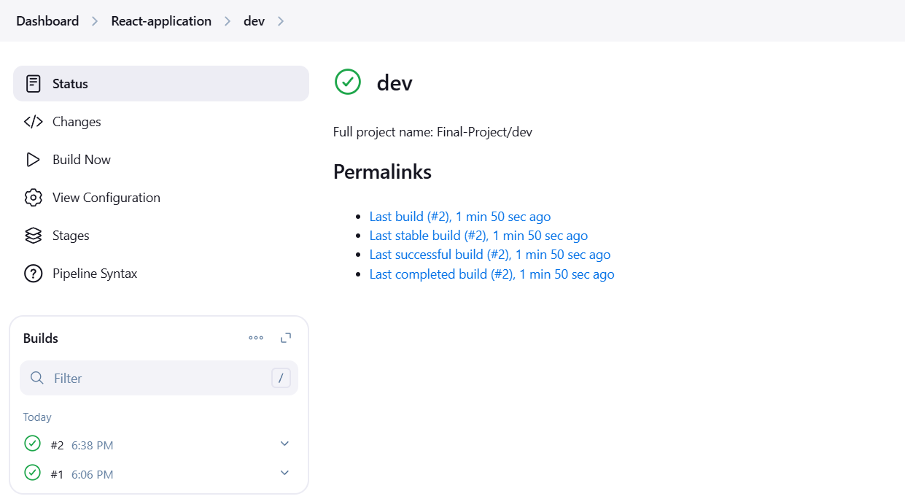

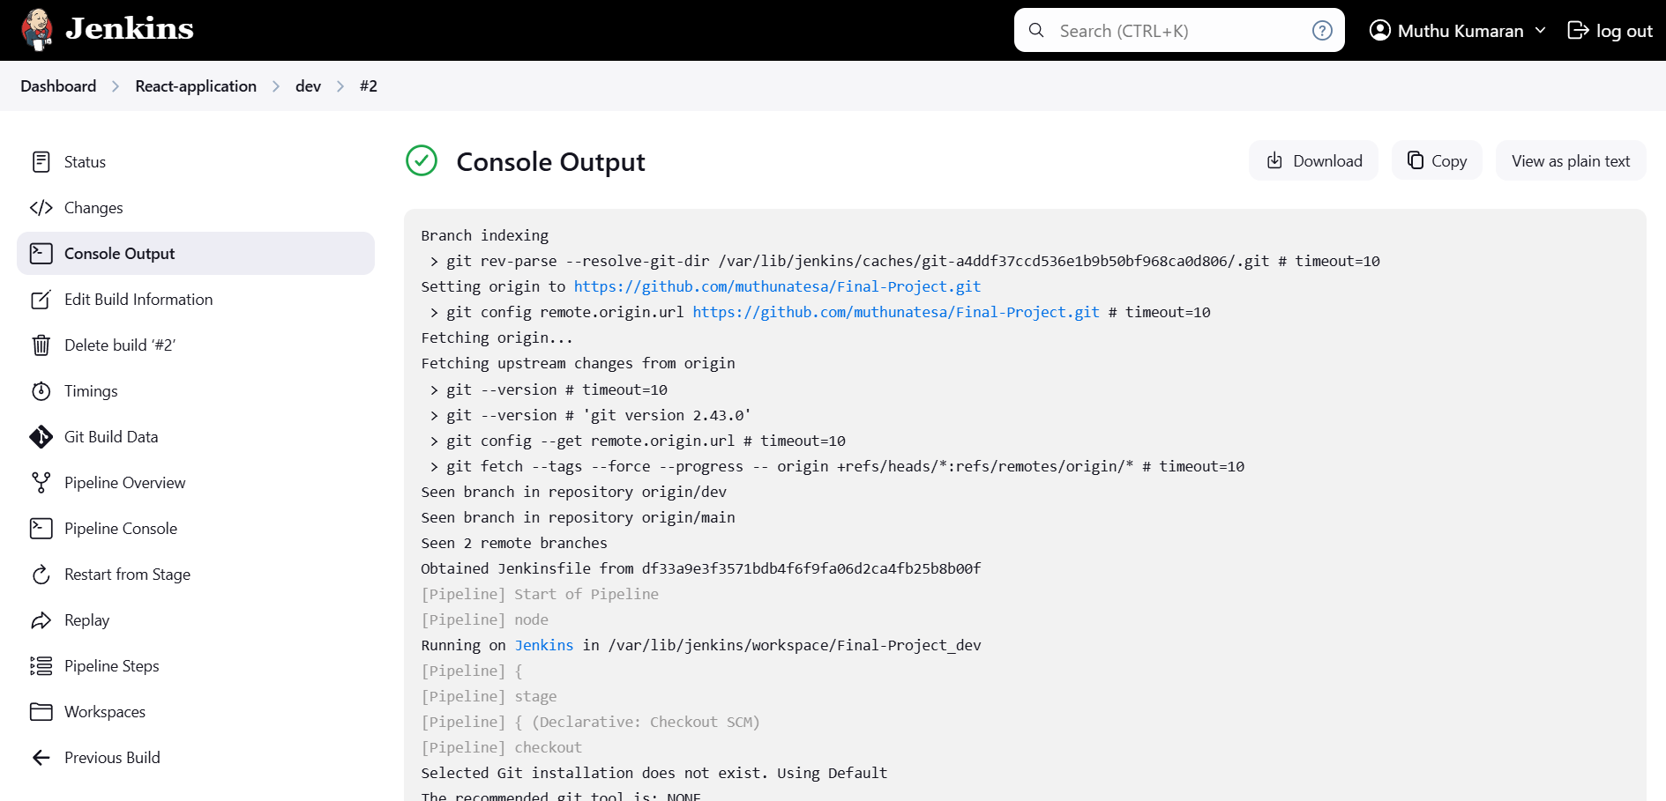

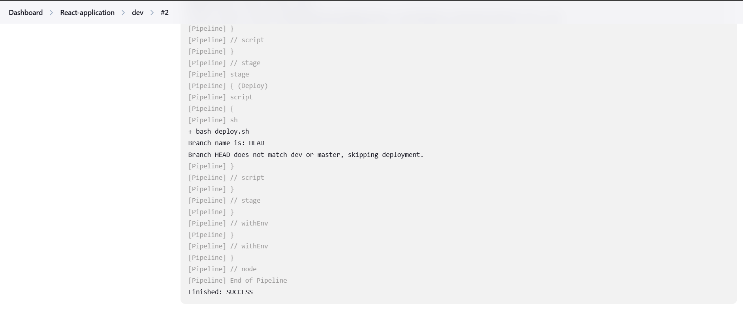

**Docker Hub After pushed code to “dev” Branch:**

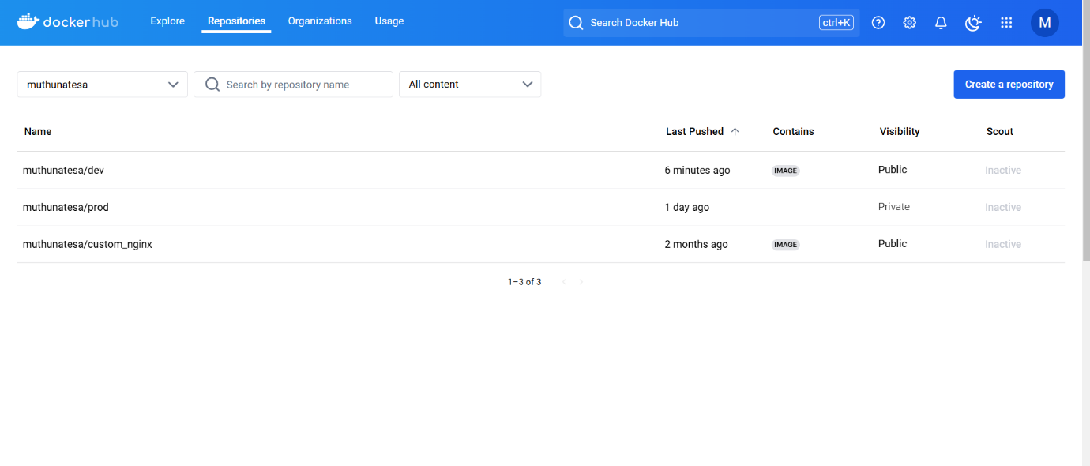

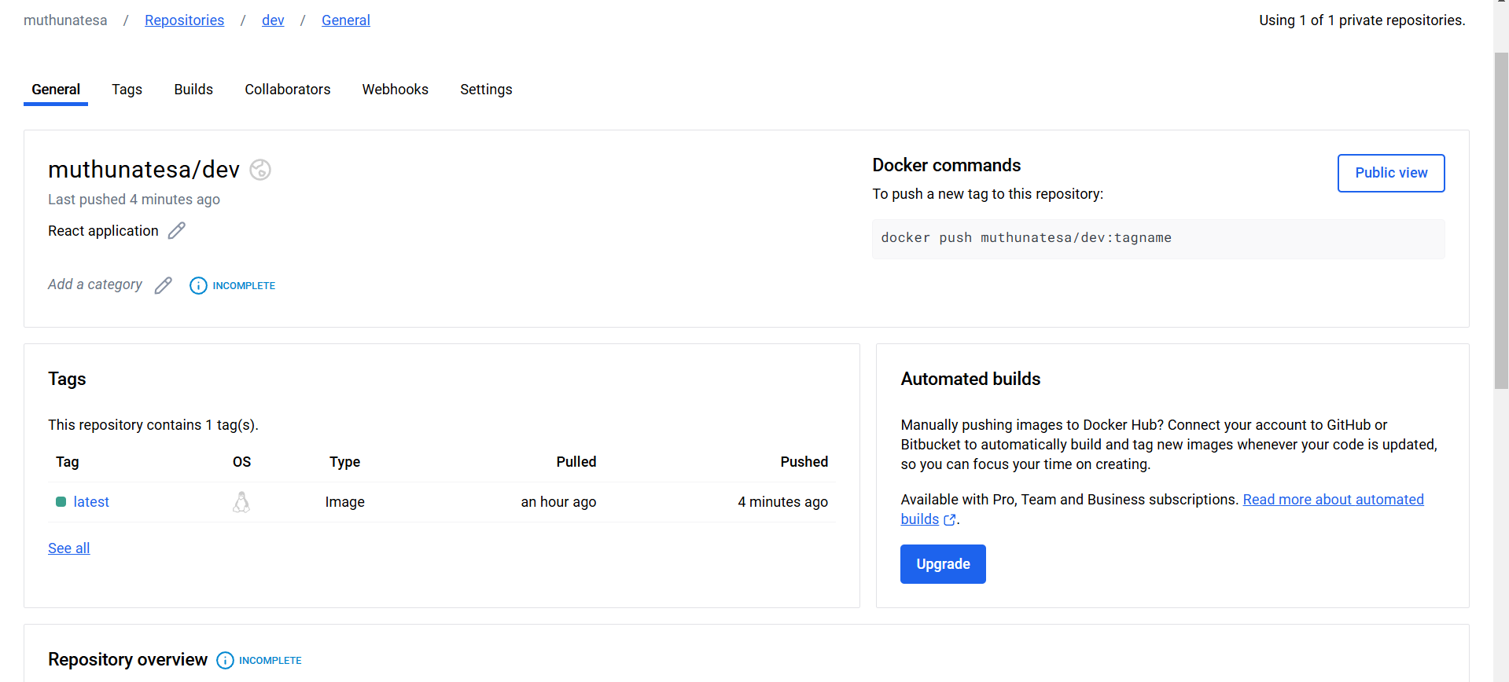

**Merging the “dev” Branch into “Main” Branch Build status in Jenkins:**

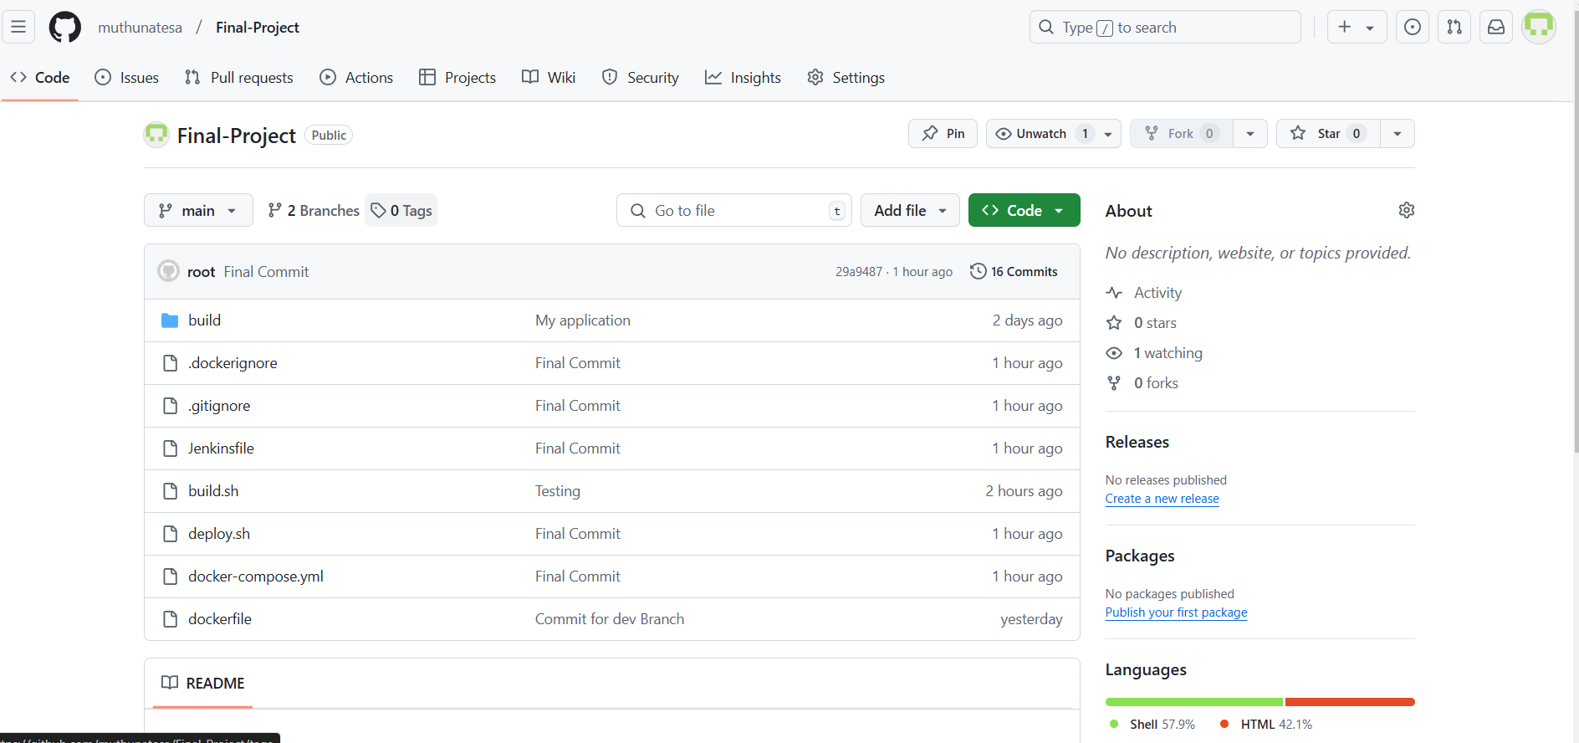

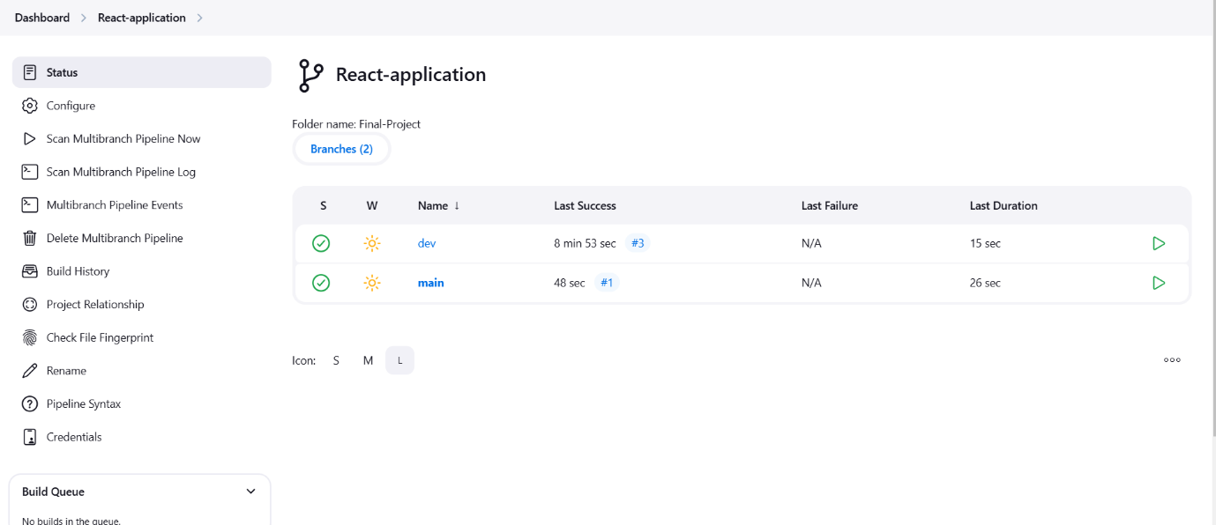

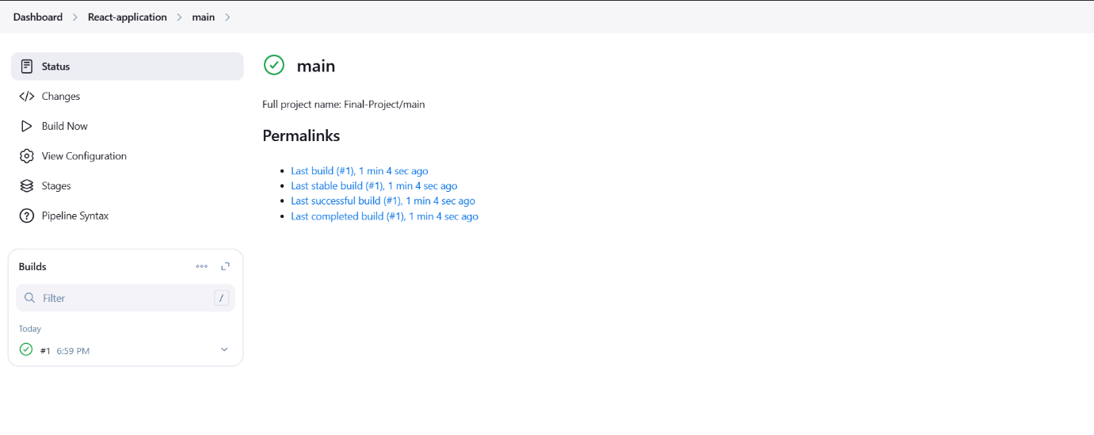

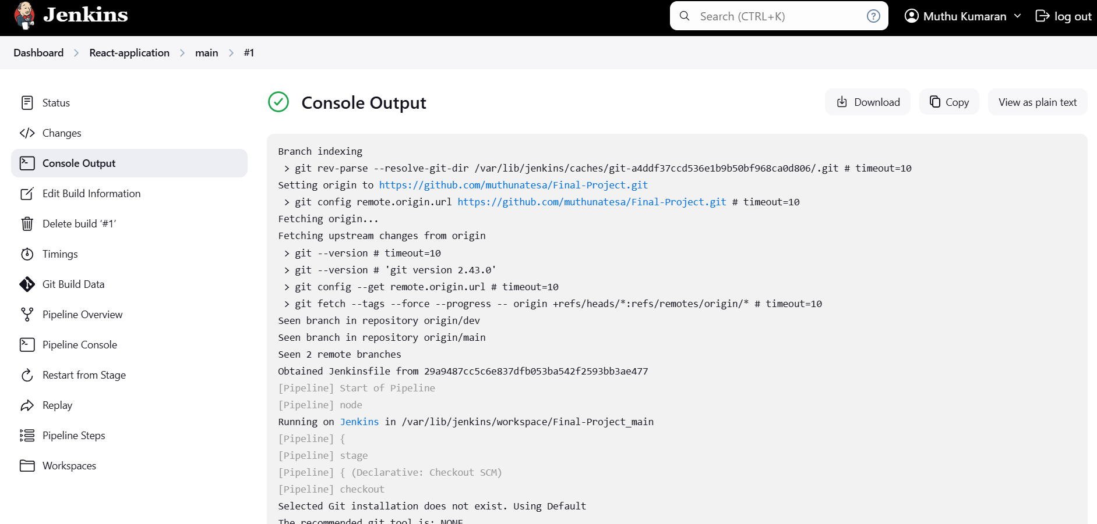

**Docker Hub status after merging the code from “dev” to “main”:**

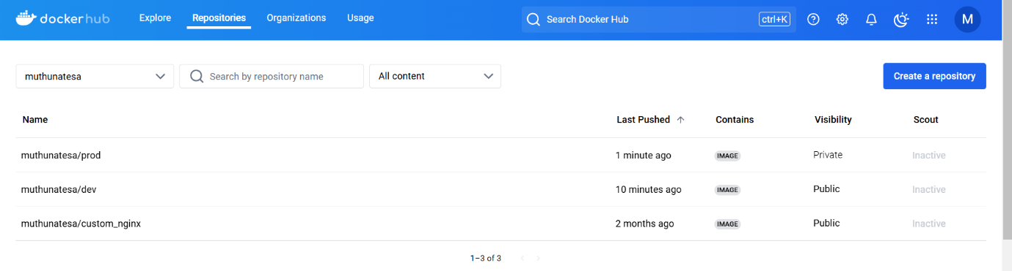

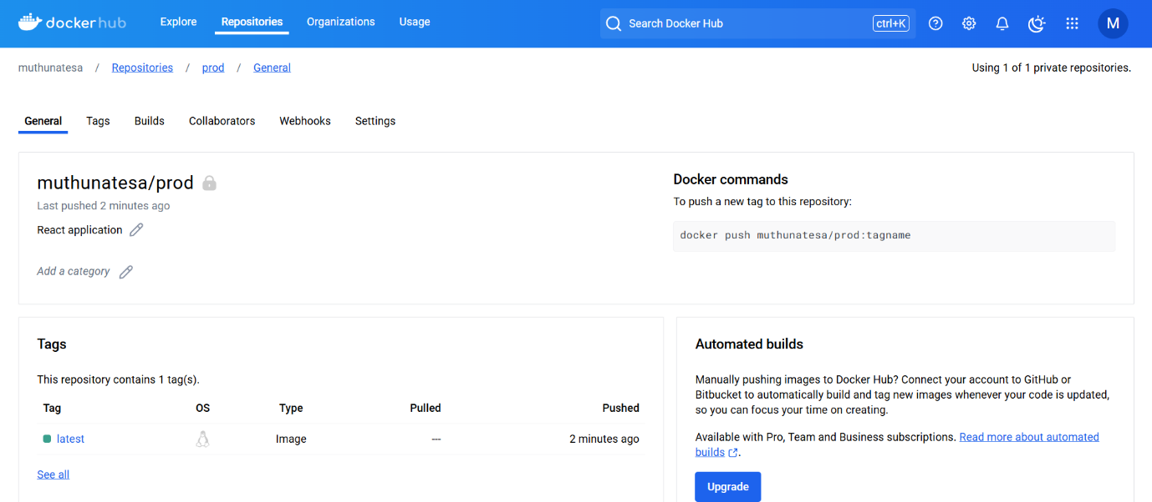

**Deployed site Page:**

