V.S.B ENGINEERING COLLEGE, KARUR
AN ATONOMOUS INSTITUTION
APTITUDE QUESTIONS

DATA INTERPRETATION:
- Study the following table and answer the questions based on it. Expenditures of a Company (in Lakh Rupees) per Annum Over the given Years. 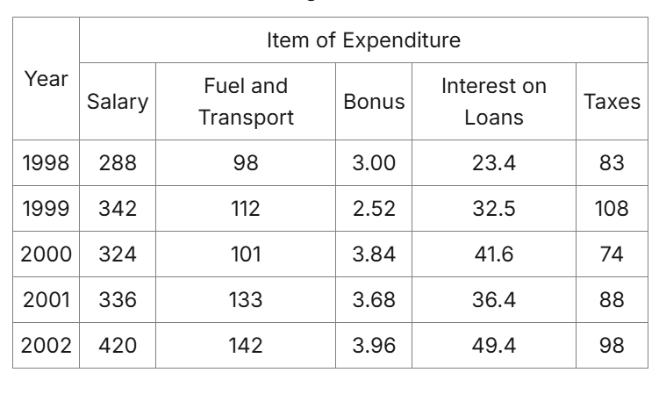

- What is the average amount of interest per year which the company had to pay during this period?
- Rs. 32.43 lakhs
- Rs. 33.72 lakhs
- Rs. 34.18 lakhs
- Rs. 36.66 lakhs

ii) The total amount of bonus paid by the company during the given period is approximately what percent of the total amount of salary paid during this period?
a) 0.1%
b) 0.5%
c) 1%
d) 1.25%
iii) Total expenditure on all these items in 1998 was approximately what percent of the total expenditure in 2002?
- 62%
- 66%
- 69%
- 71%

iv) The total expenditure of the company over these items during the year 2000 is?
- Rs. 544.44 lakhs
- Rs. 501.11 lakhs
- Rs. 446.46 lakhs
- Rs. 478.87 lakhs

v) The ratio between the total expenditure on Taxes for all the years and the total expenditure on Fuel and Transport for all the years respectively is approximately?
a) 4:7
b) 10:13
c) 15:18
d) 5:8

- Study the following table and answer the questions. Number of Candidates Appeared and Qualified in a Competitive Examination from Different States Over the Years.

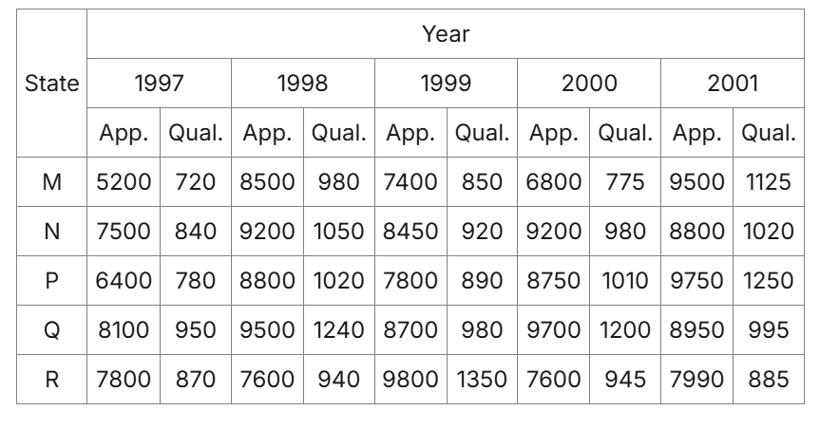

1) Total number of candidates qualified from all the states together in 1997 is approximately what percentage of the total number of candidates qualified from all the states together in 1998?
- 72%
- 77%
- 80%
- 83%

- What is the average candidates who appeared from State Q during the given years?
- 8700
- 8760
- 8990
- 8920

- In which of the given years the number of candidates appeared from State P has maximum percentage of qualified candidates?
- 1997
- 1998
- 1999
- 2001

- What is the percentage of candidates qualified from State N for all the years together, over the candidates appeared from State N during all the years together?
- 12.36%
- 12.16%
- 11.47%
- 11.15%

- The percentage of total number of qualified candidates to the total number of appeared candidates among all the five states in 1999 is?
- 11.49%
- 11.84%
- 12.21%
- 12.57%

- The following table gives the percentage of marks obtained by seven students in six different subjects in an examination. The Numbers in the Brackets give the Maximum Marks in Each Subject.

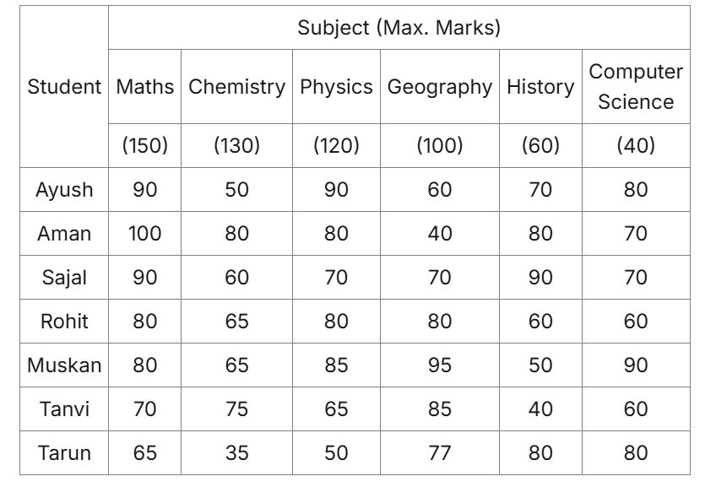
1) What are the average marks obtained by all the seven students in Physics? (rounded off to two digit after decimal)
a) 77.26
b) 89.14
c) 91.37
d) 96.11

2) The number of students who obtained 60% and above marks in all subjects is?
a) 1
b) 2
c) 3
d) None

- What was the aggregate of marks obtained by Sajal in all the six subjects?
- 409
- 419
- 429
- 449

- In which subject is the overall percentage the best?
- Maths
- Chemistry
- Physics
- History

- What is the overall percentage of Tarun?
- 52.5%
- 55%
- 60%
- 63%

ANALOGY:
- CUP : LIP :: BIRD : ?
- BUSH
- GRASS
- FOREST
- BEAK

- Flow : River :: Stagnant : ?
- Rain
- Stream
- Pool
- Canal

- Paw : Cat :: Hoof : ?
- Lamb
- Elephant
- Lion
- Horse

- Ornithologist : Bird :: Archaeologist : ?
- Islands
- Mediators
- Archaeology
- Aquatic

- Peacock : India :: Bear : ?
- Australia
- America
- Russia
- England

- REASON : SFBTPO :: THINK : ?
- SGHMJ
- UIJOL
- UHNKI
- UJKPM

- Carbon : Diamond :: Corundum : ?
- Garnet
- Ruby
- Pukhraj
- Pearl

- NATION : ANTINO :: HUNGRY : ?
- HNUGRY
- UHNGYR
- YRNGUH
- UNHGYR

- Architect : Building :: Sculptor : ?
- Museum
- Stone
- Chisel
- Statue

- Eye : Myopia :: Teeth : ?
- Pyorrhoea
- Cataract
- Trachoma
- Eczema

- Conference : Chairman :: Newspaper : ?
- Reporter
- Distributor
- Printer
- Editor

- Safe : Secure :: Protect : ?
- Lock
- Sure
- Guard
- Conserve

- Master : OCUVGT :: LABOUR : ?
- NCDQWT
- NDERWT
- NBERWT
- NEDRWT

- Microphone : Loud :: Microscope : ?
- Elongate
- Investigate
- Magnify
- Examine

- Melt : Liquid :: Freeze : ?
a) Ice
- Condense
- Solid
- Force

