NAME: KINSHIYA CJ REG NO: 963323121034
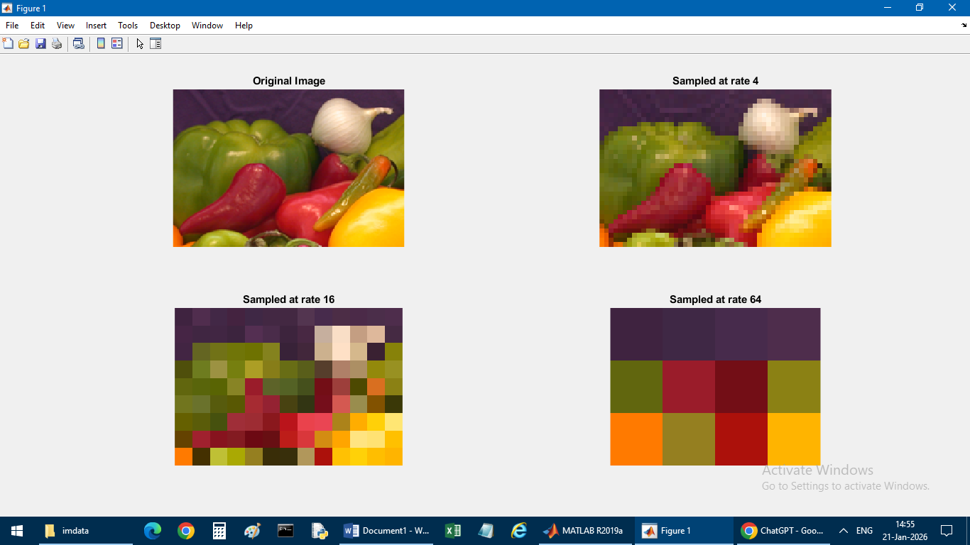
OUTPUT
SAMPLING

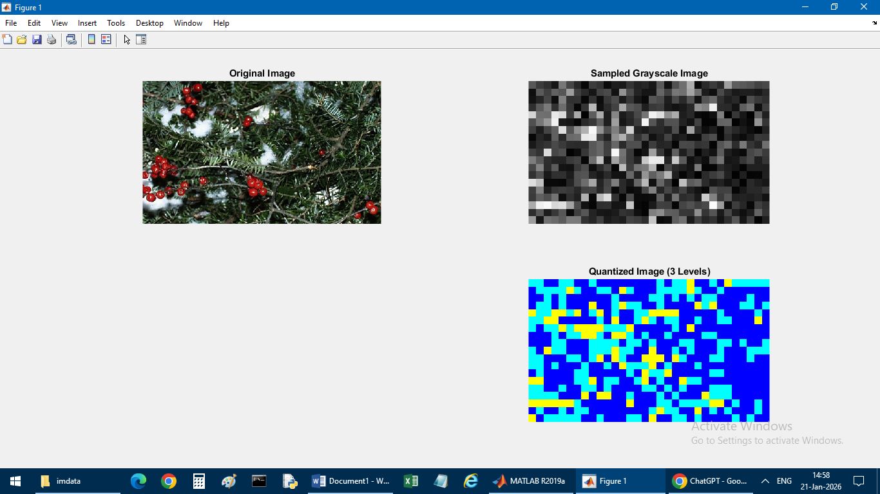
QUANTIZATION

NAME: KINSHIYA CJ REG N:963323121034
PROGRAM

% IMAGE SAMPLING
clc;
close all;
clear;
% Read built-in image
a = imread('Onion.png');
% Display original image
subplot(2,2,1);
imshow(a);
title('Original Image');
% Sampling rates
rates = [4 16 64];
% Sampling loop
for i = 1:length(rates)
% Subsample image
S = a(1:rates(i):end, 1:rates(i):end,:);
% Display subsampled image
subplot(2,2,i+1);
imshow(S);
title(['Sampled at rate ' num2str(rates(i))]);
end

NAME: KINSHIYA CJ REG NO:963323121034
PROGRAM
% IMAGE QUANTIZATION
clc;
close all;
clear;
filename = 'Desert.jpg';
% If image not found, automatically use peppers.png silently
if ~isfile(filename)
filename = ('greens.jpg'); % built-in image
end
a = imread(filename);
% ---- Original Image ----
subplot(2,2,1);
imshow(a);
title('Original Image');
% Convert to grayscale for quantization
gray = rgb2gray(a);
% ---- Sampling ----
subsample = 16;
S = gray(1:subsample:end, 1:subsample:end);
subplot(2,2,2);
imshow(S);
title('Sampled Grayscale Image');
% ---- Quantization ----
thresh = multithresh(S, 2); % 3 levels
S1 = imquantize(S, thresh);
rgb = label2rgb(S1);

subplot(2,2,4);
imshow(rgb);
title('Quantized Image (3 Levels)');

