**Namma Yatri MySQL Queries**

**1.Total Trips**

SELECT COUNT(DISTINCT tripid) AS Total_trips

FROM trips_details4;



**2.Total Drivers**

SELECT COUNT(DISTINCT driverid) AS Total_drivers

FROM trips;



**3.Total Earnings**

SELECT SUM(fare) AS Total_earnings

FROM trips;



**4.Total Completed Trips**

SELECT SUM(end_ride) AS Total_completed_rides

FROM trips_details4;



**5.Total Searches**

SELECT SUM(searches) AS total_searches

FROM trips_details4;



**6.Total Searches Which got Estimate**

SELECT

SUM(searches_got_estimate) AS total_estimate_searches

FROM trips_details4;



**7.Total Searches for Quotes**

SELECT

SUM(searches_for_quotes) AS total_quote_searches

FROM trips_details4;



**8.Total searches which got quotes**

SELECT

SUM(searches_got_quotes) AS total_successful_quotes

FROM trips_details4;



**9.Total driver cancelled**

SELECT

SUM(driver_not_cancelled) AS total_driver_cancelled

FROM trips_details4;



**10.Total OTP entered**

SELECT

SUM(otp_entered) AS total_otp_entered

FROM trips_details4;



**11.Total end ride**

SELECT

SUM(end_ride) AS total_completed_rides

FROM trips_details4;



**12.Cancelled bookings by driver**

SELECT

SUM(customer_not_cancelled) AS total_customers_kept,

FROM trips_details4;



**13.Average distance per trip**

SELECT AVG(distance) AS AVG_DISTANCE

FROM trips;



**14.Average fare per trip**

SELECT AVG(fare) AS AVG_FARE

FROM trips;



**15.Distance travelled**

SELECT SUM(distance) AS Total_Distance

FROM trips;



**16.Which is the most used payment method**

SELECT a.method AS Payment_Method

FROM payment a

INNER JOIN

(

SELECT

faremethod,

COUNT(DISTINCT tripid) AS total_trips

FROM trips

GROUP BY faremethod

ORDER BY total_trips DESC

LIMIT 1

) b

ON a.id = b.faremethod;



**17.The highest payment was made through which instrument**

SELECT a.method AS Payment_Method

FROM payment a

Inner join

(select

faremethod,

SUM(fare)

FROM trips

GROUP BY faremethod

ORDER BY sum(fare) desc LIMIT 1) b

WHERE a.id = b.faremethod; ;



**18.Which two locations had the most trips**

SELECT *

FROM (

SELECT *, DENSE_RANK() OVER (ORDER BY total_trips DESC) AS ranking

FROM (

SELECT

loc_from,

loc_to,

COUNT(DISTINCT tripid) AS total_trips

FROM trips

GROUP BY loc_from, loc_to

) AS a

) AS b

WHERE ranking = 1;

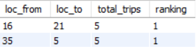

**19.Top 5 earning drivers**

SELECT *

FROM (

SELECT *, DENSE_RANK() OVER (ORDER BY fare DESC) AS ranking

FROM (

SELECT driverid, SUM(fare) AS fare

FROM trips

GROUP BY driverid

) b

) c

WHERE ranking < 6;

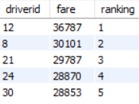

**20.Which duration had more trips**

SELECT *

FROM (

SELECT *, RANK() OVER (ORDER BY Counts DESC) AS Ranking

FROM (

SELECT duration, COUNT(DISTINCT tripid) AS Counts

FROM trips

GROUP BY duration

) b

) c

WHERE Ranking = 1;



**21.Which driver , customer pair had more orders**

SELECT *

FROM (

SELECT *, RANK() OVER (ORDER BY Counts DESC) AS Ranking

FROM (

SELECT driverid, custid, COUNT(DISTINCT tripid) AS Counts

FROM trips

GROUP BY driverid, custid

) b

) c

WHERE Ranking = 1;

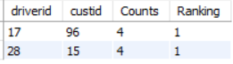

**22.Search to estimate rate**

SELECT

ROUND(SUM(searches_got_estimate) * 100.0 / SUM(searches), 2) AS Search_to_estimate_rate

FROM trips_details4;



**23.Estimate to search for quote rates**

SELECT

ROUND(SUM(searches_for_quotes) * 100.0 / SUM(searches), 2) AS Search_for_quotes_rate

FROM trips_details4;

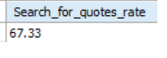

**24.Which area got highest trips in which duration**

SELECT *

FROM (

SELECT *, RANK() OVER (PARTITION BY duration ORDER BY Counts DESC) AS Ranking

FROM (

SELECT duration, loc_from, COUNT(DISTINCT tripid) AS Counts

FROM trips

GROUP BY duration, loc_from

) AS a

) AS c

WHERE Ranking = 1;

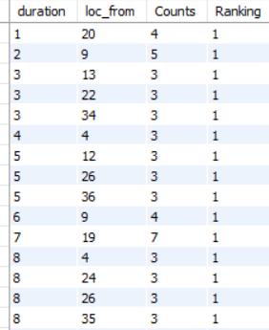

**25.Which duration got highest number of trips in each of the location present**

SELECT *

FROM (

SELECT *, RANK() OVER (PARTITION BY loc_from ORDER BY Counts DESC) AS Ranking

FROM (

SELECT loc_from ,duration, COUNT(DISTINCT tripid) AS Counts

FROM trips

GROUP BY duration, loc_from

) AS a

) AS c

WHERE Ranking = 1;

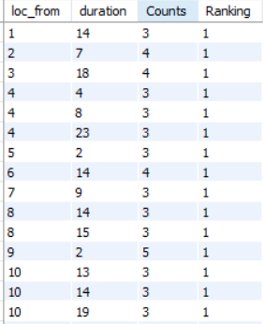

**26.Which area got the highest fares, cancellations,trips**

a. Highest fares

SELECT *

FROM (

SELECT *,

RANK() OVER (ORDER BY Total_fare DESC) AS Ranking

FROM

(SELECT loc_from,sum(fare) AS Total_fare FROM trips

GROUP BY loc_from) AS B

) AS a

WHERE Ranking = 1;



b. Highest cancellations

SELECT *

FROM (

SELECT *,

RANK() OVER (ORDER BY Cancelled DESC) AS Ranking

FROM

(SELECT loc_from,COUNT(*),sum(driver_not_cancelled) AS Cancelled FROM trips_details4

GROUP BY loc_from) AS B

) AS a

WHERE Ranking = 1;



c. Highest trips

SELECT *

FROM (

SELECT *,

RANK() OVER (ORDER BY Cancelled DESC) AS Ranking

FROM

(SELECT loc_from,COUNT(*),sum(customer_not_cancelled) AS Cancelled FROM trips_details4

GROUP BY loc_from) AS B

) AS a

WHERE Ranking = 1;



**27.Which duration got the highest trips and fares**

SELECT *

FROM (

SELECT *,

RANK() OVER (ORDER BY Total_fare DESC) AS Ranking

FROM

(SELECT duration,COUNT(distinct tripid) AS Count,sum(fare) AS Total_fare FROM trips

GROUP BY duration) AS B

) AS a

WHERE Ranking = 1;

