CVastra AI
Project Planning & System Architecture
NSDC Junior Full Stack Developer Internship — Week 1 Task
Prepared by: Muthu

1. Project Brief

1.1 Purpose
CVastra AI is a full-stack SaaS web application that gives job seekers instant, AI-powered feedback on their resumes. A user uploads a resume, optionally specifies a target job role, and receives a structured, seven-dimension score along with actionable improvement suggestions — replacing generic resume advice with feedback tailored to the document itself.

1.2 Target Users
- College students and recent graduates preparing for placements
- Job seekers applying to multiple roles who want quick, repeatable feedback
- Career-changers who need to know how their resume reads for a new domain

1.3 Core Features
- Resume upload (PDF / DOCX) with drag-and-drop
- Optional target-role input so scoring can weight relevant keywords
- AI-generated scoring across 7 dimensions: formatting, content quality, keyword match, experience, skills relevance, impact/metrics, and ATS compatibility
- Actionable, bullet-point feedback for each analysis
- Analysis history so users can track improvement across resume versions
- Downloadable PDF report of any analysis
- User authentication so history is tied to an account

1.4 Technology Stack
- Frontend: Vanilla JavaScript, HTML, CSS — deployed on Netlify
- Backend: Node.js with Express — deployed on Render
- AI Engine: Google Gemini API, driven by a structured prompt returning seven scoring dimensions
- Database: MongoDB Atlas (cloud-hosted, document store)
- Authentication: JWT-based session tokens

2. User Flow
The flowchart below traces a user's journey from first visit through resume upload, AI analysis, and reviewing results — including the return paths for checking history or re-uploading an improved resume. It is split across two figures for readability: onboarding through triggering an analysis (Figure 1a), and processing through to the final user actions (Figure 1b).
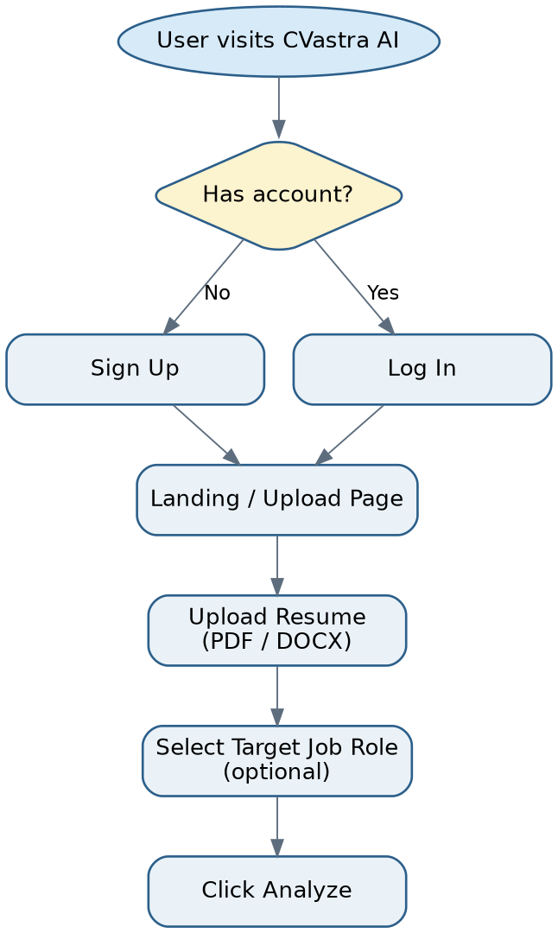
Figure 1a: User flow — onboarding to triggering analysis

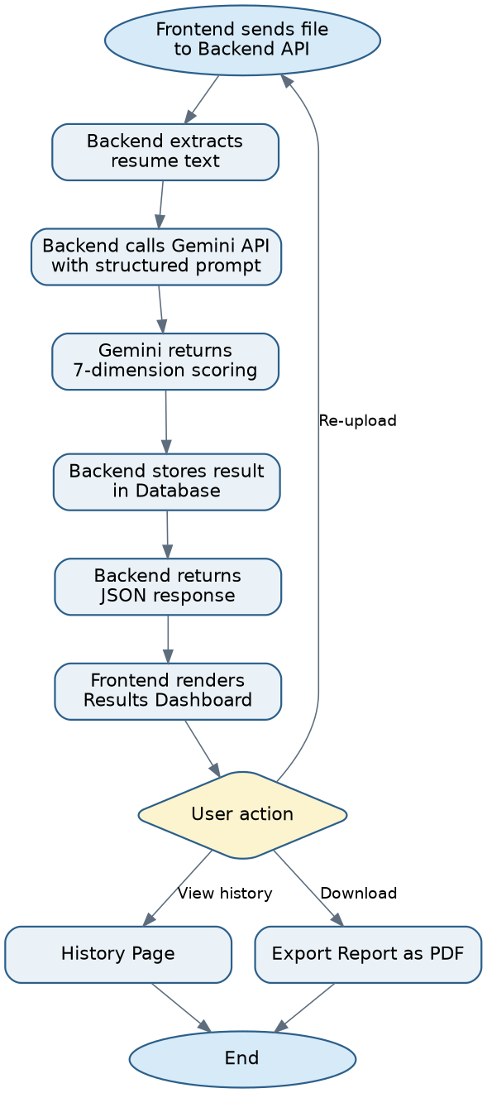
Figure 1b: User flow — processing to final actions

3. Wireframes
Low-fidelity wireframes for the two primary screens: the landing/upload screen where a user starts an analysis, and the results dashboard where scores and feedback are presented.

3.1 Landing / Upload Screen
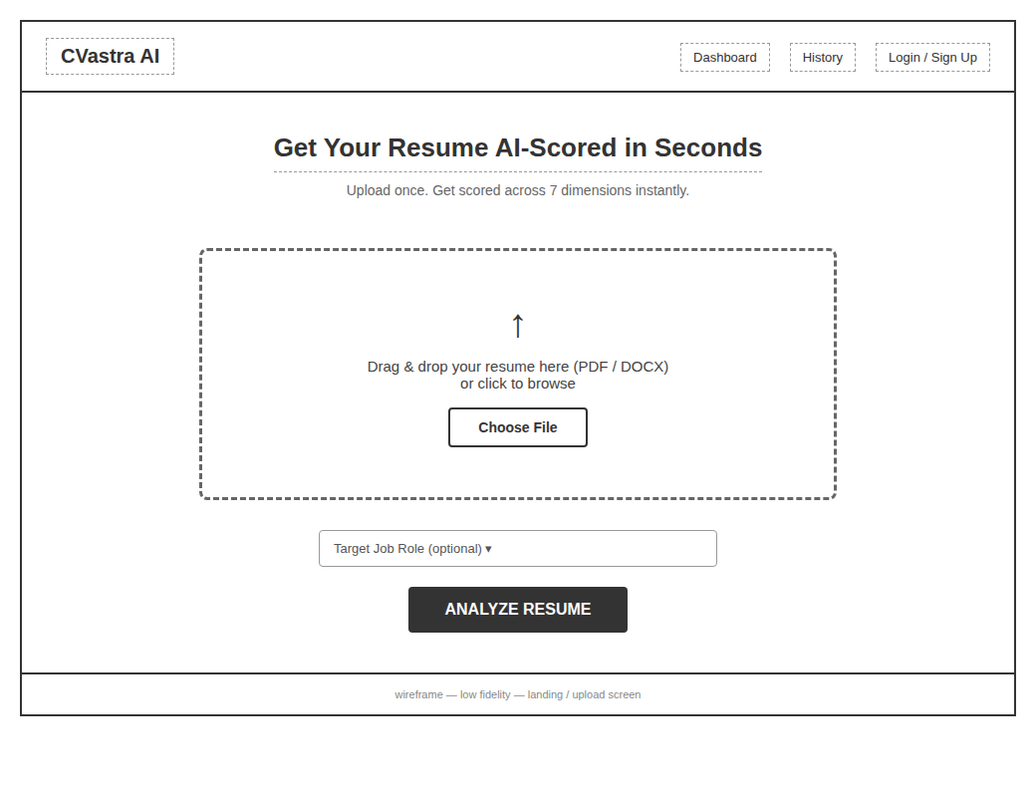
Figure 2: Landing and resume upload screen
Design intent: a single, unambiguous call to action (upload) dominates the screen. The optional role selector is secondary and does not block the primary flow, keeping first-time use frictionless.

3.2 Results Dashboard
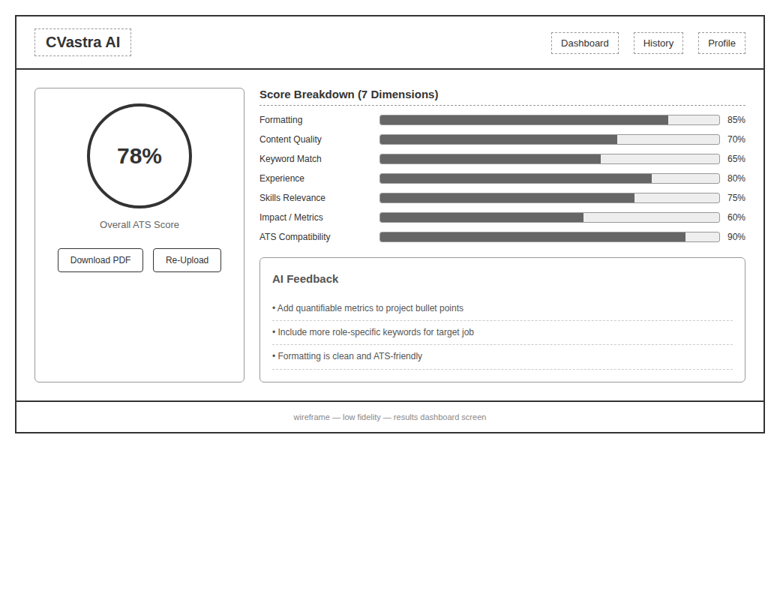
Figure 3: Results dashboard screen
Design intent: the overall score is the largest visual element (left), since it answers the user's first question immediately. The dimension breakdown and written feedback sit to the right in decreasing order of scannability — bars first, prose last — so a user can get value in five seconds or five minutes.

4. Technical Architecture
CVastra AI follows a three-tier architecture: a static frontend, a stateless API backend, and a managed database, with the Gemini API as an external analysis service called from the backend only — the frontend never talks to Gemini directly, which keeps the API key server-side and out of client code.
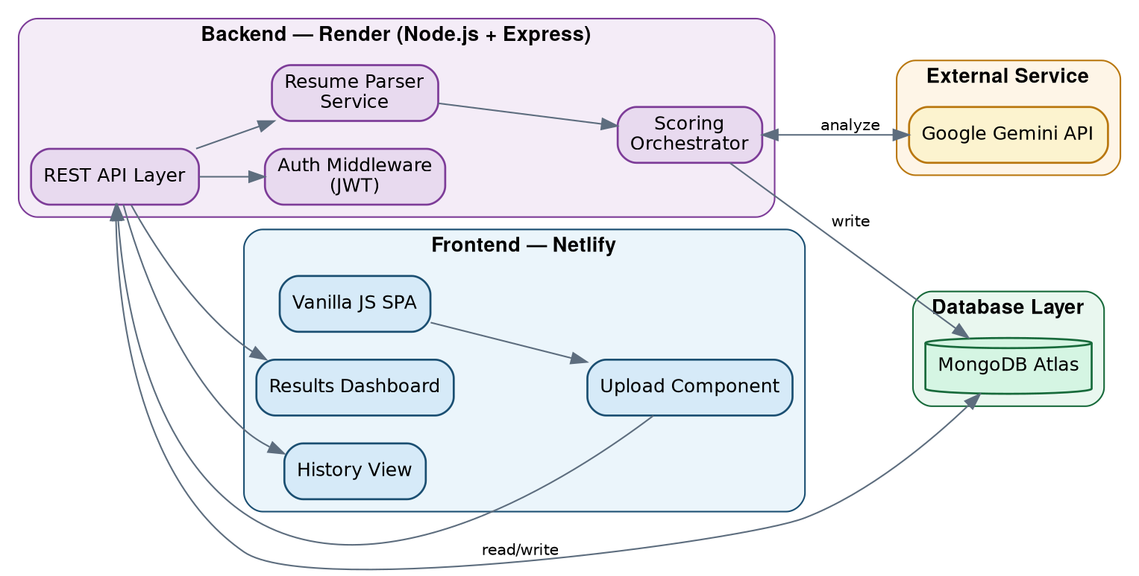
Figure 4: Technical architecture diagram

4.1 Component Responsibilities
- Frontend (Netlify): renders the SPA, handles file selection, calls the backend REST API, and displays results — holds no business logic or secrets
- REST API Layer (Express, Render): routes requests, validates input, and coordinates the parser and scoring orchestrator
- Auth Middleware: verifies JWTs on protected routes (history, export) and attaches the authenticated user to the request
- Resume Parser Service: extracts raw text from uploaded PDF/DOCX files before scoring
- Scoring Orchestrator: builds the structured Gemini prompt, sends the extracted text, and normalizes the returned JSON into the seven scoring dimensions
- Database (MongoDB Atlas): persists users, resumes, and analysis results for history and re-retrieval

4.2 API Endpoints
Method | Endpoint | Description
POST | /api/auth/signup | Register a new user account
POST | /api/auth/login | Authenticate user, issue JWT
POST | /api/resume/upload | Upload resume file, store metadata
POST | /api/resume/analyze | Extract text, call Gemini, store analysis
GET | /api/analysis/:id | Fetch a single analysis result
GET | /api/analysis/history | List all past analyses for logged-in user
GET | /api/analysis/:id/export | Generate downloadable PDF report

4.3 Database Schema
The schema uses three collections. A user owns many resumes; each resume can be analyzed multiple times (e.g. after edits), so resumes and analyses are separate collections rather than one combined document — this keeps history accurate even when a resume file is re-uploaded.
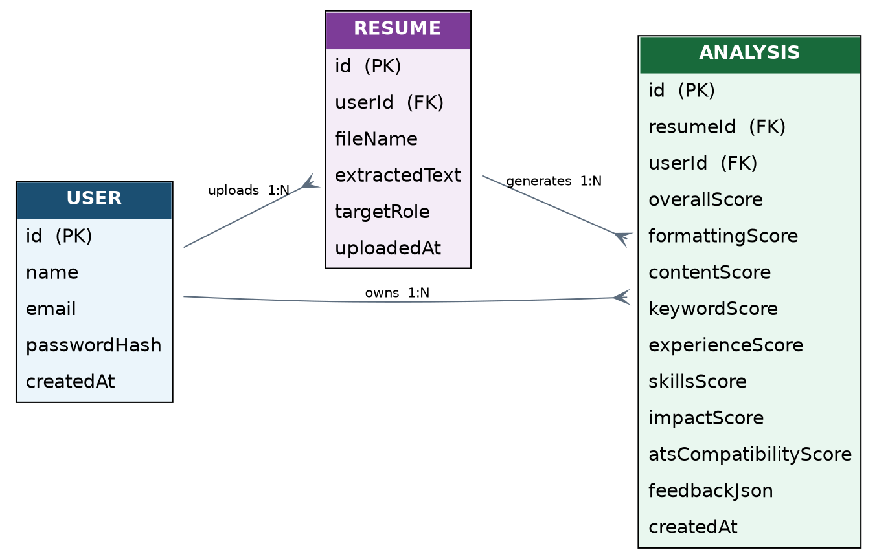
Figure 5: Entity-relationship diagram
- USER — account identity and credentials
- RESUME — one row per uploaded file, linked to its owning user
- ANALYSIS — one row per scoring run, linked to both the resume and the user, storing all seven dimension scores plus overall score and feedback

5. Design Rationale

5.1 Why a decoupled frontend/backend split
Hosting the frontend on Netlify and the backend on Render keeps static asset delivery (fast, CDN-backed) separate from compute (API + AI orchestration). It also matches free-tier hosting limits well, since Netlify's static hosting and Render's web service both have generous free tiers for a project at this scale.

5.2 Why Gemini is called only from the backend
Keeping the Gemini API key server-side prevents it from being exposed in client-side JavaScript, and lets the backend control prompt structure and enforce rate limits independent of the client.

5.3 Why separate Resume and Analysis collections
A user may want to re-analyze the same resume against a different target role, or after making edits, without losing prior results. Separating the two lets analysis history accumulate per resume rather than overwriting it.

5.4 Why JWT-based auth
JWTs avoid server-side session storage, which keeps the Express backend stateless — a good fit for Render's deployment model and for scaling the API layer independently of user sessions.

5.5 Why a 7-dimension scoring structure
A single overall score hides where a resume is weak. Breaking scoring into formatting, content quality, keyword match, experience, skills relevance, impact/metrics, and ATS compatibility gives users a specific, actionable next step instead of one opaque number.

6. Conclusion
This document lays out the purpose, user flow, screen-level design, and technical architecture for CVastra AI. The three-tier structure — static frontend, stateless API backend, managed database, with Gemini as an isolated external service — is intended to be simple to reason about, cheap to host, and straightforward to extend with features like batch resume comparison or recruiter-facing views in later iterations.

