**STOCK CHART APPLICATION**

**MILESTONE 1**

**INDEX PAGE**

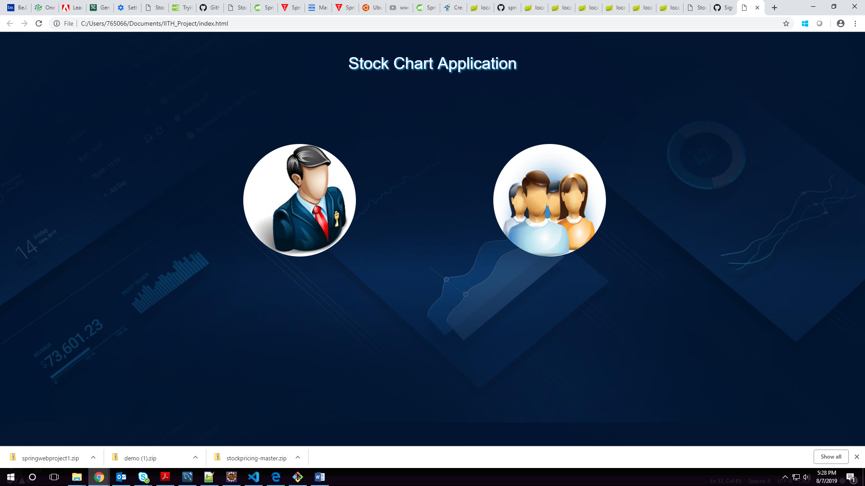

**ADMIN LOGIN PAGE**

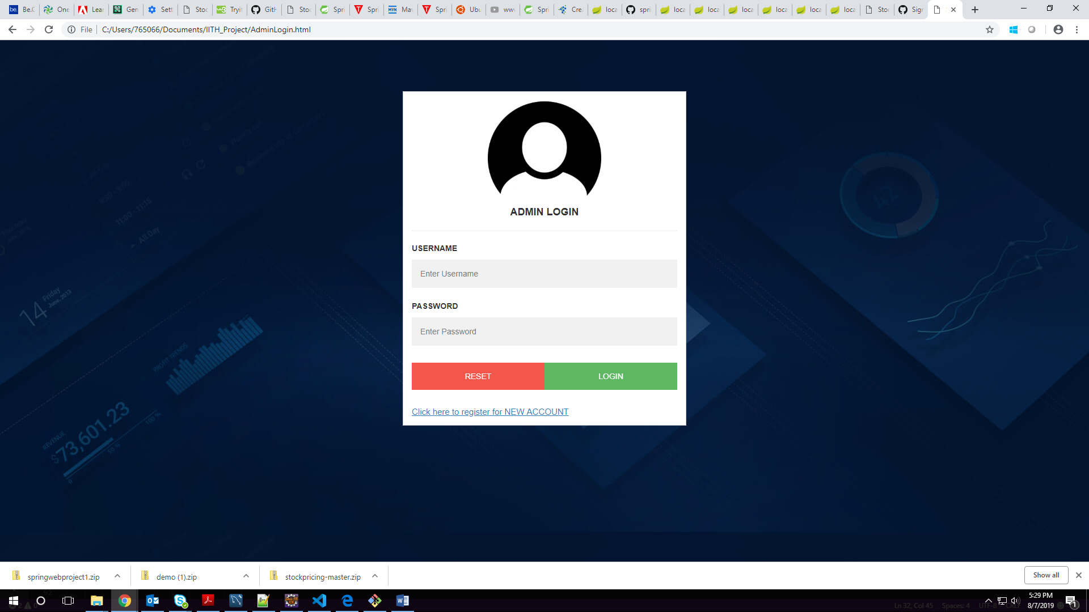

**ADMIN REGISTRATION PAGE**

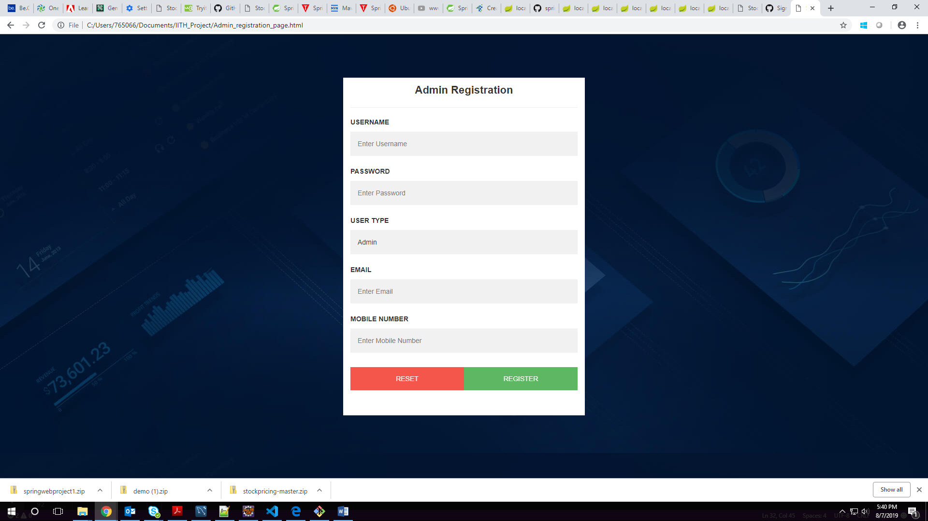

**USER LOGIN**

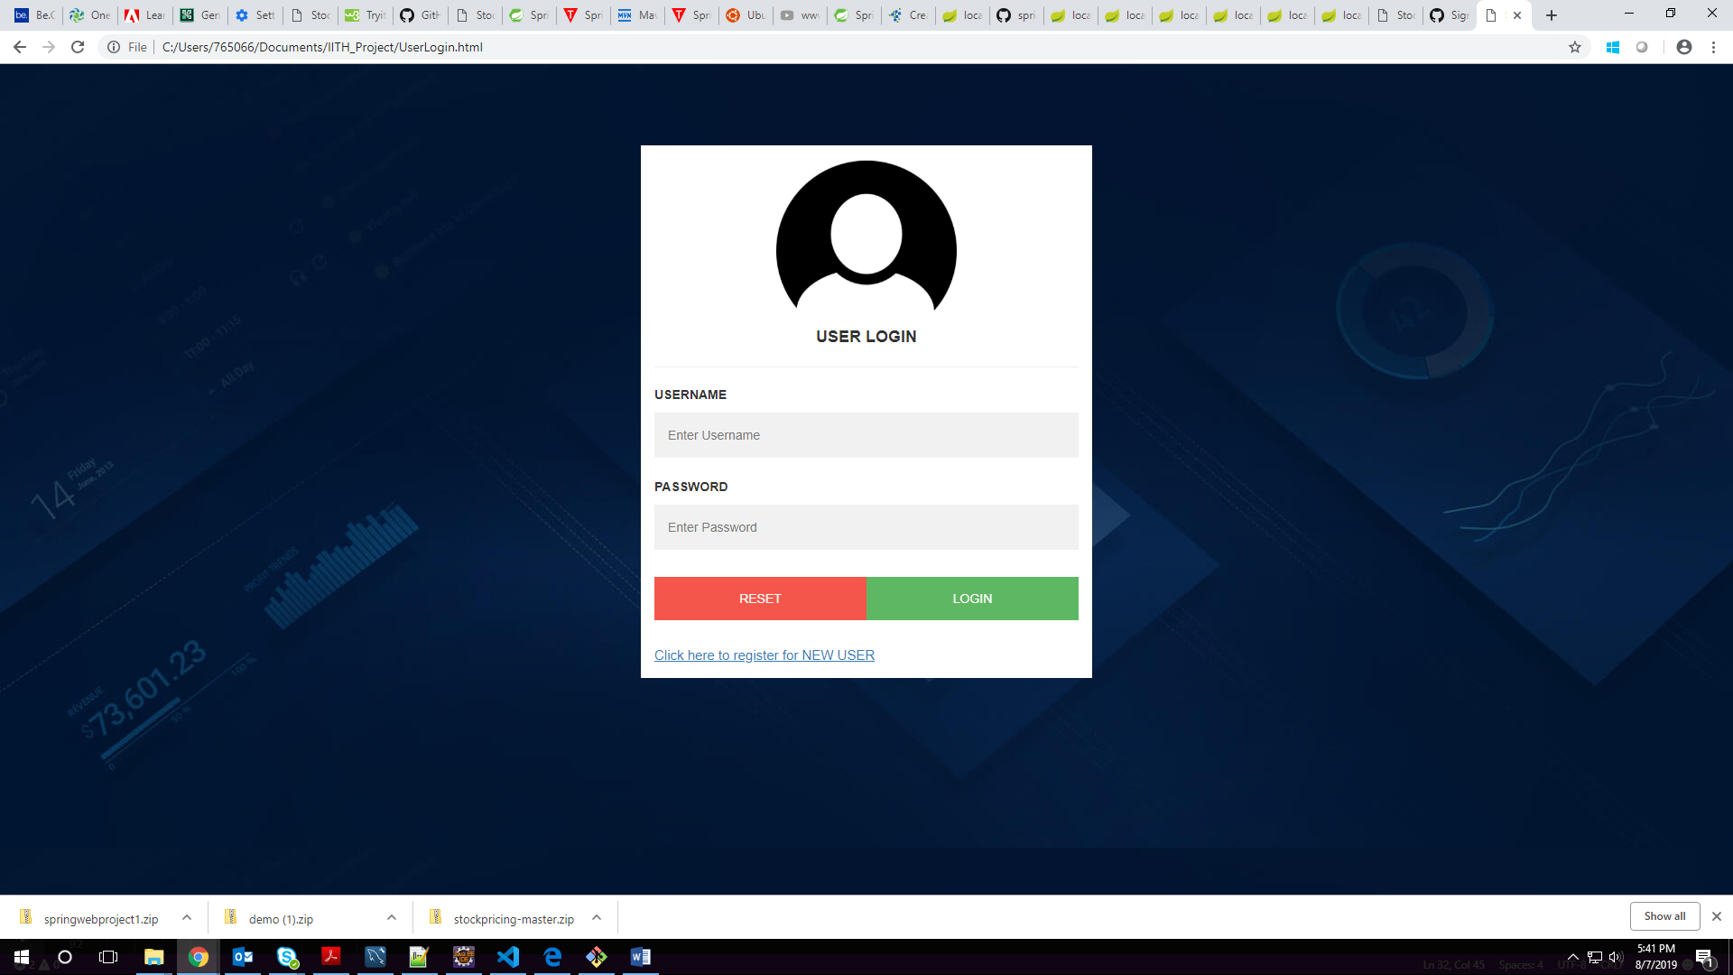

**USER REGISTRATION PAGE**

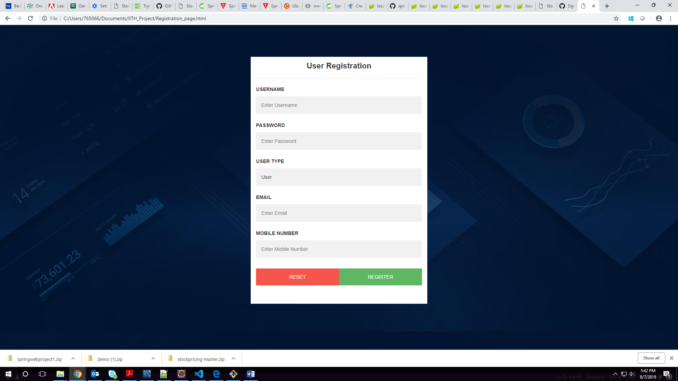

**ADMIN LANDING PAGE**

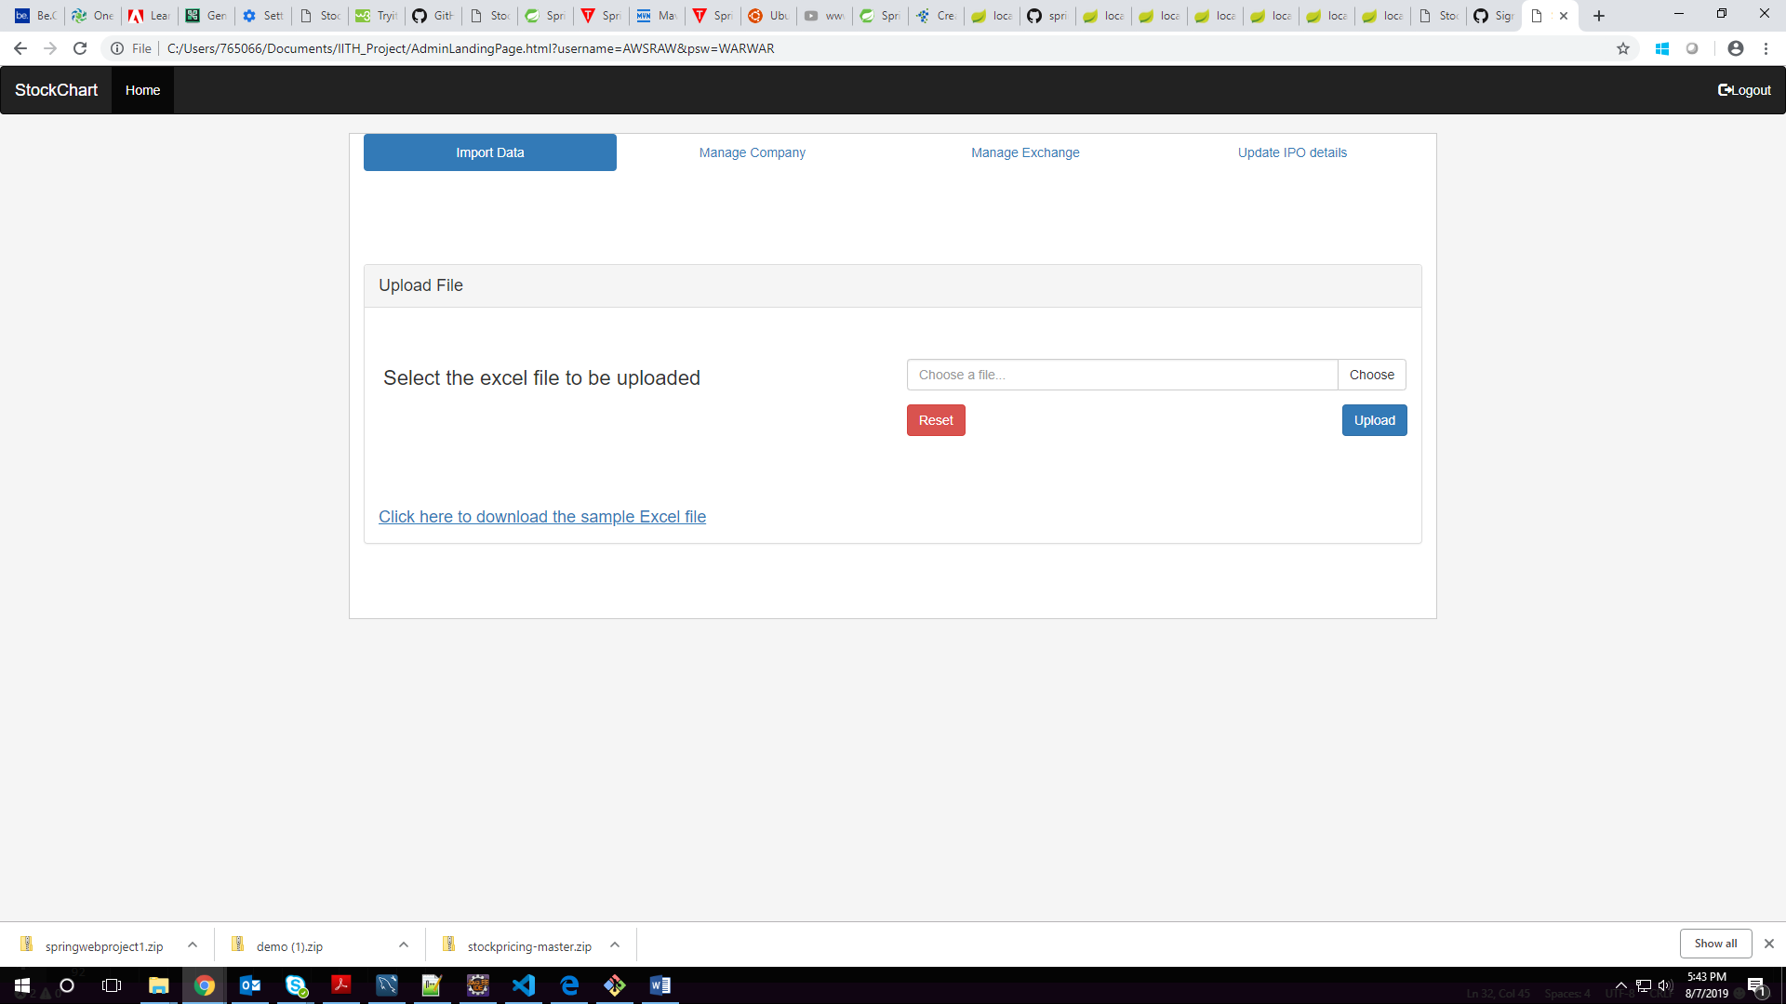

**MANAGE COMPANY**

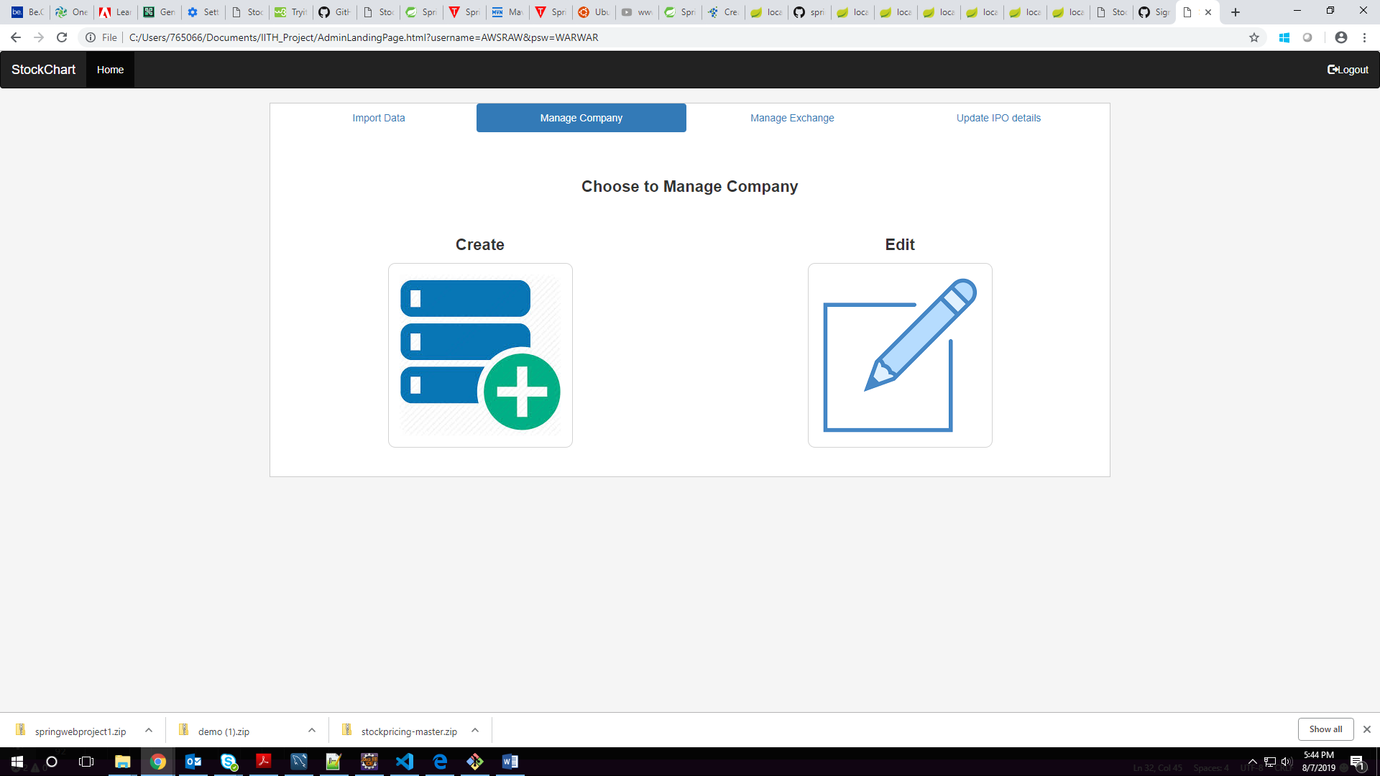

**CREATE COMPANY**

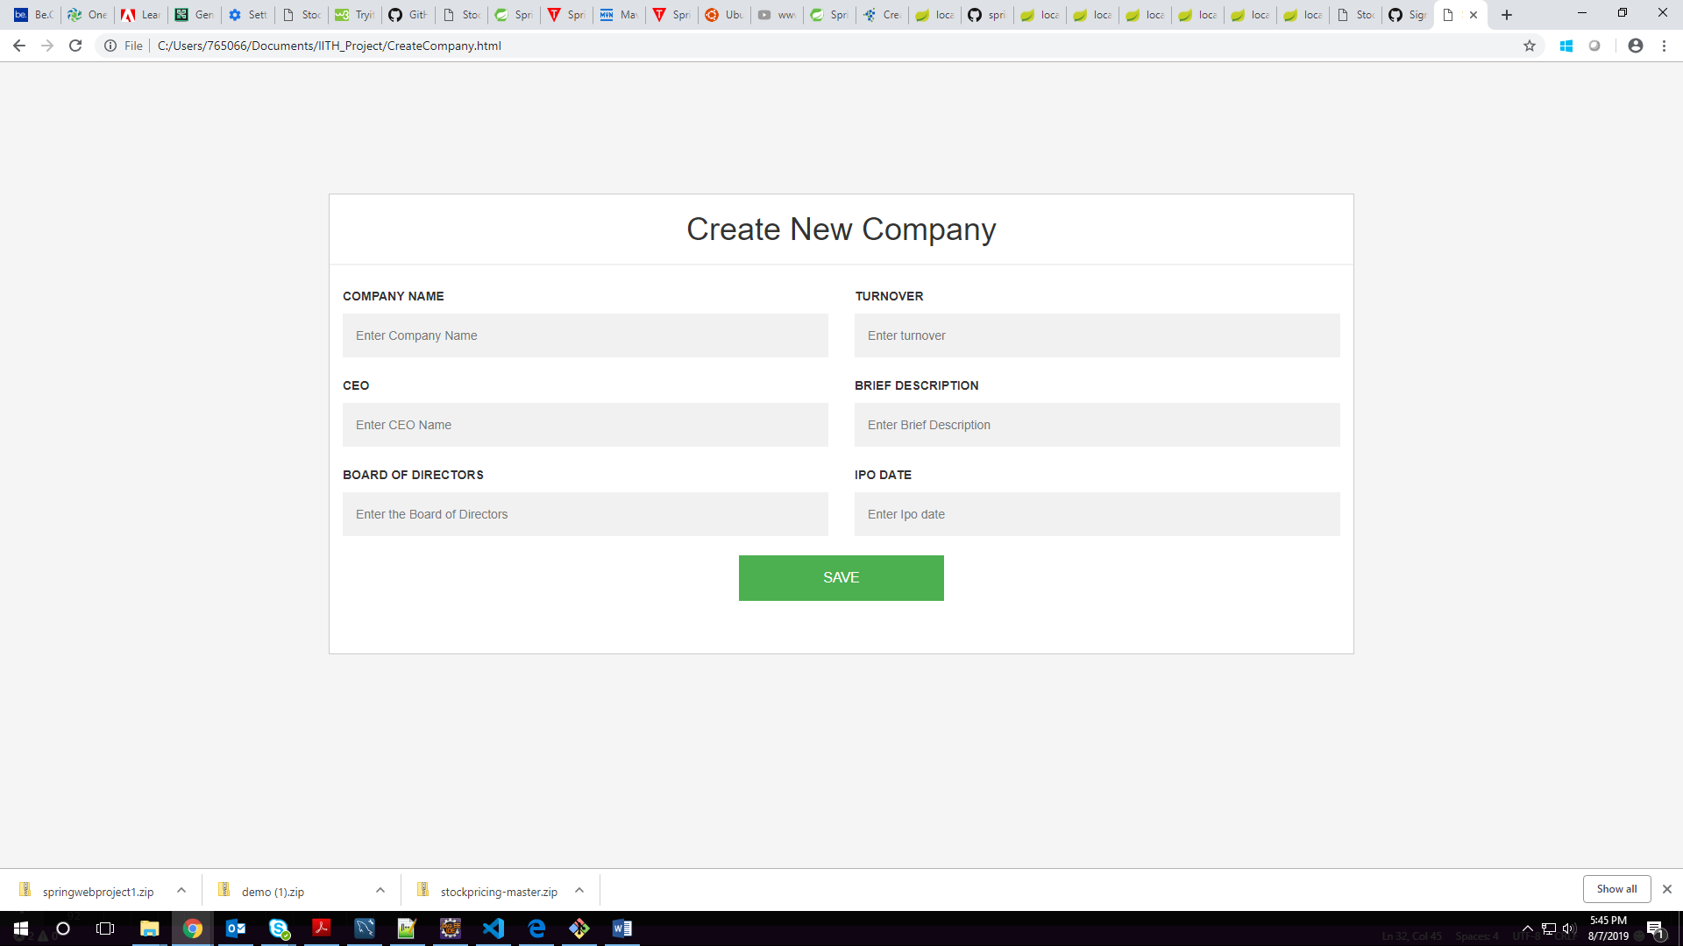

**DISPLAY AND EDIT COMPANY**

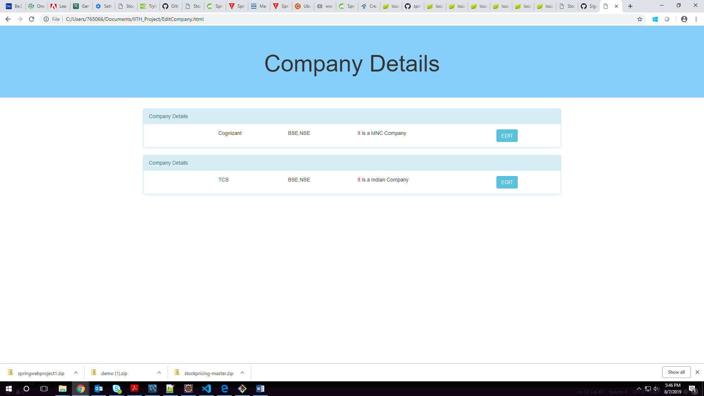

**DISPLAYED COMPANY DETAILS DYNAMICALLY**

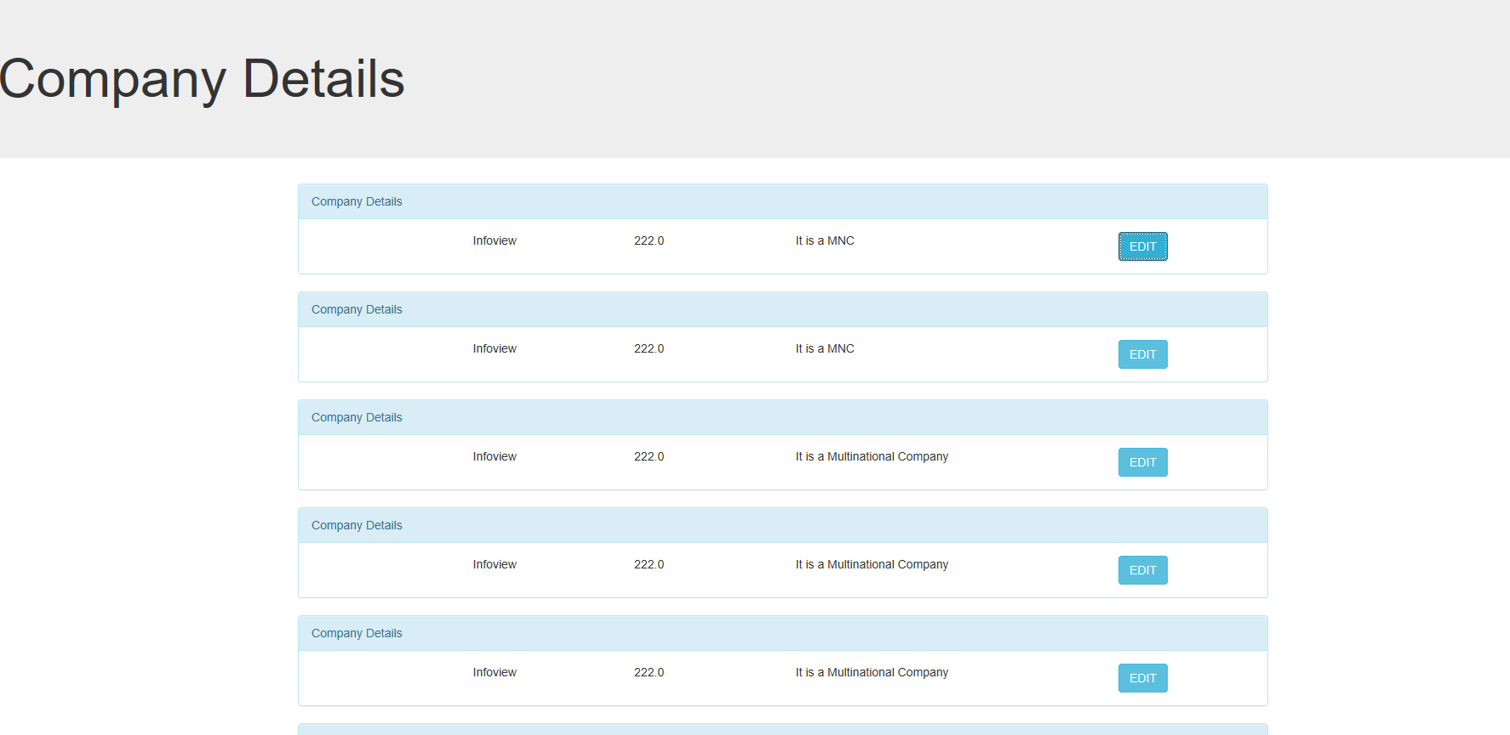

**GITHUB LINK OF THE PROGRAM**

<https://github.com/muthupriyavv/stockprojectmvc>

**SCHEMA DIAGRAM OF THE PROGRAM**

