**STOCK CHART APPLICATION**

**MILESTONE 2**

**INDEX PAGE**

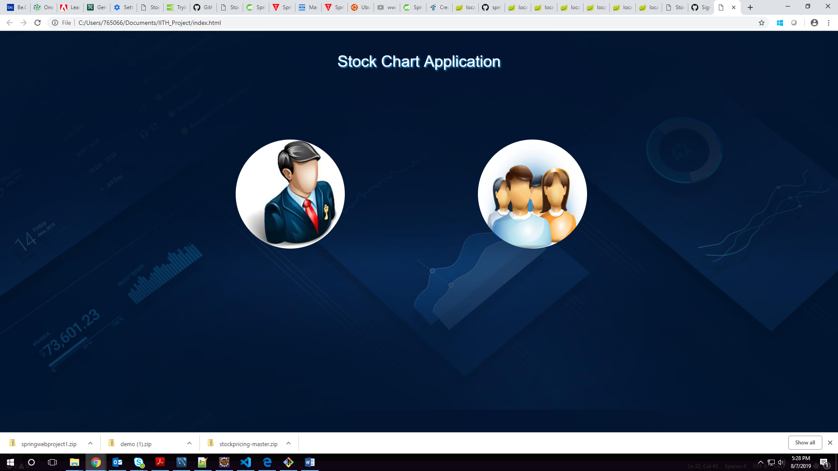

**ADMIN LOGIN PAGE**

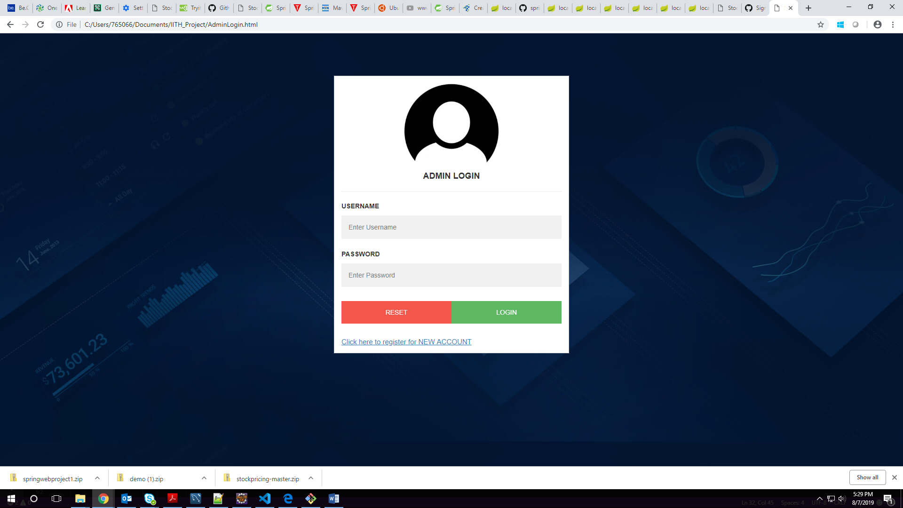

**ADMIN REGISTRATION PAGE**

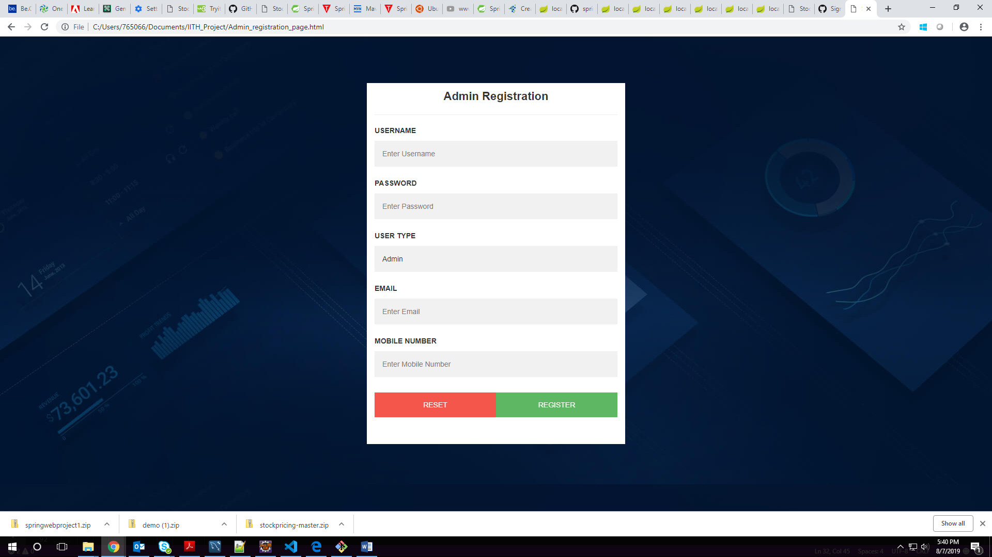

**USER LOGIN**

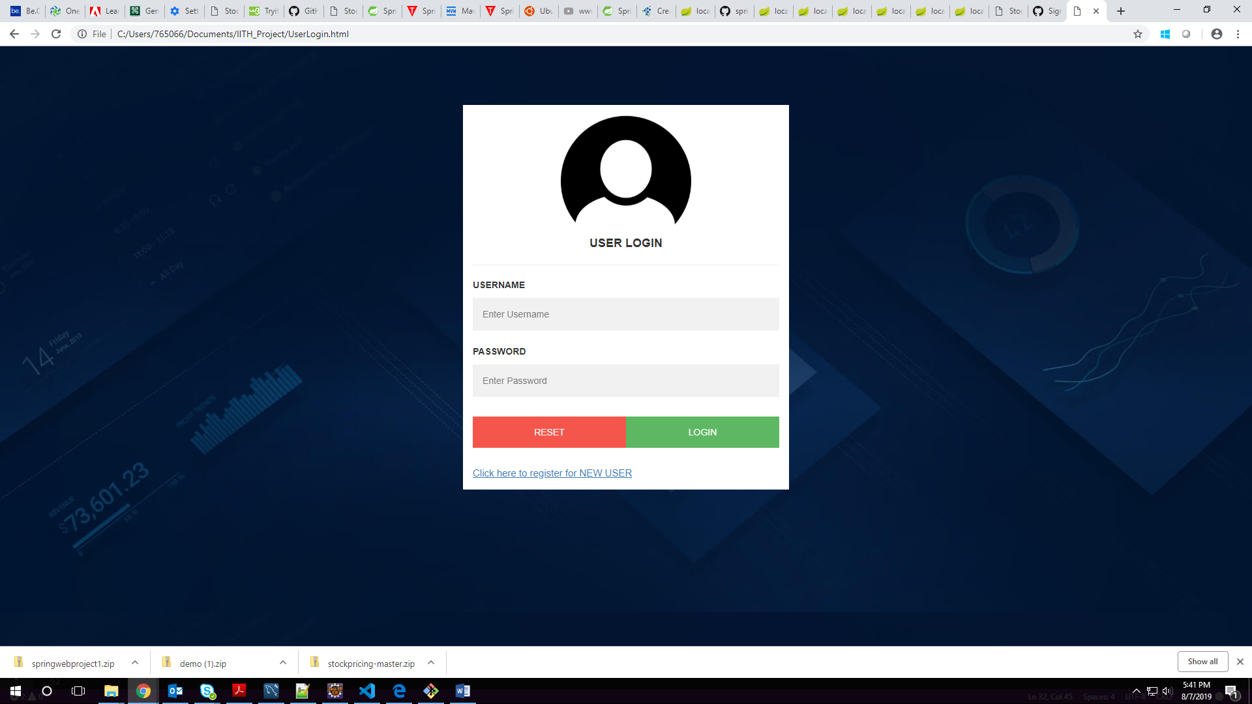

**USER REGISTRATION PAGE**

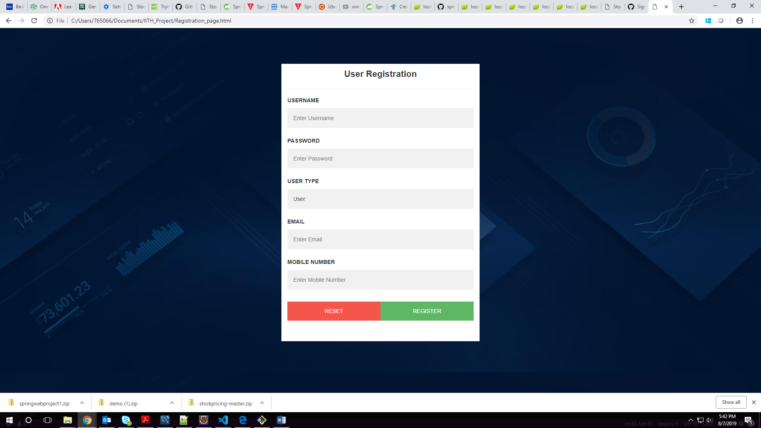

**ADMIN LANDING PAGE**

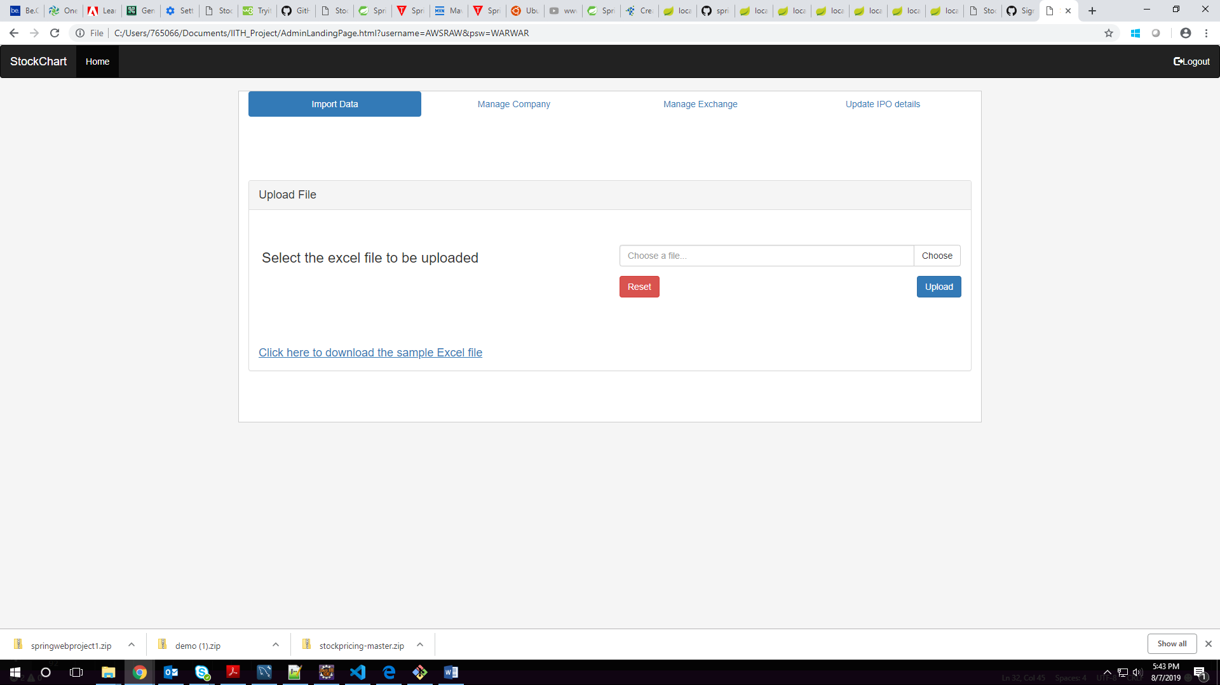

**MANAGE COMPANY**

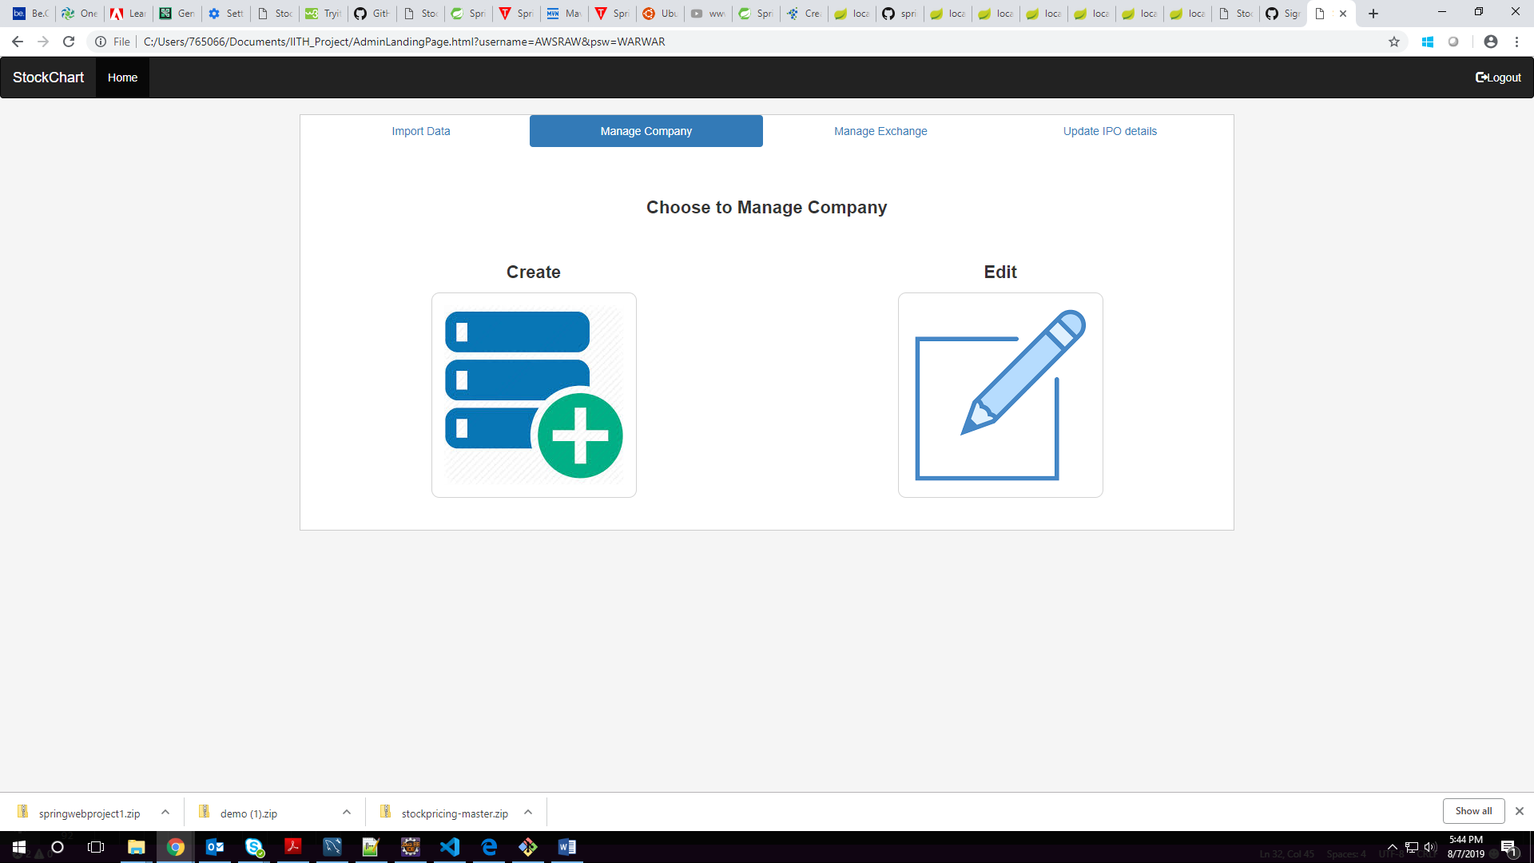

**CREATE COMPANY**

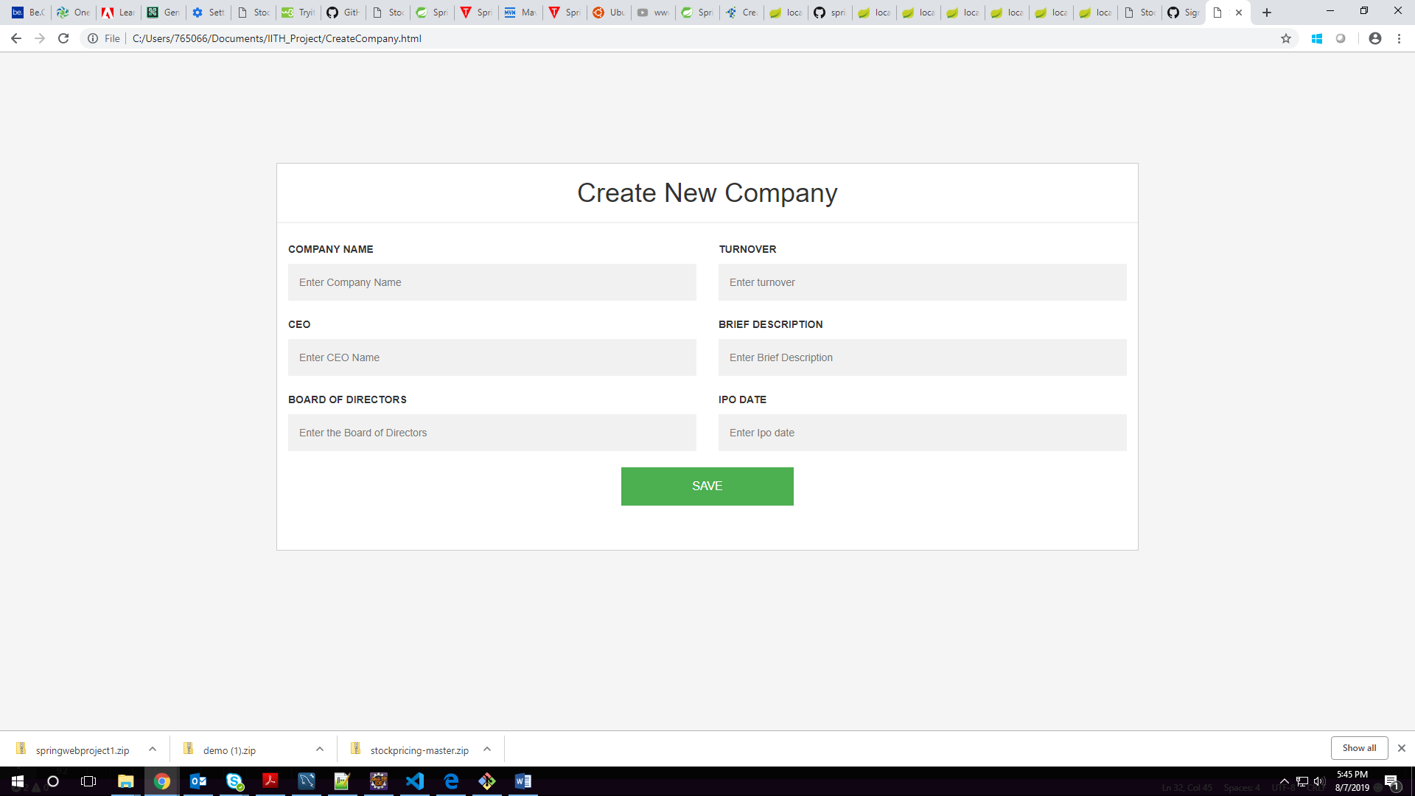

**DISPLAY AND EDIT COMPANY**

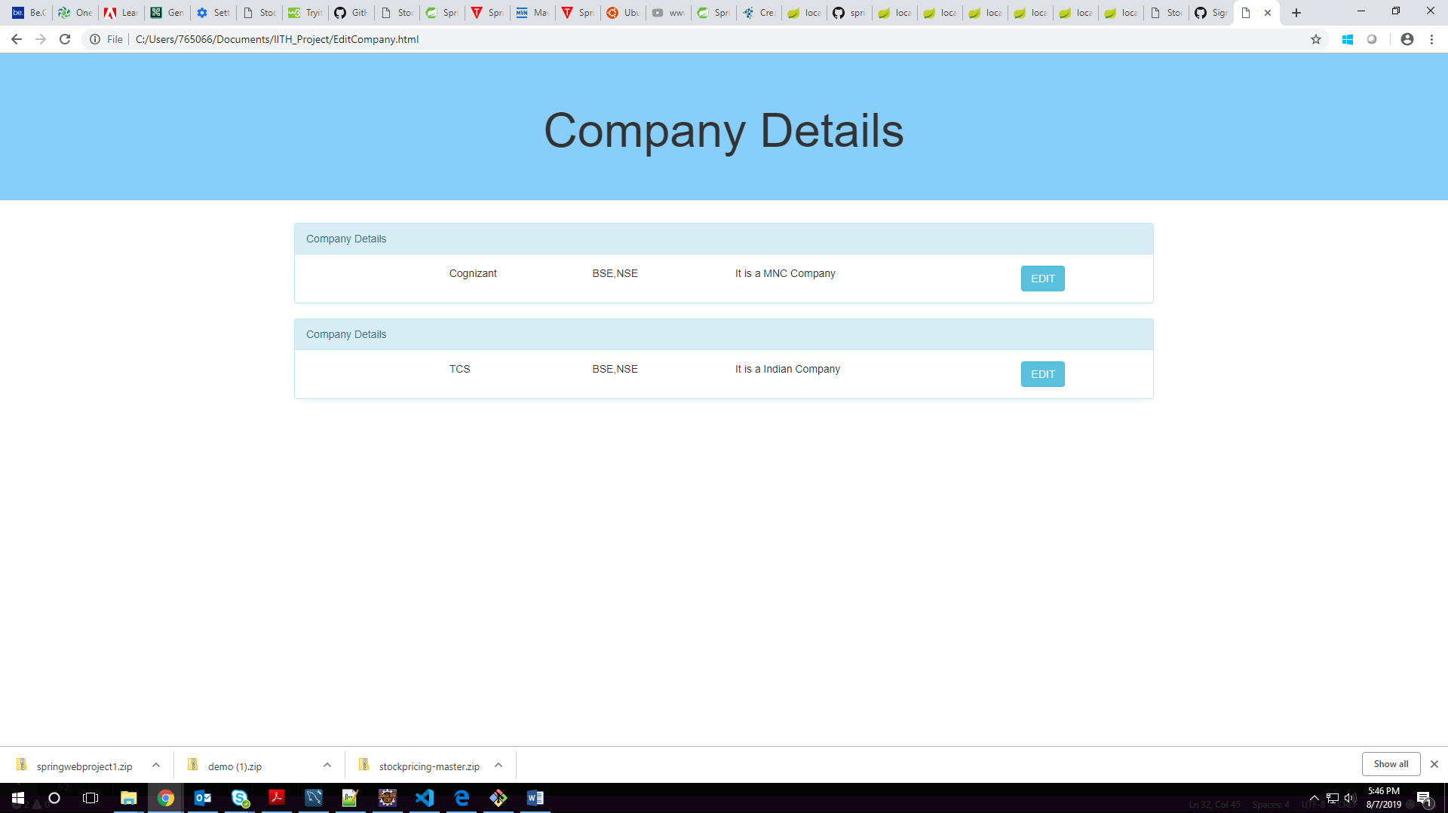

**DISPLAYED COMPANY DETAILS DYNAMICALLY USING JBDC**

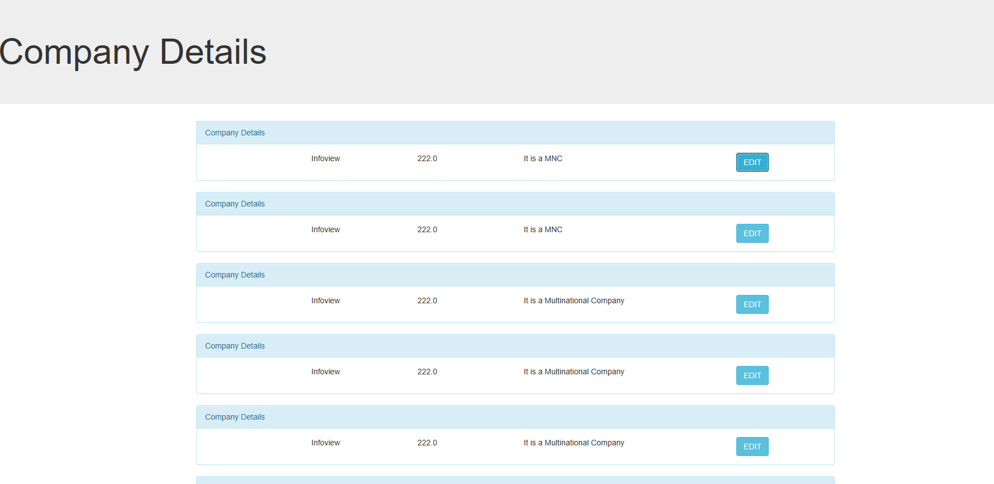

**SCHEMA DIAGRAM OF THE PROGRAM**

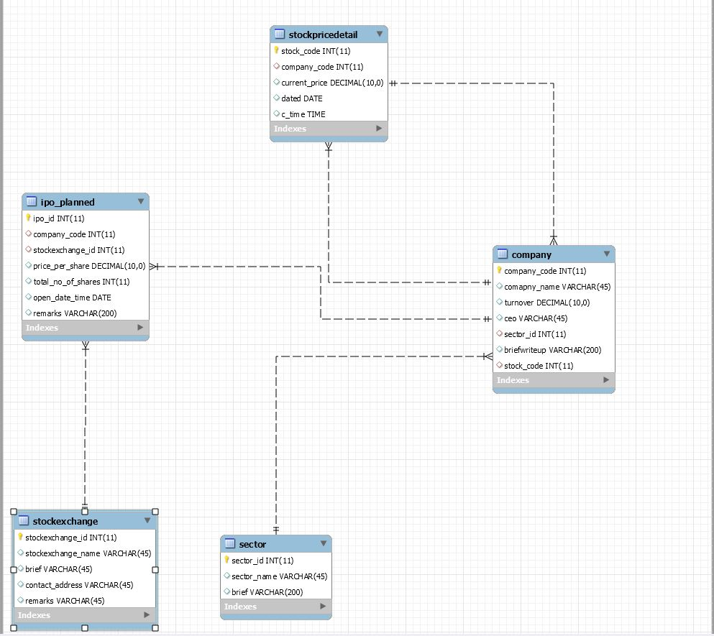

**OUTPUT OF MILESTONE 2**

SCREENSHOT OF DISPLAY COMPANY:

Details of the company displayed using Spring JPA

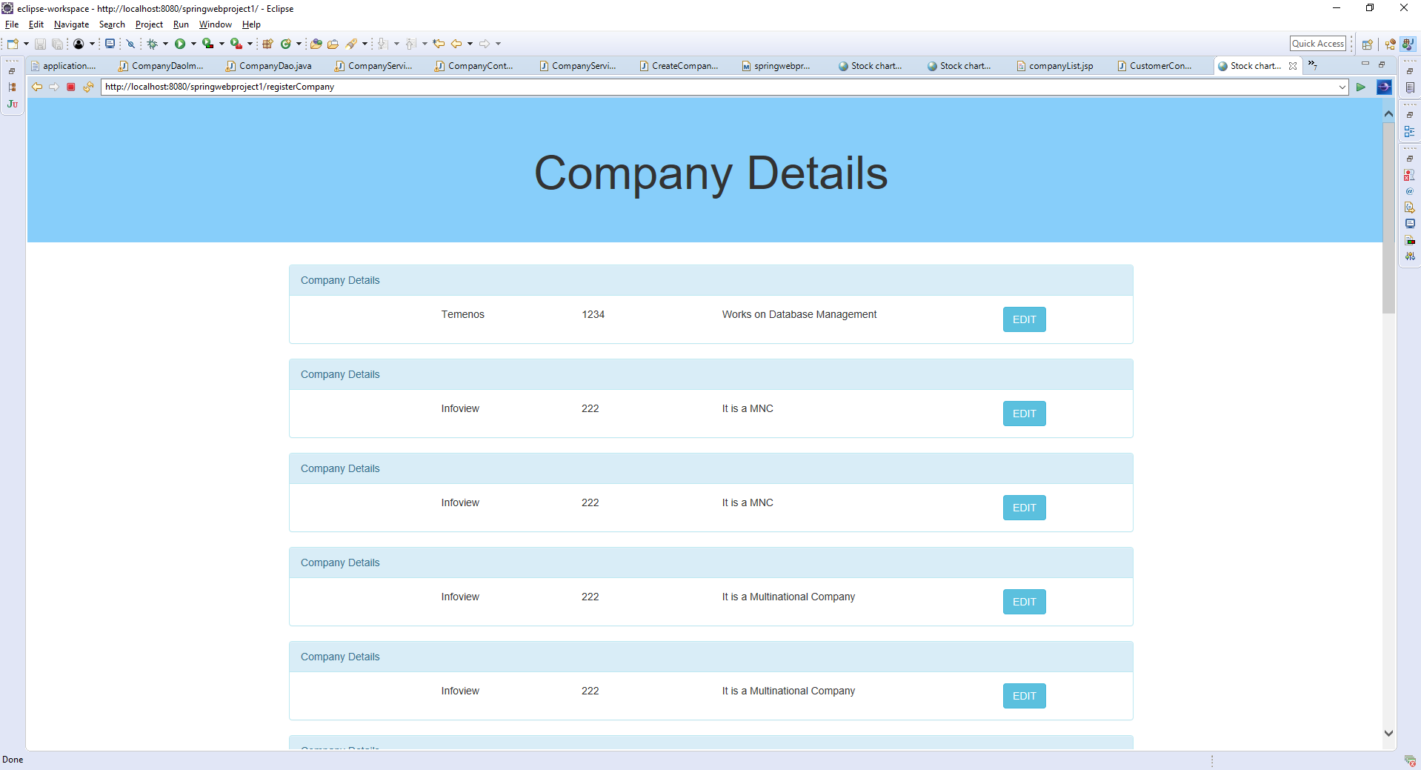

SCREENSHOT OF COMPANY REGISTRATION FORM:

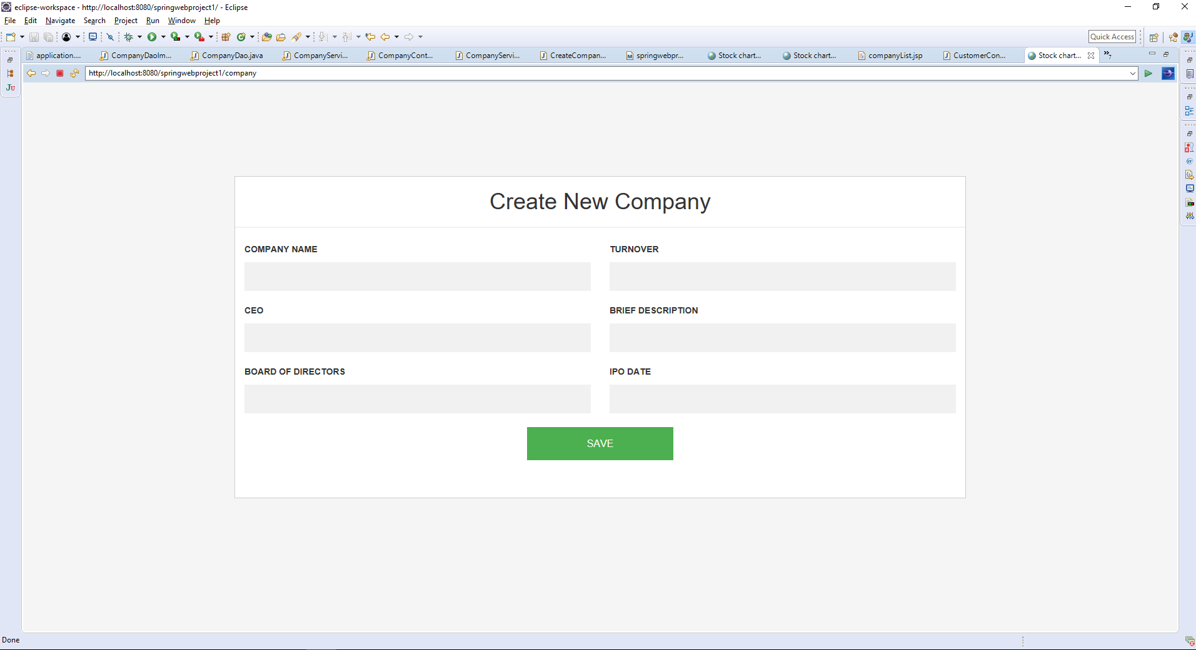

**GITHUB LINK OF THE PROGRAM IMPLEMENTED WITH Spring Jpa**

<https://github.com/muthupriyavv/Stockchartapplication_springjpa>