**SMART PARKING**

Phase 5: Project Documentation & Submission

**Documentation:**

**Project Objectives :**

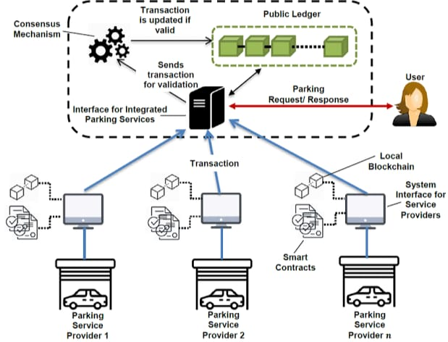The Smart Parking project aims to revolutionize parking management by integrating IoT technology, mobile app development, and Raspberry Pi integration. Addressing the persistent issue of parking inefficiency, the project seeks to create a real-time parking availability system. Through strategically positioned IoT sensors, the system will collect data on parking space occupancy, which will be processed and updated in real-time via a backend system. A user-friendly mobile app will provide drivers with instant access to this information, allowing them to locate available parking spots, reserve spaces, and navigate efficiently. The Raspberry Pi integration acts as the backbone, facilitating the data transmission from sensors to the backend, ensuring a seamless and reliable parking management solution.

This innovative project endeavors to streamline parking, reducing search time for drivers while mitigating traffic congestion and optimizing parking space utilization.

**Iot Sensors Setup :**

IoT sensor setup for a smart parking system involves strategically deploying sensors, such as ultrasonic, infrared, or camera-based devices, within parking spaces to detect occupancy. These sensors are interconnected to a central network that collects and processes real-time data on parking space availability. Each sensor communicates its status, either occupied or vacant, to a backend system, typically using wireless communication protocols.

The sensors used in this project:

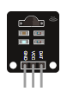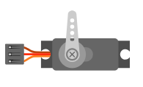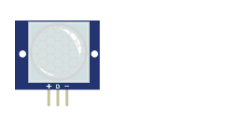

**Mobile App Development :**

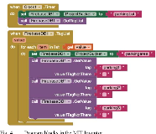The development of a mobile app for Smart Parking using MIT App Inventor involves creating a user-friendly interface that allows drivers to check real-time parking availability, reserve spots, and navigate to vacant spaces. MIT App Inventor offers a visual, block-based programming environment, simplifying the app development process for users with minimal coding experience. The app will integrate with the smart parking system's backend, receiving live updates on available parking spaces from the sensors. Users can easily view a map or a list displaying parking availability, select a spot, and receive directions to the chosen location.

MIT App Inventor's drag-and-drop functionality will enable the creation of an intuitive app interface, enhancing user experience in finding and securing parking spaces efficiently.

**Raspberry Pi Integration :**

**Raspberry Pi Integration in Smart Parking:**

**Hardware Selection**:

Choose the appropriate Raspberry Pi model (e.g., Raspberry Pi 4, Raspberry Pi Zero) based on your project requirements, considering factors like processing power, connectivity options, and form factor.

**Data Collection:**

Develop or adapt software on the Raspberry Pi to collect data from the connected sensors. This may involve reading sensor values, capturing images, or other data collection methods.

**Data Processing:**

Implement data processing logic on the Raspberry Pi. This could include aggregating data from multiple sensors, filtering noise, and preparing the data for transmission.

**Data Transmission:**

Use communication protocols like Wi-Fi, Ethernet, or cellular (using external modules if necessary) to transmit the processed data to the central backend system. MQTT or HTTP are common protocols for IoT data transmission.

**Security Measures:**

Implement security measures on the Raspberry Pi to protect data during transmission, ensuring the integrity and confidentiality of the information.

**Real-Time Updates:**

Integrate the Raspberry Pi into the real-time update system, ensuring that parking availability data is transmitted promptly to the backend for inclusion in the parking management system.

**Error Handling:**

Implement error-handling mechanisms to address potential issues with sensor data, connectivity, or the Raspberry Pi itself. This might include automatic rebooting or alerting in case of failures.

**Monitoring and Maintenance:**

Set up monitoring tools to keep an eye on the Raspberry Pi's performance and connectivity. Regular maintenance, including software updates and hardware checks, will help ensure system reliability.

If your smart parking system is to be deployed on a larger scale, consider strategies for scaling up Raspberry Pi integration to handle more sensors and data. Also, plan for potential enhancements and improvements to the system in the future.

**Code Implementation :**

Code implementation in a smart parking project involves multiple components and layers, including sensor data processing, backend system development, and mobile application integration.

**1. Sensor Data Processing:**

* Sensor Integration: Code is required to interface with the sensors (ultrasonic, infrared, etc.) to gather parking space occupancy data.
* Data Collection: Develop code to collect sensor data, interpret readings, and identify available or occupied parking spots.
* Data Filtering and Validation: Implement algorithms to filter out noise or erroneous readings and ensure data accuracy.

**2. Backend System Development:**

* Data Management: Create code for storing and managing sensor data in a database or server.
* Real-Time Updates: Develop code to update parking space availability in real-time based on incoming sensor data.
* API Development: Design APIs to enable communication between the backend system and the mobile app for data retrieval and updates.

**3. Mobile App Integration:**

* User Interface Code: Develop the app's user interface using languages like JavaScript, Swift, or Kotlin.
* Data Integration: Write code to communicate with the backend system's APIs for accessing real-time parking availability information.
* Functionality Implementation: Code functionalities like viewing available parking spaces, reserving spots, and navigation to selected parking spots.

**4. Raspberry Pi Integration:**

* Sensor Interface: Code is needed to interface Raspberry Pi with sensors, collecting and transmitting sensor data.
* Data Transmission: Develop code to format and transmit sensor data to the backend system using protocols like MQTT, HTTP, or custom APIs.

**Real-Time Parking Availability :**

* **Sensors and Data Collection:** Sensors installed in individual parking spaces or at entry/exit points detect whether a space is occupied or vacant. They transmit this information to a central server or database.
* **Data Processing and Storage:** The collected data is processed to determine the availability of parking spaces in real-time. Algorithms can analyze this information and update availability in a matter of seconds.
* **Communication to Users:** This information is made available to drivers through various means, such as mobile apps, digital signage, websites, or other communication platforms. Drivers can access this data to find nearby available parking spots.

**Benefits of Real-Time Parking Availability Systems:**

* **Reduced Search Time:** Drivers can quickly locate available parking spots, reducing the time spent searching for a space. This not only saves time but also minimizes traffic congestion caused by vehicles circling in search of parking.
* **Optimized Space Utilization:** Real-time availability data enables better management of parking spaces. It can help authorities optimize parking lots, efficiently use space, and potentially reduce the need for constructing additional parking infrastructure.
* **Improved User Experience**: Access to real-time parking availability information enhances the overall user experience for drivers. They can plan their parking in advance, reserve spots, or be guided directly to an available space, reducing frustration and stress associated with parking.
* **Economic Benefits:** Efficient parking systems can lead to economic benefits for businesses and local authorities, attracting more visitors and potentially increasing revenue.Reduced Search Time: Drivers can quickly locate available parking spots, reducing the time spent searching for a space. This not only saves time but also minimizes traffic congestion caused by vehicles circling in search of parking.
* **Optimized Space Utilization:** Real-time availability data enables better management of parking spaces. It can help authorities optimize parking lots, efficiently use space, and potentially reduce the need for constructing additional parking infrastructure.

**Submission:**

**Replication Instruction :**

**Hardware Setup:**

The first step involves selecting and deploying the appropriate IoT sensors. Sensors such as ultrasonic sensors, magnetic sensors, or camera-based sensors are installed in each parking space to detect occupancy. These sensors communicate with a central system or gateway, typically a device like a Raspberry Pi or a microcontroller, which acts as the bridge between the sensors and the backend system.

**Connectivity and Data Collection:**

The deployed sensors continuously monitor the parking spaces, detecting whether a space is occupied or vacant. They transmit this information to the central system using wireless communication protocols like Wi-Fi, Bluetooth, or LoRa. The central system collects and processes this data, identifying available and occupied parking spaces in real time.

**Backend Infrastructure:**

The data collected from the sensors is then processed in a backend infrastructure. This could involve cloud-based servers, local databases, or edge computing platforms. Algorithms analyze the incoming data to determine parking space availability. The backend system updates and maintains a database reflecting the real-time status of parking spaces.

**Mobile App Development:**

To make this information accessible to drivers, a mobile application is developed. The app connects to the backend system and displays the real-time parking availability to users. It can provide a map showing available parking spots, navigation to those spots, and potentially allow users to reserve or pay for parking in advance.

**Integration and User Interface:**

The mobile app communicates with the central system, pulling the updated parking availability data. User interfaces are designed to be intuitive and user-friendly, enabling drivers to easily access real-time information about parking availability in their vicinity.

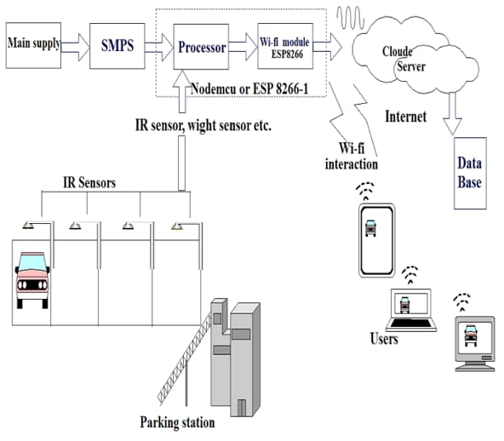

**Example Outputs Of Datasets :**

|  |  |  |  |
| --- | --- | --- | --- |
| **Video Filename** | **Accuracy (%)** | **Precision (%)** | **Recall (%)** |
| data10-1.mp4 | 86.34 | 86.34 | 100.00 |
| data10-2.mp4 | 83.52 | 83.52 | 100.00 |
| data10-3.mp4 | 72.28 | 72.28 | 100.00 |
| data10-4.mp4 | 76.20 | 76.20 | 100.00 |
| data10-5.mp4 | 84.26 | 84.26 | 100.00 |
| data10-6.mp4 | 93.44 | 93.44 | 100.00 |
| data10-7.mp4 | 98.44 | 98.44 | 100.00 |
| data10-8.mp4 | 87.95 | 87.95 | 100.00 |
| data2-2.mp4 | 72.99 | 72.99 | 100.00 |
| data2-3.mp4 | 80.42 | 80.42 | 100.00 |
| data2-4.mp4 | 70.72 | 75.17 | 92.27 |
| data23-1.mp4 | 72.79 | 72.79 | 100.00 |
| data23-2.mp4 | 75.00 | 75.00 | 100.00 |
| data23-3.mp4 | 71.75 | 71.75 | 100.00 |
| data23-4.mp4 | 80.95 | 80.95 | 100.00 |
| data23-5.mp4 | 87.50 | 87.50 | 100.00 |
| data23-6.mp4 | 90.00 | 90.00 | 100.00 |
| data23-7.mp4 | 93.75 | 93.75 | 100.00 |
| data24-1.mp4 | 93.75 | 93.75 | 100.00 |
| edit_25.mp4 | 92.12 | 92.12 | 100.00 |
| Average | **83.21** | **83.43** | **99.61** |

**Conclusion:**

In conclusion, the Smart Parking project presents an innovative and practical solution to the persistent challenges of urban parking. By integrating IoT sensors, a robust backend system, and a user-friendly mobile application, this system offers real-time parking availability information to drivers, significantly reducing search time and congestion while optimizing parking space utilization. The deployment of sensors in parking lots or urban areas enables the collection of accurate data, which, when processed and made accessible through the mobile app, empowers drivers to quickly locate and reserve available parking spaces. This project not only enhances the overall user experience but also contributes to environmental sustainability by minimizing fuel consumption and reducing emissions. Through the amalgamation of hardware, software, and efficient data processing, the Smart Parking system showcases the potential for technological innovation to alleviate a widespread urban challenge, promising enhanced convenience, economic benefits, and more efficient urban mobility for drivers and authorities alike.