PocketSmart AI – AI Powered Budget Recommendation System

Introduction
Project Design is the phase where the overall structure and architecture of the system are planned. It defines how different modules interact with each other and how data flows through the application.
The design phase helps convert project requirements into a structured solution that can be implemented efficiently.

System Architecture
PocketSmart AI follows a simple architecture consisting of the User Interface, Backend Processing Layer, AI Recommendation Engine, and Database.

Architecture Flow
User
↓
Frontend Interface
↓
FastAPI Backend
↓
Gemini AI Service
↓
Recommendation Engine
↓
User Output

System Design
The system is divided into different modules that work together to generate recommendations.

Modules
Home Budget Planner
Event Planner
Jewelry Recommendation
AI Recommendation Engine
Database Management
Module Design
Home Budget Planner Module
Purpose
To provide home décor and interior planning recommendations based on user budget and preferences.
Input
Budget
Home category
User preferences
Output
Recommended products and suggestions

Event Planner Module
Purpose
To assist users in planning events within their budget.
Input
Event type
Budget
Number of guests
Additional preferences
Output
Event planning recommendations

Jewelry Recommendation Module
Purpose
To suggest jewelry options according to user requirements.
Input
Budget
Jewelry type
User preferences
Output
Personalized jewelry recommendations
AI Recommendation Engine
Purpose
To process user inputs and generate intelligent recommendations using Gemini AI.
Input
User data
Budget details
Preferences
Output
Personalized recommendation results

Database Design
Database Name
pocketsmart.db
Tables Used
Users
Stores user-related information.
Requests
Stores user requests and inputs.
Recommendations
Stores generated recommendations.
Feedback
Stores user feedback and responses.
Data Flow Design
Data Flow

User Input
↓
Backend Processing
↓
Gemini AI Analysis
↓
Recommendation Generation
↓
Display Output

User Interface Design
The system provides a simple and user-friendly interface that allows users to:
Enter their budget.
Select recommendation categories.
Submit requests.
View generated recommendations.
Main Screens
Home Page
Home Budget Planner Page
Event Planner Page
Jewelry Recommendation Page
Recommendation Result Page
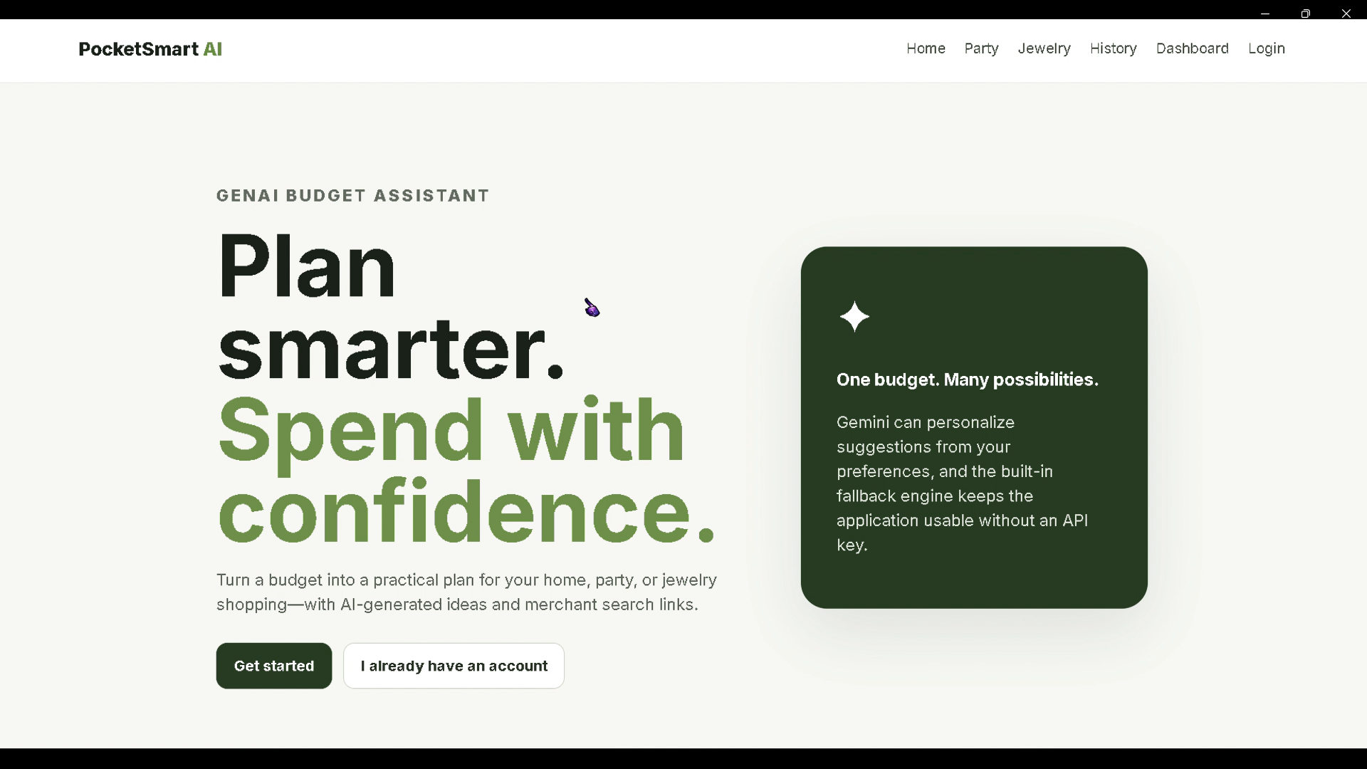

Design Advantages
Simple architecture
Easy maintenance
Scalable design
User-friendly interface
AI-powered recommendation generation

Design Summary
The project design provides a structured architecture for implementing PocketSmart AI. The modular design improves maintainability, scalability, and overall system performance.

Conclusion
The Project Design Phase established the architecture, modules, database structure, and workflow required for PocketSmart AI. This design serves as the blueprint for project development and implementation.

