PocketSmart AI – AI Powered Budget Recommendation System

Introduction
Project Testing is an important phase in software development that ensures the system functions correctly and meets the specified requirements. The purpose of testing is to identify and fix errors before the final deployment of the project.

PocketSmart AI was tested to verify that all modules work properly and generate accurate recommendations based on user inputs.

Objectives of Testing
The objectives of testing are:
Verify system functionality.
Ensure proper recommendation generation.
Identify and fix errors.
Validate user inputs.
Improve system reliability and performance.
Testing Environment
Hardware
Laptop/Desktop Computer
Internet Connection
Software
Windows Operating System
Python
FastAPI
SQLite
Google Gemini API
Visual Studio Code
Google Chrome / Microsoft Edge

Types of Testing Performed

1. Functional Testing
Functional testing was performed to ensure that all project features work correctly.
Tested Features
User input submission
Budget processing
Recommendation generation
AI integration
Data storage operations
Result
All functional requirements were successfully tested and verified.

2. Integration Testing
Integration testing was performed to verify communication between different modules.
Modules Tested
Frontend and Backend
Backend and Gemini API
Backend and Database
Result
All modules interacted successfully without major issues.

3. User Interface Testing
The user interface was tested to ensure proper display and usability.
Tested Areas
Form inputs
Navigation
Output display
User interaction
Result
The interface functioned properly and was easy to use.

4. Performance Testing
Performance testing was conducted to evaluate system response time.
Tested Areas
Recommendation generation speed
API response handling
Data processing
Result
The system generated recommendations within an acceptable response time.

5.Error Handling Testing
The system was tested with invalid and incomplete inputs.
Test Scenarios
Empty input fields
Invalid budget values
Missing required information
Result
The system handled invalid inputs appropriately and prevented incorrect processing.
Bug Fixes
During testing, minor issues were identified and corrected.
Issues Fixed
Input validation improvements
API response handling
Recommendation display formatting

Home Budget Planner Testing
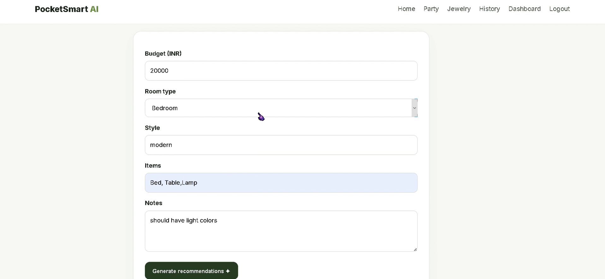
Description: Testing of home décor recommendation generation.

Event Planner Testing
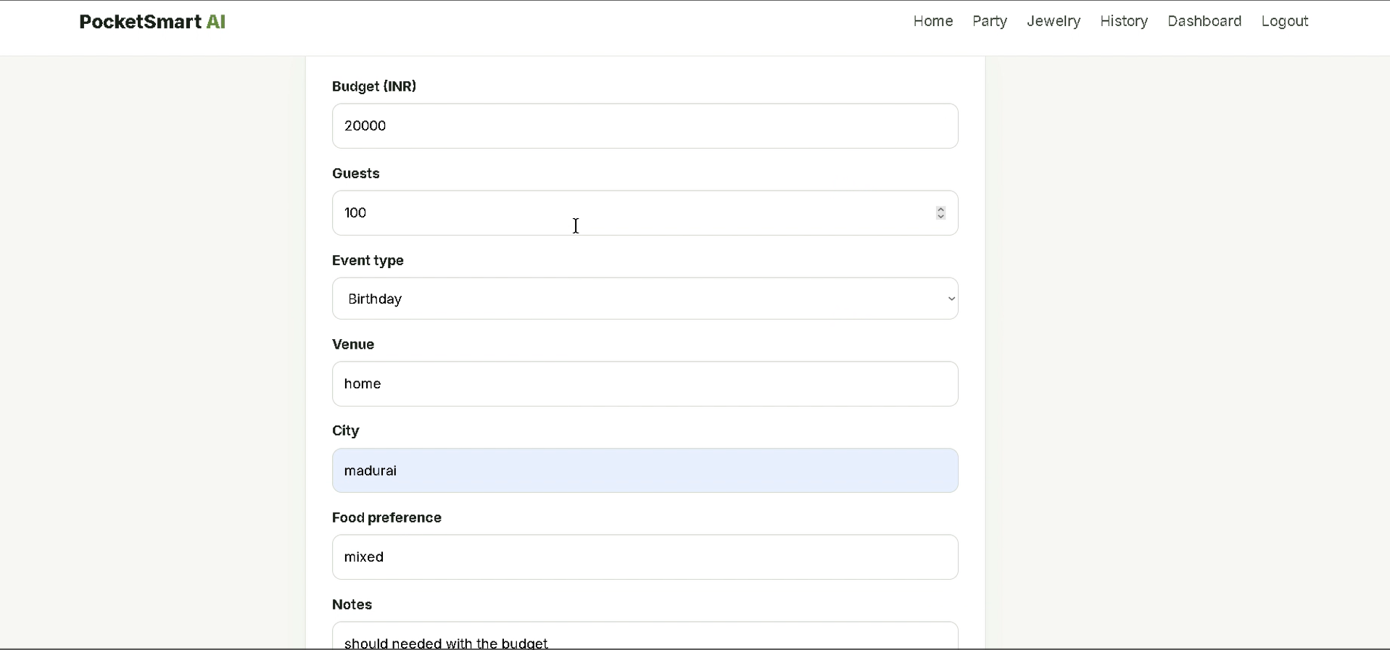
Description: Testing of event planning recommendation generation.

Jewelry Recommendation Testing
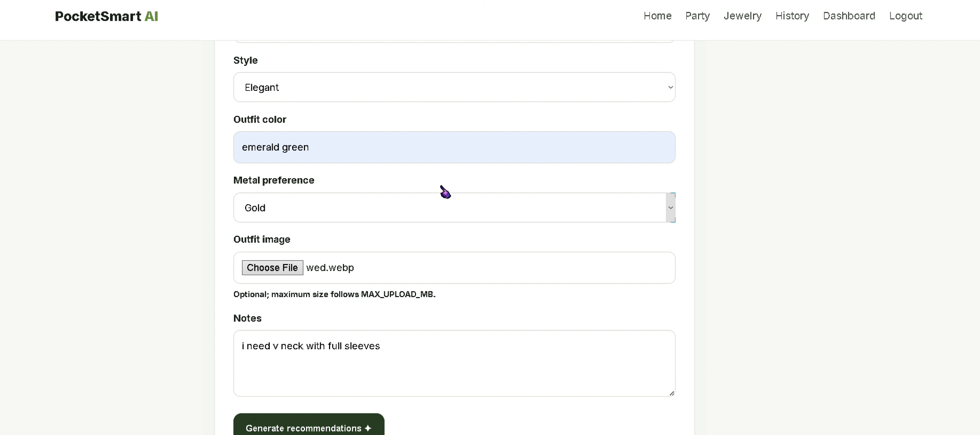
Description: Testing of jewelry recommendation module.

AI Recommendation Output
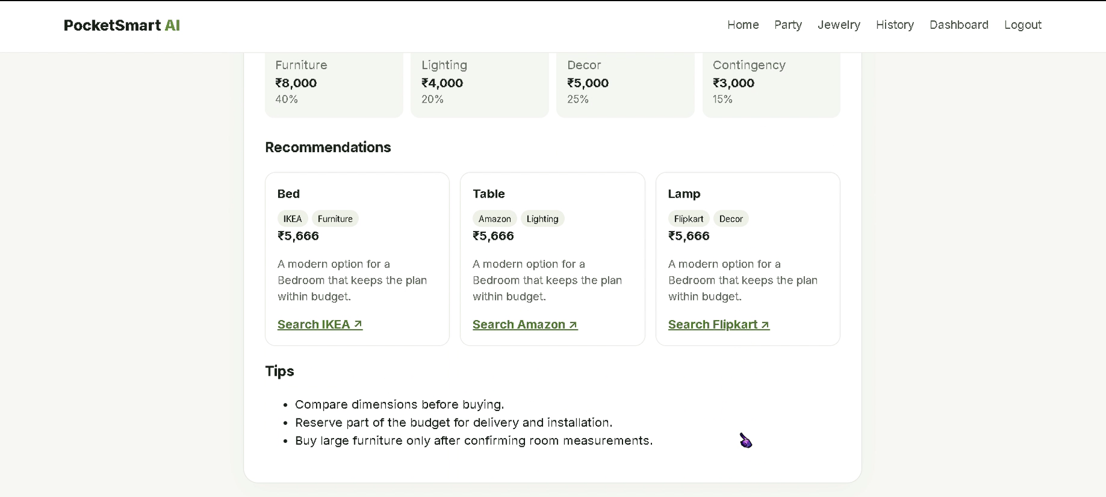

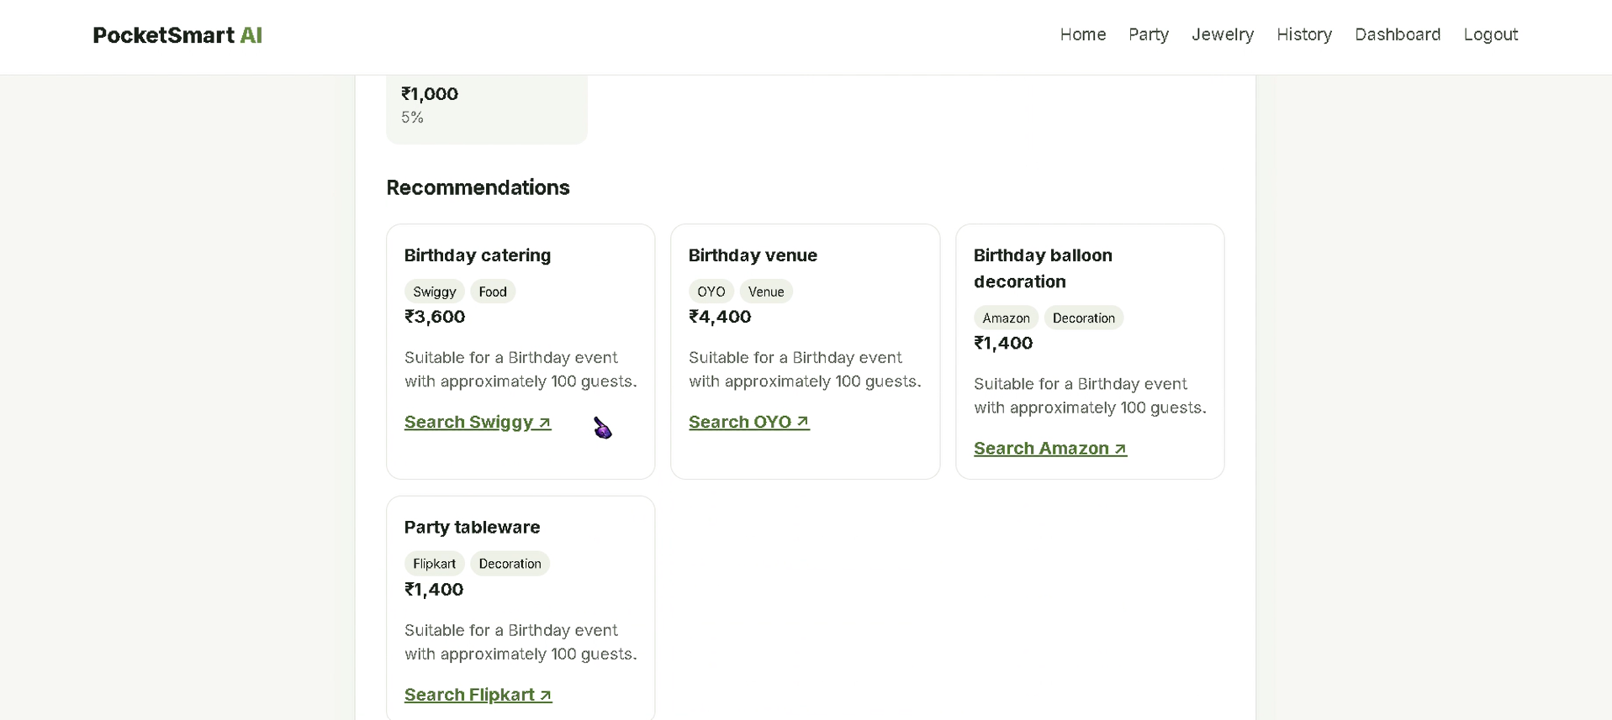

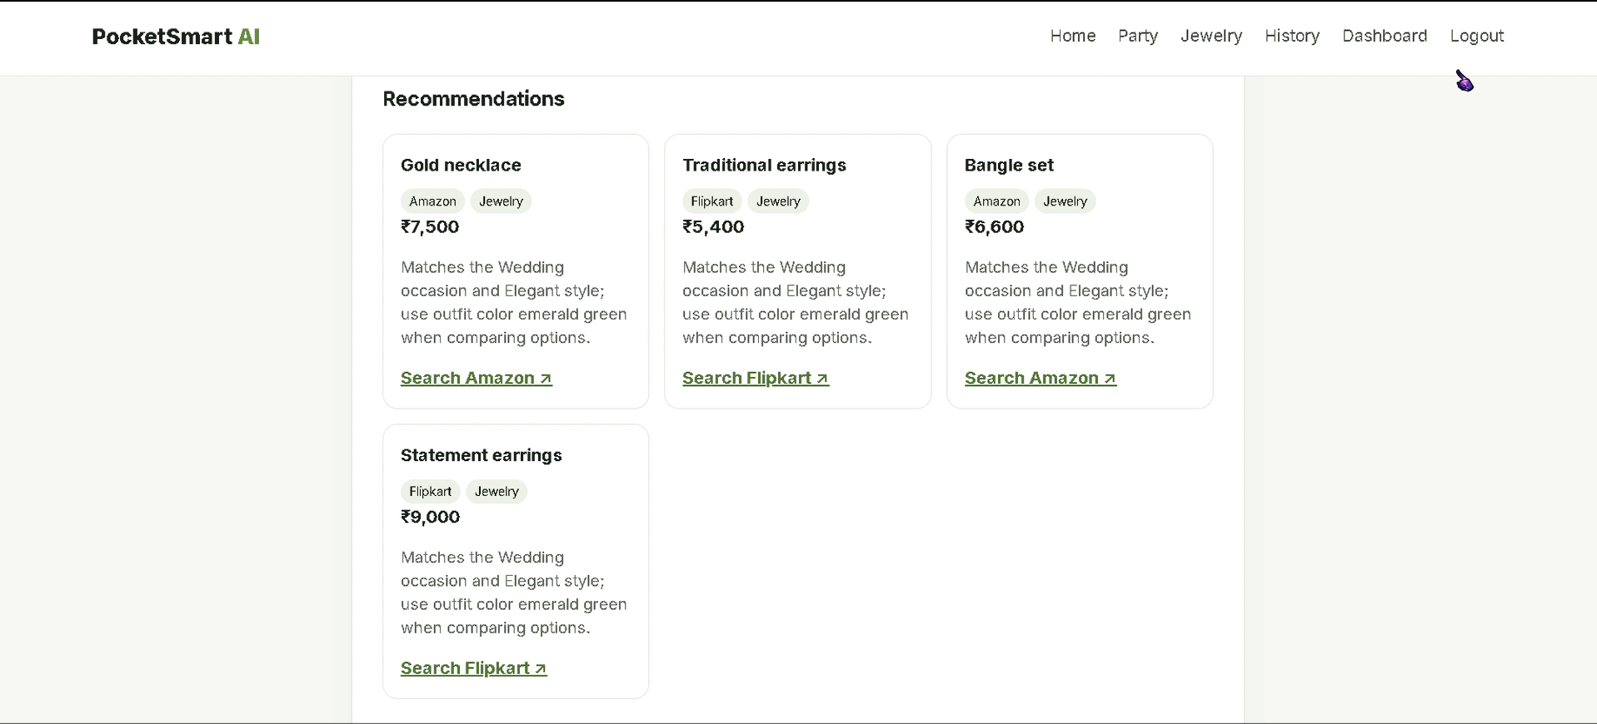
Description: AI-generated recommendation results.

Advantages of Testing
Improves software quality.
Detects errors early.
Enhances reliability.
Improves user experience.
Ensures system stability.

Conclusion
The testing phase successfully verified the functionality, performance, and reliability of PocketSmart AI. All major modules were tested and found to operate correctly. The system is ready for final documentation and project demonstration.

