SOFTEON, INC.
11700 Plaza America Dr., Suite 910
Reston, Virginia USA 20190
Tel 703-793-0005
WWW.SOFTEON.COM



SPMS Packing
User Guide
Contents
Conventions Used 3
1. SPMS Mobile Packing 4

Conventions Used
This section interprets the various conventions used in the document for better understanding of the screen functionality.
Convention | Usage
 | Denotes the mandatory fields in the screen. Values need to be specified in the fields in order to proceed with the screen operations.
 | Denotes the fields that show values retrieved from the system.
 | Any subject content encapsulated in a section marked by this icon indicates that the given information will serve as a useful tip for the end users.

SPMS Packing
You can use the SPMS Packing screen for:
- packing the orders with single SKU and multiple units (Batch mode)
- packing the orders with multiple SKUs (Multi SKU mode)
- packing the picking completed SCNs (SCN mode)
Menu Access: Operations > Outbound > Shipping > Packing > SPMS Packing

Packing Orders with Single SKU
You can use this option to pack the orders with single SKU and various units.
- Click the option as ‘Batch Mode’.
- Select the Packing Station ID at which the orders will be packed.
- Specify the SKU/UPC, which has to be packed.
On tabbing out, the system displays the #Available Orders, # of Units, Customer, Ship To Address and other related details. The system also displays the SKU with Pick and Pack units details in the grid.
The system displays the # Available Orders based on the least # of units (order quantity) of the given SKU, if the given SKU belongs to multiple orders to be packed.
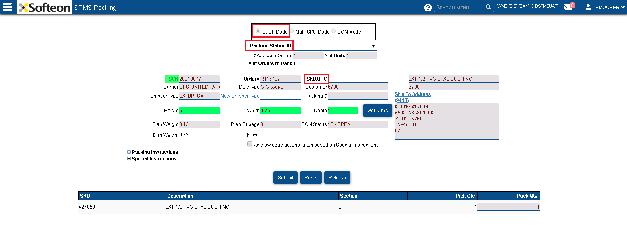
Figure 1 – Packing in Batch mode
- Specify the # of Orders to Pack number of orders to be packed).
- Specify the number of units to be packed under Pack Qty column in the grid.
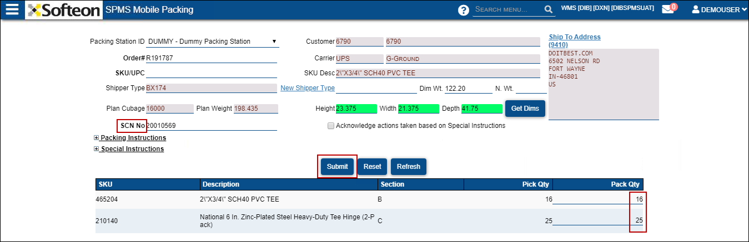
Figure 2 – Moving SKU units to another SCN
On clicking Submit, the system displays the message as “Process Completed Successfully”.

