**Step 1: Data Preparation and Exploration**

1. Import necessary libraries like pandas, matplotlib, Seaborn, Plotly, scikit-learn, and transformers.
2. Load the dataset from the provided CSV file into a pandas DataFrame.
3. Data Preprocessing:
   * Remove the 'Patient Id' column as it's not relevant for analysis.
   * Recode the 'Level' column to numerical values, converting 'Medium' to 'High' and 'High' to '1', 'Low' to '0'.
   * Convert the 'Level' column to a numeric data type.

**Step 2: Data Visualization and Exploration**

1. Use Seaborn to create a heatmap to visualize missing data.
2. Create count plots and box plots to explore the relationship between variables like 'Smoking', 'ChestPain', 'Age', and 'Level'.
3. Generate a sorted DataFrame to display the count of smokers by age.
4. Create interactive bar and line charts using Plotly to visualize the number of smokers by age.

**Step 3: Model Building and Evaluation**

1. Split the data into training and testing sets using **train_test_split**.
2. Train a Random Forest Classifier model and make predictions.
   * Calculate and display the accuracy score, log loss, and F1 score.
   * Visualize the confusion matrix using a heatmap.
3. Determine the best value for k in the K-Nearest Neighbors (KNN) model.

* Use cross-validation to find the best k.

1. Train a KNN model with the best k and make predictions.

* Calculate and display the accuracy score, log loss, and F1 score.
* Visualize the confusion matrix using a heatmap.

1. Train a K-Means clustering model and predict cluster assignments.

* Calculate and display the accuracy score, log loss, and F1 score.
* Visualize the confusion matrix using a heatmap.

1. Train a Decision Tree Classifier and make predictions.

* Calculate and display the accuracy score, log loss, and F1 score.
* Visualize the confusion matrix using a heatmap.

1. Train a Support Vector Classifier (SVC) model and make predictions.

* Calculate and display the accuracy score, log loss, and F1 score.
* Visualize the confusion matrix using a heatmap.

**Step 4: Zero-Shot Classification (ZSL) for Model Evaluation**

1. Install the 'transformers' library and import necessary components.
2. Use the Zero-shot classification (ZSL) model from the 'transformers' library for text-based predictions.
3. Define candidate labels for ZSL, which in this case are ["High", "Medium", "Low"].
4. Prepare text inputs for ZSL by converting rows from the test dataset to text.
5. Perform ZSL on the test data to predict labels.
6. Extract the predicted labels and evaluate the ZSL predictions:
   * Calculate and display the accuracy score, log loss, and F1 score.
   * Visualize the confusion matrix using a heatmap.

**CODE :**

importimportimportimport pandas as pd

import matplotlib.pyplot as plt

%matplotlib inline

importimportimportimporttt cufflinks as cf

import plotly

from plotly.offline import init_notebook_mode,iplot,plot

importimporttnotebook_mode(connected=True)

df = pd.read_csv('/content/Cancer.ccsv')

ccsv'sv'df.drop(['Patient Id'],aaxisxis = 1,inplace=True)

df['Level']

OUTPUT :  
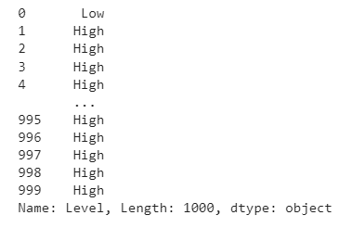

df['Level'].replace('Medium','High',inplace=True)

df['Level'].replace('High','1',inplace=True)

df['Level'].replace('Low','0',inplace=True)

df['Level'] = pd.to_numeric(df['Level'])

import seaborn as sns

sns.heatmap(df.isnull())

OUTPUT :  
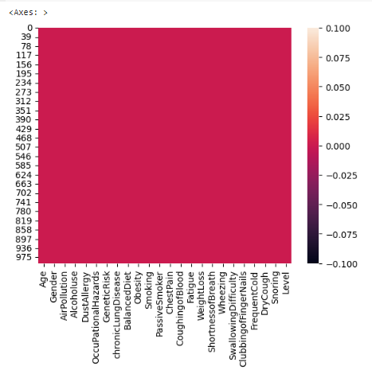

plt.figure(figsize=(10,5))

sns.countplot(x='Smoking',data=df)

OUTPUT :  
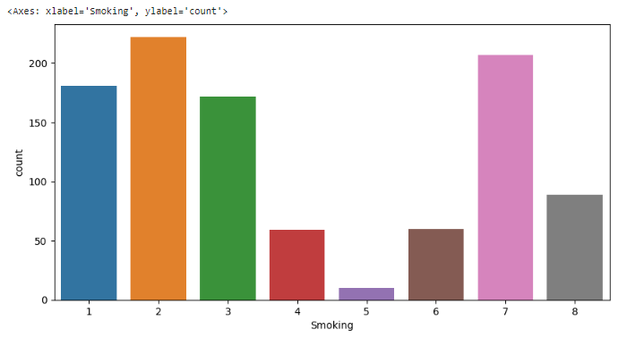

plt.figure(figsize=(10,5))

sns.boxplot(x='ChestPain',y='Age',data = df)

OUTPUT :  
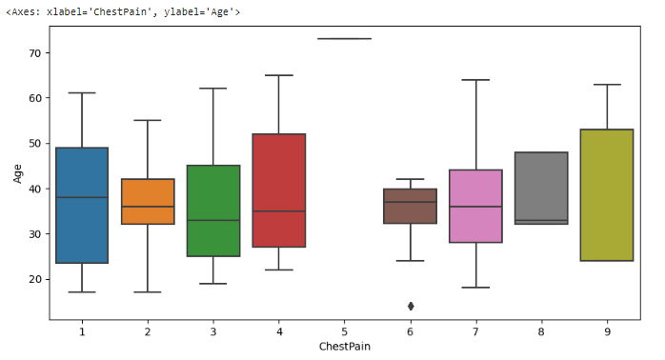

plt.figure(figsize=(10,5))

sns.boxplot(x='Smoking',y='Age',data = df)

OUTPUT :  
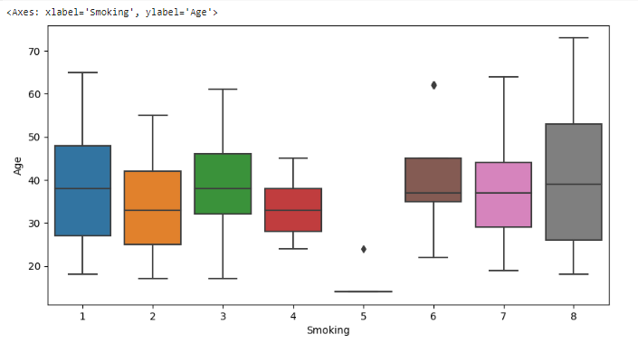

sorted_smokers = df.groupby('Age')['Smoking'].count().to_frame()

sorted_smokers.style.background_gradient(cmap = 'Reds')

OUTPUT :  
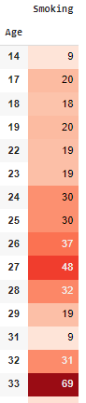

df.style.background_gradient(cmap = 'Reds')

OUTPUT :

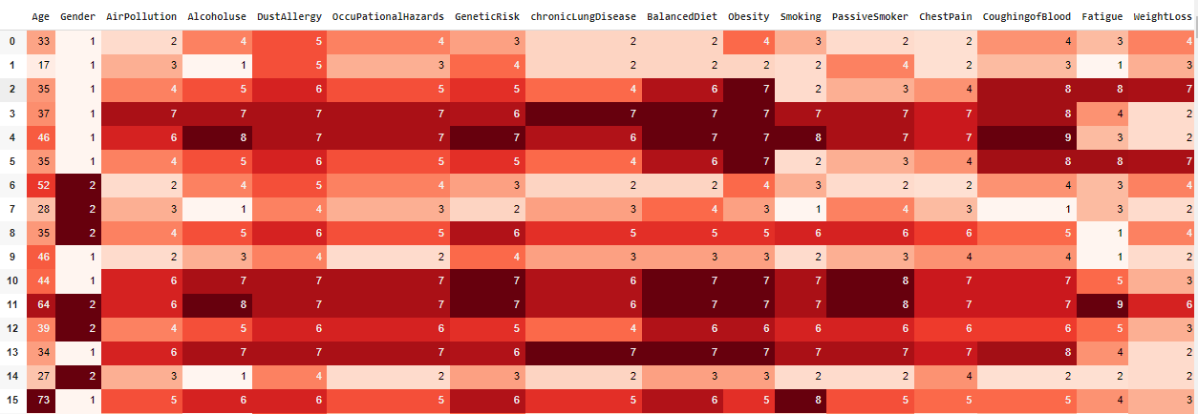

label = df.Age.sort_values().unique()

target = sorted_smokers.Smoking

from sklearn.model_selection import train_test_split

from sklearn.metrics import accuracy_score, confusion_matrix

from sklearn.metrics import log_loss, f1_score

from sklearn.model_selection import cross_val_score

import numpy as np

acc_dict = {}

# create the data

X = df.drop('Level',axis = 1)

y = df['Level']

X_train, X_test, y_train, y_test = train_test_split(X,y)

from sklearn.ensemble import  RandomForestClassifier

# create model

model = RandomForestClassifier()

# fit the data in the model

model.fit(X_train,y_train)

y_pred_randomF = model.predict(X_test)

print('Accuracy score : ',accuracy_score(y_test, y_pred_randomF)*100)

acc_dict['RFC_log_loss'] = log_loss(y_test, y_pred_randomF)

acc_dict['RFC_F!1_Score'] = f1_score(y_test, y_pred_randomF,average='weighted')

# prediction visualization

plt.imshow(np.log(confusion_matrix(y_test,y_pred_randomF)),cmap = 'Blues',interpolation = 'nearest')

plt.ylabel('True')

plt.xlabel('Predicted')

plt.show()

OUTPUT :  
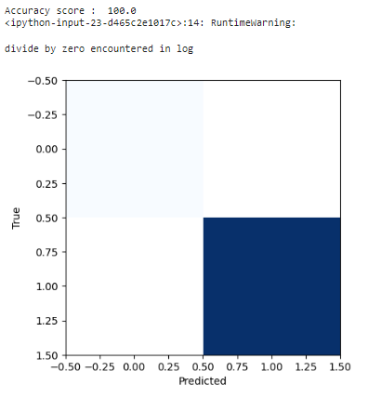

from sklearn.neighbors import KNeighborsClassifier

# to find the best k

score = 0

scores, highscore, bestk = 0, 0, 0

for k in range(3,12):

    knn = KNeighborsClassifier(n_neighbors=k)

    scores = cross_val_score(knn, X_train, y_train)

    score = scores.mean()

    if score>highscore:

        highscore = score

        bestk = k

print('Best k is {} with score {}'.format(bestk, highscore))

knn = KNeighborsClassifier(n_neighbors=bestk)

knn.fit(X_train,y_train)

# prediction

y_predict = knn.predict(X_test)

print('Accuracy score : ',accuracy_score(y_test,y_predict)*100)

acc_dict['KNN_log_loss'] = log_loss(y_test, y_predict)

acc_dict['KNN_F!1_Score'] = f1_score(y_test, y_predict,average='weighted')

# prediction visualization

plt.imshow(np.log(confusion_matrix(y_test,y_predict)),cmap = 'Blues',interpolation = 'nearest')

plt.ylabel('True')

plt.xlabel('Predicted')

plt.show()

OUTPUT :

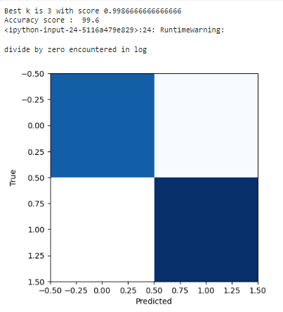

from sklearn.cluster import KMeans

clf = KMeans()

clf.fit(X_train)

maxx = clf.predict(X_test)

print('Accuracy score : ',accuracy_score(y_test,maxx)*100)

acc_dict['kMeans_log_loss'] = log_loss(y_test, maxx)

acc_dict['kMeans_F1_Score'] = f1_score(y_test, maxx,average='weighted')

plt.imshow(np.log(confusion_matrix(y_test,maxx)),cmap='Reds', interpolation = 'nearest')

plt.ylabel('True')

plt.xlabel('Predicted')

plt.show()

OUTPUT :  
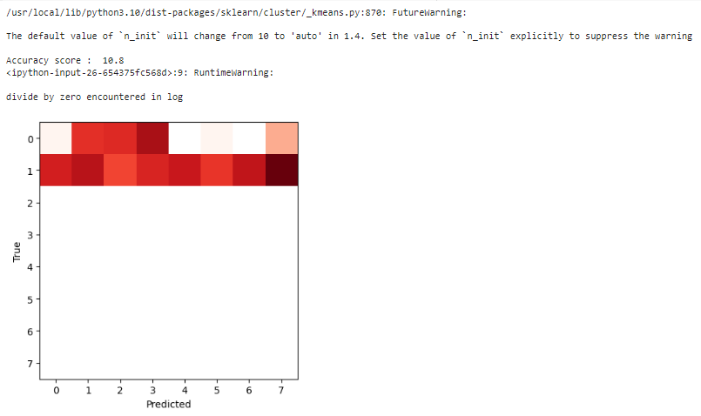

from sklearn.tree import DecisionTreeClassifier

tree_ = DecisionTreeClassifier()

tree_.fit(X_train,y_train)

y_pred = tree_.predict(X_test)

print('Accuracy score : ',accuracy_score(y_test, y_pred)*100)

acc_dict['Tree_log_loss'] = log_loss(y_test,y_pred)

acc_dict['Tree_f!1_score'] = f1_score(y_test,y_pred)

# prediction visualization

plt.imshow(np.log(confusion_matrix(y_test,y_pred)),cmap = 'Blues',interpolation = 'nearest')

plt.ylabel('True')

plt.xlabel('Predicted')

plt.show()

OUTPUT :

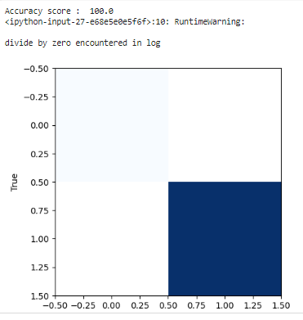

from sklearn.svm import SVC

model = SVC()

model.fit(X_train, y_train)

y_pred = model.predict(X_test)

print('Accuracy score : ',accuracy_score(y_test, y_pred)*100)

acc_dict['svc_log_loss'] = log_loss(y_test,y_pred)

acc_dict['svc_f!1_score'] = f1_score(y_test,y_pred)

# prediction visualization

plt.imshow(np.log(confusion_matrix(y_test,y_pred)),cmap = 'Blues',interpolation = 'nearest')

plt.ylabel('True')

plt.xlabel('Predicted')

plt.show()

OUTPUT :  
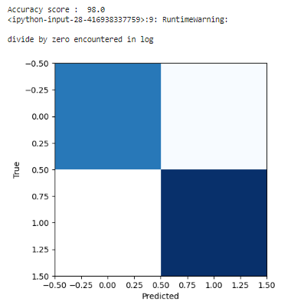

import pandas as pd

import matplotlib.pyplot as plt

from sklearn.model_selection import train_test_split

from sklearn.metrics import accuracy_score, log_loss, f1_score, confusion_matrix

from transformers import pipeline

# Load the Zero-shot classification model

zsl_model = pipeline("zero-shot-classification")

# Assuming your dataframe is already loaded as `df`

# Define the candidate labels that the ZSL model can predict

candidate_labels = ["High", "Medium", "Low"]

X = df.drop('Level', axis=1)

y = df['Level']

X_train, X_test, y_train, y_test = train_test_split(X, y)

# Prepare the text inputs for zero-shot classification

X_test_text = [" ".join(map(str, row)) for row in X_test.values]

# Perform zero-shot classification

zsl_results = zsl_model(X_test_text, candidate_labels)

# Extract the predicted labels

zsl_predictions = [result['labels'][0] for result in zsl_results]

zsl_predictions = [candidate_labels.index(label) if label in candidate_labels else -1 for label in zsl_predictions]

# Evaluate the zero-shot classification predictions

print('Accuracy score (ZSL): ', accuracy_score(y_test, zsl_predictions) * 100)

print('Log loss (ZSL): ', log_loss(y_test, zsl_predictions))

print('F1 Score (ZSL): ', f1_score(y_test, zsl_predictions, average='weighted'))

# Visualize the confusion matrix

plt.imshow(np.log(confusion_matrix(y_test, zsl_predictions)), cmap='Blues', interpolation='nearest')

plt.ylabel('True')

plt.xlabel('Predicted')

plt.show()

OUTPUT :

