HR Data Analysis Report
Comprehensive Workforce Analytics and Strategic Insights

Total Employees Average Age Avg Salary
1,470 37 6.50K

Avg Rating Attrition
3.15 237

Executive Summary
This report provides a comprehensive analysis of the organization's human resources metrics based on the HR Data Analysis Dashboard. The analysis covers workforce demographics, compensation patterns, attrition trends, and departmental insights across 1,470 employees.
The organization maintains an average employee age of 37 years with an average salary of $6,500. The overall employee satisfaction rating stands at 3.15 out of 5, indicating moderate engagement levels. With 237 employee departures recorded, the organization faces significant retention challenges that require strategic intervention.

Workforce Demographics and Attrition Analysis

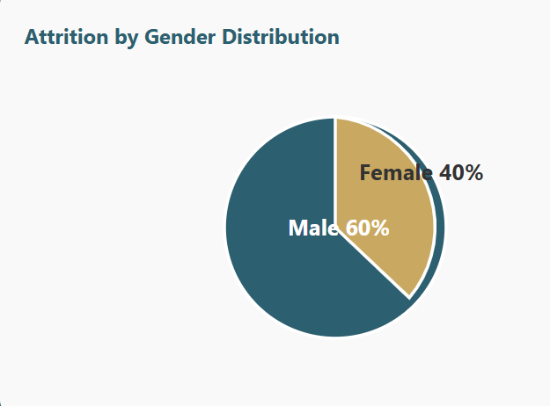
Key Finding: The attrition analysis reveals a notable gender disparity, with males representing 60% of departures compared to females at 40%. This 20-percentage-point difference suggests potential gender-specific retention challenges that may be linked to career progression, work-life balance policies, or compensation equity issues.

Educational Background Impact on Attrition

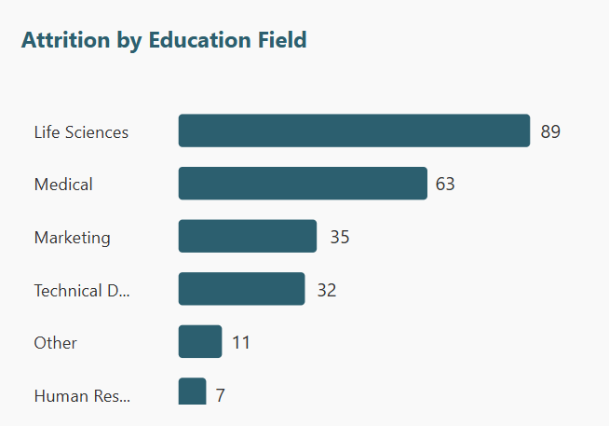
Critical Insight: Life Sciences emerges as the dominant educational background among departing employees with 89 individuals (37.6% of total attrition), followed by Medical at 63 (26.6%). These two fields alone account for nearly two-thirds of all attrition, suggesting significant challenges in retaining specialized STEM talent. This concentration likely reflects competitive market pressures, limited internal advancement opportunities, or better external offers in these high-demand fields.

Compensation Analysis

Salary Distribution Across Job Roles

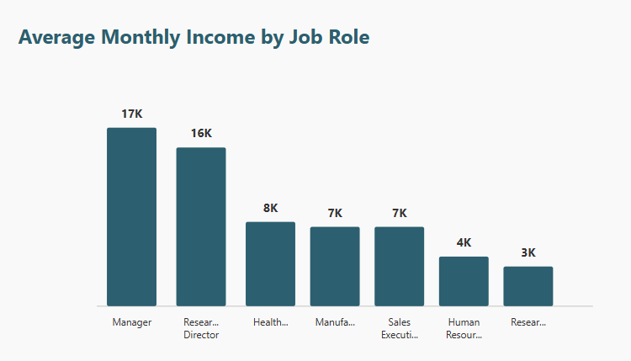
Compensation Hierarchy: A clear three-tier compensation structure exists:
- Senior Leadership ($16K-17K): Managers and Research Directors command premium salaries
- Mid-Level Professionals ($7K-8K): Healthcare Representatives, Manufacturing Directors, and Sales Executives
- Entry to Mid-Level ($3K-4K): HR staff, Research Scientists, Laboratory Technicians, and Sales Representatives

Departmental Salary Increase Trends

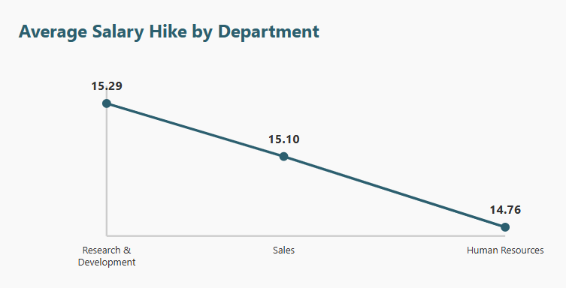
Salary Growth Disparity: While all departments show positive salary growth, a concerning pattern emerges. Research & Development leads with 15.29% average increases, followed closely by Sales at 15.10%. However, Human Resources significantly trails at 14.76%. This 0.53 percentage point gap, while seemingly small, compounds over time and may contribute to retention challenges in HR, particularly when HR professionals see their colleagues in other departments receiving more substantial increases.

Age Distribution and Workforce Composition
Multi-Generational Workforce: The organization maintains a diverse age structure spanning five distinct generations, from young professionals (20 or below) to experienced veterans (50-60). With an average age of 37, the workforce canters in the 30-40 age bracket, representing employees in their prime productive years. This distribution suggests a healthy balance of innovation from younger employees and institutional knowledge from senior staff.

Strategic Recommendations
1. Targeted Retention Programs
Implement specialized retention initiatives focusing on male employees and those with Life Sciences and Medical backgrounds. Consider developing career advancement pathways, mentorship programs, and competitive compensation packages specifically designed for high-demand STEM roles to address the disproportionate attrition in these critical areas.
2. Compensation Equity Review
Conduct a comprehensive salary audit to address disparities between departments, particularly the lower salary increases in Human Resources. Establish transparent compensation frameworks that ensure equitable growth opportunities across all functions, preventing talent loss due to perceived inequity.
3. Employee Engagement Enhancement
With an average satisfaction rating of 3.15 out of 5, there is substantial room for improvement. Launch engagement surveys to identify specific pain points, implement recognition programs, improve communication channels, and create opportunities for professional development and career growth.
4. Gender-Specific Retention Analysis
Investigate the root causes of higher male attrition through focus groups and exit interviews. Assess whether factors such as career advancement opportunities, work culture, compensation equity, or work-life balance policies differ by gender and develop targeted interventions accordingly.
5. Specialized Talent Development
Create dedicated career pathways and development programs for Life Sciences and Medical professionals. Partner with educational institutions, offer continuing education opportunities, and establish clear promotion criteria to demonstrate the organization's commitment to these specialized fields.
6. Cross-Departmental Equity
Address the salary hike disparity by implementing consistent performance-based increase frameworks across all departments. Ensure that support functions like HR receive competitive raises that reflect their strategic value to the organization.

Conclusion
The HR Data Analysis Dashboard reveals an organization with a substantial workforce of 1,470 employees and competitive compensation for senior leadership roles. However, several critical challenges require immediate attention:
- Significant Attrition: 237 departures represent a meaningful loss of talent and institutional knowledge
- STEM Retention Crisis: Concentrated attrition in Life Sciences and Medical fields threatens specialized capabilities
- Moderate Engagement: A 3.15 rating indicates employees are neither highly satisfied nor actively disengaged, presenting both risk and opportunity
- Compensation Inequities: Departmental disparities in salary increases may fuel retention challenges
- Gender-Based Patterns: The 60-40 male-female attrition split warrants investigation
By implementing the recommended strategic initiatives focusing on targeted retention, compensation equity, enhanced engagement, and specialized talent development, the organization can transform these challenges into opportunities for building a more stable, satisfied, and high-performing workforce.

