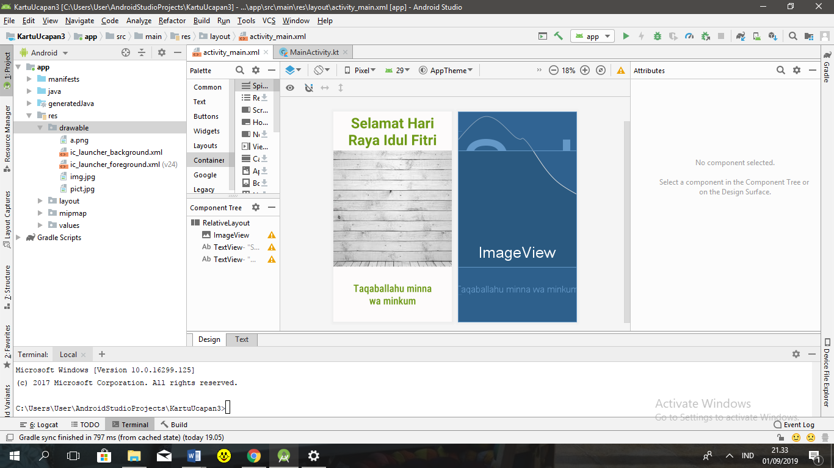

<**RelativeLayout  
 xmlns:android="http://schemas.android.com/apk/res/android"  
 xmlns:tools="http://schemas.android.com/tools"  
 android:layout_width="match_parent"  
 android:layout_height="match_parent"  
 tools:context=".MainActivity"**>  
 <**ImageView  
 android:layout_width="match_parent"  
 android:layout_height="match_parent"  
 android:scaleType="centerCrop"  
 android:src="@drawable/a"** />  
 <**TextView  
 android:layout_width="wrap_content"  
 android:layout_height="wrap_content"  
 android:text="Selamat Hari Raya Idul Fitri"  
 android:textColor="#6d9917"  
 android:background="#fdfbfb"  
 android:textSize="50sp"  
 android:padding="5dp"  
 android:textAlignment="center"  
 android:textStyle="bold"  
 android:layout_centerHorizontal="true"  
 android:layout_alignParentTop="true"**/>  
 <**TextView  
 android:layout_width="wrap_content"  
 android:layout_height="wrap_content"  
 android:text="Taqaballahu minna wa minkum"  
 android:layout_centerHorizontal="true"  
 android:layout_alignParentBottom="true"  
 android:padding="50dp"  
 android:textAlignment="center"  
 android:textColor="#6d9917"  
 android:background="#fdfbfb"  
 android:fontFamily="sans-serif-condensed-medium"  
 android:textSize="36sp"**/>  
</**RelativeLayout**>