BlogsPostAPI is a Java Spring Boot Application that supports adding of posts by bloggers(Users) who are connected in the network by virtual of being friends(Assumed)

The Relational Schema design takes an approach where the Post is written by a User. A User can write and update various posts to the network without limitation to other CRUD operations to perform.

Each user is described by their details and Location. Location is of interest in the application because Several users may occupy the same location hence the title of the Posts that they write might be related based on category and occurrences they encounter.

Accessing the API from an advanced REST client and also via browser clients

URL is **http://localhost:8090/posts**

<http://localhost:8090/users> 🡺View users in the network

<http://localhost:8090/posts> 🡺View blogs by users in the network

<http://localhost:8090/locations> 🡺View locations spanning the extent of the social network

Samples from Chrome Advanced REST Client for CRUD tasts

GET request – All users

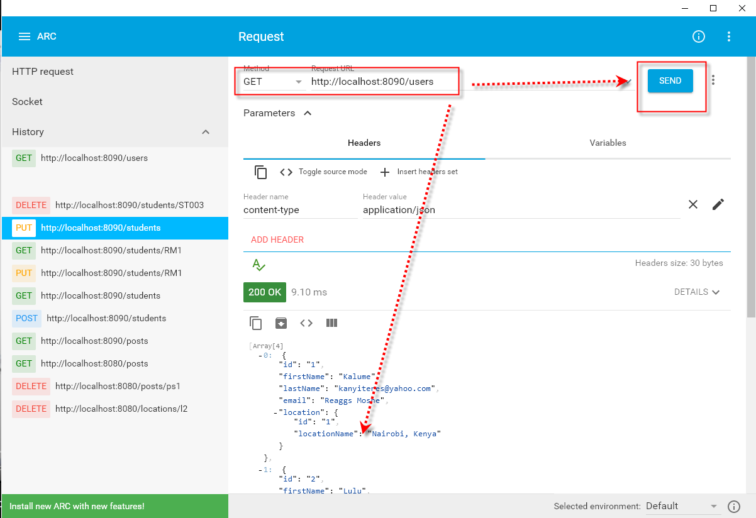

GET all Posts

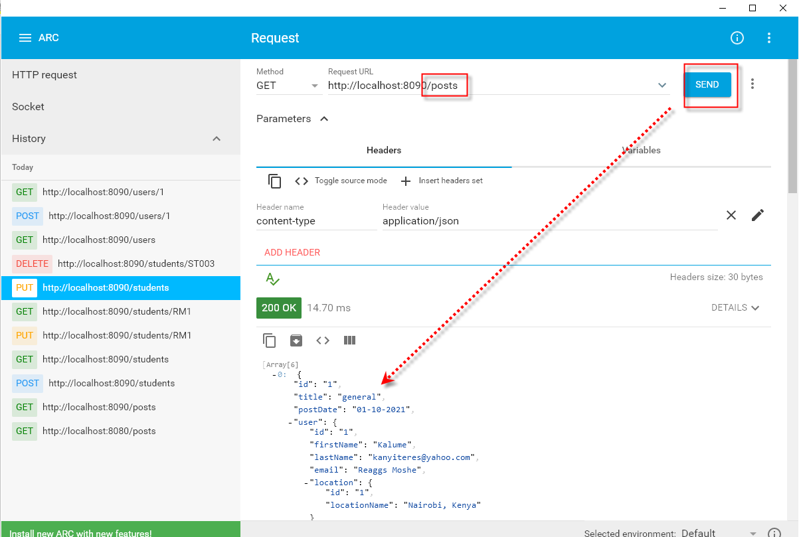

GET request – Filter One user

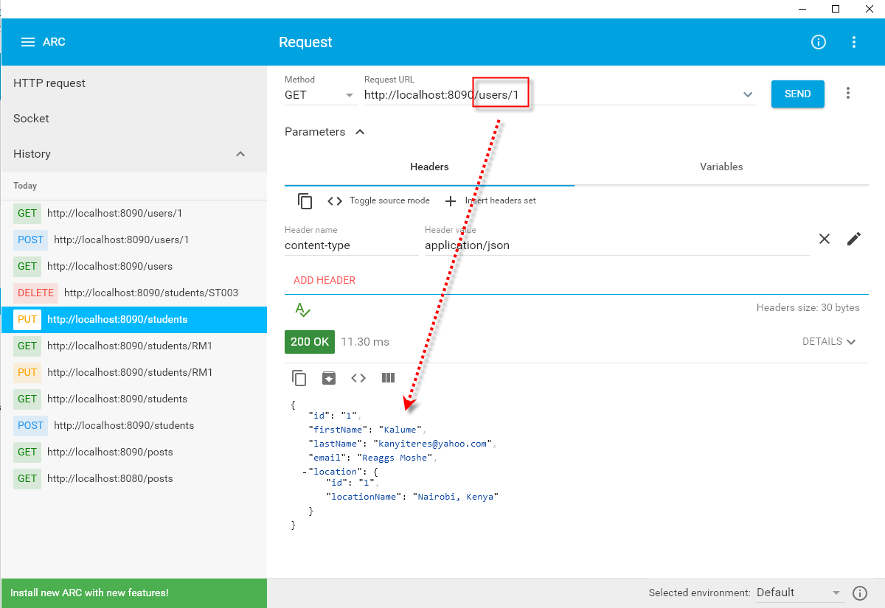

POST request

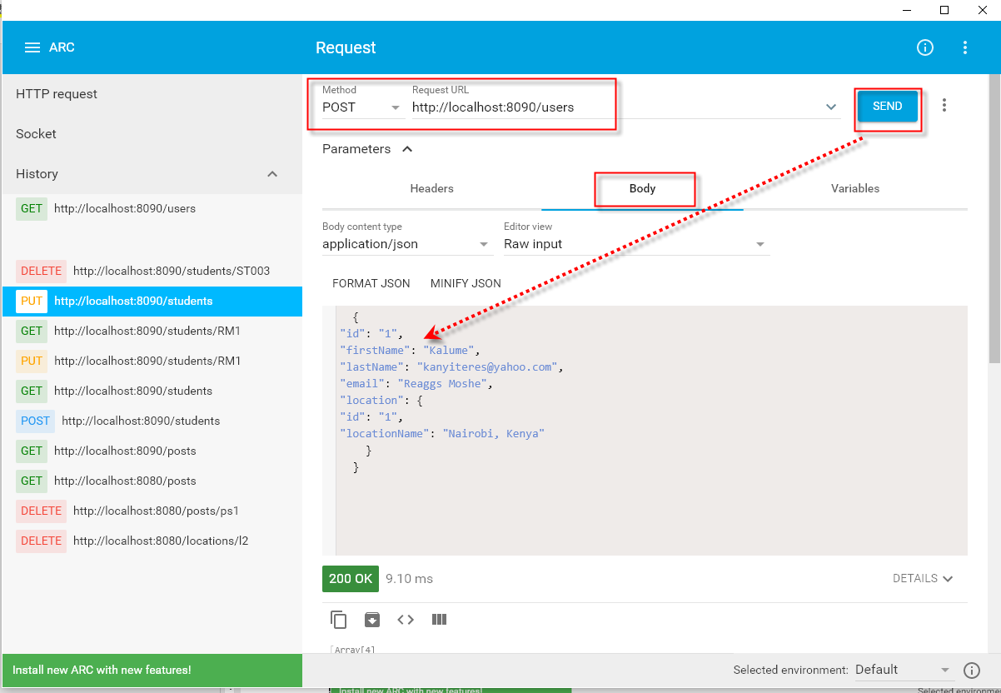

Initial data reload and application structure

