**GROUP 6**

***CHIAMA ERICK OTIENO – P15/81737/2017***

***MALUKI MUTHUSI MALUKI – P15/817541/2017***

***OKITE ROY DIXON – P15/81769/2017***

**1. With the help of a well labeled diagram describe the key physical components of a LAN with the star topology. Discuss the location and function of the medium interface.** [5 Marks]

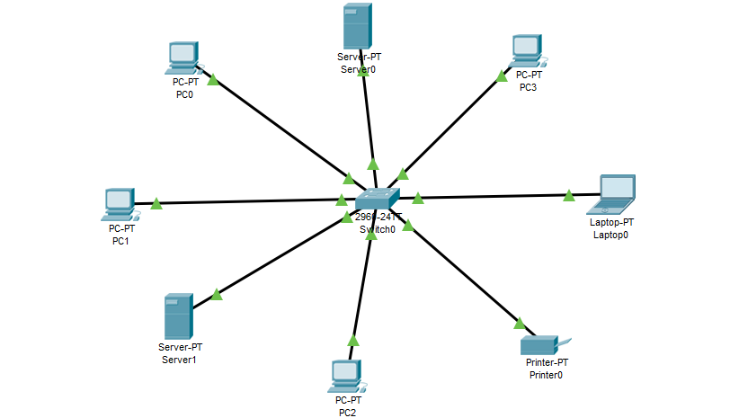

The hardware/physical components of a LAN consist of:

***Workstations and servers***. These are basically where the data transferred over the network originate from and are also received at.

***Network Interface Card***. This is a circuit board inserted into each network station, workstation or server, to allow communication with other stations. .

***Cabling and connectors***. Examples are coaxial, fibre optic or Unshielded Twisted Pair cables. Networking cables are networking hardware used to connect one network device to other network devices or to connect two or more computers to share hardware resources such as the printer shown above. Different types of network cables are used depending on the network's physical layer, topology, and size. The devices can be separated by a few meters such as via Ethernet or great distances.

***Network devices*** such as a hub, bridge, Switch or Router. In our case a switch has been used. A switch, in the context of networking is a high-speed device that receives incoming data packets and redirects them to their destination on the LAN. A LAN switch operates at the data link layer or the network layer of the OSI Model and, as such it can support all types of packet protocols.

The medium interface describes the interface (both physical and electrical/optical) in a computer network from a physical layer implementation to the physical medium used to carry the transmission.

**2. Logical topology defines the Transmission (unicast, multicast and broadcast) and delivery of data from station to station as seen by the software. Describe the logical topology for a physical star/logical ring network in each transmission case. Discuss how frame removal is accomplished in the physical star/logical ring in each transmission case**. [5 Marks]

*Unicast-* In this case there is just one sender, and one receiver. The data is goes from first node to the other, without being fed from the central hub, the data movement is what makes it a logical ring network. The frame is removed at the destination, in this cast the one receiver decides whether to keep or discard the frame.

*Multicast-* Information is sent from one or more points to a set of other points. The data would think it was a ring network because, inside the central point where we can't see it, the cables connected from each node are actually connected across to the cable that leads to the next node. The data is therefore going from node to node rather than being fed from the central hub, data movement makes it a logical ring network. If a hub is used and a frame is transmitted, all station will receive it. Each station decides whether to keep or discard the frame based on the destination address of the frame.

*Broadcast-* Information is sent from one point to all other points. The data believes it to be a ring network like the one above because the cables connected from each node are actually connected across to the cable that leads to the other nodes. The data is therefore going from node to node rather than being fed from the central hub. In this case there is just one sender, but the information is sent to all connected receivers. All receiving stations decide whether to keep or discard the frame based on the destination address of the frame.

**3. Describe the CSMA Medium access protocol while distinguishing between the following variants of that protocol, Non persistent CSMA, Persistent CSMA and p-persistent CSMA. Describe the advantage of each variant.** [10 Marks]

CSMA is a network access method used on shared network topologies such as Ethernet to control access to the network. Devices attached to the network cable listen, this is carrier sense, before transmitting. If the channel is in use, devices wait before transmitting. Multiple Access indicates that many devices can connect to and share the same network. All devices have equal access to use the network when it is clear. This method was developed to decrease the chances of collisions when two or more stations start sending their signals over the datalink layer. Carrier Sense multiple access requires that each station first check the state of the medium before sending.

There Are Three Different Type of CSMA Protocols:

*I-persistent CSMA-* In this method, station that wants to transmit data continuously senses the channel to check whether the channel is idle or busy. If the channel is busy, the station waits until it becomes idle. When the station detects an idle channel, it immediately transmits the frame with probability 1. Hence it is called I-persistent CSMA. This method has the highest chance of collision because two or more stations may find channel to be idle at the same time and transmit their frames. When the collision occurs, the stations wait a random amount of time and start all over again.

The advantage of I-persistent is that there is no idle time, therefore continuous transmission can occur without wasting resources by leaving the medium unused when there is data to be sent.

*Non- Persistent CSMA-* In this scheme, if a station wants to transmit a frame and it finds that the channel is busy then it will wait for fixed interval of time. After this time, it checks the status of the channel again and if the channel is free it will transmit. A station that has a frame to send senses the channel, if the channel is idle, it sends immediately but if the channel is busy, it waits a random amount of time and then senses the channel again. In non-persistent CSMA the station does not continuously sense the channel for the purpose of capturing it when it detects the end of previous transmission.

The advantage of non-persistent is that it reduces the chance of collision because the stations wait a random amount of time. It is unlikely that two or more stations will wait for same amount of time and will retransmit at the same time.

*P-persistent CSMA-* This method is used when channel has time slots such that the time slot duration is equal to or greater than the maximum propagation delay time. Whenever a station becomes ready to send, it senses the channel and if channel is busy, the station waits until the next slot. If the channel is idle, it transmits with a probability p. If the next slot is also idle, it either transmits or waits again with probabilities p and q. This process is repeated till either frame has been transmitted or another station has begun transmitting. In case of the transmission by another station, the station acts as though a collision has occurred and it waits a random amount of time and starts again.

The advantage of p-persistent is that it reduces the chance of collision and improves the efficiency of the network.

**4. Describe the Ethernet frame format. Explain how the MAC layer in Ethernet LANs assembles a frame.**

Ethernet frame starts with Preamble and SFD, both work at physical layer. Ethernet header contains both Source and Destination MAC address, after which the payload of frame is present. The last field is CRC which is used to detect the error.

*Preamble* – Ethernet frame starts with 7-Bytes Preamble. This is pattern of alternative 0’s and 1’s which indicates starting of the frame and allow sender and receiver to establish bit synchronization.

*Start of frame delimiter (SFD)* – This is a 1-Byte field which is always set to 10101011. SFD indicates that upcoming bits are starting of frame, which is destination address.

*Destination Address* – This is 6-Byte field which contains the MAC address of machine for which data is destined.

*Source Address* – This is a 6-Byte field which contains the MAC address of source machine.

*Length* – Length is a 2-Byte field, which indicates the length of entire Ethernet frame.

*Data* – This is the place where actual data is inserted, also known as Payload.

*Cyclic Redundancy Check (CRC*) – CRC is 4 Byte field. This field contains 32-bits hash code of data, which is generated over Destination Address, Source Address, Length and Data field. If the checksum computed by destination is not same as sent checksum value, data received is corrupted.

The Ethernet MAC sublayer has two primary responsibilities which are data encapsulation and media access control. The data encapsulation process includes frame assembly before transmission, and frame disassembly upon reception of a frame. In forming the frame, the MAC layer adds a header and trailer to the network layer PDU. Data encapsulation provides three primary functions:

*Frame delimiting-* The framing process provides important delimiters that are used to identify a group of bits that make up a frame. This process provides synchronization between the transmitting and receiving nodes.

*Addressing-* The encapsulation process also provides for data link layer addressing. Each Ethernet header added in the frame contains the physical address (MAC address) that enables a frame to be delivered to a destination node.

*Error detection-* Each Ethernet frame contains a trailer with a cyclic redundancy check (CRC) of the frame contents. After reception of a frame, the receiving node creates a CRC to compare to the one in the frame. If these two CRC calculations match, the frame can be trusted to have been received without error.

The use of frames aids in the transmission of bits as they are placed on the media and in the grouping of bits at the receiving node.