Assignment
Q.1
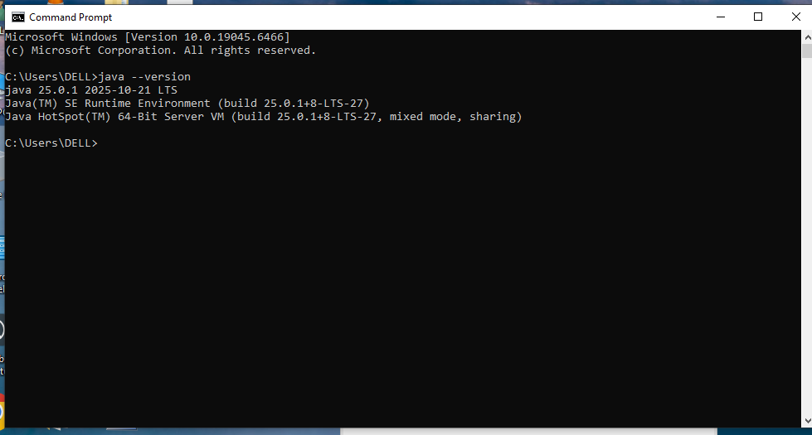

The Java Development Kit (JDK) was successfully installed on my computer. The installed version is JDK 25. I verified the installation by running the commands java -version and javac -version in the Command Prompt/Terminal. Both commands displayed the correct version, which confirms that Java and the Java compiler are properly installed.

Q.2
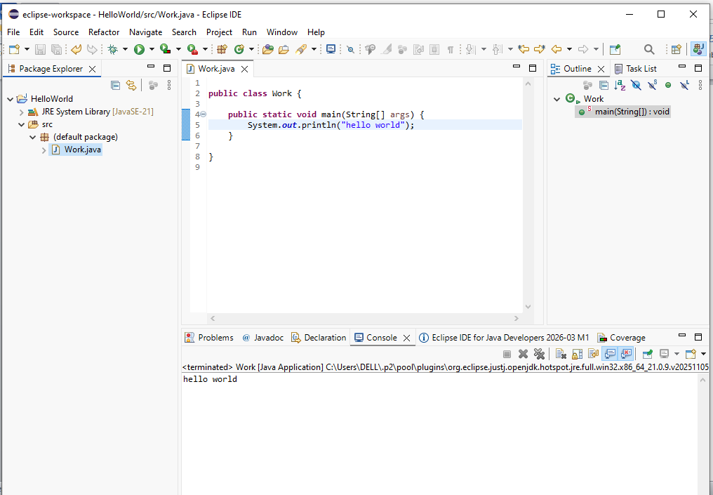
I successfully installed and configured my IDE for Java development. I created a new Java project, which confirms that the IDE recognizes the JDK correctly. The IDE is now ready for writing and running Java programs. I did not face any serious issues during setup.

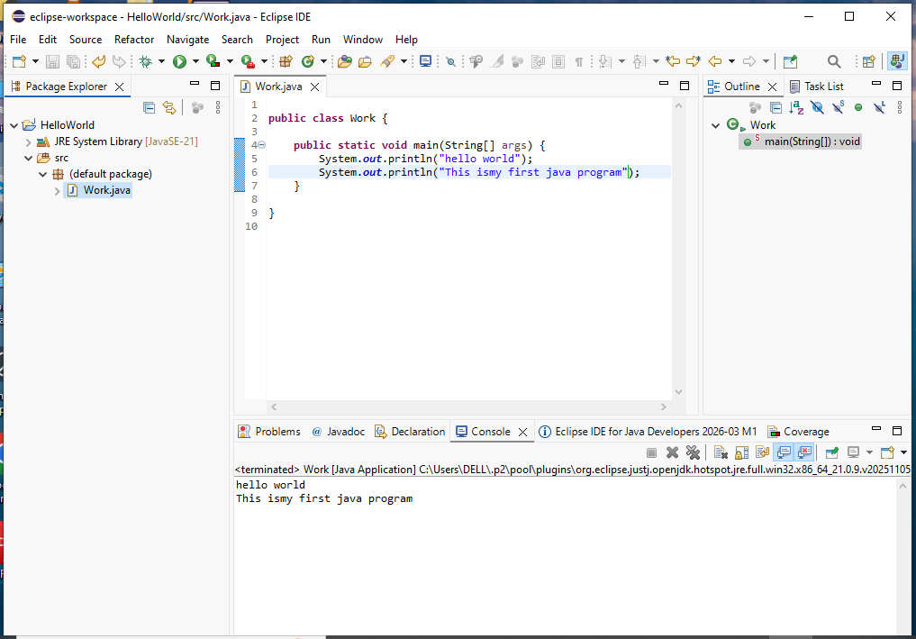

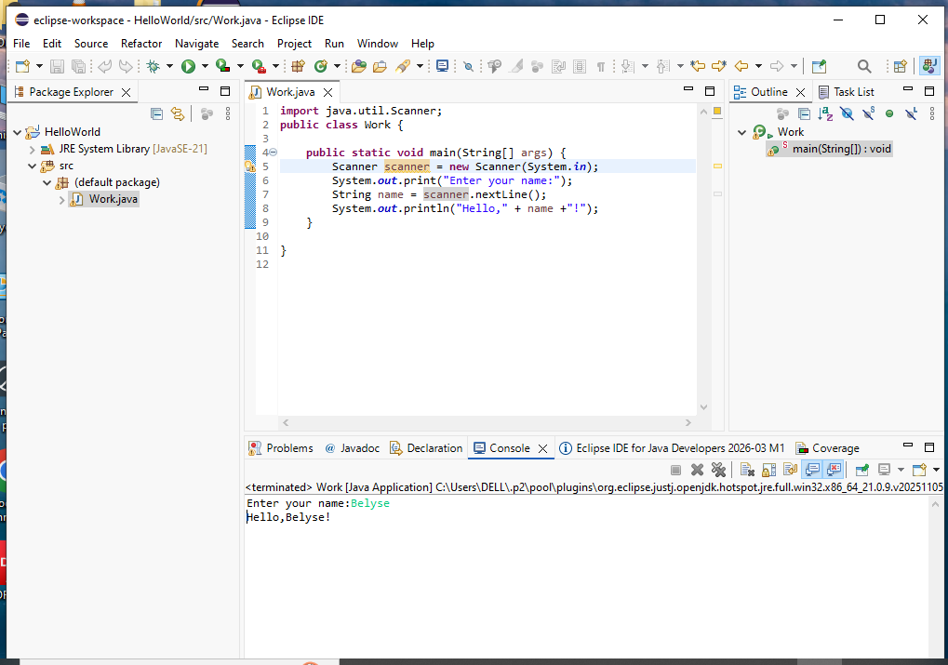
Q.3
To set up my Java development environment, I first installed the Java Development Kit (JDK) and verified it using the java -version and javac -version commands. After that, I installed an IDE and created a Java project to ensure everything was configured correctly.
The main challenge I faced was making sure the IDE detected the JDK, but this was solved by setting the correct JDK path.
From writing and modifying the HelloWorld program, I learned how Java programs are structured, how to print output to the console, and how to use the Scanner class to receive user input. This helped me understand the basics of Java programming.

