
Department of Computer Science and Engineering, Amrita School of Computing, Coimbatore

24CSE738- CLOUD COMPUTING
2025-2026-Even
Case Study Report Topic: Design and Implementation of a Scalable Data Pipeline Using Azure Data Factory and Synapse Analytics

NAME | ROLL NO
MUTTA RATNA VYKUNTA AKHIL | CB.SC.P2CSE25021

Problem Statement
In modern data-driven organizations, large volumes of data are generated from multiple sources such as APIs, CSV files and external datasets. However, this data is often unstructured, inconsistent, and stored across different platforms, making it difficult to perform efficient analytics and decision-making.
Traditional data processing systems lack scalability, automation, and real-time processing capabilities. Therefore, there is a need to design a robust, scalable, and automated data pipeline that can:
- Ingest data from multiple sources
- Perform data cleaning and transformation
- Store structured data efficiently
- Enable fast querying and analytics
This project addresses these challenges by implementing a cloud-based data pipeline using Microsoft Azure services.

Project Objectives
The primary objectives of my project to design a scalable data pipeline architecture using Azure services
- To perform data ingestion using Azure Data Factory (ADF)
- To implement data transformation using Azure Databricks (PySpark)
- To organize data using Bronze, Silver and Gold layers
- To enable efficient querying using Azure Synapse Analytics
- To integrate the pipeline with Power BI for visualization

Project Modules:

1. Data Source & Understanding Module

API data extraction

Kaggle dataset ingestion

Schema analysis and validation

2. Data Ingestion (Bronze Layer)

Raw data ingestion using Azure Data Factory

Storage in Azure Data Lake Gen2

No transformation (raw format preserved)

3. Data Storage Module (ADLS Gen2)

Centralized data storage

Organized into:

Bronze

Silver

Gold (Business-ready)

4. Data Transformation Module (Databricks)

Data cleaning (null handling, duplicates)

Schema standardization

Data enrichment using joins

PySpark-based transformations

5. Data Warehousing Module (Gold Layer)

Aggregated and business-ready datasets

Fact and dimension tables

Stored for analytics consumption

6. Analytics & Query Module (Synapse)

Query data using:

OPENROWSET

External Tables

SQL-based analytics

7. Visualization Module (Power BI)

Dashboard creation

KPI analysis

Business insights

Cloud Services Used:

1. Azure Data Factory (Integration Platform as a Service - iPaaS)

1.1 Orchestrates end-to-end data pipeline workflows.
1.2 Ingests data from APIs, GitHub, and Kaggle datasets into Azure Data Lake.
1.3 Automates ETL processes using pipelines, triggers, and scheduling.
1.4 Enables real-time and batch data ingestion scenarios.

2. Azure Data Lake Storage Gen2 (Storage as a Service)

2.1 Stores raw, processed, and analytical data in Bronze, Silver, and Gold layers.
2.2 Provides scalable and secure storage for big data workloads.
2.3 Supports hierarchical namespace for efficient data organization.
2.4 Enables high-performance access for analytics tools like Databricks and Synapse.

3. Azure Synapse Analytics (Data Warehousing as a Service)

3.1 Provides a unified analytics platform for querying large datasets.
3.2 Uses serverless SQL pool to query data directly from Data Lake.
3.3 Implements external tables and OPENROWSET for efficient querying.
3.4 Stores Gold layer data for business intelligence and reporting.

4. Azure Data bricks

4.1 Securely stores credentials, secrets, and connection strings.
4.2 Enables secure access between Azure services using managed identities.
4.3 Prevents exposure of sensitive data in pipelines and notebooks.

6. Power BI (Business Intelligence as a Service)

6.1 Connects to Azure Synapse for data visualization and reporting.
6.2 Creates dashboards and KPIs from Gold layer data.
6.3 Enables interactive data analysis and business insights.

Project Execution Steps:
User Registration and Login

🔹 Step 1: Data Understanding
- Analyze API & Kaggle dataset
- Identify schema, attributes, missing values

🔹 Step 2: Create Azure Resources
- Resource Group
- Storage Account (ADLS Gen2)
- Data Factory
- Databricks Workspace
- Synapse Workspace

🔹 Step 3: Data Ingestion – Bronze Layer
- Create ADF pipelines
- Use Copy Activity
- Load raw data into ADLS (bronze/)
- Maintain original format

🔹 Step 4: ADF Pipeline Design
- Linked Services
- Datasets
- Pipelines with:
  - Copy Activity
  - ForEach

🔹 Step 6: Databricks Setup
- Create cluster
- Configure Service Principal
- Connect to ADLS

🔹 Step 7: Data Transformation
- Read Bronze data
- Clean & transform using PySpark
- Write to Silver layer
Example:
df = spark.read.format("csv").option("header", "true").load(bronze_path)
df_clean = df.dropDuplicates().fillna(0)
df_clean.write.mode("overwrite").parquet(silver_path)

🔹 Step 8: Silver Layer
- Store cleaned data
- Use Parquet/Delta format
- Optimize for queries

🔹 Step 9: Gold Layer – Synapse
- Create analytical datasets
- Store aggregated data
- Build warehouse-ready tables

🔹 Step 10: Query using OPENROWSET
SELECT *
FROM OPENROWSET(
BULK 'https://<storage>/gold/data/*.parquet',
FORMAT = 'PARQUET'
) AS data;

🔹 Step 11: External Tables
- Create reusable SQL tables on data lake
- Enable structured querying

🔹 Step 12: Power BI Integration
- Connect Synapse to Power BI
- Build dashboards
- Visualize K

Screenshots:

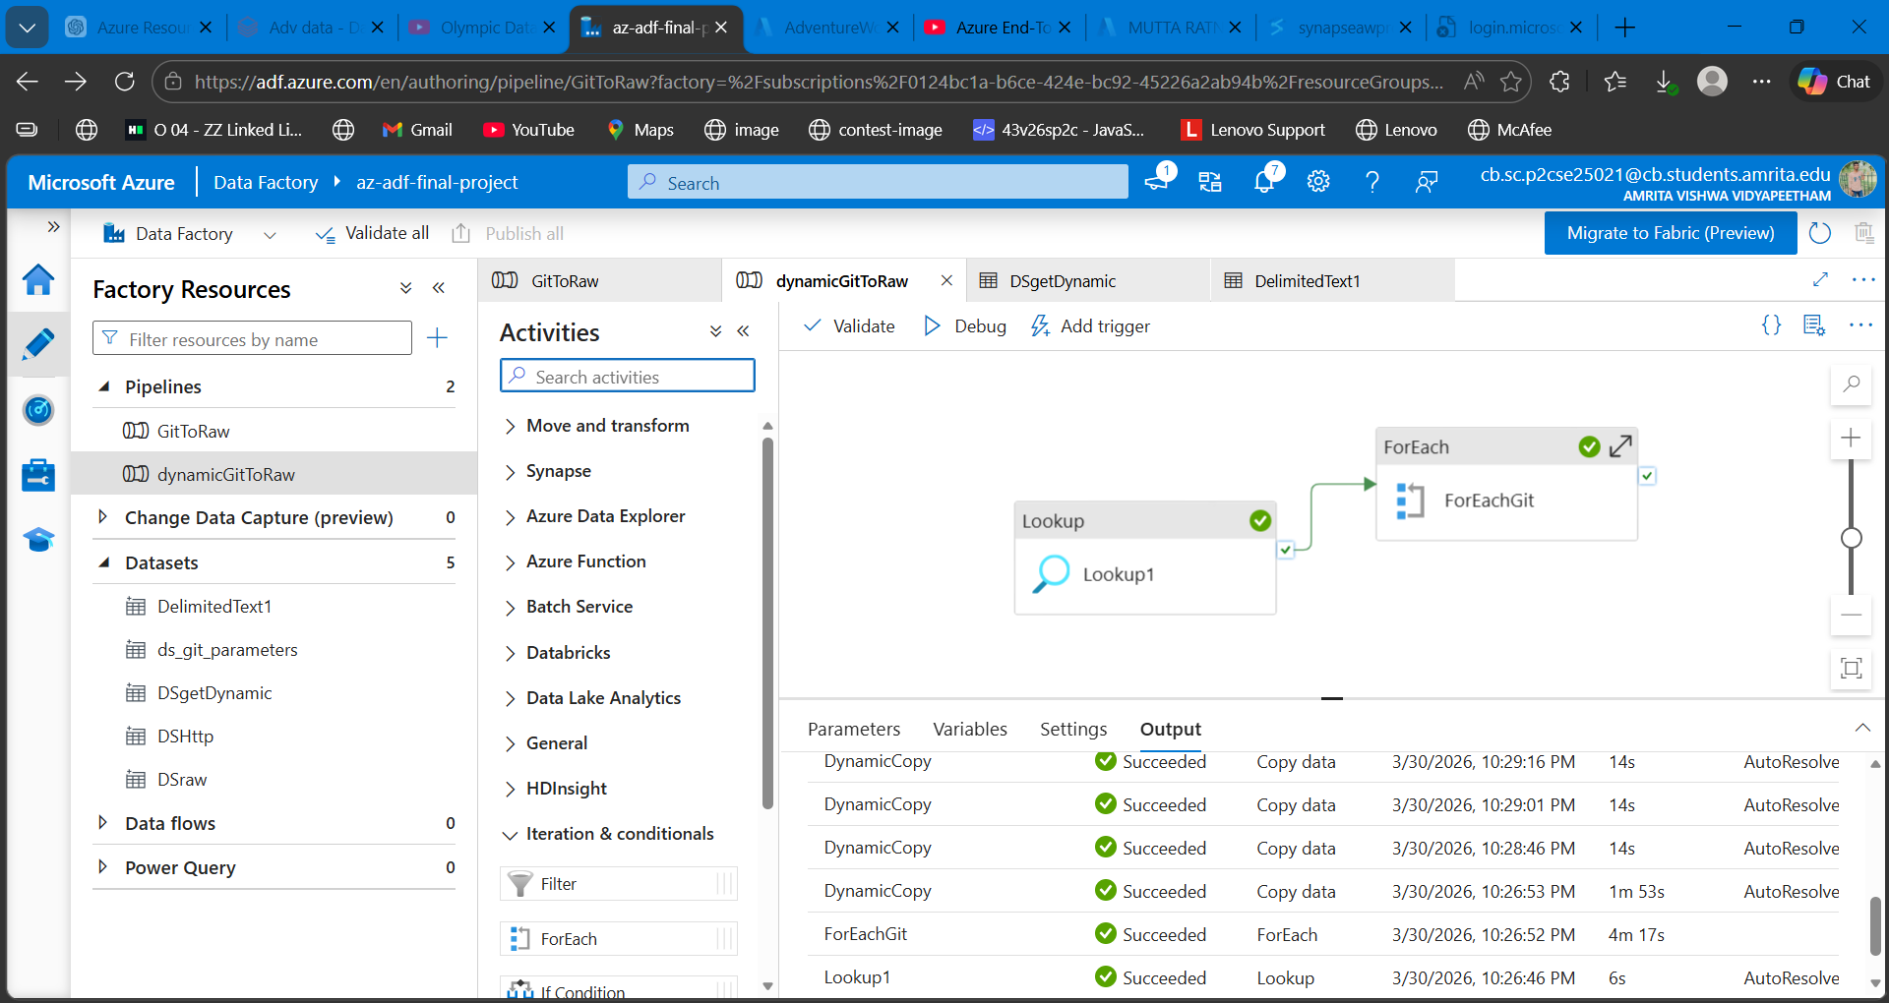

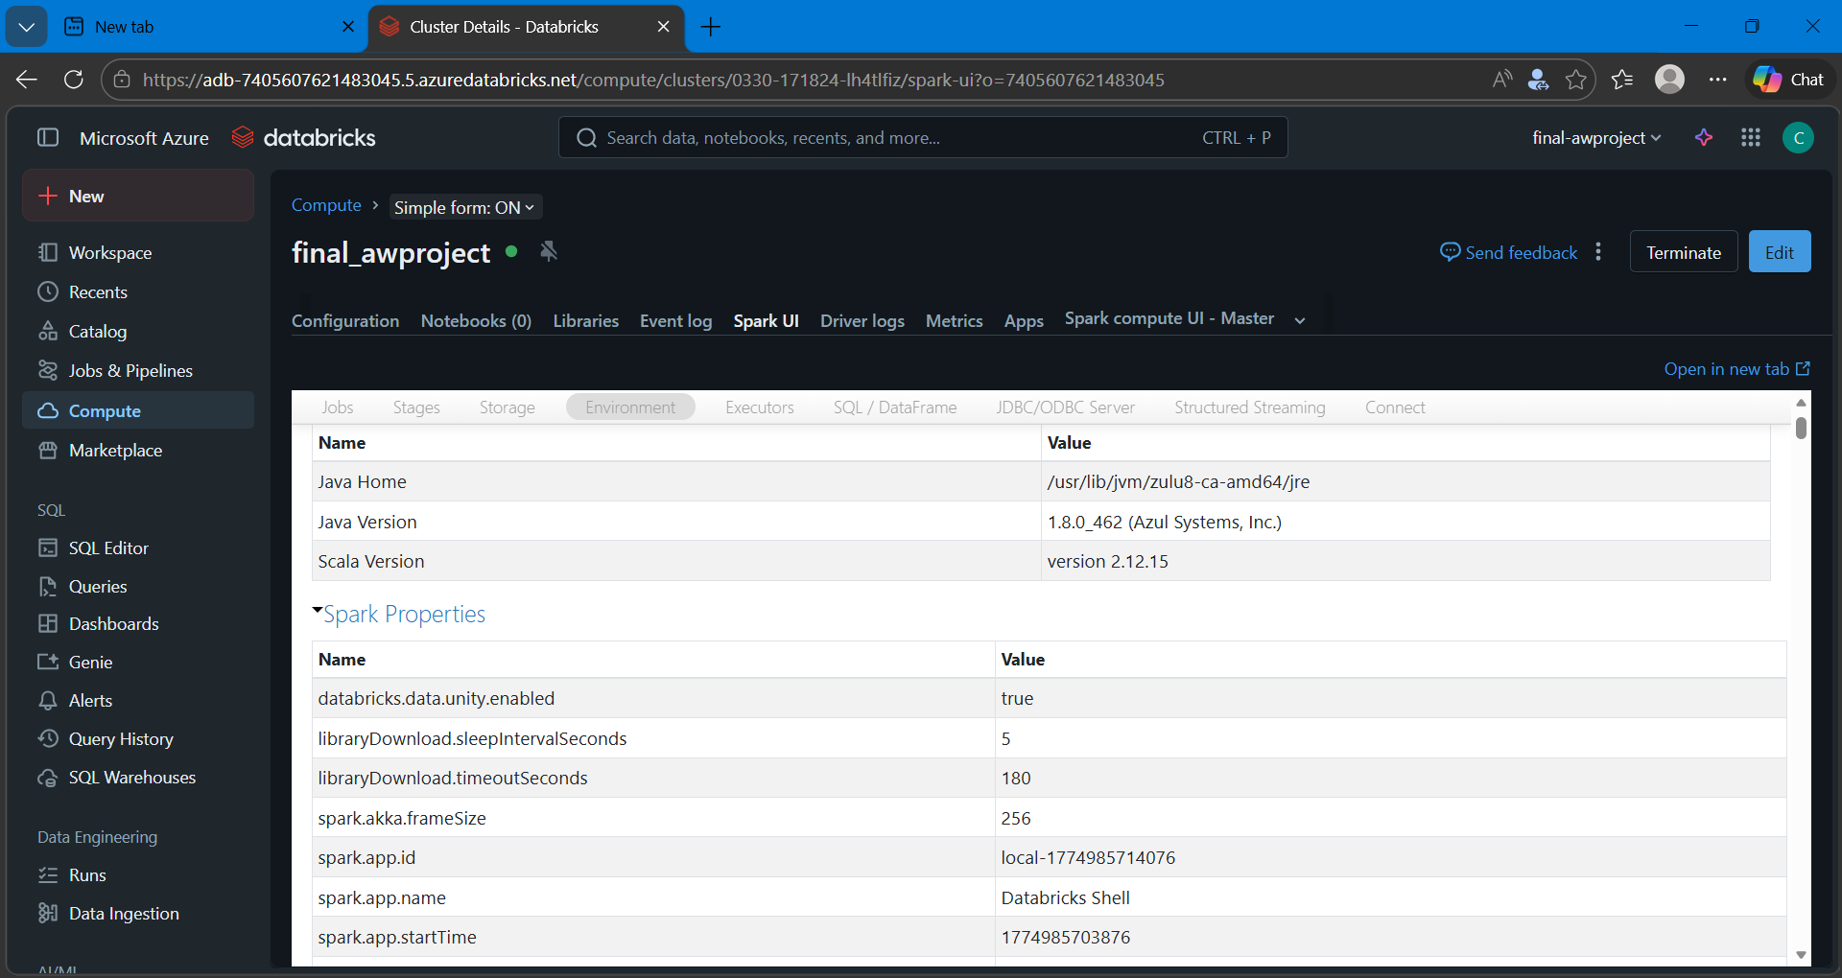

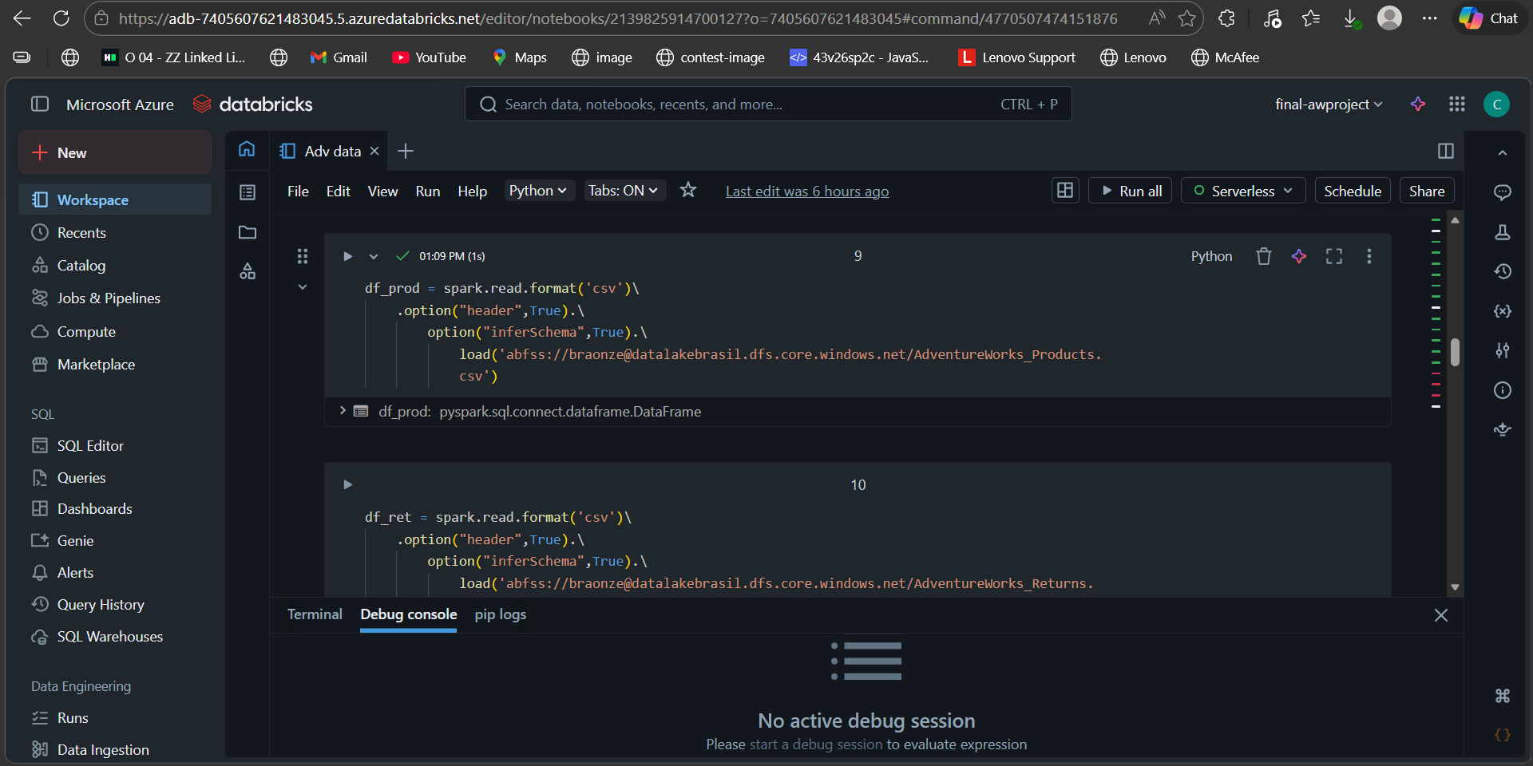

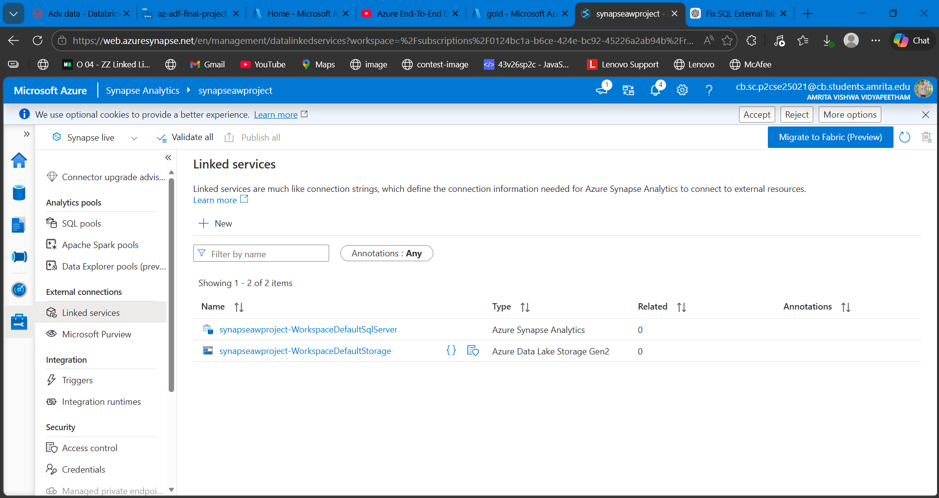

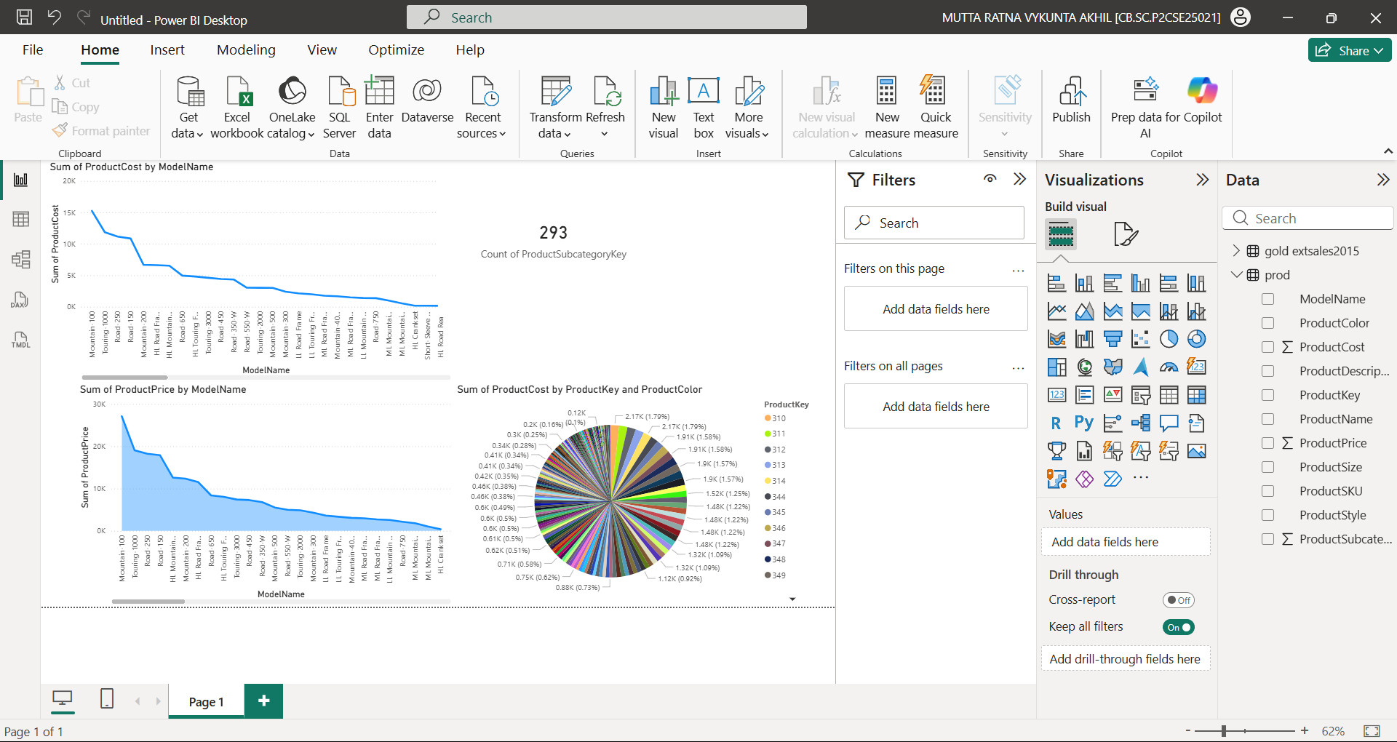

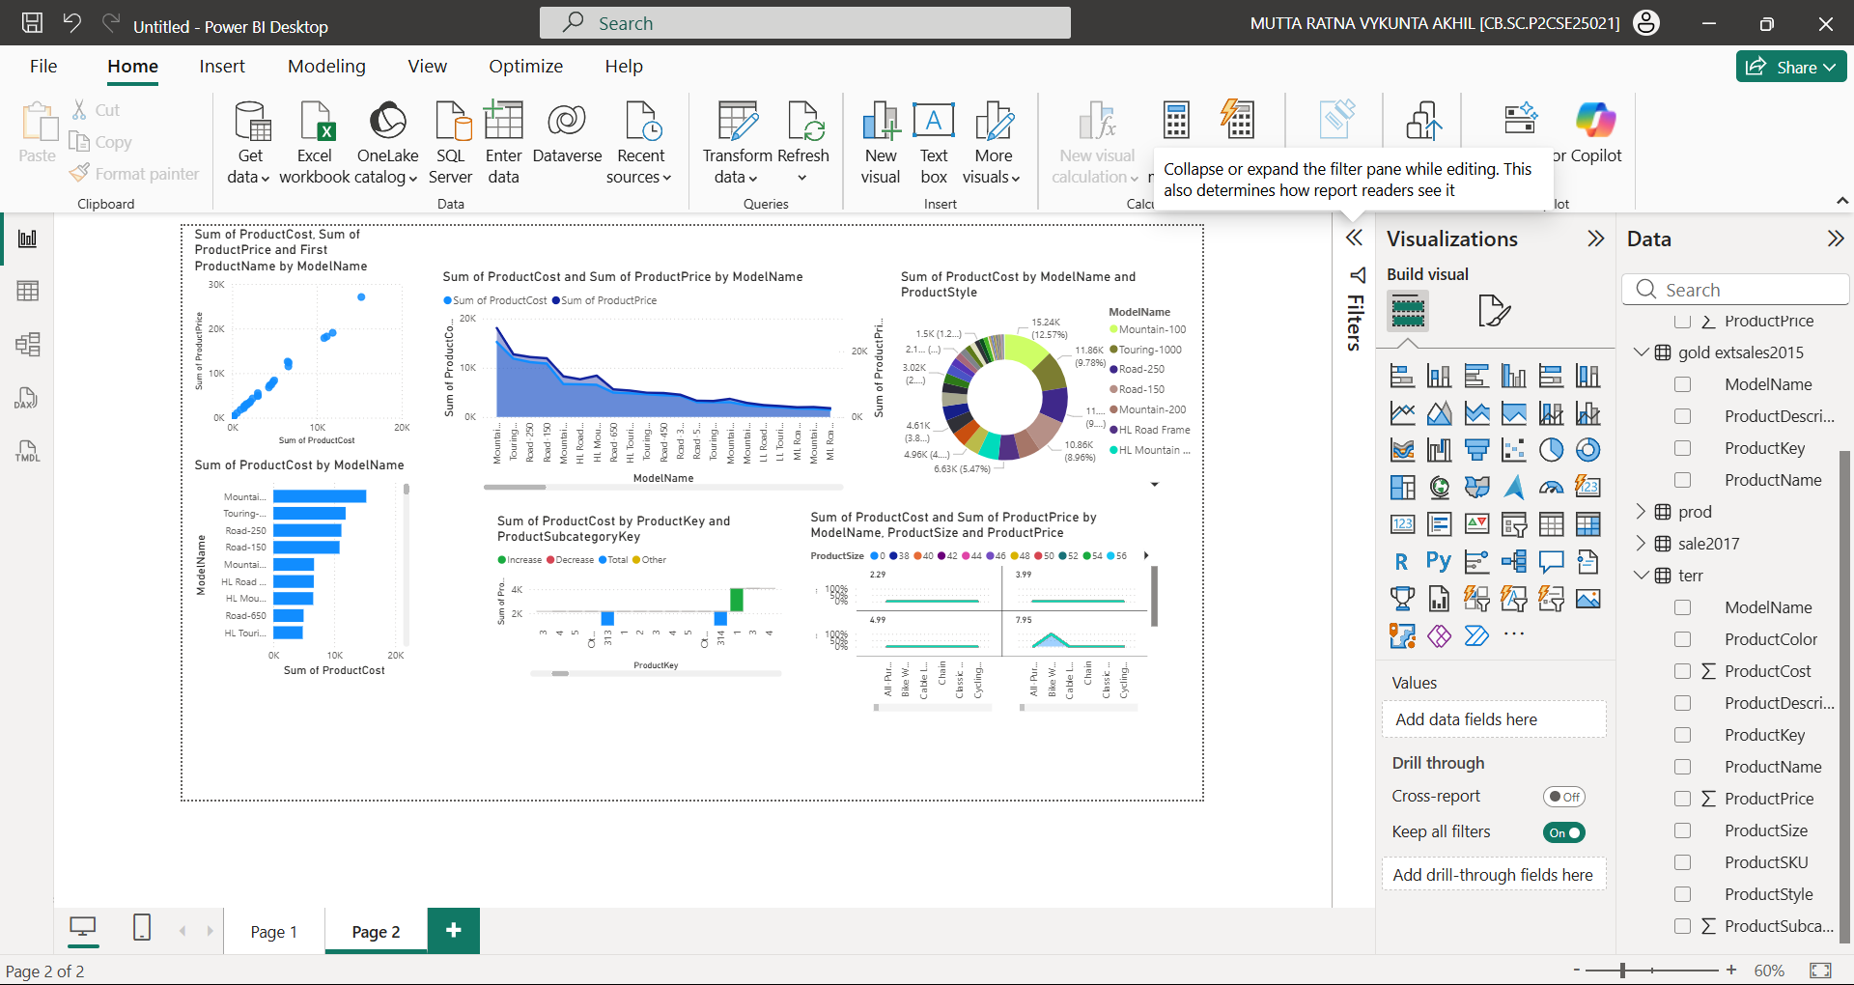
GIT HUB:
https://github.com/muttaakhil/Adv_Works_Dataset

