Contents

Introduction 1

Purpose 1

Webserver Details 1

Installation 1

Tomcat server folder structure 2

Exploration results 3

Deployment 3

Other observations 3

Challenges 3

# Introduction

This document describes about exploration summary of react app deployment in tomcat server.

# Purpose

To explore on react based application deployment on standard web servers like tomcat.

# Webserver Details

|  |  |  |
| --- | --- | --- |
| Server Name | Version | License |
| Apache Tomcat | 9.0 | Apache License, Version 2.0 |

## Installation

Down load the windows mis installer from the path and follow the instructions and install it as windows service .

<http://www-eu.apache.org/dist/tomcat/tomcat-9/v9.0.0.M26/bin/apache-tomcat-9.0.0.M26.exe>

After installing we can see tomcat server service in the taskbar status area. From here we can able to start/stop the tomcat service.

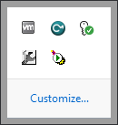

## Tomcat server folder structure

1. Navigate to tomcat installation directory

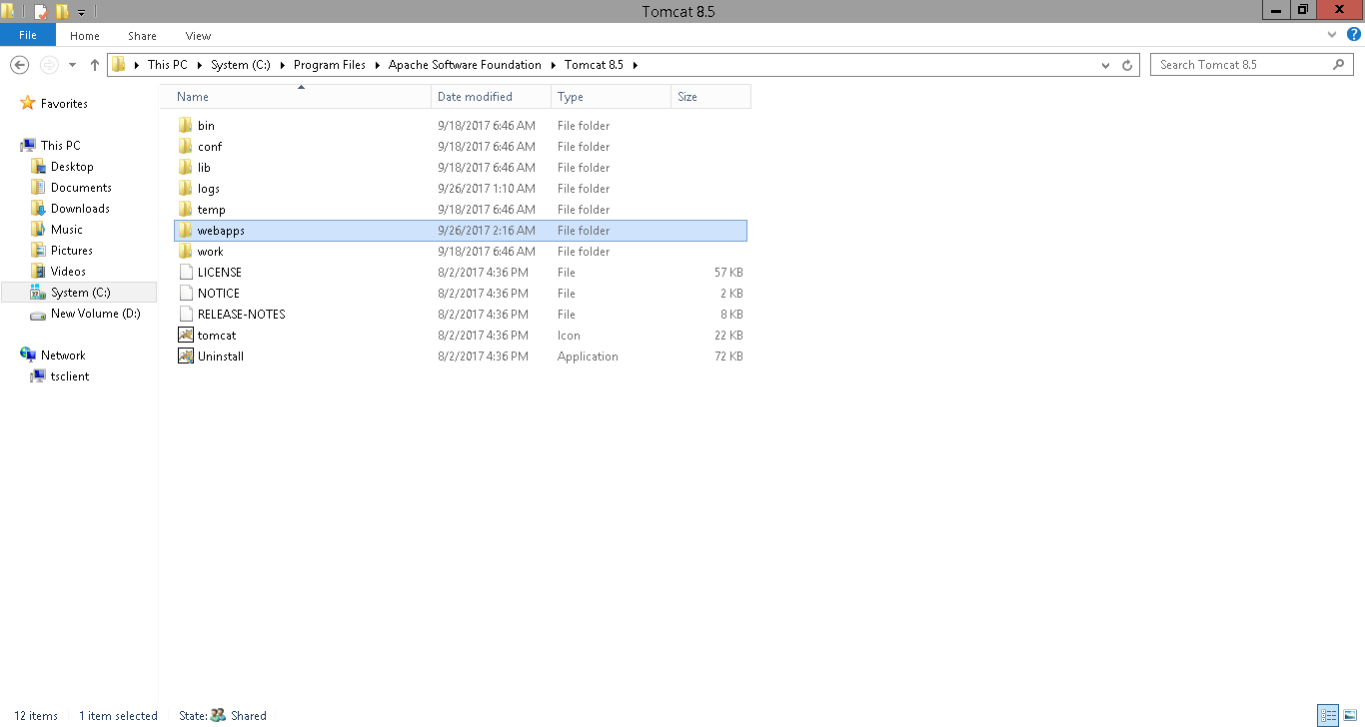

2. Open webapps folder , where apps will be hosted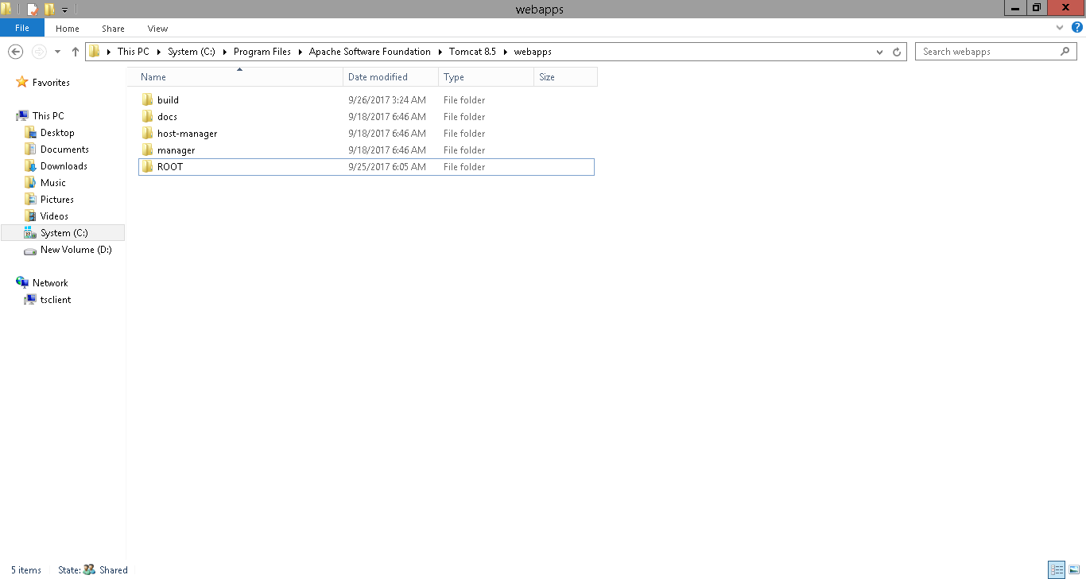

# Exploration results

### Deployment

1. If recipe editor build binaries copied to tomcat webapps Root folder (\Apache Software Foundation\Tomcat 8.5\webapps\ROOT\ ) ,Recipe editor application URL is accessible and application is loaded correctly .(URL http://hostname:8080)

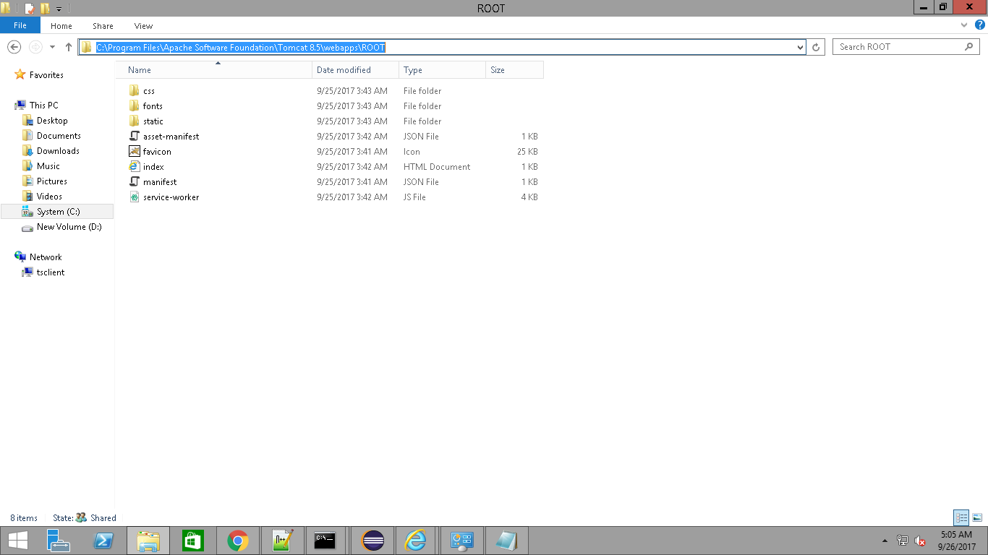

1. If we create separate application folder inside webapps folder and binaries copied to this folder then recipe editor is not loading.

(I tried with adding application context path in the server.xml).

### Other observations

By default, Create React App produces a build (npm run build) assuming your app is hosted at the server root.  
To override this, specify the homepage in your package. Json.

for example:

"homepage": "http://mywebsite.com/relative path",

Find more details in the path

<https://github.com/facebookincubator/create-react-app/blob/master/packages/react-scripts/template/README.md#building-for-relative-paths>

**Followed the above link and generate the build with different host locations and tested, it did not work**.

# Challenges

1. Less information is available on react based application deployment on webservers other than node servers
2. Need to find the way to generate build with correct relative paths if build hosted outside Root folder
3. Application domain name configuration