Delivery Analytics Dashboard
This comprehensive analytics suite demonstrates sophisticated data visualization and analysis capabilities, providing actionable insights for delivery operations optimization and strategic decision-making.
The dashboard effectively combines multiple analytical perspectives - temporal, geographical, and operational - to provide a holistic view of the delivery service performance and patterns.
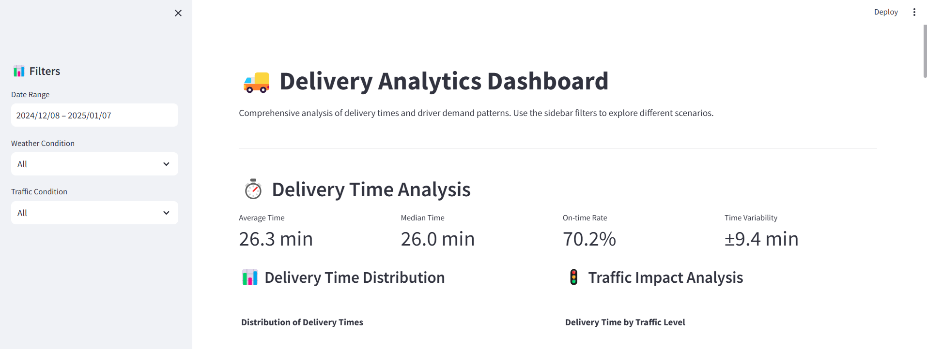 The interface displays critical KPIs including an average delivery time of 26.3 minutes, a median time of 26.0 minutes, and an impressive on-time rate of 70.2%.
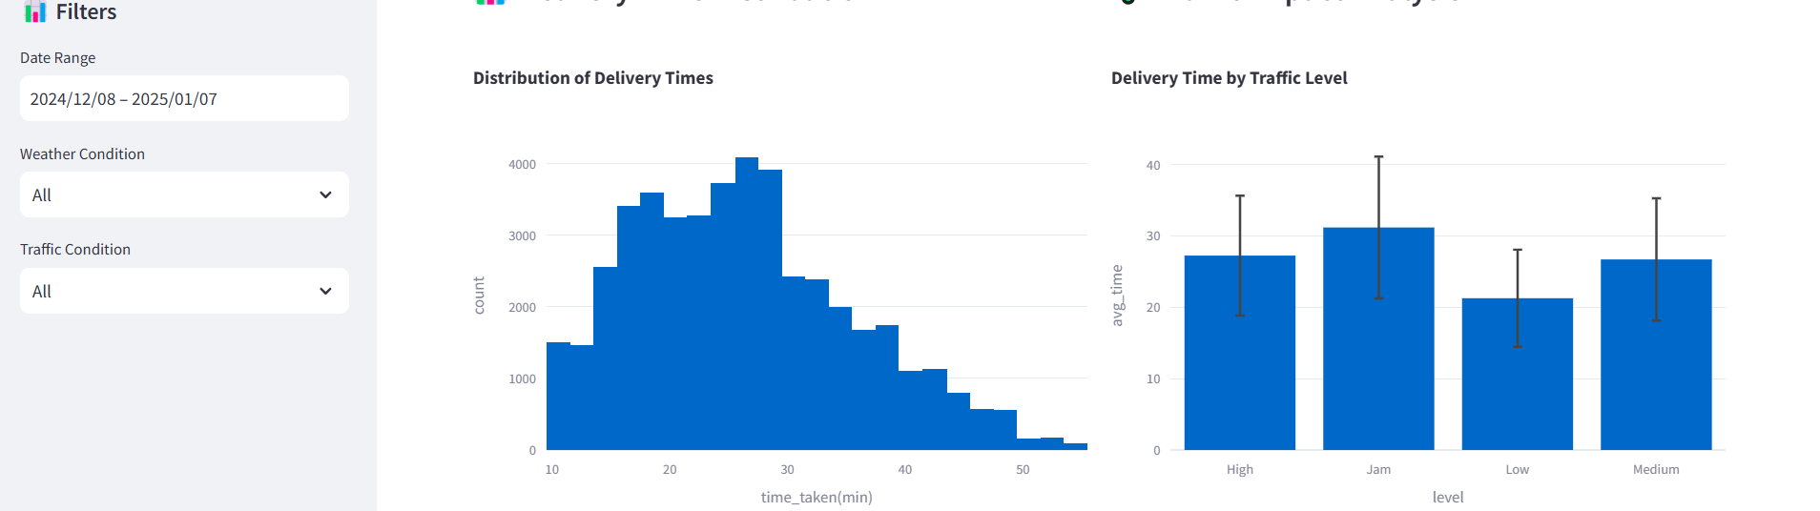
The distribution histogram reveals a right-skewed pattern of delivery times, while the traffic impact analysis demonstrates delivery performance across different traffic levels through error-bar enhanced bar charts.
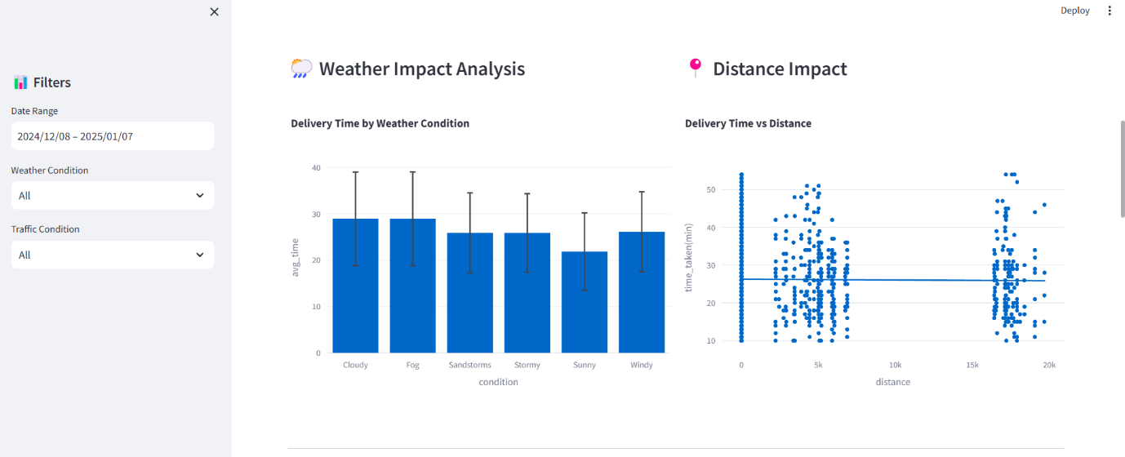
• The Weather Impact Analysis utilizes a bar chart with error bars to demonstrate delivery time variations across different weather conditions, enabling statistical significance assessment of weather effects
• The Distance Impact visualization employs a scatter plot with a trend line, revealing the correlation between delivery distance and time, with clustered data points suggesting distinct delivery zones or service areas
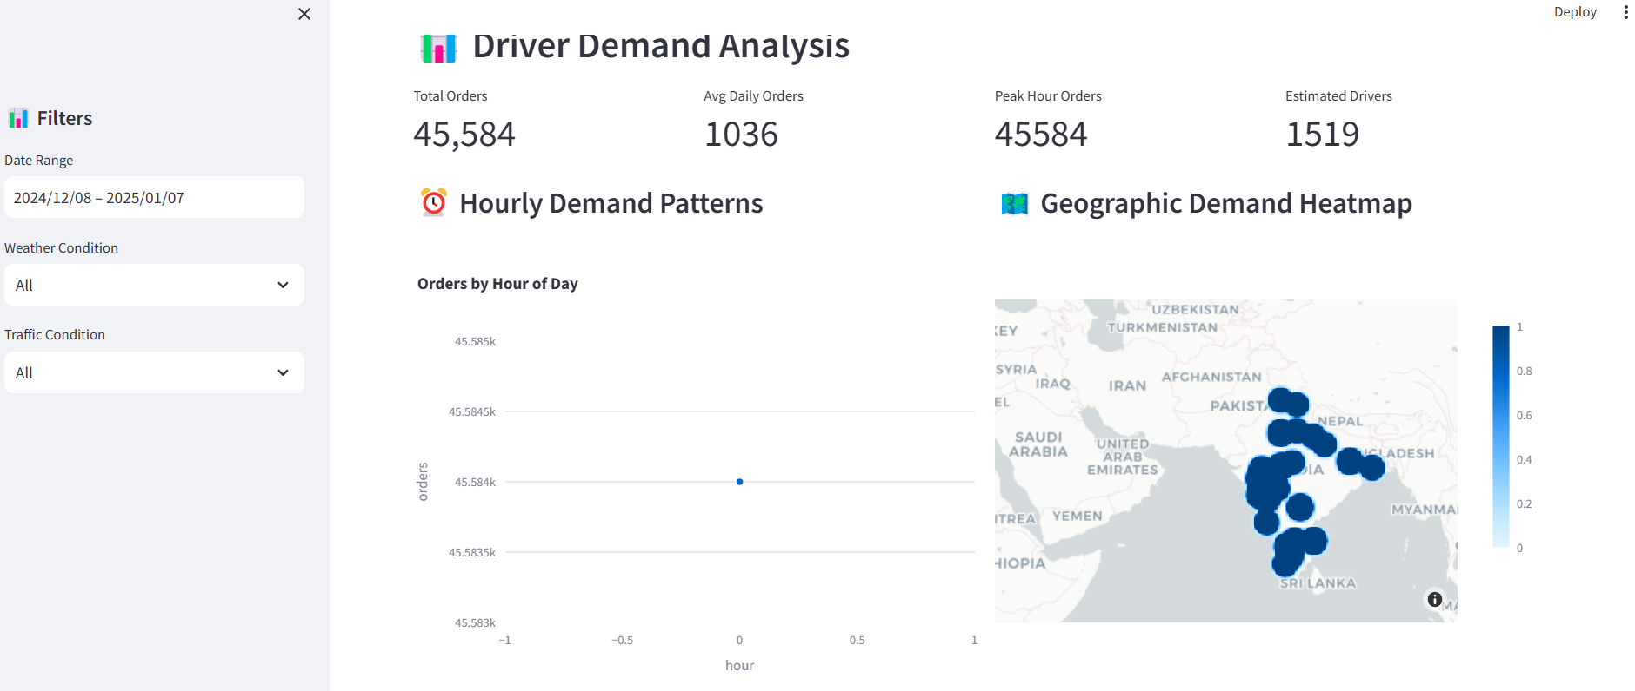
Demand Pattern Analysis : The dashboard incorporates multiple demand visualization components:
- An hourly demand pattern chart displaying intraday variations
- A geographic heat map highlighting demand concentration across different regions
- A daily demand pattern chart showing weekly trends with consistent bar chart visualization
- A dedicated peak demand analysis section for optimizing resource allocation

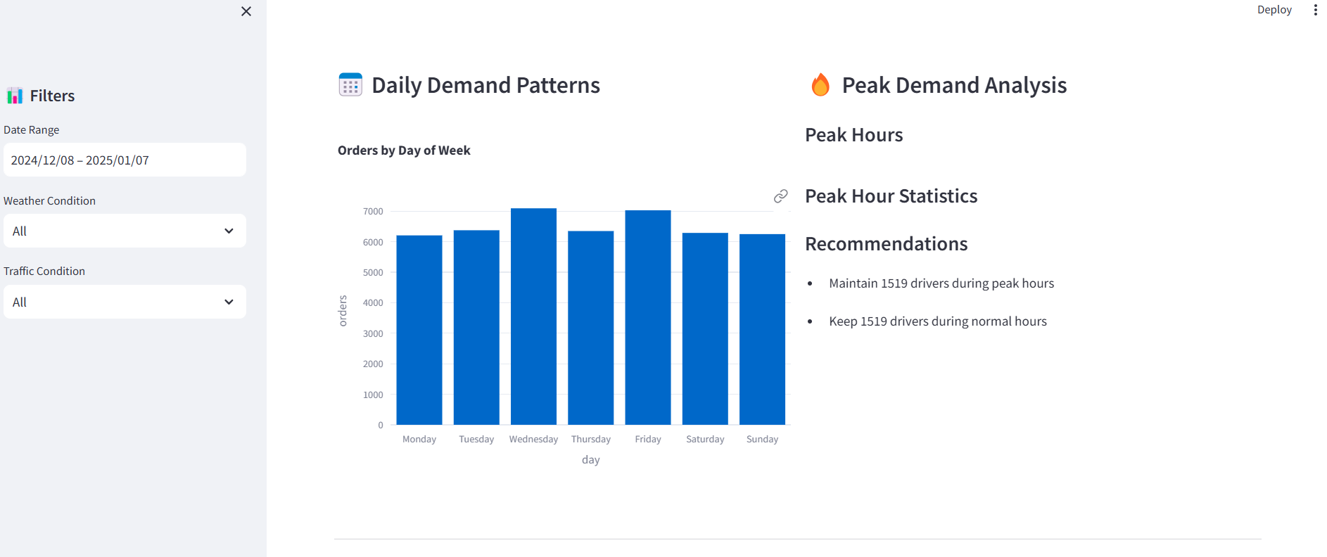
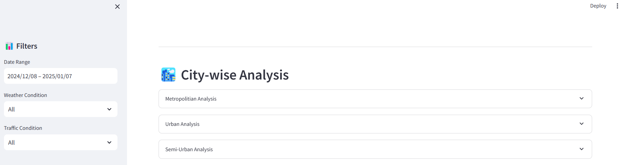
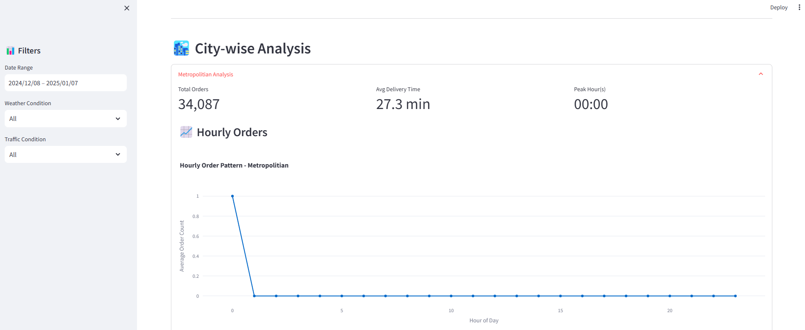
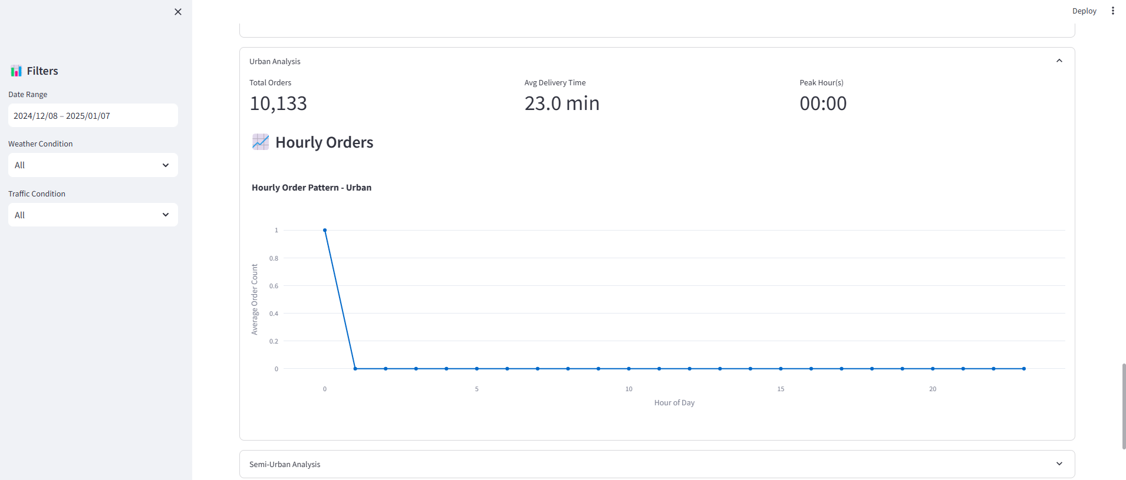
City-wise Analysis Details: The detailed city-level metrics showcase:
- Temporal analysis of hourly orders with trend lines
- Performance metrics including average delivery times
- Order volume metrics (~15,133 orders)
- Time-series visualizations demonstrating order patterns and operational efficiency

