INTRODUCTION TO MOBILE APPLICATION DEVELOPMENT.
Student Name: Faith Mueni.
Admission Number: BIT/2024/74441.
School/faculty: Computing and informatics.
Programme: Degree
Academic Year: III
Semester: II
Lecturer: Michael Nyoro.
Phone Number: 0722313169

WEEK 1.
Tools used:
Android studio.
Figma
Vs code
Flutter SDK
Android phone

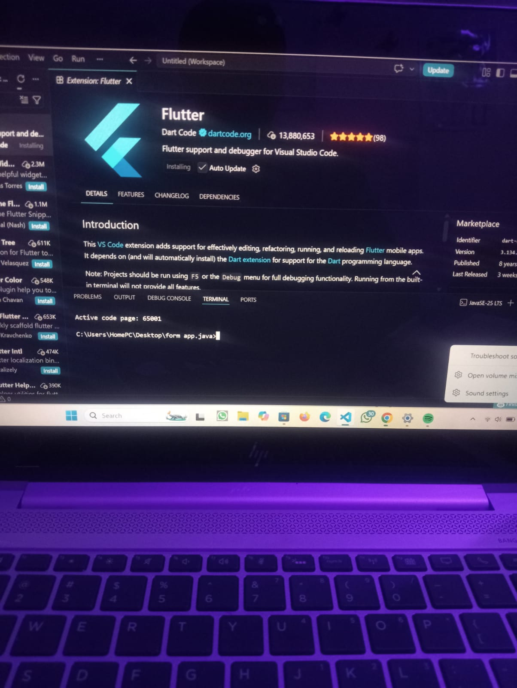

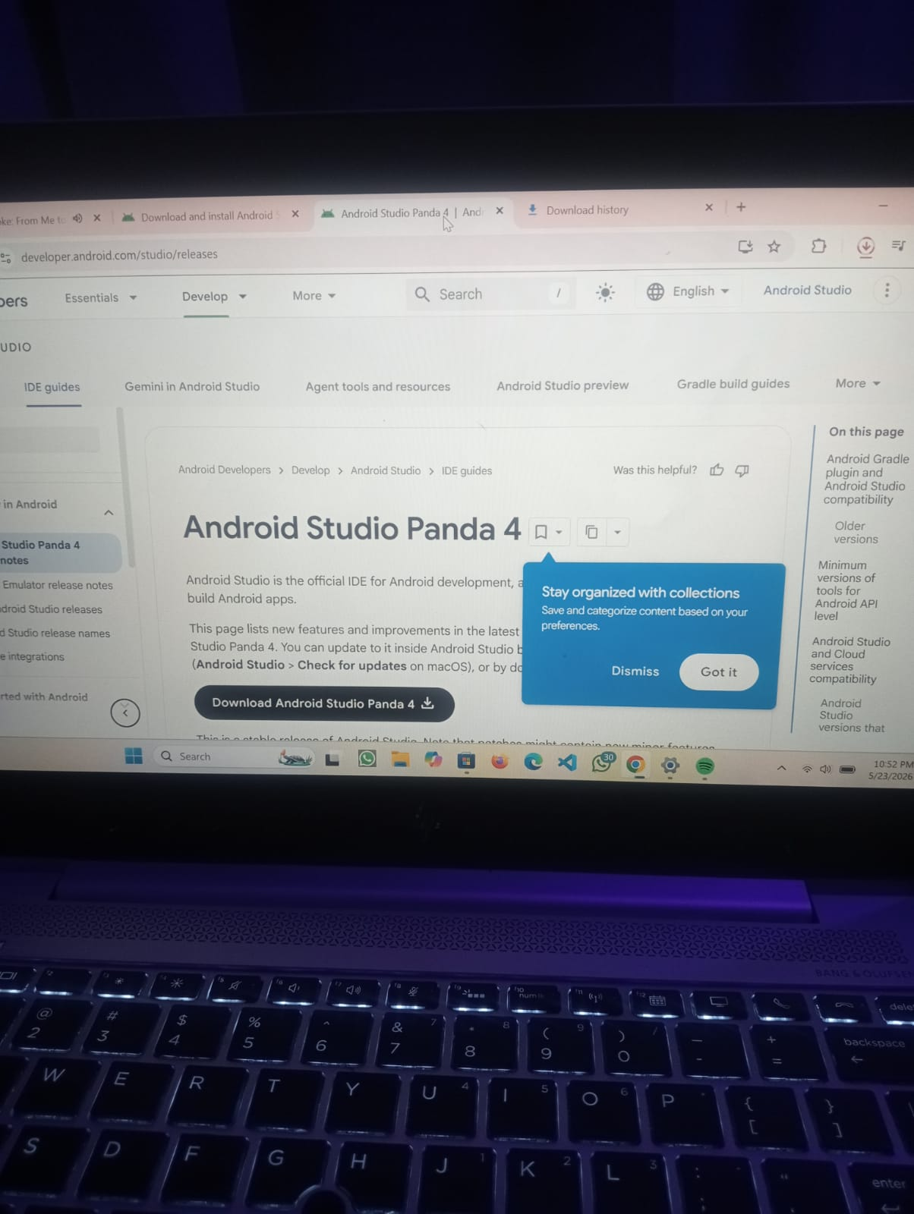

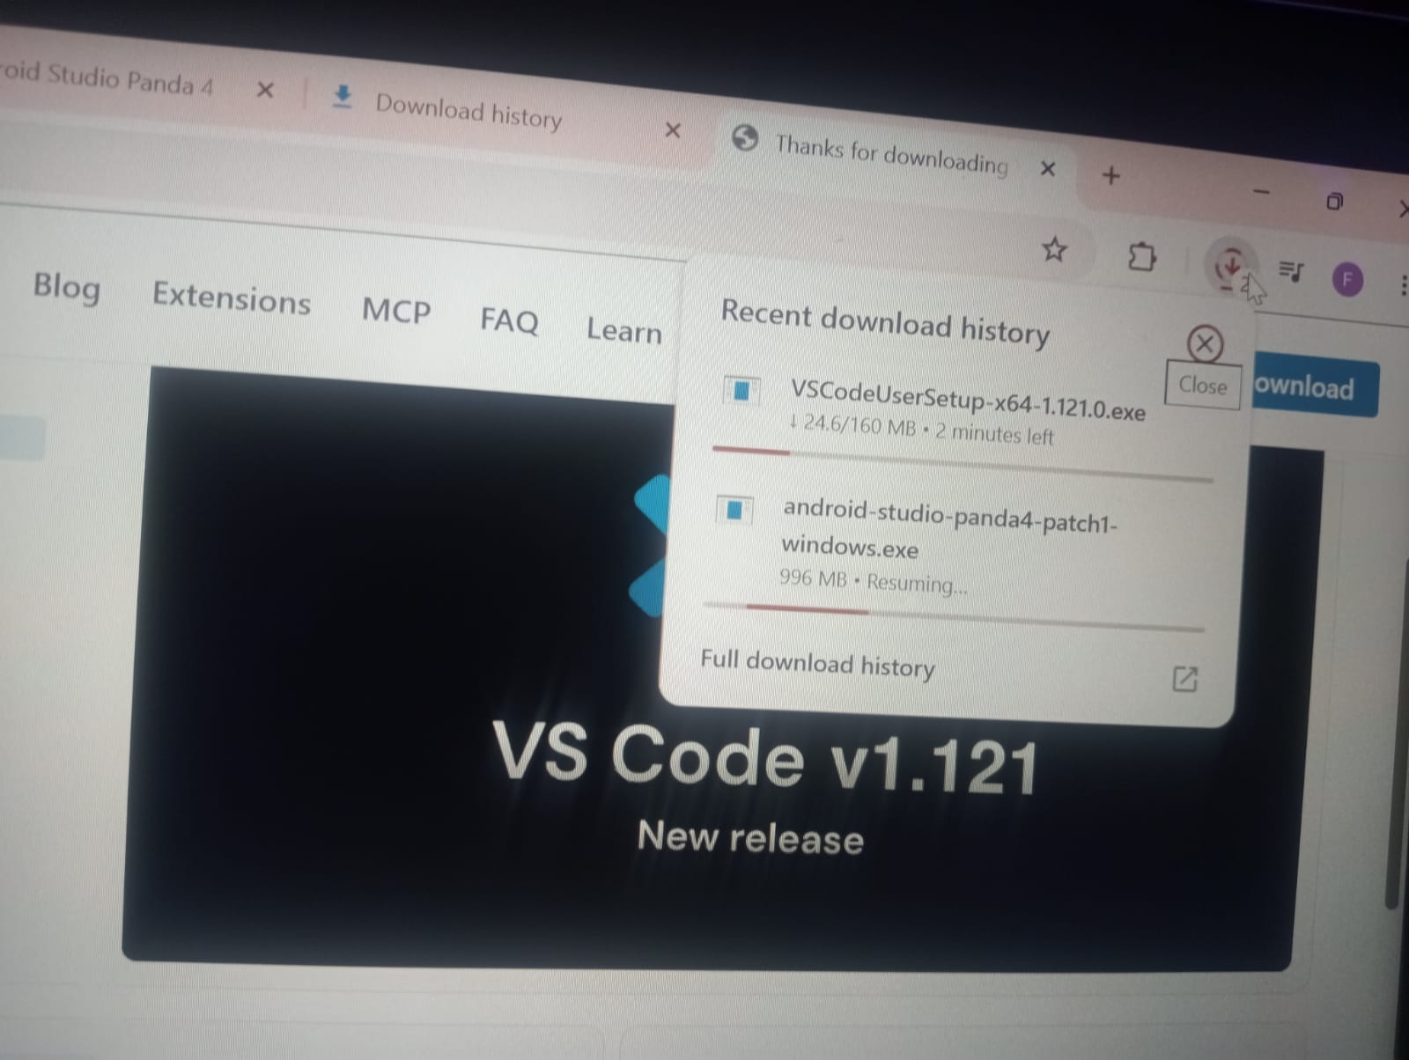

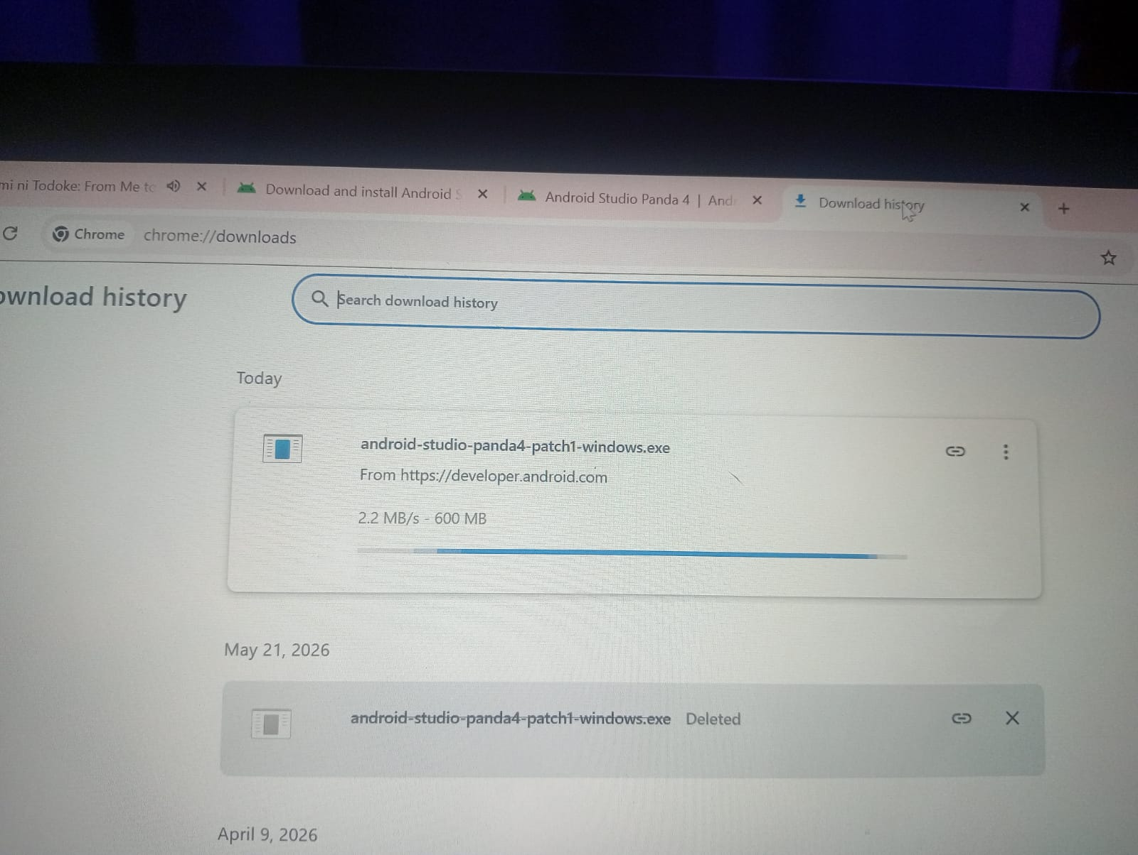

PERSONAL REFLECTION
Installing the tools was challenging at first due to errors and configuration issues, but it improved my problem-solving skills. I gained practical experience in setting up development environments and became more confident in using modern software tools for app development.

WEEK 2: MOBILE DEVELOPMENT ENVIRONMENT.
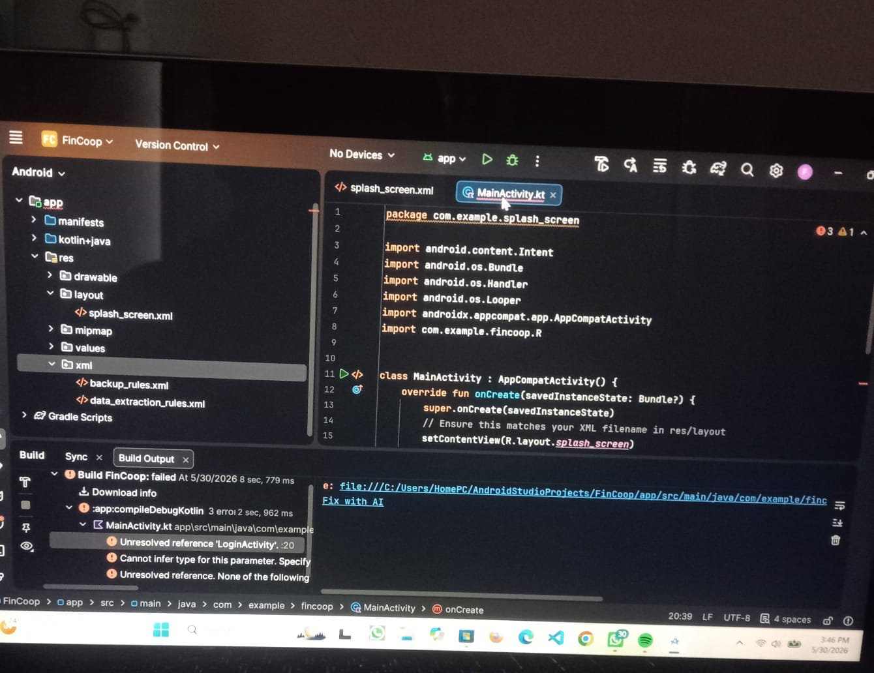

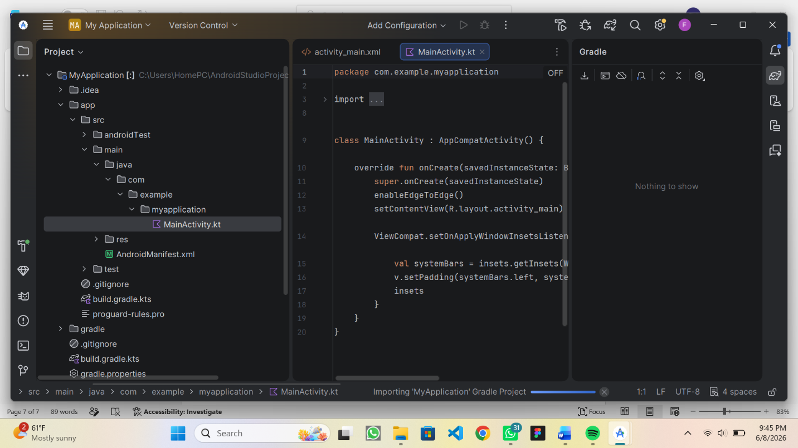

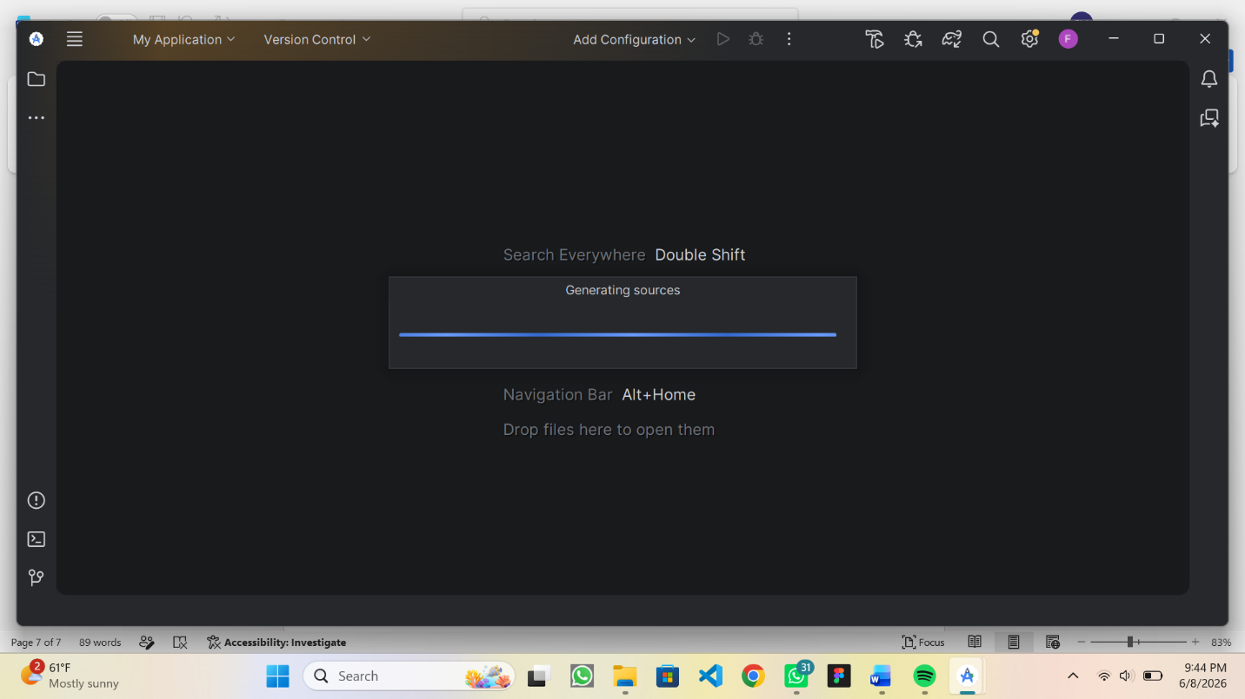

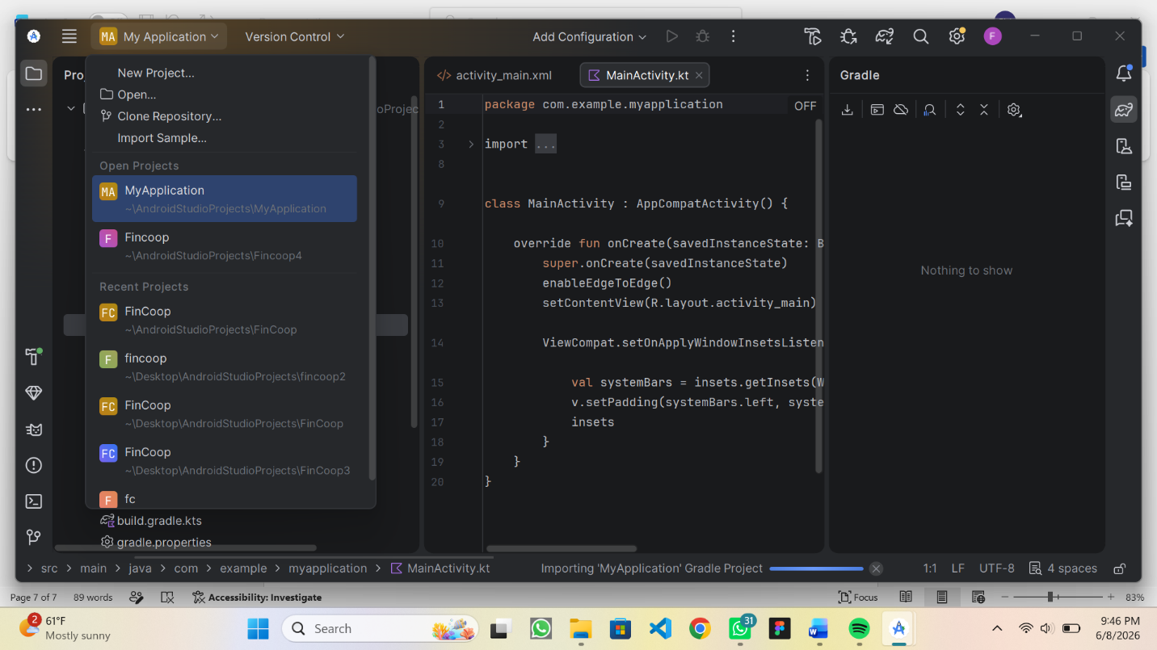

PERSONAL REFLECTION
I set up the mobile development environment by installing and configuring tools like Android Studio, Flutter SDK, and device emulators. This process helped me understand how different components work together, though I faced minor setup challenges that enhanced my troubleshooting and technical skills.

WEEK 3: USER INTERFACE DESIGN.

Personal reflection
I focused on user interface design for the blood donation app using Figma. I learned how to create and organize screens, design user-friendly layouts, and improve overall system usability. This improved my understanding of UI/UX principles and enhanced my design skills.

WEEK 4: EVENT HANDLING AND USER INTERACTION.
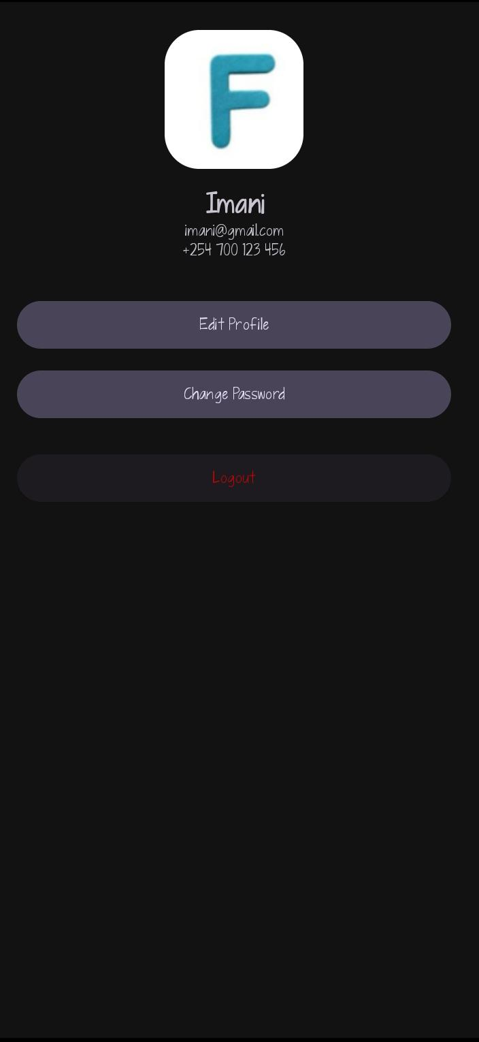

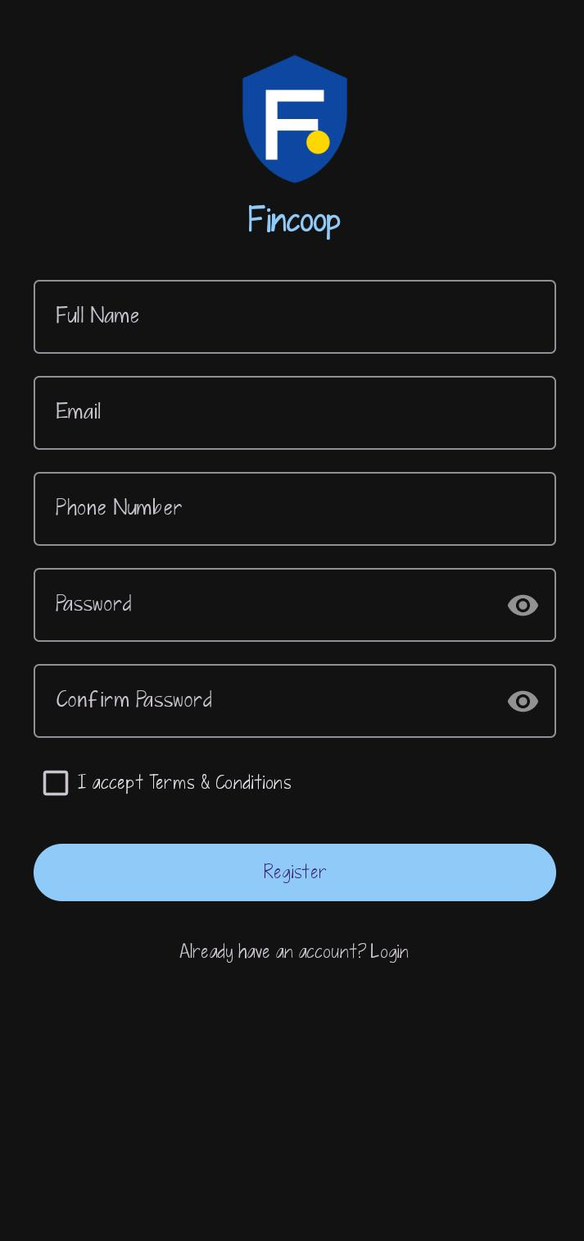
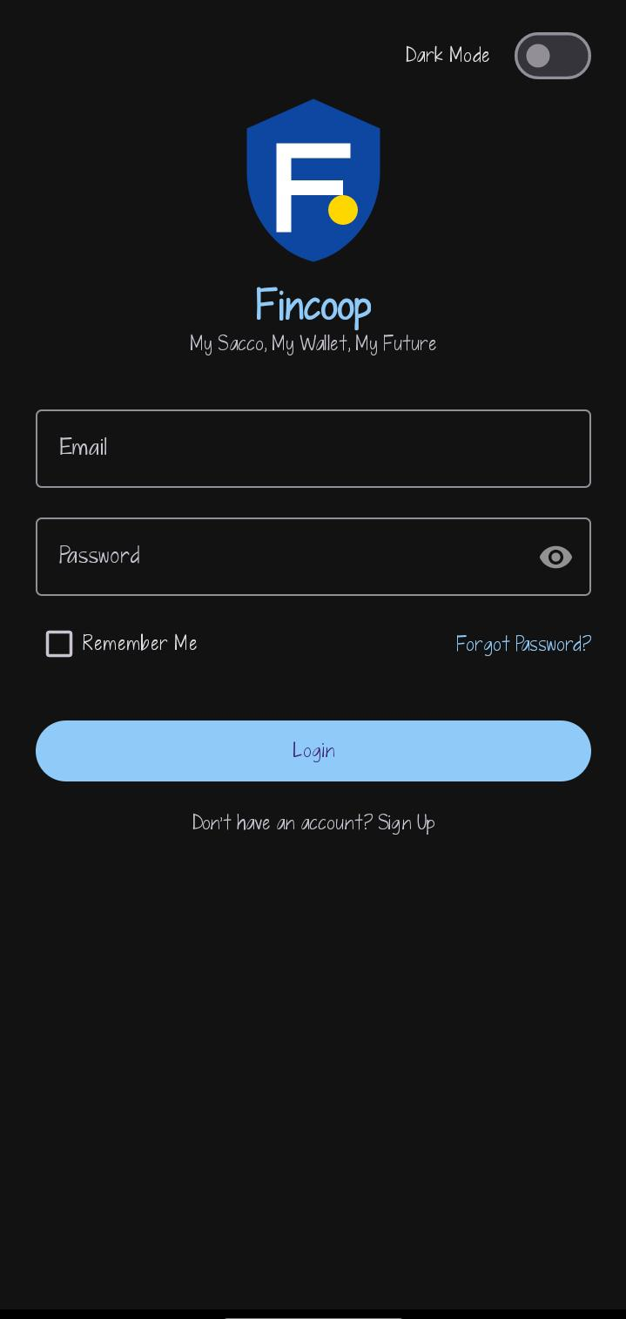
Personal reflection
I learned about event handling and user interaction in the blood donation app. I implemented how users interact with the system through buttons, forms, and input fields. This improved my understanding of how applications respond to user actions and enhanced my programming skills.

WEEK 5 DATA MANAGEMENT.
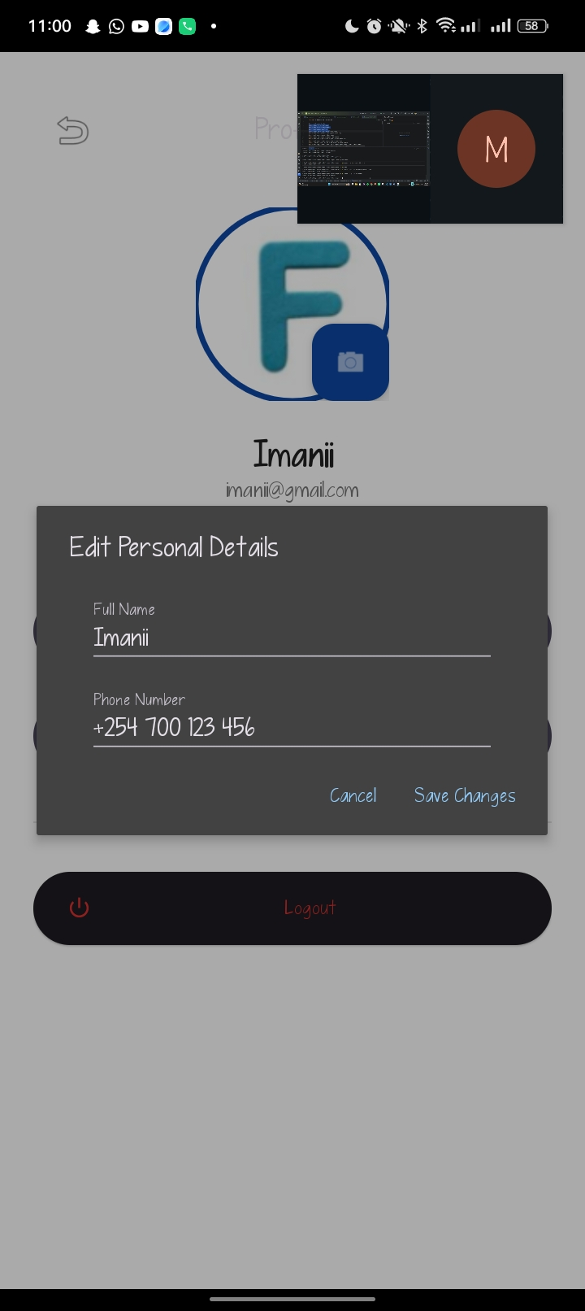

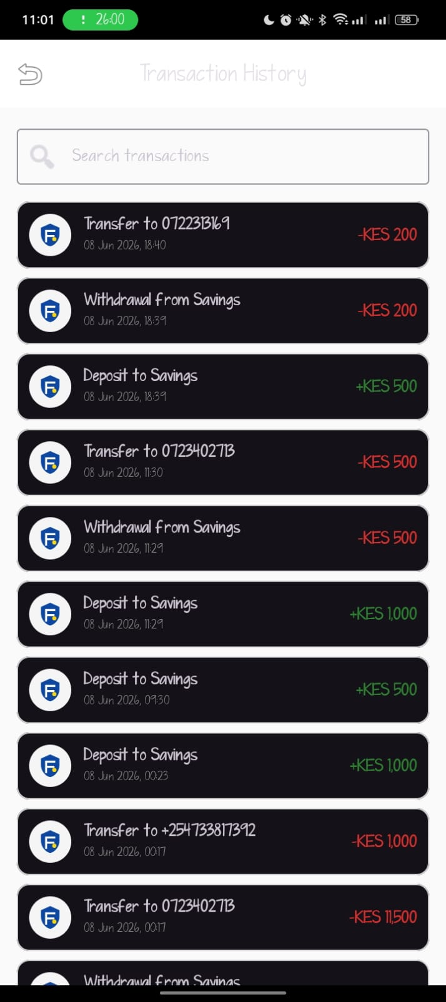
Personal Reflection

I focused on data management in the FinCoop application project. Through this role, I learned how to store, retrieve, update, and manage member information, savings records, loan details, and transaction data using local storage and database systems. This experience enhanced my understanding of database management, data security, and efficient record keeping in financial applications. It also improved my technical skills in handling application data and strengthened my ability to develop reliable systems that support accurate and secure financial operations.

WEEK 6: NETWORKING AND API

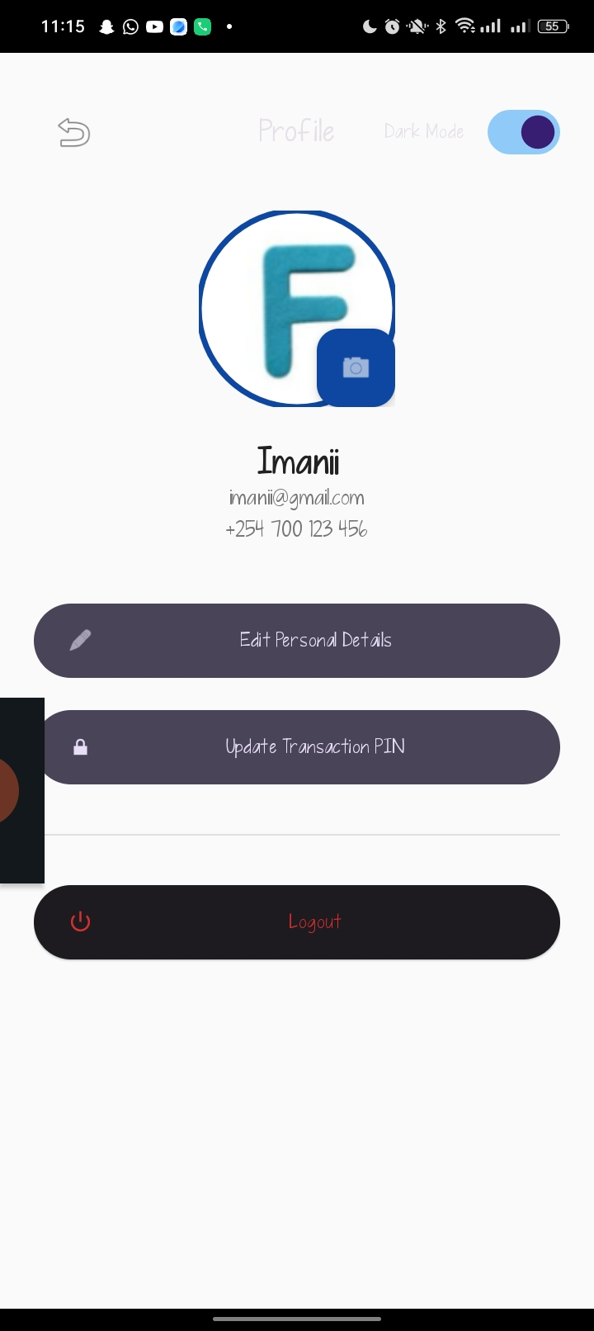

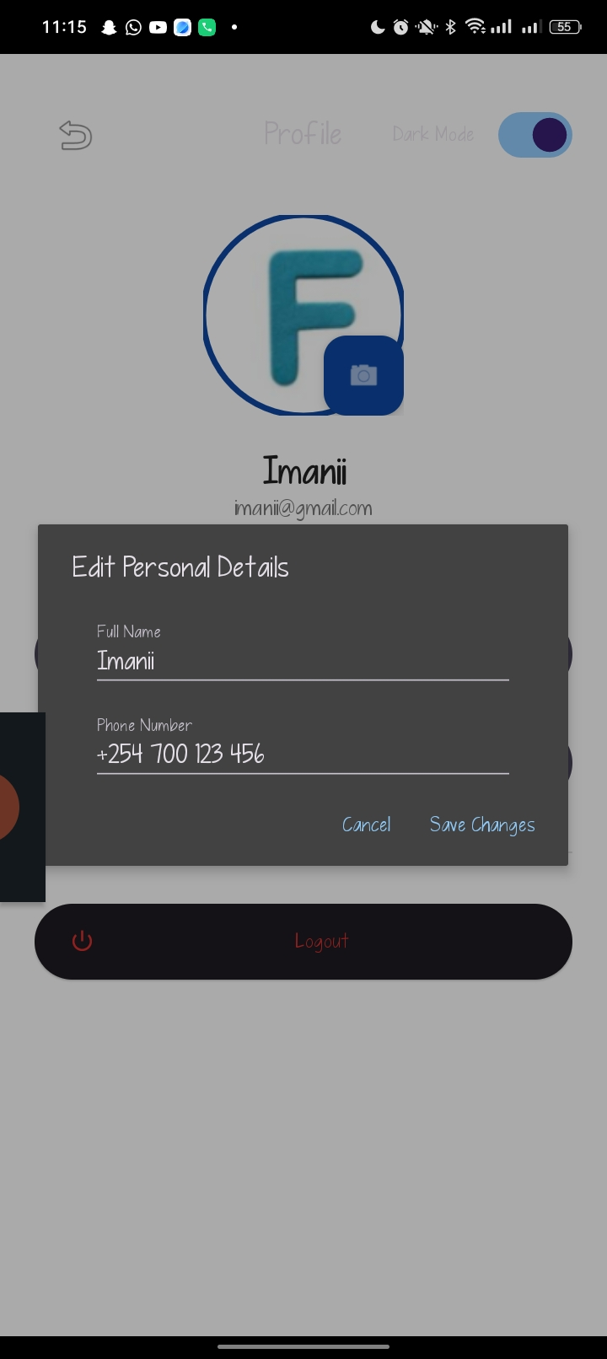

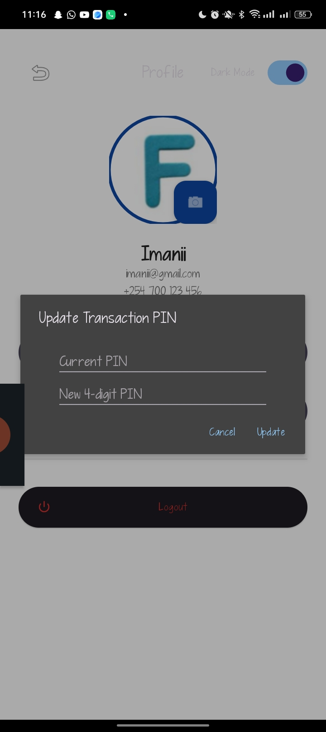

WEEK 7:APPLICATION ARCHITECTURE.



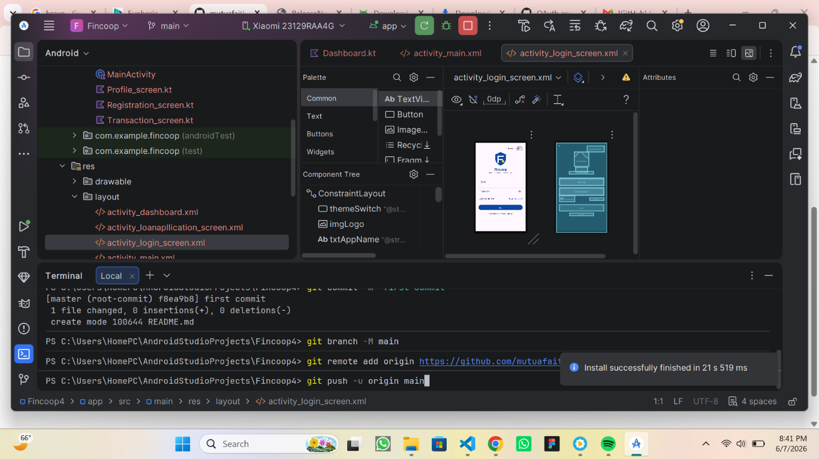

Personal Reflection
I focused on application architecture for the FinCoop system. I learned how to organize the application into different modules, including member management, savings management, loan management, and report generation. This improved my understanding of how various components work together to support cooperative financial operations. Through this process, I gained valuable skills in designing a well-structured, efficient, and maintainable system that meets the needs of SACCO members and administrators.

WEEK 8:PROJECT PLANNING.
Task | Week
Problem identification and analysis | 1-2
System design | 3-4
Development | 5-8
Testing and debugging | 9-10
Implementation | 11-12
Documentation | 13
Presentation | 14

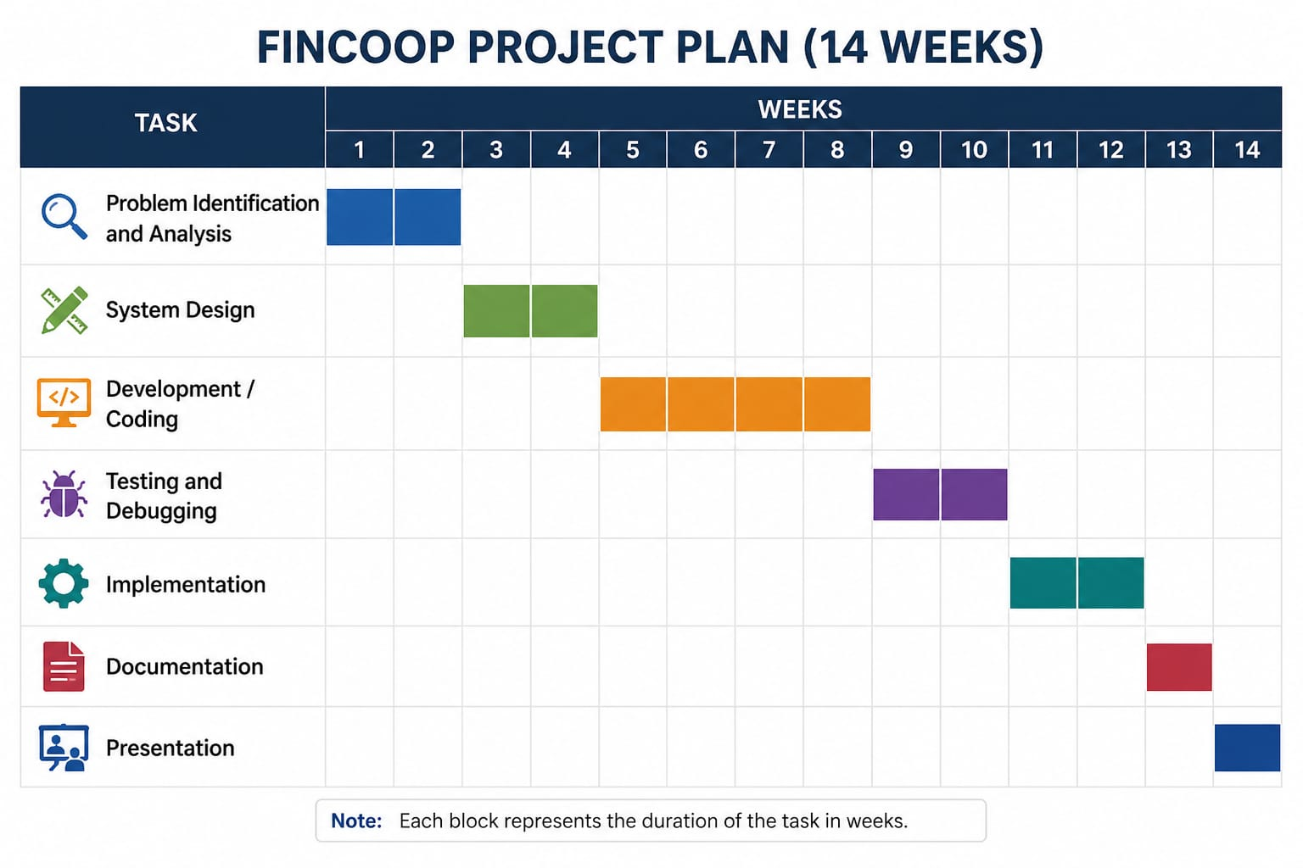
Personal Reflection
I focused on project planning for the FinCoop system. I learned how to organize project activities, allocate time effectively, and establish clear milestones using planning tools such as a Gantt chart. This improved my ability to manage the development process of the system, including member management, savings management, loan processing, and report generation modules. Through this experience, I gained valuable project management skills and ensured that the development followed a well-structured timeline, helping the project progress efficiently and meet its objectives.

WEEK 9: DEVICE FEATURES AND SENSORS.

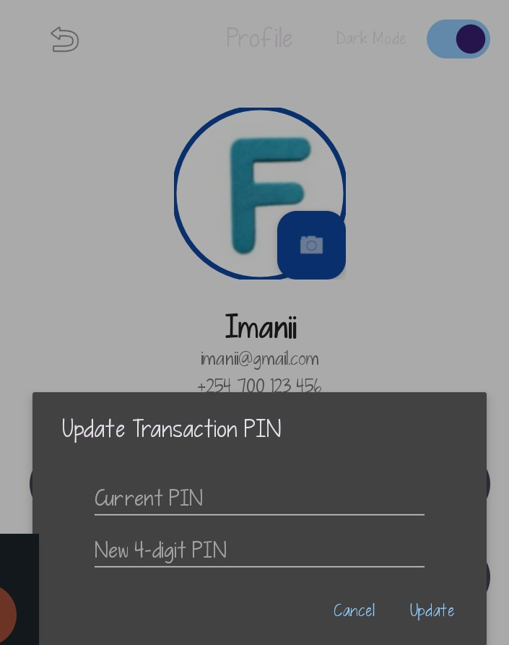

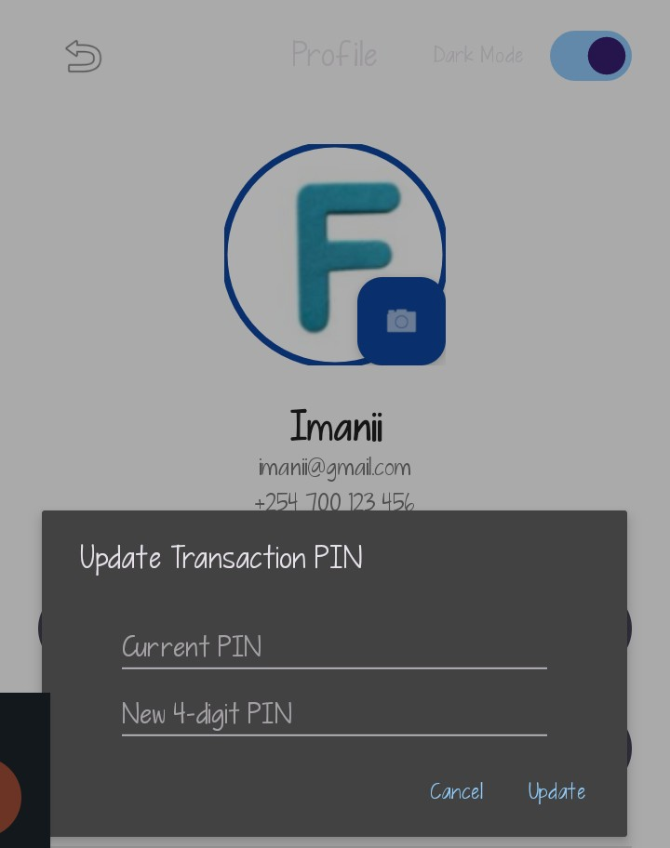

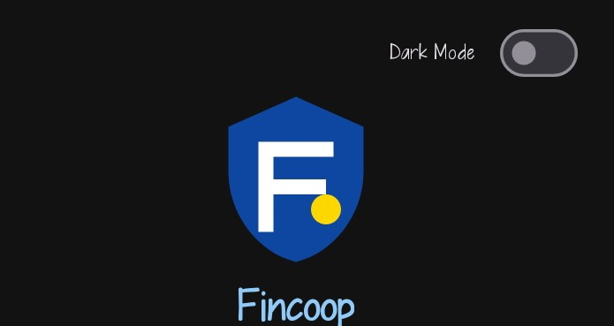

Personal Reflection
I focused on device features and sensors in the FinCoop application. I learned how mobile device features such as Dark Mode can be integrated to improve user experience, readability, and accessibility. I also gained a better understanding of how device capabilities can be utilized to enhance the functionality and responsiveness of the application. This experience improved my mobile development skills and helped me create a more user-friendly and efficient financial management system.

WEEK 9: NOTIFICATIONS AND BACKGROUND SERVICES.


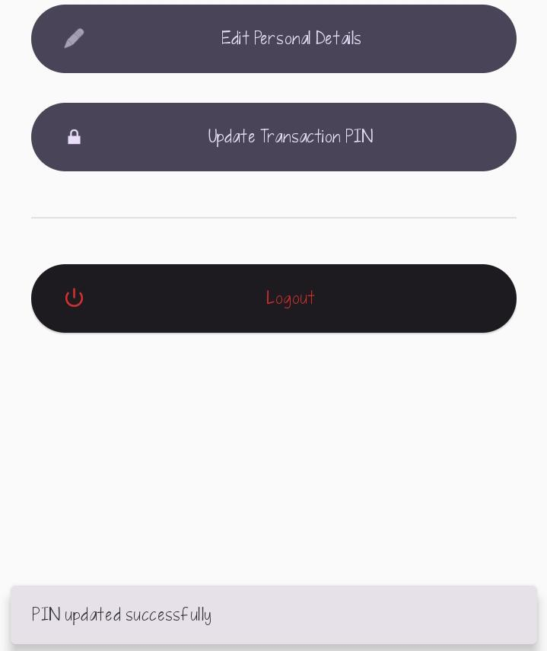

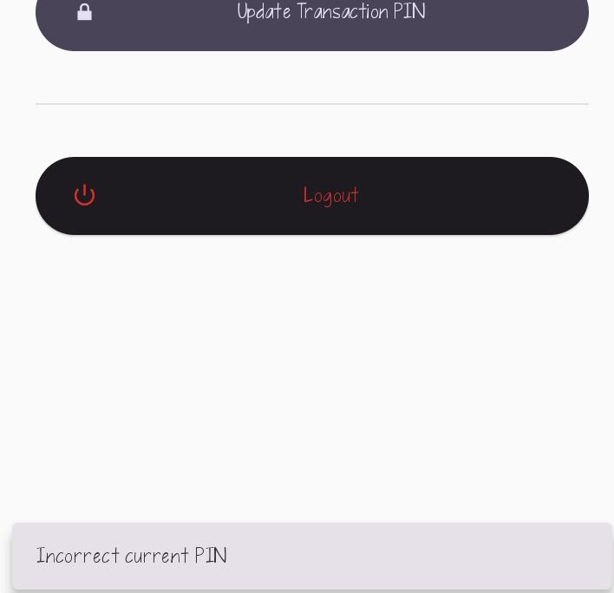

Personal reflection
I focused on notifications and background services in the FinCoop app. I learned how the system can send alerts and updates to users even when the app is not actively in use. This improved my understanding of real-time communication and background processing, which are important for keeping users informed and engaged. It also helped me appreciate how background services enhance the responsiveness and overall functionality of financial applications like FinCoop.

WEEK 11: MOBILE SECURITY.
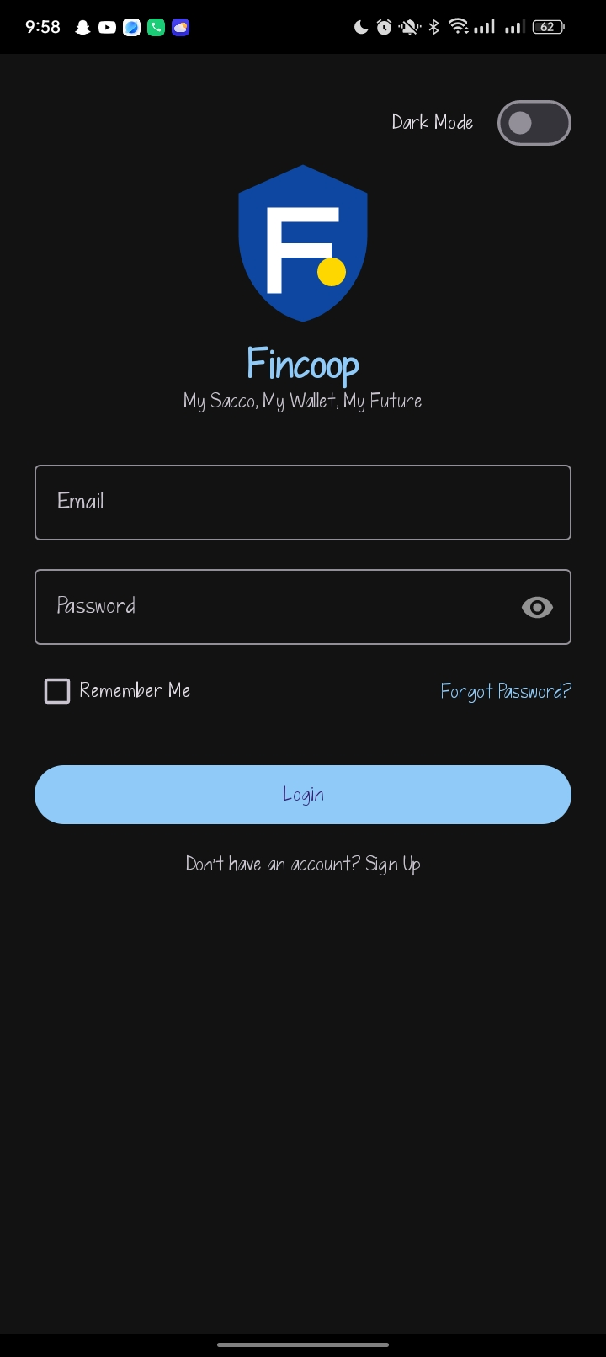
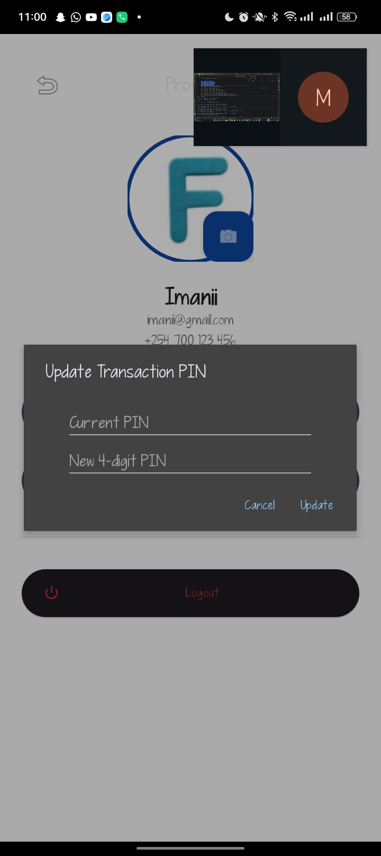
Personal reflection
I focused on mobile security in the FinCoop application. I learned how to protect user data through authentication, secure storage, and access control mechanisms. This improved my understanding of application security and ensured that sensitive financial information is handled safely within the system.
WEEK 12: TESTING AND DEBUGGING


Personal reflection
I focused on testing and debugging the FinCoop system. I tested different system functions to ensure they work as expected and identified errors within the application. I also fixed bugs and improved system performance, which enhanced the reliability and stability of the system and ensured smoother user experience.
WEEK 13: APP DEPLOYMENT

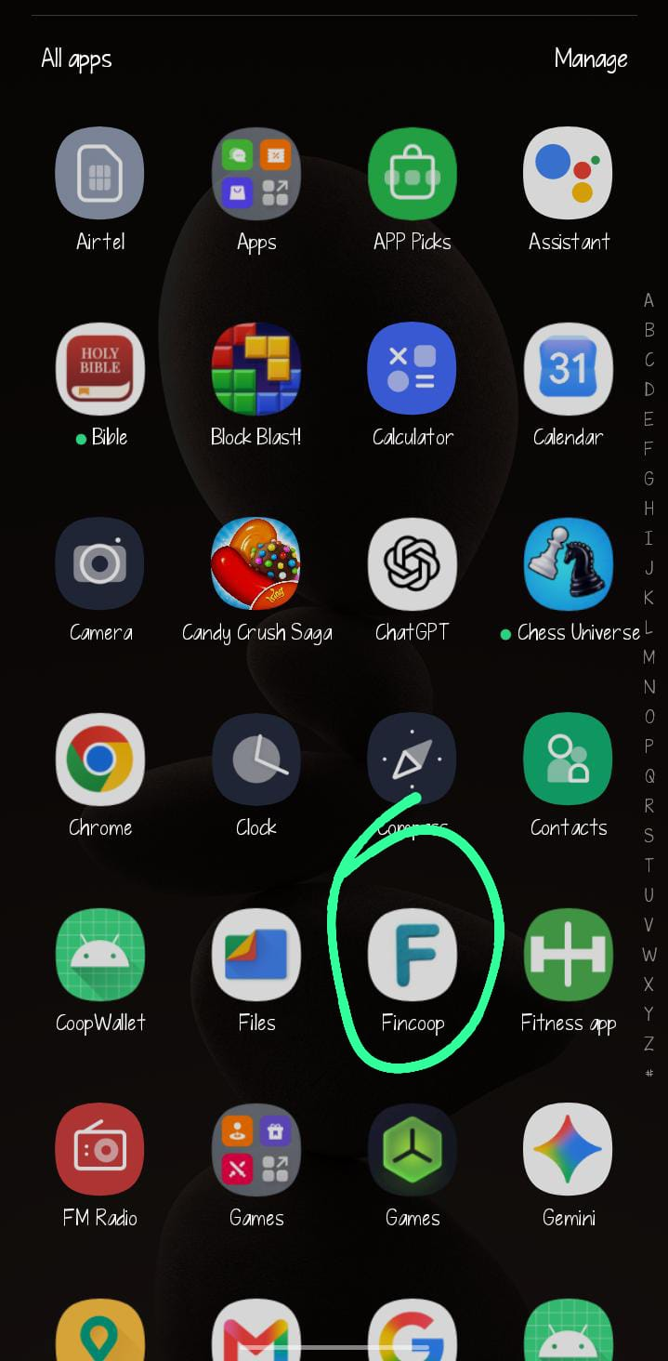


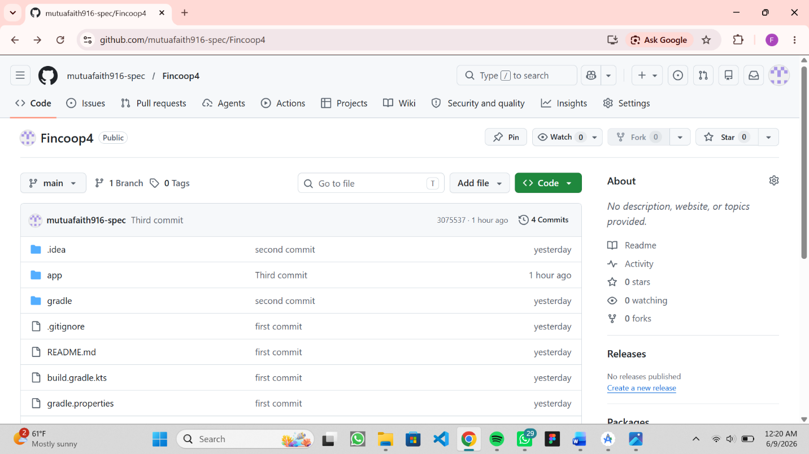
Personal reflection
I built and tested the release APK of my FinCoop app, deployed it on a physical device, and uploaded the project to GitHub. Through this process, I gained practical experience in application deployment, real-device testing, and version control. It also strengthened my understanding of preparing an app for release and maintaining organized code backups for collaboration and future updates.

