
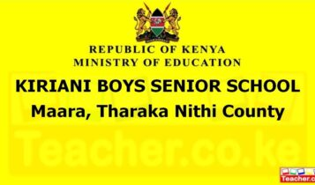
A SCHOOL OF INTEGRITY

PART X: PHYSICAL INFRASTRUCTURE, LOGISTICS, AND SCHOOL ASSETS
10.1 ACADEMIC LEARNING SPACES
Kiriani Boys High School features [Insert Number] state-of-the-art classrooms engineered for modern pedagogy. Each learning space is designed with ergonomics and focus in mind:
- Smart Learning Integration: Equipping core lecture rooms with digital whiteboards, to facilitate conducive learning learning.
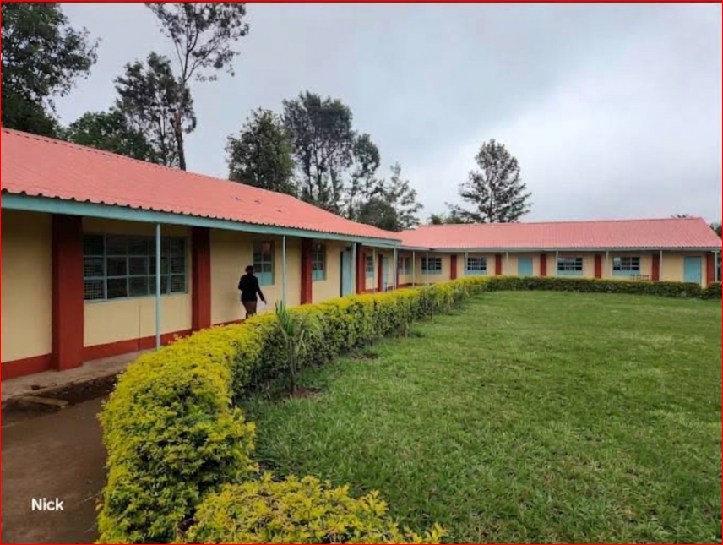
- Optimized Ventilation and Light: Large architectural windows maximizing natural daylight to reduce eye strain and optimize long-range student concentration.
- Fixed Academic Seating: High-durability dual-seater desks configured to give every young man independent working space while allowing teachers clear walking lanes for individual monitoring.
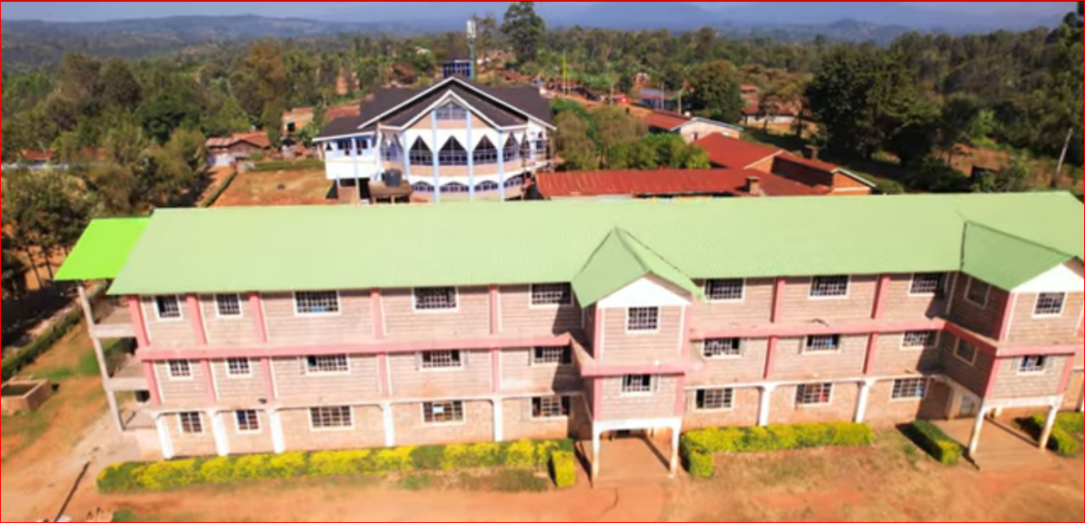
- 10.2 THE BOARDING COMPLEX: ELITE DORMITORIES
Residential life at Kiriani is built around comfort, hygiene, and iron-clad safety. Our dormitories are more than just places to sleep—they are hubs of structural brotherhood:
- High-Capacity, Well-Spaced Layouts: Optimized cubicle designs ensuring adequate space between bunk beds to eliminate congestion and maintain strict fire safety protocols.
- Premium Hygiene Infrastructure: Modern, tiled washrooms and hot-water shower systems maintained daily by a dedicated campus sanitation crew.
- Multi-Tiered Security Systems: Continuous adult monitoring overseen by resident housemasters, secure window grilles, dual-exit emergency doors, and 24/7 exterior security lighting.
Our institutional pride extends to our transport infrastructure, ensuring safe, timely, and prestigious mobility for all academic field trips, sports tournaments, and national symposia:
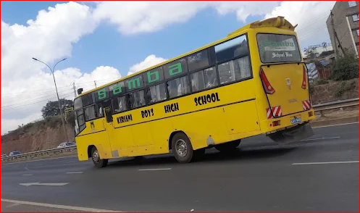
- MOBILITY AND TRANSIT: THE SCHOOL BUS FLEET
The Kiriani Flagship Bus: A high-capacity, heavy-duty luxury bus prominently branded in the school colours, acting as a moving billboard of excellence on Kenyan roads.
- Safety and Tracking Logistics: Every vehicle in the fleet features speed governors, seatbelts for all passengers, and real-time GPS fleet-tracking software managed by the administration.
10.4

VISUALIZATION: THE SCHOOL LOGO & INSIGNIA BRAND
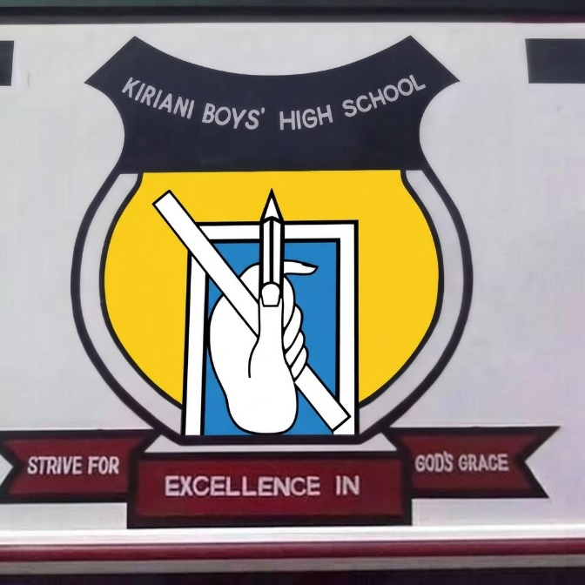
The official Kiriani Boys' High School insignia is the definitive graphic representation of the school's identity, traditions, and educational philosophy. Every visual element within the crest carries a distinct symbolic meaning designed to inspire both the faculty and the student body.
DEEP SYMBOLIC ANALYSIS & BRAND ELEMENTS
- The Upper Banner & Top Scroll:
  - Visual Design: A clean, curved dark banner situated at the crown of the crest containing the text "KIRIANI BOYS' HIGH SCHOOL" in a bold, white, legible sans-serif font.
  - Symbolic Meaning: This serves as the crown of identity, anchoring the institution’s name with authority and pride above all other visual elements.
- The Main Shield & Field Colour:
  - Visual Design: A classically styled heraldic shield with a distinct olive-green interior background, bordered by a sharp black-and-white outline.
  - Symbolic Meaning: The shield represents defence, resilience, and character formation, protecting the young men from negative societal influences. The olive-green field symbolizes growth, vitality, environmental sustainability, and the fertile potential of the students' minds.
- The Core Emblem (The Hand, Ruler, and Pencil):
  - Visual Design: Cantered directly inside the green shield is a framed window element showcasing a hand firmly gripping a drafting ruler and a drawing pencil overlaying a sheet of paper or notebook.
  - Symbolic Meaning: This is the central pillar of the school's academic identity. The hand represents diligence, manual skill, and active labour. The pencil symbolizes intellect, creativity, and the power of writing one's own future, while the ruler denotes structure, discipline, accuracy, and unwavering high standards in mathematics, science, and technical building blocks.
- The Lower Motto Banners:
  - Visual Design: A multi-tiered crimson/maroon base banner supporting the entire shield, broken into three sequential ribbons reading from left to right: "STRIVE FOR" | "EXCELLENCE IN" | "GOD'S GRACE".
  - Symbolic Meaning: This establishes the tripartite moral and developmental foundation of Kiriani Boys' High School:
    - "Strive For": Teaches the boys the value of hard work, relentless effort, and determination.
    - "Excellence In": Demands top-tier results not just in academics, but in character, sports, and life skills.
    - "God's Grace": Acknowledges spiritual humility, faith, moral rectitude, and the divine guidance that steers the school community toward successful futures.
BRAND INTEGRATION AND PRINT STANDARDS
To preserve brand integrity across all print media, digital marketing flyers, and school magazine features:
- Aspect Ratio: The logo must maintain its original square scaling and must never be stretched horizontally or vertically.
- Colour Palette: The primary colours must strictly adhere to the designated Olive Green (Shield), Crimson Red (Motto Banners), Dark Navy/Black (Upper Banner), and White (Accents/Text).
To model peak professional discipline, the faculty at Kiriani Boys High School adheres to a sharp, unified dress code that commands respect and establishes corporate authority:
- Formal Weekday Attire: Customized, tailored blazers adorned with the embroidered school crest, paired with matching trousers and ties for male faculty, and elegant business suits for female faculty.
- Strategic Marketing Impact: When parents visit the campus, seeing a visually unified, sharply dressed faculty immediately establishes trust and signals top-tier institutional organization.

PART XI: ACADEMIC LEADERSHIP & DEPARTMENTAL GOVERNANCE
11.1 OFFICE OF THE PRINCIPAL: EXECUTIVE VISION
The institutional captaincy of Kiriani Boys High School is driven by a commitment to raising global leaders. The Principal acts as the chief executor of both academic standards and infrastructural expansion, maintaining a direct line of communication with parents to ensure transparent institutional governance.

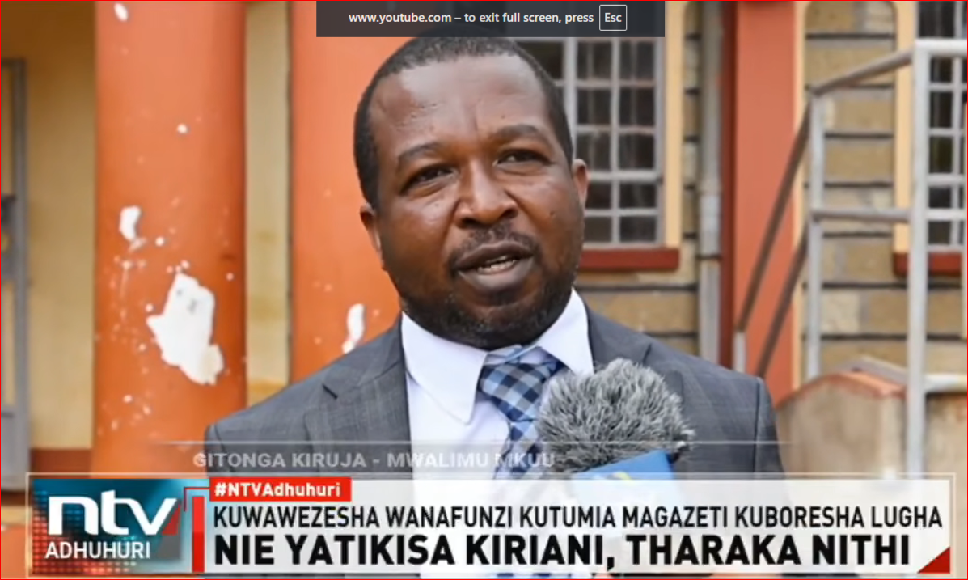
11.2 DEPARTMENT OF KISWAHILI – HOD: MR. GEORGE MUTABARI
Under the expert leadership of HOD George Mutabari, the Kiswahili Department stands as a premier pillar of linguistic excellence and cultural performance:
- Strategic Mandate: Driving peak mean scores in national examinations through targeted language workshops, structured essay-writing bootcamps, and comprehensive grammar diagnostic tracking.

- Extracurricular Impact: Spearheading the school's highly competitive Drama and Poetry societies, positioning Kiriani Boys as a powerhouse in regional and national cultural festivals.

11.3 DEPARTMENT OF ENGLISH – HOD: MRS. NAOMI
The English language and literature faculty, directed by HOD Naomi, provides students with the critical communication and analytical tools required for global corporate environments:
- Strategic Mandate: Executing rigorous reading programs, intensive creative writing mentorship, and speech training modules to optimize language fluidity.

- Competitive Edge: Leading the elite Kiriani Debate Club and School Journalism Club, training young men to articulate complex global arguments with confidence, composure, and sophisticated vocabulary.

PART XII: INSTITUTIONAL GOVERNANCE AND STRATEGIC BOARDS
12.1 THE BOARD OF MANAGEMENT (BOM)
The Board of Management stands as the core financial and structural backbone of Kiriani Boys High School. Comprising elite professionals, corporate leaders, and educational experts, the BOM directly oversees:
- Infrastructural Capital Expenditure: Funding the continuous upgrade of science laboratories, computer servers, and residential blocks.
- Policy Frameworks: Reviewing and approving strict administrative, safety, and recruitment protocols to maintain a premium educational standard.
- Quality Assurance: Auditing internal processes to guarantee that the resources available to our Grade 11 and 12 students match global benchmarks.
12.2 PARENTS TEACHERS ASSOCIATION (PTA) & ALUMNI LIAISON
- The PTA Body: A highly cooperative consultative council that bridges the gap between home environments and school expectations, tracking student welfare and emotional health.
- The Alumni Foundation: A massive global network of past Kiriani graduates providing active scholarship endowments, career mentorship clinics, and corporate internships for finishing students.

PART XIII: CO-CURRICULAR ADVANCEMENT & LEADERSHIP SOCIETIES
13.1 THE SCOUT MOVEMENT (KIRIANI TROOP)
The Scouting troop at Kiriani Boys High School is a cornerstone of our character-forging pipeline, transforming young men into resilient, self-reliant, and civic-minded citizens:
- Survival and Tactical Skills: Rigorous training in wilderness survival, pioneering, first aid, and emergency rescue operations that build immense mental and physical grit.
- Leadership and Civic Duty: Active participation in community service projects, regional camping jamborees, and school-wide event crowd management protocols.
- Discipline and Rank Structure: A clear progression framework aligned with national scouting bodies that instils a lifelong respect for order, patriotism, and servant leadership.

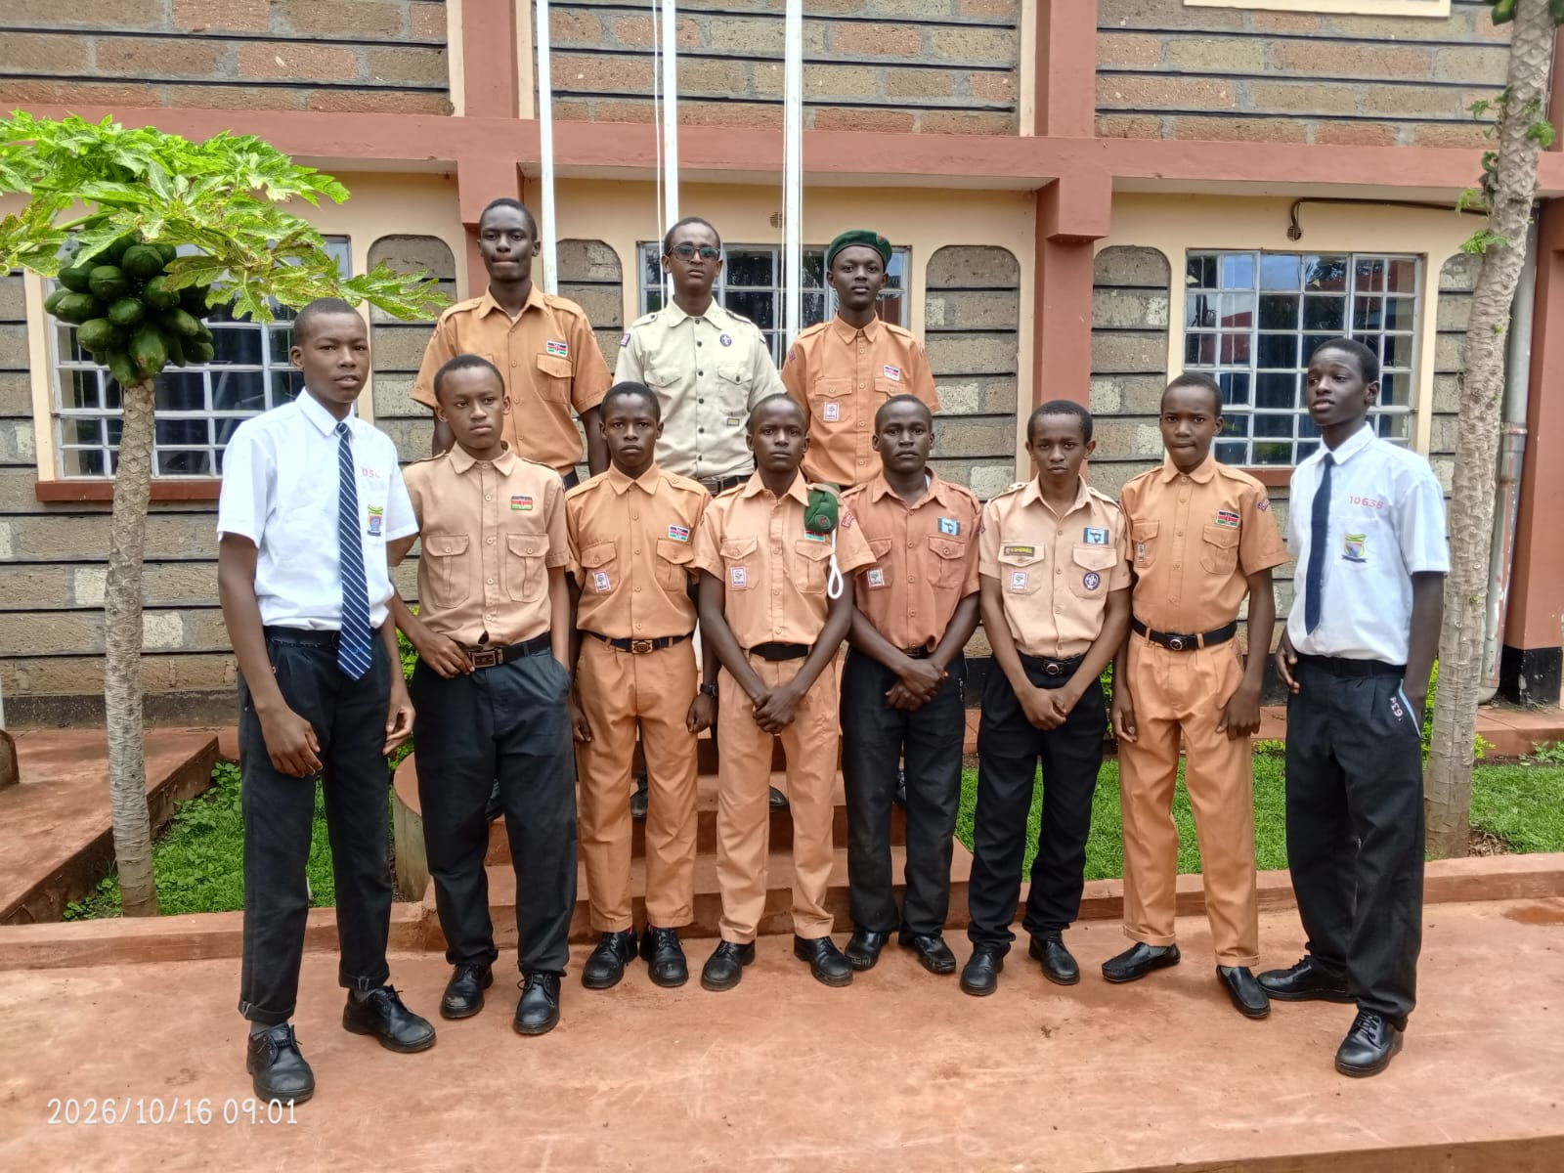
====================================================================================================================

13.2 THE CHRISTIAN UNION (C.U.) SOCIETY
Spiritual nourishment and moral rectitude are fundamental to life at Kiriani Boys. The Christian Union stands as the largest student-led spiritual organization on campus:
- Character Anchoring: Fostering high moral integrity, peer accountability, and strong ethical values based on Christian principles to guide daily decision-making.
- Community Programs: Weekly dynamic praise and worship services, small-group bible study fellowships, and peer-to-peer counselling networks that provide robust emotional support.
- Outreach and Leadership: Hosting regional high school C.U. rallies and mentoring young men to lead chapel assemblies, developing excellent public speaking capabilities.
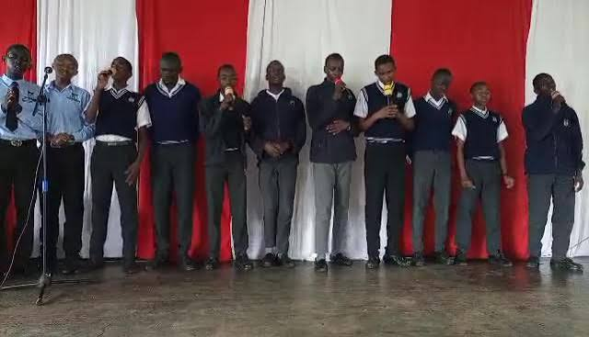
13.3 THE INFORMATION & COMMUNICATIONS TECHNOLOGY (ICT) CLUB
As part of our commitment to modern technical innovation, the ICT Club serves as the primary hub for tech-driven minds preparing for the global digital economy:
- Software Engineering Foundations: Hands-on student projects introducing key industrial concepts in web development, python coding, database structures, and digital systems design.
- Hardware & Campus Network Maintenance: Under faculty guidance, senior club members assist in maintaining the school's computer laboratories and optimizing internal networking paths.
- Competitive Edge & Innovation: Actively participating in national science and technology congresses, designing practical digital tools to solve everyday community and school challenges.

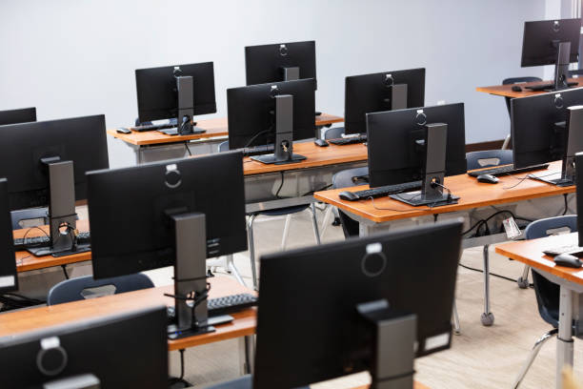
====================================================================================================================
PART XIV: DEPARTMENT OF GAMES, ATHLETICS, AND PHYSICAL EDUCATION
14.1 DEPARTMENTAL MANDATE & TALENT PIPELINE
The Games and Athletics Department at Kiriani Boys High School operates on the philosophy that a strong, disciplined body anchors a sharp, successful mind. The department is systematically structured to discover raw talent, refine physical capabilities, and project our students onto regional and national championship podiums. Through rigorous, structured training, our young men develop lifelong traits of resilience, strategic thinking, and flawless teamwork.

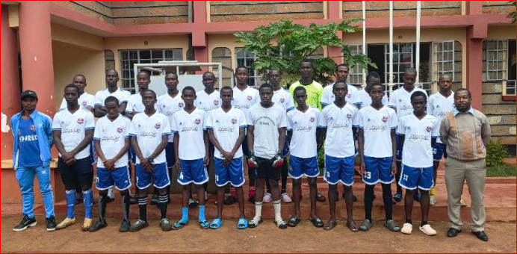======================
14.2 COMPETITIVE SPORTS DISCIPLINES
- The Elite Football (Soccer) Program
  - Tactical Framework: Driven by professional-grade coaching staff focusing on advanced spatial awareness, tactical ball retention, and high-intensity physical conditioning.
  - Track Record: Positioned as a premier regional powerhouse, consistently advancing to the final stages of school games and producing players scouted for national youth academies.
- The Rugby 15s and 7s Squads (The Kiriani Titans)
  - Core Focus: Built on the foundational pillars of absolute physical strength, unwavering tactical discipline, and a deep, unyielding brotherhood.
  - Infrastructure: Supported by dedicated strength-and-conditioning training spaces and specialized safety gear to ensure elite, high-impact athletic development.
- Basketball and Volleyball Teams
  - Operational Strategy: Utilizing our high-grade court infrastructure to master fast-break transition play, exceptional vertical leaps, and tight defensive court formations.
  - Academic Synergy: Fostering sharp cognitive processing under intense match pressure, which directly mirrors the focus needed for top-tier academic performance.
- Track, Field, and Indoor Sports
  - Individual Excellence: Tailored training regimens for short-distance sprints, middle-distance endurance running, field jumps, and competitive indoor disciplines like Chess and Table Tennis.
14.3 INFRASTRUCTURE & WELLNESS LOGISTICS
- Standardized Outdoor Pitches & Courts: Fully levelled, regularly maintained football grounds, a dedicated rugby pitch, and fenced, high-durability concrete basketball and volleyball surfaces.
- Modern Fitness & Strength Hub: Access to structured bodyweight and resistance training equipment, overseen by certified sports tutors to ensure safe and age-appropriate physical growth.
- Sports Medicine & First Aid Protocols: A highly trained pitch-side first aid team present at every training session and competitive match, working in direct coordination with the school health sanatorium to guarantee rapid response, injury management, and student wellness.

PART XV: STUDENT GOVERNANCE, PREFECTS COUNCIL, AND SCHOOL CAPTAINS
15.1 THE GOVERNANCE PHILOSOPHY: SERVANT LEADERSHIP
Student leadership at Kiriani Boys High School is built upon the foundational model of servant leadership. Prefects and captains are not merely authority figures; they are the vital bridge linking the student body to the school administration. Handpicked for their uncompromised discipline, academic focus, and moral integrity, our student leaders are trained to govern through empathy, accountability, and personal example.

======================
[.
15.2 THE ADMINISTRATIVE HIERARCHY & ROLES
- The School Captain (The Head Boy)

  - Executive Mandate: The highest student office on campus. The School Captain represents the entire student body at official functions, chairs the Prefects Council, and works directly with the Principal to maintain institutional order.
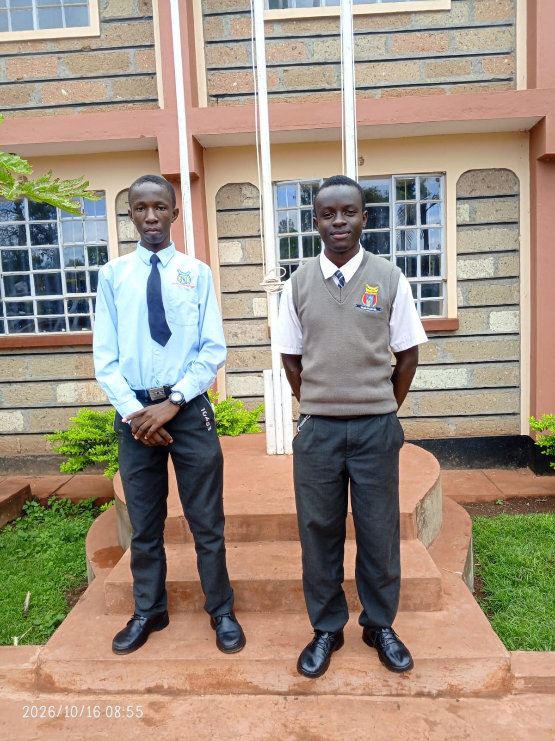
  - Public Relations Impact: Acts as the primary student ambassador for prospective families, showcasing the peak output of a Kiriani education.

- The Deputy School Captains
  - Operational Scope: Divided into academic oversight and administration/boarding logistics. They ensure all daily routines run smoothly, from early morning assemblies to evening prep sessions.
- Specialized Departmental Captains
  - Games Captain: Works hand-in-hand with the Games Department to coordinate internal leagues, sports kit distribution, and inter-school match logistics.
  - Dining Hall Captain: Oversees structural order during mealtimes, tracking nutritional service delivery and maintaining absolute kitchen hygiene standards.
  - Entertainment & Welfare Captain: Manages student recreational events, weekend movie screenings, and alerts the housemasters to student wellness or health concerns.
- House Captains & Block Prefects
  - Residential Management: Stationed directly within the elite dormitories to enforce clean living standards, manage structural safety, and maintain a quiet, productive environment during study hours.

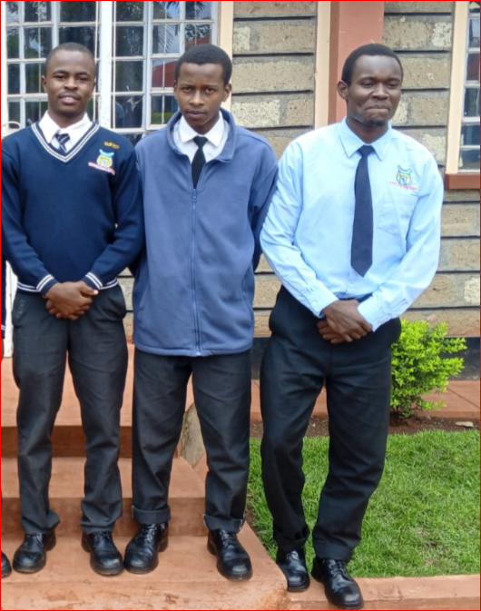
==========================================================

======================
[
15.3 SELECTION RIGOR & THE INVESTITURE CEREMONY
- Strict Vetting Pipeline: Becoming a leader at Kiriani is highly competitive. Candidates must maintain a high academic mean grade, receive structural clearance from the Guiding and Counselling department, pass peer reviews, and undergo rigorous oral interviews before a panel of HODs and the Principal.
- Leadership Training Bootcamps: Once selected, the incoming council undergoes a comprehensive leadership and conflict-resolution seminar led by professional corporate trainers.
- The Formal Investiture: The council is officially sworn into office during an annual high-profile assembly. Leaders receive their unique leadership insignia, including custom ties, specialized blazers, or badges, cementing their authority within the school community.

================================================================================
KIRIANI BOYS’ HIGH SCHOOL
P.O. Box 69-0064, chogoria, Kenya | Email: kirianiboys@gmail.com

SHAPING BOYS INTO LEADERS OF TOMORROW

================================================================================
GRADE 11 ADMISSIONS OFFICIALLY OPEN FOR 2027
Invest in an Environment of Academic Distinction, Discipline, and Innovation
As your son enters the critical final years of his secondary education, give him the competitive edge he deserves. Kiriani Boys’ High School offers a structured, distraction-free environment specifically tailored to unlock academic excellence, foster robust character, and secure direct entry into premier university programs.
THE KIRIANI ADVANTAGE: WHY CHOOSE US?
- UNMATCHED ACADEMIC TRACK RECORD
  - Driven by an elite team of expert educators, including celebrated language and technical specialists.
  - Consistent history of top regional performance and exceptional university transition rates.
- WORLD-CLASS CAMPUS INFRASTRUCTURE
  - State-of-the-art Multimedia Classrooms designed for active, modern digital pedagogy.
  - Fully updated Chemistry, Physics, Biology, and ICT/Coding laboratories.
  - Elite, highly secure, well-ventilated Boarding Complex and modern dormitories.
  - High-capacity luxury school bus fleet ensuring safe transport for all academic and sports tours.
- HOLISTIC TALENT & CO-CURRICULAR POWERHOUSE
  - Games Department: Championship coaching in soccer, rugby, basketball, and track.
  - Vibrant Student Societies: Active Scout Movement, Christian Union (C.U.), and innovative ICT Club.
  - Strong Student Governance: A disciplined, structural hierarchy led by our student Prefects Council.

================================================================================

[IMAGE MULTI-GRID PLACEHOLDER: SCIENCE LAB, SPORTS, AND CAMPUS LIFE]
Description: A grid layout of three small, high-quality images side-by-side: (1) Students working behind computers in the ICT club, (2) A soccer match action shot, and (3) The Scout troop in crisp uniforms.
Dimensions: Horizontal split grid across the page.
OUR GUIDING PILLARS: STRIVE FOR EXCELLENCE IN GOD’S GRACE
"At Kiriani Boys, we don’t just deliver text-book notes. We mentor young men to think critically, carry themselves with deep moral integrity, and step out into the corporate world as principled, capable global citizens."
— The Kiriani School Administration & Board of Management (BOM)

================================================================================
TAKE THE DEFINITIVE STEP TODAY – SECURE HIS SPOT
Due to our strict student-to-teacher ratio requirements, available vacancies for the incoming 2027 Grade 11 cohort are strictly limited.
- Pick Up Application Forms: Available now at the School Administration Registry Office.
- Download Directly Online: Visit www.kirianiboys.ac.ke/admissions2027
- Talk to our Admissions Desk: Call +254 (0) 7XX XXX X / +254 (0) 7XX XXX XXX
KIRIANI BOYS’ HIGH SCHOOL: INTELLECT | INTEGRITY | INNOVATION

