Use of the terminal in SEPAL

One of the ways SEPAL provides access to cloud computing infrastructure is through Amazon Web Services (AWS) cloud computing.

In SEPAL you can select from a variety of cloud computers of various sizes.

These cloud computers are referred to as **instances** and when they are switched on, you are running a **session**. An instance will automatically start if you launch an application in the processing options. The instance that automatically starts is always the smallest available one, the t2small, which has 1 GB of CPU and 2 GB of RAM power, for a small price of 0.03 USD per hour.

If the session is not active for more than 15 minutes (i.e. you are not using any of the processing tools nor are you actively running anything in the terminal), the instance will be automatically shutdown.

Using the terminal to start an instance

Go to the terminal 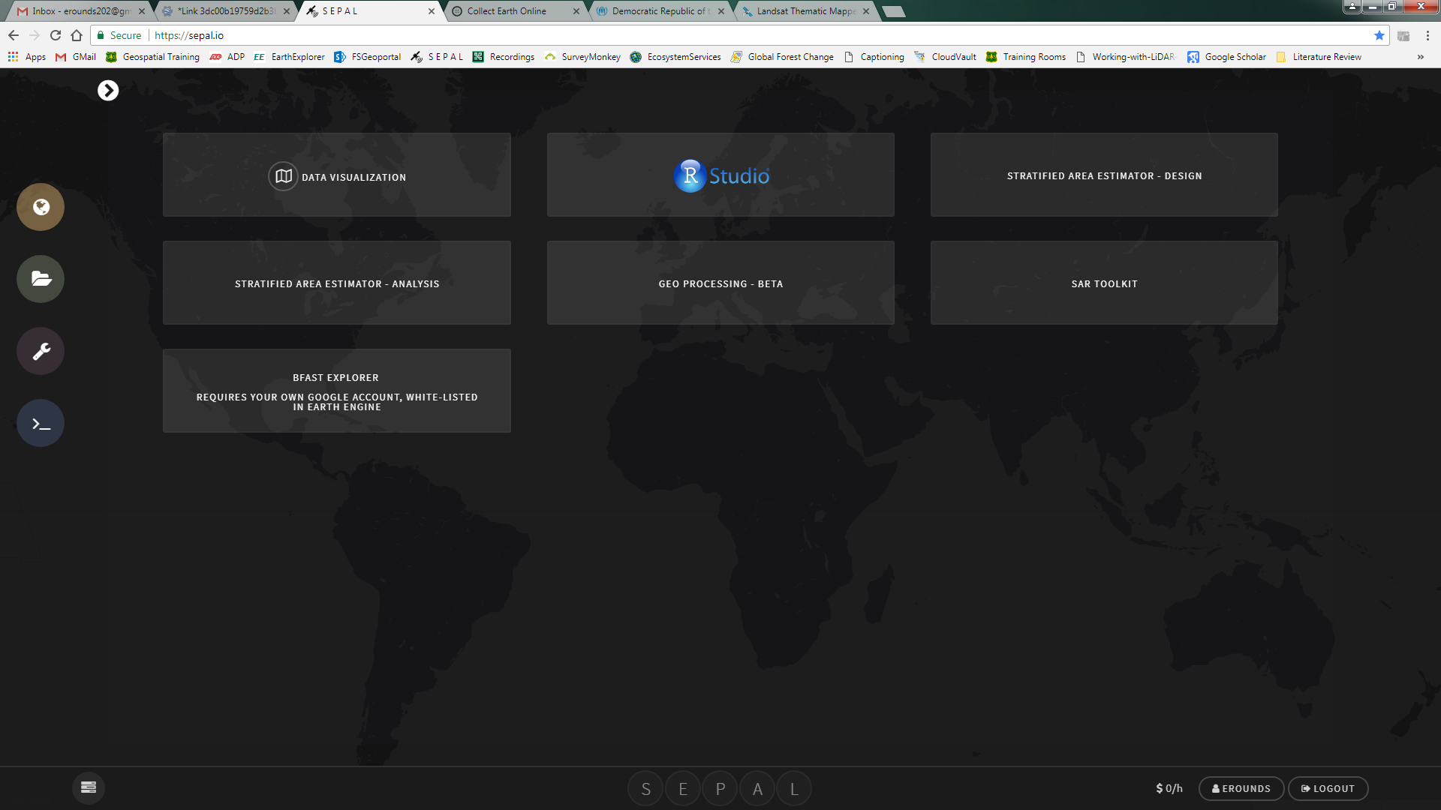

If you don’t have any instance running you should see the option to start a new session and the list of instances (see image below)

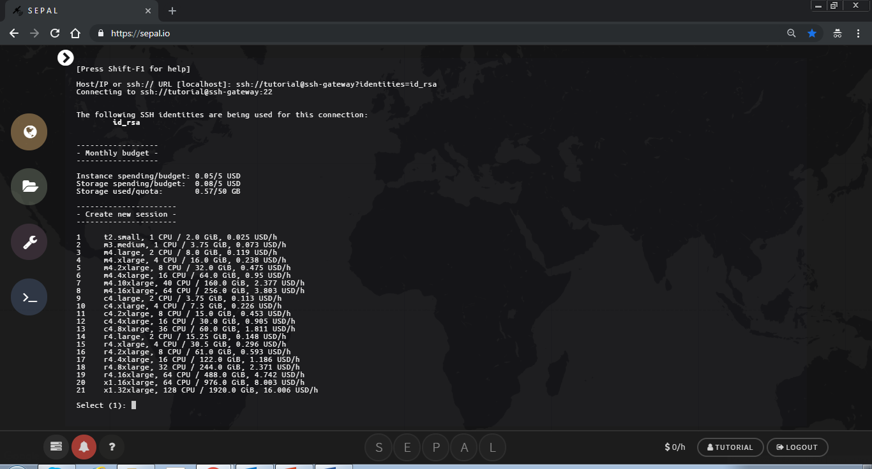

What type of instance do I need ?

It is good practice to adapt the type of instance to your needs.

If you want to run calculations in R with big objects (national scale raster), you will require a lot of RAM (at least 16GB, instance #4)

The time series analysis application is computationally intensive. You will need an instance with more CPUs and less memory because the algorithm is parallelized among many CPUs and does not require a huge amount of memory. Running a larger instance saves you time and money in your SEPAL account, depending on the size of the area. If the area is large, processing can take days to complete if using a small instance.

For running the test data set, you can first try selecting the c4.xlarge. If you are planning on running the application on your own area of interest, consider using a larger instance, such as c4.4xlarge or c4.8xlarge

To select the instance you need to type the number corresponding to the instance you would like to start. For example if you are starting the c4.xlarge, type **10** in the terminal and then hit the ENTER key on the keyboard. The command line only works by typing text in the terminal.

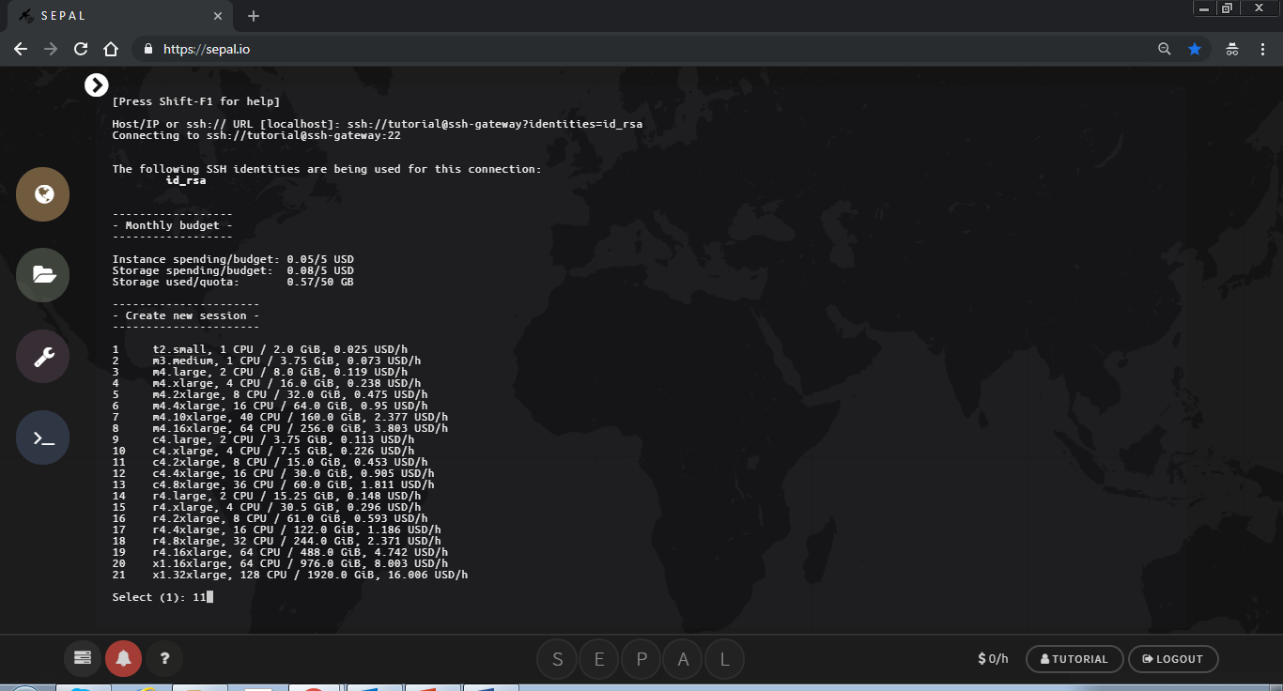

You will then see text about the amount of time you can leave your session running according to your user resources.

1. If your user resources are limited you will be asked if you would like to proceed with starting this instance. 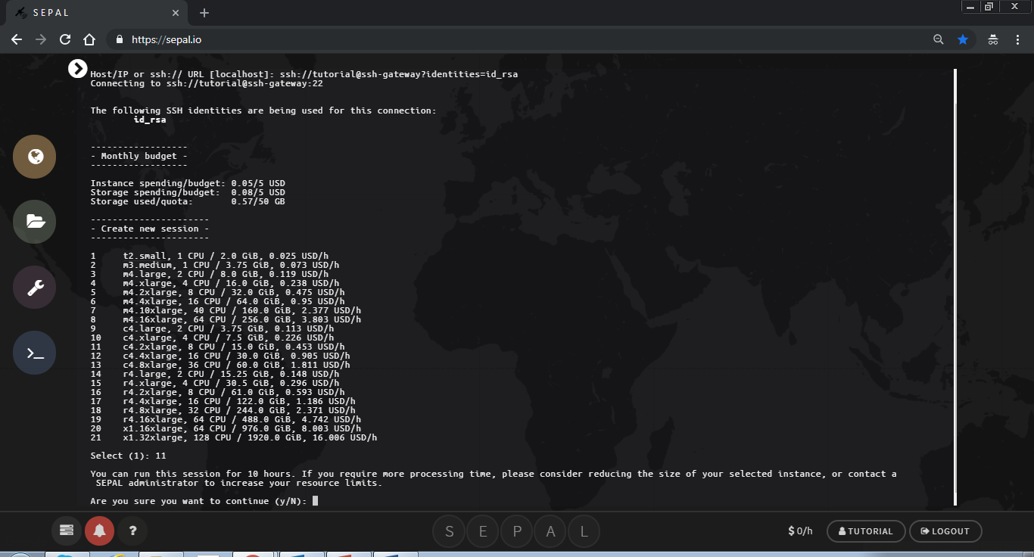
2. If you would like to proceed, type **y** (which stands for yes) in the terminal. Otherwise, if you would like to select another instance type **n** (which stands for no)**.**
3. If you have plenty of resources you will not see this text.

It can take a minute to start an instance. You will see text that says ‘Please wait….’

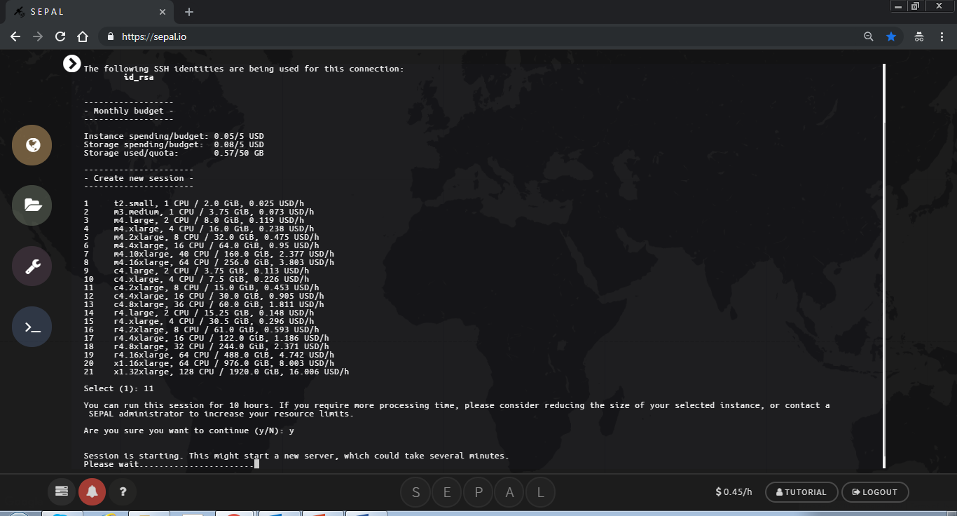

When the session has completed loading you will see your username@numbersandletters$

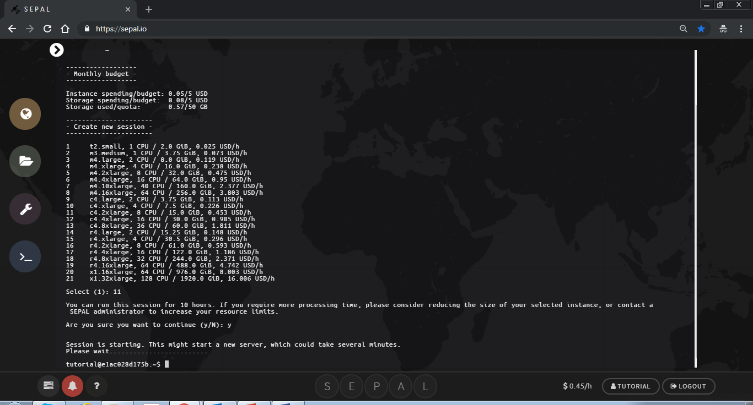

Shut down a existing instance

You can manually shutdown an instance in your user resources, which you can access by clicking on your name.



Click the X next to the running instance to shutdown the existing instance.

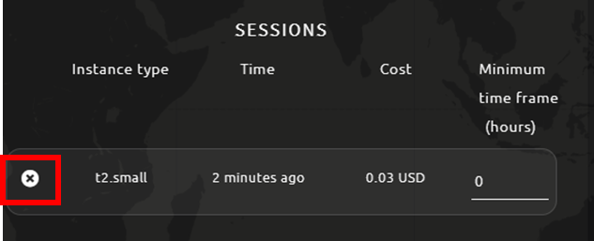

What can I do in the Terminal ?

SEPAL is running under a Linux server with the latest long term release Ubuntu operating system and the corresponding Bash Shell. You can run all the basic Linux commands in the terminal. In addition, several geospatial processing libraries are available such as GDAL/OGR ([www.gdal.org](http://www.gdal.org)) or the Orfeo Toolbox ([www.orfeo-toolbox.org](http://www.orfeo-toolbox.org)) and you can run processing commands from the terminal.

You can also clone, update and push git repositories directly in the terminal as illustrated in the below examples.

Clone a repository:

git clone https://github.com/yfinegold/uga_activity_data

Go to a repository:

cd ~/uga_activity_data/

Update a repository:

git pull

If you want to modify repositories and keep up to date the latest version of the scripts, you need to have more control and sign-up a git account for that.

You can sign-up in <https://.github.com> for example. If you don’t have any you can choose the same username as your SEPAL username and use the same email.

You will need to specify to your SEPAL environment your git configuration. Replace in the following commands “my-user-name” and ["my-email@example.com"](mailto:\"my-email@example.com\") with your credentials:

git config --global user.name "my-user-name"

git config --global [user.email"my-email@example.com"](mailto:user.email\"my-email@example.com\")

You can follow the amount of CPU’s used for a task with the top command:

top

