
AMRITA SCHOOL OF ENGINEERING, BENGALURU

DEPARTMENT OF ELECTRONICS & COMMUNICATION ENGINEERING

B. TECH. II SEMESTER AY 2024-2025
23ECE105 Iot LABORATORY
SYSTEM DESIGN REPORT
JANUARY TO APRIL 2025

TITLE OF THE SYSTEM DESIGN

Submitted by

BL.EN.U4EAC24044 MUTYALA PADMAJA
BL.EN.U4EAC24051 PARUCHURU RANGA KEERTHY
BL.EN.U4EAC24056 PRARTHANA NAIR
BL.EN.U4EAC24060 SAHITHYA MADHUSUDAN
BATCH NUMBER:

FACULTY EXAMINER SIGNATURE WITH EVALUATION DATE

COMMENTS (IF ANY)

Aim: To implement water purity sensor
Components required along with their specifications: TDS meter, lcd, Arduino, jumper wires
Circuit diagram:
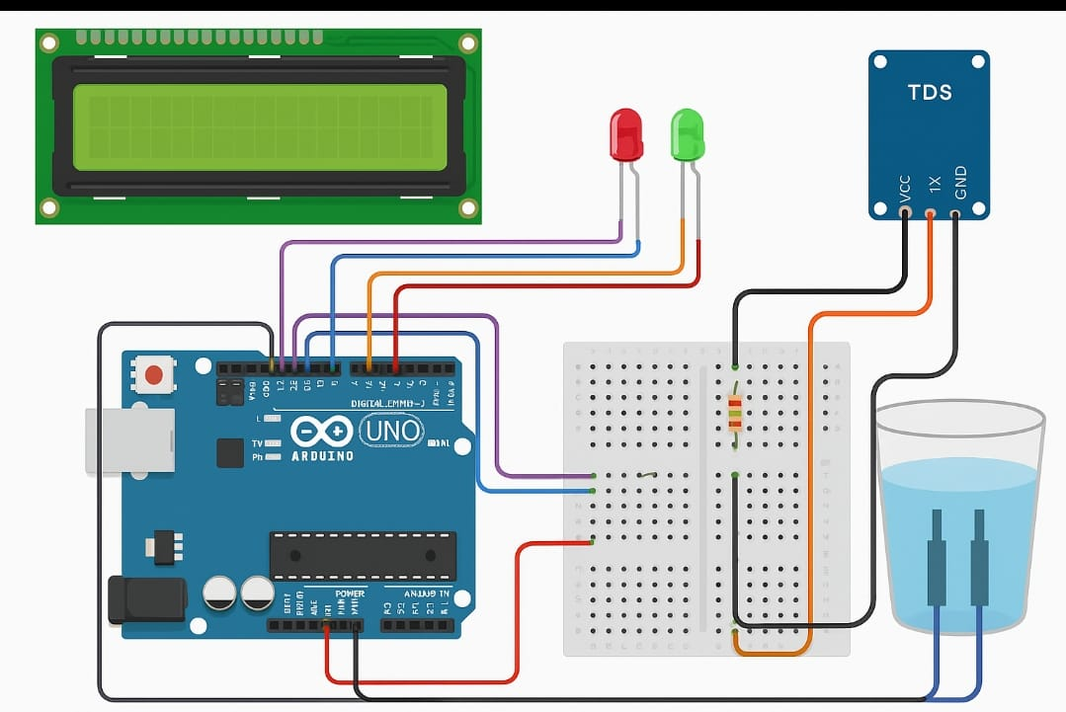

Theory and working principle:
Using the data on Total Dissolved Solids (TDS) to determine water purity.
- The TDS sensor detects the electrical conductivity of the water.
- Arduino reads this data, calculates the TDS in ppm, and categorizes the water quality.
- The result is displayed locally using an LCD screen.
Water Sampling:
The TDS sensor is submerged in a water sample to detect its conductivity.
Signal Conditioning:
The sensor converts conductivity to a voltage signal, which is read by the Arduino’s analog pin.
TDS Calculation:
The Arduino uses a formula to convert the analog reading into TDS in ppm:
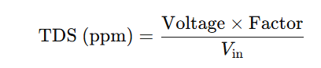
Data Processing:
- Arduino calculates the TDS value and determines if the water is Pure, Moderately Pure, or Impure based on thresholds.
IoT Communication:
- The data is sent to an IoT platform via Wi-Fi (ESP8266/NodeMCU), where it can be monitored remotely in real time.
Local Display
- An OLED or LCD screen displays the TDS value locally.

Program:

#include<Wire.h>
#include <LiquidCrystal.h> // Include the LiquidCrystal library

// Pin setup
const int tdsPin = A0; // Analog pin for TDS sensor
const int pureLedPin = 2; // Digital pin for "PURE" LED
const int impureLedPin = 3; // Digital pin for "IMPURE" LED
float voltage; // Voltage calculated from sensor value
float tdsValue; // TDS value in ppm

// Initialize the LCD (RS, E, D4, D5, D6, D7 pins)
LiquidCrystal lcd(7, 8, 9, 10, 11, 12); // Adjust pin numbers as per your connection

void setup() {
lcd.begin(16, 2); // Set up the LCD's number of columns and rows
Serial.begin(9600);

// Set LED pins as OUTPUT
pinMode(pureLedPin, OUTPUT);
pinMode(impureLedPin, OUTPUT);

lcd.setCursor(0, 0);
lcd.print("Water TDS Meter");
delay(2000);
lcd.clear();
}

void loop() {
int sensorValue = analogRead(tdsPin);
voltage = sensorValue * (5.0 / 1024.0);

// Calculate TDS (simplified formula)
tdsValue = (133.42 * voltage * voltage * voltage
- 255.86 * voltage * voltage
+ 857.39 * voltage) * 0.5;

// Line 1: Show TDS value in ppm
lcd.setCursor(0, 0);
lcd.print(tdsValue, 1); // One decimal place
lcd.print(" ppm "); // Pad spaces to clear leftovers

// Line 2: Show water purity status and control LEDs
lcd.setCursor(0, 1);
if (tdsValue < 300) {
lcd.print("PURE ");
digitalWrite(pureLedPin, HIGH); // Turn on "PURE" LED
digitalWrite(impureLedPin, LOW); // Turn off "IMPURE" LED
} else {
lcd.print("IMPURE ");
digitalWrite(pureLedPin, LOW); // Turn off "PURE" LED
digitalWrite(impureLedPin, HIGH); // Turn on "IMPURE" LED
}

// Also print to Serial Monitor
Serial.print("TDS Value: ");
Serial.print(tdsValue);
Serial.println(" ppm");

delay(1000); // Replace with millis() for non-blocking updates
}
Output: 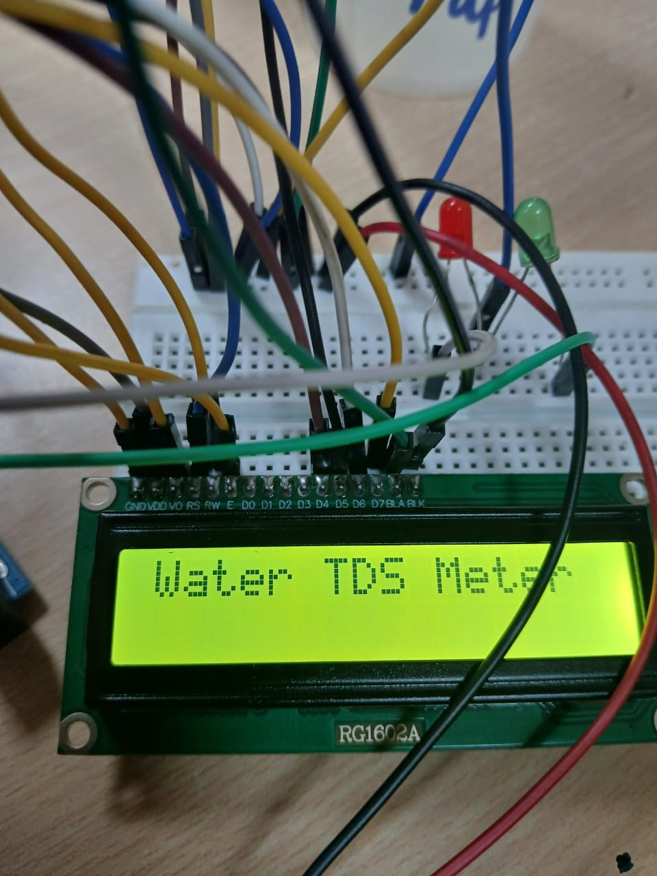

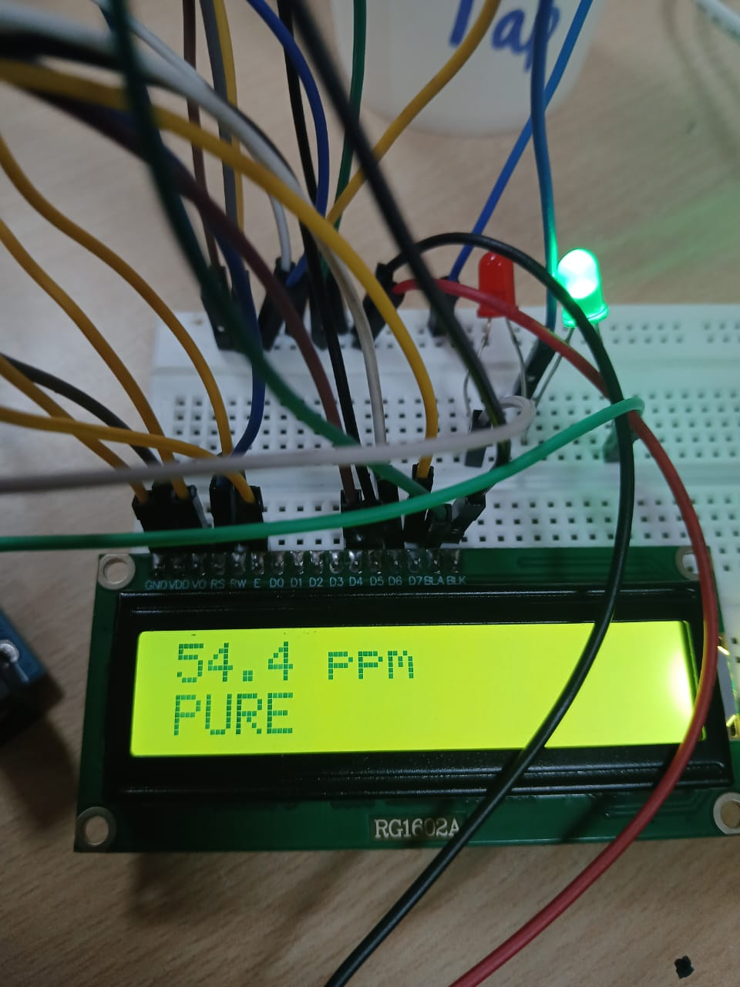
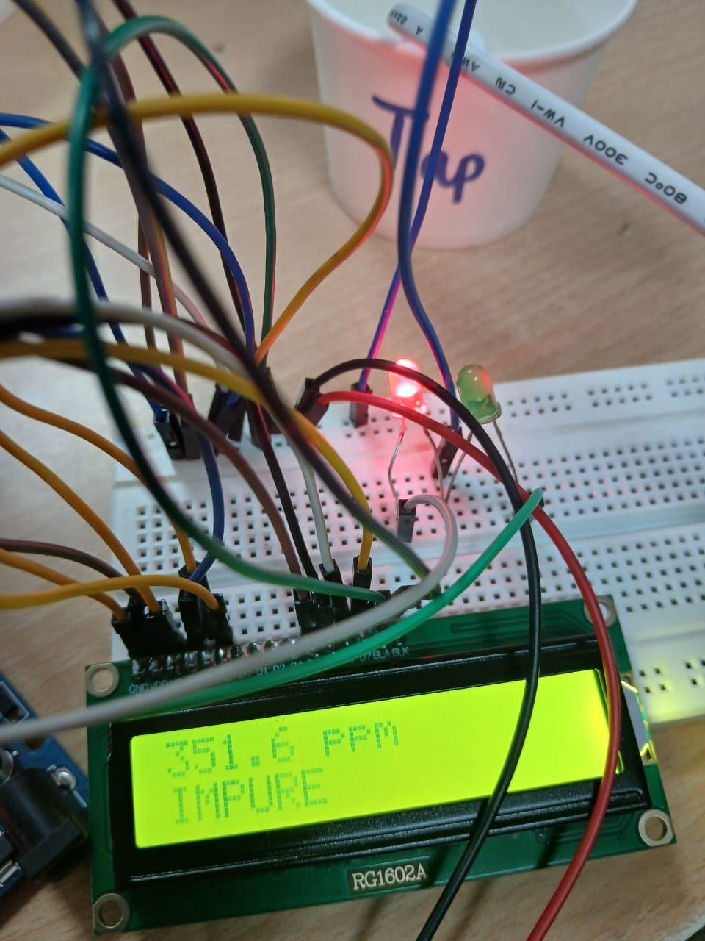
Conclusion:
In this project, we successfully designed and implemented an offline water purity monitoring system using an Arduino microcontroller and a TDS (Total Dissolved Solids) sensor. The system effectively measures the TDS value of water and displays the real-time data on a 16x2 LCD screen.
By analysing the TDS levels, the system categorizes the water quality into Pure, Moderate, or Impure, helping users make informed decisions about water usage. This solution is cost-effective, portable, and easy to use, making it ideal for field applications, educational purposes, and rural areas where internet connectivity might be limited.
Overall, this project demonstrates the practical application of embedded systems and sensor technology in real-time environmental monitoring, emphasizing the importance of water quality in daily life.

References:
A Strip-Based Total Dissolved Solids Sensor for Water Quality Analysis

Authors: Mohammad Makhdoumi Akram, Mohammad Ramezannezhad, Alireza Nikfarjam, et al.

IoT-Based Smart Water Quality Monitoring System
Authors: Monira Mukta, Md. Emon Miea, Samia Islam, et al.

