AIR QUALITY INDEX PREDICTION USING MACHINE LEARNING
M.SAMBASIVA RAO - 241FA18166
AIML-3, VFSTRF
Mutyala.sambasiva6@gmail.com
Abstract - Air pollution is a major environmental concern, and reliable air-quality prediction can support monitoring and decision-making. This paper presents a machine learning approach for predicting the Air Quality Index (AQI) using the city_day.csv dataset from the Air Quality Data in India collection. The dataset contains daily observations from 26 cities and pollutant measurements including PM2.5, PM10, nitrogen oxides, ammonia, carbon monoxide, sulfur dioxide, ozone, benzene, toluene and xylene. The workflow includes dataset understanding, exploratory data analysis, missing-value handling, duplicate checking, outlier inspection, feature engineering and feature selection. AQI is used as the regression target, while AQI_Bucket is excluded to avoid target leakage. Five models are evaluated: Linear Regression, Decision Tree, Random Forest, Gradient Boosting and XGBoost. Performance is compared using mean absolute error, root mean squared error and R-squared. On the prepared data, Random Forest achieves the best R-squared score of 0.9094, with an MAE of 20.68 and RMSE of 40.73. Feature analysis shows that PM2.5 and CO are the dominant predictors. The final model is also demonstrated on an unseen sample and saved for future reuse.
Index Terms - air quality, AQI prediction, machine learning, pollution, regression, XGBoost

I. INTRODUCTION
Air quality varies substantially across locations and time because of traffic, industrial activity, weather conditions and other emission sources. The Air Quality Index provides a single numerical representation of pollution severity, making it easier to communicate air quality to the public. Predictive models can complement conventional monitoring by learning relationships between measured pollutants and AQI.
This study focuses on supervised regression using the city_day.csv dataset. The objective is to estimate AQI from pollutant concentrations and calendar-derived variables. The work follows a complete machine learning workflow covering data understanding, EDA, preprocessing, feature engineering, model development, evaluation, comparison, interpretation and unseen-data prediction.
II. DATASET AND PROBLEM DEFINITION
The city_day.csv dataset contains 29,531 records and 16 columns, covering daily observations from 26 cities between 01 January 2015 and 01 July 2020. The variables include City, Date, twelve pollutant measurements, AQI and AQI_Bucket.
The prediction problem is formulated as a regression task. AQI is the target variable, while pollutant concentrations and calendar features are used as predictors. AQI_Bucket is not used as a predictor because it is derived from AQI and could leak target information into the model.

TABLE I. DATASET SUMMARY

Property | Value
Original records | 29,531
Columns | 16
Cities | 26
Date range | 2015-01-01 to 2020-07-01
Missing AQI values | 4,681
Duplicate rows | 0
Prepared records | 24,850

III. EXPLORATORY DATA ANALYSIS
Exploratory analysis was performed before model training to understand the target distribution, relationships among pollutants and the quality of the raw data. AQI values show substantial variation, reflecting differences in pollution conditions across cities and days.
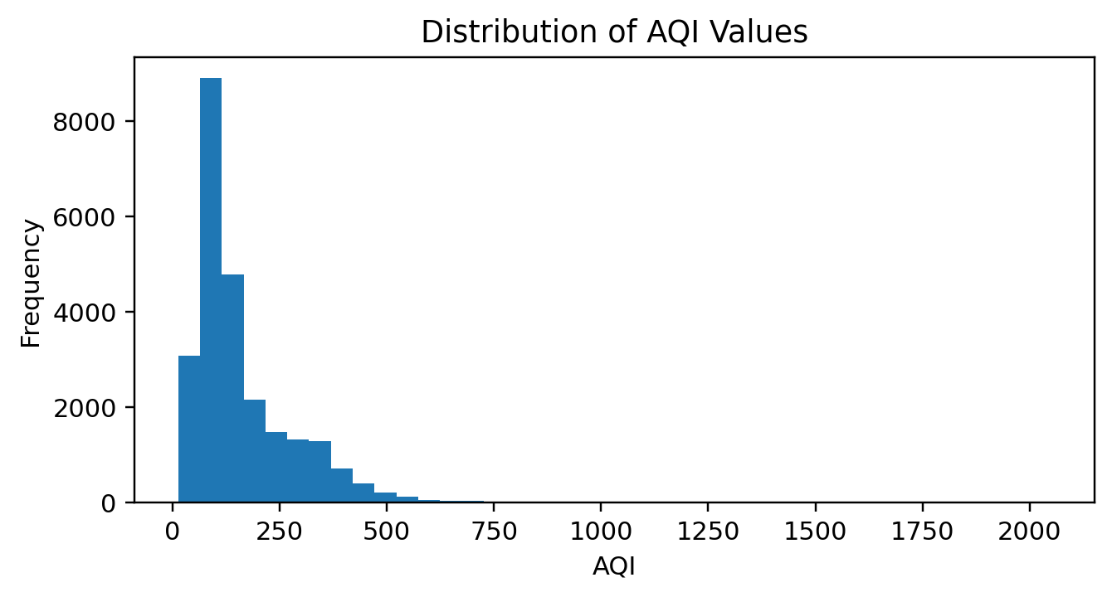
FIGURE 1. DISTRIBUTION OF AQI VALUES.
Correlation analysis was used to identify linear associations between pollutants and AQI. The correlation matrix also helps identify highly related pollutant variables and provides an initial indication of which measurements may be useful for prediction.

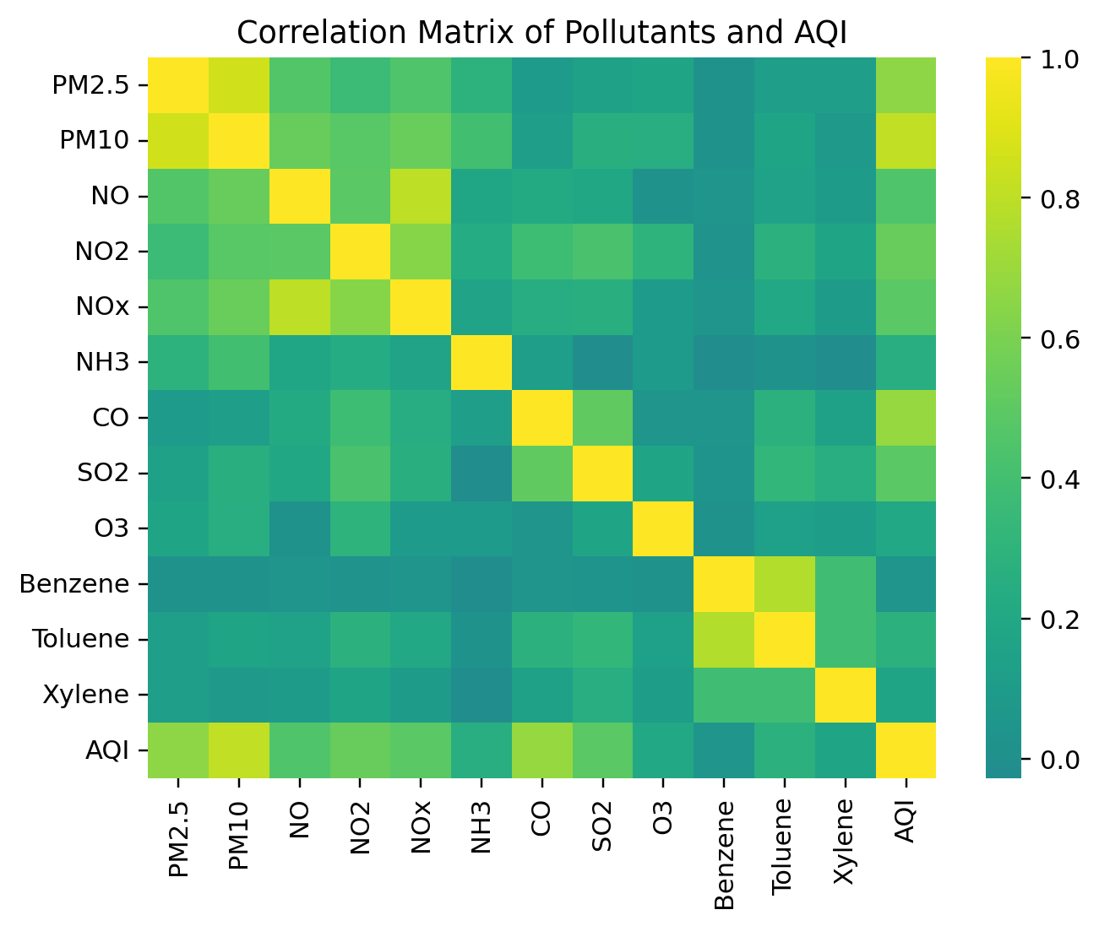
FIGURE 2. CORRELATION MATRIX OF POLLUTANTS AND AQI.

IV. DATA PREPROCESSING

Duplicate analysis found 0 exact duplicate rows in the original dataset. Missing values were inspected for each variable. Because AQI is the target, records without AQI were removed from supervised training. Remaining numerical pollutant gaps were handled using median imputation within the modeling pipeline.
Potential outliers were examined using distribution and boxplot-based analysis. Extreme pollution measurements were not automatically deleted because high values can represent genuine pollution events. Retaining them preserves potentially meaningful environmental variation.
The Date field was converted to datetime format. The resulting Year, Month, Day and DayOfWeek variables were extracted as additional predictors. Numerical preprocessing was performed inside the model pipelines so that imputation and scaling were learned only from the training data.
V. FEATURE ENGINEERING AND SELECTION
The feature set consists of twelve pollutant measurements together with four calendar-derived variables. AQI is retained only as the target, and AQI_Bucket is excluded because it is a categorical representation derived from AQI.
For Linear Regression, standardization is applied after median imputation. Tree-based models use the imputed numerical features directly. This combination keeps preprocessing appropriate to the characteristics of each algorithm while avoiding information leakage from the test set.
VI. MODEL DEVELOPMENT
The prepared data was divided into 80% training and 20% testing sets using a fixed random state of 42. Five regression algorithms were implemented to provide a broad comparison between a linear baseline, single-tree learning and ensemble boosting methods.
Linear Regression provides an interpretable baseline. Decision Tree captures nonlinear decision rules. Random Forest averages predictions from multiple trees to reduce variance. Gradient Boosting builds trees sequentially to correct previous errors. XGBoost provides an optimized gradient-boosting implementation for structured data.
TABLE II. MODEL PERFORMANCE ON THE TEST SET
Model | MAE | RMSE | R²
Random Forest | 20.68 | 40.73 | 0.9094
XGBoost | 22.01 | 43.07 | 0.8987
Gradient Boosting | 24.39 | 44.67 | 0.8910
Decision Tree | 24.77 | 50.21 | 0.8623
Linear Regression | 31.00 | 59.26 | 0.8082

VII. RESULTS AND DISCUSSION
The model comparison shows that Random Forest gives the highest R-squared score (0.9094) and the lowest MAE (20.68) among the five tested models. Its RMSE is 40.73. The ensemble approach therefore provides the strongest overall performance for this prepared dataset.
XGBoost and Gradient Boosting also perform strongly, while the single Decision Tree improves on the linear baseline but has larger error than the ensemble methods. Linear Regression provides a useful baseline but is less capable of representing the nonlinear relationships present in air-quality data.
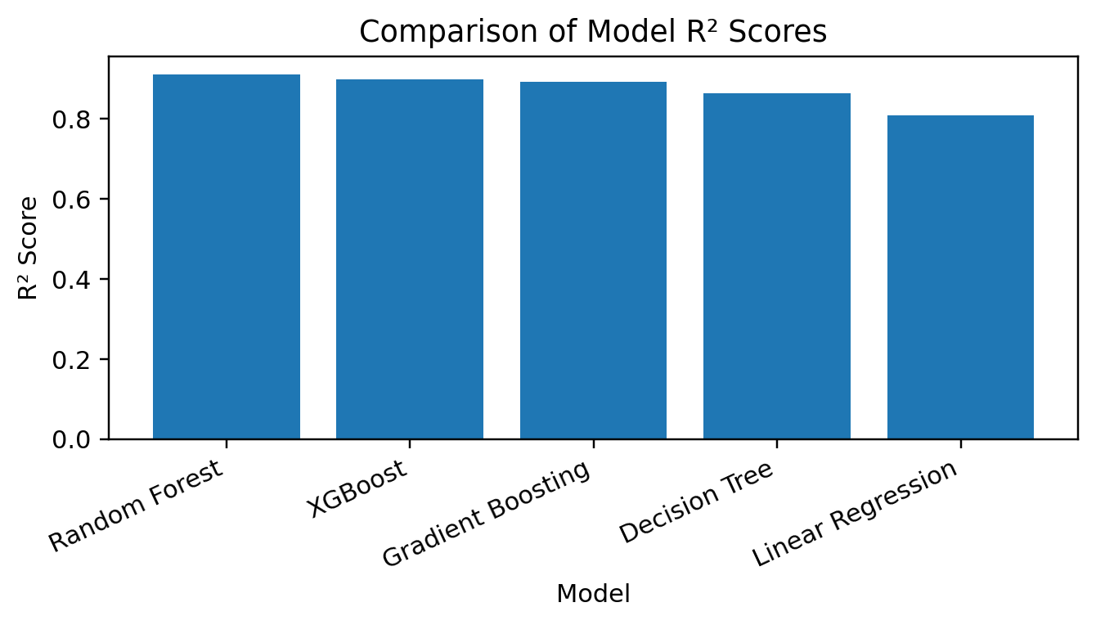
FIGURE 3. COMPARISON OF R-SQUARED SCORES FOR THE FIVE REGRESSION MODELS.

VIII. BEST MODEL AND FEATURE IMPORTANCE

Random Forest is selected as the final model because it achieves the best test-set R-squared score. Feature importance from the trained forest indicates that PM2.5 is the most influential feature (0.4894), followed by CO (0.3661). These results indicate that particulate matter and carbon monoxide carry substantial predictive information.

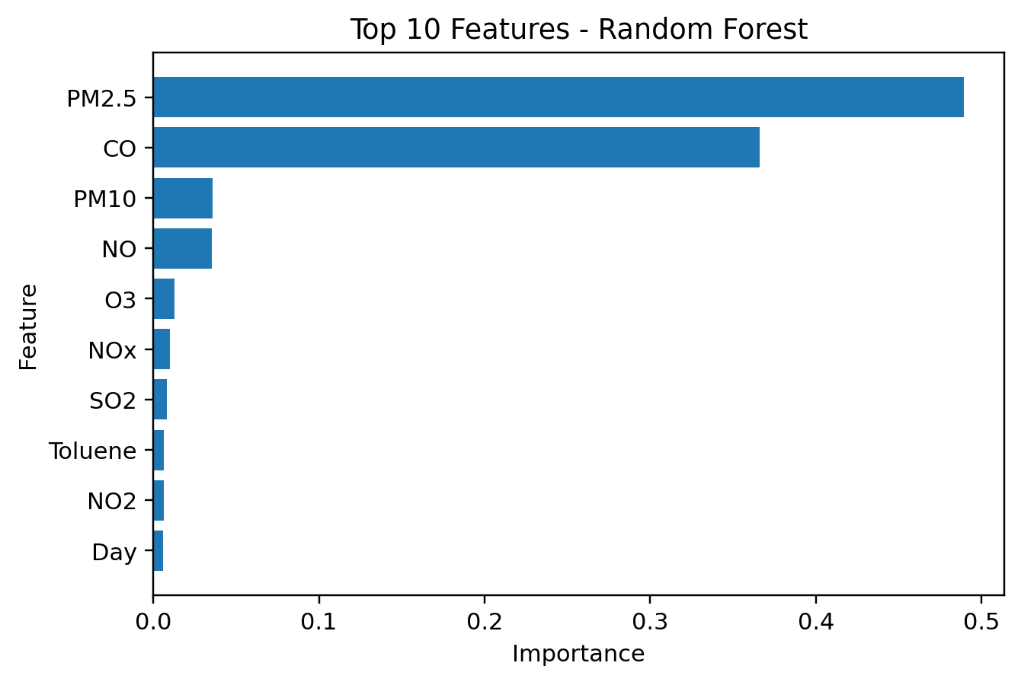
FIGURE 4. TOP TEN FEATURE IMPORTANCES FROM THE SELECTED RANDOM FOREST MODEL.
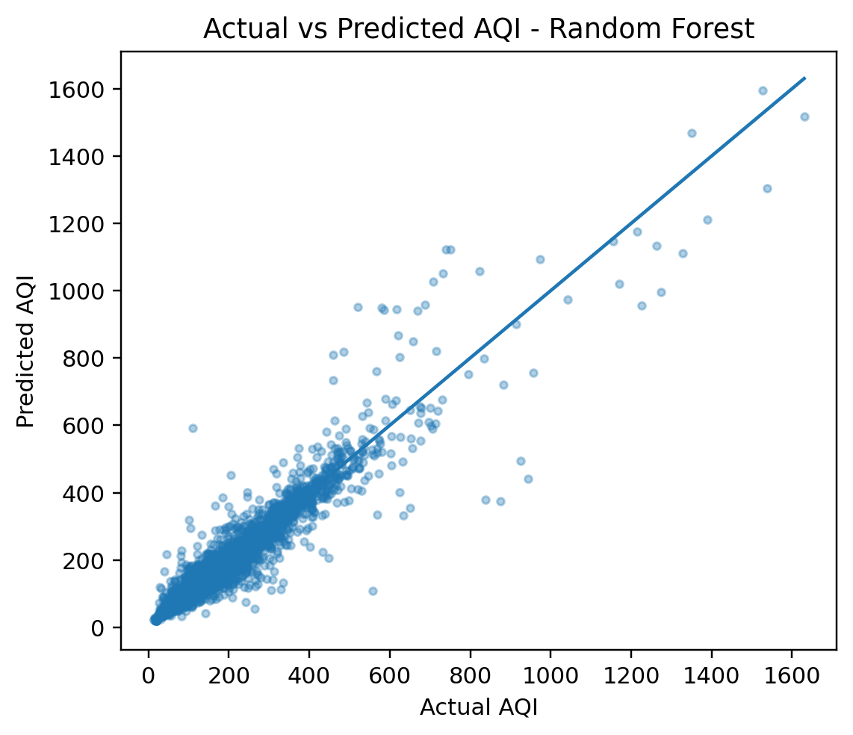
FIGURE 5. ACTUAL VERSUS PREDICTED AQI VALUES FOR THE SELECTED MODEL.

IX. UNSEEN DATA PREDICTION AND MODEL PERSISTENCE
To demonstrate deployment-oriented use, a new observation containing pollutant and calendar values was supplied to the selected model. The example observation produced a predicted AQI of approximately 112.54. This value is an illustrative model output and does not represent a verified environmental measurement.
The trained Random Forest pipeline was saved using Joblib. Saving the complete pipeline preserves the preprocessing and trained estimator together, allowing the same transformation logic to be reused when new data is supplied.

X. CONCLUSION
This study developed an end-to-end machine learning workflow for AQI prediction using the city_day.csv dataset. The work included data inspection, EDA, missing-value treatment, duplicate checking, outlier inspection, date-based feature engineering, feature selection and a consistent train-test evaluation.
Among the five evaluated algorithms, Random Forest achieved the strongest overall test performance with R² = 0.9094, MAE = 20.68 and RMSE = 40.73. Feature analysis identified PM2.5 and CO as the most influential predictors. The final model was tested on unseen data and saved for future reuse. Future work could include systematic hyperparameter tuning, time-aware validation, additional meteorological features and deployment as a real-time AQI prediction service.

REFERENCES
[1] R. Rao, “Air Quality Data in India,” Kaggle, dataset, 2020.
[2] F. Pedregosa et al., “Scikit-learn: Machine Learning in Python,” Journal of Machine Learning Research, vol. 12, pp. 2825–2830, 2011.
[3] T. Chen and C. Guestrin, “XGBoost: A Scalable Tree Boosting System,” in Proc. 22nd ACM SIGKDD Int. Conf. Knowledge Discovery and Data Mining, 2016, pp. 785–794.
[4] T. Hastie, R. Tibshirani, and J. Friedman, The Elements of Statistical Learning, 2nd ed. New York, NY, USA: Springer, 2009.
ABOUT THE AUTHORS
[Your Name] is a student in [Department, College/University]. The author worked on data preprocessing, exploratory analysis, machine learning model development and evaluation for this study.

