

Assignment no 3
Name: Syeda Mutzahra Batool
RegNo: 23-ARID-604
Program: BSCS (B) 5th M
Course Name: Mobile App Development
Submitted to: Muhammad Azhar

- Source code of some imp file….

- LoginActivity.java

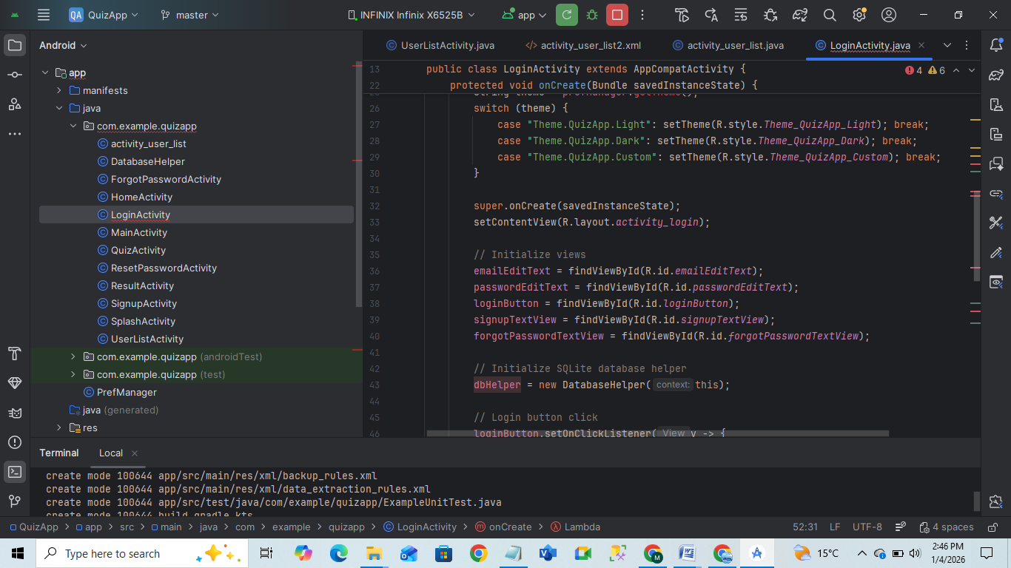

- Login.xml file

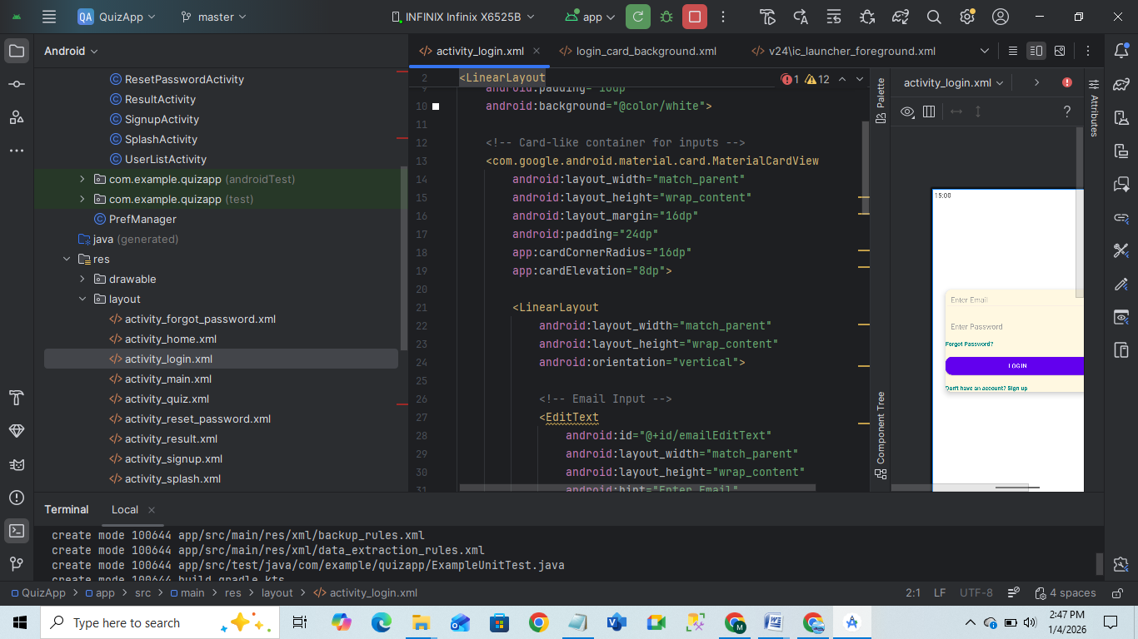

- Homeactivity.java

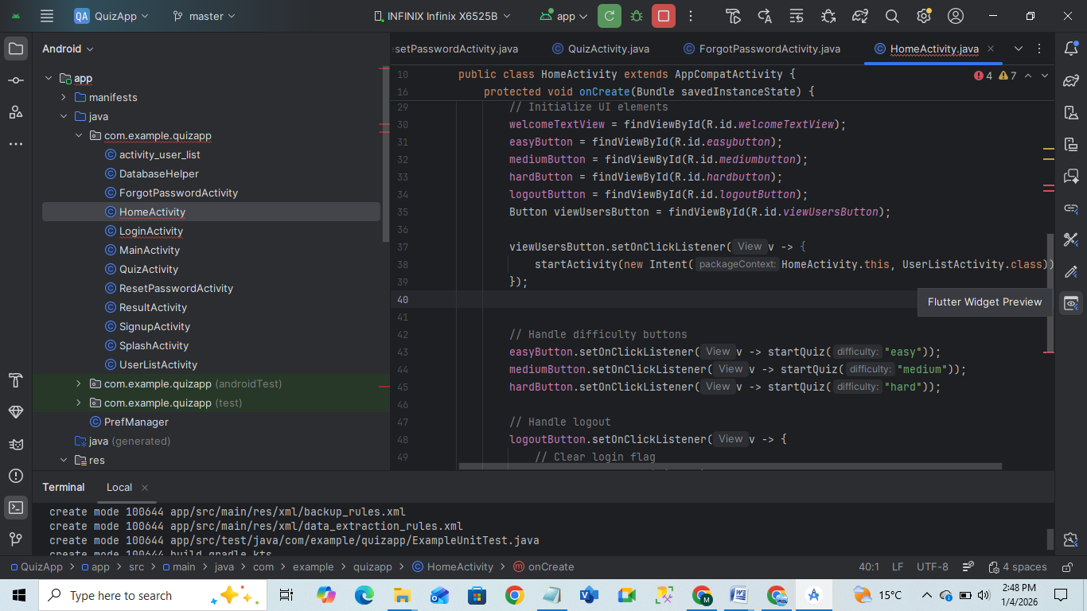

Here are just some source codes of important login functionality,rest of all the source code has been provided to github repository sir yo can check via link given below.

NOTE:

Output pages are already provided to you in assignment 2 you can see there. Thank you.

GITHUB REPOSITORY LINK

https://github.com/mutzahrabatool1082-web/quiz.App

https://github.com/mutzahrabatool1082-web/quiz.App

