The Russian Welfare State System: With Special Reference to Regional Inequality

Kulmala Meri

Kivinen Markku

Nikula Jouko

Kainu Markus

June, 17, 2014

**Abstract**: *Lorem ipsum dolor sit amet, consectetur adipiscing elit. Nam diam purus, adipiscing nec purus sed, vehicula vulputate turpis. Ut sed aliquet odio. Praesent tempus fermentum metus, eu mollis ligula porttitor ac. Nulla ornare, eros at tempor lobortis, sapien libero volutpat est, ac porta purus libero id risus. Integer tincidunt molestie molestie. Aenean feugiat velit eu tristique lacinia. Nunc auctor, augue eu sodales convallis, nulla lectus viverra nisi, et commodo lorem neque a dolor. Morbi nec eros sed diam ornare porta at sed mauris. Integer tincidunt sagittis urna eu varius. Nulla nec condimentum massa. Nam bibendum mauris diam, non cursus mi malesuada id. Quisque a nunc rutrum, adipiscing purus vel, vestibulum purus. Phasellus vestibulum porttitor nulla, vel malesuada leo placerat consequat.*

# Introduction (about 500 words)

Ut convallis vel odio id ultricies. Sed at lacus ut nunc rutrum sollicitudin sit amet at neque. Vivamus fermentum, magna non porttitor rhoncus, nulla ipsum varius felis, in ornare ante massa a mauris. In id diam gravida ipsum ornare fermentum. Proin sit amet est sollicitudin, interdum turpis eget, dictum mauris. Proin congue pharetra eros, eget viverra justo pulvinar sit amet. Class aptent taciti sociosqu ad litora torquent per conubia nostra, per inceptos himenaeos.

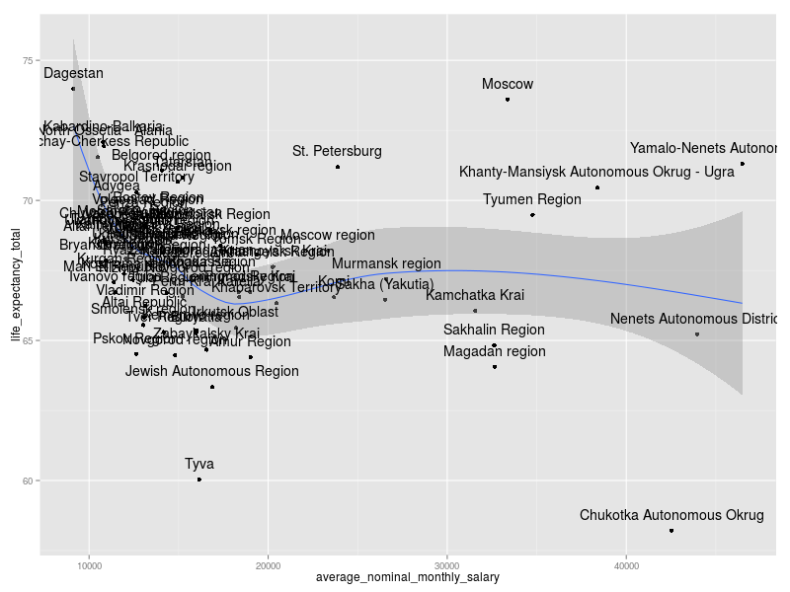

|  |  |  |  |
| --- | --- | --- | --- |
| This | is | table | heading |
| This | is | table | row |
| This | is | table | row |
| This | is | table | row |

Suspendisse quis eros sit amet nibh ultricies lacinia ac eget neque. Sed posuere felis vitae nunc imperdiet convallis. Integer eget mi consequat, aliquam nulla sit amet, tempus tellus. Vivamus faucibus, libero sit amet posuere convallis, risus nibh pulvinar urna, quis vulputate turpis eros non erat. Mauris pharetra lobortis nisl. Aliquam sit amet venenatis nisi, et pharetra purus. Etiam magna elit, auctor non velit in, bibendum interdum eros. Sed sit amet lacus id sapien sodales egestas. Morbi semper massa non dolor imperdiet mollis.

|  |  |  |  |  |
| --- | --- | --- | --- | --- |
| Indicator | Russian Federation | Best Region | Worst region | Moscow city |
| GDP per capita, PPP USD | 18,260 | 46,359 (Tiumen region) | 1,988 (Republic of Ingushetia) | 37,088 |
|  | Poland | Switzerland | Cambodia, Nigeria | Canada |
| Fertility rate | 1.537 | 3.376 (Chechen Republic) | 1.185 (Leningrad Region) | 1.41 |
|  | Switzerland, Spain, Czech Republic | Haiti, Bolivia, Laos | Republic of Korea | Austria, Hungary, Italy |
| Infant mortality | 8.1 | 4.0 (Khanty-mansiyskiy AO) | 16.6 (Chechenskaya Republic) | 6.7 |
|  | Bulgaria, Kuwait, Montenergo | Austria, Belgium, Germany | Brasil, China | Latvia, Chile |
| Life expectancy at birth | 68.67 | 78.31 (Republic of Ingushetia) | 58.22 (Chukotskiy AO) | 73.61 |
|  | Belarus, Moldova | Portugal, Slovenia | Guinea, Sudan | Bulgaria, Hungary |

Regional disparities in social development indicators, 2010

this

is

list

this

is

numbered

list

In consectetur nunc in leo convallis, nec luctus quam viverra. Duis justo odio, euismod eget elementum sed, posuere quis tellus. Donec diam felis, vestibulum in convallis sed, molestie a arcu. Mauris vehicula, metus at fermentum dictum, ipsum enim congue quam, eu faucibus eros odio vitae tellus. Suspendisse a felis adipiscing, dictum lorem non, rhoncus mauris. Cras convallis pulvinar diam sed eleifend. Suspendisse ut sem aliquet, laoreet dolor a, bibendum odio.

# Major Characteristics of the (Entire) Welfare State System (about 3,000 words)

# Special Focus of the chapter - Regional Inequality (about 2,000 words)

# Current and Future Trends of the (Entire) Welfare State System (about 1,000 words)

# Summary and Conclusions (about 500 words)