**Financing the welfare system**

All in all, the fiscal conservatism of Russian economic policy (cf. Sutela 2007 and 2012), the lack of strong political or trade union organizations (Clarke 2005) of the working class, and the symbolic reference to middle class interests seem to be characteristic features of the contemporary hegemonic project in Russia. On the other hand, raising living standards and creating order out of the chaos of the 1990s help to legitimise the contemporary political elite in Russia in the eyes of the ordinary working class.

Economic reform had been the key priority in president Putin’s first term. In 2006, Dmitry Medvedev argued that Russia was already another country. Political and economic stability had been secured and the country was able to start working for the future. The power vertical was in place, and rising export revenues with more effectively working taxation instruments would give Russia a possibility to use state resources to face the social crisis. ‘National priority projects’ in health, education and housing were established and they were allocated a budget equivalent to about USD 7.6 billion. The projects were managed by a specially established presidential council with high level participants and with the intention to overcome too strict barriers between administrative branches. The council was presided over by Medvedev, who soon became the First Deputy Prime Minister, and since 2008 the President of Russia. The projects were meant to be limited in time but they should get issues on these fronts moving. In fact, the budget resources given to the programmes were no more than eight percent of spending planned for these sectors. However, in his inauguration speech President Medvedev already underlined that the programmes had proven their worth. They were made normal parts of the budget process, but they are often still referred to as specific programmes.

**Table . Expenditure for social functions by tier of government as a percentage of total expenditure, 2006**

|  |  |  |  |
| --- | --- | --- | --- |
|  | *Federal* | *Regional* | *Local* |
| Housing | 8 | 49 | 43 |
| Education | 22 | 26 | 52 |
| Health | 22 | 59 | 19 |
| Social welfare | 81 | 14 | 5 |

Source: De Silva *et al.* (2009).

It is not easy to judge how systematic and significant the role of national priority projects in fact has been. Cerami has presented evidence based on the Ministry of Finance's 2008 federal budget framework until 2010. It forecasted a 48 percent increase for social expenditure. Pekka Sutela (2012, 200–201) has pointed out that the budget grew overall larger, and inflation increased beyond expectations. Consequently, nominal values would not be the most relevant indicator. Therefore, one should preferably look at percentage distribution and compare the actual outcome with the framework. It should be observed also that a lot of welfare expenditure is not decided at the federal level (Table 4). As the information for the available year 2006 shows, half of public education is funded by local budgets and most public money for health is channelled via the regional level. Housing is almost not a federal issue at all, while social welfare expenditure is overwhelmingly federal (Sutela 2012, 200–202). On the other hand, budget transfers from the federation to the regional and local levels should also be taken into account. Using the Bank of Finland Economies of Transition unit’s calculations prepared by Vesa Korhonen, Sutela has constructed the actual consolidated budget expenditure by calculating the expenditure of the federal, regional and local levels as well as expenditure from extra-budgetary funds. In Table 5, dated calculations, prepared for this article by Vesa Korhonen, are presented. Table 6 shows the subcategories of social security in social expenditure. In the light of these tables, the ‘Russian miracle’ is not evident at all. In actual fact, the rise in budgeted welfare was a lot from 2005 to 2009 (125 percent); however, the relative share was not growing and the actual rise at the same time in all expenditure was even more comprehensive (132 percent).

**Table . Social expenditure as a share of all consolidated budget expenditure, 2005–2009, (%)**

|  |  |  |  |  |  |  |
| --- | --- | --- | --- | --- | --- | --- |
|  | *Total* | *Housing & communal utilities* | *Education* | *Culture* | *Health care, physical culture and sports* | *Social security* |
| Billions of roubles (*percentage)* | | | | | | |
| *2005* | 6821  *(100)* | 471  *(6.9)* | 802  *(11.8)* | 86  *(1.3)* | 797  *(11.7)* | 1889  *(27.7)* |
| *2006* | 8375  *(100)* | 632  *(7.5)* | 1036  *(12.4)* | 130  *(1.6)* | 962  *(11.5)* | 2359  *(28.2)* |
| *2007* | 11379  *(100)* | 1102  *(9.7)* | 1343  *(11.8)* | 172  *(1.5)* | 1382  *(12.1)* | 2852  *(25.1)* |
| *2008* | 13992  *(100)* | 153  *(8.2)* | 1664  *(11.9)* | 219  *(1.6)* | 1546  *(11.1)* | 3766  (26.9) |
| *2009* | 16048  *(100)* | 1006  *(6.3)* | 1778  *(11.1)* | 222  *(1.4)* | 1653  *(10.3)* | 4546  *(28.3)* |
| *2010* | 17617  *(100)* | 1071  *(6.1)* | 1894  *(10.8)* | 238  *(1.4)* | 1709  *(10.8)* | 6178  *(35.1)* |
| *2011* | 19995  *(100)* | 1195  *(6.0)* | 2232  *(11.2)* | 277  *(1.4)* | 2096  *(11.2)* | 6512  (32.6) |

Perhaps the most striking result in Table 5 is that the relative shares of social expenditure categories remain almost the same during the years of the new emphasis on social policy. There is a significant increase in social security and Table 6 shows that this concerns mainly pensions and family and childhood protection. Housing has a pro-cyclical pattern. In the crisis year 2009, the share of social expenditure other than pensions declined rather steeply.

All this seems to lead to the conclusion that in spite of the economic recovery and increased budgetary resources, the Russian miracle in social policy might still be an overstatement. Seen in the context of particular social problems and institutional settings, the situation is still rather gloomy. This can be seen in a more detailed analysis concerning housing, education, health and pensions (Kivinen 2014 forthcoming). Especially the analysis of pension development shows the complexity of political agency in contemporary Russian social policy.

**Table . Subcategories of social security in social expenditure**

|  |  |  |  |  |  |  |  |
| --- | --- | --- | --- | --- | --- | --- | --- |
|  | *Social security* | *Pensions* | *Other than pensions* | *Social services* | *Social welfare* | *Family & childhood protection* | *Other issues* |
| Billions of roubles (*percentage)* |  | | | | | | |
| *2005* | 1889  *(27.7)* | 1421  *(20.8)* | 469  *(6.9)* | 94  *(1.4)* | 269  *(3.9)* | 11  *(0.2)* | 95  *(1.4)* |
| *2006* | 2359  *(28.2)* | 1678  *(20.0)* | 681  *(8.1)* | 118  *(1.4)* | 490  *(5.9)* | 14  *(0.2)* | 60  *(0.7)* |
| *2007* | 2852  *(25.1)* | 1948  *(17.1)* | 904  *(7.9)* | 148  *(1.3)* | 646  *(5.7)* | 20  *(0.2)* | 90  *(0.8)* |
| *2008* | 3766  (26.9) | 2578  *(18.4)* | 1189  *(8.5)* | 190  *(1.4)* | 919  *(6.6)* | 37  (0.3) | 42  *(0.3)* |
| *2009* | 4546  *(28.3)* | 3235  *(20.2)* | 1311  *(8.2)* | 230  *(1.4)* | 989  *(6.2)* | 47  *(0.3)* | 45  *(0.3)* |
| *2010* | 6178  *(35.1)* | 4436  *(25.2)* | 1742  *(9.9)* | 260  *(1.5)* | 1383  *(7.9)* | 51  *(0.3)* | 47  *(0.3)* |
| *2011* | 6512  (32.6) | 4380  *(21.9)* | 2133  *(10.7)* | 293  *(1.5)* | 1308  *(6.5)* | 241  (1.2) | 290  *(1.5)* |

The Russian population is ageing rapidly and this implies a rising dependency ratio, especially because the retirement age is low (60 for men and 55 for women). During the next twenty years the number of pensioners is going to increase by ten million, whereas the working population will decline by eleven million. Already by 2020 there will be around 800 retired persons for every 1,000 working age citizens. This seems to indicate a pressure to increase the age of retirement.

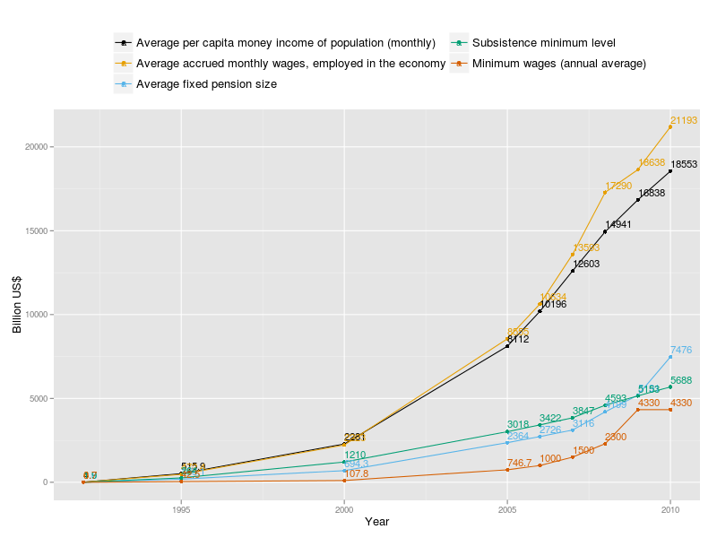

Figure Development of income, wages, pensions, subsistence minimum and minimum wages in 1992–2010

Source: Rosstat 2012

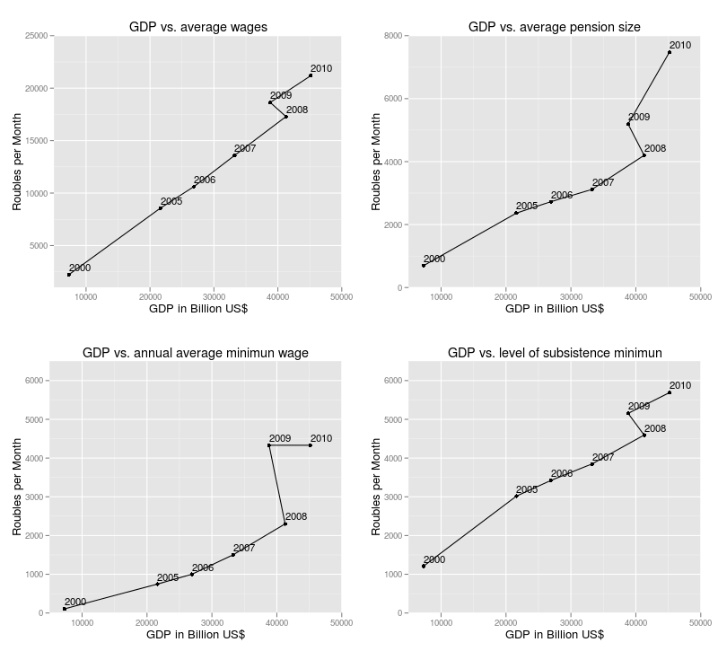

Figure Change in dependency between GDP and wages, pensions, minimum wage and subsistence minimum

Source: Rosstat 2012

As Figure 6 shows, a major increase in budget expenditure for pensions occurred in 2009 with the implementation of a new phase in pension reform. It is not clear whether this expenditure should be treated as an anti-crisis measure. At least the World Bank and the IMF usually treat additional pension payments as anti-crisis instruments. The pension reform seemed to make social payment the priority in the crisis period. Whether this is sustainable in the long run, taking into account the challenging population structure, remains to be seen.

Christian Aspalter (2006, 4-7) argues that explanatory theories of social welfare may be characterised either as actor-based (conflict) theories, or structural (functional) theories. Actor-based theories suggest that it is the power and the programmes of different actors that are the key to the formation of welfare regimes. On the other hand, structural theories are apt to predict a convergence of social policies based on common structural determinants, such as the degree of economic development, urbanisation, modernisation or the advance of the capitalist market economy. There is not much evidence that the Russian development could be explained by these basic structural aspects. Our analysis here adheres to an action-based explanation. On the other hand, none of the actors are omnipotent and specific historical structures must be taken into account as well.

Classes are not major actors in Russian social policy. They may have different interests, but there is not much of a democratic class struggle in the Nordic sense (Korpi 1983). The Russian political system is based on a power vertical that underlines the role of the elite (cf. Sakwa 2008 and 2004, OPFR 2008). There is no doubt the elite has been emphasising social policy since 2005. Indeed, welfare funding has increased rapidly. However, a more detailed analysis of relative percentages of welfare in the federal budget reveals that in these figures the political will can hardly be seen. Social federal outlays have increased but not more rapidly than other outlays. Russian social policy seems to be hovering between fiscal conservatism and active social policy. Since everybody is aware of the social crisis all political forces tend to raise social policy issues on the agenda. In real terms, fiscal conservatism has so far been more significant. Within the ministerial structures, the Ministry of Economic Development has been the most important. Except for the ideology of fiscal conservatism, this could be linked with the strong bureaucratic tradition within state structures.

When it comes to other actors, professional organisations tend to be at the margins of major decision-making in social policy. This is most visible in the demography programme in which the vast problem of mortality is not given priority. The role of corporate structures is strong in pension policy, but the actual outcome is not what the government and the Russian Union of Industrialists and Entrepreneurs intended. At the local level, quasi-formal corporatist institutions, such as regular consultation between governors and major enterprises and between the executive and the heads of party factions in the Duma (Remington 2011, 213 ), establish an arena for political compromises. In many cases this has created hybrids of public and private welfare structures. Even in more general terms Russian welfare policy seems to oscillate between contradictory tendencies: between neoliberalism and state-based social policy, between individualisation of risks and strong administrative control.

Alfio Cerami argues that contemporary Russian welfare policy is highly vulnerable. He emphasises that this form of social policy expansion based on volatile equilibriums present in the global arena is unlikely to be sustainable in the long run, even in the presence of the additional surplus reserve fund (Cerami 2009b, 216): “Due to the impossibility of predicting the trends in global markets, the destiny of the ‘Russian miracle’ remains highly unpredictable.”

Except for this exogenous vulnerability, there seems to be endogenous vulnerability as well. If the increased financing is not connected to institutional reform, huge questions concerning contradictory approaches and incentives will not be solved.

Our results seem to highlight the interdependency between various challenges of Russian modernisation. Eventually, successful social policy depends on economic diversification and on the democratisation of the political system.

**Acknowledgements**

The authors want to thank Vesa Korhonen from the Bank of Finland Institute for Economies in Transition for his help in collecting the budgetary data for this article.

**BIBLIOGRAPHY**

Anderson, Barbara A. & Brian D. Silver. The Changing Shape of Soviet Mortality, 1958–1985: An Evaluation of Old and New Evidence. *Population Studies*, Vol. 43/1989, 243–65.

Aspalter, Christian: New Developments in the Theory of Comparative Social Policy. *Journal of Comparative Social Welfare* Vol. 1, 2006/1, 3–22.

Cerami, Alfio: Socio-Economic Transformations in Post-Communist Countries: Central and Eastern Europe and Russia Compared. *Romanian Journal of Political Science*, Vol. 9 No. 1, 2009 (http:///www.sar.org.ro/polsci/), (2009a)

Cerami, Alfio: Welfare State Developments in the Russian Federation: Oil-Led Social Policy and ‘The Russian Miracle’. *Social Policy & Administration*, Vol.43 no. 2, 105–120, (2009b)

Clarke, Simon: The contradictions of ‘state socialism’. In Simon Clarke et al.: *What about the Workers. Workers and the Transition to Capitalism in Russia.* Edgar Elgar 1993.

Clarke, Simon: Post-socialist trade unions: China and Russia. Industrial Relations Journal, Vol. 36, 2005/1, 2–18.

Cook, Linda J.: *Postcommunist Welfare states: Reform Politics in Russia and Eastern Europe.* Cornell UP 2007.

Cooper, Julian: *Reviewing Russian Strategic Planning. The Emergence of Strategy 2020*. Nato Defence College Research Division 2012.

De Silva, M.O & G. Kurlyanskaya & E. Andreeva & N. Golovanova: *Intergovernmental Reforms in the Russian Federation: One Step Forward, Two Steps Back?* Washington, DC: The World Bank.

Feshbach, Murray: Between the Lines of the 1979 Soviet Census. In *Problems of Communism*, January 1982, pp. 27–37.

Gaidar, Yegor: *Vlast i sobstvennost; Smuty i instituty; Gosudarstvo i evolutsiya*. Sankt-Peterburg, Norma 2009.

Gaman-Golutvina, Oxana: The Changing Role of the State and State Bureaucracy in the Context of Public Administration Reforms: Russian and Foreign Experience. In Anton Oleinik (ed.): *Reforming the State without Changing the Model of Power?* Routledge 2009.

Geroimenko, Vladimir, A. & Grigori A. Klucharev & John W. Morgan*:* Private Higher Education in Russia: Capacity for Innovation and Investment*.* *European Journal of Education*, Vol. 47, No 1, 2012

Golovljanitsina, E.B.: Innovatsionen li rossijskij srednij klass? Osobennosti professional’noj struktury i trudovyh tsennostej srednego klassa nakanune krizisa. *Mir Rossii,* Vol. 18, 2009/4, 19-36.

Gorshkov, M.G. (et al.): *Srednij klass v sovremennom Rossiiskom obschestve.* Moscow 1999.

Gorshkov, M.G. (et al.) (Ed.): *Srednij klass v sovremennoj Rossii*. Institut sotsiologii RAN 2008.

Gorshkov, M.G.: Rossijskoe obschestvo v sotsiologitsheskom izmerenii. *Mir Rossii,* Vol. 18, 2009/2, 3-21.

Grigoriev, Leonid & Maleva, Tatyana: Srednii klass v sovremennom rossiiskom obshchestve. *Voprosy ekonomiki* 2001/1, 40-50.

Hughes, M.C.: Smashing the iron bowl. *Foreign Affairs*, Vol. 77, 1998/4.

Kivinen, Markku: Classes in the Making. Russian Class Structure in Transition. In Göran Therborn (ed.): Inequalities of the World. Verso 2007, 247-294.

Kivinen, Markku & Chunling Li: The Free-Market State or the Welfare State. In Christer Pursiainen (Ed.): *At the Crossroads of Post-Communist Transition: Comparative Analysis of Russia and China*, Palgrave Macmillan 2012 (forthcoming).

Korpi, Walter: *The Democratic Class Struggle*. Routledge and Kegan Paul 1983.

Kulmala, Meri: Russian Society. In: *Russia of Challenges*, Helsinki, Ministry of Defence 2007, 9–31.

Lin, Ka & Kangas Olli: Social Policymaking and its institutional basis: Transition of the Chinese social security system. *International Social Security Review*, Vol. 59, 2/2006, 61–76.

Merkulova, T.V.: Ekonomitsheskij rost i neravenstvo: institutsionalnyj aspect I modelirovanie vzaimosvjazi. Mir Rossii Vol. 19, 59-77.

OPFR: O sostojanii grazhdanskogo obshchestva v Rossiiskoi Federacii. Moskva: Obshchesvennaia palata Rossiiskoi Federacii 2008.

Osadchaya, G.I.: L’goty v kontekste reformirovaniya socialnoj politiki*. Sotsiolgicheskie issledobaniya* 2006/11, 38-42.

Petuhov, V.V.: Ot monetizatsiya l’got k natsionalnym projektam*. Sotsiolgicheskie issledobaniya* 2006/12, 22-27.

Pickvance, C.: State socialism post-socialism and their urban patterns: theorizing the Central and Eastern Europena Experience, In Eale J. & C. Mele (Eds.) *Understanding the City*. Oxford, Blackwell 2002, 183–203.

Radaev, V.V.: Obytshnye in innovatsionnie praktiki. In T.M. Maleva (Ed*.): Srednie klassi v Rossii:* ekonomitsheskie i sotsialnye strategii. Gendal’f 2003.

Remington, Thomas F.: *The Politics of Inequality in Russia.* New York, Cambridge UP 2011.

Ruoppila, Sampo: *Residential Differentiation, Housing Policy and Urban Planning in the Transformation from State Socialism to a Market Economy: The Case of Tallinn*. Espoo 2006, Helsinki University of Technology, Centre for Urban and Regional Studies.

Sakwa, Richard: *Putin Russia’s Choice*. Routledge 2004.

Sakwa, Richard*: Russian Politics and Society*. Routledge 2008.

Shkaratan, O.I.: Vozproizvodstvo sotsialno-ekonomitsheskogo neravenstva v postsovetskoj Rossii: dinamika urovna zhizni i polozenie sotsialnyh nizov. *Mir Rossii*, Vol. 17, 2008/4, 60-89.

Shkaratan, O.I. & S.A. Injasevskij & T.S. Ljubimova: Novyj srednij klass i informatsional’nye na rossijskom rynke truda. *Obchshestvennye nauki i sovremennost’*, 2008/1.

Shorrocks, Anthony & Stanislav Kolenikov *Poverty Trends in Russia during Transition*, Wider Institute, Helsinki 2001.

Sutela, Pekka: The Economic Future of Russia. *International Journal of Economic Policy in Emerging Economies* 2007/1, 21–33.

Sutela, Pekka: *The Political Economy of Putin’s Russia*. London and New York, Routledge 2012.

Szelenyi, Iván: *Urban Inequalities under State Socialism.* New York, Oxford University Press 1983.

Tuomi, Marja: *Diffusion of Social Innovations Across the Borders. Social Sector Cooperation with the Republic of Karelia*. Publications of the University of Eastern Finland. Dissertations in Social Sciences and Business Studies No 33

UNDP: *Human Development Report 2010. The Real Wealth of Nations: Pathways to Human Development*. United Nations Development Programme. Palgrave Macmillan. New York.

UNDP: *National Human Development Report for the Russian Federation 2011: Modernisation and Human Development*, Moscow, UNDP Russia.

Vihavainen, Rosa: Homeowners’ Associations in Russia after the 2005 Housing Reform. Helsinki, Kikimora Publications 2009.

Vishnevsky, A.: *Sberezhenie naroda ili depopulyatsiya Rossiya?* Moskva, Izdatelskij dom Gosudarstvennogo universiteta Vyshey shkolu ekonomiki 2010.

Williamson, John B. & Stephanie A. Howling & Michele L. Maroto: The political economy of Pension reform in Russia: Why partial privatisation*? Journal of Aging Studies*, Vol. 20, 2006, 165–175.

The World Bank: *The World Bank in Russia: Russian Economic Report* 18, Mach 2009, 17–22.