Example of a simple convertible documentation with Markdown & Pandoc

Author Name

September 8, 2014

# Introduction

Content of this doc is copy-pasted from from [Pandoc Markdown](http://rmarkdown.rstudio.com/authoring_pandoc_markdown.html)-documentation by Rstudio, which is basicly a reproduction of most of the pandoc markdown documentation on the Pandoc website, and is © 2006-2013 John MacFarlane (jgm at berkeley dot edu), released under the GPL, version 2 or greater.

Pandoc understands an extended and slightly revised version of John Gruber’s original markdown syntax. This document explains the syntax, noting differences from standard markdown.

# Lists

* fruits
  + apples
    - macintosh
    - red delicious
  + pears
  + peaches
* vegetables
  + broccoli
  + chard

# Images



Caption is placed here

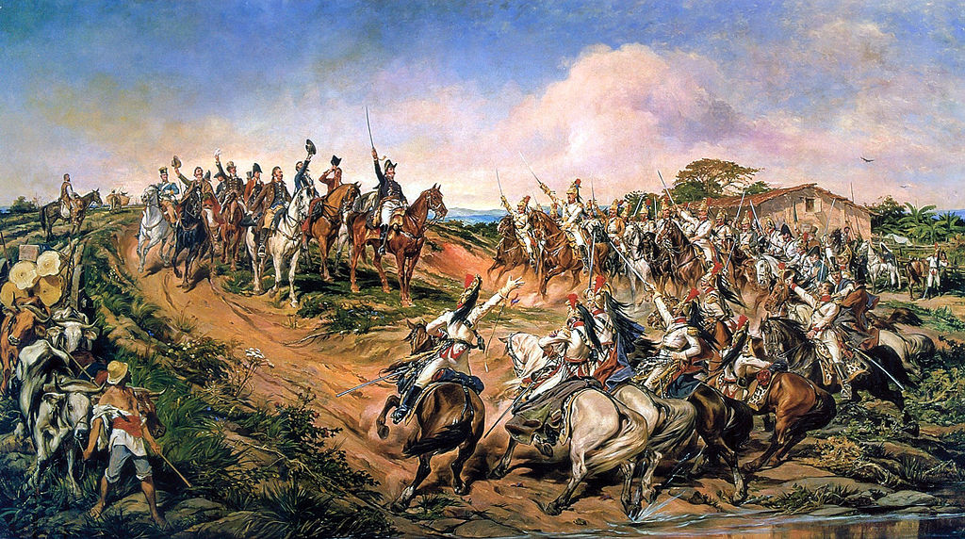

Picture of the day in Wikimedia Commons [See](http://commons.wikimedia.org/wiki/Main_Page)

# Tables

## Simple tables

Four kinds of tables may be used. The first three kinds presuppose the use of a fixed-width font, such as Courier. The fourth kind can be used with proportionally spaced fonts, as it does not require lining up columns. Simple tables

|  |  |  |  |
| --- | --- | --- | --- |
| Right | Left | Center | Default |
| 12 | 12 | 12 | 12 |
| 123 | 123 | 123 | 123 |
| 1 | 1 | 1 | 1 |

Demonstration of simple table syntax.

## Multiline tables

|  |  |  |  |
| --- | --- | --- | --- |
| Centered Header | Default Aligned | Right Aligned | Left Aligned |
| First | row | 12.0 | Example of a row that spans multiple lines. |
| Second | row | 5.0 | Here's another one. Note the blank line between rows. |

Here's the caption. It, too, may span multiple lines.

# Footnotes

Here is a footnote reference,[1] and another.[2]

This paragraph won't be part of the note, because it isn't indented.

1. Here is the footnote.
2. Here's one with multiple blocks.

   Subsequent paragraphs are indented to show that they belong to the previous footnote.

   { some.code }

   The whole paragraph can be indented, or just the first line. In this way, multi-paragraph footnotes work like multi-paragraph list items.