**Title:**

**Examine Neural Network Approaches for Unified Membership Integration in Diverse Applications**

**Abstract:** The unified membership integration system, powered by neural network technologies, represents a significant advancement in consolidating and managing membership data across various stores or businesses within a single application. This paper delves into the intricacies of this system, highlighting its importance in streamlining data management processes, reducing redundancy, and enhancing customer engagement. By centralizing membership information, businesses can unlock valuable insights into customer behaviour, preferences, and loyalty patterns, enabling them to tailor services and promotions effectively. Furthermore, the system's transition from physical cards to a digital platform aligns with the contemporary demand for convenient and seamless customer experiences. This paper explores the technical aspects, benefits, challenges, and future implications of implementing a unified membership integration system.

Objective: To evaluate the feasibility and effectiveness of utilizing neural network approaches to develop a unified membership integration system, wherein a single application replaces the need for multiple store-specific membership or loyalty cards.

Hypotheses: If a neural network-based unified membership integration system is implemented, it will efficiently consolidate and manage membership data from various stores or businesses into a single application.

**Methodology**

**1. Data Collection**

**1.1. Secondary Data:**

**Retail Food stores** [**link**](https://catalog.data.gov/dataset/retail-food-stores)

**This data is from the USA, and I haven’t fully decided to use it yet. If you want to change the data, that’s okay with me. You can also adjust the topic slightly to better fit the data. Below, I have provided information about the data.**

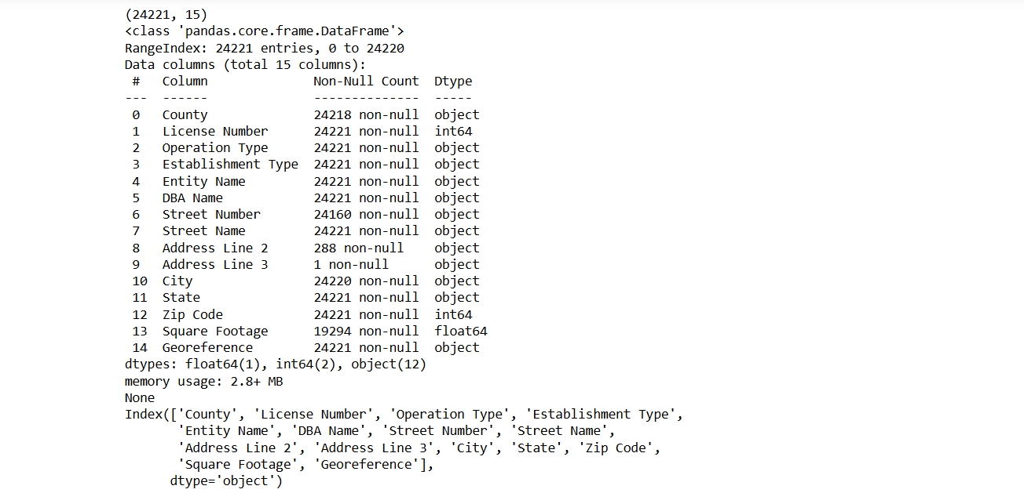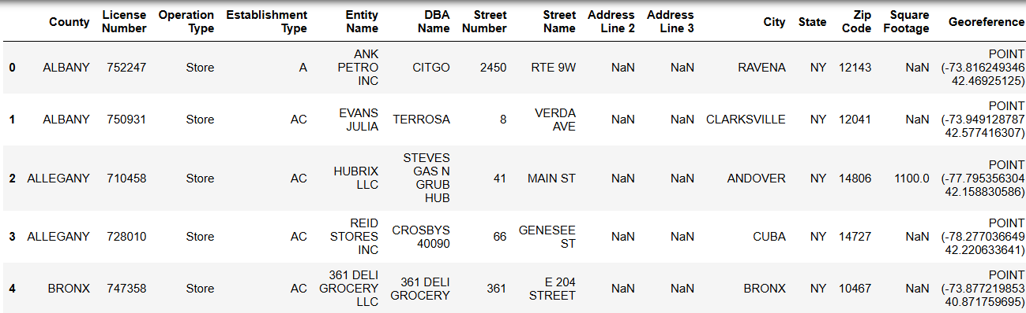

**1.2. Primary Data:**

* **Surveys** [**Survey link**](https://ns9gm2hnnsh.typeform.com/to/rojdXym3)

**I am conducting a survey with 100-150 people from Ireland. The survey focuses on customer experiences and preferences related to loyalty programs. This will help gather insights specific to the Irish market for my research.**

* **Interview**

**I haven't done any interviews yet, but I plan to have 4-5 interviews with managers from retail companies. I'm not sure how to use these interviews in the data analysis part of my thesis. Maybe after conducting the interviews, I can transcribe the conversations and look for common themes or patterns**

**2. Data Preprocessing**

**3. Neural Network Model Development**

**4. Model Training and Testing**

**5. Evaluation Metrics**

**6. Model Validation and Fine-Tuning**