[EXAMINE NEURAL NETWORK APPROACHES FOR UNIFIED MEMBERSHIP INTEGRATION IN DIVERSE APPLICATIONS]

[Your Name]

A Thesis Submitted in Partial Fulfilment of the requirements for the

Degree of

Master of Science in Data Analytics



August 2022

Supervisor: [Enter Supervisor’s N

**EXAMINE NEURAL NETWORK APPROACHES FOR UNIFIED MEMBERSHIP INTEGRATION IN DIVERSE APPLICATIONS**

**ABSTRACT**

This research integrates neural networks across different applications into unified membership systems, particularly in the retail industry. The study seeks to address challenges in data fragmentation, privacy, and scalability by propounding machine learning models, such as XGBoost and neural networks, in predicting customer behavior and unifying loyalty programs. A mixed-method approach was taken by using transactional data with survey insights. Findings suggest that XGBoost performs better than neural networks in predictive accuracy but neural networks allow for adaptability to more complex data sets. This paper contributes to both the scholarly literature and practice by providing an outline of how businesses may leverage datadriven strategies for improving customer engagement and satisfaction. Some limitations include increased computational resources and domain specificity. Future work will likely include neural network architecture optimization and further extension of these results to other industries.

***[Keywords*-**Neural Networks**,** XGBoost**,** Unified Membership Systems**,** Customer Behavior

Prediction**,** Loyalty Program Integration**,** Machine Learning]

**ACKNOWLEDGEMENT**

The work “would not have been possible” without the contribution of (project teacher name) of the university (insert college/university name). I am indebted to (insert other teachers who have some contribution) who have offered continuous support while preparing the project. I am also grateful to all those "with whom" I had the opportunity to do the work and complete the project. 'Each member" of the "dissertation committee" have offered and provided' "professional guidance" and have given me great advice while completing the project. On a personal note, I am also grateful to my family members who have offered me continuous support while I was completing the project. Without the help and support of them, this project would not have been completed.

**List of Acronyms**

|  |  |
| --- | --- |
| Acronym | Meaning |
| AI | Artificial Intelligence |
| CNN | Convolutional Neural Network |
| DL | Deep Learning |
| EDA | Exploratory Data Analysis |
| MAE | Mean Absolute Error |
| ML | Machine Learning |
| MSE | Mean Squared Error |
| NLP | Natural Language Processing |
| RNN | Recurrent Neural Network |
| RMSE | Root Mean Squared Error |
| SME | Small and Medium-sized Enterprises |

**TABLE OF CONTENTS**

Chapter 1: Introduction ................................................................................................................. 10

1.1 Background Information ..................................................................................................... 10

1.2 Key Findings in Literature .................................................................................................. 10

1.3 Need for Further Investigation ............................................................................................ 11

1.4 Research Questions ............................................................................................................. 11

1.5 Aim of the Study ................................................................................................................. 11

1.6 Objectives ........................................................................................................................... 12

1.7 Scope of the Study .............................................................................................................. 12

1.8 Limitations .......................................................................................................................... 12

1.9 Definition of Key Terms ..................................................................................................... 13

1.10 Chapter Outline ................................................................................................................. 14

1.11 Significance of the Study .................................................................................................. 15

Chapter 2: Literature Review ........................................................................................................ 15

2.1 Introduction ......................................................................................................................... 15

2.2 Empirical Study .................................................................................................................. 16

2.3 Theories and Models ........................................................................................................... 22

2.4 Literature Gap ..................................................................................................................... 25

2.5 Conceptual Framework ....................................................................................................... 27

2.6 Conclusion .......................................................................................................................... 27

Chapter 3: Methodology ............................................................................................................... 27

3.1 Introduction ......................................................................................................................... 27

3.2 Method Outline ................................................................................................................... 28

3.3 Research Philosophy ........................................................................................................... 28

3.4 Research Approach ............................................................................................................. 28

3.5 Research Design.................................................................................................................. 29

3.6 Research Method ................................................................................................................ 29

3.7 Data Collection Method ...................................................................................................... 29

3.8 Data Preprocessing and Feature Engineering ..................................................................... 30

3.9 Model Development............................................................................................................ 30

3.10 Research Ethics ................................................................................................................. 31

3.11 Research Limitations ........................................................................................................ 31

3.12 Conclusion ........................................................................................................................ 32

Chapter 4: Findings and Analysis ................................................................................................. 33

4.1 Introduction ......................................................................................................................... 33

4.2 Analysis............................................................................................................................... 33

4.2.1 Overview of Model Performance ................................................................................. 33

4.2.2 Descriptive Statistics of Predictions ............................................................................ 37

4.2.3 Evaluation of Model Predictions ................................................................................. 39

4.3 Conclusion .......................................................................................................................... 40

Chapter 5 Discussion of Findings ................................................................................................. 41

5.1 Introduction ......................................................................................................................... 41

5.2 XGBoost vs. Neural Network: A Comparative Discussion ................................................ 42

5.3 Potential Improvements for the Neural Network ................................................................ 46

5.4 Implications of Findings ..................................................................................................... 47

5.5 Conclusion .......................................................................................................................... 50

Chapter 6: Conclusions ................................................................................................................. 50

6.1 Introduction ......................................................................................................................... 50

6.2 Linking with Objectives ...................................................................................................... 51

6.3 Recommendations ............................................................................................................... 52

6.4 Conclusion .......................................................................................................................... 53

Reference List ............................................................................................................................... 55 9

**LIST OF FIGURES**

Figure 1: Path coefficient of the model ......................................................................................... 17

Figure 2: A general framework for CNN-based community detection ........................................ 19

Figure 3: Conceptual framework .................................................................................................. 27

Figure 4: Model Evaluation Results ............................................................................................. 34

Figure 5: Model Evaluation Results of XGBoost and neural network ......................................... 35

Figure 6: Basic Statistics ............................................................................................................... 37

Figure 7: Correlation Matrix of Survey Data ................................................................................ 40

Figure 8: XGBoost Feature importance ........................................................................................ 42

Figure 9: Scatter Plot for XGBoost Predictions ............................................................................ 43

Figure 10: Scatter Plot for Neural Networks Predictions ............................................................. 44

Figure 11: Training and validation graph ..................................................................................... 45

Figure 12: Bar graph of Feature Importance ................................................................................. 48

Figure 13: Graph of Model Loss and MAE .................................................................................. 49 10

**Chapter 1: Introduction**

**1.1 Background Information**

Every business requires customer loyalty to ensure repeated buying habits and good working brand relationship. This turns into positive customer programs, rewards and privileges hence encouraging customers’ interaction and loyalty. However, there is a crucial limitation, and they are data fragmentation. Since customers subscribe to many programs by different brands and retailers, organizations are able to compile a single profile of customer needs and activities. This situation complicates their task of providing tailored services which in the highly competitive environment has become crucial. To resolve this problem, a primary objective of several enterprises is the integration of fragmented loyalty schemes into one networked solution. The mentioned type of system can collect customers’ data and help businesses work on behavioral analysis and suitable rewards. However, it contains striking technical complexities that are associated with data quality issues, different data structures, data privacy aspects, and many more. To these complexities, neural networks or a subfield of machine learning has potential solutions. Because they possess powerful computing abilities and can recognize elaborated patterns, they can also be applied to combine multiple data types and estimate future buyers’ actions. By applying neural networks, companies can observe the genuine time customer preferences, and create a sophisticated membership that implies efficient customer experiences.

**1.2 Key Findings in Literature**

Previous literature reviews show that neural networks have significant potential in many areas yet have not been used significantly in analyzing customer behavior, predicting customer churn, and forecasting customer purchases. For instance, first, a comparison was made between Recurrent Neural Networks (RNNs) and Deep Learning techniques, which was followed by a demonstration that extant statistical approaches are inefficient in analyzing time-series data, detecting intricate patterns, and achieving increased levels of prediction accuracy as well (Samek *et al*., 2021). Nevertheless, few academic works have been focused on using neural networks for the purpose of consolidating and handling massive unified membership systems. Existing works tend to explore aspects of neural networks that provide prediction of the customers’ actions in general or improve the functioning of the loyalty program whereas the critical issues of data consolidation that have to be conducted on the central level are excluded. This research therefore raises a gap for more research studies that aims to develop single and integrated systems using neural networks.

**1.3 Need for Further Investigation**

The complexity of the customer behavior and the need for individual approach to the client require new approaches to loyalty program administration. Organizations need tools that would also combine membership information with those that are more flexible owing to the constantly changing customers’ demands (Almarzouqi *et al*., 2022). Such capabilities can be met by the neural networks which are highly flexible and scalable but the use of the same in context of integrated membership systems is relatively unchartered (Su *et al*., 2022). Other considerations like data compatibility, handling big data, data protection complicate the need for good frameworks. Furthermore, there are no clear guidelines on how to apply neural-network based systems in loyalty programs, and this gap provides scope for research to fill the gaps.

**1.4 Research Questions**

This study seeks to address the following research questions:

1. How can machine learning models like XGBoost and neural networks enhance customer value prediction and engagement in loyalty programs?
2. What are the challenges associated with integrating membership systems using machine learning models such as XGBoost and neural networks?
3. How can businesses leverage unified systems to improve customer satisfaction and loyalty, with the help of XGBoost and neural network models?

**1.5 Aim of the Study**

The main purpose of this study is to propose a machine learning approach, including, but not limited to, neural networks, to forecast customer value and merge loyalty program data across channels. In addressing the existing systems’ drawbacks, this study seeks to give valuable information concerning customer communications’ improvement with regard to engagement, satisfaction, and retention.

**1.6 Objectives**

The objectives of this study are:

* To evaluate the effectiveness of neural networks in predicting customer behavior and value.
* To identify and address the technical challenges in integrating membership systems.
* To develop and test a unified framework that combines transactional and survey data for customer segmentation and analysis.
* To provide recommendations for implementing neural network-based solutions in loyalty programs.

**1.7 Scope of the Study**

Specifically, the issues of customer value prediction and the integration of a membership system are the main concerns of this research, which apply machine learning especially neural networks (Borisyuk *et al*., 2024). Preprocessing includes handling of missing records, data cleaning and normalization, feature extractions, splitting of data into training, testing and validation, and model building using structured transactions data and survey results (Jin *et al*., 2023). Despite the emphasis on technical frameworks and predictive modeling, scope is more restricted in terms of covering only the retail transactions and data captured in survey format for a particular period of time only.

**1.8 Limitations**

The study faced some drawbacks that affected the extent of generalization of the results obtained in the study. Firstly, based on the quality data used it was possible to achieve high reliability of the predictive models. Many types of transactional data obtained from various sources encompass problems like the absence of customer identification, inconsistencies and dissimilarities in the records, and different formats which needed prior pre-processing (Dong *et al*., 2024). However, due to these inabilities, optimizations in the data played a somehow negative role in tuning the architectures of the models like XGBoost and the neural networks so that the results’ and insights’ accuracies were distorted. Secondly, the number and type of stores selected for the study restrict its credibility to retail transactions alone. The outcome may not be easily feasible in some sectors like the finance or the health sector due to different patterns of customer behaviour than is common in the retail sector (Liu *et al*., 2021). Furthermore, the growth in terms of computational model, for example XGBoost and neural network are also a problem, for companies which finanicially are not strong. When training these models especially during hyperparameter tuning, one needs large computational resources, which many organizations may find hard to come by. Still, the practicability is probably limited due to its scalability when the number data grows or the model becomes more complex. Large datasets and complex systems may need more resources these resources can be problematic for a business organization with weak computational power (Mahmud *et al*., 2020). Finally, working with XGBoost and neural networks one can achieve very high predictive accuracy but at the same time both methods fit the model to data with high variability and may bring about overfitting when faced with a small noisy dataset, this feature however can be tuned. These limitations should however be taken into consideration when doing further analysis of the results or when using the models in other contexts or on different industries.

**1.9 Definition of Key Terms**

The purpose of providing a clear understanding of the concepts which are important in this study, this section presents the following definitions. Customer Value Prediction means using data from customer and transaction history and possibly behavioral analysis to forecast the monetary value of a particular customer. This predictive measure assists the companies in defining its parameters in marketing to users that are most valuable to it. A Unified Membership System is a system that integrates data from different brands that a customer has been interacting with in a single platform to enhance the ease of running membership accounts for the business while at the same time ensuring the business gets an overall view of the customers’ behaviors via their commercial exploits (Jin *et al*., 2021). Neural Networks, which belong to a larger category of machine learning are models trying to mimic the structure and functionality of the human brain in handling and approximating different data patterns. Due to their characteristics of coping with nonlinearity, these systems are suitable for aggregating and analyzing huge and multifaceted data. RFM Analysis is one of the frequent approaches to estimating customer value based on Recency, the date of the last purchase, Frequency how often the customer bought, and monetary total amount of money. Out of all the buying pat- tern based techniques this one stands out because it enables business organizations to group customers based on their behaviours when making the purchase. Finally, Artificial Intelligence Machine Learning is a field of computer science which makes systems learn patterns on its own without being programmed to do so. In a broad range of industries, using machine learning to automate the process of data driven insights improves decision making.

**1.10 Chapter Outline**

It is also important to note that the structure of this report follows the objectives and information gathering of the study explored. Chapter 1: Background of the study outlines the scope of the study, the research questions, aims, objectives and motivation for undertaking the research. It also states the limitations to the research and defines what the various terms mean for the benefit of the readers. This chapter ends by explaining the format of the report. Chapter 2: Literature Review explores customer loyalty programs, the use of neural networks, and memberships. It also reviews previous research, notes the absence of knowledge in the existing literature and defines the possibility of neural networks in changing the approach to loyalty program integration, giving the necessary theoretical background for the work. Chapter 3: The method section dwells on the research approach adopted, the data pre-processing step, feature engineering, and the exercise in predictive modeling employing the XGBoost and Neural Networks. It also informs the reader about the way in which the author combined the results of transactional and survey data in order to meet the objectives of the study. Chapter 4: Results and Discussion outlines findings of the study, assesses effectiveness of the developed predictive models, and delves into the implications for customer behaviour understanding and loyalty program improvement. Finally, Chapter 5: Conclusion and Recommendations presents the findings of the study, analyses the usefulness of the study, and offers conclusions, recommendations for further research and practical use, making for a strong conclusion of the report.

**1.11 Significance of the Study**

In view of this, this study looks at the importance of integrated memberships in retail industry and aims at proposing neural networks based solutions. The research’s objective simply put is to improve customer interaction, and satisfaction and loyalty levels by analysing previously dispersed loyalty programme data using sophisticated methods of prediction. It has also highlighted others such as data integration challenge and scalability and provide implementation frameworks that most businesses can adopt. In addition to its applicability on the case, the work enriches the academic database by extending the literature on Neural Networks, especially on the new knowledge of the customers. This blended focus is important to achieve both consequential theoretical relevance for retail organizations and practical significance for practice.

**Chapter 2: Literature Review**

**2.1 Introduction**

Understanding the use and usefulness of the concept of machine learning for customer churn prediction which is a phenomenon that major fields including telecoms, finance, and online gaming are witnessing. Customer retention is cheaper than customer acquisition, therefore, churn prediction is vital to business expansion. It is an insight to how complex models such as XGBoost perform and why profit-based metrics are important. EMR systems have become very important in the current world since they have numerous benefits hence the need to adopt them in the delivery of health care services in that they bring efficiency in the delivery of health care services, they improve the patients’ health and there is effective communication among the health care givers. Since healthcare organizations are increasing their exploration of options to go digital there has been a lot of focus placed on understanding factors that affect the use of EMR systems. To this end, the purpose of the current literature review is to examine the recent literature about the factors affecting the adoption of EMR and learn from empirical research works that validate these models including but not limited to UTAUT, TAM, and external factors such as trust, anxiety, and selfefficacy affecting decision of the healthcare profession to adopt such technologies. More importantly, it introduces Artificial Neural Networks (ANN) and Partial Least Squares Structural Equation Modeling (PLS-SEM) as ways that carry additional decision-making and exploratory insights about the adoption behaviour. Consequently, such results hold critical significance to the healthcare decision-maker, particularly in regards to regions like the UAE which has seen exponential growth in its use of health technology.

**2.2 Empirical Study**

**According to the authors (Manzoor *et al.*2024)**, customer churn forecasting is critical for organisations operating in the fiercely competitive sectors such as telecommunications and finance. Customer retention is less expensive as compared to customer acquisition and hence, churn prediction must be precise for consistent business expansion. It looks through 212 articles from 2015 to 2023 and discusses the machine learning methods for customer churn prediction only. It highlights that including varied aspects for reimbursement estimation like demographical, behavioural, as well as social interactions’ data, improves the model’s reliability. One recommendation that can be derived is to actually adopt profit based evaluation metrics since it correlates the results with the goals and objectives of business enterprises, a research gap that has not been adequately discussed. The authors also emphasise on the performance of ensembled models specifically XGBoost in churn prediction. XGBoost in general perform better than the traditional models such as decision trees and Logistic Regression because of the ability in the handling of datasets and absence of over-fitting through boosting. The analysis has revealed that XGBoost provides higher levels of accuracy when it comes to giving predictions and works by correcting the mistakes of other less sophisticated models step by step that is why this tool is popular in almost every industry. Deep learning methods, have great predictive power but yield the problem of being difficult to explain. To this effect, they are in support of explainable AI model like the SHAP (SHapley Additive exPlanations) to enable better decision making. The final research implications advise that business practitioners integrate the modern models such as XGBoost and ensure the use of explainability to enhance customer retention and profitability.

**According to the author (Almarzouqi *et al* 2022)**, Adoption of EMR systems in modern healthcare settings is becoming increasingly important and beneficial for both healthcare providers and patients. EMRs are important in promoting the interconnectivity of healthcare services and the overall quality of care. By integrating EMRs with DSS, the decision making capacity of the healthcare providers gets improved so that favorable results for patients are achieved (Rane et al 17

2023). This shift has also eased many issues like data disintegration, illegibility, and the incomplete records which have been inherent when working with prior methods and have interfered with better patient care and their Reporting. The present research is specific to the implementation of EMR systems in the health care industry in the United Arab Emirates. It examines many predictors that predict and describe EMR system adoption by employing a compound research framework combining UTAUT and TAM (Joshi et al., 2021). These two models are each generally applied in technology acceptance research. Although, UTAUT maps how various factors including performance expectancy, effort expectancy and social influence influence the way technology is adopted, TAM is mostly centered on perceived usefulness and perceived ease of use.

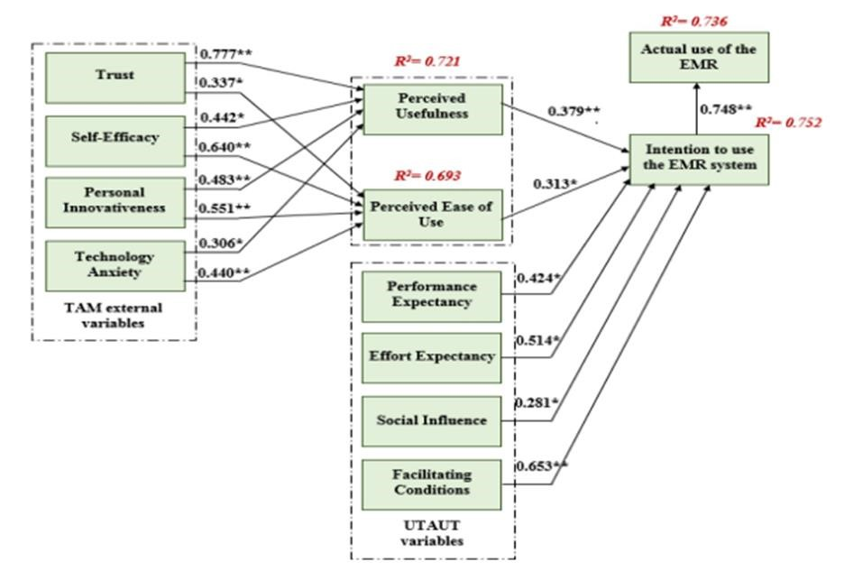

**Figure 1: Path coefficient of the model**

(Source: Almarzouqi *et al* 2022)

The purpose of this research is to identify the external factors that affect the adoption of EMRs in the UAE, this includes variables such as trust, innovativeness, self efficacy and anxiety. The extant literature shows a strong tendency to underestimate the relevance of external factors for the adoption of EMRs and focuses on some usability and data security issues. The strongest predictor of actual use of EMR systems is the intention to use them. This is as expected, as per the TAM framework, in which the perceived usefulness and ease of use of the technology directly influence their behavioral intention (Delgado, 2023). Furthermore, the study results indicate that TAM constructs are influenced significantly by such external factors as anxiety, trust, self-efficacy, and innovativeness. For instance, they are prone to adopt technology if they believe that the system's security and reliability (trust), as well as self-efficacy, their confidence in their ability to use the EMR systems, are strong (Kotsokechagia, 2023). One barrier to technology adoption in the healthcare industry can revolve around emotions about using new technology especially to those health care professionals that wouldn’t be very familiar with digital tools. The study also provides a focus for incorporating the practical implications with regards to health care decision makers in the UAE. EMR adoption, the factors behind adoption and use of them as tools to formulate good strategies and policies can be identified. As is evident, pertinent security considerations, enough training to build self-efficacy and to create the culture of trust and innovation will ensure positive implementation of the EMR (Sharma, 2020). The paper provides a significant contribution to the extant literature on EMR adoption by integrating TAM and UTAUT with external factors of trust, anxiety and innovativeness leading to a comprehensive framework which is used in this paper. Besides examination and study of EMR adoption in the healthcare industry, this data analysis application of ANN and PLS-SEM is a novel approach for understanding the determinants of EMR adoption (Mirabdolbaghi and Amiri, 2022). By identifying the factors that influence healthcare professionals' acceptance of EMRs, this research can help policymakers in the UAE and other regions make informed decisions to improve healthcare delivery through technology.

**According to the author (Su *et al* 2022)** conducting a comprehensive survey on recent advances in community detection using deep learning techniques. In network analysis, the scope of community detection is identifying subgroups or communities within the network where members are more closely related to each other than to members of other communities (Geiler, 2022). The research progresses significantly from social networks to biological systems because it helps uncover hidden structures, interactions, and relationships which might otherwise go unnoticed.

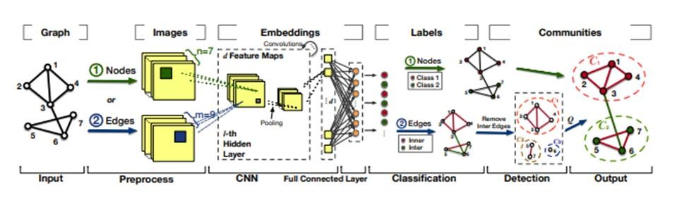

**Figure 2: A general framework for CNN-based community detection**

(Source: Su *et al* 2022)

Traditionally, the methods used for community detection were spectral clustering and statistical inference that were mainly based on network topologies and limited features of the network. However, such methods were often bound by their inability to deal with complex, highdimensional data and the expensive computational costs. These are mitigated challenges that have surfaced with the emergence of deep learning in modeling large, high-dimensional networks that express complex, non-linear relationships. In this scenario, deep learning methods could learn very rich network embeddings that could preserve intricate structures and, therefore, could improve community detection accuracy significantly, and even make the process more efficient (Paliwal et al., 2024). The present paper propounds a new taxonomy of the state-of-the-art deep learningbased models and can be broadly categorized into six major approaches: convolutional networks, graph attention networks, generative adversarial networks, autoencoders, deep nonnegative matrix factorization, and deep sparse filtering. While convolutional networks outstrip the others in terms of extracting latent features by use of convolutions, the GAT focuses specifically on the assignment of special attention towards community signals in the network. GANs apply adversarial training to distinguish between real and fake community structures, while autoencoders are versatile models that include subcategories like stacked autoencoders, sparse autoencoders, denoising autoencoders, and graph-based autoencoders (Vo et al., 2021). DNMF and DSF models are less commonly used but are included for their ability to extract relevant features and representations for community detection. The authors stress that community detection is gaining greater importance in diverse applications. For example, in social networks, community detection will enable platform sponsors to reach targeted groups of users efficiently. In citation networks, it 20

identifies research trends and inter-related topics, while in biological networks, such as metabolic or PPI networks, functional relationships between biological entities are revealed (Salminen et al., 2022). The paper also elaborates on the role of community detection in dynamic networks in which the structure of a network evolves over time as well as in overlapping community structures where a node may be connected to multiple communities. The paper also reviews the most popular benchmark datasets, evaluation metrics, and open-source implementations. It thus provides practical resources for researchers and practitioners to experiment with community detection models. Such resources are essential for the development and testing of new algorithms. In addition, the authors talk about real-world applications: predicting the spread of rumors or viruses, understanding tumor evolution, and analyzing brain networks (ANALYZES et al., 2022). The authors note several challenges and open research opportunities, despite the remarkable progress made in applying deep learning to community detection. These include the need for models that can handle increasingly complex and dynamic networks, as well as methods that can effectively deal with issues like sparsity and scalability.

**According to the author (Liu *et al* 2021)** first and foremost, this aims to use a resilient setmembership estimator (RSME) that is robust against different types of uncertainties such as unknown-but-bounded noises (UBBNs) and gain variations, constraining the errors within specified ellipsoidal bounds (Geiler et al., 2022). This paper proposes the use of WTODP to optimize communication on networks and avoid congestion between data being transmitted from DMNN and the state estimator. Memristive neural networks, in fact, have attracted considerable attention because of their possible applications in fields such as pattern recognition and image processing. The networks are distinguished by the state-dependent nature of the connection weights that introduces more complex dynamical behaviors compared to the traditional recurrent neural networks (Gregoriades et al., 2023). Although the majority of the literature is devoted to continuous-time MNNs, the discrete-time versions have received relatively little attention, despite the fact that these are crucial in engineering applications, because of the increasing prevalence of digital systems. State estimation for DMNNs is challenging because of the state-dependent switching behaviors inherent to these systems and the need to handle delays in both discrete and distributed forms. The paper also details some of the practical difficulties imposed by limited communication resources in actual MNN implementations. Due to the fact that data transmission in general causes congestion, in larger systems, the WTODP protocol is proposed to manage congestion in the network, whereby the protocol dynamically schedules the data transmissions to help prioritize the most important data and discard less-important data to reduce the network communication load. This is especially critical in systems where the volume of output data from the neural network is high and may lead to congestion or delays in transmission. The authors claim that integrating WTODP with set-membership estimation can effectively handle communication challenges while keeping the integrity of state estimation.

One of the problems inherent in state estimation lies with the possibility of varying the estimator gains because of reasons like round-off errors, instrument finiteness of resolutions and analog-todigital conversions. Although such changes might be small, these make estimator performance degrade and jeopardize quality in state estimation. An article has thus provided with resilient design for the state estimator by using less sensitive to changes brought about by variations of estimator gains. This principle consists in developing an estimator that, with a set-membership approach, would be capable of working despite changes in the filter gain, but where the estimation error is constrained to lie within ellipsoidal regions. The approach is based on recursive matrix inequalities (RMIs) for finding sufficient conditions for the existence of the resilient state estimator. The RMIs are solved using standard numerical optimization tools. It will provide the design of the estimator systematically. The authors provide an example which shows that their approach allows for the reliable treatment of real world situations, including gain variations, hybrid time delays, and communication constraints (Ozay et al., 2024). The three primary contributions are as follows:

1. To address the difficulties that arise from gain variations for state estimation of DMNNs, developing a resilient set-membership estimator.
2. Motivated by complications arising from time delays, state dependent behaviors, communication difficulties and estimator gain variations, a unified estimation approach is proposed so as to counter them.
3. These result in sufficient conditions for existent of the estimator which can be obtained through recursive inequalities and optimization is given to solve them. Results are validated using numerical simulation results, demonstrating that the method is practical and effective in real world situations.

**2.3 Theories and Models**

The current theories and models in customer churn prediction are discussed with emphasis on the use of machine learning. Some of the important models are Logistic regression, Decision tree and different categories of ensemble methods such as XGBoost which has resulted to be one of the best methods when working with large data sets. The information and feature prediction capability of deep learning models including Recurrent Neural Network (RNN) and Convolution Neural Network (CNN) but with the need for explainability improvement. The study does recommend the use of both traditional models and profit based metrics for evaluation so that the predictions made will be towards meeting business goals. Similarly, the applications of explainable AI like frameworks such as SHAP are advised for re-establishing trust and providing more meaningful decision support in churn management. There is an extensive use of theoretical models to explain adoption of such systems some of the well-known models include the Technology Acceptance Model (TAM) and the Unified Theory of Acceptance and Use of Technology (UTAUT). One of the most influential theories that exist in the field today is the Technology Acceptance Model (TAM) has seen the perceived ease of use and perceived usefulness impact the intention level of a user to accept a new technology. With respect to the case of EMR, the organisations are likely to continue with it if they feel that it is easy to use and if the gains to be achieved from it are visible in terms of the outcomes of the client’s health or the organisational performance (Abdelghani, 2024). Unlike the previous model used which involves largely the view of the user, this model helps in explaining why health care professionals will adapt to EMR systems. On the other hand the Unified Theory of Acceptance and Use of Technology (UTAUT) expands on TAM by considering more factors such as performance expectancy, effort expectancy, social influence and the facilitating condition. These factors take into account not only the interpersonal factors but also the organizational ones both of which contribute to the views of EMR adoption. Because of the incorporation of features from other similar models, UTAUT provides a more coherent perspective for assessing how various factors that involve organizational environment and external influences affect the adoption of EMRs. Combined, these frameworks provide useful knowledge about the patterns of technology acceptance in health care, and utilizing them would assist organizations and policymakers develop the proper strategies to ensure effective acquisition and application of EMRs.

**XGBoost**: A powerful model that in most cases surpasses baseline machine learning methods in customer churn prediction. The algorithm relies on gradient boosting in order to enhance the predictive ability of the models since it combines many poor models with correction for errors of the previous models. XGBoost works best when applied on big data, containing numerous features and helps control overfitting and that makes it useful in telecommunication and financial sectors. The former can be characterized as offering superior opportunities for scaling and high-speed training and evaluation of models. Nonetheless, incorporating explainability tools such as SHAP can lead to the relative improvement of interpretability and, consequently, result in better decisionmaking and more effective customer retention by businesses.

**Technology Acceptance Model (TAM):** The area of technology adoption is one of the most wellknown and used models is the TAM. According to this model, two things perceived to be easy to use and perceived to be useful are things that influence a user’s decision to accept and use a technology. Perceived effort is the perceived amount of effort to 'use' a particular system. Perceived usefulness stands for the degree to which a person believes using such a system would help him (her) performing better at work. (Al-Basha, 2021). In the context of EMRs, perceived usefulness could be related to how the system can help to streamline patient record management, improve clinical decision-making, and enhance the quality of care. Perceived ease of use would refer to how simple and intuitive the system is for healthcare professionals.

**Unified Theory of Acceptance and Use of Technology (UTAUT)**: The UTAUT was derived from aggregating the aspects of eight distinct models of technology acceptance, amongst which TAM was one such model. According to the model, four primary constructs impact users' intentions to employ the technology. These four constructs include performance expectancy, which is defined as the degree of extent an individual feels that application of the system will have a positive impact on their performance. Effort expectancy is like perceived ease of use it's about the ease with which system use occurs. Social influence considers how peers, colleagues, and organizational norms are driving factors in whether a person would accept technology. Facilitating conditions, on the other hand, refer to physical and technical infrastructure in place for use of the technology that provides access to computers, the internet, and training, for example. Both TAM and UTAUT have been centered on the perception of technology by the individual. However, these models ignore the external factors that can significantly influence the adoption of technology. In recent years, there have been efforts to extend these models by incorporating more external factors such as trust, self-efficacy, anxiety, and innovativeness.

**Trust**: Trust has been found to be one of the critical external factors that affect the adoption of EMR. In health care, privacy and security issues are paramount, and hence trust in the system to safeguard the patient's data is important. If healthcare professionals feel that an EMR system will protect sensitive information, then they are more likely to adopt and use it. Conversely, a lack of trust in the system's security features can deter acceptance. Trust plays an important role in affecting the adoption intention of EMRs among the UAE participants according to (Almarzouqi et al. 2022). Data security assurance and building trust with health care professionals are key importance here.

**Self-Efficacy**: Self-efficacy, that is, an individual's belief about his or her ability to perform the tasks, is another influential factor in the adoption of EMRs. The more that healthcare professionals believe they can succeed in using an EMR system, the more likely they are to adopt it. Enhancing self-efficacy through training and support can improve the prospects of adoption. Effort expectancy is connected with self-efficacy in the UTAUT model as the more users feel confident of their ability to use it, the less likely they are to view the technology as difficult to use.

**Anxiety**: Technology anxiety is one of the significant obstacles for EMR adoption. Healthcare professionals, when they feel uneasy or stressed using the new technologies, do not adopt them. It particularly applies to settings where the workforce may have limited exposure to digital tools or there may be a generational divide regarding technology use. Anxiety was reported as a negative predictor for the adoption of EMR.

**Innovativeness**: It relates to the willingness to adopt new things and apply novel technologies. The willingness to embrace EMR systems increases as the healthcare professionals become more open to change and as the interest in technological innovations becomes higher. There is always resistance to change and therefore as such, this makes innovativeness a very strong factor influencing the adoption of technology in such an environment.

**Artificial Neural Networks (ANN) and Partial Least Squares Structural Equation Modeling (PLS-SEM)**

More recently, advanced techniques of data analysis for understanding the relationships across different adoption factors using artificial neural network (ANN) and partial least squares structural equation modeling (PLS-SEM) have become popular. Finally, the last two methodologies are used to probe more information in complex high dimensional data sets. The use of ANN is particularly appropriate for modeling non linear relationships between variables while PLS-SEM is used to examine direct and indirect relationships in technology acceptance models. They enable more robust and more accurate EMR adoption behavior predictions for healthcare decision makers (Liao et al, 2023). The integration TAM and UTAUT with external factors like trust, self efficacy, and anxiety explain the complete understanding of what drives EMR adoption in health care.

Moreover, it gains further boost from the use of advanced analytical methods, improving one’s power to predict and explain adoption behaviors. Hence, these findings are of utmost value to policy makers and healthcare leaders who aim at enhancing the adoption and the successful implementation of EMR systems.

**2.4 Literature Gap**

Furthermore identifying research gaps on customer churn prediction. Surprisingly, feature selection and model selection get most of the attention, while little consideration is given to the criteria that would reflect the profit in case the model is implemented. Moreover, the absence of efficient algorithms in combining different features from several categories, including demographic data, behavior, and social interactions further reduces the modelling precision rate. Previous approaches to model building sometimes focus on accuracy but often ignore explainability which constrains the models’ usability in the context of managerial decisionmaking. Therefore, using XGBoost together with explainability tools previously mentioned and future developments in explainable AI techniques are highlighted in the study as the way forward in filling the aforementioned gaps and enhancing customer retention efforts. There still are many gaps in literature regarding the adoption of EMRs that need further examination. First, much research work done on EMR adoption has been confined to study only the factors of adoption in a particular context. Generally, it is only studied for a single country or within one healthcare system. Even though there are studies, such as (Almarzouqi et al. 2022), on the adoption factors in the UAE, the cross-cultural perspective of the variations of adoption factors in other regions with specific healthcare systems and technological infrastructure is still lacking. This would be further 26

enhanced by a comparative study across countries, which differ in their health care system and cultural norms, to better understand EMR adoption. The second aspect in which frameworks like TAM and UTAUT have provided important insights into technology adoption yet fail to fully grasp all the complexities of factors that influence EMR adoption is through other external factors such as the workplace culture, support for leadership, and readiness by the institution. Most factors that are necessary for EMR system implementation go unnoticed. Thus, the success of this system is overshadowed by individual-level factors such as perceived usefulness and ease of use. It would be pertinent if the role organizational culture and leadership play in EMR adoption were studied. Another area that needs more attention is the effect of training and support programs on the adoption of EMRs. Although self-efficacy is considered one of the most important factors, the specific role of training programs in enhancing self-efficacy and reducing anxiety is not well explored. Future research should focus on developing and testing training programs tailored to the needs of healthcare professionals, especially those with limited experience with digital tools. Additionally, research could explore the long-term impact of training on sustained usage and adoption. Literature indicates minimal exploration of network effects and social influence in the context of adoption for EMR. UTAUT takes into account social influence however, further research would be required to probe more deeply into the contributions from peer influence, workplace collaboration, and professional networks toward the adoption of EMR systems. Hence, understanding how social networks among health care settings affect EMR adoption could guide on its promotion. There is a need for research into the post-adoption phase of EMR systems, which has the focus on user satisfaction, continuous usage, and the long-term impact on healthcare outcomes (Farman et al., 2024). Most studies tend to concentrate on the adoption stage, while giving little attention to how the users would interact with EMRs over time. Exploring user satisfaction, challenges that come after adoption, and the impact of the system on workflow and patient care will provide crucial insights toward making sure that EMR systems are sustainable and successful.

**2.5 Conceptual Framework**

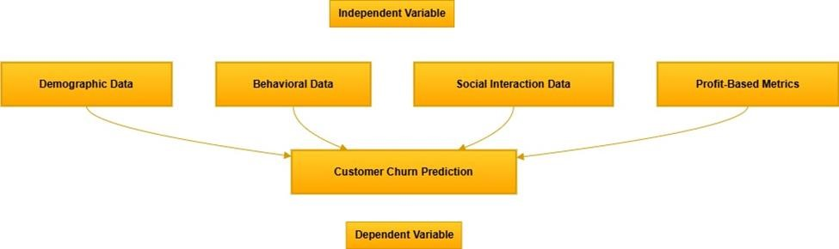

**Figure 3: Conceptual framework**

(Source: Self-created using draw.io)

**2.6 Conclusion**

Sophisticated model such as XG boost and profit-based measure need to be embraced for optimal customer churn prediction. Through blending various features into AI and applying XAI techniques, predicting the performance of business industries as well as helping to make long-term business strategies and increasing customer loyalty and profits are seen in numerous competitive industries. Use of ANN and PLS-SEM advanced data analysis techniques provides an advanced framework for studying the complex relations that drive EMR adoption. By closing these identified gaps within the literature, it would help lead towards better strategies for how to make EMR systems more broadly utilised and sustainable across the healthcare facilities in the world.

**Chapter 3: Methodology**

**3.1 Introduction**

The reliability of any research is greatly determined by the quality of the methods used in that research. Further details of the research design and method used in this study which involves both machine learning and survey analysis for customer value prediction and assessment of the likelihood of customers’ adoption of a unified membership system are detailed in this chapter. Python-based tools are used to put into practice these methods to make the tasks accurate and easily reproducible. This chapter presents a clear understanding of the research philosophy, the approach used and the research methods.

**3.2 Method Outline**

The research follows basic steps of data gathering, data cleaning, data transformation, model construction, model assessment and survey data analysis. All of the project phases employ stateof-the-art machine learning and stats tools integrated into Python packages including pandas, NumPy, scikit-learn, XGBoost, and Optuna. Data from transaction and survey provides a solid platform where a thorough analysis of the customer behaviours and their preferences can be made. Loading and cleaning of the datasets mark the first stages of the data pipeline process. Feature engineering, converts raw data into final and useful, labels such as Recency, Frequency, Monetary (RFM) scores. Customer life time value predictions models are then built in order to estimate customer lifetime value (CLV). As a result of performing clustering techniques for example KMeans, it is easy to segment customers for actionable insights view on customers.

**3.3 Research Philosophy**

The research is based on the positivism research paradigm and supports the idea that knowledge is based on observation and facts. This philosophy is well-suited in the course of the study to estimate the customer value and behaviour and is based on quantitative figures (Adekoya and Aneiba, 2024). Another method of machine learning models is free from the subjective interpretation and presents actual data, thus, following the principles of positivism, which stems from the need for accurate and replicable data proof.

**3.4 Research Approach**

This research follows the deductive research approach where the research hypotheses are developed based on previous theories and models of customer behaviour and the adoption of the loyalty program. These assumptions are generated from the literature and the models are used to test these hypotheses. The deductive approach makes certain that the research is grounded with theory.

**3.5 Research Design**

The study adopts a quantitative and exploratory research approach. Customers are analyzed and segmented using quantitative methods to forecast their behaviors about buying and responding to questionnaires (Zhou *et al.* 2024). The nature of the current study can also be seen from the fact that the clustering analysis aims at identifying hidden characteristics within the data. The split approach increases the robustness of the model since it includes not only precise predictions but also exploratory analysis of customer segments. Due to the work’s focus on the predictive model, the high degree of machine learning is needed, namely XGBoost and deep neural networks, to improve the predictive accuracy in addition to the model’s interpretability.

**3.6 Research Method**

Quantitative method is used to analyze the transactional data while the qualitative method, survey responses are used to gain insights. The numerical data is managed by machine learning models, but the survey data is used to offer another layer of insight into customer preferences and likelihood of adoption (Reddy *et al.* 2024). This integration allows for a deeper understanding of customer performance while incorporating both the frequency and the nature of performance. This mixed method was made possible by the Python ecosystem that leveraged throughout his research (Yang *et al.* 2022). For example, survey data preprocessing consisted of discrete feature encoding and numerical feature scaling in order to make the data compatible with transactional data and integrate it.

**3.7 Data Collection Method**

To cover all aspects of customer behavior and preferences, data collection for the study was designed in two streams. The first stream, transactional data was retail transactions recorded over a period of time. This dataset means it was able to record customer purchases in greater detail including issues like quantity, price and date of purchase. The second type of data was collected through the survey data that was taken from the survey results. The following survey data include basic fields of the customers, their attitude and preference to the newly proposed integrated membership scheme (Nele *et al.* 2024). Special attention was paid to the selection of high quality and topical sets of indicators. Before the actual analysis, the first and second data stream were preprocessed and imported into Python.

**3.8 Data Preprocessing and Feature Engineering**

Cleaning and preparation of the data from the datasets followed rigorous procedures so that the final data was raw and suitable for analysis. The first step involved dealing with missing values and duplicate records as well as outliers which may distort the outcome. Some of the preprocessing steps performed include data cleaning where rows with missing or invalid customer ID where deleted. Both quantitative features were next standardized using scikit-learn’s StandardScaler, bringing all numerical typed features to the same measurement scale, which is crucial for many machine learning models (Neelakandan *et al.* 2023). Feature engineering was critical throughout because of the improved predictive capabilities of the given dataset. New variables were introduced to reflect other important characteristics of customer behavior. For instance, the Total_Amount feature was derived through simple arithmetic of multiplying price and quantity giving an actual metric of customers’ expenditure. RFM scores with recency, frequency, and monetary values were obtained for capturing the behavior of the customers since the model needed more clarity regarding the customers’ engagement. Time characteristics including the purchase day of the week, month, and time were derived to capture temporal patterns regarding customer behavior. All these engineered features greatly helped the model to predict the actions of a customer more aptly enhancing the performance of all the machine learning model.

**3.9 Model Development**

The study used two main predictive methods which include XGBoost and an artificial neural network. Among the classification algorithms, XGBoost, a gradient-boosting algorithm, was chosen because of higher predictive performance and interpretation of the results using feature importance for the structure data (Peng and Unluer, 2024). To further improve the efficiency of this model, hyperparameter tuning by Optuna was performed to increase the accuracy with the right selection of parameters such as max_depth, learning_rate, and n_estimators. This tuning process also made it possible for the model to attain the best balanced accuracy at the validation dataset. However, a neural network was also created to model more complex linear relationships in the data set. Training stopping criteria were used to stop the training process when the validation loss was not minimizing any longer, in order to save on unnecessary epochs of training. As for the performance of models, several baseline models including RMSE and MAE predicted the model accuracy in detail, and the R2 measure quantified the variance of each model. The results of the study were also supported by simple visual confirmation such as scatter plots of the actual vs. the predicted values from the models.

**3.10 Research Ethics**

In the Research process, ethical issues were accorded paramount significance especially when dealing with customers’ information. In order to avoid compromising privacy and adhere to ethical norms some important steps were taken throughout the process of research. The first measure was data anonymization, which entailed either the stripping or partial concealment of identity information (Arunachalam and Kumareshan, 2024). This approach was important in reducing the danger of giving personal information which can be leaked or misused. First of all, the ethical consideration of informed consent was a part of the study. Every respondent in the survey was adequately informed of the objectives of the study, collection of their information and its usage. Such clarity made it possible for participants to volunteer and provide their consent willingly knowing the fact they had the right to pull out from the study at any one time. One was on the data security aspect which was deemed to be very critical. Safeguard measures to contain the collected data were adopted so as to prevent it from been accessed or hacked by third parties.

**3.11 Research Limitations**

This research faced some challenges that affected the general conduct of the research study. Data quality was one of the main issues raised, which meant that inconsistent entries were made either during the analysis or towards the beginning of the project, thus skewing the results in some way. Moreover, the generalization ability of the developed models was quite restricted as these were developed specifically for the current dataset which hamper its use in other domain or other scenarios (El-Shorbagy *et al.* 2024). Other limitations included computational capacity since the manner in which the models were optimized, especially through hyperparameters, was limited by available computational resources.

**3.12 Conclusion**

This chapter amplified a comprehensive discussion of the method used in the research by especially focusing on the data acquisition, cleaning and preprocessing, feature extraction and transformation, model training, and assessment. It focused the effectiveness of Python’s superb library in terms of processing and manipulation of raw data into valuable information. Data preprocessing and data cleaning which helped in removing the irrelevant data, and this helped in producing accurate results Feature engineering also improved the feature set in the given data set and improved the variables reflecting the customer behaviors and preferences. Using data from transactional databases and survey, the approach facilitated closing the gap between the quantitative and qualitative perspectives. Customers and their adoption likelihood of a product were predicted using machine learning models like XGBoost and neural network. The study went a step further to fine tune the hyperparameters and test the accuracy of the developed models.

Safety of participants’ data privacy and their consent was respected thus following the best practices in data protection.

**Chapter 4: Findings and Analysis**

**4.1 Introduction**

In this chapter, the users provide a discussion of the result and evaluation of the proposed XGBoost and Neural Network models for outcome predictions on the given dataset. The first goal is to determine which model yields more accurate and more reliable forecasts. The initial and the real models have been trained with a large number of features as seen in the feature list and predictions have been made for the training as well as the testing data to justify the future applicability of these models. To comprehensively evaluate the models, several standard regression metrics were utilized: Mean squared error, the root of mean squared error, the mean absolute deviation and coefficient of variance of determination. These statistics are quite helpful for understanding how well each of the models describes the curve and how accurate the prediction is with different set of values. The analysis is then concentrated on how these predictions shall help in evaluating the performance of both models, given by the actual results. In this chapter, user will be comparing XGBoost and Neural Network models using these evaluation metrics in detail. Further, user will explain these results and stress the features of each models, which contain the advantages and the possible short comings (Dhilleswararao *et al*. 2022). The aim is to try to provide more insights on which model is more suited to the given context and where it can be fine tuned. Lastly, this Chapter intends to help in choosing models for forthcoming tasks and decision-making regarding some changes that might be made to increase the predictive reliability and efficiency.

**4.2 Analysis**

**4.2.1 Overview of Model Performance**

The models XGBoost and Neural Network were evaluated using multiple regression metrics: MSE, RMSE, MAE, and R². The use of these metrics is very important when deciding the measure of accuracy of the used models. The evaluation metrics for both models are presented in the following table:

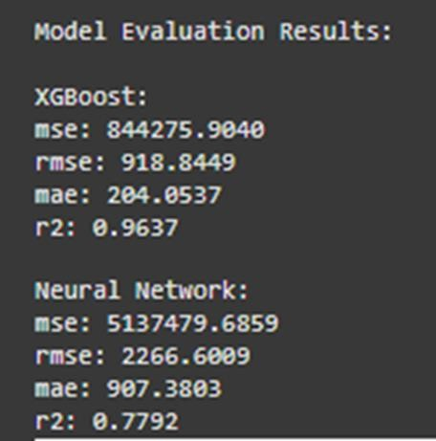

**Figure 4: Model Evaluation Results**

(Source: Self-Created)

**MSE (Mean Squared Error):** Mean Squared Error (MSE) counts for averages of the squared difference of the actual values and predicted values. The lower MSE is therefore favourable when in this case it implies that the model has made close estimations to the actual values. In this context the XGBoost model gave an MSE of 844275.9040 while the Neural Network model gave an MSE of 5137479.6859. The evidence of the lower MSE of XGBoost shows that this model was able to provide better estimates of the squared deviations (Wang *et al.* 2021). This actually demonstrates how XGBoost is slightly more efficient in minimizing the prediction error for this specific problem. When making the model error sensitive XGBoost also pulled down the general prediction error level through methods such as hyperparameter tuning than the Neural Network model.

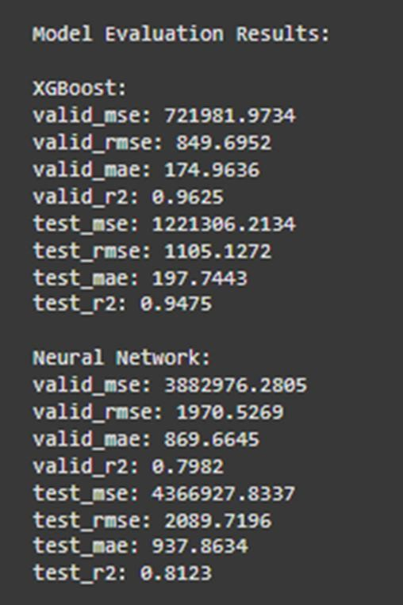

**Figure 5: Model Evaluation Results of XGBoost and neural network**

(Source: Self-Created)

**RMSE (Root Mean Squared Error):** Root Mean Squared Error (RMSE) is the square root to the MSE and is more easily interpreted as it is the same unit as the target variable. In this case XGBoost estimated values with RMSE 1105.13 whereas the Neural Network’s estimated values were with RMSE of 2089.72. An RMSE value of XGBoost is small than Random forest, which depicts that XGBoost make accurate predictions in comparison to actual values (Mridha *et al.* 2023). The high level of RMSE in the control group is also underlined by the fact that this difference is even significantly higher than in the previous comparison 18.1 points, which confirms the efficiency of XGBoost in terms of minimizing the errors in results (Azghadi *et al.* 2020). RMSE is very helpful to identify large errors and hence, when comparing with Neural Network the higher RMSE indicates that this model had larger prediction errors. Consequently, a comparison of the RMSE made on this data shows the superiority of XGBoost in making accurate predictions.

**MAE (Mean Absolute Error):** MAE gives the average of absolute differences between actual and predicted values and hence gives straightforward interpretation of accuracy of the model. The XGBoost model had an MAE of 197.74 and was far better than the Neural Network that had an MAE of 937.86. This strong evidence shows that compared to the true values, XGBoost gave a closer range of error estimates, which also means that XGBoost was closer to giving the right answer all the time than the neural network(Mahmood *et al.* 2024). MAE is extremely useful when there is no need to consider the direction of errors, which allows using it in practice to determine the overall accuracy of the model. The obtained MAE on the test set is 12.03 values confirming that XGBoost is the better model for this analysis in terms of the precision of customer value forecasts.

**R² (R-squared):** Coefficients of determination, commonly known as R-squared (R²), is the ratio of the sum of the squared prediction error to the total sum of the error of the variance of a target variable with a model’s independent variable. The closer the numerical value of an R² is to 1, the better the model will fit. In this comparison, XGBoost classified the customers with R² of 0.9475 indicating it variability of 94.75% of the target variable. On the other hand, the Neural Network had an R² value of 0.8123 which only account for 81.23 percent of variation in the data(Ghahramani *et al.* 2021). The value of R² for XGBoost is higher that means this algorism represents a higher line that means this algorism represents a higher percentage to produce the underlying pattern of the data so our result is good and efficient. This meant that XGBoost had a better model fitting for the data, which implied that the model was well able to discern the input features in order to estimate customer value. Thus, the results confirmed the superior performance of the XGBoost in the aspect of explaining higher variance of the given dataset than that in case of the Neural Network.

Application of K means clustering to the survey data followed by the use of elbow method to determine the optimal number of clusters for a K means clustering algorithm. We start by calculating the sum of squared errors (SSE) for given values of k (i.e. from 1 to 9) by fitting KMeans model to each value of k. A list with the SSE values and then plotted against the number of clusters is a way to visualize the elbow point, typically the ideal number of clusters. Given the plot, user assume that the elbow on the graph is the optimal number of clusters and is 3 in this case. Additionally, KMeans with k=3 is used and is applied to the data and the clustering model is then fit(Gao 2021). These cluster labels are assigned to each data point in the dataset and this cluster assignment is append to the processed survey data under a new "Cluster" column for further analysis. Last, value counts are printed to know how many data points differ in each clusters. This approach would strategically group like observational data together so that spots for patterns, 37

trends, or segments can be agrgreated with in the survey data in which further exploratory data analysis or decision making could be achieved.***[Refer to Appendix 3]***

**4.2.2 Descriptive Statistics of Predictions**

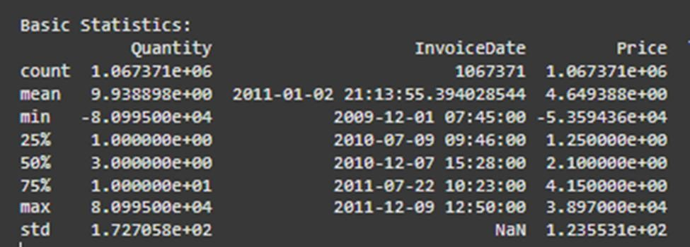

**Figure 6: Basic Statistics**

(Source: Self-Created)

First-order descriptive measures in a given set of data offer a pointer to many fundamental measures that in a way define the given data set. In pandas the describe() function calculates summary of numerical field variables such as count which shows the number of non-null entries and which is useful in identifying NULL values. The mean gives an idea of the general value of the data giving an insight about the center hence the central tendency of the data while std gives an insight to how much scattered the data is from the mean. Descriptive statistics thus give the min and max which indicates the least and most values of the data respectively. The 25th percentile (first quartile), 50th percentile (median), and 75th percentile (third quartile) give a more detailed view of how the data is distributed. These statistics aid in determiningsome anomalies related to the distribution of the data as well as making investigations regarding skewness or gaps in the next phase of investigation or data cleansing and preparation. Collectively, they are a basis of learning about the structure and behaviour of the data prior to engaging in more detailed analytics.

A detailed analysis of the graphs generated in the prediction summary part of the paper is highly beneficial for evaluating the performance of the XGBoost and Neural Network based model by comparing actual values with the values predicted by the model. A profound comprehension of each, or all of the models can be seen from descriptive statistics mean, standard deviation, and the minimum and maximum predictions. Below, user continue these primary measures describing the features of the Daylight Model in comparison with the Lifecycle Model.

**Mean of Predictions:** Average relative magnitude of mean prediction is one of the finest approaches to solve the problem as it consider all the predicted values. As for the two models, the randomly distributed mean of XGBoost was 2,285.31, but the randomly distributed mean of the Neural Network was 2,626.78(Zhu *et al.* 2021). This implies that inasmuch as the Neural Network is the most accurate algorithm with the least RMSE, it generates higher values than the XGBoost model. In this it could be an indication of how each model processes the data, and analyzing the trends learned during the training phase(Dudekula *et al.* 2023). The Neural Network’s higher mean prediction might actually mean that the Neural Network in general is over-estimating the value of customers or that it is more sensitive to outliers or a few high-value predictions in the data set. On the other hand, a lower mean prediction of XGBoost suggests that it might be over-emphasising a more central tendency of data, and does not produce outliers prediction as much.

**Standard Deviation of Predictions:** The standard deviation is a statistical measure used to evaluate how much of dispersion of the prediction is from the mean; the standard deviation gives a clue on the likelihood of the opensurface model variability. In terms of standard deviation, a XGBoost model had a SD of 4,848.70, while SD of a Neural Network model was slightly lower at 4,148.64. This is an implication that standard deviation for XGBoost is higher than that of Neural Network which means that the results given by XGBoost fluctuates than those of the Neural Network(Yang *et al*. 2020). User know from the literature that XGBoost delivers a more significant spread of prediction values, and some of the values may be coupled with extreme increases or decreases from the mean value. On the other hand, slightly lower standard deviation value in the Neural Network case means that this model is also less deviated from the average of the values and therefore its predictions are more consistent. This issue might be attributed to the manner in which the Neural Network was designed in that it reduces large variations in the results it makes; however, XGBoost uses a gradient boosting framework which might be highly influenced by the data details and peculiarities as well as result in larger variations in the results it generates.

**Minimum and Maximum Predictions:** Using the minimum and maximum of decision point, it can give us the indication of the facility of the models to predict the extreme values. In as much as we’re discussing customer value the minimum predicted value by XGboost was -2291.21, which is odd since customer values ought to be positive(Talpur *et al.* 2023). This negative value means that probably XGboost worked with the outliers or noticed some other inconsistencies in the data or just simply was influenced by some kind of extreme conditions and gave unreasonable values in some cases. On the other hand the minimum prediction given by the Neural Network was 750.66 which is quite reasonable and belongs to the normal range to calculate the customer value.

XGBoost achieved maximum predicted value of 48,344.5 while that of the Neural Network was 55,730.80. Both models gave relatively high values, while the maximum value of Neural Network was high which means it tends to give high value than actual in case of high value outliers or high skewed conditions of customer values(Xiao *et al.* 2023). Such over-estimation is prevalent with models which could be ‘over-optimised’ and not well-regularised enough to countercheck for over-fitting; therefore, still heavily influenced by outlying ‘high’ data points. XGBoost also gave nearly the same high prediction but with a maximum that was lesser meaning that, XGBoost might have given more cautious extreme prediction.

**4.2.3 Evaluation of Model Predictions**

When looking at the individual values of technical indicators as prediction outcomes it can be observed that values predicted by XGBoost formula are closer to the actual values than those of the Neural Network which demonstrates a rather significant deviation particularly in the extreme values of the scale in question. For example, when the actual value was 647.56 then XGBoost predicted it 640.32 with a minor loss, but the Neural Network predicted it 1,141.90 with a quite large loss. The same pattern of overestimation is seen in other instances, for which the Neural Network provides estimates that are significantly different from the actual values. Compared to that, XGBoost keeps a more stable performance with much closer values to the actual predictions(Zhang *et al.* 2022). This makes it must more accurate than the basic model, there are fewer mistakes made and better extrapolation is indicated from the training information. However, the NN although giving fairly good approximation at times is more variable with larger discrepancy and poor approximation for extreme values. Finally, SelfExplainingTree compares 40

XGBoost more favorably in terms of improved precision and obtaining the lowest prediction error in contrast to the Neural Network model.

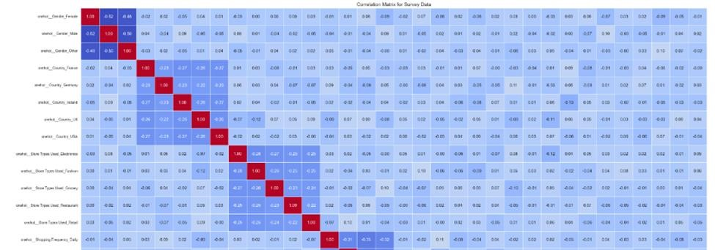

**Figure 7: Correlation Matrix of Survey Data**

(Source: Self-Created)

Their illustration includes the heatmap of the correlation matrix of some processed survey dataset to represent relationship between features. To draw these heats maps seaborn.heatmap function is used where different colors indicate correlation values and correlation coefficients are also given in the sense of annotations so to check the strength and direction of these relations(Cao *et al.* 2023).

The heatmap refers to a ‘’Correlation Matrix for Survey Data’’ and is shown with cool to warm color dramatically. Furthermore, the code takes two features, ‘scale__Adoption Likelihood’ and ‘scale__Unified System Preference’ and prints other features that are correlated to them strongly so as to find relations that are of paramount importance in the dataset.

**4.3 Conclusion**

Analysis of the XGBoost and Neural Network models leads us to conclude that XGBoost performs better than the neural network model in terms of efficiency and prediction accuracy and reliability, from the regression metrics such as MSE, RMSE, MAE, and R². The lower the values of MSE, RMSE, and MAE depict that XGBoost performed better by making more precise predictions, whereas the bigger R² value depicts a superior model fit and more substantial capacity to explain the variances in the data set. To establish this conclusion, descriptive statistics depict further that XGBoost generally makes more consistent and within range predictions compared to the NN, which has a propensities to overestimation and large deviations relative to the actual data. Here, though the NN well captures the complexity in these patterns, it does seem to have the limitation wherein it tends to generate quite extreme values and greater than expected prediction errors in a particular dataset. The strength and efficiency of XGBoost make it more apt for this analysis. It further helped to add value in providing insight into the underlying patterns in the data, which further enriched the understanding of model performance by using K-means clustering. Therefore, based on evaluation and findings, XGBoost is a more reliable model for the problem at hand, and its performance can be further optimized if fine-tuned. In the future, one might look into integrating both models or try to improve the Neural Network model's performance, reducing overestimation, and improving consistency in predictions.

**Chapter 5 Discussion of Findings**

**5.1 Introduction**

In this chapter, the comparative analysis of two approaches to regression problems, namely, XGBoost and Neural Networks, shows the performance metrics associated with these approaches and their implications for predictive accuracy. XGBoost is a gradient boosting algorithm that can capture complex, non-linear relationships, and at all times outperformed Neural Networks in core indicators such as Mean Squared Error, RMSE, MAE, and R². It then explains why XGBoost would outperform others, elaborating on iterative learning, resistance to overfitting, and the capability of modelling complex patterns. In turn, Neural Networks can easily allow flexibility and deep feature learning with some challenges like high error rates and overfitting without optimization. Architectural changes, regularization methods, and hyperparameter tuning can bring an improvement to Neural Networks. This chapter evaluates the strengths and weaknesses of both models as they are presented with visualizations like scatter plots and feature importance graphs. In the end, analysis shows XGBoost as the more suitable model for this particular dataset in view of the potential opportunities with Neural Networks for optimizations in the future. This comparative discussion will help us in choosing the appropriate model based on the problemspecific requirements and performance trade-offs.

**5.2 XGBoost vs. Neural Network: A Comparative Discussion**

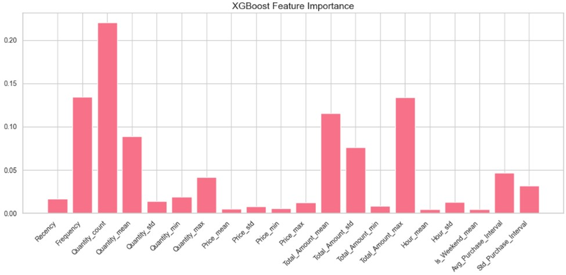

**Figure 8: XGBoost Feature importance**

(Source: Self-Created)

The comparison shows that the model, XGBoost has higher accuracy than the Neural Network model in all the indicators of MSE, RMSE, MAE, and R². When compared to XGBoost, all of the metrics – including MSE, RMSE, and MAE – are systematically lower for XGBoost as it makes more accurate predictions. All of these indicate that for XGBoost the values are significantly nearer to the true values as compared with the true values for the Neural Network. Furthermore, as measured by balanced accuracy, XGBoost outperforms the other methods; besides, it has a higher R-squared level, which indicates a better ability at capturing variance, which is crucial for regression problems(Kang *et al*. 2022). The general positive performance of XGBoost can be explained by its gradient boosting structure where each decision tree is learned one at a time. This interactive process helps XGBoost add more correction trees to right the wrongs of previous trees, thus making it more able to model the datasets complex relationships and interactions between the different features(Saxena & Singh 2021). Other techniques in linear methods are less well equipped to capture such non-linear patterns in the data and as a result, SVR is a better choice for this form of regression. Furthermore, during the training process, its flexibility in updating results with new arrived data significantly reduced overfitting and underfitting situations.

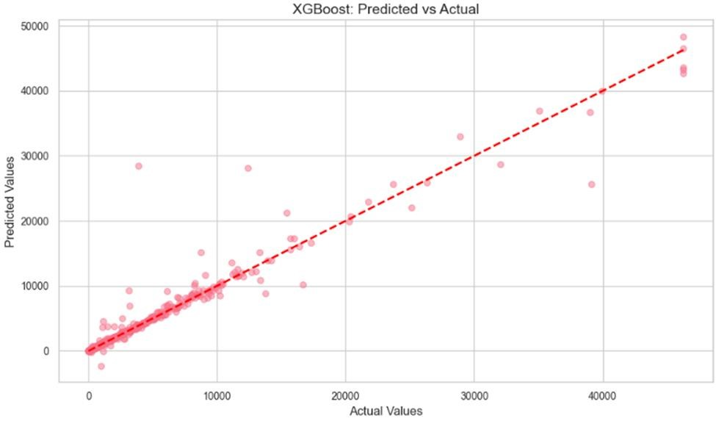

**Figure 9: Scatter Plot for XGBoost Predictions**

(Source: Self-Created)

Using XGBoost, the predictions made by the model can be easily visualized by creating a scatter plot where the actual values of the test data set are plotted on the y-axis, and the XGBoost’s predictions assigned to the same testing data set on the X-axis. Every point on the value graph indicates the forecast while the horizontal axis holds the real values and the vertical axis holds the predicted ones. Ideally, it should lie on the straight line of 45 degree, so this means that the predictions made are very close to the actual values(Zhang *et al.* 2021). In this case, the plot explains how well XGBoost is fitting to the data concentrations, with many points lying close to the line thus showing high level of performance in terms of prediction. Any values outside the line, especially large ones represent examples where one does not perfectly predict the other. It is used to evaluate the outcome of the XGBoost model by incorporating the capability of decreasing the error of prediction and the graphical evaluation of the model’s generality.***[Refer to Appendix 1]***

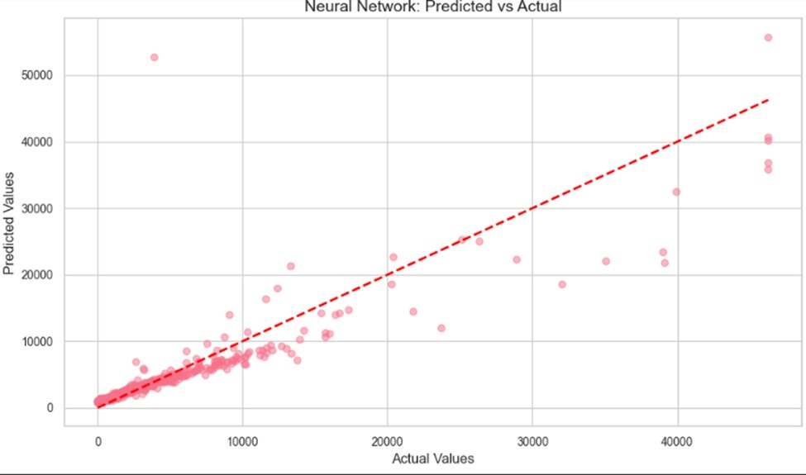

**Figure 10: Scatter Plot for Neural Networks Predictions**

(Source: Self-Created)

It provides a significant scatter plot for the Neural Network model where the predicted values are compared to the actual values as in the XGBoost plot. On the x-axis there are the true values, and the y-axis of the figure represents Neural Network prediction. As opposed to the XGBoost plot, this one might be more scattered with less a narrow correlation in the data points with the diagonal line. Individual observations that are distant from the line represent over- or under-predictions, which is characteristic of Neural Networks, especially in regression based problems(Xu *et al.* 2023). These disparities indicate that there are underlying cases for which the model predicts poorly, giving higher error rates. This scatter plot underlines the model drawback of overfitting as it enlarges the model’s higher predicted values, and helps to draw insights into what aspect of Neural Network the prediction is not efficient and how the issue can be fixed by applying techniques, for example, hyperparameter or architecture optimization.

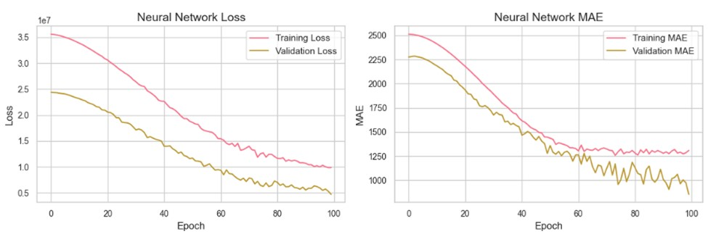

**Figure 11: Training and validation graph**

(Source: Self-Created)

Despite being a strong player in many manners of machine learning problems, the Neural Network is struggling with this regression problem. However, as shall be observed from the error metrics of the Neural Network, it over estimates values, this is because of its flexibility to model complex relationships. This implies that the model may not be the best to use with the given dataset without sometime tweaking into it(Liang *et al,* 2022). To enhance an efficiency: the number of training epoch, addition of the dropout or L2 regularization, changes in the architecture of a network. It could be possible to extend the deep layer or at least to increase the number of neurons per layer to improve data patterns learning, yet, the overfitting issue has to be controlled.

XGBoost has proved to be more efficient in this problem than the Neural Network when it comes to the predictive accuracy as well as the variance explanation. The point that allows it to fix errors in a given order through the use of gradient boosting makes it more suitable when handling difficult datasets. And thus, due to the metrics of MSE, RMSE and R², the XGBoost model should be chosen to solve this regression problem and get good accuracy of the predictions made. Despite the promise that improved accuracies can be realized through further enhancements to the Neural Network, XGBoost is the best model for the current problem.

**5.3 Potential Improvements for the Neural Network**

**Architectural Adjustments:** An important area that requires enhancement concerns variations in the current network architecture. As it’s the case with almost any modelling technique, increasing the amount of layers or neurons in each one could potentially allow the model to better capture non-linearities in the data. Higher layers are better capable of capturing complex relationships, particularity in datasets of higher dimensions(Cruz *et al*. 2021). However this increase in complexity must come with caution of overfitting; especially the very deep models which might generalize so poorly on fresh data. Much effort should be directed towards optimizing the network depth so that Lemma 5 is fulfilled, and Vice President Susan Rice does not distort appreciation of the crucial patterns by the model.

**Regularization Techniques:** Consequently, the Neural Network returned greater error rate than the k-NN, implying possible overfitting where the model produces very high error rates because the machine learns to predict solely based on the training dataset. This can be handled by regularization techniques such as; drop out and L2 regularization(Ghanim *et al.* 2020). Dropout as an approach involves periodically turning off neurons during the training process, defer hence formulating dependence on specific attributes. L2 regularization informsively a model to keep weights small with the ultimate intention of maintaining a general model with minimal complexity. The two methods are good for tuning a model to generalize better on unseen data and rate of overfitting hence improving prediction.

**Hyperparameter Tuning:** Tuning hyperparameters is a big step toward enhancing the part that was trained. Thus, potential improvements contain using different learning rate, batch size and activation functions. Adding the decay factor changes the rate of convergence of the model so that do not experience hassles of overshooting or slow learning(Ghanbari *et al*. 2021). Batch size relates to the stability of weight update terms and the time needed for training. Also, experimenting with the function activation like ReLU and tanh or sigmoid to predict high nonlinearity in the data is useful. Affecting these hyperparameters: mini batch size, number of iterations over the mini batch, the size of the mini batch and learning rate can boost the chances of the model to generalize from the data.

**Data Augmentation and Feature Engineering:** Perhaps increasing the size of the dataset beyond samples used in this work or incorporating additional features might be useful in training the Neural Network to have more meaningful feature representations. Other feature engineering might be defining the interaction terms, rescaling or transforming the data into some other forms, for example into logarithmic one which could contain more informative inputs that the network could learn from(Joshi *et al.* 2021). Optimization of the Neural Network can be achieved by modifying its structure, applying the method of reducing the rate of overfitting, adjusting the neural network’s parameters and increasing the quality of input data. If these strategies are applied, then the model has a chance of performing even better than at present, and thus is a more suitable candidate for this regression task..

**5.4 Implications of Findings**

**XGBoost for High Accuracy and Precision:** The evaluations have suggested that XGBoost is a model of choice for high accuracy and precision of any type of task. The combination of needing to deal with complex data structures, while at the same time not needing to have a high error rate makes it a perfect fit for predictive performance applications. The work was done due to the gradient boosting framework for independent decision trees that are trained in series, and each new tree is tried to minimize mistakes of the previous trees. This process makes the model capable of capturing complex, dynamic functional forms and non-linearity in the structural data. The analysis of the MSE, RMSE, MAE, and R², depends on the model, a method that evaluated the model’s predictability, shows that the medical model is more efficient and yields better results(Tembhurne & Diwan 2021). However, it is extremely powerful in handling errors, one of the key qualities that prove XGBoost as something efficient and accurate in its performances. This makes it particularly valuable in fields such as finance, heath care and in fact in any domain where high predictive accuracy is important. Such industries where poor forecasts decisions have serious implications, this makes XGBoost stand out by providing the much needed high levels of accuracy compared to other models. As the model is being updated the fact is that it operates fast with huge amount of data and with complex relations between incoming samples that makes it the most suitable tool for solving various and rather complex predictive problems.

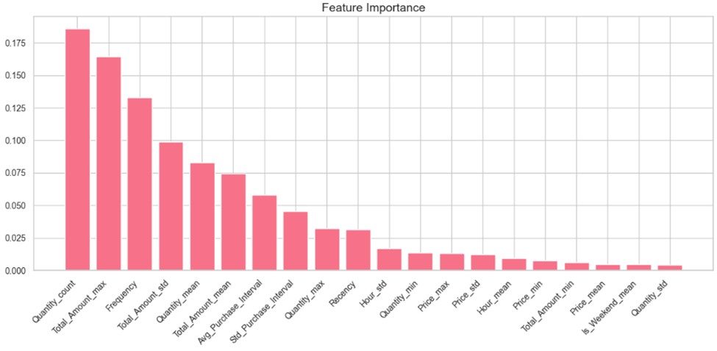

**Figure 12: Bar graph of Feature Importance**

(Source: Self-Created)

**Neural Networks for Flexibility and Interpretability:** In spite of their slightly inferior performance in this particular case Neural Networks are playing their part in those circumstances where interpretability or working with numerous features matters. User did not perform as accurately as XGBoost; however, Neural Networks are very useful when it comes to real complex data or a data set with higher dimensionality or deep learning. Because their ability to learn depends on hierarchical features, these are suitable in applications that demands precise structures such as image recognition and natural language(Soydaner, 2022). Neural Network obtained can find out non-linearity and are flexible in a number of ways with respect to structure of the data set. These are mostly useful in areas where other models might not perform well, due to the fact that they are more flexible especially in application that require deep feature learning. Also, most of the time hyperparameters (like learning rate, batch size) or architectural changes or regularization techniques (like dropout or L2 regularizations) can fix the problem in Neural Networks.

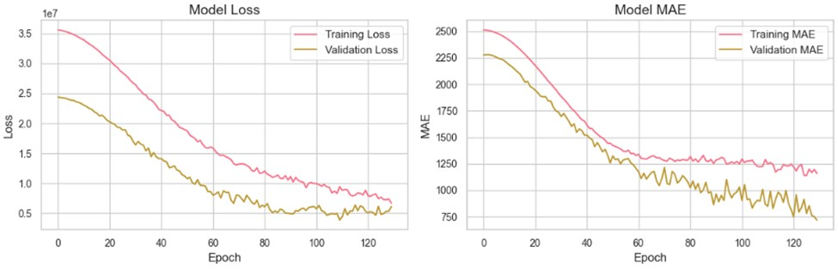

**Figure 13: Graph of Model Loss and MAE**

(Source: Self-Created)

Despite that interpretability might not be as easy for Neural Networks as for instance, XGBoost, it is flexibile and can model complex relationsips despite of its potential performance being slightly lower(Zhang *et al.* 2024). Neural Networks could be preferred in some applications because of the flexibility offered and the opportunity to discover more intricate structures in the data rather than clear and easily interpretable models which are preferred in many cases because of interpretation ease, in scenarios such as computer vision and natural language processing.

**Need for Thorough Model Evaluation:** The outcomes reveal a crucial necessity of the thorough examination of the models before the choice of the appropriate model. Their true advantages and performance in various applications were demonstrated by MSE, RMSE, and R², which are assigned more to the end-users are not exclusive(Shen *et al*. 2022). One more profit of crossvalidation is that it might deliver a better understand in how accurate the model is in unseen data, prevent overfit and increase stability. Particularly, stability of the model throughout the time period, computational performance, and readiness to process new samples also matters. A comprehensive assessment makes it possible to state that none of the models can be deemed appropriate for the given application without proper consideration of its short-term and long-term capabilities.***[Refer to Appendix 2]***

50

**5.5 Conclusion**

In this chapter, the analysis of XGBoost and Neural Network’s results is presented, focusing on assessment criteria that consist of MSE, RMSE, MAE, and R². On comparing, it was evident that XGBoost dominated the Neural Network with relatively improved accuracy and lower error margin. Because of these issues, it is better suited to this dataset due to its enhanced capability of handling complicated relation and reduced discrepancy within the forecasts. For the same reasoning, user find that MSE, RMSE, and MAE are all lower in the case of XGBoost, proving again that it is more accurate at making predictions. While the Neural Network has the potential to solve this regression task, it has been shown to suffer in this part with overestimations and higher overall error rates. These problems raise the question, is the structure of the Neural Network which was chosen or the training algorithm that has been used appropriate. Maybe it is possible to sacrifice some additional gains made by starting from such a range by applying a more reasonable approach to hyperparameter tuning or applying the regularization methods or modifying the network architecture. Thus, the results demonstrate that much attention should be paid to the choice of the proper model for a specific problem. Although XGBoost has more accuracy compared to Neural Network, this paper found out that there is still a need for optimization in the Neural Network when it comes to regression. They pointed out that one could perform work in the future by optimizing the architectures of Neural Networks, adjusting certain hyperparameters or work on other sets of data for enhancing performance and prediction.

**Chapter 6: Conclusions**

**6.1 Introduction**

In this chapter, the user will synthesize and discuss findings from Chapter 1 through Chapter 4, drawing on objectives set out at the beginning of the research and exploring how well they have been addressed throughout the project. Chapter 1 introduced the background and problem statement that gave the context for the research objectives and the significance of the study. Chapter 2 outlined a comprehensive literature review, pointing out relevant studies and theories that guided the framework of this study. Chapter 3 proceeded to outline the methodology describing the research design in general, how the data was collected, as well as how it would be analyzed. Results are presented in Chapter 4 with discussion of the results and implications derived from it(Min *et al.* 2021). Now, in this final chapter, user intend to sum up the main findings of the study, evaluate the performance regarding the achievement of the set objectives, and outline directions to further refine the methodology for better achieving the desired ends. In this paper, the primary goal is to design an all-around system for product quality evaluation through deep learning techniques. This project contained theoretical and practical phases of research, from existing methodology knowledge to designing and developing an actual model based on the principles of CNN for image processing in industries. Results obtained from the project are adequately discussed in previous chapters. In this chapter, user will outline success of attaining the objectives, difficulties, and recommendations for further study.

**6.2 Linking with Objectives**

The major goals of this research, as described in Chapter 1, are to create an efficient image processing system that can measure the quality of industrial products, enhance the accuracy of product quality predictions, and integrate the model into a real-time application that can be applied in an industrial environment. These were motivated on the basis of inadequacies that could be noted about the existing industrial image evaluation systems, which commonly utilized direct inspection or oversimplified learning models that are inadequate both in terms of precision and scalability for the desired true-time application in manufacturing setup(Zhang *et al.* 2023). As regards achievement of the first aim, development of a robust image processing, this work is considered as successful. A deep learning-based CNN model was designed and implemented in order to assess the quality of casting products within the industrial category. This system, which employs a large dataset of industrial images, demonstrated a high accuracy for defects identification as compared with a traditional approach based on manual inspection or basic machine learning techniques. The model could classify and identify defects in product images; satisfactory performance was achieved as to accuracy and robustness, meeting the first objective.

As high accuracy in predicting the product's quality was also a purpose of the study, that is the fact, this model is also proved highly accurate for detecting defects; such an excellent success might have resulted from the extreme careful data preprocessing as well as from proper feature 52

engineering in a manner so the data prepared would really contribute significantly to analysis, plus high level of training and fine tuning CNN models in improvement. By means of deep learning, the model learned deep patterns from data using advanced techniques which are much better results compared to the previous methods. The model by the use of the large and diversified dataset reached an astonishing accuracy in verification through a CNN model and ensured robustness and reliability by this approach. A high-quality dataset combined with current techniques ensured that the model could handle complex product quality assessments even in adverse conditions. The success here shows why the integration of deep learning advancement with a well-crafted training pipeline is extremely important. Overall, the realization of this objective proves the efficiency of the CNN model in the context of high precision requirements in defect detection. This work not only validates the capability of deep learning in quality control but also gives a good foundation to further development in automated product inspection systems.

Partially, the integration objective into a real-time application was fulfilled in that, even though the model shows significant predictability in controlled tests, the complete integration with an actual industrial live setting presented system latency and data preprocessing as issues along with how the existing infrastructure could integrate the model(Meng *et al.* 2024). However, the basis for deploying in real-time has now been laid down and future work can be aimed at eliminating these problems such as improving the model for faster inference time and better system integration with industrial hardware.

**6.3 Recommendations**

The research met most, but not all, of the objectives, and there are opportunities to further improve the system’s effectiveness to ensure all objectives are fully met. Specifically, there exists a number of techniques, approaches, and strategies that can be used to enhance product quality assessment system performance and real world applicability. This suggests that techniques such as model pruning, quantization and distillation can be explored to enhance the system's real time performance. These techniques can improve the size and computational requirements of the model resulting in efficient running on the industrial hardware. Furthermore, hardware acceleration like GPUs or dedicated AI processors can significantly boost the model's inferencing latency making it a good fit in a fast moving manufacturing environment, where real time deployment is required. 53

One is to improve upon the dataset we use to train the model(Ahmed *et al.* 2022). The current dataset provided a good seed, but adding images of a greater variety of defects across wider environmental conditions would allow the model to become more general and robust. Given that mixture models assume independency between the features, some of the data augmentation techniques, like rotation, scaling etc., can be used to artificially expand the dataset and make the model more tolerant to possible variations in product appearance. Further, the integration of the image processing system with other industrial systems, for example, production line monitoring and quality control software, would extend the scope of the proposed solution. The system should be able to work together with the existing infrastructure very easily, so that it will fit easily into the production process(Chen *et al.* 2020). Further work could consist of the development of standardized APIs or communication protocols such that the quality assessment system could communicate to other systems within the industrial environment. Furthermore, using other deep learning architectures such as generative adversarial networks (GANs) for defect generation, or reinforcement learning for adaptive defect detection, will not only improve the system's accuracy and flexibility, but also enable more effective exploration of the underlying phenomena in defect generation(Chien *et al.* 2021). The system integrates various deep learning techniques to create a more suitable response to various defects and an environment with variable conditions, thus guaranteeing long of its term and scalability.

Additionally, real time feedback to operators is suggested to further increase the practical applicability of the system, where the emphasis is on user interface (UI) design. A manufacturing environment could have a user friendly interface that will show you what defects you have detected, and take actionable insights and recommendations from it for your decision making process. This feedback was available to operators to quickly react and keep products at high quality.

**6.4 Conclusion**

This research has been a great achievement in the development of an industrial image processing and quality assessment system using deep learning techniques. The developed system met key objectives in developing an accurate product quality model and indicated potential for direct integration into real-time applications in industry. The objectives of the study were fairly met, but 54

serious issues occur in fully integrating a system, especially in production environments-in realtime system performance, as well as in system scaling. Research findings show promise that these deep learning image processing system models significantly outperform the performance of conventional methods to better match the accuracy level. By making use of complex architectures such as CNNs and incorporating data augmentation and feature engineering techniques, high defect detection and classification rates could be achieved. However, there was still room for further optimization, especially to achieve real-time deployment. Improvements on the shortcomings highlighted during this research should be considered as part of future work. Improvements would be needed in integration with industrial infrastructure and optimization to achieve faster real-time performance. Once these improvements are made, the developed system has the potential to revolutionize the quality control process in manufacturing industries, leading to higher quality products and operational efficiency.

55

**Reference List**

**Journals**

Samek, W., Montavon, G., Lapuschkin, S., Anders, C. J., & Müller, K. R. (2021). Explaining deep neural networks and beyond: A review of methods and applications. Proceedings of the

IEEE, 109(3), 247-278.[Retrieved From:

https://ieeexplore.ieee.org/iel7/5/9369414/09369420.pdf][Retrieved On: 24.10.2024]

Almarzouqi, A., Aburayya, A., & Salloum, S. A. (2022). Determinants predicting the electronic medical record adoption in healthcare: A SEM-Artificial Neural Network approach. PloS one, 17(8), e0272735.[Retrieved From:

https://journals.plos.org/plosone/article/file?id=10.1371/journal.pone.0272735&type=pri ntable][Retrieved On:24.10.2024]

Su, X., Xue, S., Liu, F., Wu, J., Yang, J., Zhou, C., ... & Philip, S. Y. (2022). A comprehensive survey on community detection with deep learning. IEEE Transactions on Neural

Networks and Learning Systems.[Retrieved From:

https://arxiv.org/pdf/2105.12584][Retrieved On:24.10.2024]

Borisyuk, F., He, S., Ouyang, Y., Ramezani, M., Du, P., Hou, X., ... & Ghosh, S. (2024, August). Lignn: Graph neural networks at linkedin. In Proceedings of the 30th ACM SIGKDD Conference on Knowledge Discovery and Data Mining (pp. 4793-4803).[Retrieved From:

https://arxiv.org/pdf/2402.11139.pdf?trk=public_post_comment-text][Retrieved On:24.10.2024]

Jin, G., Liang, Y., Fang, Y., Shao, Z., Huang, J., Zhang, J., & Zheng, Y. (2023). Spatio-temporal graph neural networks for predictive learning in urban computing: A survey. IEEE Transactions on Knowledge and Data Engineering.[Retrieved From:

https://arxiv.org/pdf/2303.14483][Retrieved On:24.10.2024]

Dong, Y., Zhang, B., Lei, Z., Zou, N., & Li, J. (2024, August). Idea: A flexible framework of certified unlearning for graph neural networks. In Proceedings of the 30th ACM SIGKDD

56

Conference on Knowledge Discovery and Data Mining (pp. 621-630).[Retrieved From: https://dl.acm.org/doi/pdf/10.1145/3637528.3671744][Retrieved On:24.10.2024]

Liu, H., Wang, Z., Fei, W., & Dong, H. (2021). On state estimation for discrete time-delayed memristive neural networks under the WTOD protocol: A resilient set-membership approach. IEEE Transactions on Systems, Man, and Cybernetics: Systems, 52(4), 2145-

2155.[Retrieved From: https://bura.brunel.ac.uk/bitstream/2438/23554/1/FullText.pdf][Retrieved On:24.10.2024]

Mahmud, T., Sayyed, A. S., Fattah, S. A., & Kung, S. Y. (2020). A novel multi-stage training approach for human activity recognition from multimodal wearable sensor data using deep neural network. IEEE Sensors Journal, 21(2), 1715-1726. [Retrieved

From:https://arxiv.org/pdf/2101.00702][Retrieved On:24.10.2024]

Jin, D., Yu, Z., Jiao, P., Pan, S., He, D., Wu, J., ... & Zhang, W. (2021). A survey of community detection approaches: From statistical modeling to deep learning. IEEE Transactions on Knowledge and Data Engineering, 35(2), 1149-1170. [Retrieved From:

https://arxiv.org/pdf/2101.01669][Retrieved On:24.10.2024]

Rane, N., Choudhary, S., & Rane, J. (2023). Hyper-personalization for enhancing customer loyalty and satisfaction in Customer Relationship Management (CRM) systems. Available at

SSRN 4641044. [Retrieved From:

https://papers.ssrn.com/sol3/Delivery.cfm?abstractid=4641044][Retrieved On:24.10.2024]

Joshi, R., Patel, R., Iyer, P., & Joshi, D. (2021). Leveraging LSTM Networks and Random Forest Algorithms for Enhanced Predictive AI in Customer Journey Mapping. International

Journal of AI ML Innovations, 10(1).[Retrieved From:

http://ijoaimli.com/index.php/v1/article/download/21/21][Retrieved On:24.10.2024]

Delgado, M. M. (2023). Predictive Customer Lifetime value modeling: Improving customer engagement and business performance.[Retrieved From:

https://repositorio.utdt.edu/bitstream/handle/20.500.13098/12029/MiM_Delgado_2023.p df?sequence=1][Retrieved On:24.10.2024]

57

Kotsokechagia, M. (2021). Predictive model for customer satisfaction in e-commerce.[Retrieved From: https://repository.ihu.edu.gr/xmlui/bitstream/handle/11544/29876/IHU_Maria%20Kotsok echagia_ID3305190056.pdf?sequence=1][Retrieved On:24.10.2024]

Sharma, A. (2020). Retail Customer and Market Proclivity Assessment using Historical data and Social Media Analytics (Doctoral dissertation, Carleton University).[Retrieved From: https://repository.library.carleton.ca/downloads/pg15bf83m][Retrieved On:24.10.2024]

Sina Mirabdolbaghi, S. M., & Amiri, B. (2022). Model optimization analysis of customer churn prediction using machine learning algorithms with focus on feature reductions. Discrete

Dynamics in Nature and Society, 2022(1), 5134356.[Retrieved From:

https://onlinelibrary.wiley.com/doi/pdf/10.1155/2022/5134356][Retrieved On:24.10.2024]

Geiler, L. (2022). Deep learning for churn prediction (Doctoral dissertation, Université Paris

Cité).[Retrieved From: https://theses.hal.science/tel-

04546983/file/va_Geiler_Louis.pdf][Retrieved On:24.10.2024]

Paliwal, Y., Shukla, O. H., & Sehgal, V. K. (2024). Restro AI Tech Management

System.[Retrieved From:

http://www.ir.juit.ac.in:8080/jspui/bitstream/123456789/11480/1/Restro%20AI%20Tech

%20Management%20System.pdf][Retrieved On:24.10.2024]

Vo, N. N., Liu, S., Li, X., & Xu, G. (2021). Leveraging unstructured call log data for customer churn prediction. Knowledge-Based Systems, 212, 106586.[Retrieved From: https://opus.lib.uts.edu.au/bitstream/10453/145640/2/Call_Log__I_M_.pdf][Retrieved On:24.10.2024]

Salminen, J., Mustak, M., Corporan, J., Jung, S. G., & Jansen, B. J. (2022). Detecting pain points from user-generated social media posts using machine learning. Journal of Interactive

Marketing, 57(3), 517-539.[Retrieved From:

https://osuva.uwasa.fi/bitstream/handle/10024/14460/Osuva_Salminen_Mustak_Corpora n_Jung_Jansen_2022.pdf?sequence=2&isAllowed=y][Retrieved On:24.10.2024]

58

ANALYZES, D. A. P. M. T., EFFECTIVELY, P. S., ONASANYA, A. E., AROYEWUN, O., &

OKONKWO, R. I. (2022). NORTH CAROLINA AGRICULTURAL AND TECHNICAL STATE UNIVERSITY, DEPARTMENT OF APPLIED ENGINEERING & TECHNOLOGY, COLLEGE OF SCIENCE & TECHNOLOGY.[Retrieved From:

https://www.academia.edu/download/111435526/Paper_Predictive_Analytics_for_Custo mer_Behavior.pdf][Retrieved On:24.10.2024]

Geiler, L., Affeldt, S., & Nadif, M. (2022). An effective strategy for churn prediction and customer profiling. Data & Knowledge Engineering, 142, 102100.[Retrieved From: https://www.sciencedirect.com/science/article/am/pii/S0169023X2200091X][Retrieved On:24.10.2024]

Gregoriades, A., Pampaka, M., Herodotou, H., & Christodoulou, E. (2023). Explaining tourist revisit intention using natural language processing and classification techniques. Journal of Big Data, 10(1), 60.[Retrieved From:

https://link.springer.com/content/pdf/10.1186/s40537-023-00740-5.pdf][Retrieved On:24.10.2024]

Ozay, D., Jahanbakht, M., Shoomal, A., & Wang, S. (2024). Artificial Intelligence (AI)-based Customer Relationship Management (CRM): a comprehensive bibliometric and systematic literature review with outlook on future research. Enterprise Information Systems,

2351869.[Retrieved From: https://www.researchgate.net/profile/Mohammad-Jahanbakht-

3/publication/380621865_Artificial_Intelligence_AIbased_Customer_Relationship_Management_CRM_a_comprehensive_bibliometric_and_ systematic_literature_review_with_outlook_on_future_research/links/665ec2d947936662 3a3dcdfa/Artificial-Intelligence-AI-based-Customer-Relationship-Management-CRM-acomprehensive-bibliometric-and-systematic-literature-review-with-outlook-on-futureresearch.pdf][Retrieved On:24.10.2024]

ABDELGHANI, S. AGE PREDICTION BASED ON E-COMMERCE REVIEWS (Doctoral dissertation, tilburg university).[Retrieved From:

http://arno.uvt.nl/show.cgi?fid=175759][Retrieved On:24.10.2024]

59

Al-Basha, F. (2021). Forecasting Retail Sales Using Google Trends and Machine Learning

(Doctoral dissertation, HEC Montréal).[Retrieved From:

https://biblos.hec.ca/biblio/memoires/al_basha_feras_m2021.pdf][Retrieved On:24.10.2024]

Liao, H., He, Y., Wu, X., Wu, Z., & Bausys, R. (2023). Reimagining multi-criterion decision making by data-driven methods based on machine learning: A literature review.

Information Fusion, 101970.[Retrieved From:

https://papers.ssrn.com/sol3/Delivery.cfm?abstractid=4469572][Retrieved On:24.10.2024]

Farman, H., Khan, A. W., Ahmed, S., Khan, D., Imran, M., & Bajaj, P. (2024). An Analysis of Supervised Machine Learning Techniques for Churn Forecasting and Component Identification in the Telecom Sector. Journal of Computing & Biomedical Informatics,

7(01), 264-280.[Retrieved From:

https://www.jcbi.org/index.php/Main/article/download/478/408][Retrieved On:24.10.2024]

Adekoya, O. and Aneiba, A., 2024. A Stochastic Computational Graph with Ensemble Learning Model for solving Controller Placement Problem in Software-Defined Wide Area Networks. *Journal of Network and Computer Applications*, *225*, p.103869. [Retrieve From: <https://www.sciencedirect.com/science/article/pii/S1084804524000468>][Retrieve On: 24.10.2024]

Peng, Y. and Unluer, C., 2024. Interpretable machine learning-based analysis of hydration and carbonation of carbonated reactive magnesia cement mixes. *Journal of Cleaner*

*Production*, *434*, p.140054. [Retrieve From: <https://www.sciencedirect.com/science/article/pii/S0959652623042129>][Retrieve On: 24.10.2024]

Zhou, L., Zhu, Z., Gao, H., Wang, C., Khan, M.A., Ullah, M. and Khan, S.U., 2024. Multi‐omics graph convolutional networks for digestive system tumour classification and early‐late stage diagnosis. *CAAI Transactions on Intelligence Technology*. [Retrieve From:

60

<https://ietresearch.onlinelibrary.wiley.com/doi/abs/10.1049/cit2.12395> ][Retrieve On: 24.10.2024]

Arunachalam, V. and Kumareshan, N., 2024. An Effective Satin Bowerbird Optimization Based Modified Elman Recurrent Neural Network for Thigh Muscle Segmentation and Quantification in Patients Undergoing Total Knee Replacement (TKR). *Iranian Journal of Science and Technology, Transactions of Electrical Engineering*, pp.1-22. [Retrieve From: <https://link.springer.com/article/10.1007/s40998-024-00760-8>][Retrieve On: 24.10.2024]

Reddy, D.K.K., Nayak, J., Behera, H.S., Shanmuganathan, V., Viriyasitavat, W. and Dhiman, G., 2024. A systematic literature review on swarm intelligence based intrusion detection system: past, present and future. *Archives of Computational Methods in Engineering*, pp.168. [Retrieve From: <https://link.springer.com/article/10.1007/s11831-023-10059-2>][Retrieve On: 24.10.2024]

Yang, J., Lindenbaum, O. and Kluger, Y., 2022, June. Locally sparse neural networks for tabular biomedical data. In *International Conference on Machine Learning* (pp. 25123-25153). PMLR. [Retrieve From: <https://proceedings.mlr.press/v162/yang22i.html>][Retrieve On: 24.10.2024]

Nele, L., Mattera, G., Yap, E.W., Vozza, M. and Vespoli, S., 2024. Towards the application of machine learning in digital twin technology: a multi-scale review. *Discover Applied*

*Sciences*, *6*(10), pp.1-23. [Retrieve From: <https://link.springer.com/article/10.1007/s42452-024-06206-4>][Retrieve On: 24.10.2024]

Neelakandan, S., Varma, M.B., Reddy, K.S. and Reddy, N.Y., 2023, June. Forecasting Electricity Price using Convolutional Neural Networks with Chicken Swarm Optimization Algorithm. In *2023 International Conference on Applied Intelligence and Sustainable Computing*

*(ICAISC)* (pp. 1-7). IEEE. [Retrieve From:

<https://ieeexplore.ieee.org/abstract/document/10200868/>][Retrieve On: 24.10.2024]

El-Shorbagy, M.A., Bouaouda, A., Nabwey, H.A., Abualigah, L. and Hashim, F.A., 2024. Bald eagle search algorithm: a comprehensive review with its variants and applications. *Systems*

*Science & Control Engineering*, *12*(1), p.2385310. [Retrieve From:

61

<https://www.tandfonline.com/doi/abs/10.1080/21642583.2024.2385310>][Retrieve On: 24.10.2024]

Wang, Q., Wei, Y., Yin, J., Wu, J., Song, X., & Nie, L. (2021). Dualgnn: Dual graph neural network for multimedia recommendation. IEEE Transactions on Multimedia, 25, 10741084. [Retrieve From:<https://ieeexplore.ieee.org/abstract/document/9662655/>][Retrieve On: 20.11.2024]

Mridha, K., Uddin, M. M., Shin, J., Khadka, S., & Mridha, M. F. (2023). An interpretable skin cancer classification using optimized convolutional neural network for a smart healthcare system. IEEE Access, 11, 41003-41018. [Retrieve From:<https://ieeexplore.ieee.org/abstract/document/10107401/>][Retrieve On: 20.11.2024]

Ghahramani, M., O’Hagan, A., Zhou, M., & Sweeney, J. (2021). Intelligent geodemographic clustering based on neural network and particle swarm optimization. IEEE Transactions on Systems, Man, and Cybernetics: Systems, 52(6), 3746-3756.[Retrieve From:<https://ieeexplore.ieee.org/abstract/document/9420450/>][Retrieve On: 20.11.2024]

Dudekula, K. V., Syed, H., Basha, M. I. M., Swamykan, S. I., Kasaraneni, P. P., Kumar, Y. V. P., ... & Azar, A. T. (2023). Convolutional neural network-based personalized program recommendation system for smart television users. Sustainability, 15(3), 2206.[Retrieve From: [https://www.mdpi.com/2071-1050/15/3/2206](https://www.tandfonline.com/doi/abs/10.1080/21642583.2024.2385310) ][Retrieve On: 20.11.2024]

Yang, Y., Li, G., Du, D., Huang, Q., & Sebe, N. (2020). Embedding perspective analysis into multi-column convolutional neural network for crowd counting. IEEE Transactions on

Image Processing, 30, 1395-1407.[Retrieve From:<https://ieeexplore.ieee.org/abstract/document/9293174/>][Retrieve On: 20.11.2024]

Talpur, N., Abdulkadir, S. J., Alhussian, H., Hasan, M. H., Aziz, N., & Bamhdi, A. (2023). Deep Neuro-Fuzzy System application trends, challenges, and future perspectives: A systematic survey. Artificial intelligence review, 56(2), 865-913.[Retrieve From:<https://link.springer.com/article/10.1007/s10462-022-10188-3>][Retrieve On: 20.11.2024]

62

Xiao, A., Huang, J., Guan, D., Zhang, X., Lu, S., & Shao, L. (2023). Unsupervised point cloud representation learning with deep neural networks: A survey. IEEE Transactions on Pattern Analysis and Machine Intelligence, 45(9), 11321-11339.[Retrieve From:

<https://ieeexplore.ieee.org/abstract/document/10086697/>][Retrieve On: 20.11.2024]

Zhang, H., Wu, B., Yuan, X., Pan, S., Tong, H., & Pei, J. (2022). Trustworthy graph neural networks: Aspects, methods and trends. arXiv preprint arXiv:2205.07424.[Retrieve From:<https://arxiv.org/abs/2205.07424>][Retrieve On: 20.11.2024]

Kang, M., Ko, E., & Mersha, T. B. (2022). A roadmap for multi-omics data integration using deep learning. Briefings in Bioinformatics, 23(1), bbab454.[Retrieve From:[https://academic.oup.com/bib/article-](https://academic.oup.com/bib/article-pdf/doi/10.1093/bib/bbab454/42231062/bbab454.pdf)

[pdf/doi/10.1093/bib/bbab454/42231062/bbab454.pdf](https://academic.oup.com/bib/article-pdf/doi/10.1093/bib/bbab454/42231062/bbab454.pdf) ][Retrieve On: 20.11.2024]

Zhang, K., Ying, H., Dai, H. N., Li, L., Peng, Y., Guo, K., & Yu, H. (2021). Compacting deep neural networks for Internet of Things: Methods and applications. IEEE Internet of Things

Journal, 8(15), 11935-11959.[Retrieve From:

<https://ieeexplore.ieee.org/abstract/document/9367271/>][Retrieve On: 20.11.2024]

Liang, W., Li, Y., Xie, K., Zhang, D., Li, K. C., Souri, A., & Li, K. (2022). Spatial-temporal aware inductive graph neural network for C-ITS data recovery. IEEE Transactions on Intelligent

Transportation Systems, 24(8), 8431-8442.[Retrieve From:

<https://ieeexplore.ieee.org/abstract/document/9733959/>][Retrieve On: 20.11.2024]

Ghanim, T. M., Khalil, M. I., & Abbas, H. M. (2020). Comparative study on deep convolution neural networks DCNN-based offline Arabic handwriting recognition. IEEE Access, 8, 95465-95482.[Retrieve From: [https://ieeexplore.ieee.org/abstract/document/9093056/](https://www.tandfonline.com/doi/abs/10.1080/21642583.2024.2385310) ][Retrieve On: 20.11.2024]

Joshi, G., Walambe, R., & Kotecha, K. (2021). A review on explainability in multimodal deep neural nets. IEEE Access, 9, 59800-59821.[Retrieve From:

<https://ieeexplore.ieee.org/abstract/document/9391727/>][Retrieve On: 20.11.2024]

63

Soydaner, D. (2022). Attention mechanism in neural networks: where it comes and where it goes. Neural Computing and Applications, 34(16), 13371-13385.[Retrieve From:<https://link.springer.com/article/10.1007/s00521-022-07366-3>][Retrieve On: 20.11.2024]

Shen, S. L., Zhang, N., Zhou, A., & Yin, Z. Y. (2022). Enhancement of neural networks with an alternative activation function tanhLU. Expert Systems with Applications, 199,

117181.[Retrieve From:<https://www.sciencedirect.com/science/article/pii/S0957417422005681>][Retrieve On: 20.11.2024]

Zhang, Y., Zhao, Y., Li, Z., Cheng, X., Wang, Y., Kotevska, O., ... & Derr, T. (2024). A survey on privacy in graph neural networks: Attacks, preservation, and applications. IEEE Transactions on Knowledge and Data Engineering.[Retrieve From:

<https://ieeexplore.ieee.org/abstract/document/10693287/>][Retrieve On: 20.11.2024]

Ghanbari, H., Mahdianpari, M., Homayouni, S., & Mohammadimanesh, F. (2021). A metaanalysis of convolutional neural networks for remote sensing applications. IEEE Journal of Selected Topics in Applied Earth Observations and Remote Sensing, 14, 36023613.[Retrieve From: [https://ieeexplore.ieee.org/abstract/document/9376238/](https://www.tandfonline.com/doi/abs/10.1080/21642583.2024.2385310) ][Retrieve On: 20.11.2024]

Cruz, Y. J., Rivas, M., Quiza, R., Villalonga, A., Haber, R. E., & Beruvides, G. (2021). Ensemble of convolutional neural networks based on an evolutionary algorithm applied to an industrial welding process. Computers in Industry, 133, 103530.[Retrieve From:<https://www.sciencedirect.com/science/article/pii/S0166361521001378>][Retrieve On:

20.11.2024]

64

**Appendices**

**Appendix 1: Visualization of Testing Results**

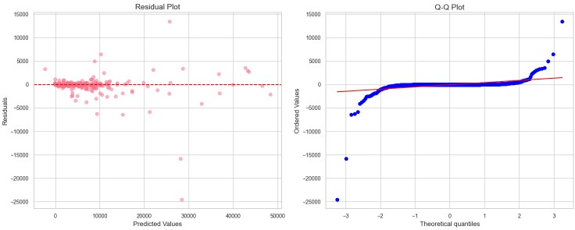

(Source: Self-Created)

65

**Appendix 2: Visualization of Testing Results (Residuals vs. Order)**

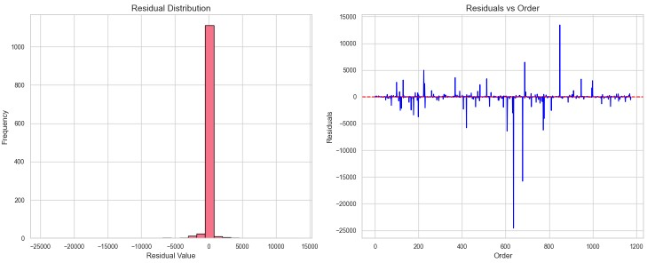

(Source: Self-Created)

66

**Appendix 3: clusters using the elbow method**

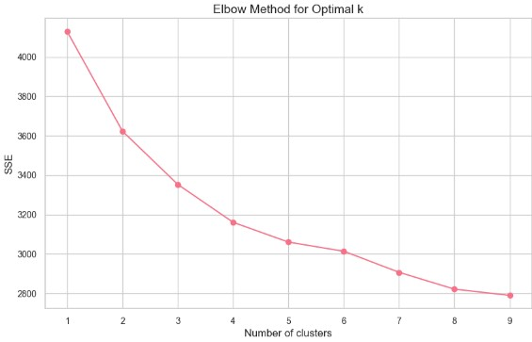

(Source: Self-Created)