Of Muslims and Vermin

Mouli Sharma

For The Voice Express 1st March 2023

**Title:** All That Breathes **Genre:** Documentary **Duration:** 97 Minutes

**Release:** 2022

**Directed By:** Shaunak Sen

**Synopsis:** As Delhi’s air worsens for non-vegetarian birds and religions alike, three men attempt to save what they can among all that breathes.

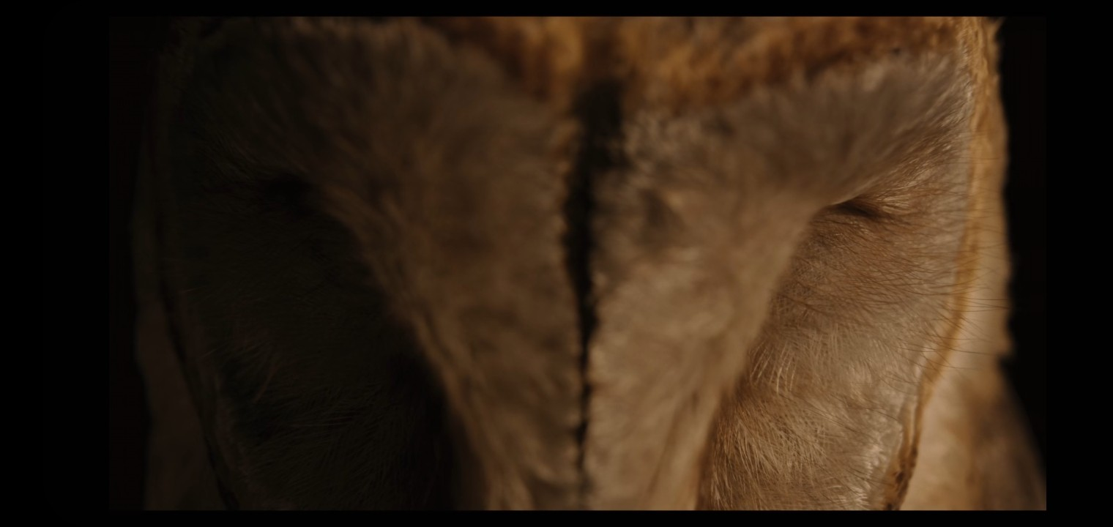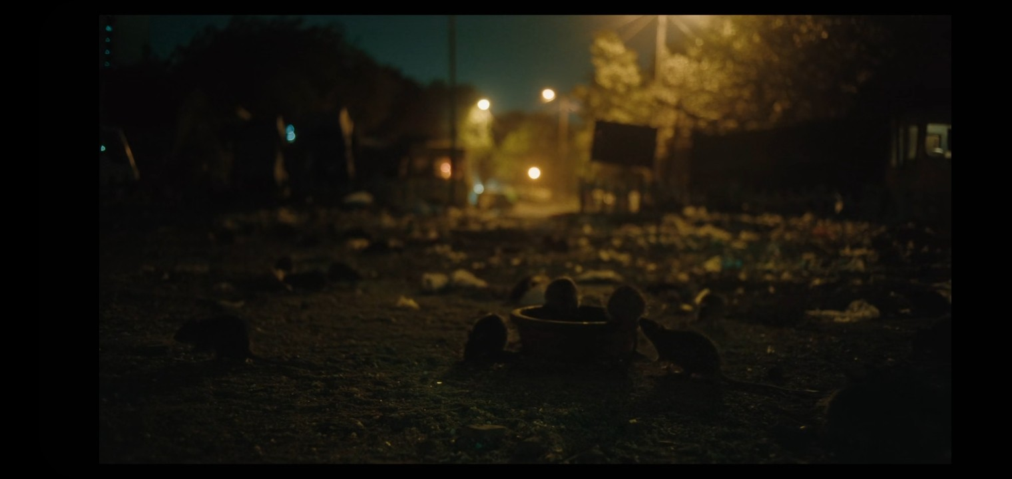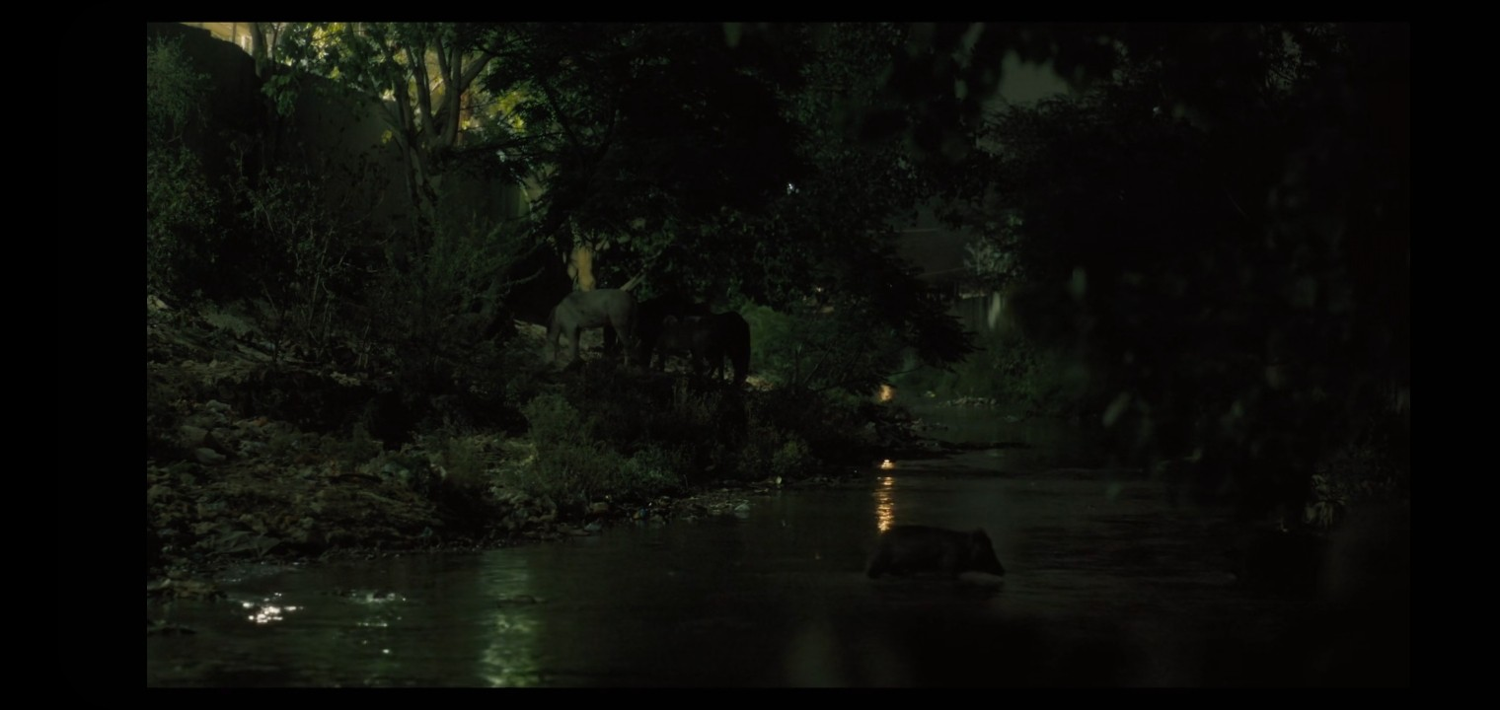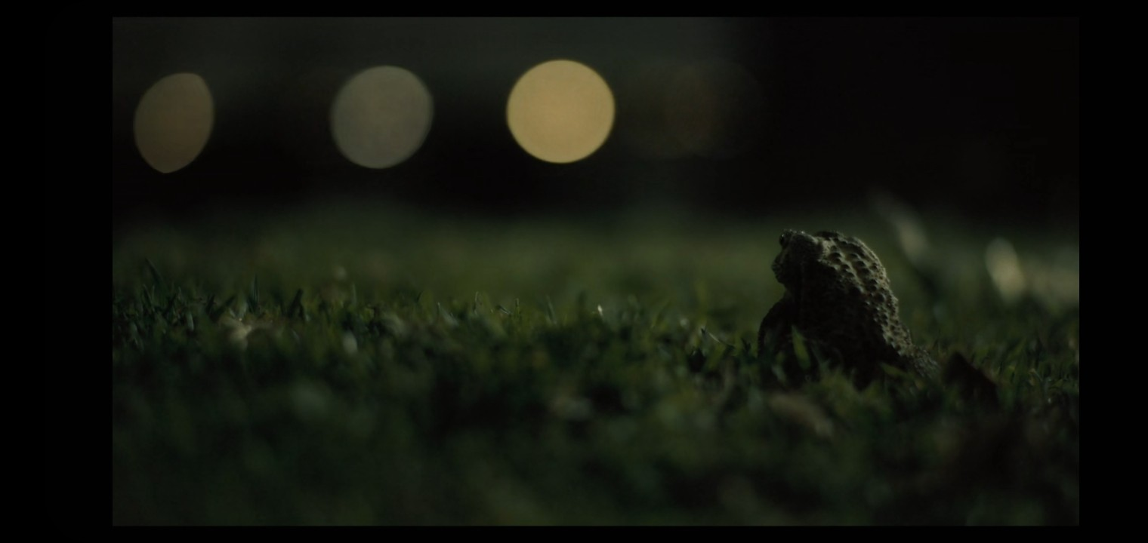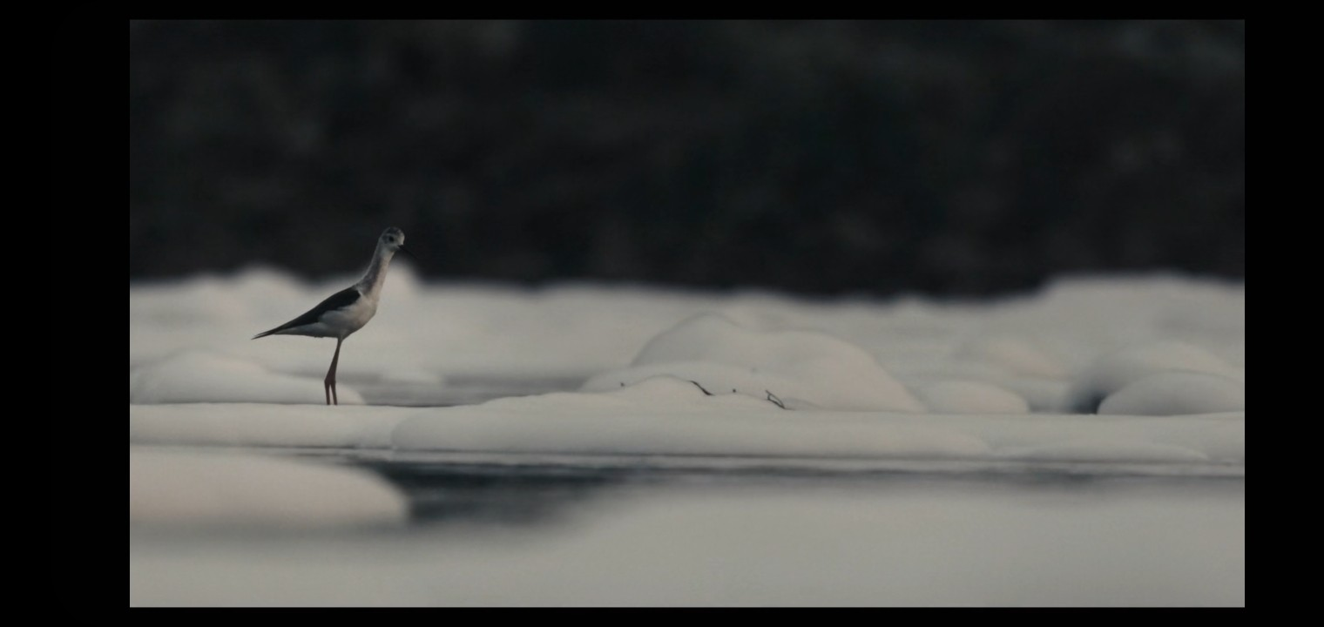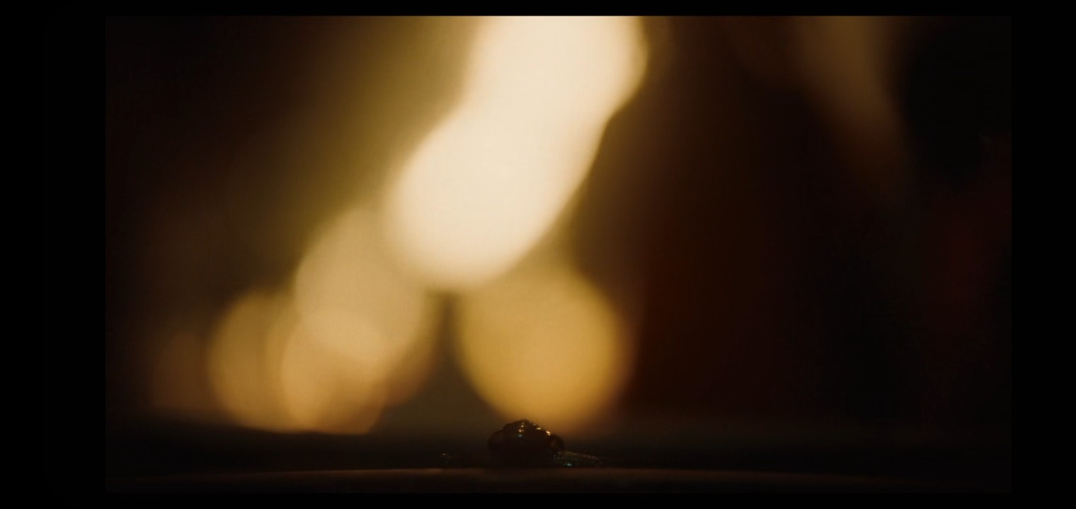

Figure 1: *“We came to animals and science through our late mom’s fables about ghosts and holy spirits. The ‘cat-saint’, ‘vulture shrine’, spirits that appeared as snakes and insects. One shouldn’t differentiate between all that breathes.”*

1

Saud and Nadeem, two brothers running a veterinary hospital for birds of prey out of the basement of their brick laden west Delhi family home along with their friend Salik navigate the fiscal and familial difficulties of ‘saving kites’ as the family business as more and more birds fall from the sky in Delhi’s worsening air, while a threat that has little to do with brotherhood or medicine begs whether they should be saving themselves instead.

1Screencaps and text from the film.

Similar in structural principle to *Eeb Allay Ooo!* (2019, Prateek Vats), *All That Breathes* alternates from exquisite and beautiful shots of the city and its wildlife to the unpretentious, voyeuristic comedy of a middle class Delhi man’s everyday. The transitions and fills are lingering and gorgeous, making the most judicious and clever use of narration possible, collaging painstakingly personal, breathtaking moments of breath itself within the city with insights from two self made veterans of the same. Centipede breaking the surface of a puddle as an aeroplane flies overhead. Rats having a pixar dinner by a burst-gutter Sein. Cows migrating across a storm clogged river. Flies on a car deck. Everything that breathes.

Not a moment is wasted, not a single set half assed. The sound is withheld and haunting, it tells with what it doesn’t tell. The backdrop of the streets screams with protests and political agitation as Salik opens a refrigerator filled with meat. News headlines of the progression of violence over the CAA score the outline of themselves overlayed on shots of the streets and people. The whole film walks a circle around this violence; around prejudice and words. Only one section within the entire film even bothers stating violence, explicitly - not in as many words, but in pictures, and those too not of the violence itself, but of it’s aftermath. Of the space left behind by it, of the ashes left in its wake. It lasts for less than a minute. It is silent.

*“By calling people termites and rats, they’ve somehow made it about hygiene. Just like the kite’s different, people are also treated differently. Violence is al- ways an act of communication.”*2

There is a term, for cinematic behaviour like this. Environmental story- telling. Telling a story not with what is there but with what is around it. ”What’s a crater?” ”A hole where something happened.”3 Every single one of the film’s 97 minutes is hand sculpted around this principle. Ultimately, *All That Breathes* is a film that chooses to be about the smaller picture. Cutout of empty space on the road, “what is a streetlight?” a streetlight is what is not there. It rejects the opportunity to say what it therefore ends up saying much more clearly; it is as much about Nadeem and Saud and what is left unsaid between them as the political commentary that it will end up being remem- bered for (one that it perhaps only makes incidentally). It is as much about the cost of doing something noble as it is about something noble perhaps not being enough. It is as much about the critters writhing in the dirt stuck underneath our fingernails as those blacklisted in the Citizenship Amendment Act. Some- times, all a parent can leave his child behind with is purpose. Perception can be a lineage, too, you know. *All That Breathes* is as much about why some men do what they do as it is about recognising that there is no reason for them to want to anymore than you and me. It dares you to recontinue the convenience of transferring the burden of care onto those that have the spine to carry it un-

2Text from the film.

3Room, 2010, Emma Donoghue

der the guise of acknowledging the goodness of their hearts. Of your miserable attempts to justify your apathy, your inaction, your gutlessness. It dares you to look a black kite in the eye from an inch away and not fall in love with it because it kills to eat.

This is the worth of technical excellence; no labour of love is invisible. This film falls to me, within the unnervingly small category of perfect; deeply funny, deeply human, and absolutely flawless. It dares you to decide or admit that you’ve already decided - what is too dirty for you to mourn? What corpse are your hands too clean to pray for. What won’t you bury.

What will you burn.