periods long war

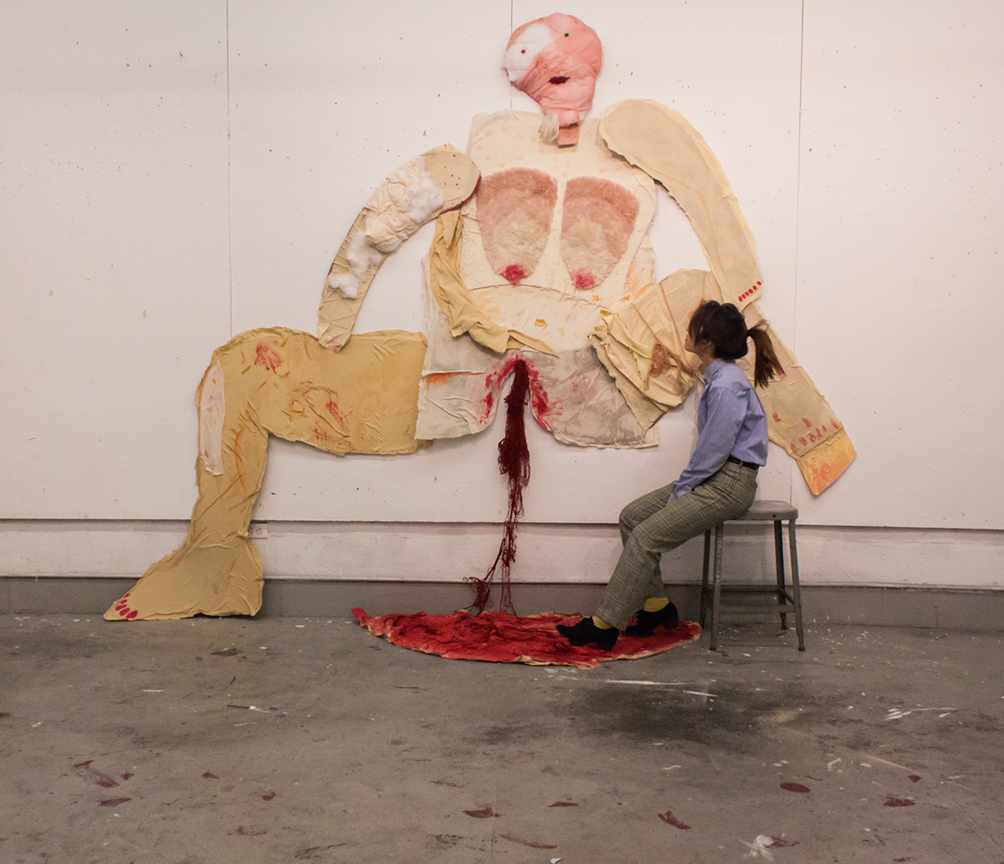(behance)

Shruti 22 february’2023

On 8 march 1914, the arrest of Sylvia Pankhurst is the escapade that paved the way for the celebration of International women’s day. To say, it has been over a century since the incident occurred, and the consolation that we get to this day is that at least ‘things are changing’. So let us talk about these institutions and the generation that is the ‘flag bearer’ of this change.

I am a regular going student college at Kalindi College, an institution that takes great pride in calling itself an all-women’s institution. It is almost daily that we are given lessons on feminist studies, studying the intricacies of different thinkers on women’s psyche and the history of long struggles. It is empowering in a sense, seeing women around you grow and finally given the ground which we rightfully deserve. With the long backing history of people relinquishing their skins to form the way that we trod today, one can expect these ‘modern institutions’ to be the change maker. But what hope does one have left when you see them opening the gates we all tried so hard to close?

My friend was on her period and went to take a pad from the school infirmary wherein we were expected a fee of 5 rupees for the napkin. The incident was stupefying in a way. It is not about the mere amount that you pay but the very existence of a fee to buy a product that has the sole role of hygiene. The situation is not any different at other places either. Incidents like this pose the question of your very existence, we are expected to pay for something which is out of our area of authority. The worsening of the situation dates back to 1994 when the pink tax was brought on the spectrum. The doubled cost for the products directed towards the feminine audience is so normalized in the market.

The fight is undoubtedly a long and demanding one, but it is incident like these that makes one question whether to are we really trying. Is demarcating a day enough?